
DAYANANDA SAGAR COLLEGE OF
ARTS, SCIENCE AND COMMERCE
BANGALORE – 560111

DEPARTEMENT OF COMPUTER APPLICATIONS
Master of Computer Applications (MCA)

Project On
"Binary Calculator Using Logic Gates"

Submitted by :-
Neha A Kalaburagi (P03CJ25S126049)
Pruthvish S (P03CJ25S126058)
B Tousif Umar (P03CJ25S126009)

Under the Guidance of:
Mrs. Akshata Deepak
Asst. Professor,
Department of Computer Applictaions

CONTENTS

1. | Introduction and Objective | 01
2. | Block Diagram | 02 - 05
3. | Simulator Details and Implementation Files | 06 - 09
4. | Implementation | 10 - 12
5. | Test Cases and Result | 13 - 14
6. | Conclusion | 15 - 16
7. | Link of Working Project | 17

INTRODUCTION AND OBJECTIVE

INTRODUCTION
The Binary Calculator Using Logic Gates is a digital logic simulation project that implements a 4-bit Ripple Carry Adder-Subtractor. This project demonstrates how fundamental logic gates specifically XOR, AND, and OR—can be combined to perform arithmetic operations on binary numbers. A key feature of this system is its ability to perform both addition and subtraction using the same core hardware circuit, controlled by a single "Mode" bit. The project provides a dual-perspective result, interpreting output bits in both Unsigned (0 to 15) and Signed 2's Complement (−8 to +7) formats.

OBJECTIVE
The primary objectives of this project are:
- Circuit Simulation: To design and simulate a functional 4-bit adder-subtractor circuit using logic gate principles.
- Mode Control: To implement conditional bit inversion via XOR gates, allowing the circuit to switch between addition (Mode = 0) and subtraction (Mode = 1).
- Arithmetic Logic: To demonstrate the application of 2's Complement arithmetic for performing subtraction through addition hardware.
- Error Detection: To implement and explain Carry Out (for unsigned arithmetic) and Overflow Detection (for signed arithmetic).
- Educational Visualization: To provide a step-by-step breakdown of the ripple carry process to enhance the understanding of bit-level computation.

BLOCK DIAGRAM
The 4-bit Binary Adder-Subtractor is a Ripple Carry architecture. It consists of four identical stages, each handling one bit of the 4-bit input. The logic is divided into two main layers: the Control Layer (XOR gates) and the Arithmetic Layer (Full Adders).
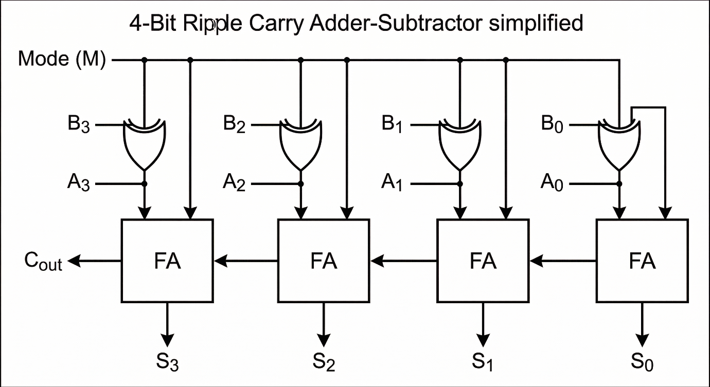

A. Mode Control Logic (The XOR Layer)
The top-most part of the circuit is the Mode (M) control line, which is connected to one input of every XOR gate. This layer acts as a "Conditional Inverter."
- When M = 0 (Addition): The XOR gates pass the B inputs (B₀, B₁, B₂, B₃) through to the adders without any change.
- When M = 1 (Subtraction): The XOR gates invert all bits of B, creating the
1's Complement.

B. The Full Adder (FA) Chain
The circuit uses four Full Adders (FA) connected in series. The output carry of one stage becomes the input carry of the next significant stage.
- Initial Carry-in (C₀): The Mode bit is also connected to the Carry-in of the first FA. In subtraction (M=1), this adds the required "+1" to the inverted B bits, effectively completing the 2's Complement of the number.
- A and B Inputs: Each FA receives one bit from number A and the modified bit from number B.
- Ripple Propagation: The carry "ripples" from right to left (FA $→$ FA $→$ FA $→$ FA), which is why the final result (S₀, S₁, S₂, S₃) is only stable once the carry has moved through all stages.

C. Output and Status Flags
The bottom and left side of the diagram show the results of the computation:
- Sum Bits (S₀ to S₃): These represent the 4-bit binary result of the operation.
- Carry-out (C_{out}): The final carry from the last FA. This indicates if an unsigned addition has exceeded the 4-bit limit (greater than 15).
- Overflow Logic (V): Though simplified in the diagram, the circuit monitors the carry entering the last FA and the carry exiting it. If they are different (C_{in} $≠$ C_{out} for the last stage), the Overflow flag is triggered, indicating an error in signed arithmetic.

Working Principle: Step-By-Step Calculation
To understand how the logic gates and FA (Full Adder) blocks interact, let’s trace a specific subtraction example: 5 - 3.
Step 1: Input Representation
- Number A (5): 0101
- Number B (3): 0011
- Mode (M): 1 (Subtraction)
Step 2: The XOR Layer (1's Complement)
The Mode bit (M=1) is sent to all XOR gates. Each bit of B is XORed with 1:
- B₀: 1 $⊕$ 1 = 0
- B₁: 1 $⊕$ 1 = 0
- B₂: 0 $⊕$1 = 1
- B₃: 0 $⊕$ 1 = 1
- Resulting B': 1100 (The 1's complement of 3)
Step 3: Completing 2's Complement
The Mode bit (M=1) is also sent to the Initial Carry-in (C₀) of the first FA. This adds the required "+1" to the 1's complement:
- B' + C₀ = 1100 + 1 = 1101 (This is the 2's complement of 3, which represents -3).
Step 4: The Ripple Carry Process
The four FA blocks now perform a standard addition of A + (-B):
- FA0 (LSB): Adds A₀(1) + B'₀(0) + C₀(1).
  - Sum S₀ = 0, Carry C₁ = 1.
- FA1: Adds A₁(0) + B'₁(0) + C₁(1).
  - Sum S₁ = 1, Carry C₂ = 0.
- FA2: Adds A₂(1) + B'₂(1) + C₂(0).
  - Sum S₂ = 0, Carry C₃ = 1.
- FA3 (MSB): Adds A₃(0) + B'₃(1) + C₃(1).
  - Sum S₃ = 0, Carry C₄ = 1.
Step 5: Final Result Interpretation
- Binary Output (S₃ S₂ S₁ S₀): 0010
- Decimal Result: 2 (Which is correct: 5 - 3 = 2).
- Flags: C_{out}: 1 (In subtraction, a carry-out of 1 means no "borrow" was needed, and the result is positive).
  - Overflow (V): C₃(1) $⊕$ C₄(1) = 0. Since V=0, the signed result is valid and within the 4-bit range.

SIMULATOR DETAILS & IMPLEMENTATION FILES
The project is implemented through two distinct but logically identical platforms: an interactive Web-Based Simulator and a MATLAB-based Command-Line Calculator. Both versions utilize the same gate-level logic to ensure consistency across different environments.
A. Interactive Web Simulator (index.html)
The web simulator provides a high-fidelity, visual experience designed with a modern "Neon" aesthetic. It allows for real-time experimentation with binary arithmetic.
- Interactive Input Layer: Users interact with two 4-bit input rows (A and B). Each bit is a clickable toggle that switches between logic high (1) and logic low (0).
- Mode Control: A dedicated operation toggle allows users to switch between Addition (0) and Subtraction (1). Changing this mode instantly recalculates the output using the 2's complement logic for subtraction.
- Dynamic Visual Results: Result Bits: Four glowing output bit displays (S₃, S₂, S₁, S₀) show the final sum or difference.
  - Status Flags: Real-time indicators for Carry Out (essential for unsigned range) and Overflow (critical for signed 2's complement range).
- Dual Interpretation Engine: The simulator simultaneously processes and displays the binary result in two ways:
  - Unsigned Interpretation: Values ranging from 0 to 15.
  - Signed 2's Complement: Values ranging from −8 to +7, including a "True Answer" comparison if an overflow occurs.
- Step-by-Step Logic Trace: A tabbed interface allows users to view the internal "Ripple Carry" process. It breaks down the calculation into individual Full Adder stages, showing A_{i}, B'_{i}, and Carry_{in} for every bit.

B. MATLAB Implementation (calculator.m)
The calculator.m file serves as the algorithmic backbone of the project, providing a robust command-line interface for the same logic circuit.
- Input Validation Loop: The script includes a robust validation mechanism that forces the user to enter exactly four bits (0s and 1s only) in an array format (e.g., [1 0 1 0]).
- Gate-Level Modeling: Unlike simple decimal subtraction, the script simulates hardware behaviour:
  - Conditional Inversion: Uses the xor (B, mode) function to bitwise-invert B when the mode is set to subtraction.
  - Loop-Based Ripple Carry: A for loop iterates from the LSB (i=4) to the MSB (i=1), calculating the sum and carry for each stage using Boolean logic:
S(i) = A(i) $⨁$ B_{mod}(i) $⨁$carry
- Advanced Diagnostics: Overflow Logic: It specifically captures C₃ (carry into the MSB) and C₄ (carry out) to calculate the overflow flag: overflow = xor(C3, C4).
  - Signed Conversion: It programmatically handles the 2's complement conversion for display, applying the formula: if S(1) == 1, sR = uR - 16; end.
- Formatted Reporting: The script uses fprintf to generate a structured text report, detailing the binary result, unsigned decimals, signed decimals, and explicit warnings if an overflow is detected.
C. Logic Circuit Simulator (CircuitVerse)
The core gate-level logic of this project was designed, implemented, and verified using CircuitVerse, an online digital logic simulation platform. This environment provided a highly visual and interactive method to validate the mathematical theories of Boolean algebra and 2's complement arithmetic before algorithmic verification in MATLAB.

1. Interactive Hardware Toggles
- Input Bit Array: The simulator features two rows of four interactive switches representing the binary inputs A (A₀-A₃) and B (B₀-B₃).
- Manual Manipulation: Users can manually toggle each bit between logic high (1) and logic low (0), allowing for the testing of specific bit patterns and edge cases.
- Binary-to-Decimal Sync: These inputs are directly mapped to the arithmetic layer, providing an immediate visual representation of how binary values are processed by the gates.

2. Mode Control (M) Mechanism
- Operational Switch: A dedicated master toggle, labeled Mode (M), acts as the primary control signal for the entire circuit.
- Logic Engagement: When the Mode switch is set to High (1), the circuit dynamically engages the subtraction logic by activating the XOR inversion layer.
- Arithmetic Shift: When set to Low (0), the circuit performs standard addition, demonstrating how a single hardware layout can be multiplexed to perform different functions.

3. Visual Logic Probes and LEDs
- Real-Time Output: The result of every logic change is instantly visible through glowing LED output probes representing the Sum bits (S₀-S₃).
- Status Flags: Dedicated probes monitor critical status indicators, including the Carry-out (C_{out}) for unsigned operations and the Overflow flag (V) for signed 2's complement operations.
- Interpretation: This immediate visual feedback allows for the rapid verification of test cases against expected decimal results.

4. Gate Connectivity and Ripple Propagation
- Structural Transparency: The simulator provides a clear view of the "wiring" between components, specifically showing how the XOR inversion layer connects to the Full Adder (FA) blocks.
- Ripple Visualization: Users can observe the sequential "ripple" effect, where the carry bit generated in the Least Significant Bit (FA₀) stage propagates through the intermediate stages (FA₁ and FA₂) to reach the Most Significant Bit (FA₃).
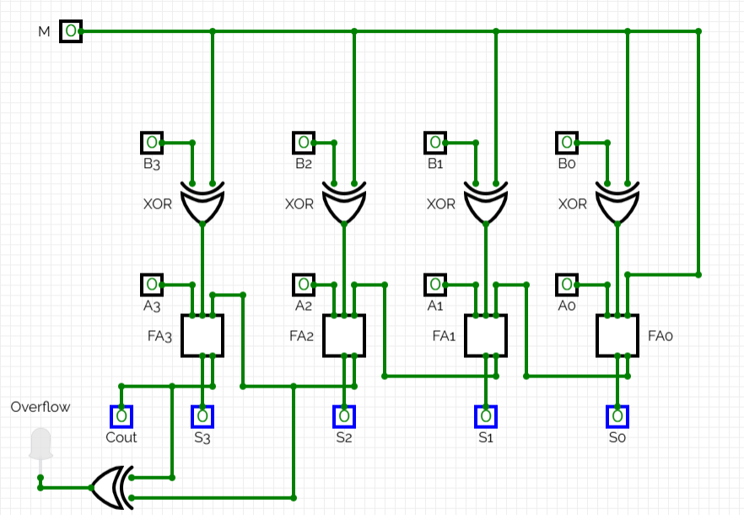
- Educational Insight: This level of connectivity confirms the timing and dependency constraints inherent in a Ripple Carry architecture, illustrating why the final result is only valid once the carry has stabilized through all four stages.
IMPLEMENTATION
The implementation details the logic required to build the 4-bit Ripple Carry Adder-Subtractor hardware.
A. Full Adder Logic
The core of the system is the Full Adder, which adds three bits.
Full Adder Truth Table:
A | B' | C_{in} | Sum (S) | Carry Out (C_{out})
0 | 0 | 0 | 0 | 0
0 | 0 | 1 | 1 | 0
0 | 1 | 0 | 1 | 0
0 | 1 | 1 | 0 | 1
1 | 0 | 0 | 1 | 0
1 | 0 | 1 | 0 | 1
1 | 1 | 0 | 0 | 1
1 | 1 | 1 | 1 | 1
Boolean Equations:
- Sum (S):
A∖BCin​ | 00 | 01 | 11 | 10
0 | 0 | 1 | 0 | 1
1 | 1 | 0 | 1 | 0

- S = A’B’C_{in} + A’BC’_{in} + AB’C’_{in} + ABC_{in}
- S = A $⨁$ B' $⨁$ C_{i}
- Carry Out (C_{out}):
A∖BCin​ | 00 | 01 | 11 | 10
0 | 0 | 0 | 1 | 0
1 | 0 | 1 | 1 | 1

- C_{out} = AB + BC_{in} + ACin

B. Subtractor Logic
Subtraction is achieved through 2's complement addition.
- XOR Conditional Inversion: Input B is processed as B' = B $⨁$ Mode. If Mode=1, B is bitwise inverted (1's complement).
- Initial Carry (C₀): The Mode bit is fed into the first carry-in, adding 1 to the 1's complement to complete the 2's complement.
Full Subtractor Truth Table (for direct subtraction A-B-B_{in}):
A | B | B_{in} | Difference (D) | Borrow-out (B_{out})
0 | 0 | 0 | 0 | 0
0 | 0 | 1 | 1 | 1
0 | 1 | 0 | 1 | 1
0 | 1 | 1 | 0 | 1
1 | 0 | 0 | 1 | 0
1 | 0 | 1 | 0 | 0
1 | 1 | 0 | 0 | 0
1 | 1 | 1 | 1 | 1

Boolean Equations:
- Difference (D):
A∖BBin​ | 00 | 01 | 11 | 10
0 | 0 | 1 | 0 | 1
1 | 1 | 0 | 1 | 0
- D = A’B’B_{in} + A’BB’_{in} + AB’B’_{in} + ABB_{in}
- D = A $⨁$B $⨁$ B_{in}

- Borrow-out (B_{out}):
A∖BBin​ | 00 | 01 | 11 | 10
0 | 0 | 1 | 1 | 1
1 | 0 | 0 | 1 | 0

- B_{out} = A’B + A’B_{in} + BB_{in}
- B_{out} = $\overline{A}$B + ($\overline{A}$ + B)B_{in}

C. Signed and Unsigned Logic
- Unsigned: Uses standard binary weighting for a range of 0 to 15.
- Signed (2's Complement): The MSB is treated as a sign bit with a negative weight (-8), providing a range of −8 to +7.
- Conversion: In both MATLAB and JavaScript, if the MSB (S₃) is 1, the signed value is calculated as Unsigned - 16.
D. Overflow Detection
- Logic: Overflow occurs only in signed arithmetic when the result exceeds the range [-8, +7].
- Implementation: Overflow = C₃ $⨁$ C₄, where C₃ is the carry into the MSB and C₄ is the carry out.

TEST CASES & RESULTS
The project was validated using a series of strategic test cases designed to verify the accuracy of the ripple carry logic, 2's complement subtraction, and error detection (carry and overflow). The following results were consistent across both the Web Simulator and the MATLAB implementation.
A. Addition Test Cases (Mode = 0)
Case | Input A | Input B | Binary Result | Unsigned | Signed | Status
Simple Addition | 0011 (3) | 0010 (2) | 0101 | 5 | 5 | Correct
Negative+ Positive | 1001 (-7) | 0110 (6) | 1111 | 15 | -1 | Correct
Signed Overflow | 0111 (7) | 0010 (2) | 1001 | 9 | -7 | Overflow Detected

Observation (Case 3): In signed mode, 7 + 2 = 9. Since 9 is outside the range [-8, +7], the MSB becomes 1, and the circuit detects an overflow (C₃ $⨁$ C₄ = 1).
B. Subtraction Test Cases (Mode = 1)
Case | Input A | Input B | Binary Result | Unsigned | Signed | Status
Simple Subtraction | 0111 (7) | 0011 (3) | 0100 | 4 | 4 | Correct
Result < 0 (Borrow) | 0011 (3) | 0101 (5) | 1110 | 14 | -2 | Correct
Zero Result | 0101 (5) | 0101 (5) | 0000 | 0 | 0 | Correct
Observation (Case 2): When A < B in unsigned mode, a "borrow" occurs, indicated by Carry Out = 0. In signed mode, the result 1110 correctly represents -2 via 2's complement.

C. Summary of Results
- Logical Accuracy: The XOR gates correctly inverted Input B during subtraction, and the initial carry-in (C₀ =1) successfully completed the 2's complement operation.
- Interpretation: The dual-display system accurately converted binary strings to decimal for both unsigned and signed formats in real-time.
- Flag Verification: The overflow flag correctly triggered only during signed operations where the result exceeded 4-bit boundaries.
Addition (0011 + 0010 = 0101):-
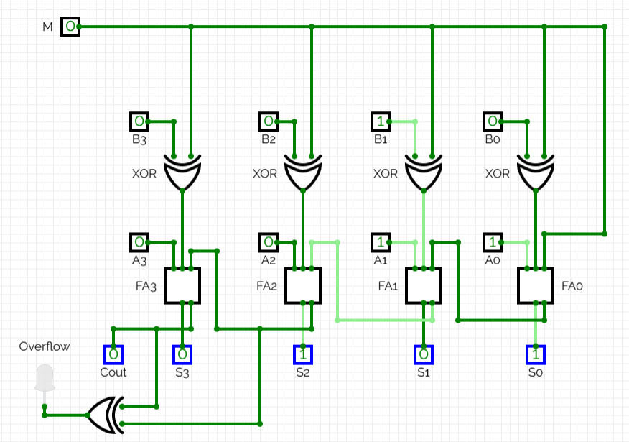

Subtraction (1011 - 0101 = 1110):-
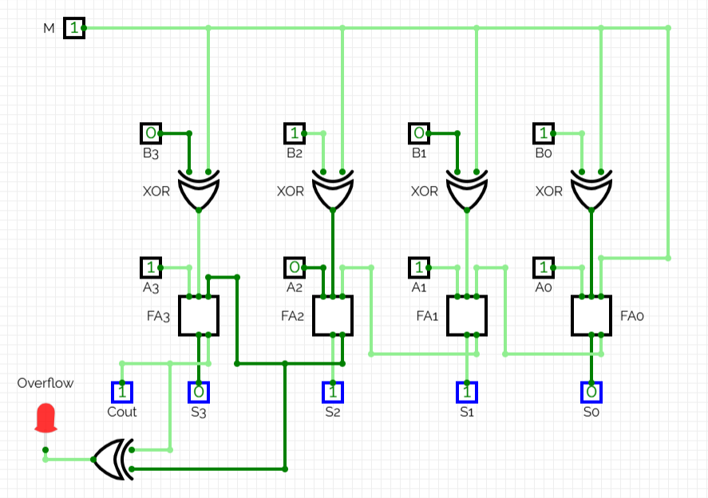

CONCLUSION
A. Conclusion and Key Findings
The Binary Calculator Using Logic Gates project successfully demonstrates the practical application of Boolean algebra and digital electronics in modern computing. By implementing a 4-bit Ripple Carry Adder-Subtractor, the project illustrates how a single hardware circuit can be multiplexed to perform multiple arithmetic operations using the 2's Complement method.
The project highlights the following key technical insights:
- Hardware Efficiency: The strategic use of XOR gates for conditional inversion proves that addition and subtraction do not require separate circuits, mirroring the architectural efficiency of actual Arithmetic Logic Units (ALUs).
- Data Interpretation: The implementation underscores that binary data is inherently neutral; its meaning (Unsigned vs. Signed) depends entirely on the architectural interpretation of the Most Significant Bit (MSB).
- Error Diagnostics: The integration of Carry-out and Overflow flags provides a clear distinction between unsigned range exhaustion and signed arithmetic errors (V = C₃ $⊕$ C₄).
- Cross-Platform Consistency: Developing the logic in both MATLAB and JavaScript verifies that the underlying mathematical algorithms are platform-independent, robust, and mathematically sound.
B. Learning Outcomes
Through the development of this simulator, the following competencies were mastered:
- Digital Logic Design: Expertise in using XOR gates as conditional inverters to streamline circuit complexity.
- Mathematical Rigor: Deep understanding of 2's complement arithmetic and its role in binary subtraction.
- Circuit Optimization: Proficiency in deriving optimized Boolean expressions using Truth Tables and K-Maps.
- Diagnostic Logic: Ability to implement hardware-level error detection for different numerical representations.
C. Project Limitations
While functional, the current design has specific constraints:
- Bit-Width Constraint: The 4-bit architecture restricts the numerical range to 0 to 15 (Unsigned) or -8 to +7 (Signed).
- Propagation Delay: As a Ripple Carry design, each stage must wait for the carry from the previous stage, creating a sequential delay that limits high-speed performance.
- Arithmetic Scope: The circuit is strictly designed for integer arithmetic and does not support floating-point (decimal) calculations or complex operations like multiplication and division.
D. Future Scope
To evolve this project into a more advanced computing tool, the following enhancements are proposed:
- N-Bit Scalability: Expanding the architecture to 8-bit, 16-bit, or 32-bit versions to support modern computational ranges.
- Performance Optimization: Transitioning from Ripple Carry to Carry-Lookahead Adder (CLA) logic to drastically reduce propagation delay.
- Full ALU Integration: Incorporating additional logic gates to support bitwise operations (AND, OR, NOT, NOR) and bit-shifting.
- Physical Prototyping: Implementing the software-verified logic onto a physical FPGA (Field Programmable Gate Array) or a breadboard using 74-series integrated circuits.
LINK OF WORKING PROJECT
The complete source code and interactive elements of this project can be accessed through the following files:
- Interactive Web Simulator: index.html (Open in any modern web browser)
- MATLAB Algorithm: calculator.m (Run in MATLAB R2016b or later)
- Project Documentation: README.md

Link:- https://github.com/Nehakalaburgi/COA-Project-Based.git

