//icon 1 - 3D SIERPINSKI GASKET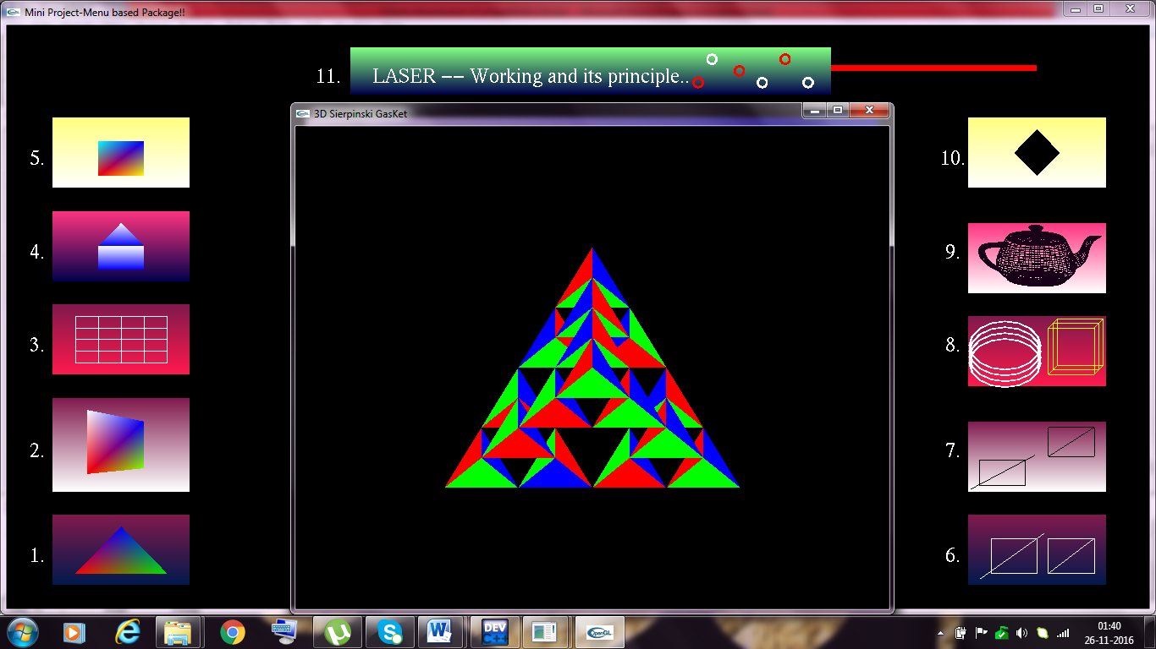

//icon 2 - COLOR CUBE VIEW
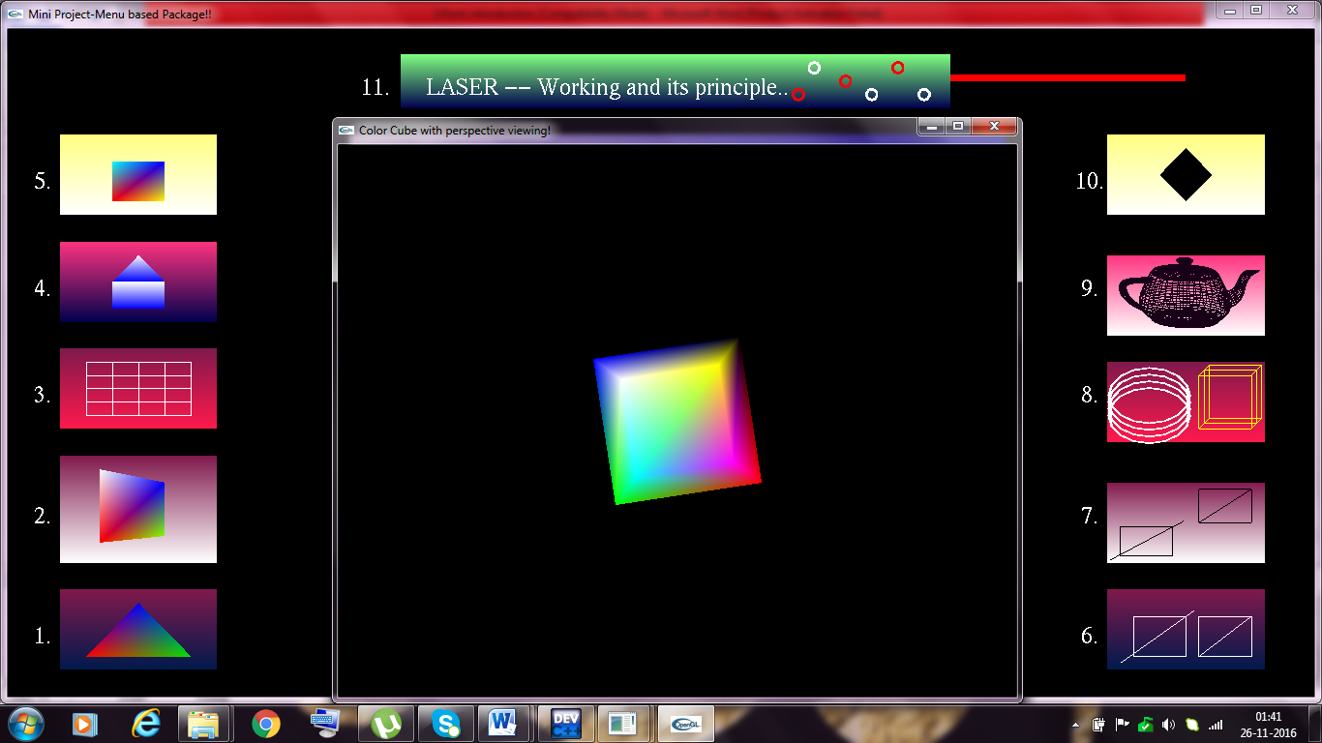
//icon 3 - RECTANGULAR MESH
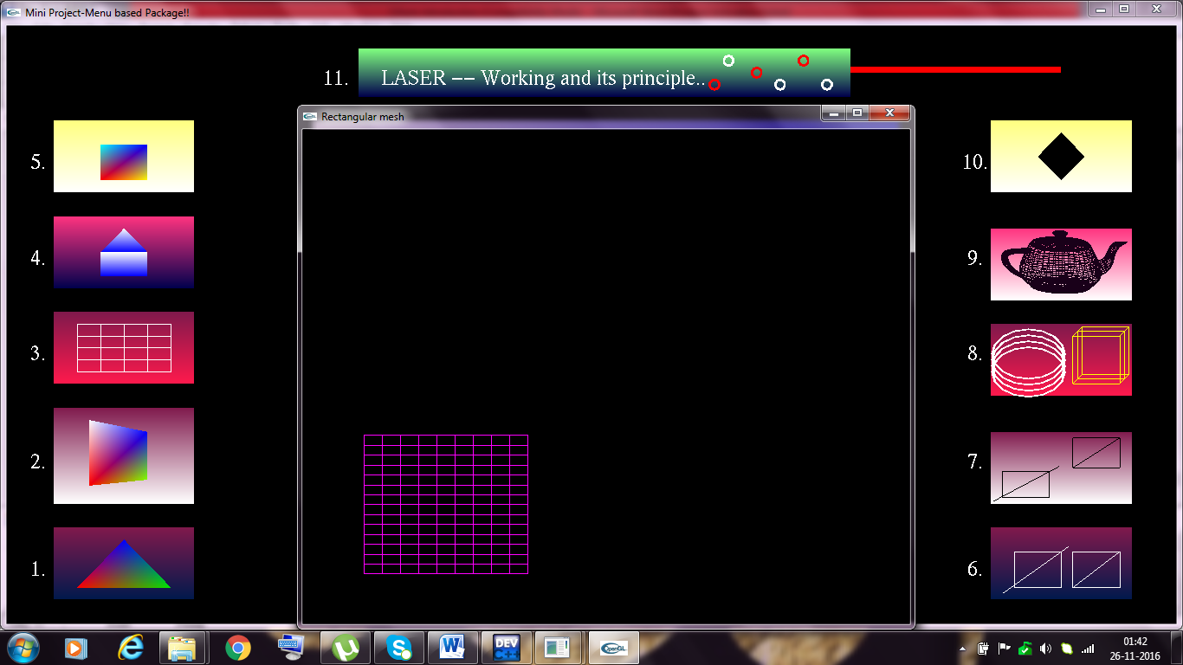
//icon 4 - HOUSE
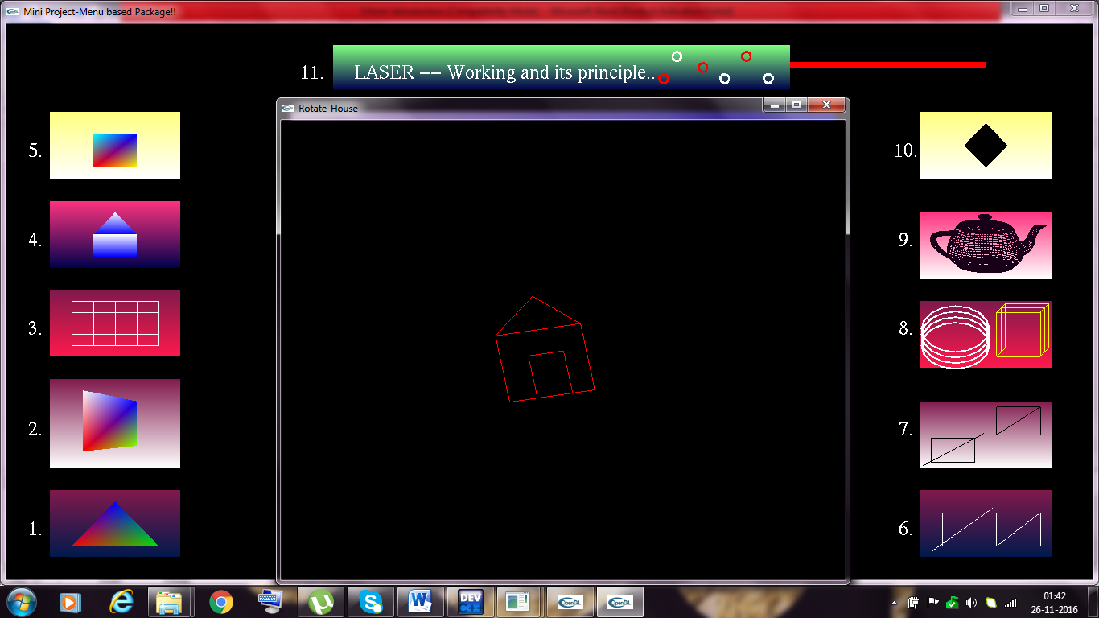
//icon 5 - COLOR CUBE
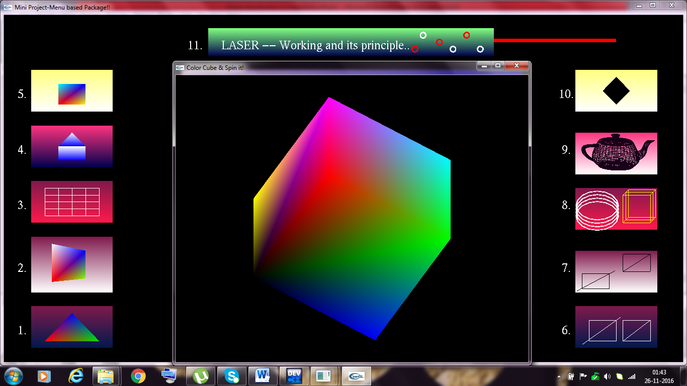

//icon 6 - COHEN-SUTHERLAND
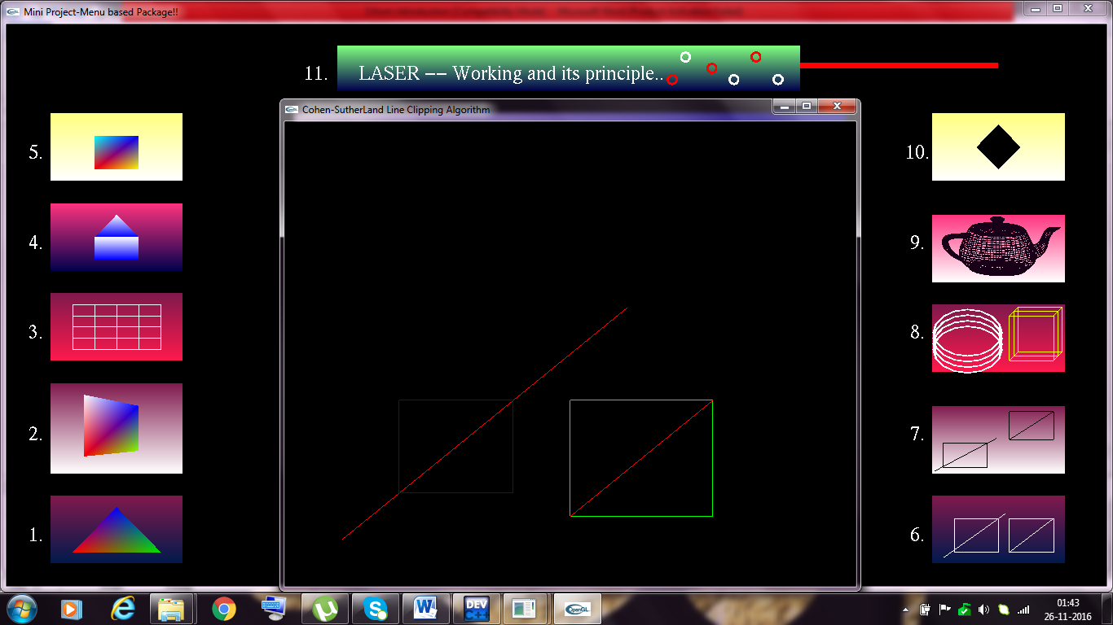
//icon 7 - LIANG-BARSKY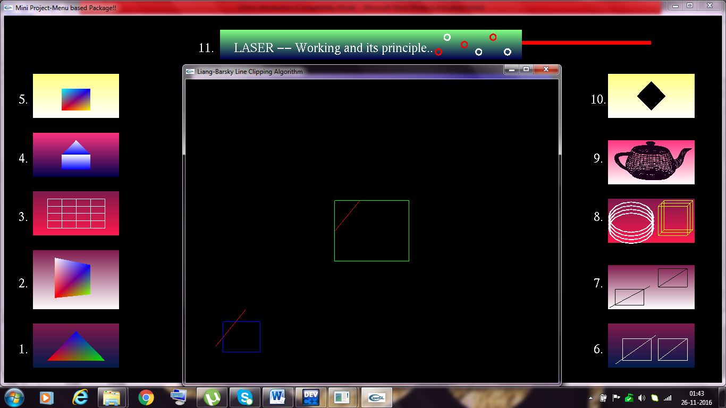

//icon 8 - CYLINDER AND PARALLELEPIPED
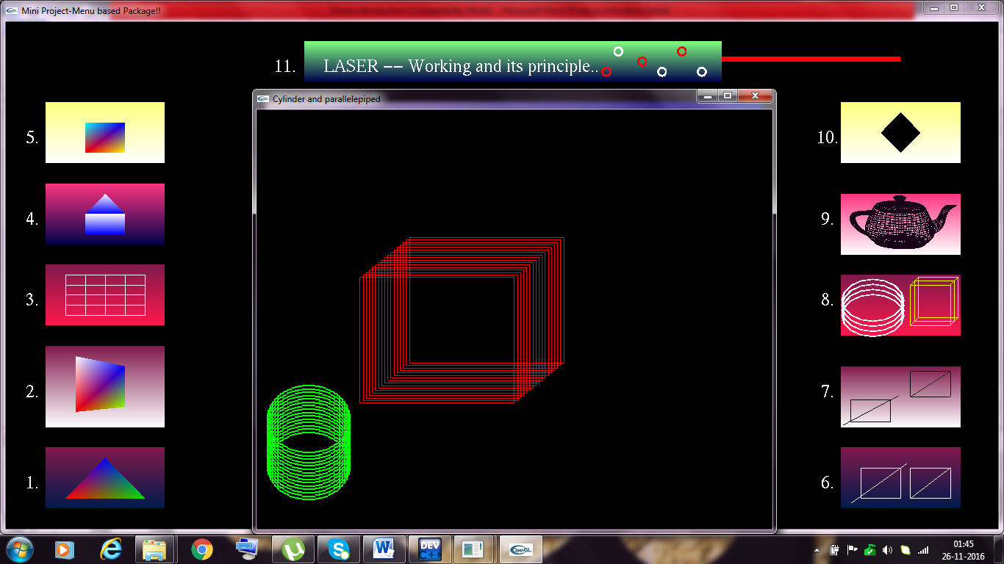
//icon 9 - TEAPOT
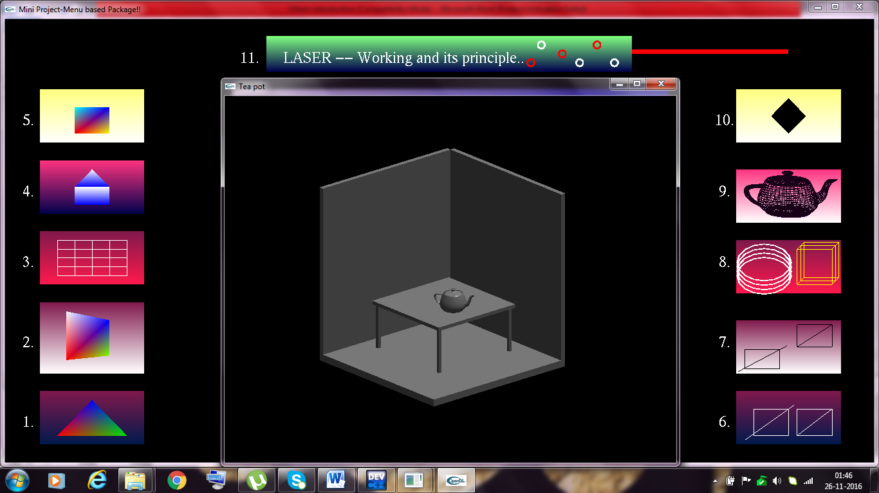

//icon 10 - SCANLINE FILLING
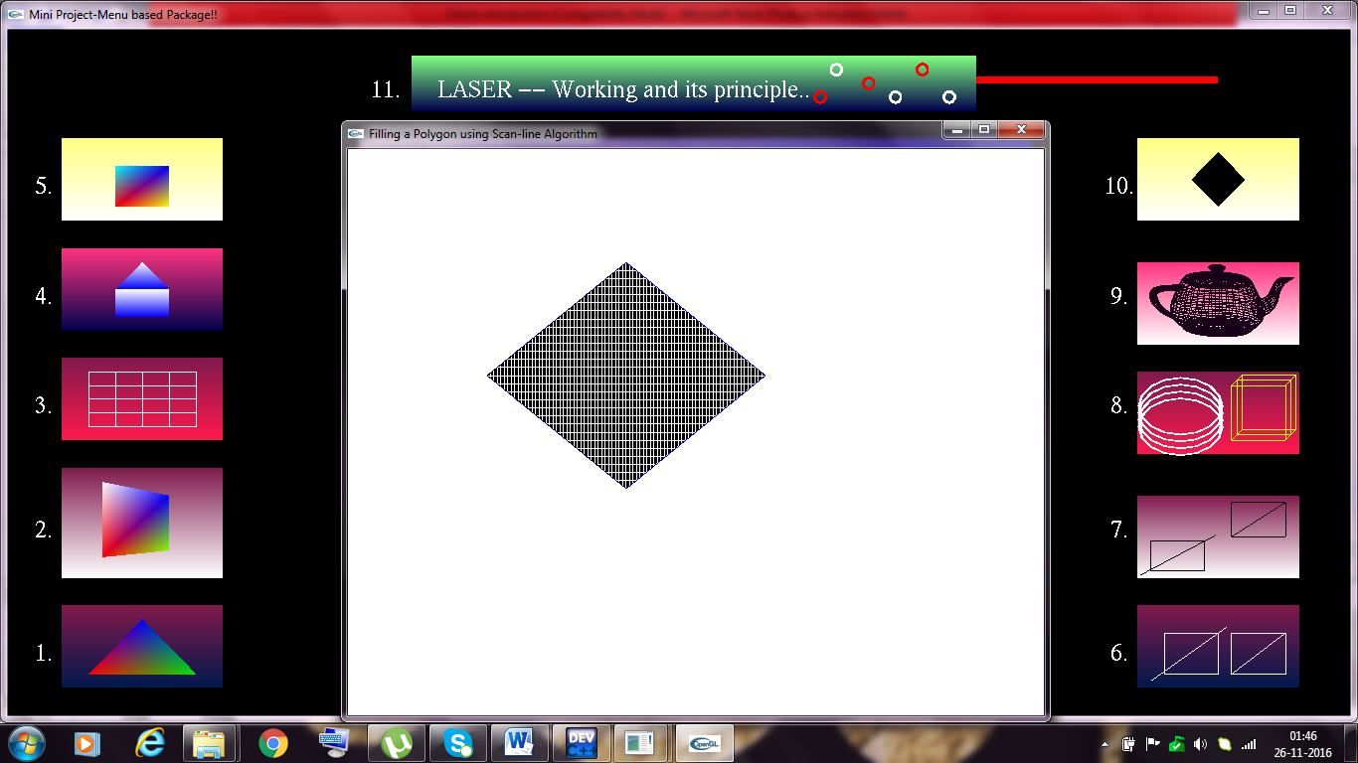
//icon 11 - LASER – Working & principle
