Workflow
- User solves a problem → Extension logs metadata → Backend stores it.
- User adds notes → Sent to backend via API.
- After 3, 7, 15 days → Spring Boot sends alert to extension/email.
- Over time → ML model trains on:
  - Time taken per topic
  - Mistake frequency
  - Struggled problems
- ML highlights trends → "You're consistently slow in Graphs", or "You forget base cases in Recursion".
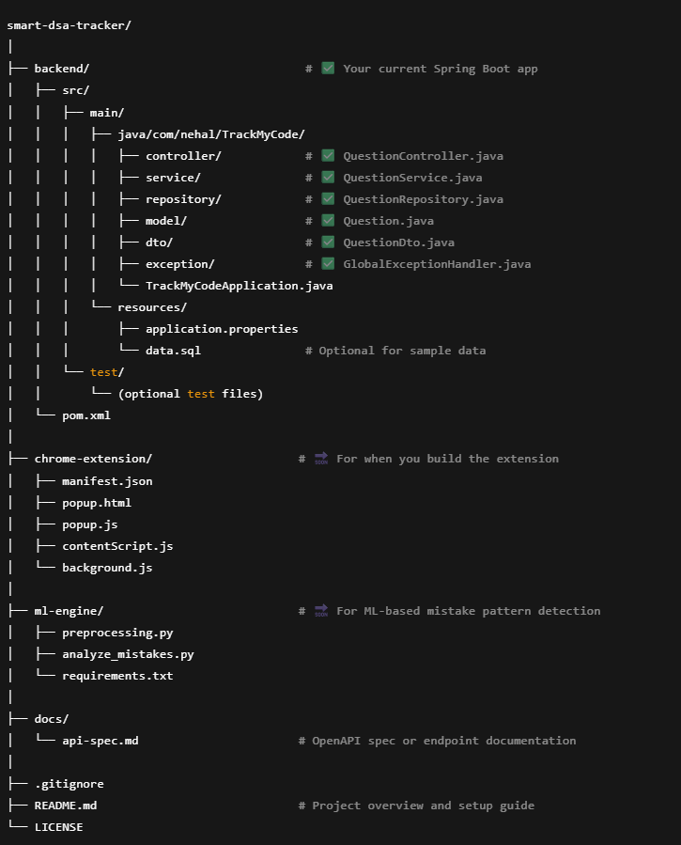

🟡 Phase 1: Feature Enhancements
Feature | Status | Notes
➕ notes field in Question | implemented | User-written notes about the question
➕ lastSolved (timestamp) | implemented | Required for revision scheduling
Revision Reminder Logic | 🔲 Not implemented | @Scheduled Spring task to find due revisions
Revision Status Tracking | 🔲 Not implemented | Flag to mark if a question was revised
Filter APIs (by topic/difficulty/date) | 🔲 Not implemented | Useful for frontend filters
API for upcoming revisions | 🔲 Not implemented | GET /api/revisions/today

🧠 Phase 2: ML Integration
Feature | Status | Notes
Store mistake logs (e.g., “missed edge case”) | 🔲 Not implemented | Could be notes or a new table
Analyze mistake trends (topic-wise, error type) | 🔲 Not implemented | Use pandas or sklearn
Recommend weak areas | 🔲 Not implemented | Based on past mistakes + time taken
Backend endpoint for ML results | 🔲 Not implemented | Example: GET /api/analysis/mistakes

🌐 Phase 3: Frontend (Chrome Extension) Integration
Feature | Status | Notes
Chrome Extension UI | 🔲 Not built yet | HTML popup, note field, timer UI
Connect extension to Spring Boot API | 🔲 Not done | Use fetch() to call /api/questions
Auto-fill metadata from coding sites | 🔲 Not done | contentScript.js reads page data
Reminder popup or badge | 🔲 Not done | Shows problems to revise today

To build a full-stack Revision Tracker app from scratch, here's a complete roadmap and step-by-step guide, assuming you're using Spring Boot (Java) for backend and React for frontend.

🧠 App Purpose
Track your solved coding questions, allow scheduled revision (after 3, 7, 14 days), and show revision status.

🏗️ 1. Project Structure
backend/
└── src/
└── main/java/com/nehal/TrackMyCode/
├── controller/
├── model/
├── repository/
├── service/
└── TrackMyCodeApplication.java

frontend/
└── revision-tracker/
├── src/
│ ├── components/
│ ├── pages/
│ └── App.js

🛠️ 2. Backend (Spring Boot)
✅ Step 1: Create the Spring Boot Project
Use Spring Initializr: https://start.spring.io/
- Project: Maven
- Language: Java
- Dependencies:
  - Spring Web
  - Spring Data JPA
  - MySQL Driver
  - Spring Boot DevTools
  - Spring Scheduling
  - Lombok (optional but helpful)
✅ Step 2: Database Configuration
# application.properties
spring.datasource.url=jdbc:mysql://localhost:3306/revision_tracker
spring.datasource.username=root
spring.datasource.password=yourPassword

spring.jpa.hibernate.ddl-auto=update
spring.jpa.show-sql=true
spring.jpa.properties.hibernate.dialect=org.hibernate.dialect.MySQL8Dialect

✅ Step 3: Define Models
// Question.java
@Entity
public class Question {
@Id @GeneratedValue
private Long id;
private String title;
private String platform;
private boolean solved;
private boolean revised;

private LocalDate dateSolved;
private Integer nextRevisionInDays; // 3, 7, 14
}

✅ Step 4: Repository
public interface QuestionRepository extends JpaRepository<Question, Long> {
List<Question> findBySolvedTrue();
}

✅ Step 5: Service
@Service
public class QuestionService {

@Autowired
private QuestionRepository repo;

public Question saveQuestion(Question q) {
if (q.getSolved()) {
q.setDateSolved(LocalDate.now());
}
return repo.save(q);
}

// Scheduler to check due revisions daily
@Scheduled(cron = "0 0 2 * * *") // Every day at 2 AM
public void checkRevisions() {
List<Question> questions = repo.findBySolvedTrue();
LocalDate today = LocalDate.now();

for (Question q : questions) {
if (q.getNextRevisionInDays() != null) {
LocalDate expectedRevisionDate = q.getDateSolved().plusDays(q.getNextRevisionInDays());
if (today.equals(expectedRevisionDate)) {
q.setRevised(false); // Due today
repo.save(q);
}
}
}
}

public List<Question> getAll() {
return repo.findAll();
}

public void markRevised(Long id) {
Question q = repo.findById(id).orElseThrow();
q.setRevised(true);
repo.save(q);
}
}

✅ Step 6: Controller
@RestController
@RequestMapping("/api/questions")
@CrossOrigin(origins = "http://localhost:3000")
public class QuestionController {

@Autowired
private QuestionService service;

@PostMapping
public Question add(@RequestBody Question q) {
return service.saveQuestion(q);
}

@GetMapping
public List<Question> getAll() {
return service.getAll();
}

@PutMapping("/{id}/revised")
public void markRevised(@PathVariable Long id) {
service.markRevised(id);
}
}

💻 3. Frontend (React)
✅ Step 1: Set Up React App
npx create-react-app revision-tracker
cd revision-tracker
npm install axios

✅ Step 2: Create the Form UI
// src/components/AddQuestionForm.js
import React, { useState } from "react";
import axios from "axios";

const AddQuestionForm = () => {
const [title, setTitle] = useState("");
const [platform, setPlatform] = useState("");
const [nextRevisionInDays, setNextRevisionInDays] = useState(3);

const handleSubmit = async (e) => {
e.preventDefault();
await axios.post("http://localhost:8080/api/questions", {
title,
platform,
solved: true,
revised: false,
nextRevisionInDays,
});
alert("Added!");
setTitle("");
setPlatform("");
};

return (
<form onSubmit={handleSubmit}>
<input value={title} onChange={(e) => setTitle(e.target.value)} placeholder="Question Title" />
<input value={platform} onChange={(e) => setPlatform(e.target.value)} placeholder="Platform" />
<select value={nextRevisionInDays} onChange={(e) => setNextRevisionInDays(Number(e.target.value))}>
<option value={3}>3 Days</option>
<option value={7}>7 Days</option>
<option value={14}>14 Days</option>
</select>
<button type="submit">Add</button>
</form>
);
};

export default AddQuestionForm;

✅ Step 3: Show Questions List
// src/components/QuestionList.js
import React, { useEffect, useState } from "react";
import axios from "axios";

const QuestionList = () => {
const [questions, setQuestions] = useState([]);

const fetchQuestions = async () => {
const res = await axios.get("http://localhost:8080/api/questions");
setQuestions(res.data);
};

useEffect(() => {
fetchQuestions();
}, []);

const markRevised = async (id) => {
await axios.put(`http://localhost:8080/api/questions/${id}/revised`);
fetchQuestions();
};

return (
<div>
<h3>All Questions</h3>
<ul>
{questions.map((q) => (
<li key={q.id}>
{q.title} ({q.platform}) -{" "}
{q.revised ? "✅ Revised" : "❌ Due"} -{" "}
<button onClick={() => markRevised(q.id)}>Mark Revised</button>
</li>
))}
</ul>
</div>
);
};

export default QuestionList;

✅ Step 4: App.js
import React from "react";
import AddQuestionForm from "./components/AddQuestionForm";
import QuestionList from "./components/QuestionList";

function App() {
return (
<div className="App">
<h1>Revision Tracker</h1>
<AddQuestionForm />
<QuestionList />
</div>
);
}

export default App;

🚀 Run Your App
🧩 Backend
cd backend
./mvnw spring-boot:run
🧩 Frontend
cd frontend/revision-tracker
npm start

✅ Features Covered
- ✅ Add questions
- ✅ Schedule revision (3, 7, 14 days)
- ✅ Scheduled job (daily) to notify due revisions
- ✅ Mark revised status
- ✅ Full-stack integration (Spring Boot + React)

If you'd like, I can package the whole GitHub repo structure for you or create a deployment plan next. Just say the word.

