- Display first 10 lines
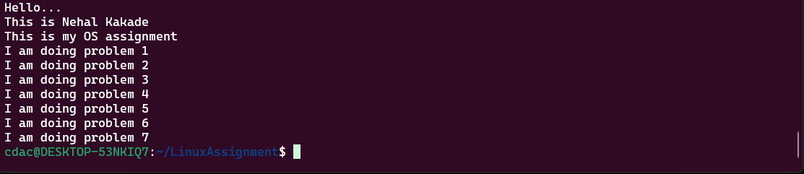
Commands Used-
- head – to display head/top lines from file [by default displays top 10 lines]
- Display last 5 lines
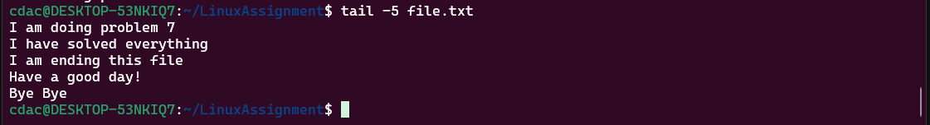
Commands Used-
- tail – to display tail/bottom lines from file

- Display first 15 lines
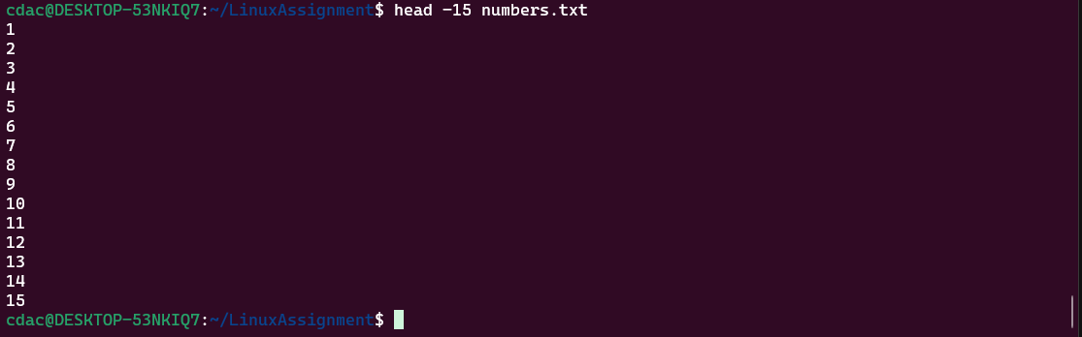
Commands Used-
- head – to display head/top lines from file [by default displays top 10 lines]

- Display last 3 lines
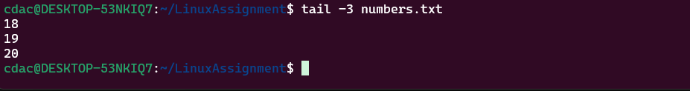
Commands Used-
- tail – to display tail/bottom lines from file

- Translate all lower case to upper case
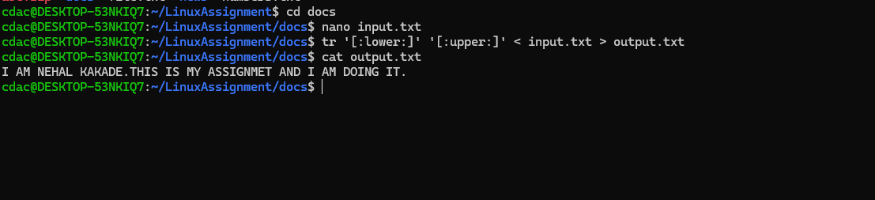

Commands Used-
- tr – to translate
- [:lower:] – for lower case
- [:upper:] – for upper case

- Display unique lines
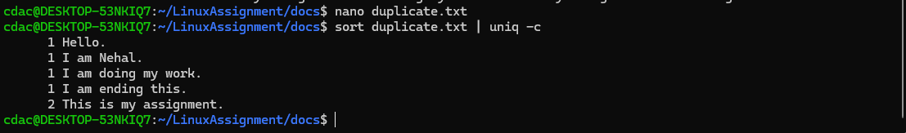

Commands Used-
- sort – to sort
- uniq – to find unique lines out of file [-c – used to count occurrence of those lines in file]
- Display unique lines and count
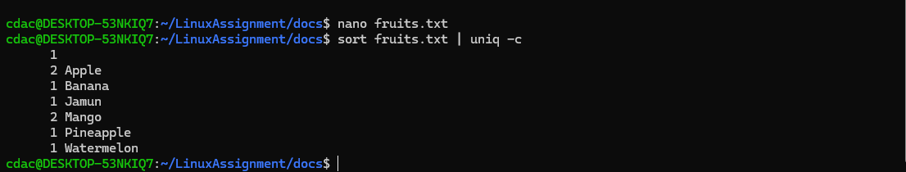

Commands Used-
- sort – to sort
- uniq – to find unique lines out of file [-c – used to count occurrence of those lines in file]

