**Chapter 4**

**IMPLEMENTATION**

**4.1 Frontend Implementation :**

**1-User**

**Navbar :**

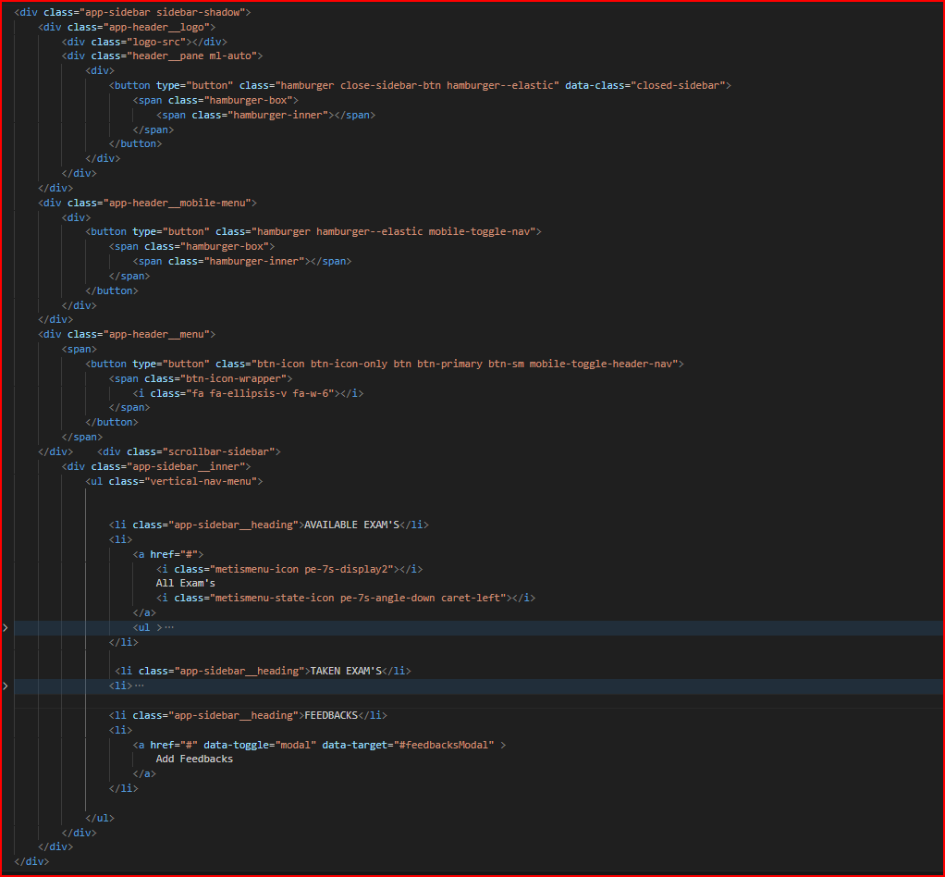

Figure 1.4 navbar code

A responsive navbar component is used to show a list of navigation links.We create navbar by using html, css and js A navigation bar (or navigation system) is a section of a graphical user interface intended to aid visitors in accessing information.. Add this class to a <nav> to define navbar component. Add this class to a <ul> to create navigation. Use <a> elements as menu item within the list.

**Header :**

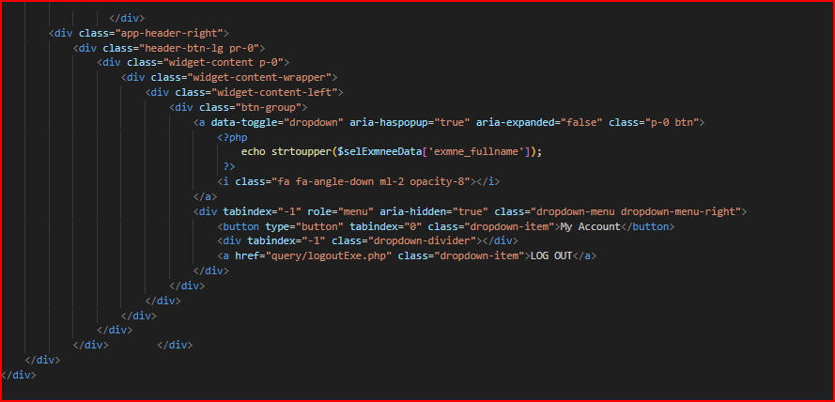

figure 2.4

The header is a part that is found on all pages and contains meta files, links to formatting files, a header section, and a body section 2.

**Links :**

**صورة تحتوي على نص, لقطة شاشة, الخط

تم إنشاء الوصف تلقائياً**

Figure 4.3

Linking JavaScript files such as the popper file, JQuery, and the website's JavaScript file.

صورة تحتوي على نص, لقطة شاشة, الخط

تم إنشاء الوصف تلقائياً

Figure 4.4

Linking CSS files to format such as the bootstrap file, icons, and its site format file.

صورة تحتوي على لقطة شاشة, نص

تم إنشاء الوصف تلقائياً

Figure 5.4

Show test and questions to answer 1.

صورة تحتوي على نص, لقطة شاشة, عرض, برمجيات

تم إنشاء الوصف تلقائياً

Figure 6.4

Show test and questions to answer 2.

صورة تحتوي على نص, لقطة شاشة

تم إنشاء الوصف تلقائياً

Figure 4.7 show results 1.

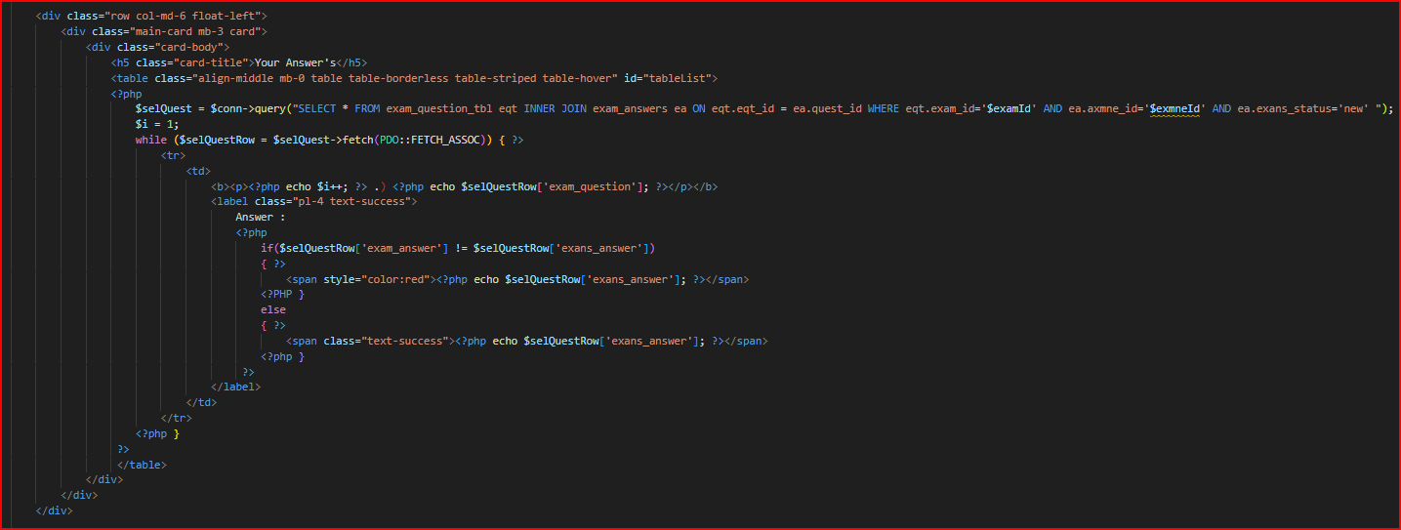

Figure 4.8 show results 2.

صورة تحتوي على نص, لقطة شاشة, عرض, برمجيات

تم إنشاء الوصف تلقائياً

Figure 4.9 show results 3.

**Login form :**

User login form to log in to access the student's powers to take the test and so on.

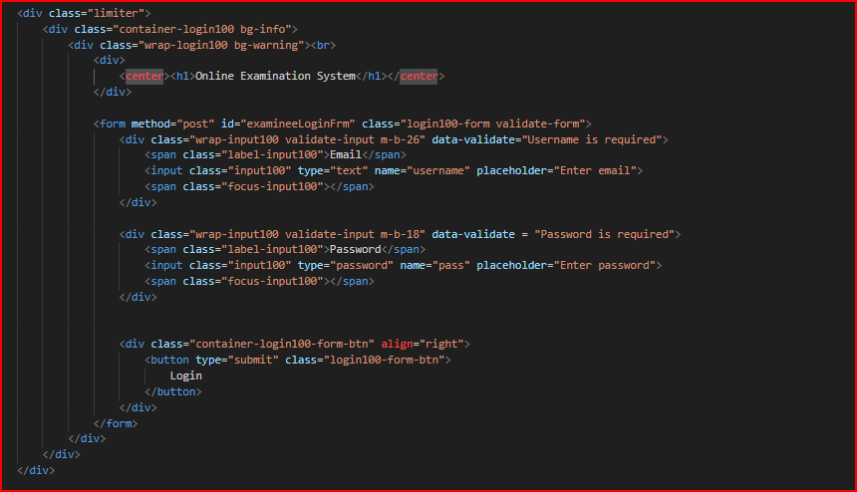

Figure 4.10

**2-Admin**

**Navbar :**

The side nav bar contains pages banks to access 1.

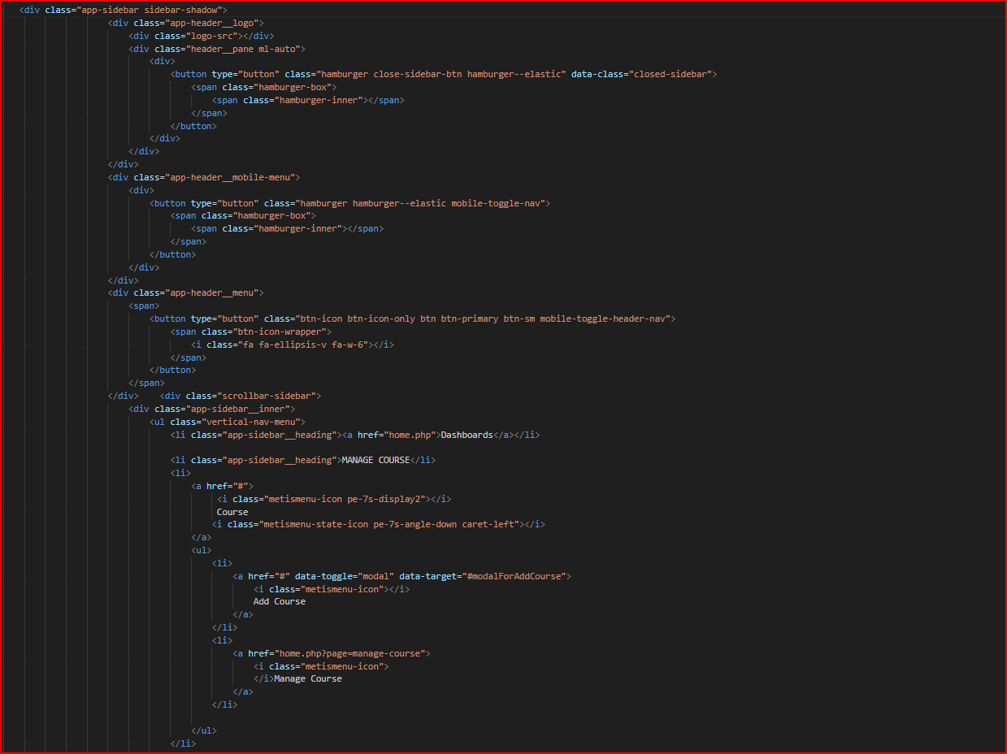

Figure 4.11

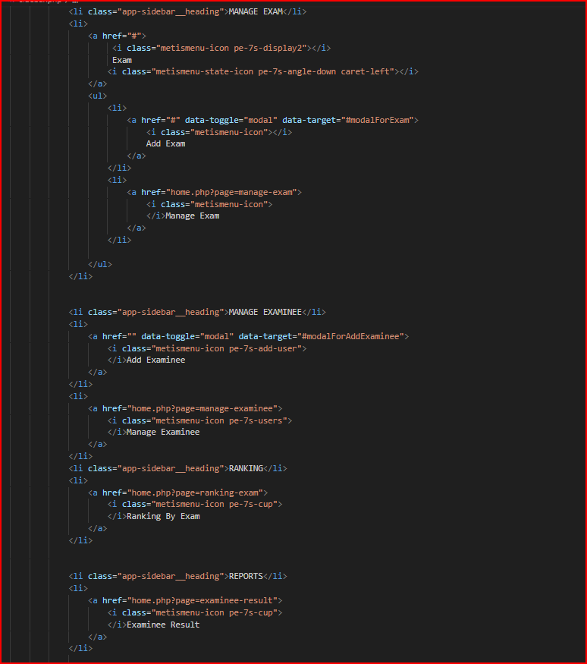

Figure 4.12 The side nav bar contains pages banks to access 2.

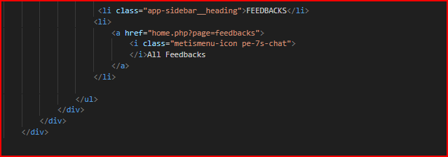

Figure 4.13 The side nav bar contains pages banks to access 3.

**Header :**

The header is a part that is present on all pages and contains meta files and links to formatting files, the header section, and the nav bar is transferred to the mobile system or vice versa, and the body section 1.

صورة تحتوي على نص, لقطة شاشة

تم إنشاء الوصف تلقائياً

Figure 4.14

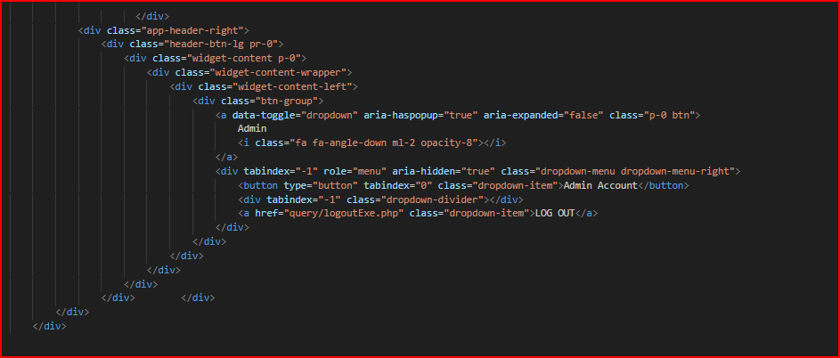

Figure 4.15

The header is a part that is present on all pages and contains meta files and links to formatting files, the header section, and the nav bar is transferred to the mobile system or vice versa, and the body section 2.

**Management :**

Management of testers or students, which is the part for adding testers or students and adding their data through the admin.

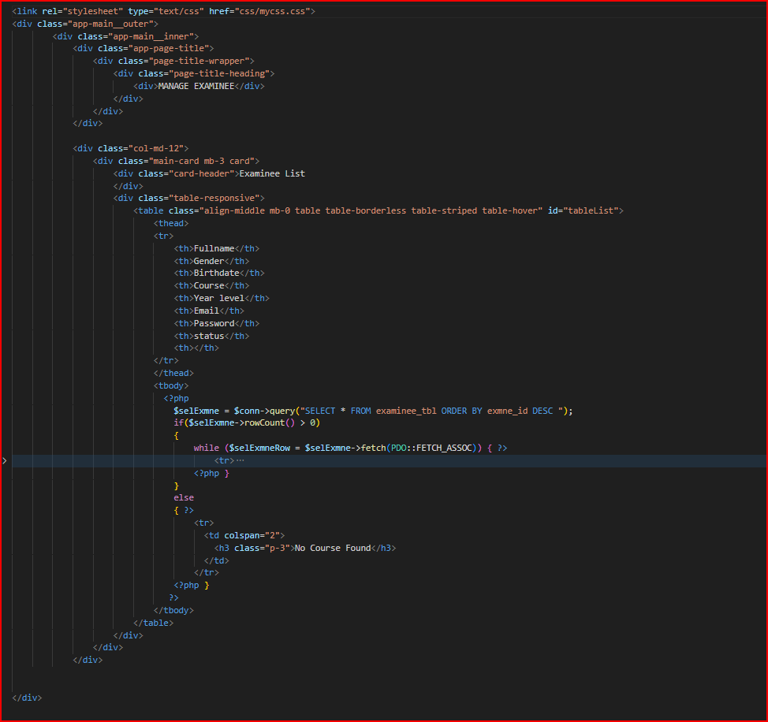

Figure 4.16

Course management, which is the part for managing courses, adding, deleting, modifying, adding questions, etc…… .

صورة تحتوي على نص, لقطة شاشة, برمجيات

تم إنشاء الوصف تلقائياً

Figure 4.17 menage courses.

Test management, which is the section for managing tests, adding, deleting, modifying, adding questions, etc……. .

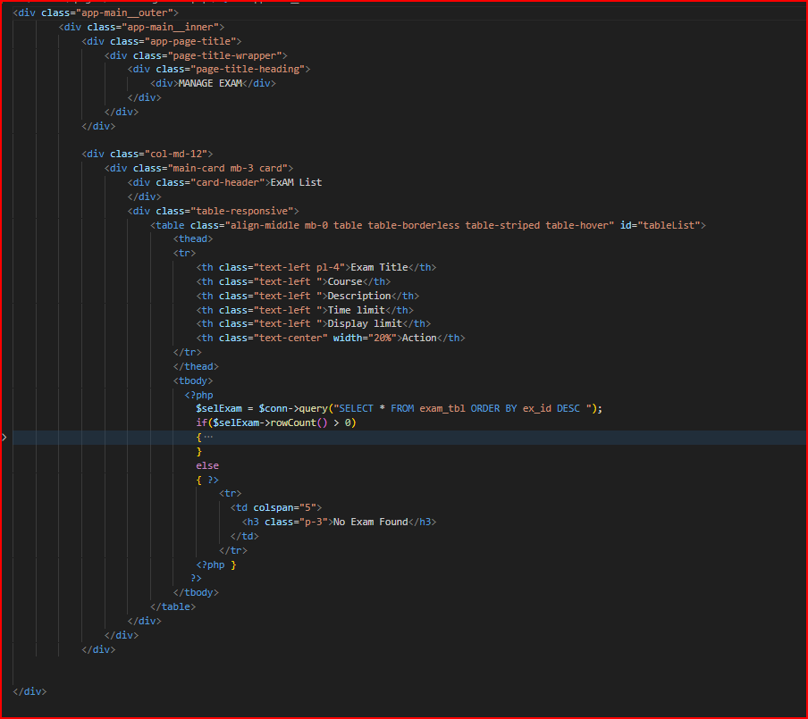

Figure 4.18 manage tests.

**Show Results:**

Displaying the final results of the site from two testers, the percentage of those who passed, and so on 1.

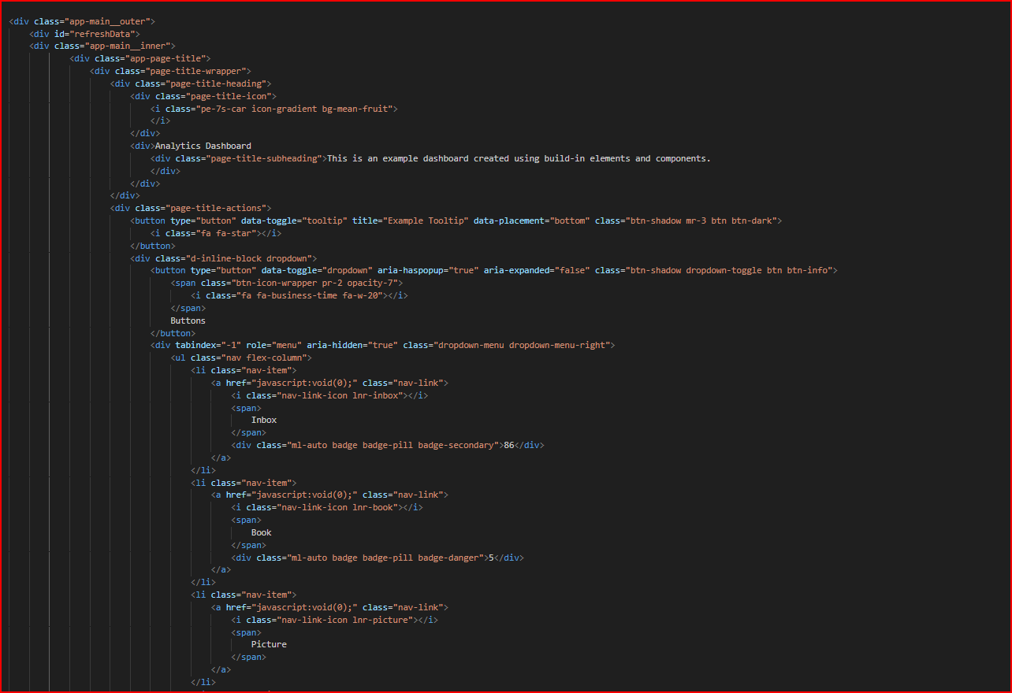

Figure 4.19

Displaying the final results of the site from two testers, the percentage of those who passed, and so on 2.

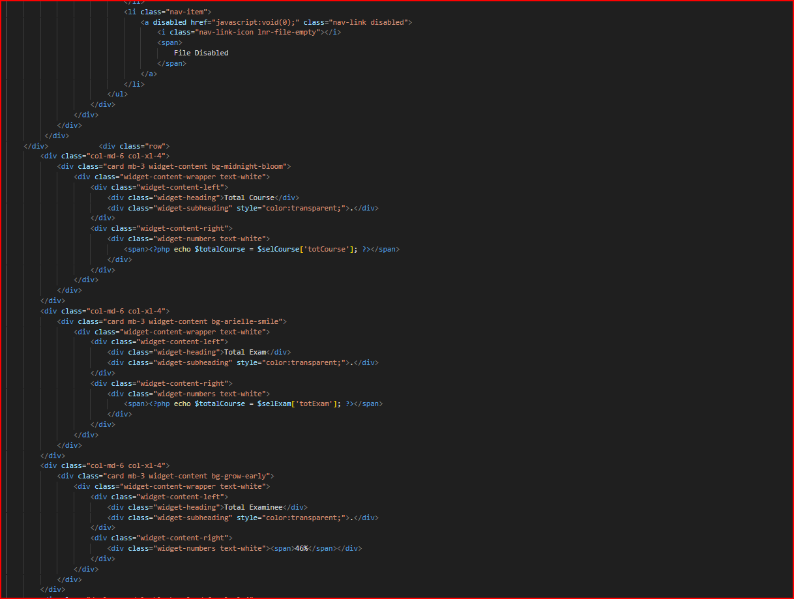

Figure 4.20

Displaying the final results of the site from two testers, the percentage of those who passed, and so on 3.

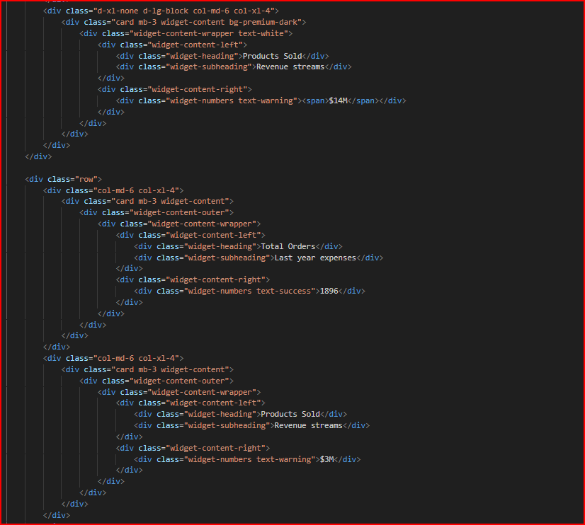

Figure 4.21

Displaying the final results of the site from two testers, the percentage of those who passed, and so on.

صورة تحتوي على نص, لقطة شاشة

تم إنشاء الوصف تلقائياً

Figure 4.22

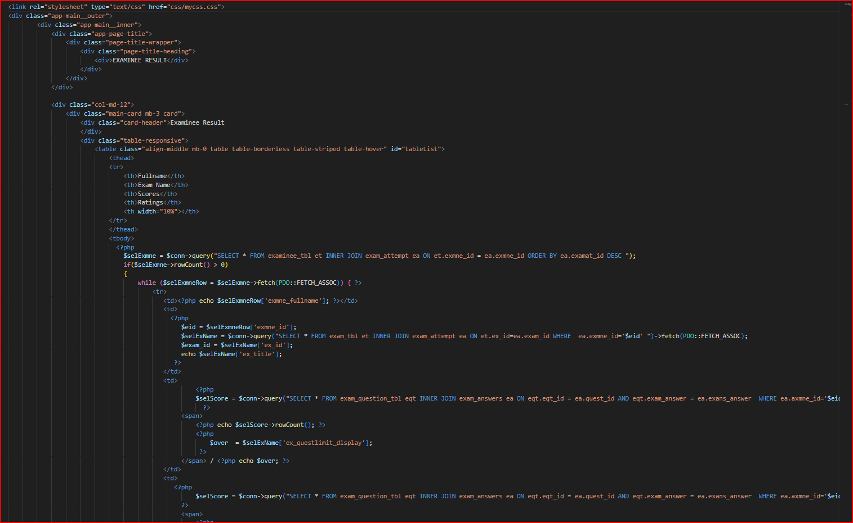

Figure 4.23

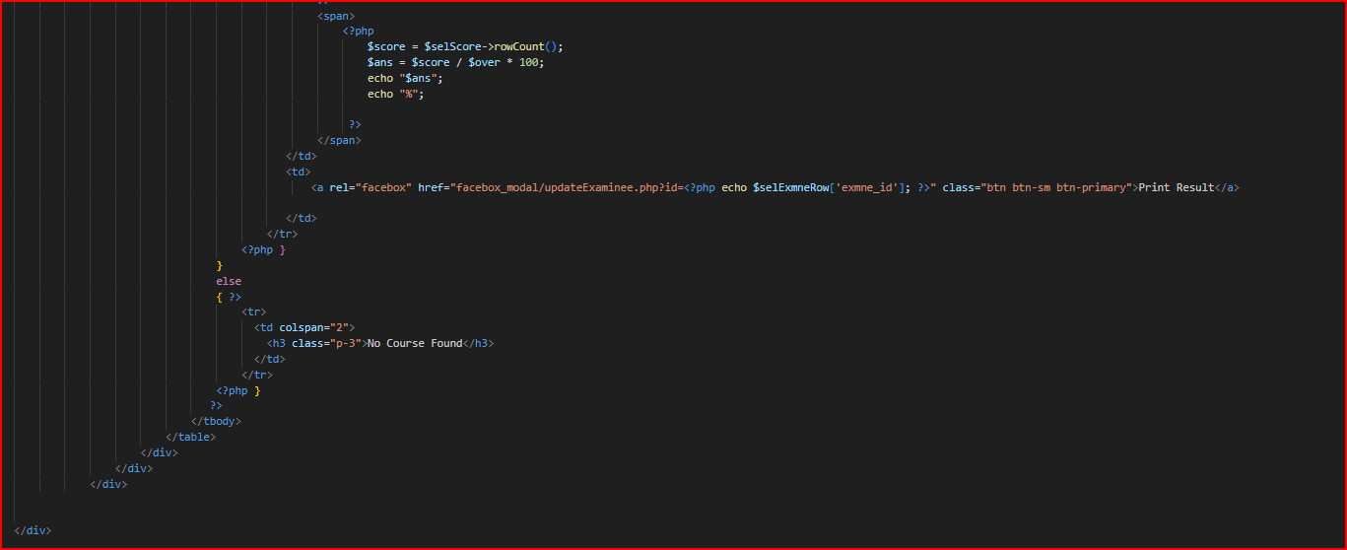

Figure 4.24 view tester results2 .

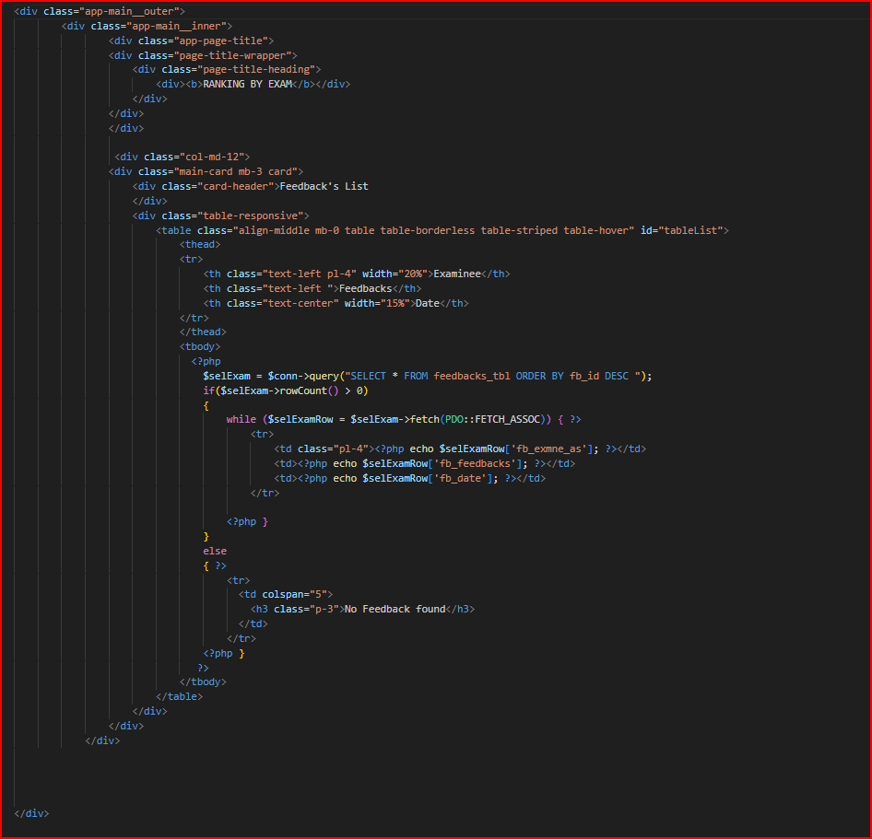

Figure 4.25 View all feed backs to help improve the site.

**Admin log in page .**

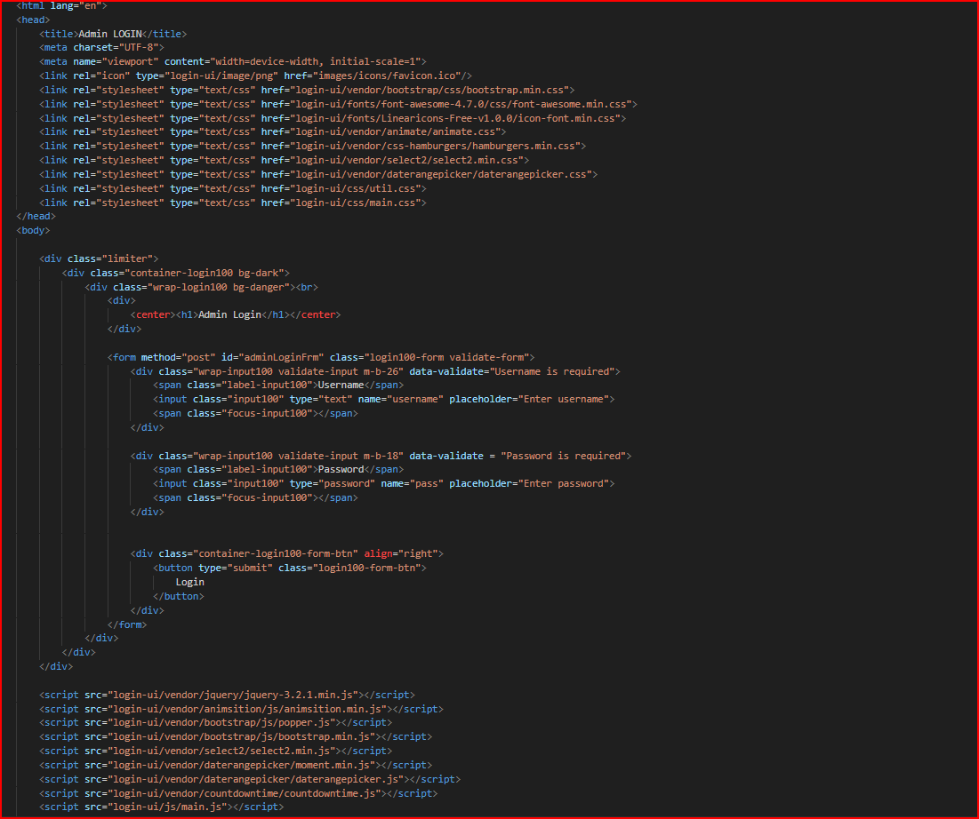

Figure 4.26

صورة تحتوي على نص, برمجيات, صفحة ويب, لقطة شاشة

تم إنشاء الوصف تلقائياً

Figure 4.27

Displaying the final results of the site from two testers, the percentage of successful students, and so on 5.

**4.2 Back-End Implimentaion :**

**1-User**

Log in as a user to take the exam.

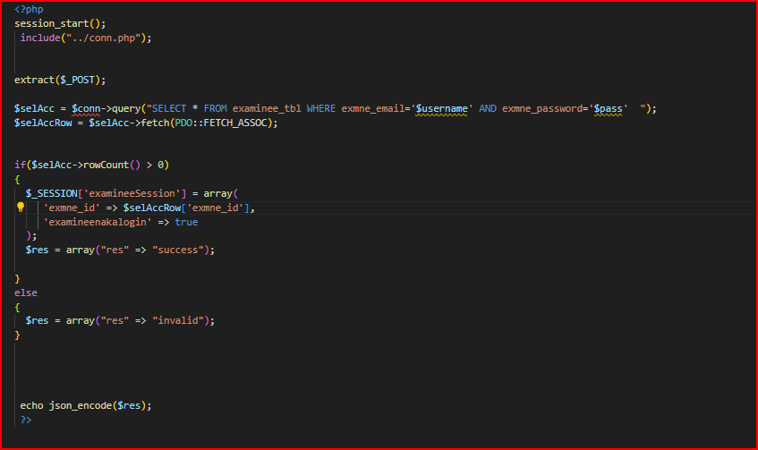

Figure 4.28

Fetch test data and questions.

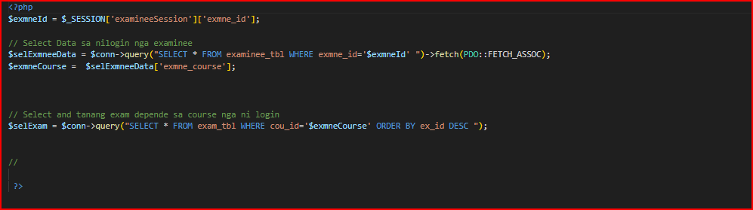

Figure 4.29

Adding answers to the questions that have been answered after selecting the answers 1.

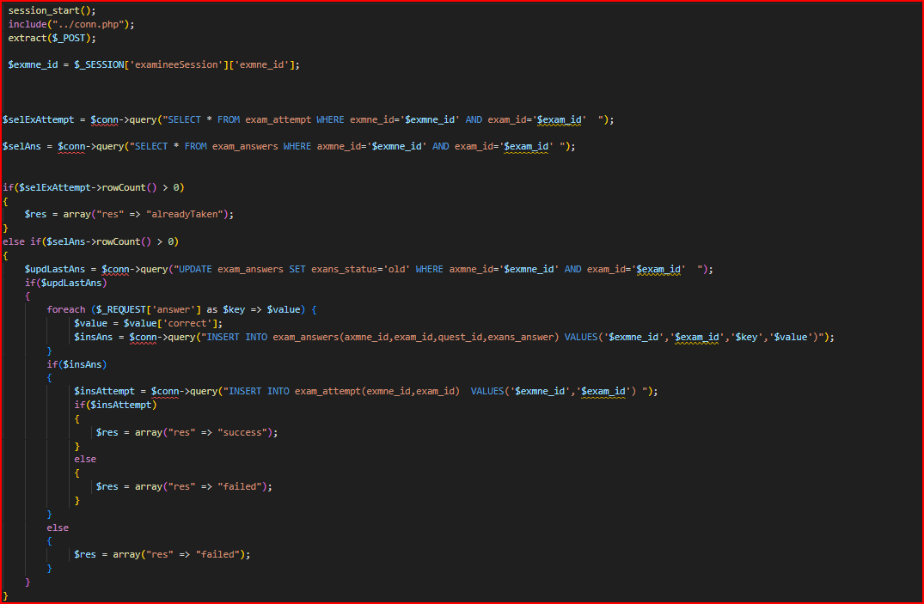

Figure 4.30

Adding answers to the questions that have been answered after selecting the answers 2.

صورة تحتوي على نص, لقطة شاشة, برمجيات, عرض

تم إنشاء الوصف تلقائياً

Figure 4.31

View the tests that have been tested.

صورة تحتوي على نص, لقطة شاشة, برمجيات

تم إنشاء الوصف تلقائياً

Figure 4.32

Add suggestions for improvement of the site.

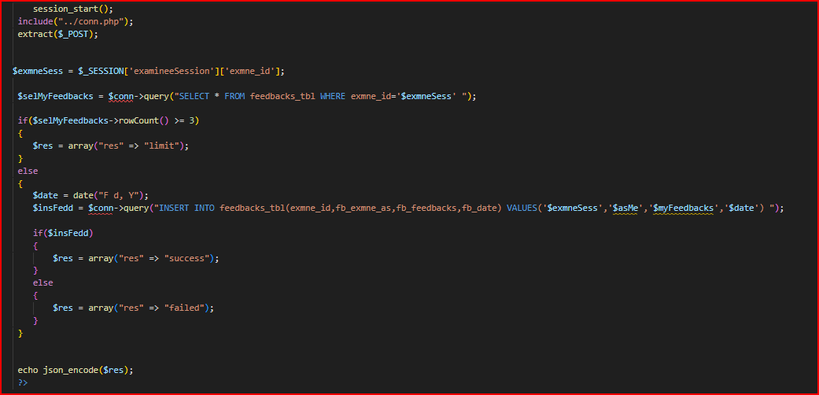

Figure 4.33

**User-Ajax :**

Log in

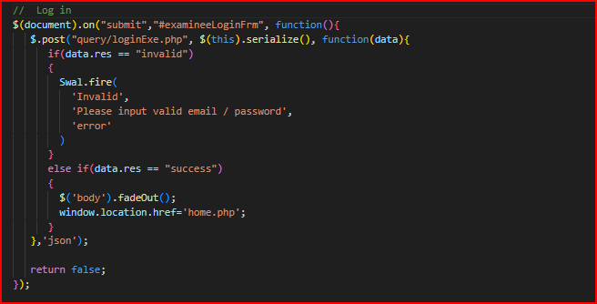

Figure 4.34

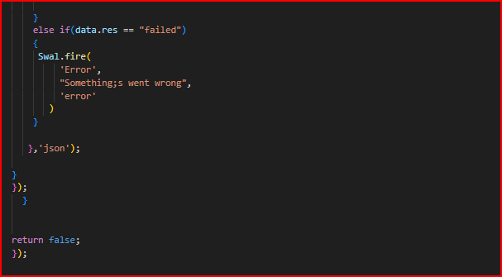

Figure 4.35 submit answer.

صورة تحتوي على نص, لقطة شاشة

تم إنشاء الوصف تلقائياً

Figure 4.36 submit answer.

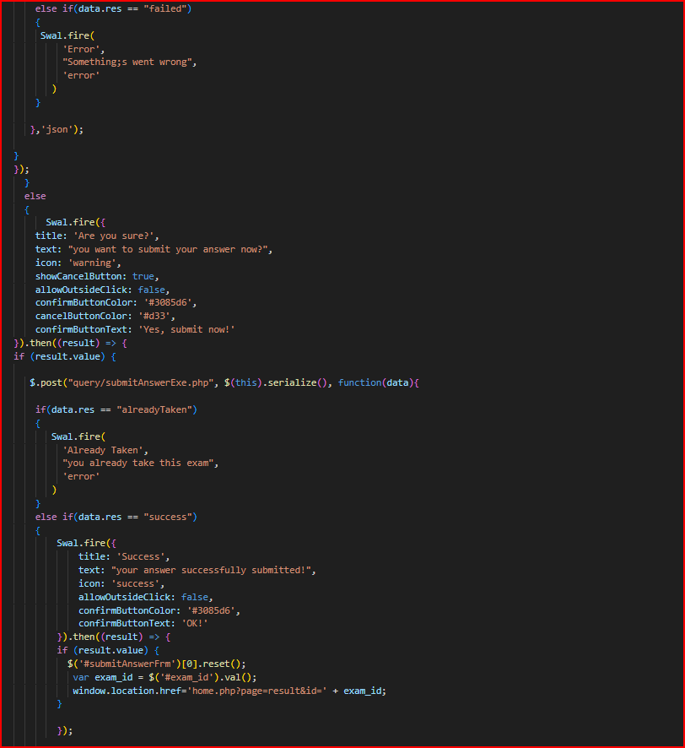

Figure 4.37 submit answer.

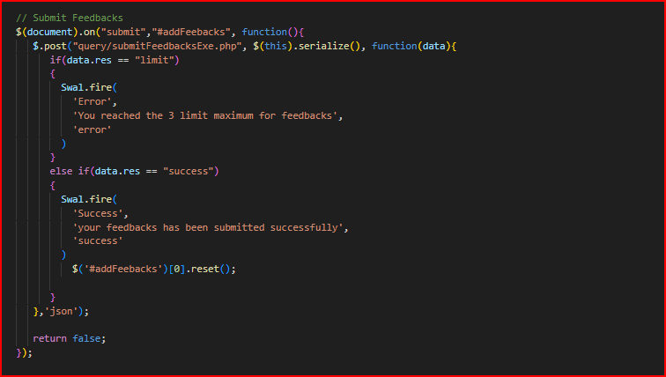

Figure 4.38 submit feedback.

**2-Admin**

Adding tests to courses or subjects.

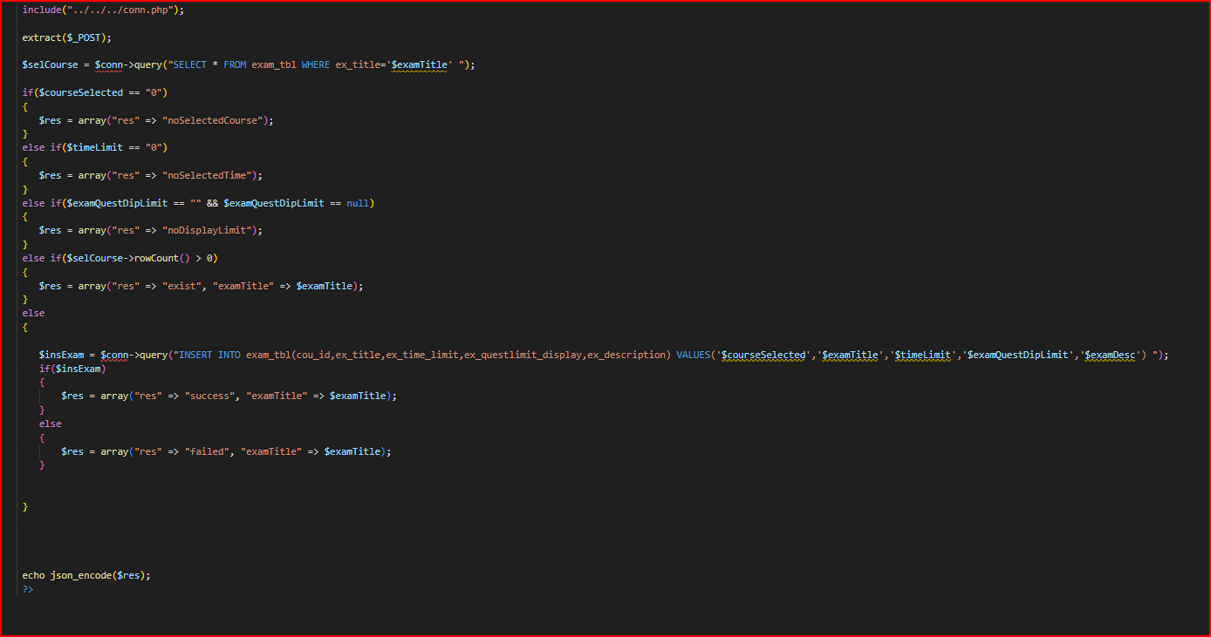

Figure 4.39

Adding questions to the uploaded tests.

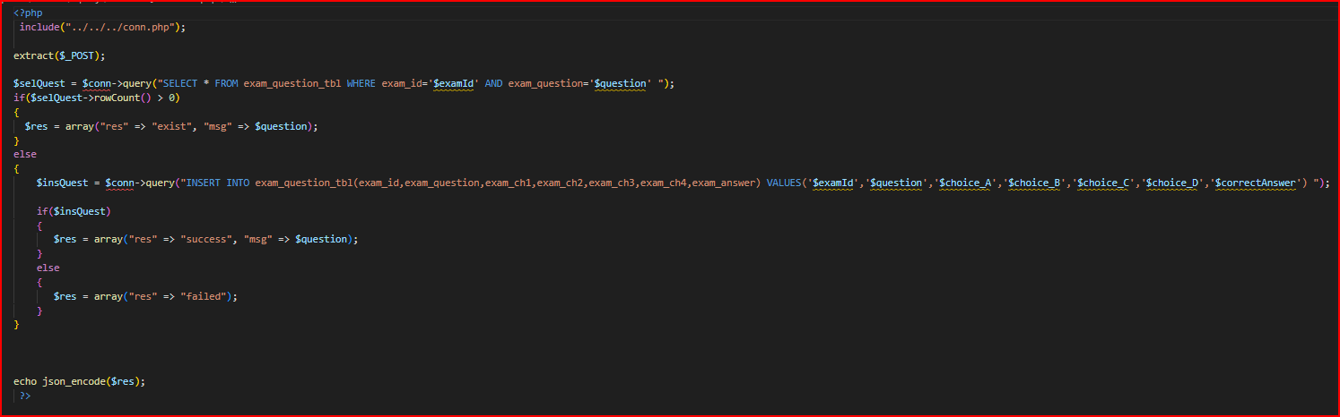

Figure 4.40

Adding courses or subjects to be tested.

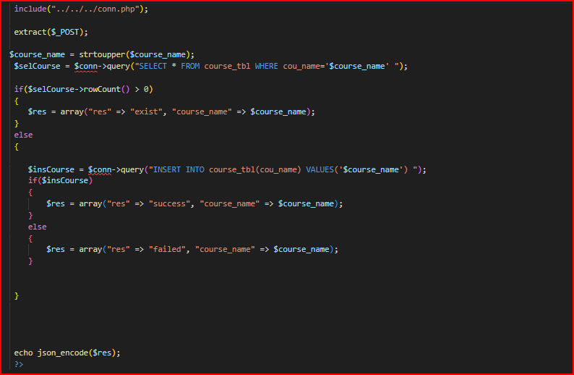

Figure 4.41

Log in as an admin to reach the admin managements.

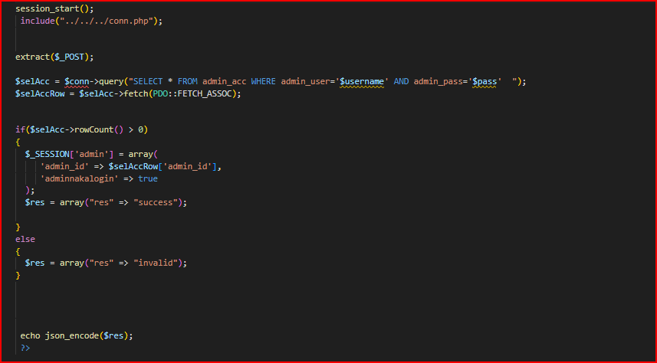

Figure 4.42

Manage questions and answers.

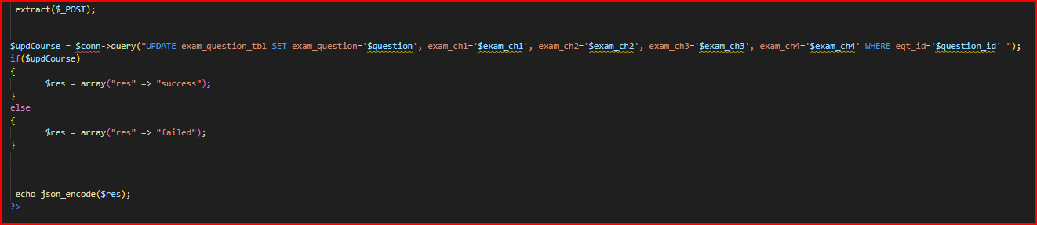

Figure 4.43

Manage data of the tests.

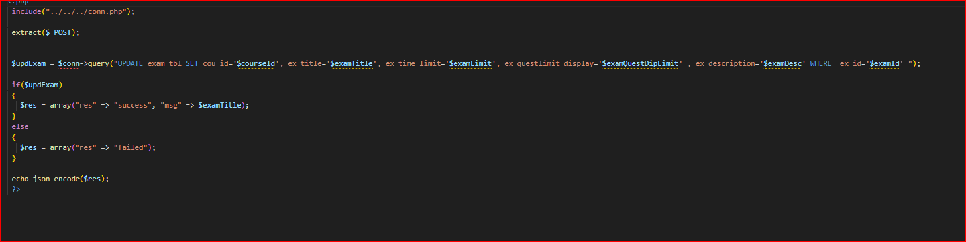

Figure 4.44

Manage data of the courses.

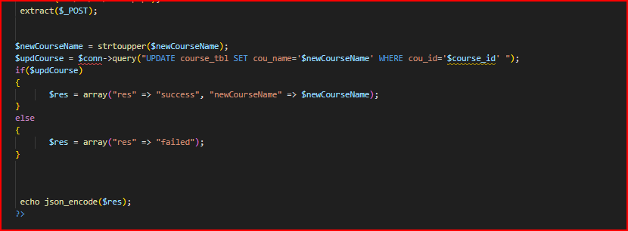

Figure 4.45

Manage data of the testers or students.

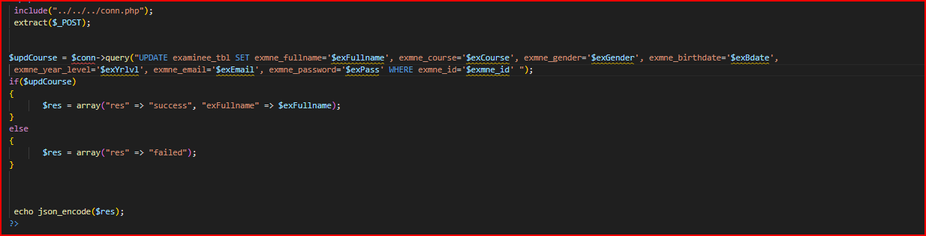

Figure 4.46

Adding testers to take the tests.

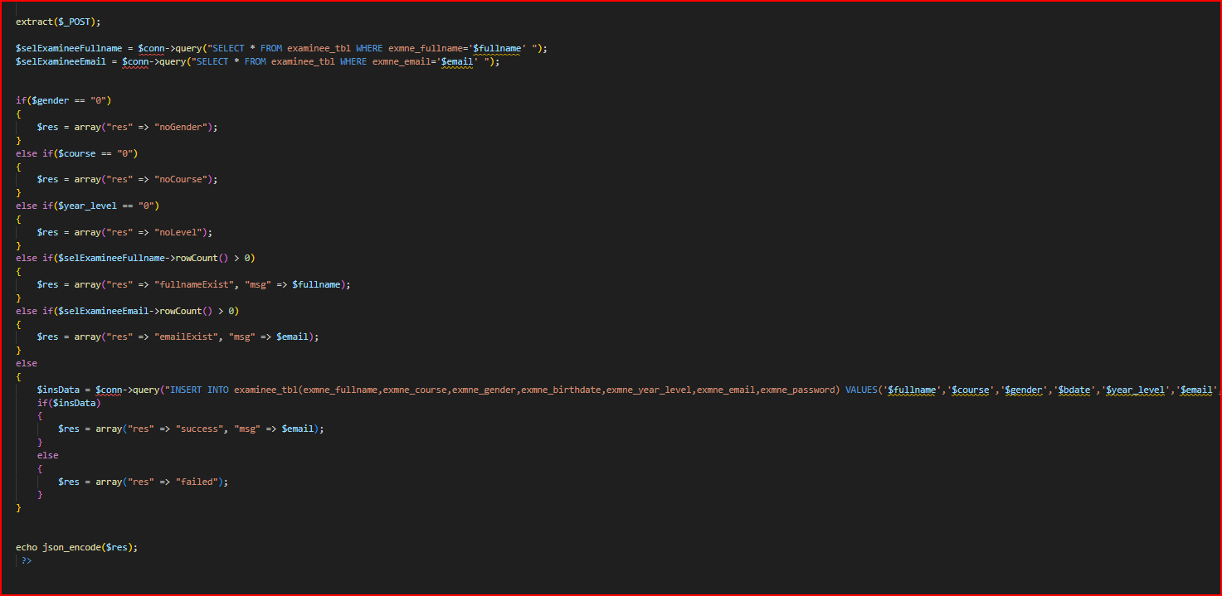

Figure 4.47

Count the number of data like courses or tests.

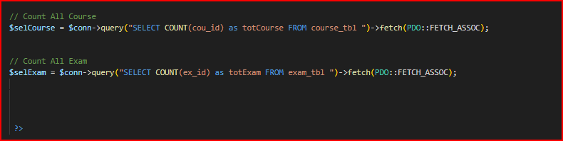

Figure 4.48

Delete courses that have been added before.

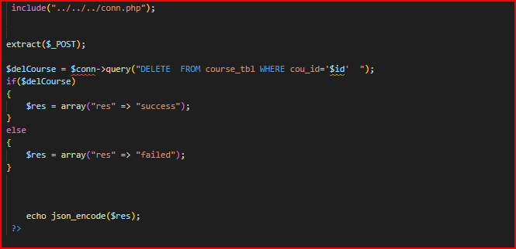

Figure 4.49

Delete tests that have been added before.

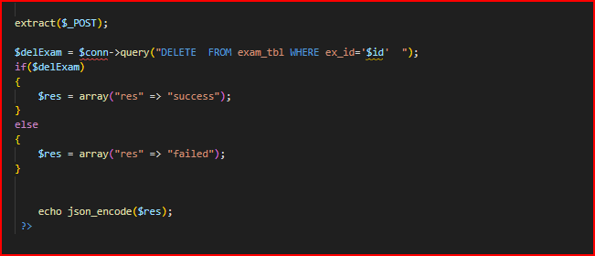

Figure 4.50

Delete questions that have been added before.

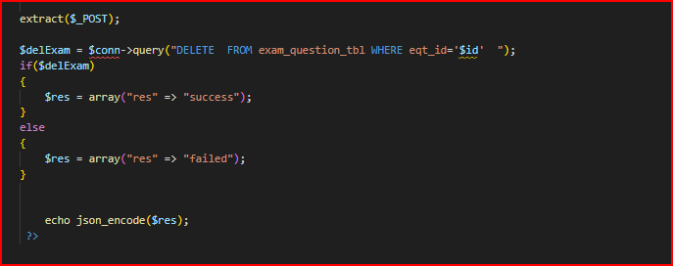

Figure 4.51

**Admin-ajax:**

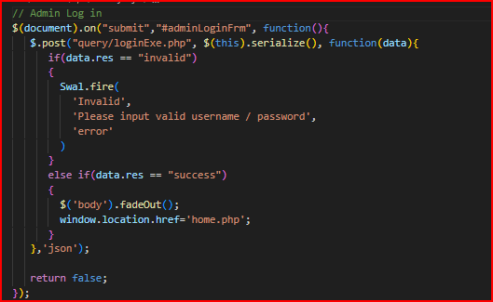

Figure 4.52 Log in.

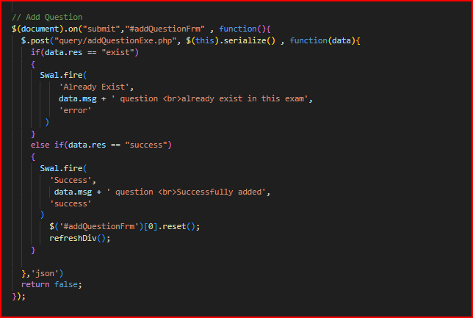

Figure 4.53 Add question.

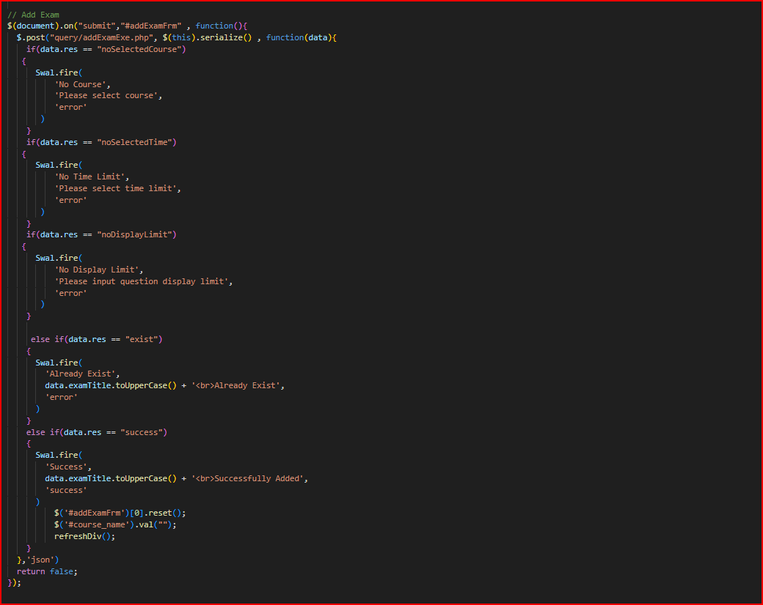

Figure 4.54 Add exame.

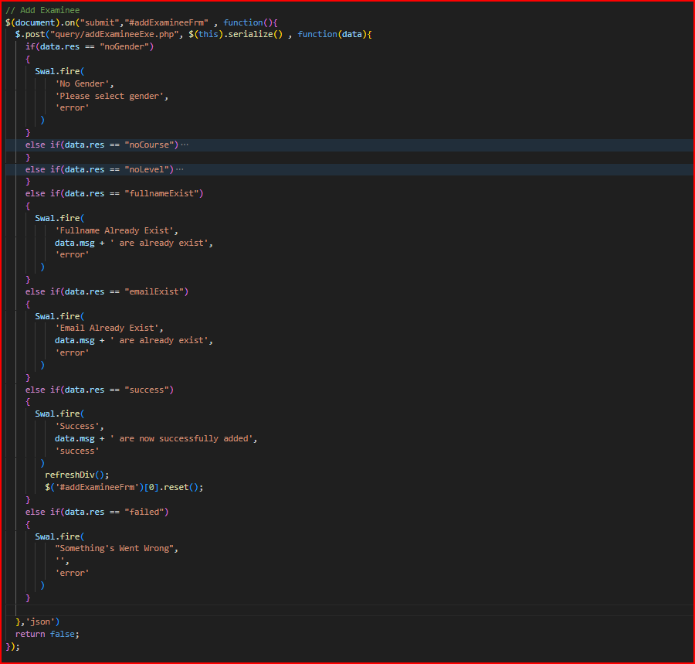

Figure 4.55 Add examinee.

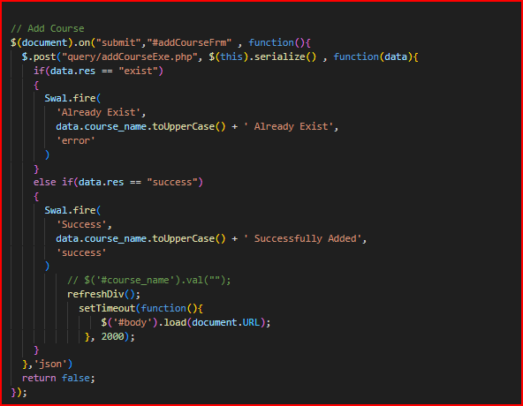

Figure 4.56 Add course.

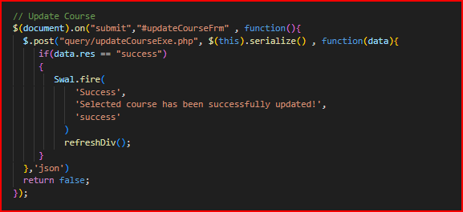

Figure 4.57 Update course

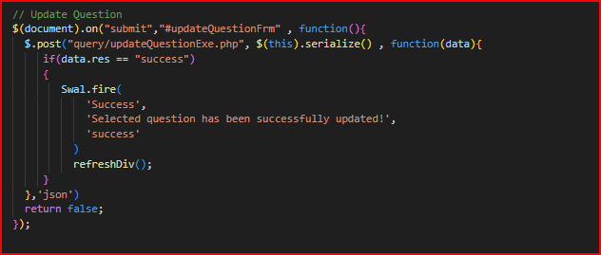

Figure 4.58 Update question.

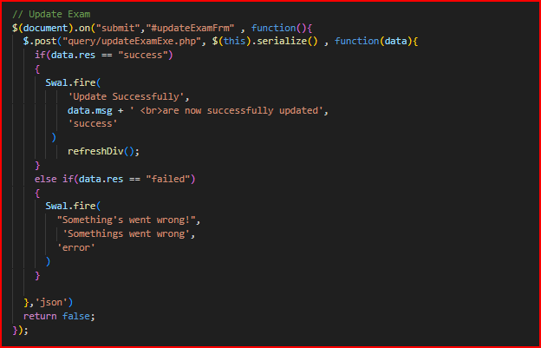

Figure 4.59 Update exam.

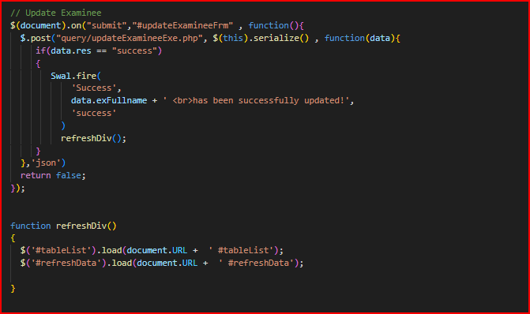

Figure 4.60 Update examinee.

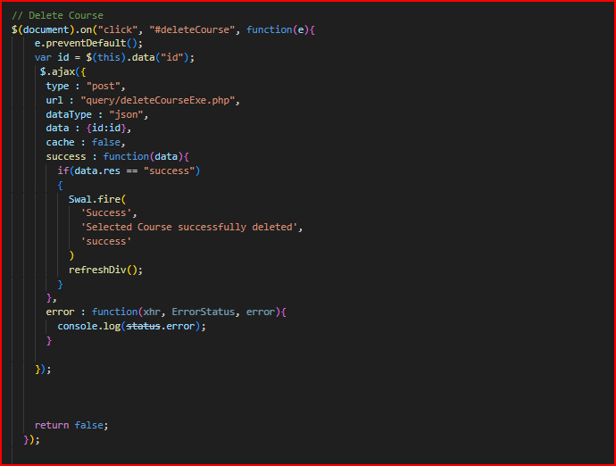

Figure 4.61 Delete course.

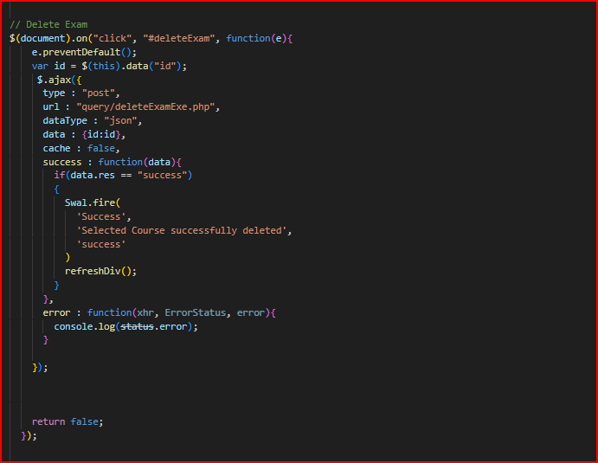

Figure 4.62 Delete exam.

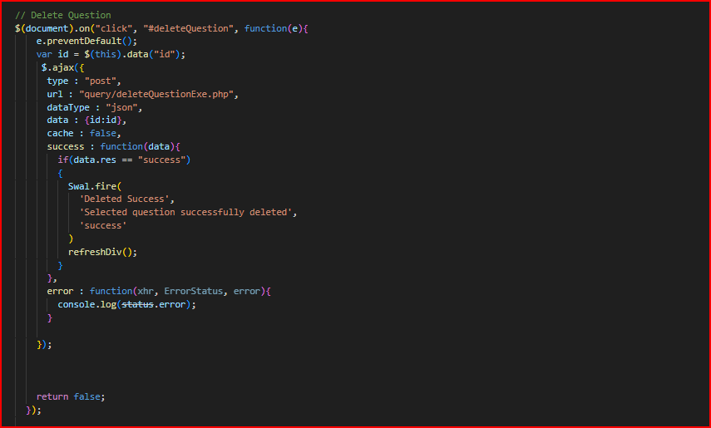

Figure 4.63 Delete question.

**General :**

Log out and deleting all sessions.

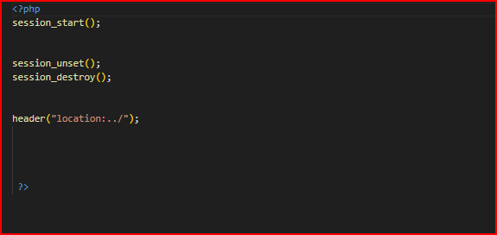

Figure 4.64

Database connection.

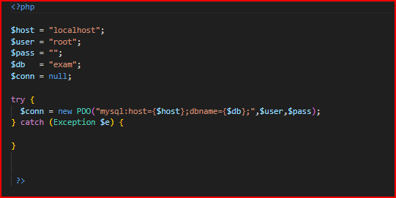

Figure 4.65

**Chapter5: Conclusion and Future Improvements**

**Conclusion:**

**Online Examination System (OLES)** is a Multiple Choice Questions (MCQ) based examination system**.** Online

Exam is a web based custom Online Examination Management system**.** Easy to use for Administrators**,** Faculties**,**

and students**.**Online Examination can be conducted at any time**.** Online Exam maintaining records, score cards**,**

student details**,** question papers and so on is very easily managed by the system**.**

**The aim of this online examination system** is to test and measure the skills of candidate deeply within a limited

time period. The peculiarity of this examination with conventional examination is**:** In the conventional examination

a student can pass even if he studied only the selected important portions of the syllabus**.** Because there will be

predefined weightage of marks for each module of the syllabus. The examiner cannot override this predefined

weightage criteria while preparing the questions. So in this type of examination the candidates who are passed in the

examination may not have the deep knowledge about the topic. But in the proposed type of examination the

candidate will be passed only if he has covered the syllabus in deep. The examination begins with registration of

candidates. During registration a unique register number will be given for each student. Registration is done by

filling up the registration form. Topic is also selected during registration. There are five levels available in the

examination .The result will be displayed at the end of examinationOnline Examination can be timed to allow Y

minutes to answer X number of questions .Available at a reduced cost. Accuracy in checking the answer ,

calculating result.User friendly. Secure because of authentication. The time of starting and completion of

examination can be recorded at the server and the student cannot manipulate the same.

**Online examination system** is a user friendly system, which is very easy and convenient to use. The system is

complete in the sense that it is operational and it is tested by entering data and getting the reports in proper order.

But there is always a scope for improvement and enhancement. During the development of this ,coding standards are

followed for easy maintainability and extensibility.

**The key concept of online examination system** is to minimize usage of paper and transform all form of data into

digital form and too bring change in existing traditional examination conduction. It is also observe that the

information require can be obtained with ease and accurate in the computerized system.x.

**In the end:**

With the completion of this project I conclude that it has achieved its purpose. The whole project provides a base for

students to take their exam using software and allow lecturers to add questions and answers into the system. The

system is developed using Java programming language and data are saved in the database. Online examination

system for introduction to management course is the best compared to paper-based exam. The automated system

helps students and lecturers to save time and makes the process faster. It saves space since answers papers will not

be used. With a user friendly system that has security, integrity and the database is neither inconsistent nor

redundant.

**Future Improvements:**

Today is the age of technology and innovation; you can find technology in every step you take. Whether you’re

greeted in the morning by notifications on your phone or the school you go to. Technology is in every area of our

lives, from the e-Books in the library to the [online examination](https://goschooler.com/online-exams-in-india-everything-you-should-know/) system used.We should prepare for the changes that

will occur in the next few years. A change in how exams are conducted may seem shocking and gruelling, but it can

be possible with the right approach.Having the right approach to online examinations is very important, especially

since a test score may dictate a considerable part of a person’s life. Therefore, making sure that an online

examination system is secure, relevant, accessible, and fair is of the utmost importance.This new form of testing

may seem intimidating, but change is always confusing and sometimes scary. It’s all in how we carry ourselves

despite the confusion.

**In the future we can solve the Security Issue.**

In online examinations, data are shared online and stored in cloud-based storage. But being in a totally online environment brings the risk of data breach and hacking. Suppose Hackers can get into the online examination system. In that case, they can completely sabotage the data and may even extract question papers.

Not every type of question can be checked automatically with the Online examination system. While online evaluation is excellent for short multiple-choice questions, they are not useful for broad questions. Teachers have to manually check the answers and grade the students.

**Network Issue:**

One of the biggest challenges in conducting online examinations is connectivity. If any network issue occurs during

the exam, the online test can be delayed or postponed. The exams can indeed be taken some other time, but it

negatively affects the students' minds.

**Limitations in question types:**

Online exams are administered through a system that is self-evaluated. Although teachers in the first place design

the exam questions a major limitation is that these questions are best evaluated close-ended. These are the types in

which there are mostly one-word answers or to put it simply they are objective types.However, a typical exam

comprises open-ended, long-for subjective type questions as well weighing more marks. It will be difficult to come

up with a system where the computer will be able to evaluate it on its own. Now here human interference will be

required and teachers will have to evaluate the long-form themselves because that is also important.The problem

here again is that the evaluation which is supposed to be human-free in online exams is not fulfilling its essence.

**Chances of cheating are wide:**

Cheating in the examination has always been a problem and that is why all the time and energy is utilized to hire

staff for invigilation. In the online exams, the systems are made good enough not to be breached but there is still a

chance for cheating.One form of it is deceitfulness in which the actual examinee is replaced by someone else.

Another form can be the use of smartwatches or smartphones that can hack the examination. There had been many

software that are used in order to minimize such dodging.One such step is biometric verification or faces recognition

more than once during an exam. There are many such systems proposed for example one of them has phone

detection, gaze estimation, active window detection, voice detection, text detection, and user verification.

**Lack of proctoring:**

The integrity of the examinee is most questionable in an online exam. In a regular exam, an invigilator is present to

check the credibility of the student. **Online exam means** that a student can be anywhere so how can the examiner

know if the person is the same who registered for the exam and also he/she will be honestly giving the exam.Even if

institutes come up with a plan through which they are able to hire a proctor it will be very costly and the purpose of

online examination serves is that it saves up on the cost of hiring invigilators.

**In the future, we hope that these problems will be resolved.**

**Future Scope:**

Scope of this project is very broad in terms of other manually taking exams.Few of them are:-

This can be used in educational institutions as well as in corporateworld.

Can be used anywhere any time as it is a web based application(userlocation doesn’t matter).

No restriction that examiner has to be present when the candidatetakes the test.

.

**References:**

[1]Web sites: [www.googlescholar.com,www.wikipedia.com](http://www.googlescholar.com,www.wikipedia.com)

[2][http**://**www.ijraset.com/reasearch-paper/paper-on-online-examination-system](http://www.ijraset.com/reasearch-paper/paper-on-online-examination-system)

[3][http**://**www.conductexam.com/blog/what-kind-of-problem-is-facing-the-online-examination-system**/**](http://www.conductexam.com/blog/what-kind-of-problem-is-facing-the-online-examination-system/)

[4] [http**://**www.onlineexambuilder.com/knowledge-center/objectives-of-online-examination-system**/**](http://www.onlineexambuilder.com/knowledge-center/objectives-of-online-examination-system/)

[5][http**://**jpinfotech.org/online-examination-system/](http://jpinfotech.org/online-examination-system/)

[6][http**://**projectsinventory.com/online-examination-system-purpose-scope-objectives/](http://projectsinventory.com/online-examination-system-purpose-scope-objectives/)

[7]<https://online.visual-paradigm.com/drive/#diagram:pro=0&diagram=list>

[8]<https://projectsinventory.com/online-examination-system-non-functional-requirements/>

[9]<https://projectsinventory.com/functional-requirements-of-online-examination-system/>

[10]<https://creately.com/guides/deployment-diagram-tutorial/>

[11]<https://www.smartdraw.com/component-diagram/>

[12] <https://www.google.com/url?sa=t&source=web&rct=j&url=https://sourcecodehero.com/class-> diagram-online-examination-system/&ved=2ahUKEwjt3LupmNn AhUTR6QEHFfKJBcUQFnoECA4QAQ&usg=AOvVaw1aqlvRw05Nu1CBQvVhh_L0

**Appendices:**

Questionnaire Form:

Do you use computer to perform your Examination? For Example taking Online Examination

system for Introduction to Management?

o Yes

o No

2. Do you want to use computer application to perform your Examination?

o Yes

o No

3. Will you use if we design for you an Online Examination system for introduction to Management?

o Yes

o No

o Not sure

4. Do you prefer online or offline application?

o Online

o Offline

5. Do you think the Online Examination system for introduction to Management will help

you to do your Examination faster?

o No

o Not sure