**Chapter 4**

**IMPLEMENTATION**

**.1.4 Frontend Implementation :**

**1-User**

**Navbar :**

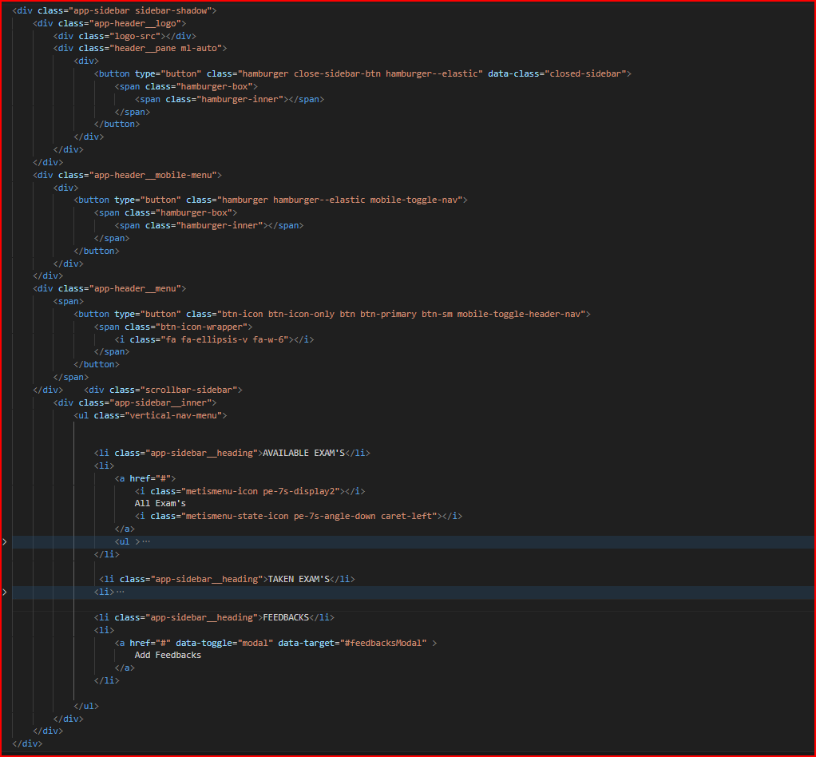**Figure 4.1 navbar code**

Figure 4.1 navbar code

A responsive navbar component is used to show a list of navigation links.We create navbar by using html, css and js A navigation bar (or navigation system) is a section of a graphical user interface intended to aid visitors in accessing information.. Add this class to a <nav> to define navbar component. Add this class to a <ul> to create navigation. Use <a> elements as menu item within the list.

**Header :**

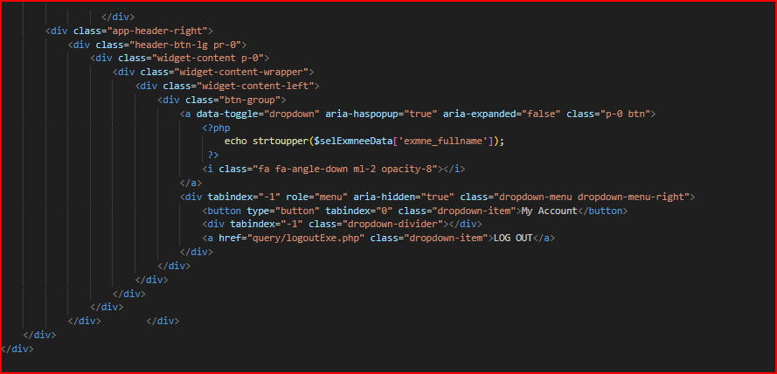

figure 2.4

The header is a part that is found on all pages and contains meta files, links to formatting files, a header section, and a body section 2.

**Links :**

