**3-database implementation**

In databases , a table is defined as set of data elements organized

into columns (they are named) and horizontal rows A table has a

specified number of columns, but it can contain any number of

rows. The row is defined by the values that appear in a part of the

columns called the candidate key.

**In the database for this project there are four tables:**

**1-Admin table:**

Its code:-

صورة تحتوي على نص, لقطة شاشة, الخط, الجبر

تم إنشاء الوصف تلقائياً

Table 1 Admin table

This table contains the login permissions represented in the id which is the primary key ,user and password.

**2-Course table:**

This table represents the main factors for creating a course.

Its code:-

**صورة تحتوي على نص, لقطة شاشة, الخط

تم إنشاء الوصف تلقائياً**

Table 2 Course table

**3-Examinee table:**

It represents all the elements that are required to be available in the student who will take the exam.

صورة تحتوي على نص, لقطة شاشة, الخط

تم إنشاء الوصف تلقائياً

table 3 Examinee table

**4-Exam answers table:**

It contains ids for the exam answer,examinee,exam and question,also elements necessary for getting from user a well defined answer.

-Its code:

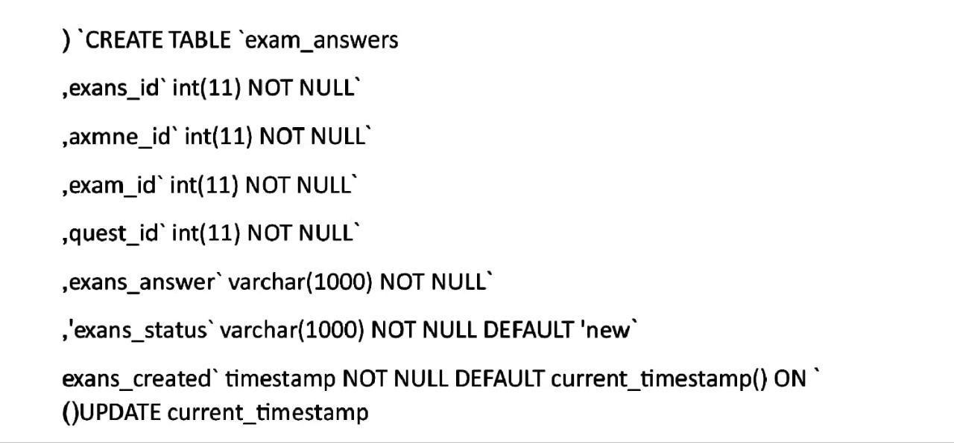

Table 4 Exam answer

**5-Exam attempt table:**

Here are the the exam attempt id and both ids of examinee and the exam.

-Its code:

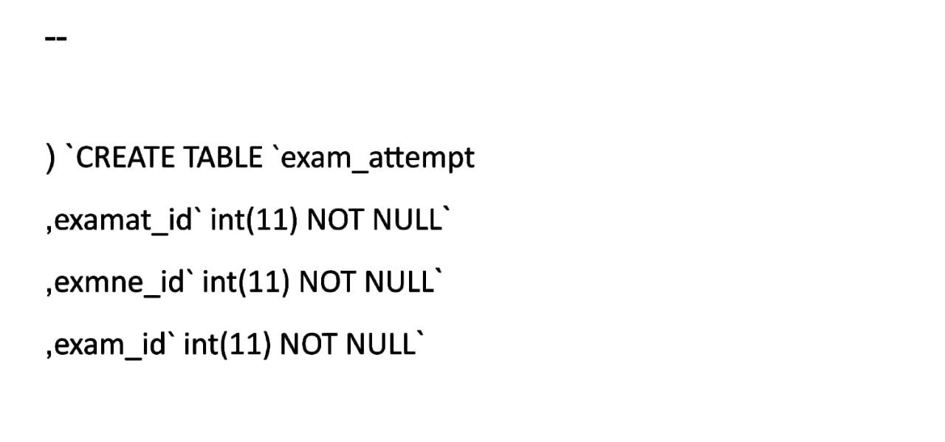

Table 5 Exam attempt

**6-Exam question table:**

This table contains question id and exam id, also it has an exam questions and answers for valid chapters which are both varchar in length of 1000.

-Its code:

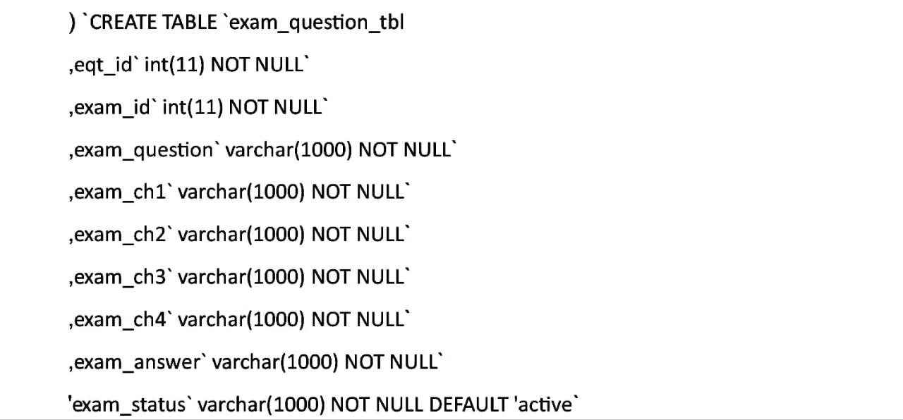

Table 6 Exam questions

**7-exam table:**

this table has exam id and course id, with title, limit, description and timestamp for the exam.

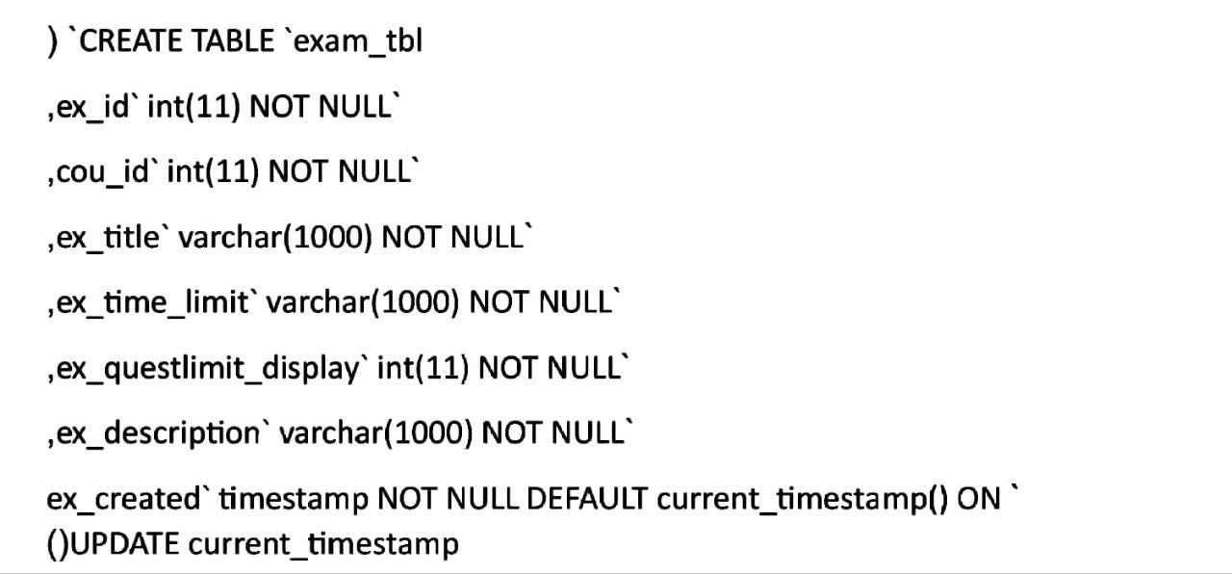

Table 7 Exam table

**8-Feedback table:**

It contains a feedback id and the exam id, also the examinee, feedback and date all varchar of length (1000).

-Its code:

صورة تحتوي على نص, الخط, لقطة شاشة

تم إنشاء الوصف تلقائياً

Table 8 Feedback table