1) WHAT IS SOFTWARE? WHAT IS SOFTWARE ENGINEERING?

Software, instruction that tell a computer what to do. Software comprises the entire set of programs, procedures and routines associated with the operation of a computer system.

software engineering is a detailed study of engineering to the design, development and of software

2) explain types of software

There are two types of software

1. system software

system software is usually defined as a set of various programs or instructions that help to control or manage the hardware devices connected to the computer and other important resources of the system specifically, it helps in making the working of the computer efficient, enables faster performance in a secure manner. in addition, the system software also establishes a platform to run the application software.

Types of system software

1) operating system

2) device drivers

3) firmware

4) language translator

5) utility

2) Application software

application software refers to a set of programs and instructions that help perform specific tasks, on a computer system. it is mainly designed to meet certain requirements of a particular environment. application software can be downloaded and installed manually on the computer system and this software have nothing to do with the system core functions.

types of operating system

1) word processors

2) database software

3) multimedia software

4) graphics software

5) web browsers

3) WHAT IS SDLC? EXPLAIN EACH PHASE OF SDLC.

The software development life cycle is the cost-effective and time-efficient process that development teams use to design and build high-quality software.

SDLC phases are given below

1)plan

the planning phase typically includes tasks like cost-benefit analysis, schedudling, resource estimation, and allocation. the development team collects requirements from serveral stakeholder such as customers, internal and external experts, and managers to create a software requirement specification document.

2)analysis

business analyst and project manager set up a meeting with customesr to gather all the information like what the customer wants to build, who will be the end-user,

what is the purpose of the product. before building a product a core understanding or knowledge of the product is very important.

3)design

in this phase, the requirement gathered in the SRS document is used as an input and software architecture that is used for implementing system development is derived.

4) implementation

5) testing & integration

6) maintenance

4) what is DFD? Create a DFD diagram on filpkart.

A data flow diagram (DFD) maps out the flow of information for any process or system. It uses defined symbols like rectangles, circles and arrows, plus short text labels, to show data inputs, outputs, storage points and the routes between each destination. Data flowcharts can range from simple, even hand-drawn process overviews, to in-depth, multi-level DFDs that dig progressively deeper into how the data is handled. They can be used to analysed an existing system or model a new one. Like all the best diagrams and charts, a DFD can often visually “say” things that would be hard to explain in words, and they work for both technical and nontechnical audiences, from developer to CEO. That’s why DFDs remain so popular after all these years. While they work well for data flow software and systems, they are less applicable nowadays to visualizing interactive, real-time or database-oriented software or systems.

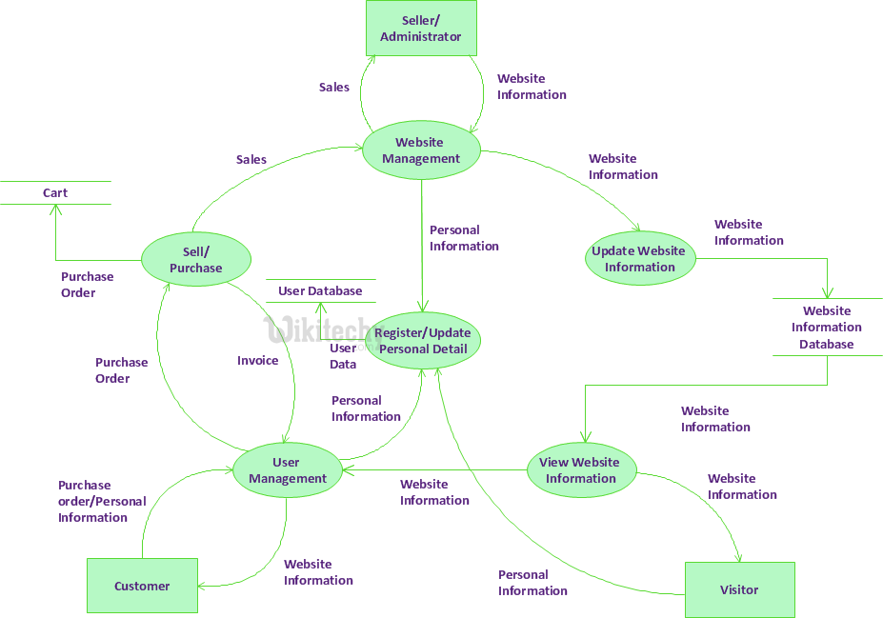

5) what is flow chart? create a flowchart to make addition of two number.

A flowchart is a type of diagram that represents a workflow or process. A flowchart can also be defined as a diagrammatic representation of an algorithm, a step-by-step approach to solving a task.

The flowchart shows the steps as boxes of various kinds, and their order by connecting the boxes with arrows. This diagrammatic representation illustrates a solution model to a given problem. Flowcharts are used in analyzing, designing, documenting or managing a process or program in various fields.

**Flowchart to Add two numbers**

[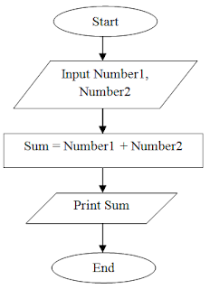](https://2.bp.blogspot.com/-36Y41WzLJo4/WORRkrRFhuI/AAAAAAAAARk/TeLffBmqLCkCq1DuXk9AafKW2PedpYlygCLcB/s1600/Flowchart%2Bto%2BAdd%2BTwo%2BNumbers.png)

6)What is use case Diagram? create a use -case on bill payment on paytm.

A use case diagram is a way to summarize details of a system and the users within that system. It is generally shown as a graphic depiction of interactions among different elements in a system. Use case diagrams will specify the events in a system and how those events flow, however, use case diagram does not describe how those events are implemented.

A use case is a methodology used in system analysis to identify, clarify, and organize system requirements. In this context, the term "system" refers to something being developed or operated, such as a mail-order product sales and service Web site. Use case diagrams are employed in UML (Unified Modeling Language), a standard notation for the modeling of real-world objects and systems. There are a number of benefits with having a use case diagram over similar diagrams such as flowcharts.

6)What is use case Diagram? create a use -case on bill payment on paytm.

A use case diagram is a way to summarize details of a system and the users within that system. It is generally shown as a graphic depiction of interactions among different elements in a system. Use case diagrams will specify the events in a system and how those events flow, however, use case diagram does not describe how those events are implemented.

A use case is a methodology used in system analysis to identify, clarify, and organize system requirements. In this context, the term "system" refers to something being developed or operated, such as a mail-order product sales and service Web site. Use case diagrams are employed in UML (Unified Modeling Language), a standard notation for the modeling of real-world objects and systems. There are a number of benefits with having a use case diagram over similar diagrams such as flowcharts.

