FaceBench: A Comparative Evaluation of Five Face Recognition Models on LFW under a Shared RetinaFace Preprocessing Pipeline
FaceBench Research Manuscript — Baseline B Multi-Model Study
Experiment ID: 20260806T192706Z_paper_lfw_five_models_baseline_b_f86260f8 | Framework: FaceBench 0.1.0 | Device: NVIDIA GeForce RTX 3050 (cuda:0)

Abstract
Fair comparison of face recognition models is often undermined by inconsistent detection/alignment pipelines, accuracy-only reporting, and incomplete experimental provenance. We present FaceBench, a reproducible benchmarking framework, and execute a locked Labeled Faces in the Wild (LFW) View-2 verification study of five pretrained recognizers—FaceNet, Dlib, InsightFace Buffalo-L, AdaFace, and MagFace—under a shared RetinaFace/SCRFD detect-and-crop protocol (Baseline B). All models used cosine similarity at a fixed decision threshold of 0.40. On up to 5958 of 6000 protocol pairs, Buffalo-L achieved the highest fixed-threshold accuracy (0.9828) with zero false accepts, while FaceNet obtained the highest AUC (0.9933). Dlib exhibited strong ranking quality (AUC 0.9922, EER 0.0234) but collapsed accuracy at 0.40 due to score-scale mismatch, illustrating why fixed-threshold accuracy alone is insufficient. AdaFace and MagFace remained competitive on AUC (0.9711 and 0.9515) under shared bbox-margin crops that differ from their native alignment recipes. We release metrics, confusion matrices, ROC/comparison figures, manifests, and weight checksums to support transparent multi-model evaluation.
Keywords: face recognition; benchmarking; reproducibility; LFW; RetinaFace; FaceNet; Dlib; Buffalo-L; AdaFace; MagFace; verification metrics

1. Introduction
Deep face recognition models are routinely compared in research and industry, yet experimental practice frequently mixes vendor-specific detectors, different crop geometries, and incomplete reporting of FAR/FRR, EER, and computational context. Such inconsistencies make it difficult to attribute performance differences to the recognition backbone rather than preprocessing.
This paper contributes (i) FaceBench, a modular Python framework for YAML-driven comparative evaluation, and (ii) a complete Baseline B LFW study of five locked models under shared RetinaFace preprocessing. Relative to our prior single-model Baseline A draft (Buffalo-L only), Baseline B freezes detection/crop once and reuses aligned faces across all recognizers.

2. Related Work
Canonical verification benchmarks such as LFW remain widely used for controlled pairwise evaluation. Model families including FaceNet (triplet learning), Dlib’s ResNet descriptor, ArcFace-style InsightFace packs (Buffalo-L), quality-adaptive margins (AdaFace), and magnitude-aware embeddings (MagFace) represent distinct training objectives and input conventions. Tooling for fair comparison must therefore normalize detection/alignment while still respecting each model’s embedding interface. FaceBench targets this gap by combining dataset/model factories, shared detection hooks, multi-axis metrics, and automated reporting with experiment manifests.

3. Methods

3.1 FaceBench overview
FaceBench organizes evaluation as: configuration → dataset integrity → identity pairs → shared align (optional) → embedding → matching → metrics → reports/figures. Recognition adapters remain unchanged in this study; AdaFace/MagFace official backbones are injected via paper-local architecture constructors without modifying framework adapter source.

3.2 Baseline B shared preprocessing
Detection uses InsightFace RetinaFace/SCRFD (buffalo_l detection pack) at det_size 640×640. Faces are cropped with crop_mode=bbox_margin (margin 0.35) to preserve context for models that re-detect internally (Buffalo-L, Dlib) while providing a face-centric crop for resize-based embedders (FaceNet, AdaFace, MagFace). Alignment is computed once per unique image and cached across models. Failed detections skip the affected pair rather than aborting the experiment.

3.3 Models and matching
Models: FaceNet (facenet-pytorch InceptionResnetV1, VGGFace2), Dlib (5-point landmarks + recognition ResNet), Buffalo-L (InsightFace ONNX), AdaFace IR-50 MS1MV2, MagFace iResNet50 MS1MV2. Matching uses cosine similarity with a locked operating threshold of 0.40 for all models. AdaFace inputs are channel-flipped to BGR in [-1,1]; MagFace uses a paper-local BGR [0,1] adaptation matching official MagFace inference, without changing FaceBench preprocess utilities.

3.4 Dataset and protocol
Factor | Setting
Dataset | LFW deepfunneled
Protocol | View-2 pairs.txt (10 folds; 3000 same + 3000 different)
Seed | 42
Device | cuda:0 (NVIDIA GeForce RTX 3050)
Skip policy | Skip pairs with missed detection / embed failure
Stub backends | Disabled

Table 1. Locked experimental protocol (Baseline B).

4. Results

4.1 Recognition metrics at threshold 0.40
Model | Acc | Prec | Rec | F1 | AUC | EER | FAR | FRR | Scored | Skipped
FaceNet | 0.9758 | 0.9886 | 0.9628 | 0.9756 | 0.9933 | 0.0275 | 0.0111 | 0.0372 | 5958 | 42
Dlib | 0.5009 | 0.5009 | 1.0000 | 0.6675 | 0.9922 | 0.0234 | 1.0000 | 0.0000 | 5893 | 107
Buffalo-L | 0.9828 | 1.0000 | 0.9657 | 0.9826 | 0.9899 | 0.0216 | 0.0000 | 0.0343 | 5936 | 64
AdaFace | 0.8098 | 0.9995 | 0.6208 | 0.7659 | 0.9711 | 0.0730 | 0.0003 | 0.3792 | 5958 | 42
MagFace | 0.8864 | 0.9432 | 0.8228 | 0.8789 | 0.9515 | 0.1079 | 0.0498 | 0.1772 | 5958 | 42

Table 2. LFW View-2 verification metrics under Baseline B (cosine similarity, threshold = 0.40).
Buffalo-L leads fixed-threshold accuracy (0.9828) with FAR = 0 and EER = 0.0216. FaceNet is close in accuracy (0.9758) and achieves the best AUC (0.9933). MagFace and AdaFace trail in Acc@0.40 primarily due to higher FRR under the shared crop and locked threshold, despite respectable ROC quality. Dlib’s Acc@0.40 ≈ 0.50 with FAR = 1.0 is an operating-point artifact: its EER threshold (≈0.90) differs sharply from 0.40, while AUC (0.9922) and EER (0.0234) confirm strong pairwise ranking.

4.2 Comparison charts
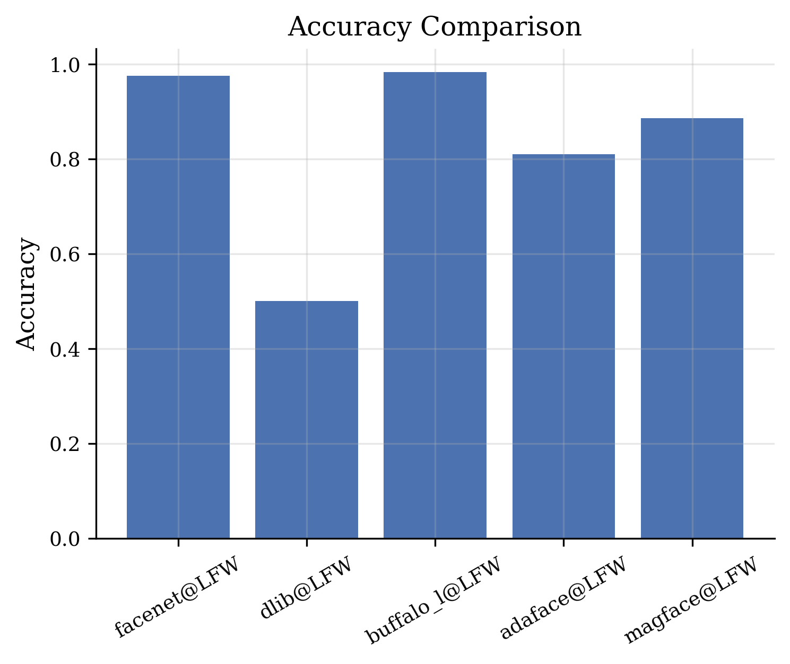
Figure 1. Accuracy comparison across the five models on LFW.
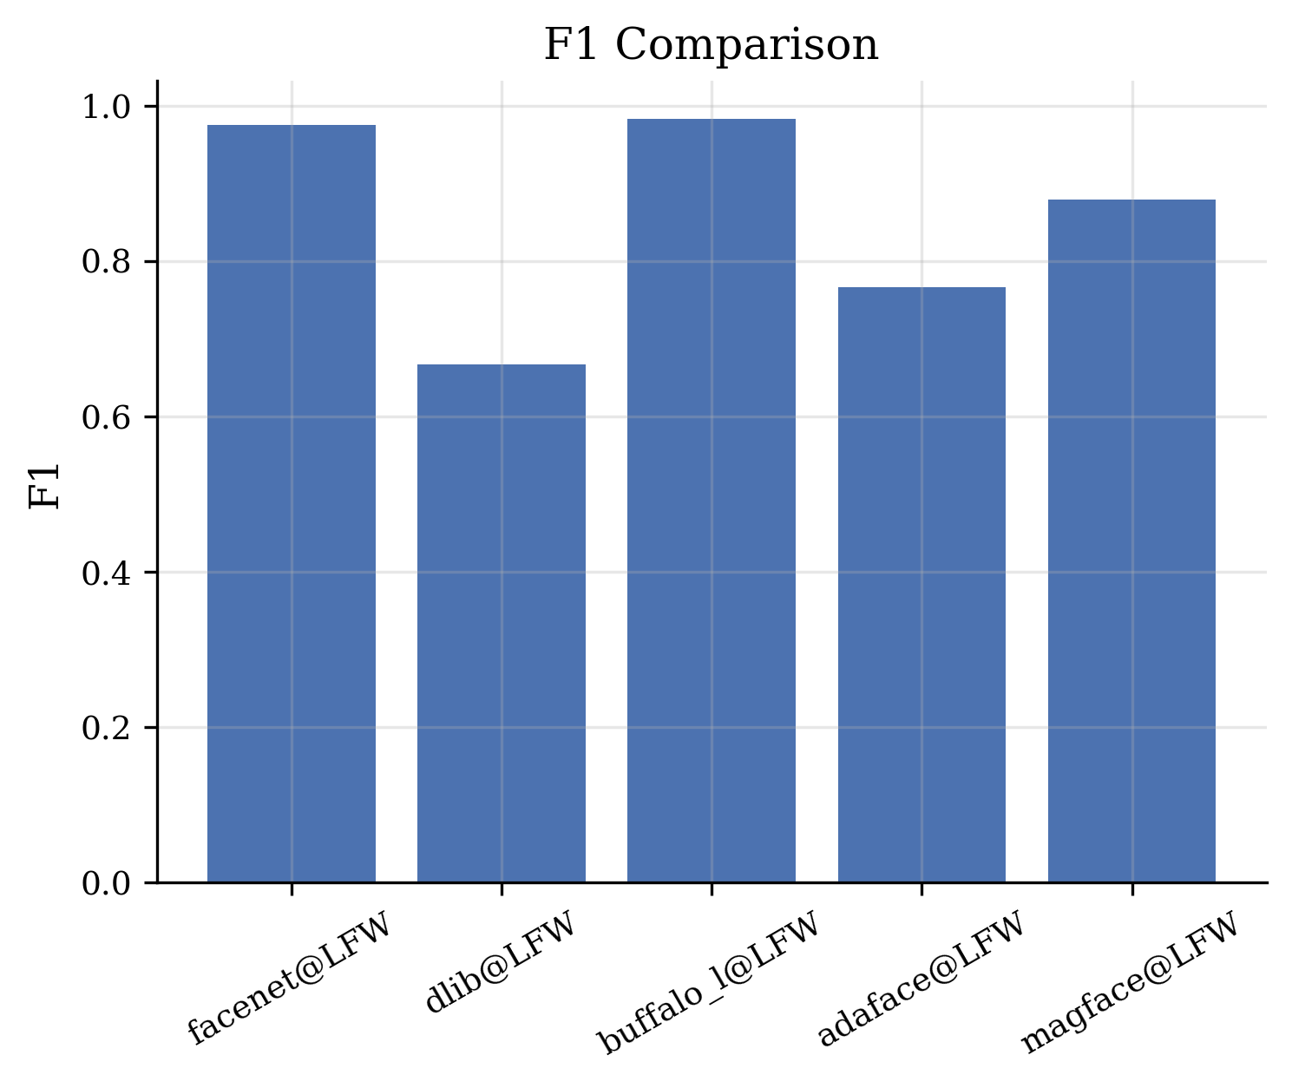
Figure 2. F1-score comparison across the five models on LFW.
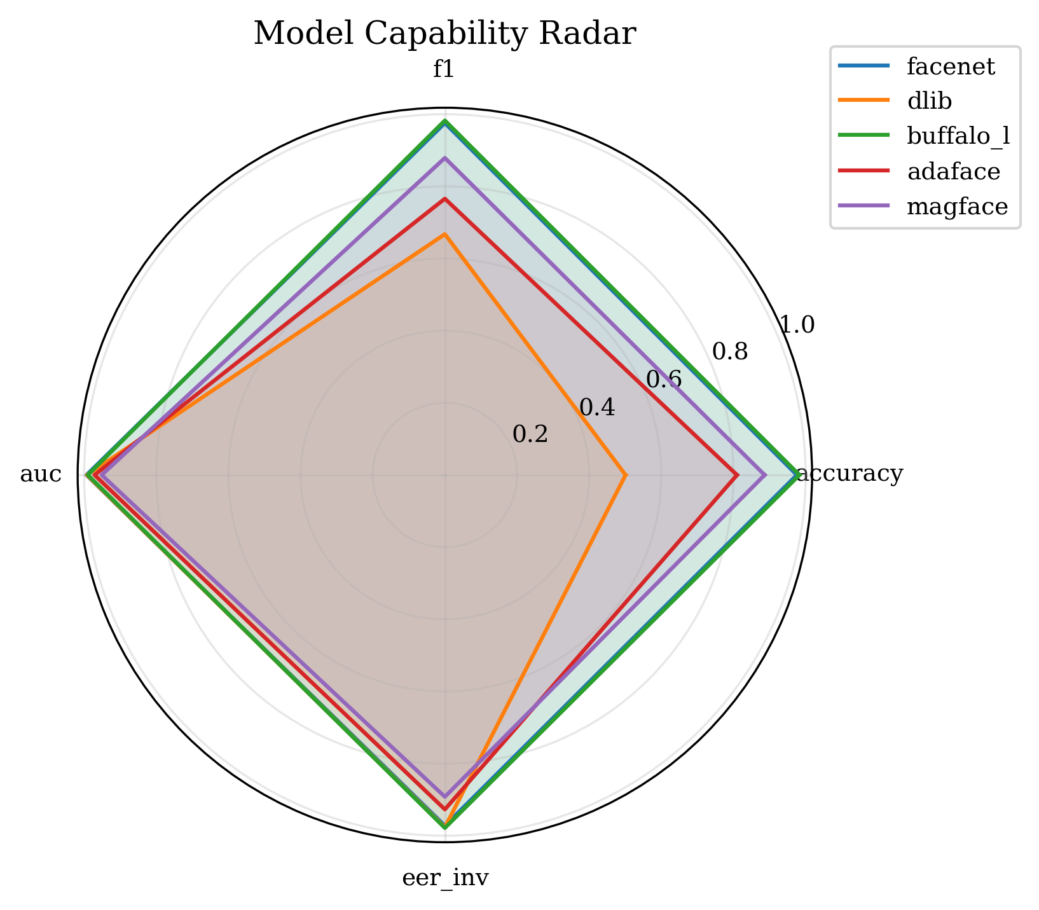
Figure 3. Radar comparison of accuracy, F1, AUC, and inverted EER.

4.3 Confusion matrices at threshold 0.40
Confusion matrices below use the locked cosine threshold 0.40. Cell layout follows FaceBench convention [[TN, FP], [FN, TP]].
Model | TP | TN | FP | FN
FaceNet | 2874 | 2940 | 33 | 111
Dlib | 2952 | 0 | 2941 | 0
Buffalo-L | 2873 | 2961 | 0 | 102
AdaFace | 1853 | 2972 | 1 | 1132
MagFace | 2456 | 2825 | 148 | 529

Table 3. Confusion counts at cosine threshold 0.40.
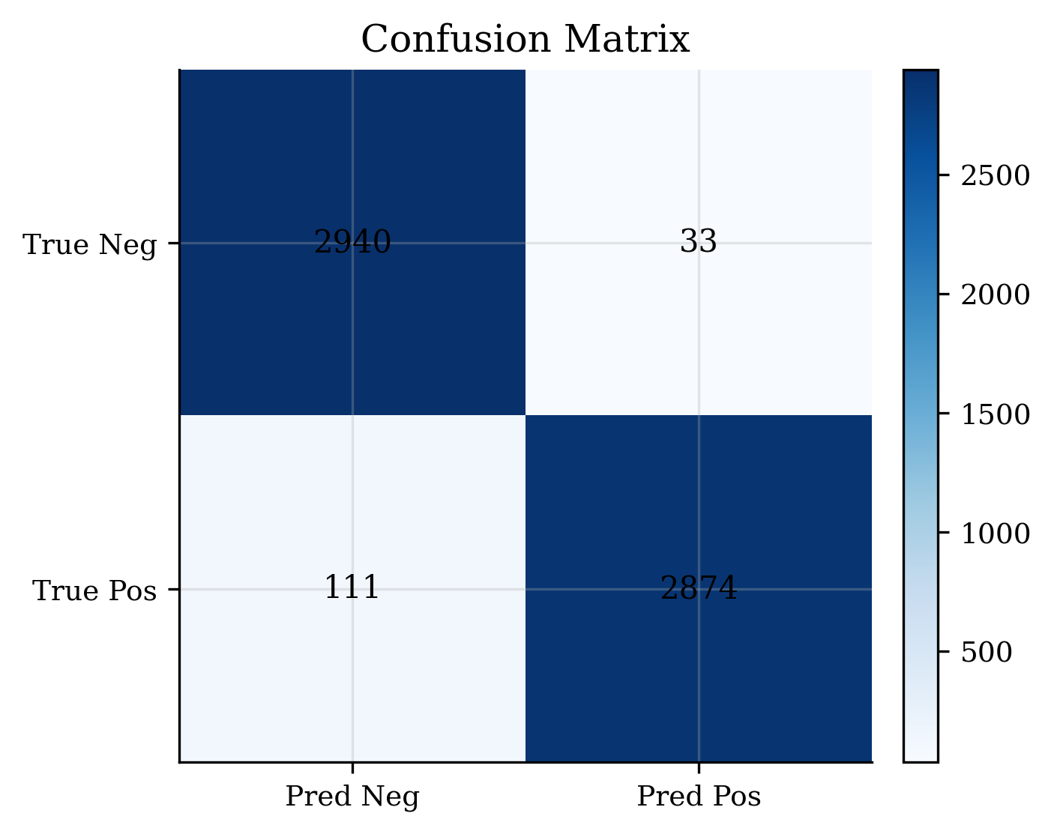
Figure. Confusion matrix for FaceNet on LFW (threshold = 0.40).
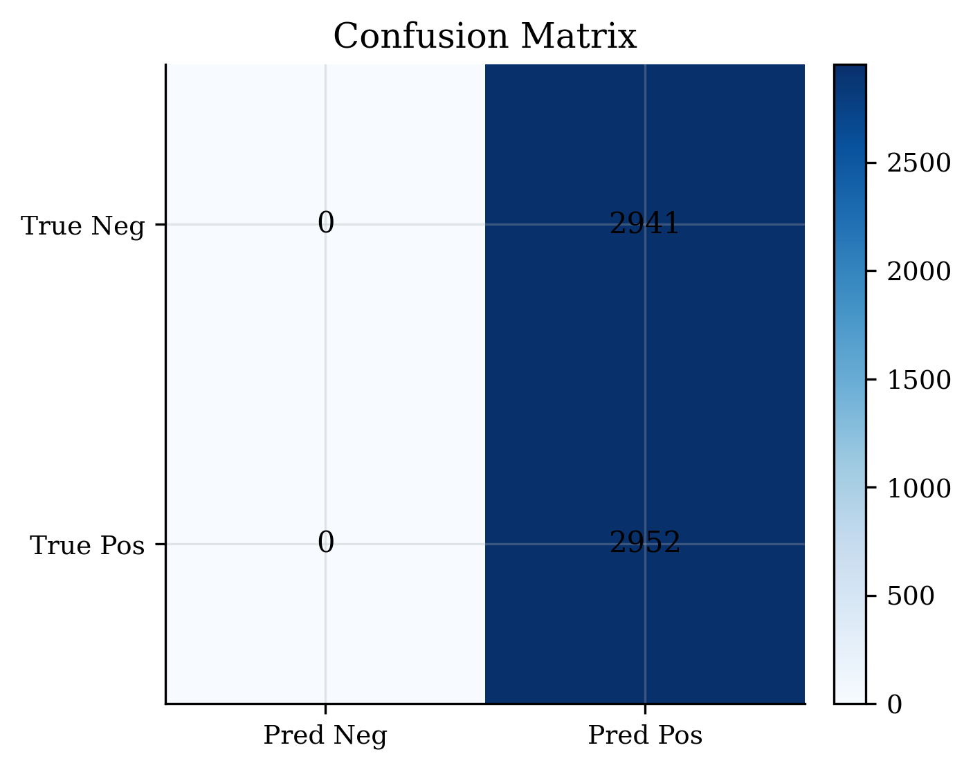
Figure. Confusion matrix for Dlib on LFW (threshold = 0.40).
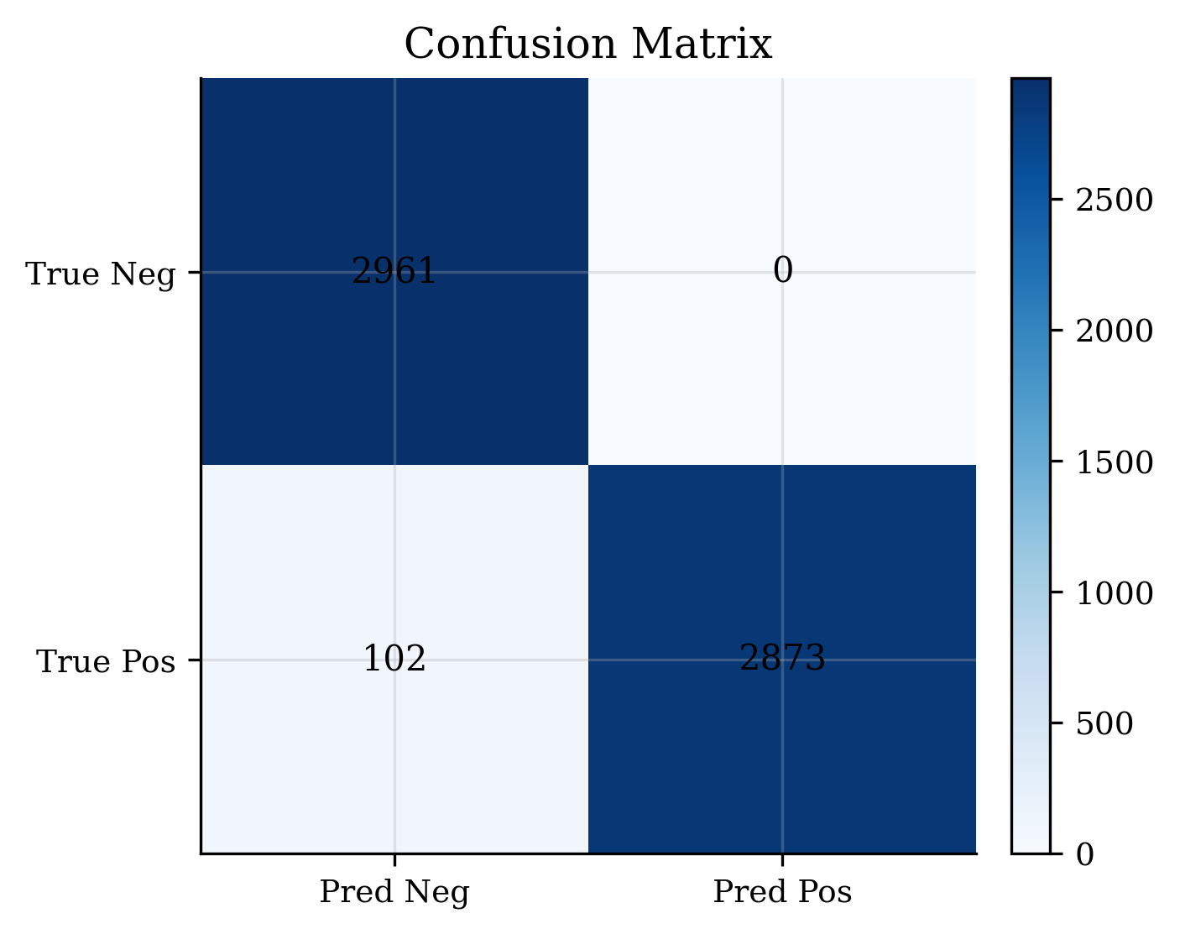
Figure. Confusion matrix for Buffalo-L on LFW (threshold = 0.40).
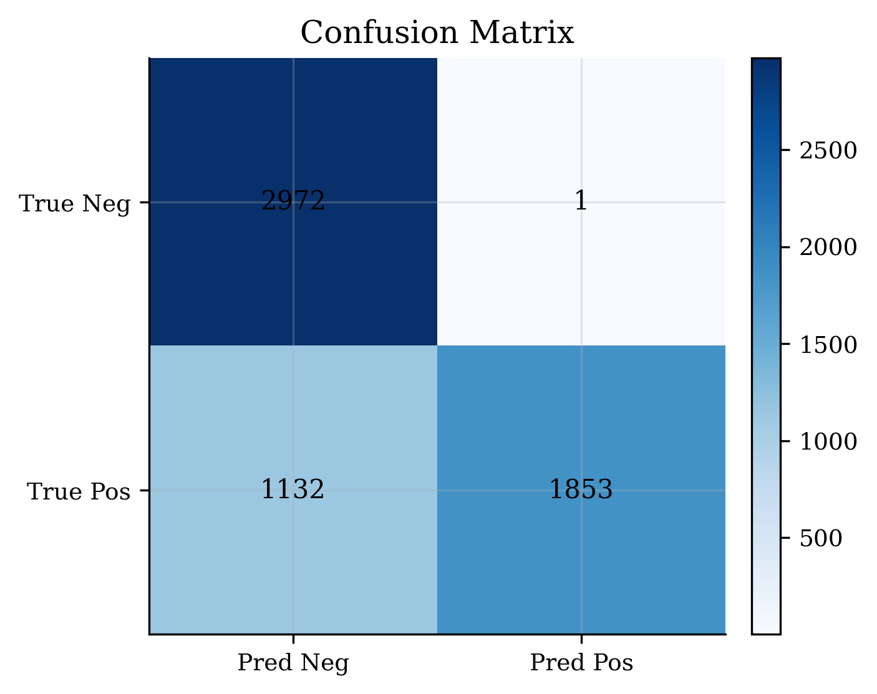
Figure. Confusion matrix for AdaFace on LFW (threshold = 0.40).
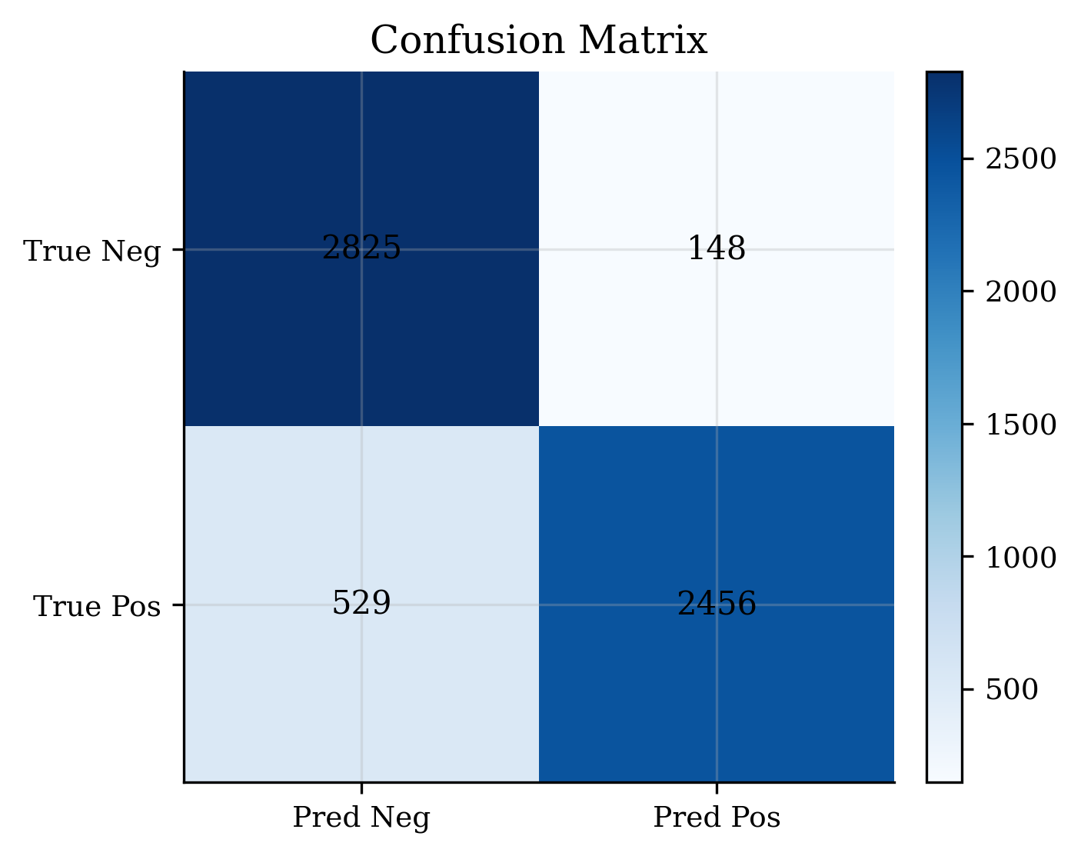
Figure. Confusion matrix for MagFace on LFW (threshold = 0.40).

4.4 ROC curves
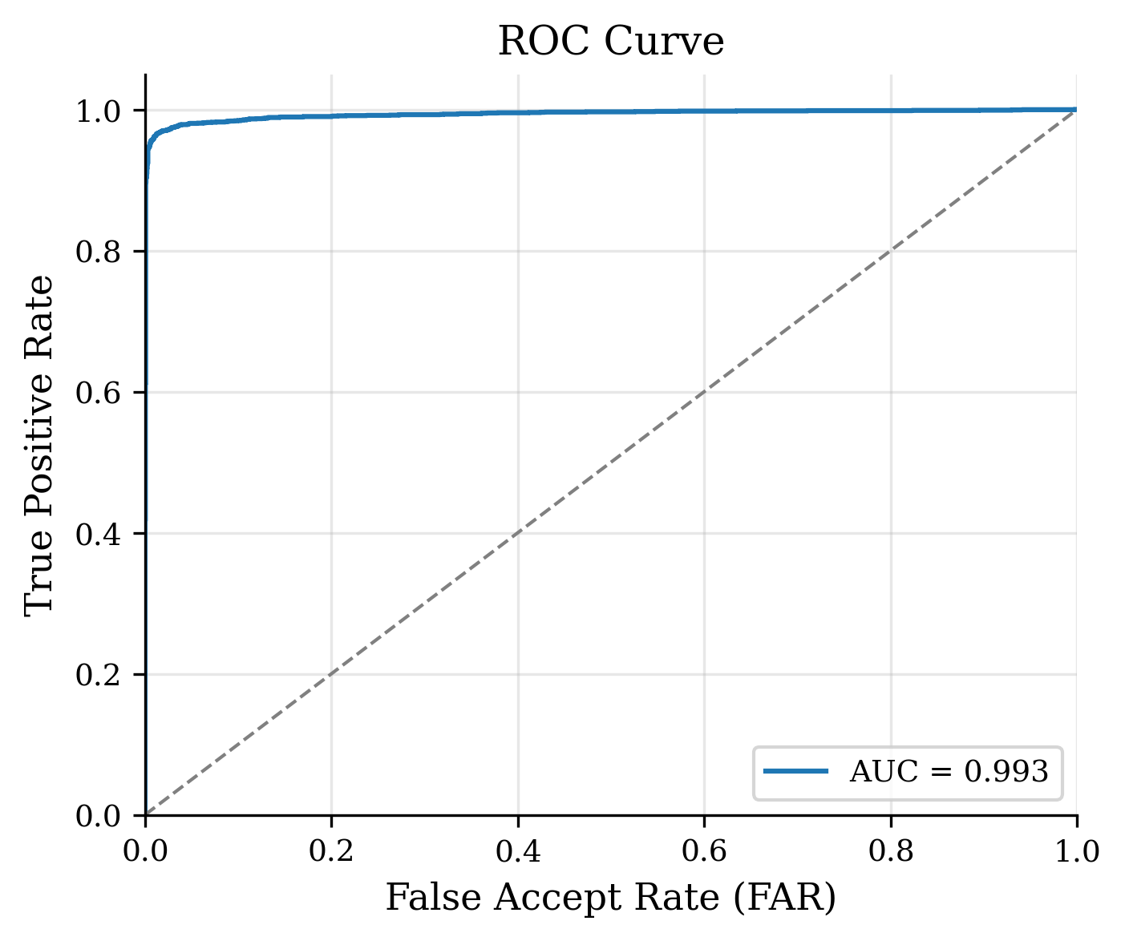
Figure. ROC curve for FaceNet on LFW View-2.
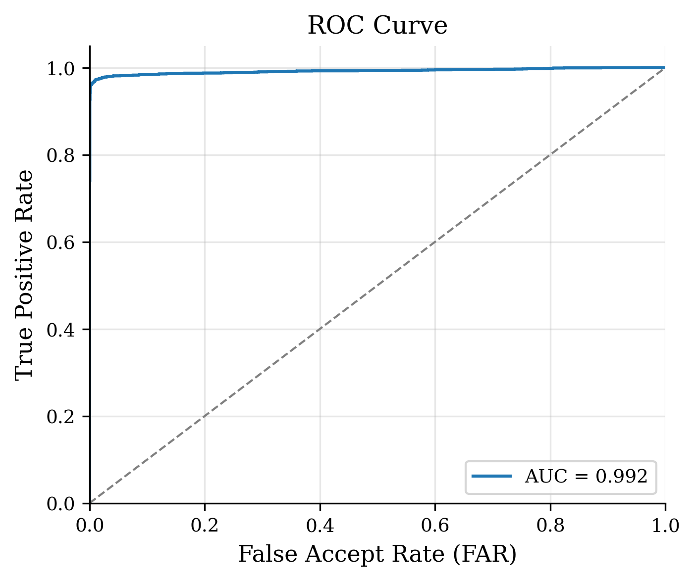
Figure. ROC curve for Dlib on LFW View-2.
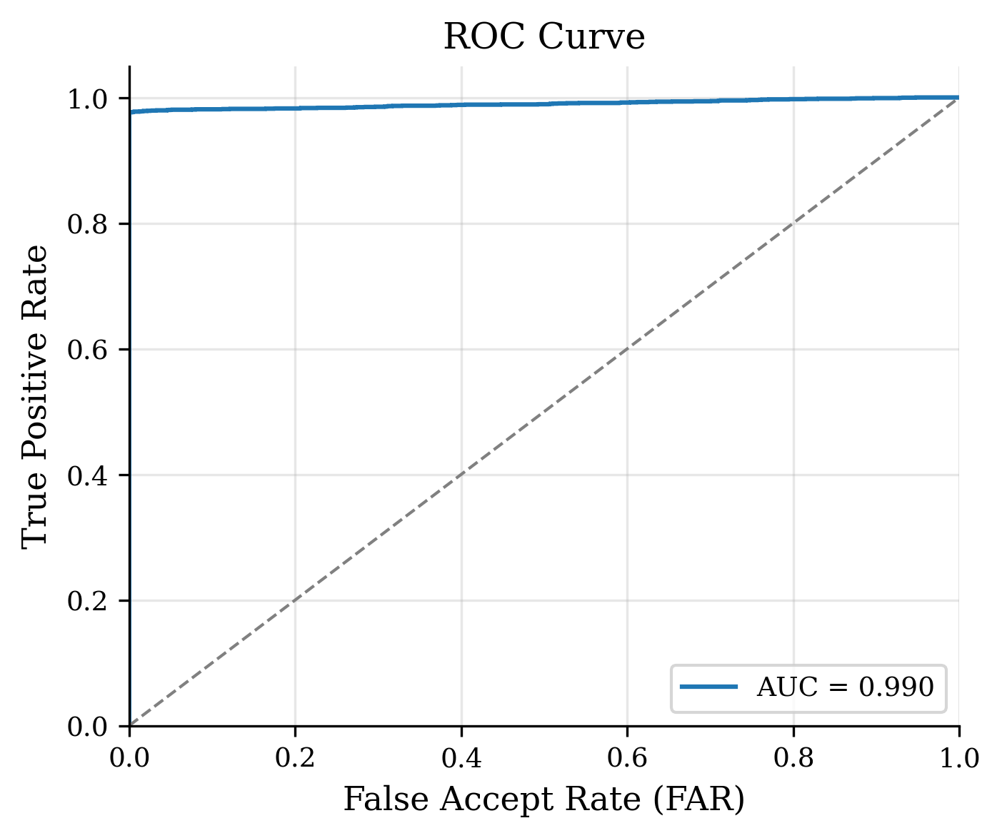
Figure. ROC curve for Buffalo-L on LFW View-2.
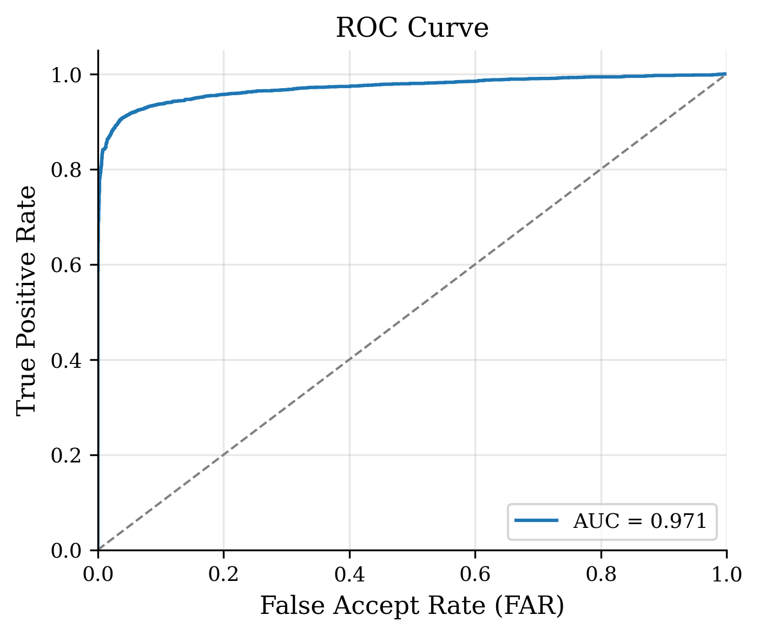
Figure. ROC curve for AdaFace on LFW View-2.
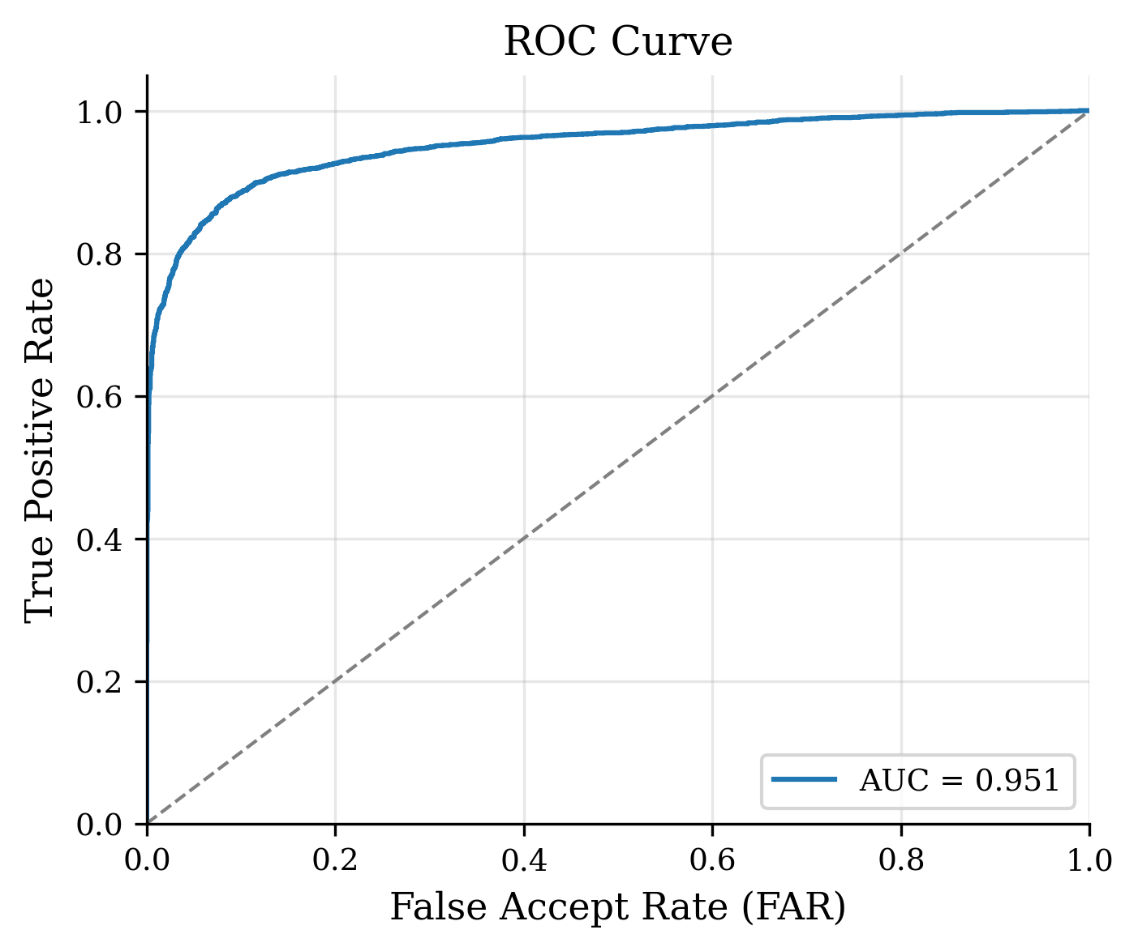
Figure. ROC curve for MagFace on LFW View-2.

5. Discussion
Shared preprocessing narrows a major confound in multi-model face recognition comparisons. Remaining gaps (AdaFace/MagFace Acc@0.40; Dlib threshold mismatch) are scientifically informative: they show that native alignment recipes and score calibrations still matter even when detection is frozen. Reporting AUC/EER alongside fixed-threshold accuracy prevents misranking models whose similarity scales differ (notably Dlib).
Limitations: this study is restricted to LFW View-2; cross-pose, age, low-resolution, and video datasets in the FaceBench roadmap are not yet included. Embedding-time figures in the aggregated latency chart are not used for ranking because the paper runner timed cached embeddings. MagFace required a paper-local input adaptation to match official BGR [0,1] inference conventions.

6. Conclusion
Under a frozen Baseline B RetinaFace pipeline on LFW, Buffalo-L and FaceNet provide the strongest overall verification behavior at the shared 0.40 cosine threshold, with FaceNet leading AUC and Buffalo-L leading accuracy/FAR. Dlib, AdaFace, and MagFace remain valuable baselines when interpreted with EER/AUC and model-specific operating points. FaceBench’s manifests, checksums, confusion matrices, and comparison figures make this multi-model study fully auditable and extensible to broader public datasets.

References
- G. B. Huang et al., “Labeled Faces in the Wild,” UMass Tech Report, 2007.
- F. Schroff et al., “FaceNet,” CVPR, 2015.
- D. E. King, “Dlib-ml,” JMLR, 2009.
- J. Deng et al., “ArcFace,” CVPR, 2019; InsightFace model zoo (Buffalo-L).
- M. Kim et al., “AdaFace,” CVPR, 2022.
- Q. Meng et al., “MagFace,” CVPR, 2021.
- J. Deng et al., “RetinaFace,” CVPR, 2020.

Appendix: Reproducibility
Primary experiment directory: experiments/20260806T192706Z_paper_lfw_five_models_baseline_b_f86260f8. Single comparison report: paper/results/lfw_five_models_baseline_b_report.md. Weight checksums: paper/weights/checksums.sha256. Runner: paper/reproduction/run_lfw_five_models_baseline_b.py. Figures copied to paper/figures/five_models_baseline_b/.

