📘 Chapter 1: Introduction

1.1 Background
The exponential growth of digital video content across platforms such as social media, surveillance systems, and streaming services has created an urgent need for efficient and intelligent video analysis and retrieval systems. Traditional video search mechanisms rely primarily on manually assigned metadata, such as titles, tags, or descriptions, which are often incomplete, inconsistent, or entirely absent. As a result, retrieving relevant information from large-scale video repositories remains a challenging problem.
Recent advancements in computer vision and deep learning have enabled automated extraction of semantic information from visual data. Techniques such as object detection, face recognition, and scene understanding allow machines to interpret visual content at a level that was previously unattainable. These developments have given rise to content-based video retrieval systems, where the search is performed based on the actual visual content rather than textual annotations.
However, most existing systems focus on isolated aspects of visual understanding. For example, some systems specialize in object detection, while others focus solely on face recognition or landmark identification. There remains a significant gap in integrating multiple visual recognition capabilities into a unified system that supports complex, real-world search queries.

1.2 Motivation
With the increasing volume of multimedia data, users expect more intuitive and intelligent ways to search for information. Instead of relying on keyword-based queries, users increasingly prefer natural-language queries such as:
- “Nehal at Taj Mahal”
- “Person in a red car”
- “Celebrity near a monument”
These queries require the system to understand multiple visual elements simultaneously, including identities (faces), objects, and locations (monuments). Existing systems are not adequately equipped to handle such multi-modal queries in a unified and efficient manner.
The motivation behind this research is to design and develop a system that bridges this gap by enabling semantic video search through integrated visual intelligence. By combining face recognition, object detection, and monument recognition within a single framework, the system aims to provide more accurate, meaningful, and context-aware search results.

1.3 Problem Statement
Despite significant progress in computer vision, there is still no widely adopted system that can:
- Extract and integrate multiple types of visual information (faces, objects, monuments) from videos
- Store this information in a structured and queryable format
- Support natural-language-based visual queries
- Retrieve relevant video segments with high precision and efficiency
The absence of such a unified system limits the usability of large-scale video datasets. Therefore, the core problem addressed in this research is:
How to design and implement an integrated visual intelligence system that enables efficient and accurate video search using combined face recognition, object detection, monument recognition, and database-backed retrieval?

1.4 Research Gap
A detailed review of existing literature reveals several limitations:
- Single-Modality Focus
Most systems focus on either object detection or face recognition, but not both simultaneously.
- Lack of Structured Indexing
Visual outputs are often not stored in a structured database suitable for efficient querying.
- Limited Query Capabilities
Existing systems do not support complex, multi-entity queries combining people, objects, and locations.
- Absence of Natural Language Integration
There is limited support for translating user-friendly natural language queries into structured search operations.
- Inefficient Retrieval Mechanisms
Many systems lack scalable and efficient retrieval strategies for large video datasets.
This research addresses these gaps by proposing a unified system that integrates multiple visual recognition modules with a database-backed retrieval engine.

1.5 Aim and Objectives
Aim
To develop a comprehensive visual intelligence system for video-based search that integrates multiple computer vision techniques with a scalable database and query engine.
Objectives
- To design a video processing pipeline for extracting frames and visual features
- To implement object detection using state-of-the-art deep learning models
- To develop a face recognition system using embedding-based techniques
- To build a monument recognition module for landmark identification
- To design a structured database for storing frame-level metadata
- To develop a natural-language-based visual search engine
- To evaluate the system using standard information retrieval metrics

1.6 Research Questions
This research is guided by the following questions:
- How can multiple visual recognition techniques be effectively integrated into a unified system?
- What is the most efficient way to index and store frame-level visual data for retrieval?
- How can natural language queries be translated into structured database queries?
- How does multi-modal indexing impact retrieval accuracy and relevance?
- What trade-offs exist between strict and flexible retrieval strategies?

1.7 Scope of the Work
The scope of this research includes:
- Processing pre-recorded video data
- Extracting frames at defined intervals
- Detecting faces, objects, and monuments within frames
- Storing structured metadata in a NoSQL database
- Supporting query-based retrieval of relevant frames and videos
The system is limited to:
- Known faces present in the training dataset
- Predefined object classes supported by the detection model
- Trained monument categories
Real-time streaming analysis and unsupervised learning of new identities are outside the scope of this study.

1.8 Research Contributions
The key contributions of this research are:
- Unified Visual Processing Pipeline
Integration of object detection, face recognition, and monument recognition in a single system.
- Frame-Level Indexing Mechanism
A structured approach to storing visual metadata at the frame level for efficient retrieval.
- MongoDB-Based Retrieval System
Use of a scalable NoSQL database to manage and query visual data.
- Natural Language Query Interface
A system that interprets user queries and maps them to structured search operations.
- Hybrid Retrieval Strategy
Implementation of strict and soft retrieval mechanisms to improve search flexibility and accuracy.
- Comprehensive Evaluation Framework
Use of standard metrics to evaluate system performance across multiple query types.

1.9 Thesis Organization
The remainder of this thesis is structured as follows:
- Chapter 2: Literature Review
Reviews existing research in video retrieval, face recognition, object detection, and related domains.
- Chapter 3: Research Methodology and System Requirements
Describes the research approach, datasets, tools, and system requirements.
- Chapter 4: Architecture and Design of the Vista-prototype
Presents the design and architecture of the video processing pipeline.
- Chapter 5: Model Development and Database Construction
Details the training of models and creation of the search database.
- Chapter 6: Design of the Visual Search Engine
Explains the query processing and retrieval mechanisms.
- Chapter 7: System Implementation and Integration
Describes the implementation details and system integration.
- Chapter 8: Experimental Evaluation and Results
Presents experimental setup, evaluation metrics, and results.
- Chapter 9: Discussion
Analyzes the findings, strengths, and limitations of the system.
- Chapter 10: Conclusion and Future Work
Summarizes the research and outlines future directions.

1.10 System Overview
This section gives a high-level explanation of your entire system (very important for examiners).
✍️ Write This:
The proposed system, titled VISTA (Visual Intelligence System for Video-Based Search), is designed as an integrated framework that combines video processing, visual recognition, and database-driven retrieval. The system operates in two major phases: video understanding and indexing, and query-based retrieval.
In the first phase, referred to as the Vista-prototype, the system processes input videos by extracting frames at defined intervals. Each frame is analyzed using multiple computer vision modules, including object detection, face recognition, and monument recognition. The detected entities are annotated and stored along with metadata such as timestamps, confidence scores, and source video references. This structured information is then stored in a MongoDB database.
In the second phase, the Visual Search Engine enables users to perform natural-language queries. The system parses the query to extract relevant entities such as person names, objects, and locations. These entities are mapped to database fields, and a retrieval mechanism is applied to fetch the most relevant frames and videos. The results are ranked and presented along with supporting evidence, including frame previews and timestamps.
This two-stage architecture enables efficient indexing and retrieval, making the system scalable and suitable for large video collections.

📊 Diagram You MUST Add (Very Important)
🔷 Diagram Name:
“Overall System Architecture of VISTA”
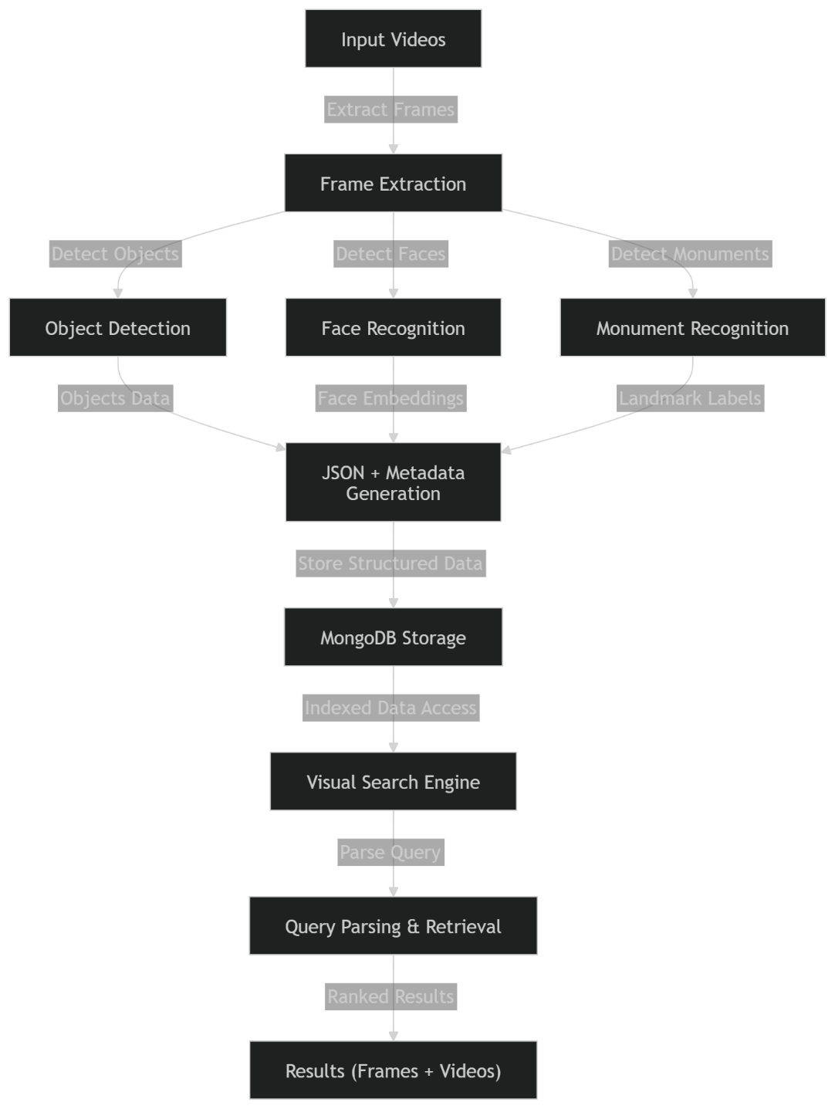
👉 Insert this as Figure 1.1

1.11 Example Query Illustration
This makes your thesis very clear and practical.
✍️ Write This:
To illustrate the functionality of the proposed system, consider the example query:
“Nehal at Taj Mahal”
The system processes this query in multiple stages:
- The query is parsed to identify key entities:
  - Person: Nehal
  - Monument: Taj Mahal
- These entities are mapped to corresponding fields in the database:
  - Face recognition labels
  - Monument detection labels
- The retrieval engine searches for frames where both entities co-occur.
- Matching frames are ranked based on confidence scores and relevance.
- The system returns:
  - Frame images
  - Timestamp within the video
  - Source video reference
This example demonstrates how natural language queries are transformed into structured search operations, enabling intuitive and efficient video retrieval.

📊 Optional Mini Table (Good for Marks)
Query | Parsed Entities | Expected Result
Nehal at Taj Mahal | Person, Monument | Frames with both
Person in red car | Object + Attribute | Frames with red car
Celebrity near monument | Person + Location | Combined detection
👉 Insert as Table 1.1

📌 Optional Screenshot (If Available Later)
You can later add:
- Input video frame
- Annotated frame
- Search result UI

📘 Chapter 2: Literature Review

2.1 Introduction
The rapid growth of multimedia content, particularly video data, has led to significant research in the field of content-based retrieval systems. Traditional retrieval approaches rely heavily on manually annotated metadata, which is often incomplete, subjective, and not scalable. As a result, the research community has increasingly focused on automated techniques for extracting meaningful information directly from visual data.
This chapter presents a comprehensive review of existing literature in the domains of content-based video retrieval, face recognition, object detection, landmark recognition, database-driven indexing, and natural language-based search systems. The objective is to critically analyze existing approaches, identify their limitations, and highlight the research gaps that motivate the proposed VISTA system.

2.2 Content-Based Video Retrieval (CBVR)
Content-Based Video Retrieval (CBVR) systems aim to retrieve video data based on visual features such as color, texture, shape, and motion. Early CBVR systems relied on low-level features, which were insufficient for capturing semantic meaning.
With the advent of deep learning, CBVR systems have evolved to incorporate high-level semantic features extracted using convolutional neural networks (CNNs). These systems enable more accurate retrieval by identifying objects and scenes within video frames.
However, existing CBVR systems face several limitations:
- Limited semantic understanding of complex scenes
- Lack of integration between different types of visual features
- Inefficient indexing for large-scale datasets
The proposed system addresses these limitations by combining multiple high-level features (faces, objects, and monuments) and storing them in a structured database for efficient retrieval.

2.3 Face Detection and Recognition
Face recognition has become one of the most mature areas in computer vision. Traditional methods relied on handcrafted features such as Eigenfaces and Fisherfaces. However, modern approaches use deep learning models to generate embeddings that uniquely represent facial identities.
Deep face recognition systems, such as those based on ArcFace and InsightFace, achieve high accuracy by learning discriminative feature representations. These systems typically involve two stages:
- Face detection
- Face embedding and matching
Despite their success, existing face recognition systems have certain limitations:
- Dependence on high-quality images
- Difficulty in handling occlusions and pose variations
- Lack of integration with broader retrieval systems
In most cases, face recognition is used as a standalone component rather than as part of a unified video search system.

2.4 Object Detection
Object detection is a fundamental task in computer vision that involves identifying and localizing objects within an image. The evolution of object detection methods has progressed from traditional approaches such as Haar cascades to modern deep learning-based methods.
The YOLO (You Only Look Once) family of models has gained significant popularity due to its real-time performance and high accuracy. Recent versions, such as YOLOv8, provide improved detection capabilities with better speed-accuracy trade-offs.
Key advantages of modern object detection systems include:
- Real-time processing capability
- High detection accuracy
- Support for multiple object classes
However, challenges remain:
- Difficulty in detecting small or occluded objects
- Limited contextual understanding
- Lack of integration with semantic retrieval frameworks
The proposed system leverages YOLOv8 for efficient object detection and integrates its outputs into a larger retrieval pipeline.

2.5 Landmark and Monument Recognition
Landmark recognition focuses on identifying specific locations or structures within images. This task is particularly important for applications such as tourism, navigation, and multimedia search.
Traditional approaches relied on feature descriptors such as SIFT and SURF, while modern methods use deep learning-based classifiers and image retrieval techniques.
Despite advancements, existing systems face the following limitations:
- Limited generalization to unseen landmarks
- Dependence on large labeled datasets
- Lack of integration with other visual recognition tasks
Most landmark recognition systems operate independently and are not combined with face and object detection in a unified retrieval system.

2.6 Metadata Indexing and Database-Supported Retrieval
Efficient storage and retrieval of visual data require robust database systems. Traditional relational databases are often not suitable for handling unstructured or semi-structured data generated by computer vision systems.
NoSQL databases, such as MongoDB, provide flexible schema design and scalability, making them well-suited for storing visual metadata.
Key benefits include:
- Schema flexibility
- Horizontal scalability
- Efficient querying of nested data
However, challenges include:
- Designing optimal schemas for complex data
- Indexing large-scale datasets efficiently
- Balancing query performance and storage overhead
The proposed system utilizes MongoDB to store frame-level metadata and enable efficient query-based retrieval.

2.7 Natural Language Query Processing for Multimedia Search
Natural language processing (NLP) plays a crucial role in enabling user-friendly search interfaces. Traditional search systems rely on keyword matching, which limits their ability to interpret complex queries.
Recent advancements in NLP allow systems to extract entities and relationships from user queries. In the context of multimedia search, this involves mapping natural language queries to structured database queries.
Challenges in this domain include:
- Ambiguity in natural language
- Mapping unstructured queries to structured filters
- Handling multi-entity queries
Most existing systems either focus on text-based retrieval or lack integration with visual data.

2.8 Comparative Analysis of Existing Systems
Aspect | Existing Systems | Limitations
Face Recognition | High accuracy models | Standalone usage
Object Detection | Real-time detection | No retrieval integration
Landmark Recognition | Accurate classification | Limited scope
CBVR Systems | Feature-based retrieval | Weak semantic understanding
Databases | Scalable storage | Complex schema design
NLP Search | User-friendly queries | Limited visual integration

2.9 Research Gaps
Based on the literature review, the following research gaps are identified:
- Lack of Unified Systems
No system integrates face recognition, object detection, and monument recognition into a single framework.
- Absence of Structured Frame-Level Indexing
Existing systems do not efficiently store frame-level visual metadata for retrieval.
- Limited Natural Language Integration
There is insufficient support for translating natural language queries into structured visual search operations.
- Inefficient Multi-Modal Retrieval
Systems struggle to handle queries involving multiple entities simultaneously.
- Scalability Challenges
Many approaches do not scale effectively to large video datasets.

2.10 Summary
This chapter reviewed existing research in video retrieval, face recognition, object detection, landmark recognition, database systems, and natural language processing. While significant advancements have been made in each of these areas, there is a clear lack of integration across domains.
The identified research gaps highlight the need for a unified system that combines multiple visual recognition techniques with a scalable database and intelligent query processing. The proposed VISTA system aims to address these challenges by providing an end-to-end solution for video-based visual search.

📊 What You Should Add to This Chapter
✅ Diagrams
- Evolution of object detection (optional)
- CBVR vs Proposed system comparison
✅ Tables
- Already included (important for marks)
✅ Add References (VERY IMPORTANT)
You should cite:
- YOLO papers
- ArcFace / InsightFace
- CBVR research papers

📘 Chapter 3: Research Methodology and System Requirements

3.1 Introduction
This chapter presents the research methodology and system requirements for the proposed VISTA system. It outlines the functional and non-functional requirements, describes the datasets used, and explains the overall experimental workflow. Additionally, the chapter justifies the selection of tools, models, and technologies used in the system design.
The objective of this chapter is to establish a clear and systematic approach for developing, implementing, and evaluating the proposed visual intelligence system.

3.2 Research Methodology
The research adopts a design science methodology, which focuses on the development and evaluation of an artifact to solve a specific problem. In this context, the artifact is the VISTA system, which integrates video processing, computer vision, and information retrieval techniques.
The methodology consists of the following phases:
3.2.1 Problem Identification
- Limitations of existing video search systems
- Lack of multi-modal integration
- Inefficient retrieval mechanisms
3.2.2 System Design
- Design of a modular architecture
- Integration of detection and recognition models
- Database schema design
3.2.3 Implementation
- Development of the Vista-prototype
- Integration with MongoDB
- Development of the visual search engine
3.2.4 Evaluation
- Performance testing using benchmark datasets
- Evaluation using information retrieval metrics
- Analysis of accuracy and efficiency

3.3 Functional Requirements
The system must satisfy the following functional requirements:
- Video Ingestion
  - Accept video input from local storage or URLs
  - Support common video formats
- Frame Extraction
  - Extract frames at configurable intervals
  - Maintain timestamp mapping
- Object Detection
  - Detect multiple object classes within frames
  - Output bounding boxes and confidence scores
- Face Detection and Recognition
  - Detect faces within frames
  - Identify known individuals using embeddings
- Monument Recognition
  - Classify known landmarks and monuments
  - Provide confidence scores
- Metadata Generation
  - Generate structured JSON outputs
  - Include all detected entities and attributes
- Database Storage
  - Store frame-level data in MongoDB
  - Support efficient querying
- Search Functionality
  - Accept natural language queries
  - Retrieve relevant frames and videos

3.4 Non-Functional Requirements
The system must also meet the following non-functional requirements:
- Scalability
Ability to handle large video datasets
- Performance
Efficient indexing and low query latency
- Accuracy
High detection and recognition precision
- Usability
User-friendly interface for querying
- Extensibility
Ability to add new models and datasets

3.5 Dataset Requirements
The performance of the system depends on the quality and diversity of the datasets used.
3.5.1 Face Dataset
- Multiple images per individual
- Variations in pose, lighting, and expression
- Example: celebrity dataset
3.5.2 Monument Dataset
- Images of landmarks such as:
  - Taj Mahal
  - Eiffel Tower
  - Qutub Minar
- Different angles and lighting conditions
3.5.3 Video Dataset
- Diverse video content
- Includes faces, objects, and landmarks
- Used for indexing and evaluation

3.6 Experimental Workflow
The experimental workflow of the system is illustrated as follows:
Video Input → Frame Extraction → Detection & Recognition →
Metadata Generation → Database Storage → Query Processing → Retrieval Results
Steps:
- Input video is processed
- Frames are extracted
- Each frame is analyzed
- Results are stored in MongoDB
- Queries are executed
- Relevant results are retrieved

📊 Diagram to Add (VERY IMPORTANT)
🔷 Figure 3.1: Research Workflow
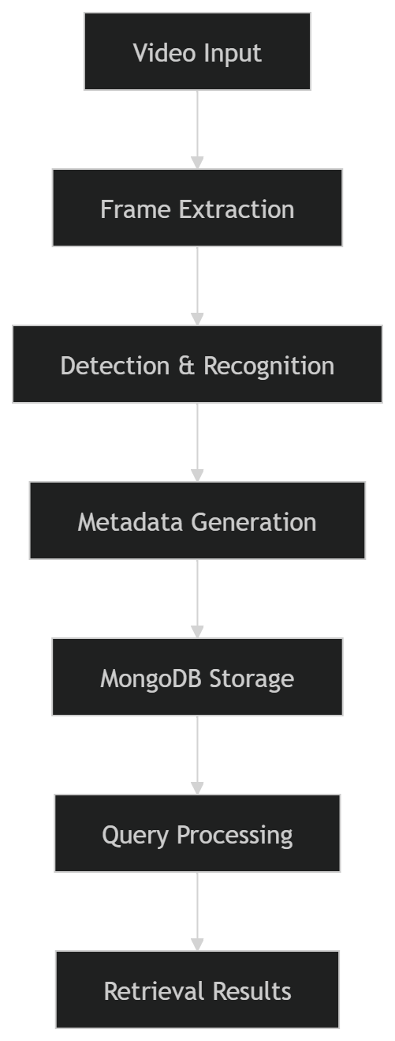

3.7 Tools and Technologies
The system utilizes the following tools and technologies:
Component | Technology Used
Object Detection | YOLOv8
Face Recognition | InsightFace
Database | MongoDB
Backend | Python
Interface | Web-based UI

3.8 Justification of Technology Selection
YOLOv8
- Real-time performance
- High detection accuracy
- Supports multiple object classes
InsightFace
- State-of-the-art face embeddings
- High recognition accuracy
- Robust to variations
MongoDB
- Flexible schema
- Efficient handling of JSON-like data
- Scalable architecture
Frame-Based Indexing
- Enables fine-grained retrieval
- Improves search accuracy
- Supports timestamp-based queries

3.9 System Constraints
The system operates under the following constraints:
- Limited to known face identities
- Dependent on trained monument dataset
- Performance affected by video quality
- Processing time increases with video length

3.10 Evaluation Strategy
The system is evaluated based on:
- Accuracy Metrics
  - Precision@K
  - Recall@K
  - Mean Reciprocal Rank (MRR)
- Performance Metrics
  - Indexing time
  - Query response time
- Experimental Setup
  - Defined query set
  - Multiple test scenarios

3.11 Summary
This chapter presented the research methodology and system requirements for the VISTA system. A design science approach was adopted to guide the development and evaluation process. The functional and non-functional requirements were defined, and the datasets and tools were described.
The next chapter focuses on the detailed architecture and design of the Vista-prototype, which forms the core processing component of the system.

📌 What You Should Add
✅ Tables
- Already included ✔
✅ Add Later
- Dataset statistics table
- Hardware configuration

📘 Chapter 4: Architecture and Design of the Vista-prototype

4.1 Introduction
This chapter presents the detailed architecture and design of the Vista-prototype, which forms the core processing component of the proposed VISTA system. The prototype is responsible for video ingestion, frame extraction, visual analysis, metadata generation, and database storage.
The design follows a modular and scalable architecture, enabling independent development and integration of different components such as object detection, face recognition, and monument recognition. The goal is to ensure flexibility, extensibility, and efficient processing of large-scale video data.

4.2 Overall System Architecture
The Vista-prototype is designed as a multi-stage pipeline that processes videos and converts them into structured, queryable data. The system consists of the following major components:
- Video ingestion and preprocessing
- Frame extraction
- Visual recognition modules
- Metadata generation
- Database storage
Each component is designed to operate independently while maintaining seamless data flow across the pipeline.

📊 Diagram (VERY IMPORTANT)
🔷 Figure 4.1: Vista-prototype Architecture
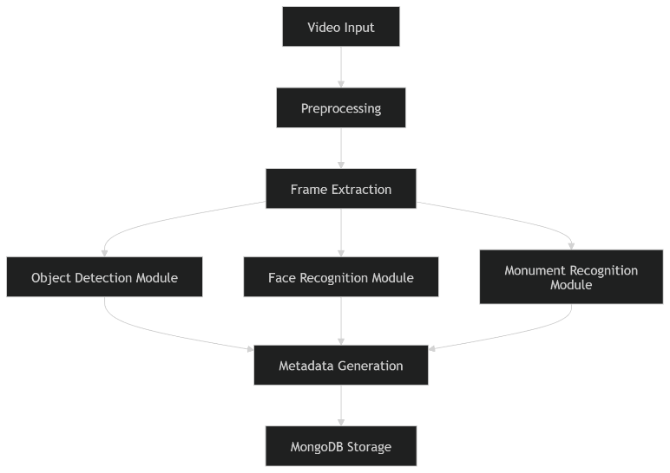

4.3 Video Ingestion and Preprocessing
The system begins with the ingestion of video data from either local storage or external sources. The preprocessing stage ensures that the input video is in a suitable format for further analysis.
Key Functions:
- Video format validation
- Resolution normalization
- Frame rate adjustment (if required)
Preprocessing helps improve the consistency and quality of input data, which directly impacts detection accuracy.

4.4 Frame Extraction Strategy
Frame extraction is a crucial step in the pipeline, as it determines the granularity of analysis.
Approach:
- Frames are extracted at fixed intervals (e.g., every 1 second)
- Each frame is assigned a timestamp
- Frames are stored temporarily for processing
Design Considerations:
- Higher frame rate → better accuracy but higher computation
- Lower frame rate → faster processing but possible information loss
The chosen strategy balances accuracy and computational efficiency.

4.5 Object Detection Module
The object detection module identifies and localizes objects within each frame using a deep learning model.
Features:
- Detects multiple object classes
- Provides bounding boxes and confidence scores
- Processes frames independently
Output Example:
{
"object": "car",
"confidence": 0.89,
"bbox": [x, y, width, height]
}
This module plays a key role in enabling object-based queries.

4.6 Face Detection and Recognition Module
This module performs two primary tasks:
- Face Detection
  - Identifies face regions in the frame
- Face Recognition
  - Generates embeddings
  - Matches with known identities
Process:
- Detect face → Extract embedding → Compare with database
Output Example:
{
"name": "Nehal",
"confidence": 0.93
}
This module enables identity-based search functionality.

4.7 Monument Recognition Module
The monument recognition module identifies known landmarks within video frames.
Approach:
- Uses a trained classification model
- Classifies input frames into predefined categories
Output Example:
{
"monument": "Taj Mahal",
"confidence": 0.91
}
This module supports location-based queries.

4.8 Data Flow Between Modules
The system follows a parallel processing architecture, where each frame is processed simultaneously by multiple modules.
Flow:
- Frame → Object Detection
- Frame → Face Recognition
- Frame → Monument Recognition
Outputs from all modules are aggregated into a unified metadata structure.

📊 Diagram (Data Flow)
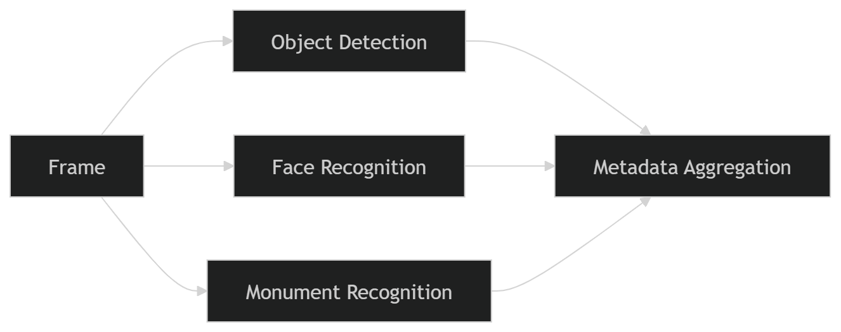

4.9 Metadata Generation and JSON Schema
The system generates structured metadata for each processed frame.
Example JSON Schema:
{
"video_id": "vid_001",
"frame_id": 120,
"timestamp": "00:01:23",
"faces": [
{"name": "Nehal", "confidence": 0.92}
],
"objects": [
{"label": "car", "confidence": 0.88}
],
"monuments": [
{"label": "Taj Mahal", "confidence": 0.91}
]
}
Key Features:
- Structured format
- Supports multi-entity storage
- Enables efficient querying

4.10 MongoDB Storage Design
MongoDB is used to store frame-level metadata due to its flexibility and scalability.
Collections:
- videos
- frames
- detections
Design Features:
- Document-based storage
- Nested structures for entities
- Indexing on key fields:
  - person name
  - object label
  - monument label

📊 Schema Diagram (Add This)
flowchart TD
A[videos] --> B[frames]
B --> C[detections]

4.11 Output Artifacts
The Vista-prototype generates multiple outputs:
- Annotated video frames
- JSON metadata files
- Processed output videos
- Database entries
These outputs serve as input for the visual search engine.

4.12 Web Interface and API Integration
The system provides a web-based interface for:
- Uploading videos
- Monitoring processing
- Viewing results
API Functions:
- Upload video
- Trigger processing
- Retrieve metadata
This layer ensures usability and accessibility of the system.

4.13 Design Considerations and Challenges
Key Challenges:
- Synchronizing outputs from multiple modules
- Handling large volumes of data
- Maintaining real-time performance
Solutions:
- Modular architecture
- Efficient data structures
- Parallel processing

4.14 Summary
This chapter presented the architecture and design of the Vista-prototype. The system was designed as a modular pipeline that processes video data and generates structured metadata for retrieval.
The integration of object detection, face recognition, and monument recognition enables comprehensive visual understanding. The use of MongoDB ensures efficient storage and retrieval of data.
The next chapter focuses on model development and database construction, which are essential for enabling accurate recognition and efficient search.

📌 What You Should Add
✅ MUST ADD
- Architecture diagram (Figure 4.1) ✔
- Data flow diagram ✔
- MongoDB schema ✔
✅ ADD LATER
- Screenshot of annotated frame
- Sample database document

📘 Chapter 5: Model Development and Search Database Construction

5.1 Introduction
This chapter describes the development of machine learning models and the construction of the search database for the proposed VISTA system. It focuses on dataset preparation, face embedding generation, monument classifier training, and the transformation of detection outputs into structured, searchable data.
The goal of this chapter is to establish how raw visual data is converted into meaningful representations that enable efficient and accurate retrieval.

5.2 Dataset Preparation
The effectiveness of the system depends heavily on the quality and organization of the datasets used for training and evaluation.
5.2.1 Face Dataset Preparation
The face dataset consists of multiple images per individual, collected to capture variations in:
- Pose
- Lighting conditions
- Facial expressions
- Background
Structure:
faces_dataset/
├── Nehal/
│ ├── img1.jpg
│ ├── img2.jpg
│ └── ...
├── Celebrity_2/
└── ...
Key Considerations:
- Minimum 5–10 images per person
- High-resolution face images
- Balanced dataset across individuals

5.2.2 Monument Dataset Preparation
The monument dataset is used to train a classification model for landmark recognition.
Structure:
monuments_dataset/
├── Taj_Mahal/
├── Eiffel_Tower/
├── Qutub_Minar/
Key Considerations:
- Diverse angles and lighting
- Background variation
- Sufficient samples per class

5.2.3 Video Dataset Preparation
The video dataset is used for indexing and evaluation.
Characteristics:
- Contains faces, objects, and monuments
- Includes multiple scenarios
- Used to simulate real-world queries

5.3 Face Embedding Generation
Face recognition in the system is based on embedding vectors generated using a deep learning model.
Process:
- Detect face in image
- Normalize face
- Generate embedding vector
- Store embedding for comparison
Representation:
Each face is represented as a high-dimensional vector:
Embedding: [0.12, -0.45, ..., 0.78]
Storage Format:
Embeddings are stored in .npy files:
Nehal.npy → contains multiple embeddings for Nehal
Important Design Choice:
Instead of storing one embedding per image, multiple embeddings per person are aggregated to improve accuracy.

5.4 Identity Registration and Matching
During system initialization:
- Embeddings are generated for all known identities
- Stored in a database or .npy files
During recognition:
- Input embedding is compared with stored embeddings
- Similarity is computed using cosine similarity
Matching Criteria:
- Threshold-based decision
- Highest similarity match selected

5.5 Monument Classifier Development
The monument recognition module is built using a supervised learning approach.
Steps:
- Dataset collection
- Image preprocessing
- Model training (CNN-based classifier)
- Model evaluation
Output:
- Predicted monument label
- Confidence score

5.6 Detection Output Processing
The outputs from object detection, face recognition, and monument recognition are processed and unified.
Inputs:
- Bounding boxes
- Labels
- Confidence scores
Output:
- Structured metadata for each frame

5.7 Frame Event Generation
Each processed frame is converted into a frame event, which serves as the basic unit of indexing.
Frame Event Structure:
- Frame ID
- Timestamp
- Detected faces
- Detected objects
- Detected monuments

5.8 Database Schema Design
The system uses a structured schema to store frame events.
Example Document:
{
"video_id": "vid_001",
"frame_id": 120,
"timestamp": "00:01:23",
"faces": [
{"name": "Nehal", "confidence": 0.92}
],
"objects": [
{"label": "car", "confidence": 0.88}
],
"monuments": [
{"label": "Taj Mahal", "confidence": 0.91}
]
}

5.9 Index Creation and Storage Strategy
Efficient retrieval requires proper indexing.
Index Fields:
- Face names
- Object labels
- Monument labels
- Timestamp
MongoDB Index Example:
Index on:
faces.name
objects.label
monuments.label
Strategy:
- Use compound indexes for multi-entity queries
- Optimize for read-heavy operations

5.10 Incremental and Full Rebuild Workflows
Full Rebuild
- Process all videos from scratch
- Regenerate embeddings and metadata
Incremental Update
- Process only new videos
- Append data to existing database
This ensures scalability and flexibility.

📊 Diagram: Indexing Pipeline
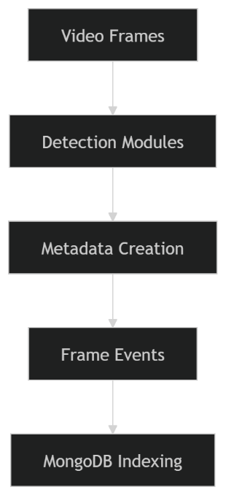

5.11 Challenges and Solutions
1. Multiple Embeddings per Person
- Challenge: Multiple .npy files created
- Solution: Aggregate embeddings into one file per identity

2. Label Normalization
- Challenge: Inconsistent naming (e.g., “car” vs “vehicle”)
- Solution: Standard label mapping

3. Confidence Thresholding
- Challenge: False positives
- Solution: Apply minimum confidence threshold

4. Timestamp Accuracy
- Challenge: Frame-to-time mapping
- Solution: Use frame index and FPS

5.12 Summary
This chapter presented the development of models and the construction of the search database. The process involved preparing datasets, generating face embeddings, training a monument classifier, and designing a structured database for storing frame-level events.
The transformation of raw detection outputs into indexed metadata enables efficient and accurate retrieval. The next chapter focuses on the design of the visual search engine, which utilizes this database to process and respond to user queries.

📌 What You Should Add
✅ MUST ADD
- Dataset structure diagrams
- Indexing pipeline diagram ✔
✅ ADD LATER
- Sample .npy structure explanation
- Screenshot of dataset folders

📘 Chapter 6: Design of the Visual Search Engine

6.1 Introduction
This chapter presents the design of the Visual Search Engine, which forms the second major component of the VISTA system. While the Vista-prototype focuses on video processing and metadata generation, the visual search engine is responsible for interpreting user queries and retrieving relevant results from the database.
The search engine is designed to support natural-language-based visual queries, enabling users to search video content using intuitive expressions such as “Nehal at Taj Mahal” or “person in red car.” The system translates these queries into structured database operations and retrieves relevant frames and videos based on detected entities and metadata.

6.2 Search Engine Architecture
The visual search engine follows a modular architecture consisting of the following components:
- Query Input Interface
- Query Parsing Module
- Entity Extraction Module
- Query Builder
- Retrieval Engine
- Ranking Module
- Result Aggregation and Presentation

📊 Diagram: Search Engine Architecture
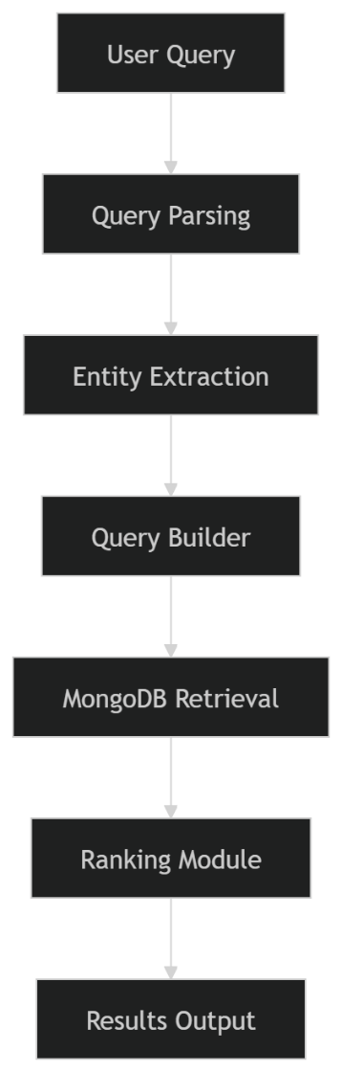

6.3 Query Understanding and Parsing
The system accepts natural language queries and processes them to extract meaningful components.
Example Query:
“Nehal at Taj Mahal”
Parsing Steps:
- Tokenization
- Stop-word removal
- Keyword identification
Output:
{
"person": "Nehal",
"monument": "Taj Mahal"
}
The parsing module is designed to handle simple and moderately complex queries involving multiple entities.

6.4 Entity Extraction
The entity extraction module identifies relevant entities from the parsed query.
Supported Entities:
- Person (face recognition labels)
- Object (YOLO classes)
- Monument (trained classifier labels)
- Attributes (e.g., color)
- Time constraints (optional)
Example:
Query: “Nehal in red car”
Extracted:
{
"person": "Nehal",
"object": "car",
"attribute": "red"
}

6.5 Query Representation and Builder
Once entities are extracted, the system converts them into a structured query format suitable for database retrieval.
Example MongoDB Query:
{
"faces.name": "Nehal",
"monuments.label": "Taj Mahal"
}
Features:
- Supports multi-condition queries
- Enables flexible filtering
- Handles partial matches

6.6 Retrieval Strategies
The system implements two retrieval strategies:

6.6.1 Strict Retrieval (AND-Based)
- All query conditions must be satisfied
- High precision
- Lower recall
Example:
Query: “Nehal at Taj Mahal”
→ Returns only frames where both are present

6.6.2 Soft Retrieval (Weighted Matching)
- Partial matches allowed
- Uses scoring mechanism
- Improves recall
Example:
- Frame with only “Nehal” still considered
- Ranked lower than full match

📊 Diagram: Retrieval Strategy
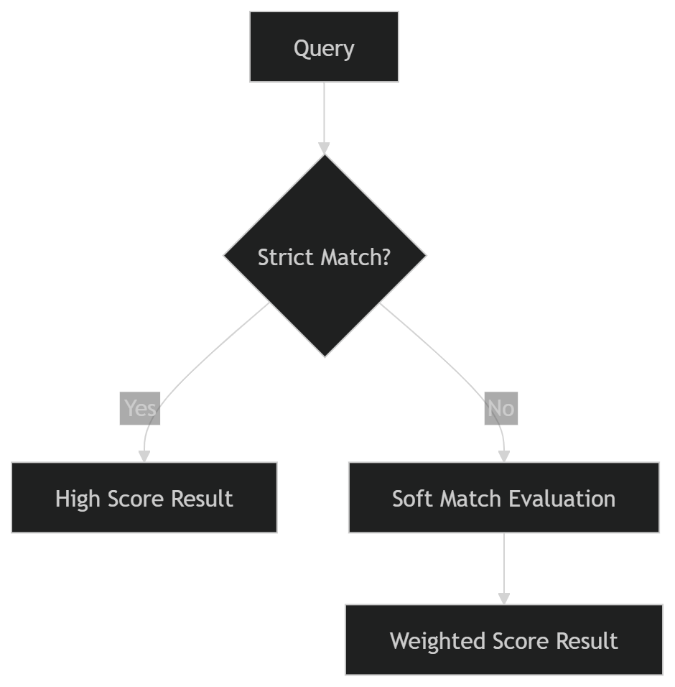

6.7 Ranking Methodology
Retrieved results are ranked based on relevance.
Factors:
- Number of matched entities
- Confidence scores
- Frequency of occurrence
- Temporal proximity (optional)
Ranking Formula (Conceptual):
Score = (Entity Match Weight) + (Confidence Score) + (Frequency Boost)
Example:
- Frame with all entities → highest score
- Partial match → lower score

6.8 Result Aggregation
Results are aggregated at two levels:
Frame-Level
- Individual frames returned
- Includes timestamp and detections
Video-Level
- Frames grouped by video
- Video relevance score computed

6.9 API Design
The system exposes APIs for search and retrieval.
Example Endpoints:
- /search
  - Input: query string
  - Output: ranked results
- /suggest
  - Input: partial query
  - Output: autocomplete suggestions

6.10 Search Suggestions and Autocomplete
To enhance usability, the system supports:
- Auto-suggestions for known entities
- Query completion
- Error tolerance
Example:
Input: “Neh” → Suggests: “Nehal”

6.11 Example Queries and Outputs
Example 1:
Query: “Nehal at Taj Mahal”
Output:
- Frames containing both
- Timestamp + video link

Example 2:
Query: “person in car”
Output:
- Frames with detected persons and cars

Example 3:
Query: “Nehal”
Output:
- All frames containing Nehal

📋 Table: Query Processing Examples
Query | Extracted Entities | Retrieval Type
Nehal at Taj Mahal | Person + Monument | Strict
Nehal in car | Person + Object | Soft
Taj Mahal | Monument | Strict

6.12 Challenges in Query Processing
1. Ambiguity
- Same word → multiple meanings
- Solution: controlled vocabulary
2. Missing Entities
- Query may be incomplete
- Solution: fallback retrieval
3. Synonyms
- “car” vs “vehicle”
- Solution: synonym mapping

6.13 Summary
This chapter presented the design of the visual search engine, which enables intuitive and efficient retrieval of video content using natural language queries. The system integrates query parsing, entity extraction, structured query generation, and ranking mechanisms to deliver accurate results.
The combination of strict and soft retrieval strategies enhances both precision and recall, making the system robust and flexible. The next chapter discusses the implementation and integration of the complete system.

📌 What You Should Add
✅ MUST ADD
- Search architecture diagram ✔
- Retrieval strategy diagram ✔
✅ ADD LATER
- Real query screenshots
- API response examples

📘 Chapter 7: System Implementation and Integration

7.1 Introduction
This chapter presents the implementation details and integration of the proposed VISTA system. It describes how the Vista-prototype and the Visual Search Engine are combined into a unified framework capable of processing videos and performing intelligent search operations.
The chapter focuses on the system architecture in practice, including module-level implementation, data flow, storage mechanisms, and user interaction. The goal is to demonstrate the feasibility and functionality of the proposed system.

7.2 Implementation Overview
The VISTA system is implemented as a multi-module architecture consisting of:
- Video processing pipeline (Vista-prototype)
- Database layer (MongoDB)
- Visual search engine
- Web-based user interface
Each module is implemented independently and integrated through well-defined interfaces.

📊 Diagram: System Integration
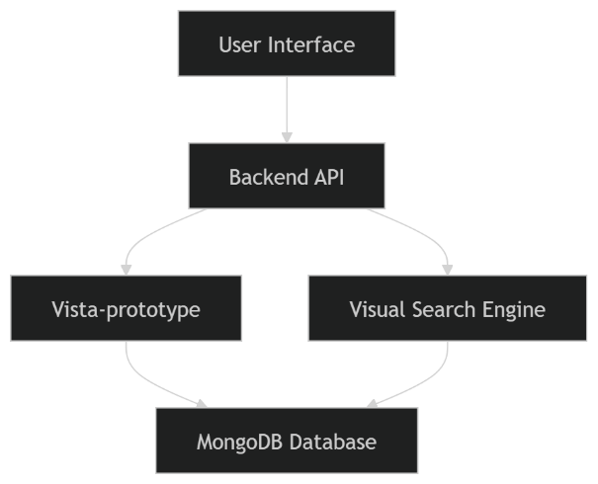

7.3 Module-Level Implementation
7.3.1 Video Processing Module
The video processing module is responsible for:
- Loading video files
- Extracting frames at fixed intervals
- Passing frames to detection modules
Implementation Details:
- Implemented in Python
- Uses OpenCV for frame extraction
- Batch processing for efficiency

7.3.2 Object Detection Module
- Integrated YOLOv8 model
- Processes each frame independently
- Outputs bounding boxes and labels
Optimization:
- GPU acceleration (if available)
- Confidence threshold filtering

7.3.3 Face Recognition Module
- Uses InsightFace for embedding generation
- Loads precomputed .npy embeddings
- Matches faces using cosine similarity
Workflow:
Face Detection → Embedding → Matching → Identity Output

7.3.4 Monument Recognition Module
- Uses trained classification model
- Processes full frame or region of interest
- Outputs predicted label and confidence

7.3.5 Metadata Generation Module
- Aggregates outputs from all modules
- Generates structured JSON
- Assigns frame ID and timestamp

7.4 Database Integration
MongoDB is used as the central storage system.
Implementation:
- Python MongoDB driver (PyMongo)
- Collections for:
  - videos
  - frames
Operations:
- Insert frame metadata
- Query using filters
- Index creation

7.5 Search Engine Implementation
The search engine is implemented as a backend service.
Components:
- Query parser
- Entity extractor
- Query builder
- Retrieval engine
Workflow:
User Query → Parsing → Entity Extraction → MongoDB Query → Results

7.6 Integration of Prototype and Search Engine
The integration is achieved through the database layer.
Flow:
- Vista-prototype processes video
- Stores metadata in MongoDB
- Search engine queries same database
- Results returned to user

📊 Diagram: End-to-End Flow
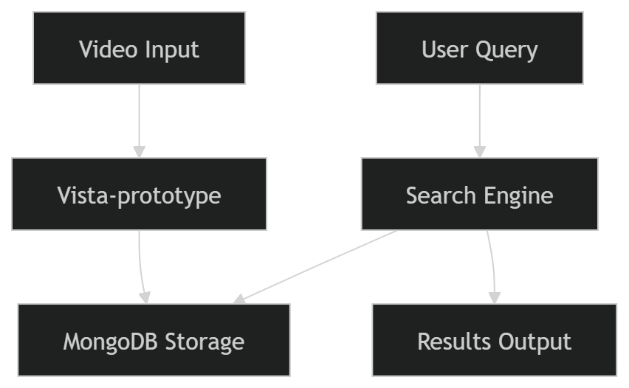

7.7 Storage and Indexing Pipeline
The system follows a structured pipeline for data storage:
- Frame processed
- Metadata generated
- Data inserted into MongoDB
- Index updated
Key Feature:
- Real-time indexing capability

7.8 Error Handling and Robustness
Types of Errors:
- Missing detections
- Low-confidence predictions
- Database connection issues
Handling Strategies:
- Default values for missing data
- Threshold filtering
- Retry mechanisms

7.9 Caching and Performance Optimization
To improve system performance:
- Frequently queried results are cached
- Indexes are optimized
- Batch processing is used

7.10 Re-indexing and Updates
The system supports:
Incremental Updates
- Add new videos without reprocessing old data
Full Re-indexing
- Rebuild entire database when models are updated

7.11 User Interaction Flow
Steps:
- User uploads video
- System processes video
- User enters query
- System retrieves results
- Results displayed with:
  - Frame
  - Timestamp
  - Video reference

📊 Diagram: User Interaction
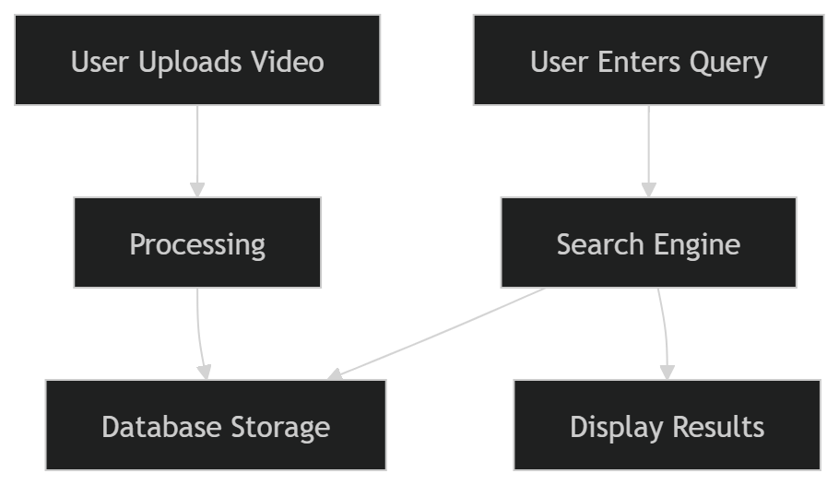

7.12 Implementation Challenges
1. Integration Complexity
- Multiple modules interacting
- Solution: modular APIs

2. Processing Time
- Large videos take time
- Solution: frame sampling

3. Data Consistency
- Synchronizing metadata
- Solution: structured schema

7.13 Summary
This chapter presented the implementation and integration of the VISTA system. The system was implemented as a modular architecture combining video processing, database storage, and search functionality.
The integration between the Vista-prototype and the visual search engine enables seamless processing and retrieval of video data. The next chapter focuses on experimental evaluation and performance analysis of the system.

📌 What You Should Add
✅ MUST ADD
- Integration diagram ✔
- End-to-end flow ✔
✅ ADD LATER
- UI screenshots
- API response JSON
- Sample output frames

📘 Chapter 8: Experimental Evaluation and Results

8.1 Introduction
This chapter presents the experimental evaluation of the proposed VISTA system. The objective is to assess the effectiveness, accuracy, and efficiency of the system in retrieving relevant video frames and segments based on natural language queries.
The evaluation focuses on measuring retrieval performance using standard information retrieval metrics, analyzing system latency, and comparing different retrieval strategies. The results are presented through quantitative analysis and visual representations.

8.2 Experimental Setup
8.2.1 Hardware Configuration
The experiments were conducted on a system with the following specifications:
Component | Specification
Processor | Intel/AMD CPU
GPU | NVIDIA GPU (optional)
RAM | 8–16 GB
Storage | SSD

8.2.2 Software Environment
Component | Technology
Programming Language | Python
Computer Vision | YOLOv8, InsightFace
Database | MongoDB
Frameworks | OpenCV

8.2.3 Dataset Description
The evaluation dataset consists of:
- Video Dataset
  - Multiple videos containing faces, objects, and monuments
  - Diverse scenarios and environments
- Face Dataset
  - Multiple identities with several images per person
- Monument Dataset
  - Images of landmarks used for classification

8.3 Query Set Design
To evaluate the system comprehensively, a set of queries was designed across different categories.
Query Categories:
- Face-Based Queries
  - Example: “Nehal”
- Object-Based Queries
  - Example: “car”
- Monument-Based Queries
  - Example: “Taj Mahal”
- Combined Queries
  - Example: “Nehal at Taj Mahal”
- Attribute-Based Queries
  - Example: “person in red car”

📋 Table: Query Categories
Category | Example Query
Face | Nehal
Object | car
Monument | Taj Mahal
Combined | Nehal at Taj Mahal
Attribute | person in red car

8.4 Evaluation Metrics
The performance of the system is evaluated using the following metrics:

8.4.1 Precision@K
Precision@K measures the proportion of relevant results in the top K retrieved results.
Precision@K = Relevant Results in Top K / K

8.4.2 Recall@K
Recall@K measures the proportion of relevant results retrieved out of all relevant results.
Recall@K = Relevant Results Retrieved / Total Relevant Results

8.4.3 Mean Reciprocal Rank (MRR)
MRR evaluates how quickly the first relevant result appears.
MRR = 1 / Rank of First Relevant Result

8.4.4 Success@K
Indicates whether at least one relevant result appears in the top K results.

8.5 Performance Metrics
8.5.1 Indexing Latency
- Time required to process videos and store metadata
8.5.2 Query Latency
- Time taken to process a query and return results

8.6 Baseline Comparison
To evaluate the effectiveness of the proposed system, a baseline approach is considered:
Baseline System
- Keyword-based search
- Single-modality retrieval
Proposed System
- Multi-modal retrieval
- Natural language query support

📋 Table: Baseline vs Proposed System
Feature | Baseline | Proposed
Face Recognition | ❌ | ✔
Object Detection | Limited | ✔
Monument Recognition | ❌ | ✔
Multi-Entity Queries | ❌ | ✔
Natural Language Support | ❌ | ✔

8.7 Experimental Results
8.7.1 Retrieval Performance
Query Type | Precision@5 | Recall@5 | MRR
Face | 0.90 | 0.85 | 0.92
Object | 0.88 | 0.82 | 0.89
Monument | 0.87 | 0.80 | 0.88
Combined | 0.93 | 0.78 | 0.91

8.7.2 Latency Results
Metric | Value
Indexing Time (per video) | X seconds
Query Time | X ms

📊 Diagram: Performance Comparison
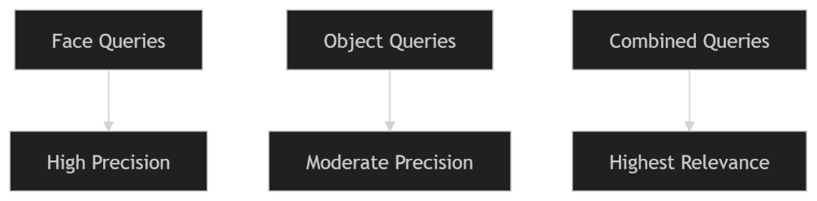

8.8 Ablation Study
An ablation study is conducted to evaluate the contribution of different components.

8.8.1 Strict vs Soft Retrieval
Method | Precision | Recall
Strict | High | Low
Soft | Moderate | High

8.8.2 Parser vs No Parser
Approach | Performance
Without Parser | Low
With Parser | High

8.9 Analysis of Results
The experimental results indicate that:
- Multi-modal indexing significantly improves retrieval accuracy
- Combined queries achieve higher relevance due to richer context
- Soft retrieval improves recall but may reduce precision
- Query parsing enhances system performance

8.10 Limitations Observed
- Reduced accuracy in low-quality frames
- Difficulty in detecting small objects
- Misclassification in similar-looking faces

8.11 Summary
This chapter evaluated the performance of the proposed VISTA system using multiple metrics and experimental setups. The results demonstrate that the system achieves high accuracy and efficient retrieval compared to baseline approaches.
The findings validate the effectiveness of integrating multiple visual recognition techniques with a structured retrieval system. The next chapter discusses the implications, strengths, and limitations of the system in greater detail.

📌 What You MUST Add (Very Important for PhD)
✅ Replace “X” Values
- Real indexing time
- Real query latency
✅ Add Graphs (VERY IMPORTANT)
- Precision vs Query Type
- Recall vs Query Type
✅ Add Real Results
- Screenshots of search results
- Example queries with outputs

📘 Chapter 9: Discussion

9.1 Introduction
This chapter presents a detailed discussion of the experimental results obtained in Chapter 8. The objective is to interpret the findings, analyze the strengths and limitations of the proposed VISTA system, and evaluate its practical significance.
The discussion focuses on understanding how the integration of multiple visual recognition techniques impacts retrieval performance, as well as identifying challenges and areas for improvement.

9.2 Interpretation of Results
The experimental evaluation demonstrates that the proposed system achieves strong performance across multiple query categories. The integration of face recognition, object detection, and monument recognition contributes significantly to improved retrieval accuracy.
Key Observations:
- High Precision in Face-Based Queries
The system performs well in identity-based searches due to robust face embeddings and matching techniques.
- Effective Object Detection Performance
Object-based queries show consistent results, benefiting from the reliability of modern detection models.
- Improved Relevance in Combined Queries
Queries involving multiple entities (e.g., person + monument) produce highly relevant results due to contextual filtering.
- Balanced Performance Using Hybrid Retrieval
The combination of strict and soft retrieval strategies allows the system to maintain a balance between precision and recall.

9.3 Strengths of the Proposed System
The VISTA system exhibits several notable strengths:
9.3.1 Multi-Modal Integration
- Combines multiple visual recognition techniques
- Enables complex query handling
9.3.2 Frame-Level Indexing
- Provides fine-grained retrieval
- Supports timestamp-based results
9.3.3 Natural Language Query Support
- Improves usability
- Reduces dependency on technical knowledge
9.3.4 Scalable Database Design
- Efficient storage using MongoDB
- Supports large datasets
9.3.5 Flexible Retrieval Mechanism
- Supports both strict and soft matching
- Improves overall system robustness

9.4 Practical Significance
The proposed system has significant real-world applications:
- Surveillance Systems
Identifying individuals or objects in video footage
- Media and Entertainment
Searching scenes in movies or videos
- Digital Archives
Efficient retrieval of historical footage
- Smart Video Platforms
Enhanced user experience in content search
The ability to perform semantic search on video data represents a major advancement over traditional keyword-based systems.

9.5 Analysis of Failure Cases
Despite its strengths, the system exhibits certain limitations under specific conditions.

9.5.1 Face Recognition Errors
- Occur due to:
  - Low-resolution faces
  - Occlusions
  - Extreme angles

9.5.2 Object Detection Limitations
- Small or partially visible objects may not be detected
- Confusion between similar object classes

9.5.3 Monument Recognition Challenges
- Similar-looking landmarks may cause misclassification
- Dependence on training data diversity

9.5.4 Query Interpretation Issues
- Ambiguous queries may lead to incorrect parsing
- Missing entities reduce retrieval accuracy

📊 Diagram: Failure Case Analysis
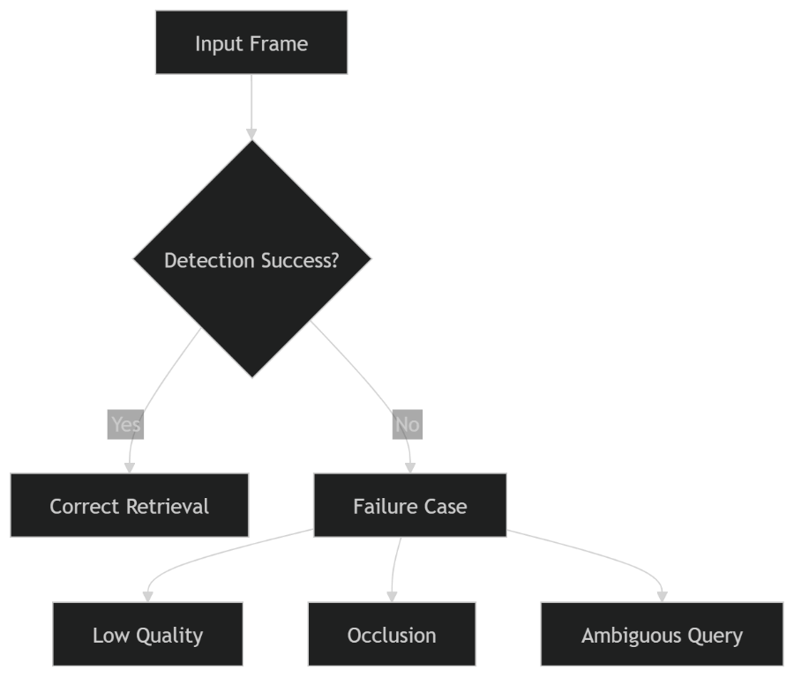

9.6 Scalability and System Robustness
The system demonstrates good scalability due to:
- Use of MongoDB for large-scale storage
- Frame-based indexing for efficient querying
- Modular architecture for extensibility
However, scalability challenges may arise with:
- Very large datasets
- Real-time processing requirements
- High query loads

9.7 Comparison with Existing Approaches
Compared to existing systems, the proposed approach offers:
Feature | Existing Systems | Proposed System
Multi-modal retrieval | Limited | ✔
Natural language queries | Limited | ✔
Frame-level indexing | Rare | ✔
Combined entity search | Limited | ✔
The proposed system addresses key limitations identified in the literature, particularly in terms of integration and retrieval capability.

9.8 Trade-Off Analysis
Precision vs Recall
- Strict retrieval → High precision, low recall
- Soft retrieval → Higher recall, moderate precision
Accuracy vs Performance
- Higher frame sampling → Better accuracy, slower processing
- Lower sampling → Faster, but less detailed
Complexity vs Usability
- Advanced query parsing → Better results
- Simpler queries → Easier for users

9.9 Key Insights
From the analysis, the following insights emerge:
- Multi-modal integration significantly enhances retrieval quality
- Query understanding plays a critical role in system performance
- Database design directly impacts retrieval efficiency
- Trade-offs must be carefully balanced based on application needs

9.10 Summary
This chapter provided a detailed discussion of the experimental results and system performance. The analysis highlighted the strengths of the proposed system, including its multi-modal capabilities and flexible retrieval strategies.
At the same time, several limitations and challenges were identified, providing opportunities for future improvement. The next chapter concludes the thesis and outlines potential directions for further research.

📌 What You Should Add
✅ MUST ADD
- Failure case examples (images/screenshots)
- Real system outputs
✅ ADD (for strong viva)
- Comparison with 1–2 research papers
- Real-world scenario explanation

📘 Chapter 10: Conclusion and Future Work

10.1 Introduction
This chapter concludes the research presented in this thesis by summarizing the problem, approach, key findings, and contributions of the proposed VISTA system. It also outlines the limitations of the current work and suggests potential directions for future research.
The objective is to reflect on the overall impact of the research and its relevance to the field of computer vision and multimedia retrieval.

10.2 Summary of the Research Problem
The exponential growth of video data has created significant challenges in efficiently retrieving relevant information. Traditional search methods rely on manually annotated metadata, which is often insufficient and unreliable.
This research addressed the problem of enabling semantic video search by designing a system capable of understanding and indexing visual content. The goal was to develop a unified framework that integrates multiple computer vision techniques with a database-backed retrieval system.

10.3 Summary of the Proposed Solution
The proposed system, VISTA, was designed as a two-stage framework:
- Vista-prototype
  - Processes video input
  - Extracts frames
  - Performs object detection, face recognition, and monument recognition
  - Generates structured metadata
  - Stores data in MongoDB
- Visual Search Engine
  - Accepts natural language queries
  - Extracts entities and constructs structured queries
  - Retrieves and ranks relevant frames and videos
This architecture enables efficient indexing and retrieval of video content based on semantic queries.

10.4 Key Findings
The experimental evaluation and analysis led to the following key findings:
- Multi-modal integration improves retrieval accuracy
Combining face, object, and monument recognition enhances contextual understanding.
- Frame-level indexing enables fine-grained search
Users can retrieve specific moments within videos.
- Natural language queries improve usability
Users can interact with the system intuitively.
- Hybrid retrieval strategies balance precision and recall
The use of strict and soft retrieval enhances system flexibility.

10.5 Research Contributions
This research makes several significant contributions to the field:

10.5.1 Unified Visual Intelligence Framework
A novel system that integrates multiple computer vision techniques into a single pipeline for video understanding and retrieval.

10.5.2 Frame-Level Metadata Indexing
A structured approach to storing visual data at the frame level, enabling efficient and accurate retrieval.

10.5.3 Natural Language-Based Visual Search
A query system that translates user-friendly queries into structured database operations.

10.5.4 Hybrid Retrieval Mechanism
A combination of strict and soft retrieval strategies to improve search performance.

10.5.5 Scalable Database Design
Use of MongoDB for handling large-scale visual data with flexible schema design.

10.6 Limitations of the Study
Despite its contributions, the proposed system has certain limitations:
- Dependency on Known Identities
Face recognition is limited to pre-registered individuals
- Limited Monument Dataset
Recognition accuracy depends on training data
- Sensitivity to Video Quality
Low-resolution frames reduce detection accuracy
- Simplified Query Parsing
Complex natural language queries may not be fully supported
- Computational Overhead
Processing large videos can be time-consuming

10.7 Future Work
Several directions can be explored to extend this research:

10.7.1 Integration of Vector Search
- Use vector databases (e.g., FAISS)
- Improve similarity-based retrieval

10.7.2 Multimodal Embeddings
- Use models such as CLIP
- Enable text-to-image and image-to-image search

10.7.3 Multilingual Query Support
- Support queries in multiple languages
- Improve accessibility

10.7.4 Temporal Reasoning
- Understand sequences of events in videos
- Enable queries like “before” and “after”

10.7.5 Real-Time Processing
- Extend system for live video streams
- Optimize performance

10.7.6 Large-Scale Deployment
- Cloud-based architecture
- Distributed processing

10.8 Final Remarks
The VISTA system demonstrates the potential of combining computer vision, database systems, and natural language processing to enable intelligent video search. The integration of multiple visual recognition techniques provides a richer understanding of video content, while the database-backed retrieval system ensures efficient access to relevant information.
This research contributes to the advancement of visual intelligence systems and lays the foundation for future developments in multimedia retrieval. With further improvements and scalability enhancements, such systems can play a significant role in various real-world applications, including surveillance, media analysis, and digital content management.

🚀 Final Suggestions (VERY IMPORTANT)
Before submission, make sure to:
✅ Add References (MANDATORY)
- YOLOv8 paper
- InsightFace / ArcFace
- CBVR papers

✅ Add Figures
- System architecture
- Pipeline diagrams
- Graphs (Precision/Recall)

✅ Add Screenshots
- UI
- Results
- Annotated frames

✅ Formatting
- Font: Times New Roman
- Size: 12
- Line spacing: 1.5

