Subject: Embedded systems

(BCSE 305L)

Digital Assignment

TEAM: ALLAM NEHAL VARMA(22BCE0414)

K.Lakshmi Venkat (22BCE0878)

**Project Title:**

**"Mobile Phone Hardware Controller via ADB Interface"**

**Purpose & Functionality**

The purpose of this project is to design and implement a web-based embedded control system that allows a user to interact with and operate key hardware functions of an Android smartphone from a computer. By using Android Debug Bridge (ADB) as the communication protocol and integrating it with a Flask-based backend server and a custom-designed browser UI, this system enables remote control of features such as:

* Volume control (up/down/mute)
* WiFi toggle
* App launching (YouTube, Play Store, Spotify)
* Taking screenshots
* Powering the screen ON/OFF

The frontend is styled like a mobile interface using HTML, CSS, and PNG icons to simulate app-like controls. The entire solution runs without requiring the mobile device to be rooted, making it accessible for users with standard Android configurations.

**1. Hardware Requirements Specification (HRS):**

* Android Phone with Developer Mode enabled
* USB Data Cable
* Laptop/PC with:
  + Python Installed
  + ADB (Android Debug Bridge) Installed
  + Flask (for backend server)
  + Modern browser (for frontend UI)

**2. Software Diagram (Architecture):**

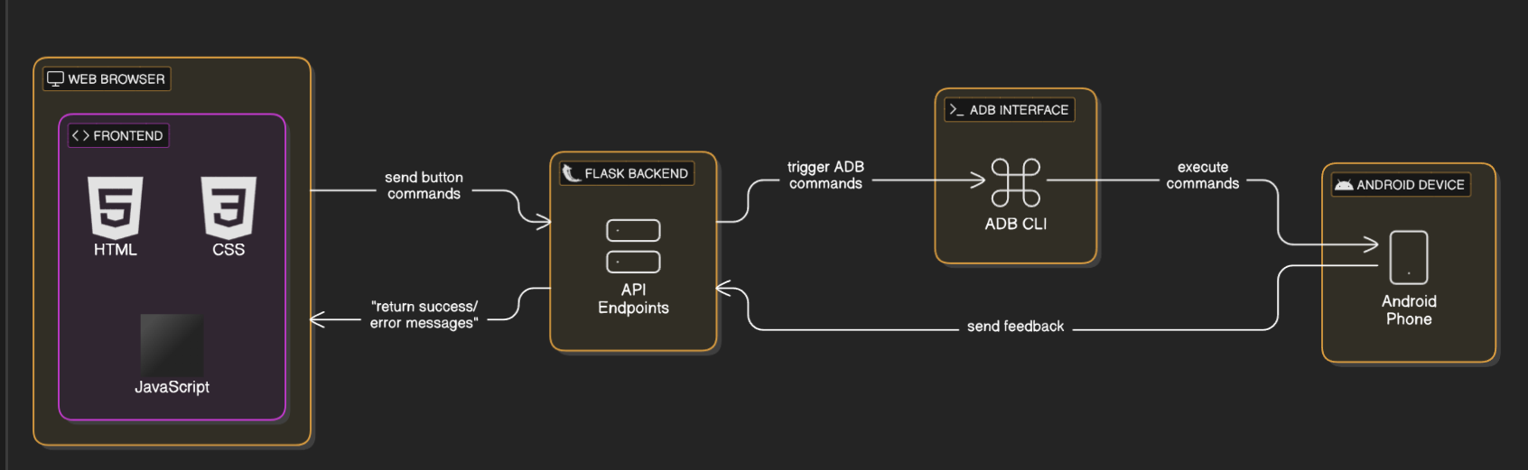

**3. Overall Block Diagram:**

**4. Screenshots:**

