**CS631 DATA MANAGEMENT SYSTEM DESIGN**

**The WALLET Payment Network**

**Project Deliverable 2**

**GROUP MEMBERS**

|  |  |
| --- | --- |
| **Nehali Parulekar** | **np67** |
| **Harshal Bhole** | **hb32** |
| **Joul Ammous** | **ja723** |

1. Outline the goals for this phase and briefly mention any revisions made to the previous phase. If you have modified your EER diagram, turn in the modified copy.

* The goal of this project is to draw the Entity Relationship diagram of The WALLET Payment Network and also analyze
* We have to list out all the operations performed in the payment app like Zelle and Venmo that enables individuals to electronically transfer money to others.
* We have modified the entire model as per the solution provided by the professor.

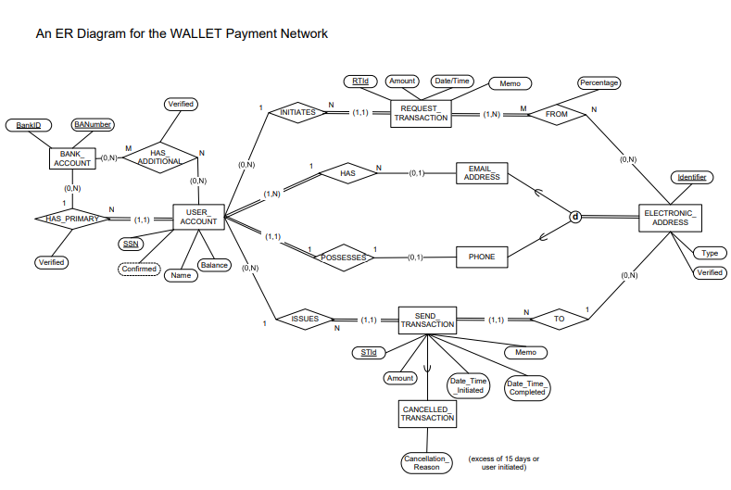

1. EER to Relational mapping:

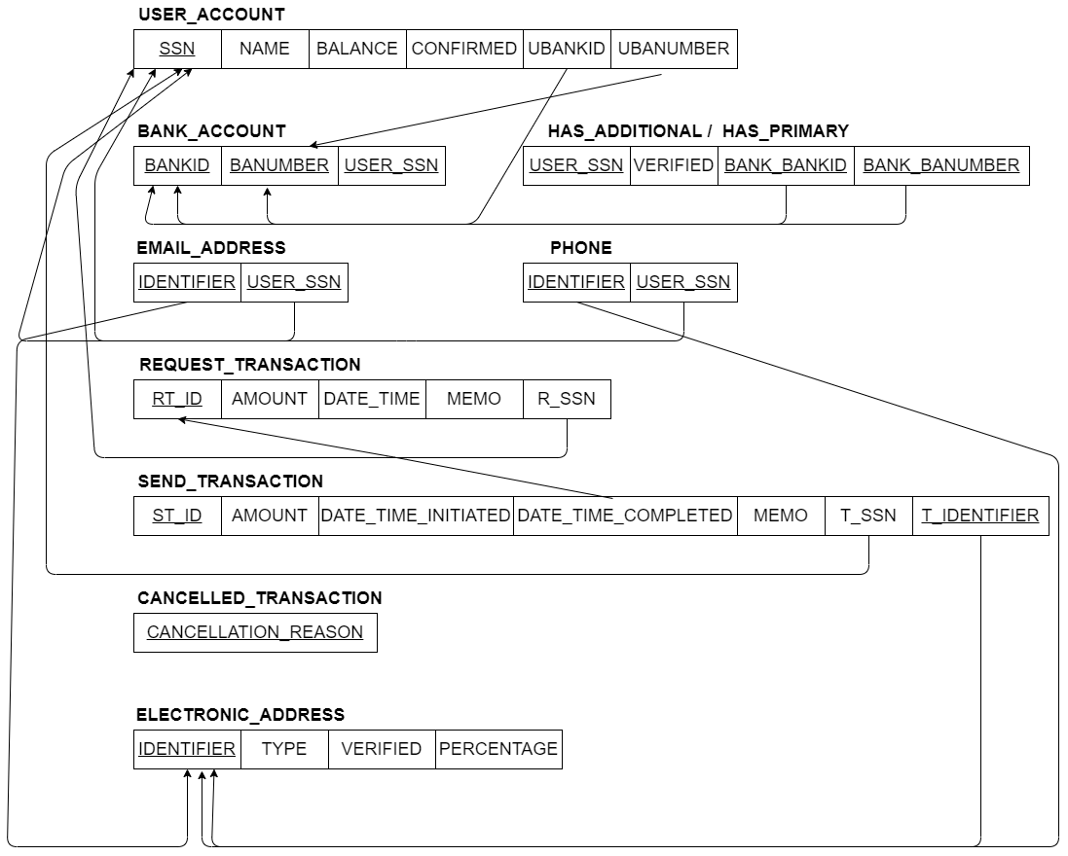

1. Identify any difficulties you may have had with this phase of the project.

* Converting the ER diagram to Relational diagram was quite easy so we did not face any difficulties.