1)
name = "Nehan"
age = 21
height = 5.6
print(f"My name is {name}, I am {age} years old and my height is {height} feet.")

Output:

2)
a, b, c = 5, 10, 15
print(a + b + c)

Output:

3)
total = (
10 +
20 +
30 +
40
)
print(total)

Output:


4)
n = (
"Hello! My name is Nehan. "
"I am learning Python programming. "
"This message is created using implicit string continuation."
)
print(n)

Output:

5)
n = [
1, 2, 3, 4,
5, 6, 7, 8
]
print(n)

Output:
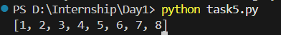

6)
name = input("Enter your name: ")
print("Welcome,", name)

Output:
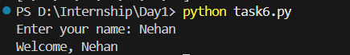

7)
num1 = int(input("Enter first number: "))
num2 = int(input("Enter second number: "))

print("Sum:", num1 + num2)
print("Diff:", num1 - num2)
print("Product:", num1 * num2)

Output:
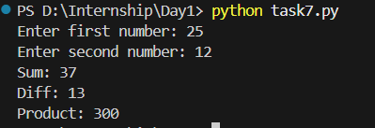

8)
num1 = input("Enter first number: ")
num2 = input("Enter second number: ")

print("First value:", num1)
print("Second value:", num2)

print("Data type of first value:", type(num1))
print("Data type of second value:", type(num2))

sum = int(num1) + int(num2)
print("Sum: ", sum)

Output:
