Task1:
A = [
[2, 4, 6],
[8, 0, 1],
[3, 5, 7]
]

A.append([10, 11, 12])
print(A)

col = [13, 14, 15, 16]
for i in range(len(A)):
A[i].append(col[i])
print(A)

A.insert(1, [16, 17, 18, 20])
print(A)

col2 = [19, 20, 21, 22, 23]
for i in range(len(A)):
A[i].insert(2, col2[i])
print(A)

Output:
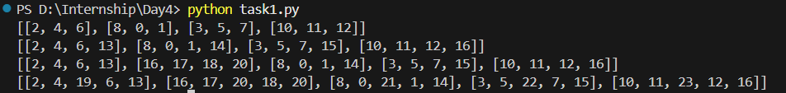

Task2:
m = [
[1, 2, 3, 4],
[5, 6, 7, 8],
[9, 10, 11, 12],
[13, 14, 15, 16]
]

print(m[1])

print([row[2] for row in m])

print(m[2], m[3])

print([row[:2] for row in m])

print(m[2][1:], m[3][1:])

print([m[1][0], m[1][3]], [m[3][0], m[3][3]])

print([m[i][i] for i in range(len(m))])

print([m[i][3-i] for i in range(len(m))])

Output:
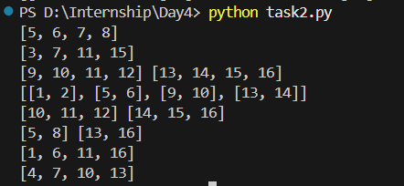

Task3:
A = [
[1, 1, 1],
[1, 1, 1],
[1, 1, 1]
]

col1 = [0, 0, 0]
for i in range(len(A)):
A[i].append(col1[i])
print(A)

col2 = [5, 5, 5]
for i in range(len(A)):
A[i].insert(1, col2[i])
print(A)

A.append([1, 2, 3, 4, 5])
print(A)

A.insert(2, [6, 7, 8, 9, 10])
print(A)

col3 = [10, 20, 30, 40, 50]
for i in range(len(A)):
A[i].append(col3[i])
print(A)

Output:
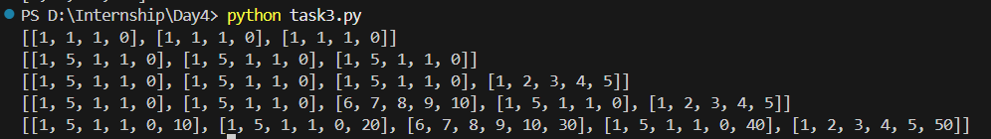

Task4:
m=[
[1,2,3, 4,5],
[6,7, 8, 9,10],
[11,12,13,14,15],
[16,17,18,19,20],
[21,22,23,24,25]
]

print(m[0], m[2], m[4])
print([row[::2] for row in m])
print(m[1][:3], m[3][:3])
print([m[i][i] for i in range(len(m))])
print([m[i][4-i] for i in range(len(m))])
print(m[0][::2], m[2][::2], m[4][::2])
print([m[i][4] for i in range(1, 4)])
print(m[1][2:4], m[3][2:4])
print(m[-1])
print(m[0][1:4:2], m[1][1:4:2], m[2][1:4:2])

Output:
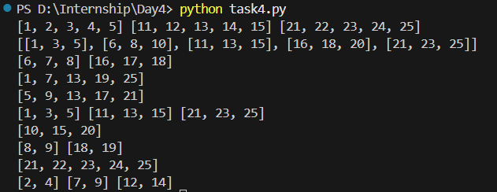

Task5:
m = [
[10, 20, 30],
[40, 50, 60],
[70, 80, 90]
]

# Replace 60 with 6
m[1][2] = 6
print(m)

# [10, 20, 30] [40, 50, 6]
print(m[0], m[1])

# [50, 6] [80, 90]
print(m[1][1:], m[2][1:])

# [10, 50, 90]
print([m[i][i] for i in range(len(m))])

# [30, 50, 70]
print([m[i][2-i] for i in range(len(m))])

# [20, 50, 80]
print([row[1] for row in m])

# [40, 60]
print([m[1][0], m[1][2]])

# [10, 70]
print([m[0][0], m[2][0]])

# [20, 30] [80, 90]
print(m[0][1:], m[2][1:])

# [40, 60] [70, 90]
print([m[1][0], m[1][2]], [m[2][0], m[2][2]])

Output:
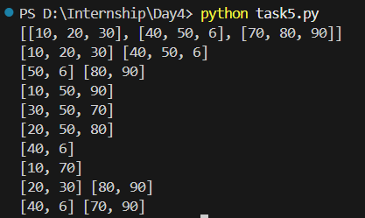

Task6:
A = [
[11, 0, 4, 6, 5],
[1, 9, 3, 2, 1],
[7, 0, 4, 9, 8],
[3, 7, 12, 15, 0]
]

# 1) 12
print(A[3][2])

# 2) [9,3,2] [0,4,9]
print(A[1][1:4], A[2][1:4])

# 3) [9,0]
print([A[1][1], A[2][1]])

# 4) [1,9,3] [7,0,4] [3,7,12]
print(A[1][:3], A[2][:3], A[3][:3])

# 5) [11,4,5] [3,12,0]
print([A[0][0], A[0][2], A[0][4]], [A[3][0], A[3][2], A[3][4]])

# 6) Add [0,0,0,0,0] after [3,7,12,15,0]
A.insert(4, [0, 0, 0, 0, 0])
print(A)

# 7) [11,9,4,15,0]
print([A[i][i] for i in range(len(A)-1)])

# 8) [5,2,4,7,0]
print([A[i][4] for i in range(len(A)-1)])

# 9) [1,9,3,2,1] [7,0,4,9,8]
print(A[1], A[2])

# 10) [4,6] [3,2] [4,9] [12,15]
print(A[0][2:4], A[1][2:4], A[2][2:4], A[3][2:4])

Output:
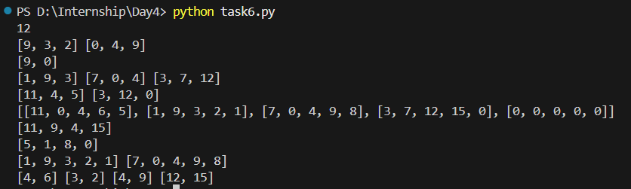

Task7:
B = [
[9, 8, 7],
[1, 3, 2],
[4, 6, 5]
]

# 1) [8,7] [3,2]
print(B[0][1:], B[1][1:])

# 2) [4,6]
print(B[2][:2])

# 3) [9,3,5]
print([B[i][i] for i in range(len(B))])

# 4) [7,3,4]
print([B[i][2-i] for i in range(len(B))])

# 5) Add column [1, 1, 1] after column [7,2,5]
for i in range(len(B)):
B[i].insert(3, 1)
print(B)

# 6) [8,1] [3,1] [6,1]
print([[B[i][1], B[i][3]] for i in range(len(B))])

# 7) [1,1]
print([B[1][0], B[1][3]])

# 8) Add row [0,0,0,0] after [1,3,2,1]
B.insert(2, [0, 0, 0, 0])
print(B)

# 9) Add column [10, 10, 10, 10] after [8,3,6,0]
for i in range(len(B)):
B[i].insert(2, 10)
print(B)

# 10) [8,7] [6,5]
print([B[0][1], B[0][3]], [B[3][1], B[3][3]])
Output:
