Task1:
t1 = (10, 20, "Python", "Code")
t2 = ("A", "B")

print(t1[0])

print(t2[-1])

l = list(t1)
l[-1] = "Program"
t1 = tuple(l)
print(t1)

a, b, c, d = t1
print(a, b, c, d)

t = t1 + t2
print(t)

print(t[1:4])

Output:
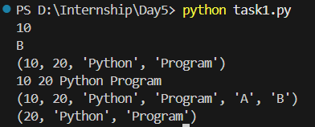

Task2:
t1 = (1, 2, 3)

# 7. Multiply the tuple by 3
result = t1 * 3
print(result)
Output:


Task3:
my_set = {10, 20, 30, 40}

# 1. Print the given set
print(my_set)

# 2. Check whether 20 is present in my_set
print(20 in my_set)

# 3. Find and print the length of my_set
print(len(my_set))

# 4. Add 50 to my_set.
my_set.add(50)
print(my_set)

# 5. Remove 30 from my_set.
my_set.remove(30)
print(my_set)

# 6. Remove an element using discard() and note the output.
my_set.discard(20)
print(my_set)

# 7. Remove a random element from my_set.
my_set.pop()
print(my_set)

# 8. Loop through my_set and print each element.
for item in my_set:
print(item)

# 9. Clear all elements from my_set
my_set.clear()
print(my_set)

Output:
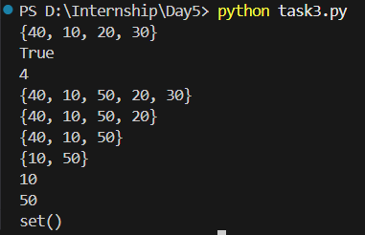

Task4:
set1 = {1, 2, 3}
set2 = {3, 4, 5, 6}

# 10. Elements in set1 but not in set2
print(set1 - set2)

# 11. Elements in either set1 or set2 but not in both (symmetric difference)
print(set1 ^ set2)

# 12. Add all items from set2 into set1
set1.update(set2)
print(set1)

# 13. Print all unique elements from both set1 and set2
print(set1 | set2)

# 14. Add 7 to set1
set1.add(7)
print(set1)

Output:
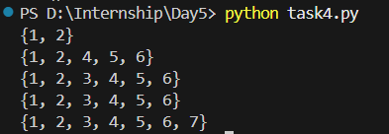

Task5:
student = {
"name": "Anu",
"age": 20,
"course": "Python"
}

# 1. Print all keys, values, and items
print(student.keys())
print(student.values())
print(student.items())

# 2. Access the value of "name"
print(student["name"])

# 3. Access the value of "course" using get()
print(student.get("course"))

# 4. Add a new key "marks" with value 85
student["marks"] = 85
print(student)

# 5. Update the value of "age" to 21
student["age"] = 21
print(student)

# 6. Remove "course" using pop()
student.pop("course")
print(student)

# 7. Remove the last inserted item using popitem()
student.popitem()
print(student)

# 8. Loop through the dictionary and print keys and values
for key, value in student.items():
print(key, ":", value)

Output:
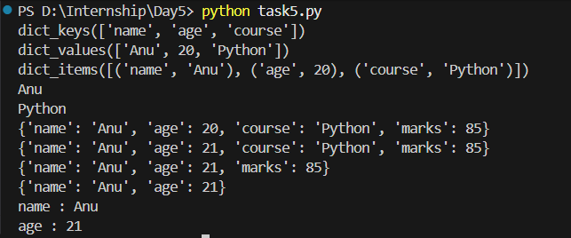

Task6:
students = {
"student1": {"name": "Anu", "age": 20},
"student2": {"name": "Ravi", "age": 21}
}

# 9. Print the complete nested dictionary
print(students)
# 10. Create a copy of the students dictionary
students_copy = students.copy()
print(students_copy)

Output:

Task7:
employee = {
"emp_id": 101,
"name": "Kiran",
"department": "HR",
"salary": 35000
}

# 13. Display all keys
print(employee.keys())

# 14. Display all values
print(employee.values())

# 15. Display all key-value pairs
print(employee.items())

# 16. Access and print the value of "name"
print(employee["name"])

# 17. Update the "salary" to 40000
employee["salary"] = 40000
print(employee)

Output:
