Task1:
# 1. Function to multiply two numbers and return the result
def multiply(a, b):
return a * b
print("Multiplication =", multiply(4, 5))

# 2. Function to check whether a number is even or odd
def even_odd(num):
if num % 2 == 0:
return "Even"
else:
return "Odd"
print(even_odd(7))

# 3. Function to find the maximum of three numbers
def maximum(a, b, c):
return max(a, b, c)
print("Maximum number =", maximum(10, 25, 15))

# 4. Function to calculate the factorial of a number
def factorial(n):
fact = 1
for i in range(1, n + 1):
fact = fact * i
return fact
print("Factorial =", factorial(5))

# 5. Function to count vowels in a given string
def count_vowels(text):
count = 0
for ch in text:
if ch in "aeiouAEIOU":
count += 1
return count
print("Vowels count =", count_vowels("Python Programming"))

# 6. Function to reverse a string
def reverse_string(text):
return text[::-1]
print("Reversed string =", reverse_string("Python"))

# 7. Function to check if a number is prime
def is_prime(num):
if num <= 1:
return "Not Prime"
for i in range(2, num):
if num % i == 0:
return "Not Prime"
return "Prime"
print(is_prime(7))

# 8. Function using default arguments
def greet(name="Student"):
print("Hello", name)
greet()
greet("Adam")

# 9. Function using keyword arguments
def student_info(name, age):
print("Name:", name)
print("Age:", age)
student_info(age=20, name="steve")

# 10. Recursive function to calculate Fibonacci series
def fibonacci(n):
if n <= 1:
return n
else:
return fibonacci(n-1) + fibonacci(n-2)
print("Fibonacci series:")
for i in range(6):
print(fibonacci(i), end=" ")

# 11. Lambda function to find the square of a number
square = lambda x: x * x
print("Square =", square(6))

Output:
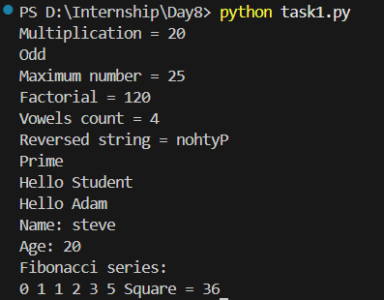

Task2:
# 1. Handle ZeroDivisionError
try:
a = int(input("Enter numerator: "))
b = int(input("Enter denominator: "))
result = a / b
print("Result =", result)
except ZeroDivisionError:
print("Error: Cannot divide by zero")

# 2. Handle ValueError when converting input to integer
try:
num = int(input("Enter a number: "))
print("You entered:", num)
except ValueError:
print("Error: Please enter a valid integer")

# 3. Program using try and except
try:
x = int(input("Enter a number: "))
print("Square =", x * x)
except:
print("Error occurred")

# 4. Program using try, except, else
try:
num = int(input("Enter a number: "))
except ValueError:
print("Invalid input")
else:
print("Number entered:", num)
print("Square =", num * num)

# 5. Program using try, except, finally
try:
a = int(input("Enter first number: "))
b = int(input("Enter second number: "))
print("Division =", a / b)
except ZeroDivisionError:
print("Cannot divide by zero")
finally:
print("Program execution completed")

# 6. Handle TypeError
try:
a = 10
b = "Python"
print(a + b)
except TypeError:
print("Error: Cannot add integer and string")

# 7. Handle multiple exceptions in a single try block
try:
num = int(input("Enter a number: "))
result = 10 / num
print("Result =", result)
except (ValueError, ZeroDivisionError):
print("Error: Invalid input or division by zero")

# 8. Raise an exception using raise keyword
age = int(input("Enter age: "))
if age < 18:
raise Exception("Age must be 18 or above")
else:
print("Eligible to vote")

Output:
