A Project Report On

Analysis on Steam Games 2025

Submitted in partial fulfillment of the requirement for the award of the degree

MASTER OF COMPUTER APPLICATIONS

Academic Year 2025 – 27
For subject
05MC0207 - Data Analytics and Visualization

Nehang Majethiya (92500584120)
Priyarajsinh Rana (92500584118)

Internal Guide
Dr. Vivek Gondaliya


Rajkot-Morbi Road, At & PO : Gauridad, Rajkot 360 003. Gujarat. India.
DECLARATION

I hereby declare that the project work entitled “Analysis of Steam Games Data” is a genuine and original work carried out by me as a part of my academic requirements.

This project has been undertaken with the objective of analyzing real-world data related to Steam games, focusing on aspects such as pricing, popularity, player engagement, and genre patterns. The work presented in this project is the result of my own efforts, carried out with sincerity and dedication, under appropriate academic guidance.

I further declare that the data used in this project has been properly processed, analyzed, and interpreted by me. All the techniques, including data preprocessing, visualization, and analysis, have been implemented by me to the best of my knowledge.

I confirm that this project work has not been submitted previously, either in full or in part, to this University or to any other University or Institution for the award of any degree, diploma, or certificate.

I take full responsibility for the authenticity and accuracy of the work presented in this project.
Place: Marwadi University- Rajkot
Date: 18/4/2026

Nehang Majethiya (92500584120)
Priyarajsinh Rana (92500584118)
ACKNOWLEDGEMENT

It is indeed a great pleasure to express my/our thanks and gratitude to all those who helped us. No serious and lasting achievement one can ever achieve without the help of friendly guidance and co-operation of so many people involved in the work.

We are very thankful to my/our faculty guide Dr. Vivek Gondaliya, the person who makes us follow the right steps during project work. we express deep sense of gratitude to his guidance, suggestions and expertise at every stage.

Thanks to our friends who have been a source of inspiration and motivation that helped us during this project work. we are also thankful to our Head Dr. Sunil Bajeja and Dean Dr. Rijwan Khan for their support as and when required. we would like to extend our gratitude towards all who directly or indirectly supported and helped me/us to accomplish our project work.

Nehang Majethiya (92500584120)
Priyarajsinh Rana (92500584118)

CONTENTS

Chapters | Particulars | Page No
1 | Introduction
1.1 | Overview of the Project
1.2 | Objective of the Analysis
1.3 | Scope and Importance of Identifying Patterns and Trends in Data
1.4 | Dataset Overview
2 | Data Collection
2.1 | Dataset Description
2.2 | Source of the Data
2.3 | Data Collection Methodology
2.4 | Data Format and Structure
2.5 | Initial Data Exploration
3 | Data Preprocessing
3.1 | Data Cleaning
3.1.1 | Handling Missing Values
3.1.2 | Removing Outliers
3.1.3 | Standardizing Formats
3.2 | Data Transformation
3.2.1 | Normalization and Scaling
3.2.2 | Feature Engineering
3.3 | Data Encoding
3.3.1 | Handling Categorical Variables
4 | Data Analysis and Data Visualisation:
4.1 | Write a problem statement, solution (Implementation code for the statement) and then data visualisation for the statement
5 | Results and Insights
5.1 | Key Patterns and Trends Identified
5.2 | Insights Derived from the Data Analysis
6 | Conclusion
6.1 | Summary of Findings
6.2 | Implications of the Analysis
6.3 | Limitations of the Project
6.4 | Future Work and Recommendations
7 | References
7.1 | Data Sources
7.2 | Tools and Libraries Used (e.g., Python, Pandas, Scikit-Learn, Matplotlib, Seaborn)

1.Introduction

  - Overview of the project

In the modern digital era, data plays a crucial role in decision-making across various industries. The gaming industry, in particular, generates a massive amount of data related to game performance, pricing, user engagement, and player behavior. Analyzing such data can provide valuable insights into market trends and user preferences.
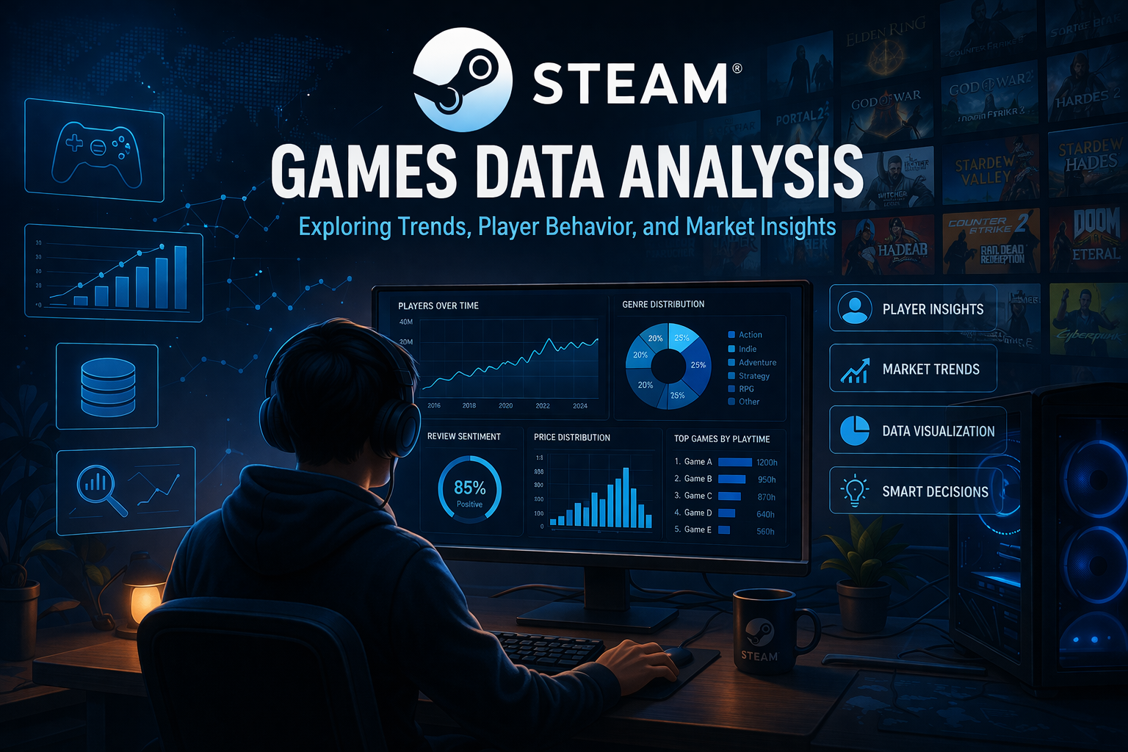

This project focuses on the analysis of the Steam Games Dataset (2025) using data analytics and visualization techniques. Steam is one of the largest digital distribution platforms for video games, offering a wide range of games across different genres and price categories. The platform provides extensive data related to games, including user reviews, playtime statistics, and engagement metrics.

The dataset used in this project consists of 89,618 records and 47 attributes, making it a large and complex dataset suitable for advanced data analysis. It includes various features such as price, genres, release date, number of positive and negative reviews, average playtime, and peak concurrent users.

The main objective of this project is to explore and analyze this dataset using Python-based tools such as Pandas, Matplotlib, and Seaborn. Through visualization techniques, the project aims to uncover patterns, trends, and relationships within the data.

The analysis helps in understanding key aspects such as:
- Distribution of game prices
- Popularity of different game genres
- Trends in game releases over time
- Relationship between price and user engagement
- Factors contributing to game success

Overall, this project demonstrates the practical application of data analytics and visualization techniques in extracting meaningful insights from real-world datasets.

  - Objective of the Analysis

The primary objective of this project is to analyze the Steam Games dataset and extract meaningful insights using data visualization techniques.

The specific objectives are as follows:
• To analyze the distribution of game prices and identify pricing patterns
• To identify the most popular game genres based on frequency and engagement
• To study trends in game releases across different years
• To analyze user engagement using metrics such as playtime and reviews
• To compare the performance of free and paid games
• To examine relationships between different variables such as price, reviews, and popularity
• To identify factors that influence the success of games on the Steam platform
These objectives help in gaining a deeper understanding of the gaming ecosystem and provide insights that can be useful for developers, publishers, and analysts.

- Apply statistical techniques to uncover patterns and relationships.
- Provide meaningful, data-driven insights based on analysis.

  - Scope and Importance of Identifying Patterns and Trends in Data

Data analysis and visualization are essential techniques for interpreting large datasets and extracting meaningful information. In the context of the gaming industry, these techniques can be used to analyze player behavior, market trends, and game performance.
The scope of this project includes:
• Analyzing structured data related to Steam games
• Applying visualization techniques to identify patterns and trends
• Understanding relationships between different features of the dataset
• Deriving insights that can support decision-making
The importance of this analysis lies in its ability to:
• Help developers understand what types of games are more successful
• Assist publishers in setting optimal pricing strategies
• Provide insights into player engagement and preferences
• Support data-driven decision-making in the gaming industry
By identifying patterns and trends, organizations can make informed decisions that improve game design, marketing strategies, and user experience.
- Data Analysis: The process of inspecting, cleaning, and transforming data to extract useful information.

- Data Visualization: Representing data through charts and graphs to make patterns and trends easier to understand.

- Statistical Techniques: Methods used to summarize and interpret data, such as averages, distributions, and correlations.

- Data Cleaning: Handling missing values, removing inconsistencies, and preparing data for analysis.

- Feature Exploration: Understanding relationships between different variables in the dataset.

By applying these concepts, the project aims to transform raw job posting data into meaningful insights, making it easier to interpret complex information and support data-driven decisions.

  - Dataset Overview

Dataset Overview and Foundation for Analysis

The dataset used in this project is the Steam Games Dataset (2025 Cleaned) obtained from Kaggle. It is a structured dataset containing detailed information about games available on the Steam platform.

Dataset Details:
• Total Rows: 89,618
• Total Columns: 47

Key Attributes in the Dataset:
• price – Price of the game
• genres – Category or type of the game
• release_date – Date on which the game was released
• positive / negative – Number of positive and negative user reviews
• average_playtime_forever – Total playtime of the game
• peak_ccu – Peak number of concurrent users
• pct_pos_total – Percentage of positive reviews

Types of Data Present:
• Numerical Data:
Includes variables such as price, playtime, number of reviews, and engagement metrics
• Categorical Data:
Includes variables such as genres, developers, and publishers
• Time-Series Data:
Includes variables such as release_date, which is useful for trend analysis

Observations from Initial Understanding:
• The dataset contains a large number of records, making it suitable for detailed analysis
• Some columns contain missing values or placeholder values such as -1
• There is a mix of numerical and categorical data, requiring preprocessing before analysis
• The dataset provides sufficient information to perform multiple types of analysis and visualization
This dataset serves as a strong foundation for performing comprehensive data analysis and deriving meaningful insights.

2. Data Collection

2.1 Dataset Description

- The dataset used in this project contains comprehensive information about games available on the Steam platform. Steam is one of the largest digital distribution platforms for video games, providing a wide variety of games across multiple genres and categories.
- The dataset includes detailed attributes related to each game such as pricing, genre classification, release dates, developer and publisher information, as well as user engagement metrics. These engagement metrics include the number of positive and negative reviews, average playtime, and peak concurrent users.
- Each row in the dataset represents a unique game, while each column represents a specific attribute associated with that game. The dataset is structured in a tabular format, making it suitable for analysis using data analytics tools.
- The presence of both numerical and categorical variables allows for a wide range of analytical techniques, including statistical analysis, trend analysis, and visualization.

2.2 Source of the Data

- The dataset used in this project was obtained from Kaggle, which is a well-known platform for data science, machine learning, and analytics projects. Kaggle provides access to a wide variety of datasets contributed by individuals and organizations.
- Dataset Name: Steam Games Dataset (2025 Cleaned)
- This dataset has been preprocessed to some extent, ensuring that it is structured and ready for analysis. However, further preprocessing is still required to handle missing values and improve data quality.
- The use of a reliable source such as Kaggle ensures the authenticity and usability of the dataset for academic and analytical purposes.

2.3 Data Collection Methodology

The dataset was compiled using publicly available data related to the Steam platform. The data collection process may involve multiple techniques, including:
• Application Programming Interfaces (APIs):
Data may have been collected using Steam APIs, which provide structured access to game-related information.
• Web Scraping:
Information about games, reviews, and engagement metrics may have been extracted from Steam’s official website using automated scraping tools.
• Public Data Sources:
Additional information may have been gathered from publicly available datasets and repositories.
The collected data was then organized into a structured format, cleaned, and made available as a CSV file for analysis.

2.4 Data Format and Structure
The dataset is provided in CSV (Comma-Separated Values) format, which is widely used for storing tabular data.

Key Characteristics of the Dataset Structure:
• The dataset is organized in a tabular format
• Each row represents a unique game
• Each column represents a specific attribute of the game
• Data is separated by commas, making it easy to import into analysis tools

Advantages of CSV Format:
• Easy to read and process using programming languages such as Python
• Compatible with data analysis libraries like Pandas
• Efficient for handling large datasets
The structured format of the dataset makes it suitable for performing various types of data analysis and visualization.

2.5 Initial Data Exploration

Initial data exploration is an important step in the data analysis process. It helps in understanding the structure, quality, and characteristics of the dataset before performing further analysis.
In this project, the dataset was explored using Python libraries such as Pandas.

Key Observations from Initial Exploration:
• The dataset contains 89,618 rows and 47 columns, indicating a large volume of data
• There is a mix of numerical, categorical, and time-based data
• Several columns contain missing or incomplete values
• Some numerical columns include placeholder values such as -1, which represent missing or unavailable data
• Columns such as price, playtime, and reviews are important for analysis

Importance of Initial Exploration:
• Helps identify missing values and inconsistencies
• Provides an understanding of data distribution
• Assists in selecting relevant features for analysis
• Guides the data preprocessing process
Initial exploration ensures that the dataset is well understood before applying data cleaning and transformation techniques.

3. Data Preprocessing

Data preprocessing is an essential step in preparing the dataset for analysis. It ensures that the data is clean, consistent, and suitable for further processing. In this project, preprocessing includes handling missing values, removing inconsistencies, and standardizing the dataset.

3.1 Data Cleaning
Data preprocessing is a critical step in the data analysis process. It involves preparing raw data for analysis by removing inconsistencies, handling missing values, and ensuring that the dataset is accurate and reliable.
The Steam Games Dataset (2025) contains a large number of records and attributes. Due to its size and complexity, it is essential to perform data cleaning before proceeding with analysis. Poor quality data can lead to incorrect conclusions and misleading visualizations.
code:
import pandas as pd
import numpy as np
df = pd.read_csv("games_march2025_cleaned.csv")
# Remove duplicates
df = df.drop_duplicates()
# Replace -1 with NaN
df.replace(-1, np.nan, inplace=True)
# Drop irrelevant columns (example)
df = df.drop(columns=['website', 'support_email'], errors='ignore')
# Check missing values
print(df.isnull().sum())

The following data cleaning operations were performed:
• Removal of duplicate records to eliminate redundancy
• Identification and handling of missing values
• Removal of irrelevant or unnecessary columns
• Detection and treatment of invalid values such as -1
• Verification of data consistency across columns
These steps ensure that the dataset is clean, consistent, and suitable for further analysis.

3.1.1 Handling Missing Values

- Missing values are commonly found in large datasets due to incomplete data collection or unavailable information. If not handled properly, they can significantly affect the results of analysis.
- In the Steam dataset:
- • Some columns contain missing values in large quantities
• Certain attributes such as website, description, or metadata fields may not be available for all games
• Placeholder values such as -1 are used to indicate missing or unknown data

Approach Used:
- • Columns with a high percentage of missing values were removed, as they do not contribute meaningful insights
• For numerical columns, missing values were handled appropriately depending on their importance
• Placeholder values such as -1 were treated as missing values and considered during analysis
• Rows with insufficient data were either cleaned or excluded where necessary
- Proper handling of missing values improves the reliability and accuracy of the dataset.
Code: # Drop columns with too many missing values
threshold = len(df) * 0.5
df = df.dropna(thresh=threshold, axis=1)

# Fill numerical missing values with median
num_cols = df.select_dtypes(include=['float64', 'int64']).columns
df[num_cols] = df[num_cols].fillna(df[num_cols].median())

# Fill categorical missing values with 'Unknown'
cat_cols = df.select_dtypes(include=['object']).columns
df[cat_cols] = df[cat_cols].fillna('Unknown')

3.1.2 Removing Outliers

- Outliers are extreme values that differ significantly from other data points. These values can distort analysis results and lead to incorrect interpretations.
- In this dataset, outliers may occur in:
- • Price (e.g., extremely high-priced games)
• Playtime (e.g., unusually large playtime values)
• Review counts (e.g., extremely high or low values)

Approach Used:
- • Statistical techniques were used to identify extreme values
• Visual inspection through graphs helped detect abnormal patterns
• Outliers were analyzed to determine whether they were valid or erroneous
• Extreme values were either removed or treated carefully during analysis
- Handling outliers ensures that the analysis reflects realistic patterns and trends.

Code:
# Function to remove outliers
def remove_outliers(df, col):
Q1 = df[col].quantile(0.25)
Q3 = df[col].quantile(0.75)
IQR = Q3 - Q1

lower = Q1 - 1.5 * IQR
upper = Q3 + 1.5 * IQR

return df[(df[col] >= lower) & (df[col] <= upper)]

# Apply on important columns
df = remove_outliers(df, 'price')
df = remove_outliers(df, 'positive')
df = remove_outliers(df, 'average_playtime_forever')

3.1.3 Standardizing Formats

- Standardization ensures that all data is stored in a consistent format, making it easier to process and analyze.

Steps Performed:
- • Converted the release_date column into datetime format for time-based analysis
• Ensured numerical columns such as price and playtime are stored in proper numeric formats
• Standardized categorical data where required
• Removed inconsistencies in data representation
- This step is important for improving compatibility with analysis tools and enabling accurate computations.

Code:
# Convert date column
df['release_date'] = pd.to_datetime(df['release_date'], errors='coerce')

# Convert numeric columns properly
df['price'] = pd.to_numeric(df['price'], errors='coerce')
df['positive'] = pd.to_numeric(df['positive'], errors='coerce')

# Strip spaces from categorical columns
df['name'] = df['name'].str.strip()
3.2 Data Transformation

Data transformation involves modifying the dataset to improve its usability and analytical value. This step ensures that the data is in the correct form for analysis and visualization.

3.2.1 Normalization and Scaling
Normalization and scaling are techniques used to bring numerical values into a consistent range. This helps in comparing different variables effectively.

Approach Used:
• Numerical columns were scaled where necessary
• Values such as price and playtime were adjusted for better comparison
• Ensured that no single variable dominates the analysis due to its scale
This step is particularly useful when analyzing relationships between variables.

Code:
# Min-Max Scaling
cols_to_scale = ['price', 'positive', 'average_playtime_forever']

for col in cols_to_scale:
df[col + '_scaled'] = (
(df[col] - df[col].min()) /
(df[col].max() - df[col].min())
)

3.2.2 Feature Engineering

- Feature engineering involves creating new variables from existing data to enhance analysis and uncover deeper insights.

Features Created:
- • Extracted year from the release_date column to analyze release trends
• Created a free/paid classification based on game price
• Calculated review ratio using positive and negative reviews
• Derived engagement-related indicators based on playtime and user activity
- These new features help improve the depth and quality of analysis.
Code: # Extract year
df['year'] = df['release_date'].dt.year

# Free vs Paid
df['is_free'] = df['price'] == 0

# Review ratio
df['review_ratio'] = df['positive'] / (df['positive'] + df['negative'])

# Engagement score (custom feature)
df['engagement'] = df['average_playtime_forever'] * df['positive']

3.3 Data Encoding

- Data encoding is used to convert categorical data into a format that can be analyzed effectively.
- In this dataset:
- • Columns such as genres, developers, and publishers contain categorical data

Approach Used:
- • Organized categorical data into structured formats
• Prepared data for grouping and aggregation
• Ensured compatibility with visualization tools
- Encoding allows categorical variables to be used in analysis and visualization processes.
Code: import ast

# Convert string list → actual list
def safe_convert(x):
if isinstance(x, str):
try:
return ast.literal_eval(x)
except:
return []
return x
df['genres'] = df['genres'].apply(safe_convert)
# Explode genres (for analysis)
df_genres = df.explode('genres')
# Example encoding (optional)
df['genres_count'] = df['genres'].apply(len)

3.4 Final Prepared Dataset
After completing all preprocessing steps, the dataset was transformed into a clean and structured format suitable for analysis.

Final Outcome:
• Missing values were handled effectively
• Invalid and inconsistent data was corrected
• Outliers were identified and managed
• New features were created to enhance analysis
• Dataset structure was improved for better usability
The final dataset is now ready for performing detailed data analysis and visualization, which is presented in the next chapter.

4. Data Preprocessing

Analysis 1: What is the distribution of game prices on Steam?
Code
price_df = df[(df['price'] > 0) & (df['price'] < 200)]

plt.figure(figsize=(10,5))

sns.histplot(price_df['price'], bins=50)
plt.title("Distribution of Game Prices (USD)")
plt.xlabel("Price (USD)")
plt.ylabel("Number of Games")

plt.tight_layout()
plt.show()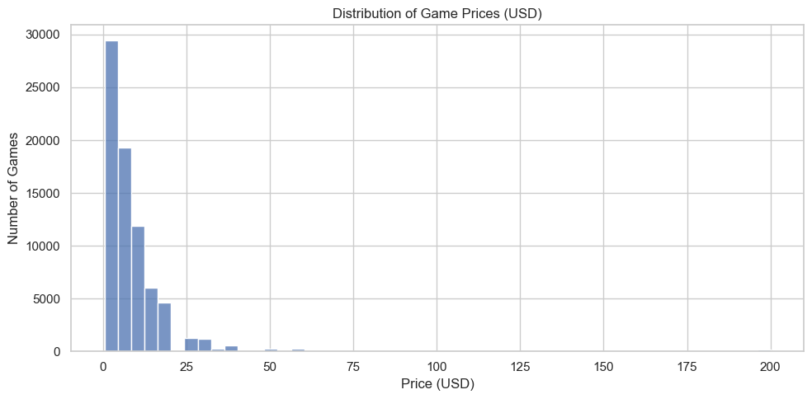

Conclusion:
The price distribution is highly skewed toward lower values, with most games priced below $20. This indicates that the Steam marketplace is dominated by affordable games, while high-priced titles are relatively rare.

Analysis 2: What is the distribution of game prices on Steam?
Code
plt.figure(figsize=(10,5))

filtered_df = df[(df['price'] > 0) & (df['price'] < 200)]

sns.histplot(filtered_df['price'], bins=40)

plt.title("Distribution of Paid Game Prices (Filtered)")
plt.xlabel("Price")
plt.ylabel("Frequency")

plt.show()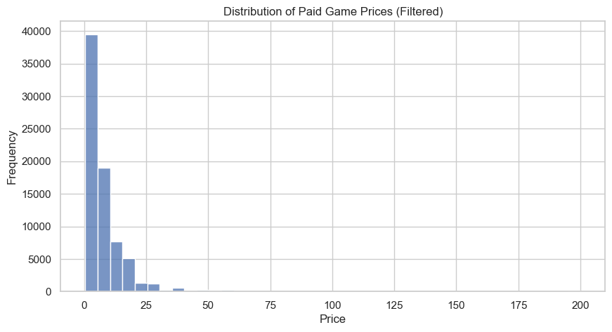

Conclusion:
Most paid games on Steam are priced in the lower range, typically below 50. The dataset is highly skewed due to a large number of low-cost games and a few high-priced outliers.

Analysis 3: Which are the most common game genres on Steam?
Code

all_genres = []

for sublist in df['genres']:
if isinstance(sublist, list): # safety check
for genre in sublist:
all_genres.append(genre.strip())

# Count top 10
genre_counts = pd.Series(all_genres).value_counts().head(10)

# Plot
plt.figure(figsize=(10,5))
sns.barplot(x=genre_counts.values, y=genre_counts.index)

plt.title("Top 10 Game Genres on Steam")
plt.xlabel("Number of Games")
plt.ylabel("Genres")

plt.show() 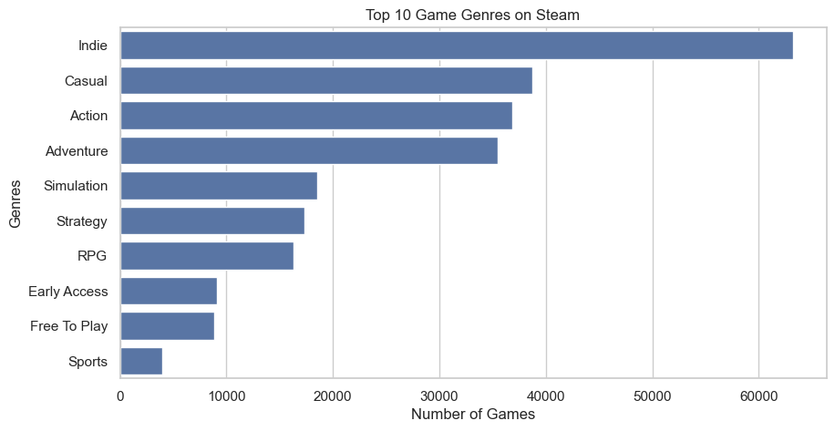

Conclusion:
Most paid games on Steam are priced in the lower range, typically below 50. The dataset is highly skewed due to a large number of low-cost games and a few high-priced outliers.

Analysis 4: Which games have the highest number of positive reviews?
Code
top_games = df.sort_values(by='positive', ascending=False).head(10)

plt.figure(figsize=(10,5))

sns.barplot(x=top_games['positive'], y=top_games['name'])

plt.title("Top 10 Games by Positive Reviews")
plt.xlabel("Number of Positive Reviews")
plt.ylabel("Game Name")

plt.ticklabel_format(style='plain', axis='x')

plt.show()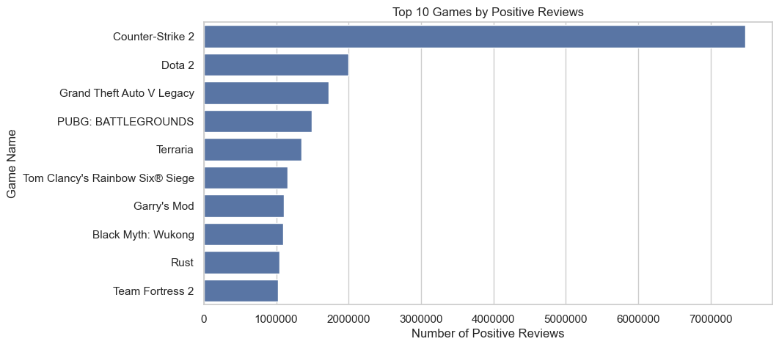

Conclusion:
Popular and long-standing multiplayer games like Counter-Strike 2 and Dota 2 have the highest number of positive reviews, indicating strong user engagement and large player bases over time.

Analysis 5: What is the relationship between price and number of positive reviews (density view)?
Code
plt.figure(figsize=(10,6))

hb = plt.hexbin(
filtered_df['price'],
filtered_df['log_positive'],
gridsize=35,
mincnt=5 # removes noise / empty bins
)

plt.title("Density of Price vs Positive Reviews (Log Scale)")
plt.xlabel("Price (USD)")
plt.ylabel("Log10(Positive Reviews)")

cb = plt.colorbar(hb)
cb.set_label('Number of Games')

plt.tight_layout()
plt.show()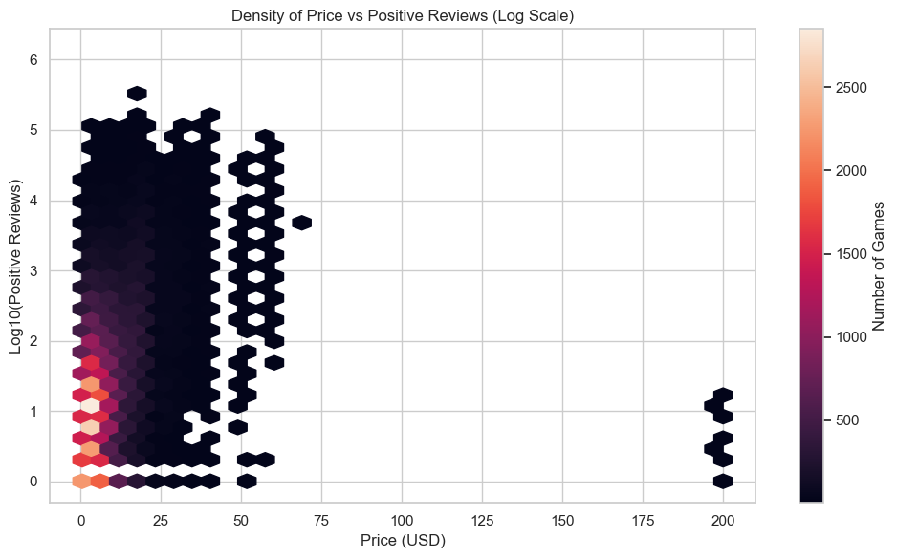

Conclusion:
The density plot shows that the majority of games cluster at low prices and low-to-moderate review counts. High-review games are concentrated in the low-price range, while higher-priced games appear less frequently and attract fewer players, indicating that accessibility plays a stronger role than pricing in engagement.

Analysis 6: How do free and paid games compare in terms of number of games?
Code
# Create free vs paid column
df['is_free'] = df['price'].apply(lambda x: 'Free' if x == 0 else 'Paid')

# Count
counts = df['is_free'].value_counts()

plt.figure(figsize=(6,4))

sns.barplot(x=counts.index, y=counts.values)

# 👉 ADD HERE
for i, v in enumerate(counts.values):
plt.text(i, v, str(v), ha='center')

plt.title("Free vs Paid Games Count")
plt.xlabel("Game Type")
plt.ylabel("Number of Games")

plt.show()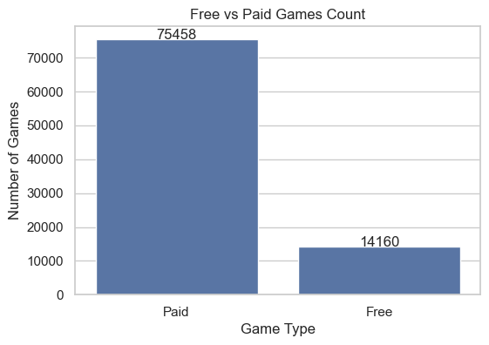

Conclusion:
The number of paid games is higher than free games on Steam. However, free games still form a significant portion of the dataset, reflecting the popularity of the free-to-play model.

Analysis 7: What is the distribution of average playtime among games?
Code
# Filter realistic playtime range
playtime_df = df[(df['average_playtime_forever'] > 0) & (df['average_playtime_forever'] < 5000)]

plt.figure(figsize=(10,5))

sns.histplot(playtime_df['average_playtime_forever'], bins=50)

plt.title("Distribution of Average Playtime")
plt.xlabel("Average Playtime (minutes)")
plt.ylabel("Number of Games")

plt.show()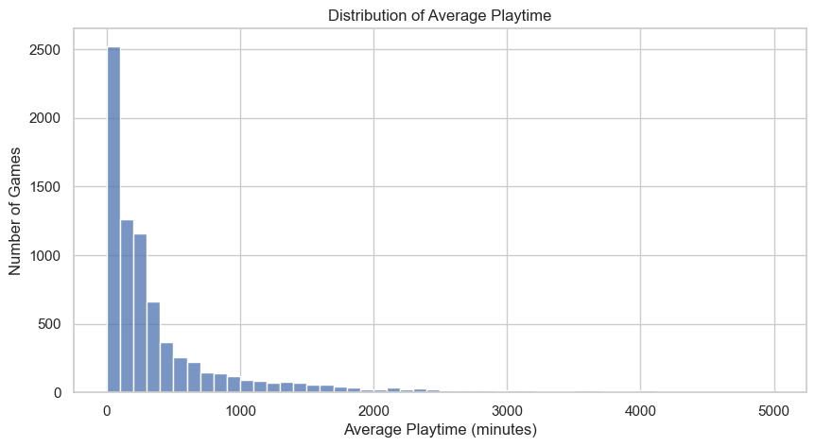

Conclusion:
Most games have low average playtime, while a small number of games have very high playtime, indicating that only a few games maintain long-term player engagement.

Analysis 8: How does peak concurrent users (peak_ccu) vary across games?
Code
# Clean and filter data properly
ccu_df = df[(df['peak_ccu'] > 0) & (df['peak_ccu'] < 50000)]

# Optional: sample to reduce heavy dataset load
ccu_sample = ccu_df['peak_ccu'].sample(5000, random_state=42)

plt.figure(figsize=(8,5))

plt.boxplot(ccu_sample, vert=False)

plt.xscale('log')

plt.title("Peak Concurrent Users Distribution (Filtered & Log Scale)")
plt.xlabel("Peak Concurrent Users (log scale)")

plt.tight_layout()
plt.show()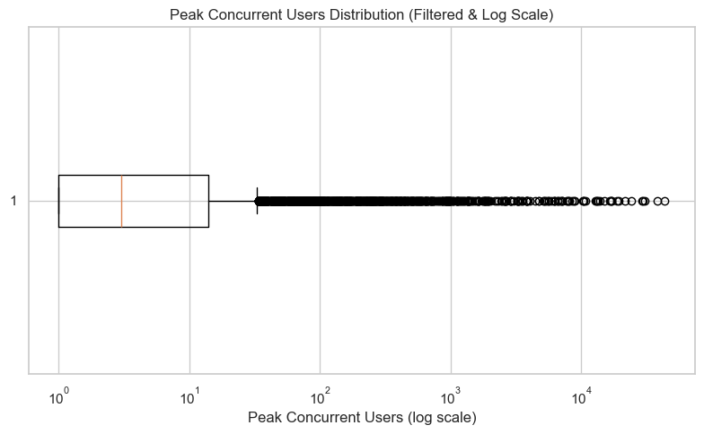

Conclusion:
The distribution of peak concurrent users is highly skewed, with most games having very low player counts and a few games achieving extremely high concurrency. This indicates that player engagement is concentrated among a small number of highly popular games.

Analysis 9: What is the distribution of positive review percentage (pct_pos_total)?
Code
# Filter valid percentage values
pct_df = df[(df['pct_pos_total'] >= 0) & (df['pct_pos_total'] <= 100)]

plt.figure(figsize=(10,5))

sns.histplot(pct_df['pct_pos_total'], bins=50)

plt.title("Distribution of Positive Review Percentage")
plt.xlabel("Positive Review Percentage")
plt.ylabel("Number of Games")

plt.tight_layout()
plt.show()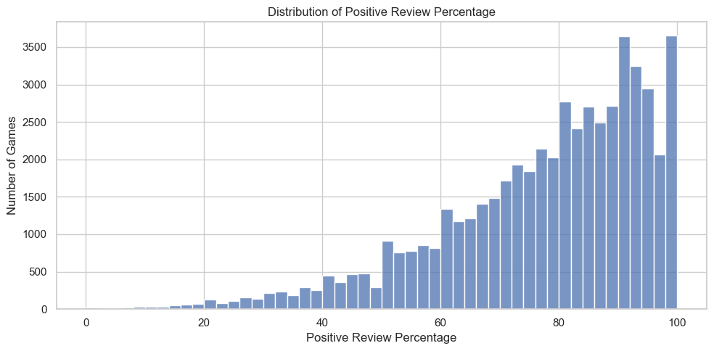

Conclusion:
Most games have a high percentage of positive reviews, indicating that user feedback on Steam is generally favorable, with many games receiving more positive than negative responses.

Analysis 10: How has the number of games released changed over time?
Code
year_counts = df['year'].value_counts().sort_index()

# Remove incomplete latest year
year_counts = year_counts[year_counts.index < 2025]

plt.figure(figsize=(10,5))

sns.lineplot(x=year_counts.index, y=year_counts.values)

plt.title("Number of Games Released Per Year")
plt.xlabel("Year")
plt.ylabel("Number of Games")

plt.tight_layout()
plt.show()
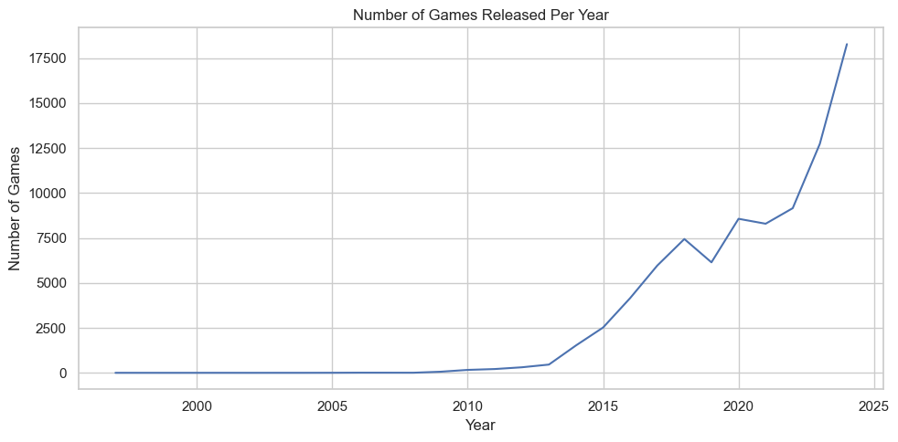

Conclusion:
The number of games released on Steam has increased significantly over time, especially after 2015, indicating rapid growth in the gaming industry. The apparent drop in the latest year is due to incomplete data and does not represent an actual decline.

Analysis 11: How does average playtime vary with game price?
Code
play_df = df[(df['price'] > 0) & (df['price'] < 100) &
(df['average_playtime_forever'] > 0) & (df['average_playtime_forever'] < 5000)]

plt.figure(figsize=(10,5))

sns.scatterplot(x=play_df['price'], y=play_df['average_playtime_forever'], alpha=0.3)

plt.title("Price vs Average Playtime")
plt.xlabel("Price (USD)")
plt.ylabel("Average Playtime (minutes)")

plt.tight_layout()
plt.show()
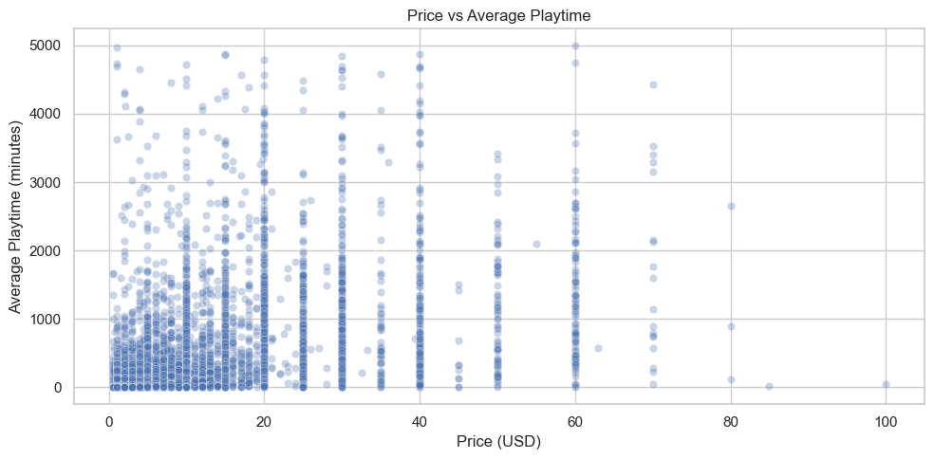
Conclusion:
There is no clear relationship between price and average playtime. High engagement is observed across various price ranges, indicating that gameplay quality and design have a greater impact on player retention than pricing.

Analysis 12: How does positive review percentage relate to average playtime?
Code
review_play_df = df[(df['pct_pos_total'] >= 0) & (df['pct_pos_total'] <= 100) &
(df['average_playtime_forever'] > 0) & (df['average_playtime_forever'] < 5000)]

plt.figure(figsize=(10,5))

sns.boxplot(x=pd.cut(review_play_df['pct_pos_total'], bins=5),
y=review_play_df['average_playtime_forever'])

plt.title("Playtime Across Review Percentage Groups")
plt.xlabel("Review Percentage Groups")
plt.ylabel("Average Playtime (minutes)")

plt.tight_layout()
plt.show()
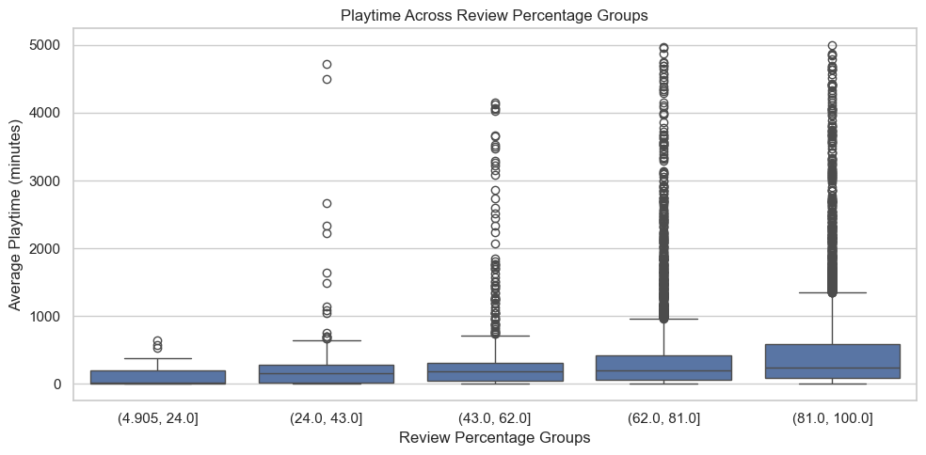
Conclusion:
Games with higher review percentages tend to have higher median playtime, indicating that better-rated games generally retain players for longer durations.

Analysis 13: Which game genres have the highest average playtime?
Code
# Clean genres properly
import ast

def safe_convert(x):
if isinstance(x, str):
try:
return ast.literal_eval(x)
except:
return []
elif isinstance(x, list):
return x
else:
return []

df['genres_clean'] = df['genres'].apply(safe_convert)

# Explode genres
genre_df = df.explode('genres_clean')
exclude_genres = [
'Web Publishing',
'Audio Production',
'Utilities',
'Video Production'
]

genre_df = genre_df[~genre_df['genres_clean'].isin(exclude_genres)]
# Filter valid playtime
genre_df = genre_df[(genre_df['average_playtime_forever'] > 0) &
(genre_df['average_playtime_forever'] < 5000)]

# Group by genre
genre_playtime = genre_df.groupby('genres_clean')['average_playtime_forever'].mean().sort_values(ascending=False).head(10)

plt.figure(figsize=(10,5))

sns.barplot(x=genre_playtime.values, y=genre_playtime.index)

plt.title("Top 10 Genres by Average Playtime")
plt.xlabel("Average Playtime (minutes)")
plt.ylabel("Genre")

plt.tight_layout()
plt.show()
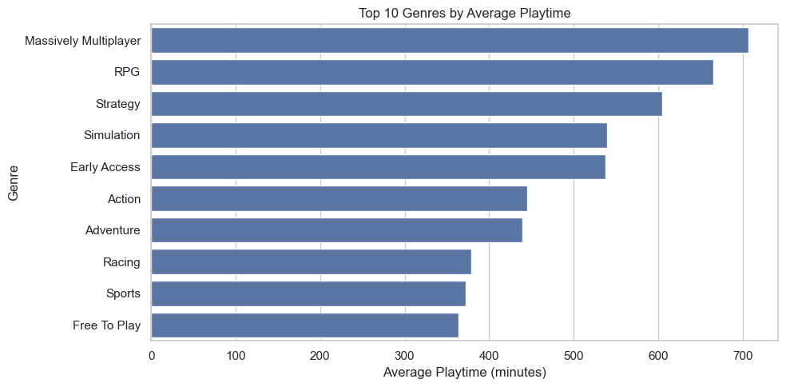
Conclusion:
Certain genres show significantly higher average playtime, indicating that genre plays a crucial role in player engagement and retention. Genres focused on strategy, simulation, or long-term progression tend to have higher playtime.

Analysis 14: Which developers have the highest number of games on Steam?
Code
import ast

# Clean developers column
def safe_convert(x):
if isinstance(x, str):
try:
return ast.literal_eval(x)
except:
return []
elif isinstance(x, list):
return x
else:
return []

df['developers_clean'] = df['developers'].apply(safe_convert)

# Explode
dev_df = df.explode('developers_clean')

# Count properly
dev_counts = dev_df['developers_clean'].value_counts().head(10)

plt.figure(figsize=(10,5))

sns.barplot(x=dev_counts.values, y=dev_counts.index)

plt.title("Top 10 Developers by Number of Games")
plt.xlabel("Number of Games")
plt.ylabel("Developer")

plt.tight_layout()
plt.show()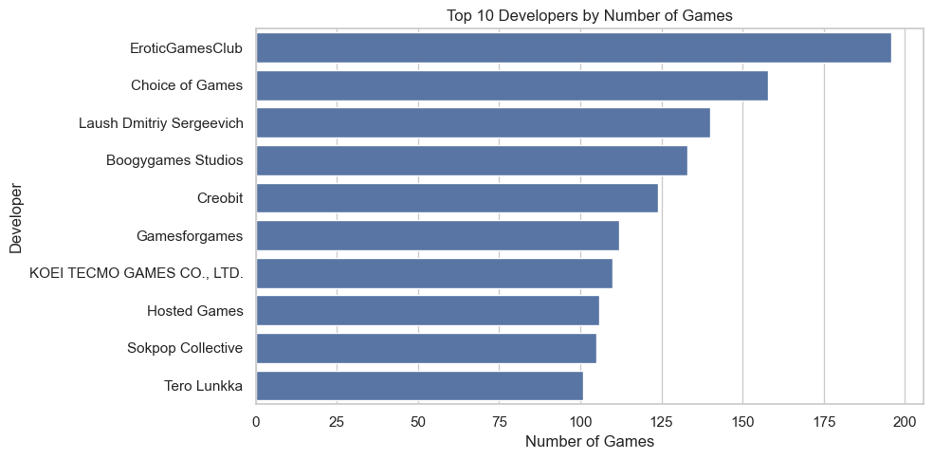

Conclusion:
The analysis shows that some developers release a large number of games on Steam, often smaller or niche titles. This indicates that high game count does not necessarily reflect popularity or impact, but rather publishing frequency.

Analysis 15: Which developers have the highest total positive reviews?
Code
# Use already cleaned developers_clean

# Group by developer and sum positive reviews
dev_reviews = dev_df.groupby('developers_clean')['positive'].sum().sort_values(ascending=False).head(10)

plt.figure(figsize=(10,5))

sns.barplot(x=dev_reviews.values, y=dev_reviews.index)

plt.title("Top 10 Developers by Total Positive Reviews")
plt.xlabel("Total Positive Reviews (Millions)")
plt.ylabel("Developer")
plt.ticklabel_format(style='plain', axis='x')
plt.tight_layout()
plt.show()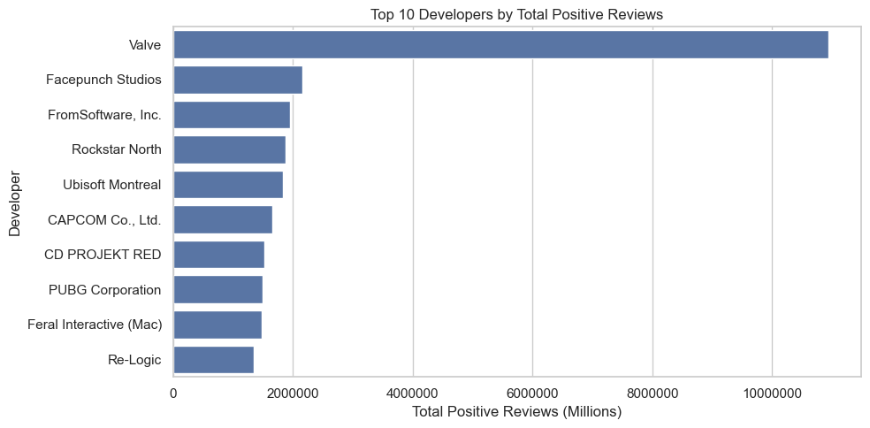

Analysis 16: Which publishers have the highest total positive reviews?
Code
import ast

# Clean publishers column
def safe_convert(x):
if isinstance(x, str):
try:
return ast.literal_eval(x)
except:
return []
elif isinstance(x, list):
return x
else:
return []

df['publishers_clean'] = df['publishers'].apply(safe_convert)

# Explode
pub_df = df.explode('publishers_clean')

# Group and sum
pub_reviews = pub_df.groupby('publishers_clean')['positive'].sum().sort_values(ascending=False).head(10)

# Convert to millions for readability
pub_reviews = pub_reviews / 1_000_000

plt.figure(figsize=(10,5))

sns.barplot(x=pub_reviews.values, y=pub_reviews.index)

plt.title("Top 10 Publishers by Total Positive Reviews")
plt.xlabel("Total Positive Reviews (Millions)")
plt.ylabel("Publisher")

plt.tight_layout()
plt.show()
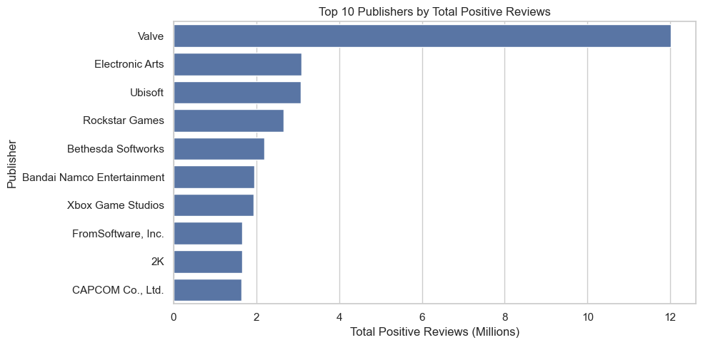

Conclusion:
A few publishers dominate total positive reviews, indicating that major publishing companies play a key role in distributing highly successful and widely played games.

Analysis 17: What are the relationships between key numerical features?
Code
import seaborn as sns

# Select relevant numeric columns
corr_df = df[['price', 'positive', 'negative', 'peak_ccu',
'average_playtime_forever', 'pct_pos_total']].dropna()

# Correlation
corr_matrix = corr_df.corr()

plt.figure(figsize=(10,7))

sns.heatmap(
corr_matrix,
annot=True,
cmap='coolwarm',
fmt=".2f",
linewidths=0.5
)

plt.title("Correlation Heatmap of Game Features")

plt.tight_layout()
plt.show()
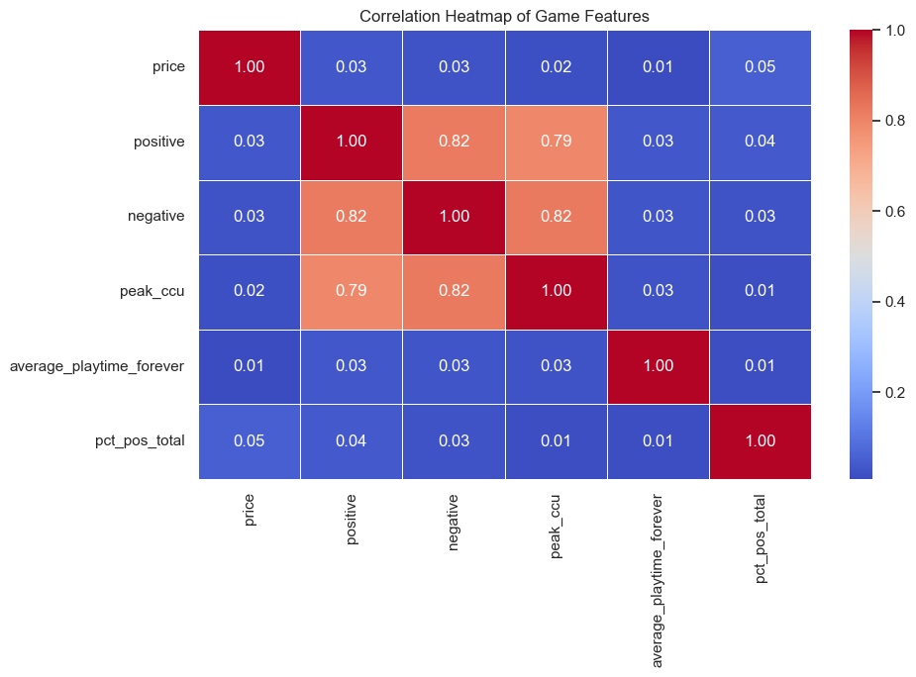
Conclusion:
The correlation heatmap shows a strong positive relationship between positive reviews and peak concurrent users, indicating that highly popular games attract more players. Price has little to no correlation with engagement metrics, suggesting that popularity depends more on game quality and reach than pricing.

Analysis 18: How does average playtime vary across different price ranges?
Code
import seaborn as sns

# Create price bins
df['price_group'] = pd.cut(df['price'], bins=[0,5,10,20,50,100,200])

# Filter valid playtime
play_df = df[(df['average_playtime_forever'] > 0) &
(df['average_playtime_forever'] < 5000)]

plt.figure(figsize=(10,6))

sns.violinplot(
x=play_df['price_group'],
y=play_df['average_playtime_forever']
)

plt.title("Playtime Distribution Across Price Ranges")
plt.xlabel("Price Range (USD)")
plt.ylabel("Average Playtime (minutes)")

plt.tight_layout()
plt.show()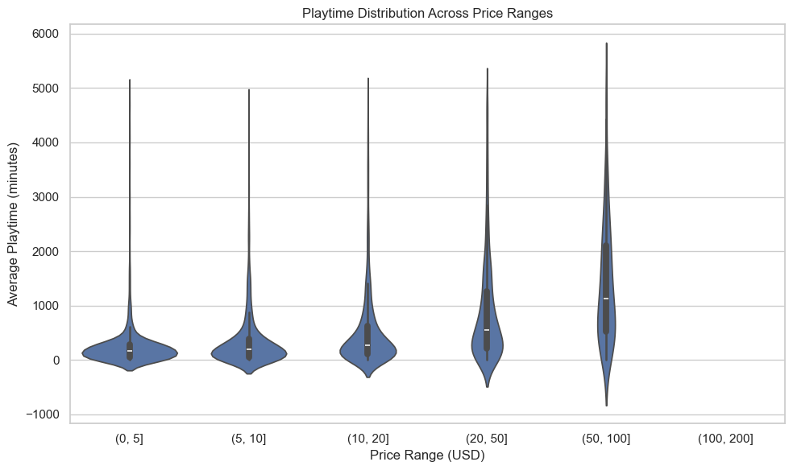

Conclusion:
The violin plot shows that lower-priced games have a wider spread of playtime, including some highly engaging titles. Higher-priced games tend to have more consistent but not necessarily higher playtime, indicating that price does not directly determine engagement.

Analysis 19: What is the distribution of positive review percentages?
Code
import seaborn as sns

# Filter valid percentage values
review_df = df[(df['pct_pos_total'] >= 0) & (df['pct_pos_total'] <= 100)]

plt.figure(figsize=(10,6))

sns.kdeplot(review_df['pct_pos_total'], fill=True)

plt.title("Distribution of Positive Review Percentage")
plt.xlabel("Positive Review Percentage")
plt.ylabel("Density")

plt.tight_layout()
plt.show()
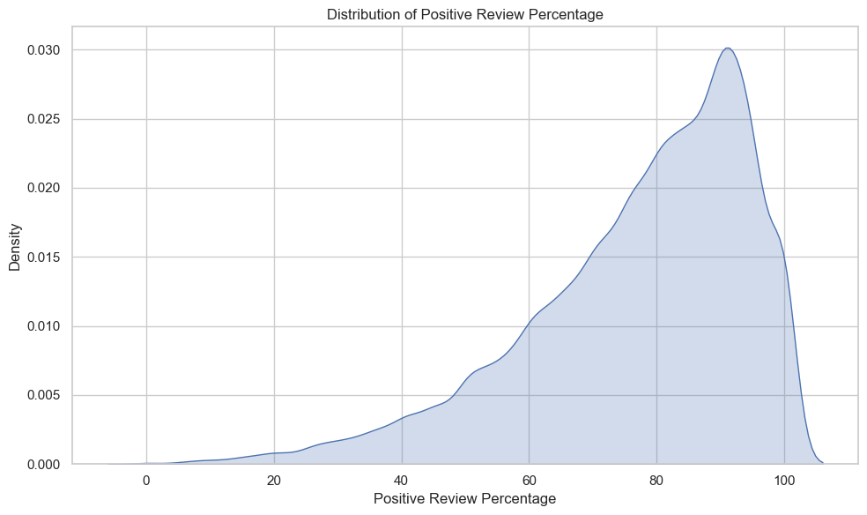

Conclusion:
The KDE plot shows that most games have high positive review percentages, with a strong concentration above 70%. This indicates that the majority of games on Steam receive generally favorable feedback from players.

Analysis 20: How does average positive review percentage vary across price ranges?
Code
plt.figure(figsize=(10,6))

x_vals = group_df.index.astype(str)
y_vals = group_df.values

plt.plot(x_vals, y_vals, marker='o')

# Add labels on points
for i, v in enumerate(y_vals):
plt.text(i, v + 0.5, f"{v:.1f}", ha='center')

plt.title("Average Positive Review Percentage by Price Range")
plt.xlabel("Price Range (USD)")
plt.ylabel("Average Positive Review (%)")

plt.xticks(rotation=30)
plt.grid(True)

plt.tight_layout()
plt.show()
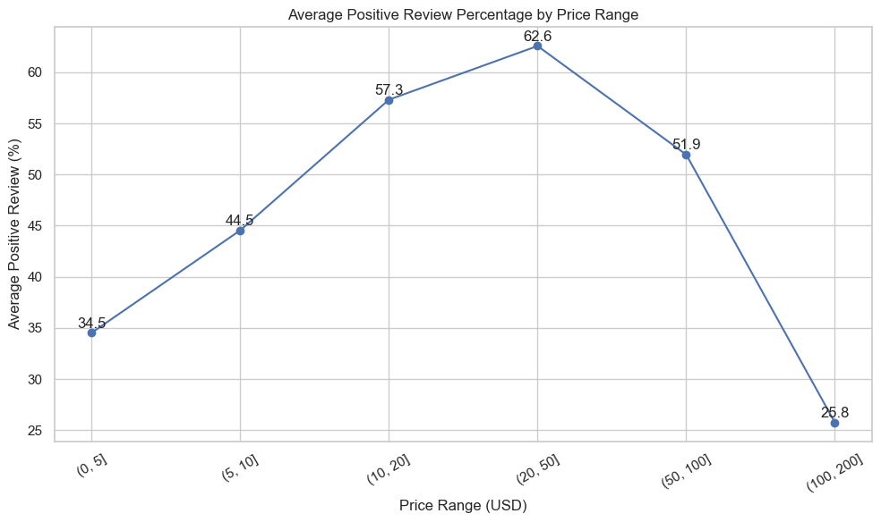
Conclusion:
The trend shows that review percentages increase from low to mid-price ranges, peaking around moderately priced games, and then decline for higher-priced games. This suggests that mid-priced games tend to balance quality and accessibility more effectively.

Analysis 21: What is the proportion of free vs paid games on Steam?
Code
# Create is_free column manually
df['is_free'] = df['price'] == 0

# Count free vs paid
counts = df['is_free'].value_counts()

labels = ['Paid', 'Free']
values = [counts.get(False, 0), counts.get(True, 0)]

plt.figure(figsize=(6,6))

plt.pie(
values,
labels=labels,
autopct='%1.1f%%',
startangle=90
)

plt.title("Proportion of Free vs Paid Games")

plt.tight_layout()
plt.show()
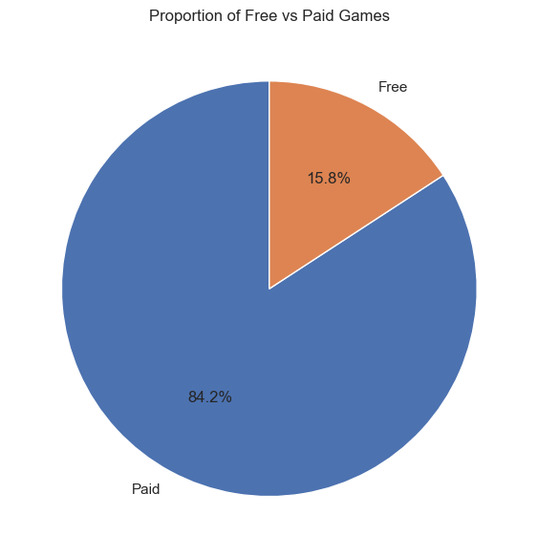
Conclusion:
The majority of games on Steam are paid, while free-to-play games form a smaller portion of the platform. This indicates that the marketplace is still largely driven by paid content, although free games play a significant role in attracting large player bases.

Analysis 22: How do free and paid games differ across release years?
Code
# Ensure is_free exists
df['is_free'] = df['price'] == 0

# Group data
year_free = df.groupby(['year', 'is_free']).size().unstack().fillna(0)

plt.figure(figsize=(10,6))

plt.stackplot(
year_free.index,
year_free[False],
year_free[True],
labels=['Paid', 'Free']
)

plt.title("Free vs Paid Games Over Years")
plt.xlabel("Year")
plt.ylabel("Number of Games")

plt.legend()

plt.tight_layout()
plt.show()
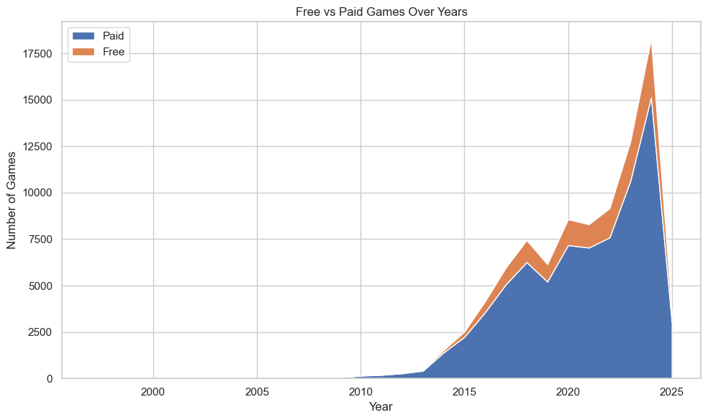
Conclusion:
The number of both free and paid games has increased over time, with paid games consistently dominating the platform. Free-to-play games show gradual growth, indicating their rising role in attracting larger audiences.

Analysis 23: What is the distribution of positive reviews after applying logarithmic scaling?

import numpy as np

# Filter valid values
pos_df = df[df['positive'] > 0].copy()

# Log transform
pos_df['log_positive'] = np.log10(pos_df['positive'])

plt.figure(figsize=(10,6))

sns.histplot(pos_df['log_positive'], bins=50, kde=True)

plt.title("Log Distribution of Positive Reviews")
plt.xlabel("Log10(Positive Reviews)")
plt.ylabel("Number of Games")

plt.tight_layout()
plt.show()
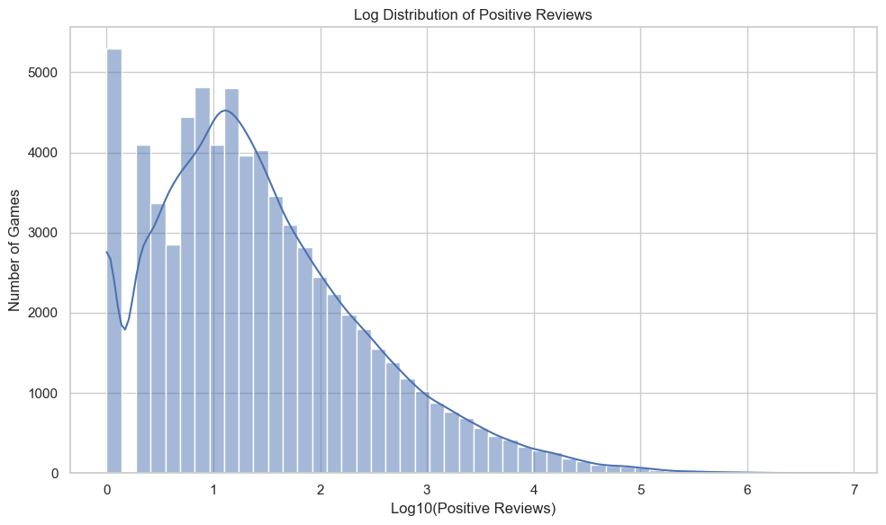
Conclusion:
After applying logarithmic scaling, the distribution of positive reviews reveals a long-tail pattern where most games receive relatively few reviews, while a small number of games achieve extremely high popularity.

Analysis 24: How are positive reviews distributed cumulatively across games?

sorted_df = df.sort_values(by='positive', ascending=False).reset_index(drop=True)

sorted_df['cum_reviews'] = sorted_df['positive'].cumsum()

total_reviews = sorted_df['positive'].sum()
sorted_df['cum_percent'] = sorted_df['cum_reviews'] / total_reviews * 100

# Correct rank
sorted_df['rank_percent'] = (sorted_df.index + 1) / len(sorted_df) * 100
plt.figure(figsize=(10,6))

plt.plot(sorted_df['rank_percent'], sorted_df['cum_percent'], linewidth=2)

plt.title("Cumulative Distribution of Positive Reviews")
plt.xlabel("Percentage of Games (%)")
plt.ylabel("Cumulative Percentage of Reviews (%)")

plt.grid(True)

plt.tight_layout()
plt.show()
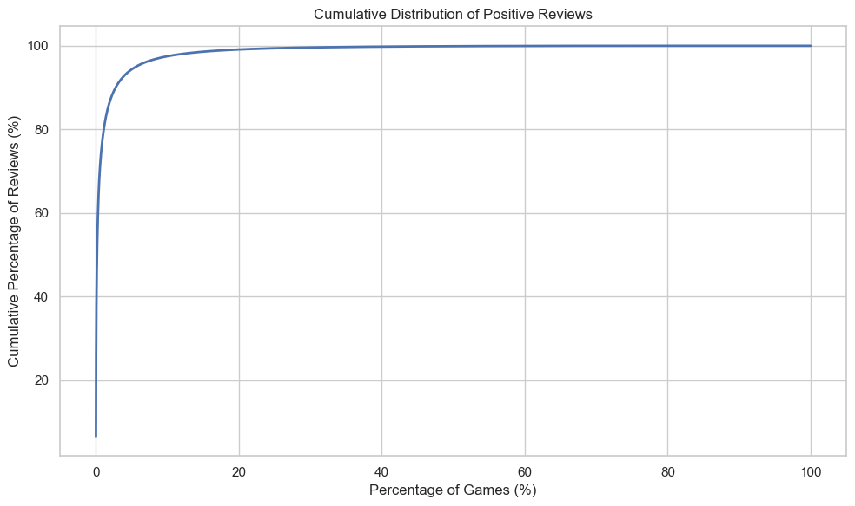
Conclusion:
The cumulative distribution shows that a small percentage of games contribute to the majority of positive reviews. This indicates a highly unequal distribution where a few popular games dominate user engagement.

Analysis 25: How unequal is the distribution of positive reviews among games? (Lorenz Curve)

# Sort data
lorenz_df = df.sort_values(by='positive').reset_index(drop=True)

# Cumulative share of reviews
lorenz_df['cum_reviews'] = lorenz_df['positive'].cumsum()
total_reviews = lorenz_df['positive'].sum()

lorenz_df['cum_reviews_pct'] = lorenz_df['cum_reviews'] / total_reviews

# Cumulative share of games
lorenz_df['cum_games_pct'] = (lorenz_df.index + 1) / len(lorenz_df)

plt.figure(figsize=(10,6))

# Lorenz curve
plt.plot(lorenz_df['cum_games_pct'], lorenz_df['cum_reviews_pct'], label='Actual Distribution')

# Perfect equality line
plt.plot([0,1], [0,1], linestyle='--', label='Perfect Equality')

plt.title("Lorenz Curve of Positive Reviews Distribution")
plt.xlabel("Cumulative Share of Games")
plt.ylabel("Cumulative Share of Reviews")

plt.legend()
plt.grid(True)

plt.tight_layout()
plt.show()
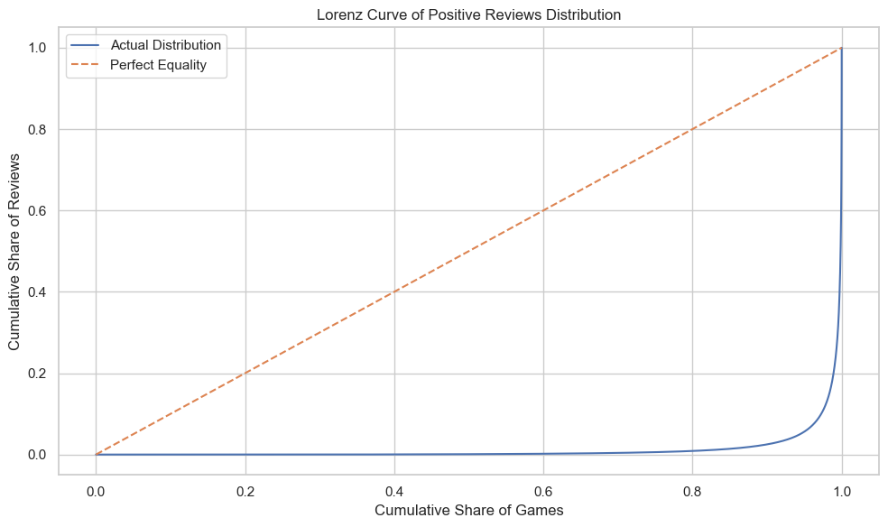
Conclusion:
The Lorenz curve shows a strong deviation from perfect equality, indicating that positive reviews are highly concentrated among a small fraction of games. This confirms a highly unequal distribution of player engagement.

Analysis 26: What relationships exist between key numerical features?
Code
import numpy as np

# Select relevant columns
corr_df = df[[
'price',
'positive',
'negative',
'peak_ccu',
'average_playtime_forever',
'pct_pos_total'
]].copy()

# Clean data
corr_df = corr_df.replace([np.inf, -np.inf], np.nan).dropna()

# Log transform skewed features
corr_df['log_positive'] = np.log1p(corr_df['positive'])
corr_df['log_ccu'] = np.log1p(corr_df['peak_ccu'])
corr_df['log_playtime'] = np.log1p(corr_df['average_playtime_forever'])

# Final features
final_corr = corr_df[[
'price',
'log_positive',
'negative',
'log_ccu',
'log_playtime',
'pct_pos_total'
]]

# Correlation
corr_matrix = final_corr.corr()

# CLUSTERED HEATMAP (key change)
sns.clustermap(
corr_matrix,
annot=True,
cmap="coolwarm",
center=0,
figsize=(8,6)
)

plt.show()
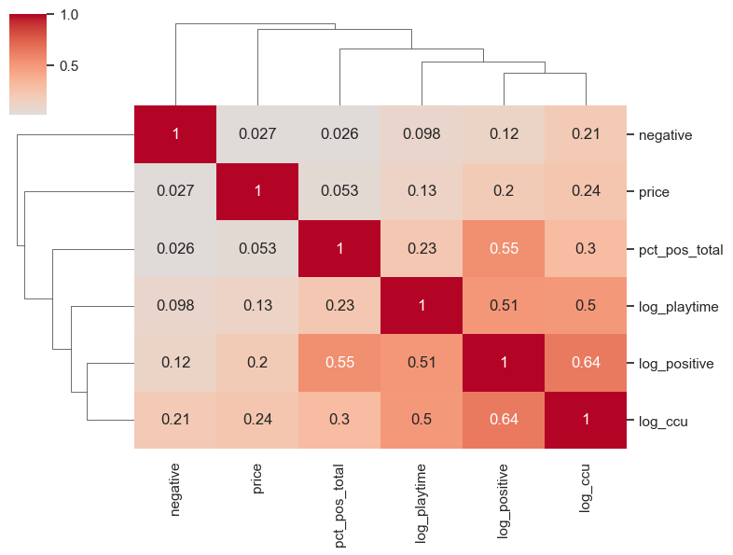
Conclusion:
The clustered heatmap reveals clear grouping among engagement-related variables such as peak concurrent users and positive reviews, indicating strong interdependence. Price remains weakly connected, suggesting that popularity is driven more by engagement factors than cost.

Analysis 27: How does playtime vary across different price categories?
Code
# Create price categories
df['price_category'] = pd.cut(
df['price'],
bins=[0, 5, 15, 30, 60, 200],
labels=['Very Low', 'Low', 'Medium', 'High', 'Very High']
)

# Filter realistic values
strip_df = df[
(df['average_playtime_forever'] > 0) &
(df['average_playtime_forever'] < 2000)
].copy()

plt.figure(figsize=(10,6))

sns.stripplot(
data=strip_df,
x='price_category',
y='average_playtime_forever',
jitter=True,
alpha=0.4
)

plt.title("Playtime Distribution Across Price Categories")
plt.xlabel("Price Category")
plt.ylabel("Average Playtime (minutes)")

plt.tight_layout()
plt.show()
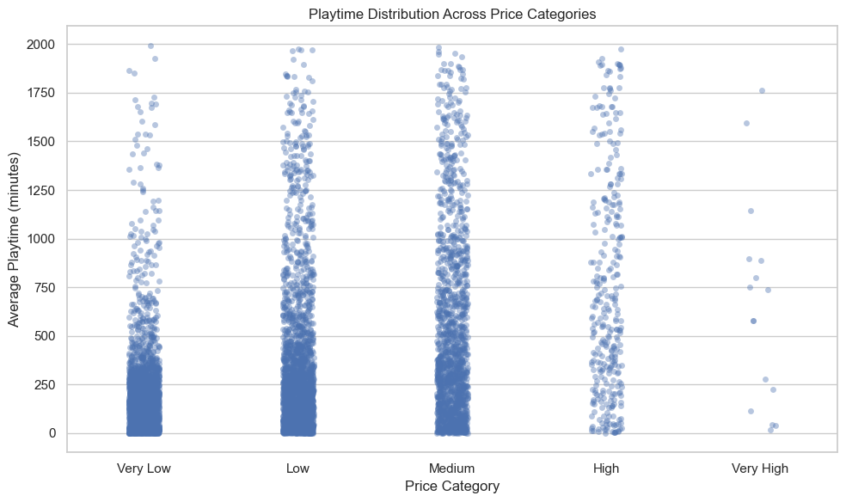
Conclusion:
Playtime varies significantly across all price categories, with no consistent increase in engagement as price rises. This suggests that higher pricing does not guarantee longer player engagement.

Analysis 28: How does playtime distribution change across price categories? (Ridgeline view)
Code
# Filter data
ridge_df = df[
(df['average_playtime_forever'] > 0) &
(df['average_playtime_forever'] < 2000)
].copy()

# Ensure category order
ridge_df['price_category'] = pd.Categorical(
ridge_df['price_category'],
categories=['Very Low', 'Low', 'Medium', 'High', 'Very High'],
ordered=True
)

# Facet Grid (correct ridgeline-style)
g = sns.FacetGrid(
ridge_df,
row="price_category",
hue="price_category",
aspect=4,
height=1.2,
sharex=True
)

g.map(sns.kdeplot, "average_playtime_forever", fill=True)

g.set_titles(row_template="{row_name}")
g.set(yticks=[], ylabel="")

g.fig.subplots_adjust(hspace=0.4)

g.set_xlabels("Average Playtime (minutes)")

plt.show()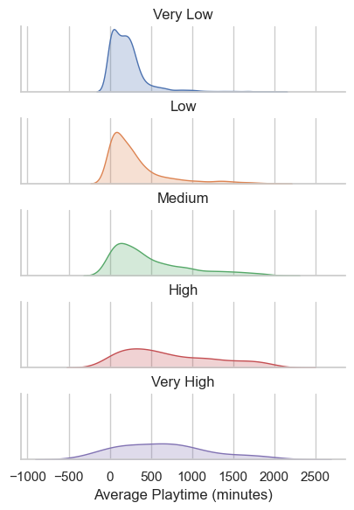

Conclusion:
The ridgeline plot shows that playtime distributions vary across price categories, but no category consistently dominates in engagement. Lower-priced games often have wider distributions, indicating both casual and highly engaged player bases.

Analysis 29: How does playtime distribution vary across top genres?
Code
# Ensure genres is list (you already did safe_convert earlier)

# Explode genres (IMPORTANT)
genre_exploded = df.explode('genres')

# Get top 5 genres
top_genres = genre_exploded['genres'].value_counts().head(5).index

# Filter for those genres
genre_df = genre_exploded[
genre_exploded['genres'].isin(top_genres)
].copy()

# Rename for clarity
genre_df = genre_df.rename(columns={'genres': 'genre'})

# Filter valid playtime
genre_df = genre_df[
(genre_df['average_playtime_forever'] > 0) &
(genre_df['average_playtime_forever'] < 3000)
]

plt.figure(figsize=(10,6))

sns.boxenplot(
data=genre_df,
x='genre',
y='average_playtime_forever'
)

plt.title("Playtime Distribution Across Top Genres")
plt.xlabel("Genre")
plt.ylabel("Average Playtime (minutes)")

plt.xticks(rotation=30)

plt.tight_layout()
plt.show()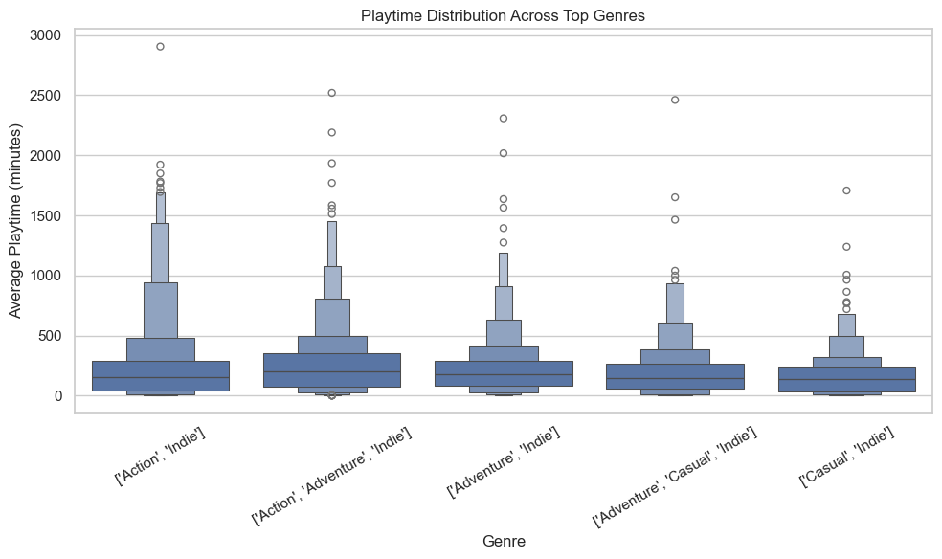

Conclusion:
Different genres show distinct playtime distributions, with some genres exhibiting wider variability and longer engagement tails. This suggests that player engagement patterns vary significantly depending on game genre.

Analysis 30: Where are games concentrated in terms of price and popularity?
Code
# Filter realistic values
hex_df = df[
(df['price'] > 0) &
(df['price'] < 100) &
(df['positive'] > 0)
].copy()

# Reduce skew
hex_df = hex_df[hex_df['positive'] < 500000]

plt.figure(figsize=(10,6))

plt.hexbin(
hex_df['price'],
hex_df['positive'],
gridsize=40,
bins='log'
)

plt.yscale('log')

plt.title("Density of Games by Price and Popularity (Hexbin)")
plt.xlabel("Price (USD)")
plt.ylabel("Positive Reviews (log scale)")

cb = plt.colorbar()
cb.set_label('Density')

plt.tight_layout()
plt.show()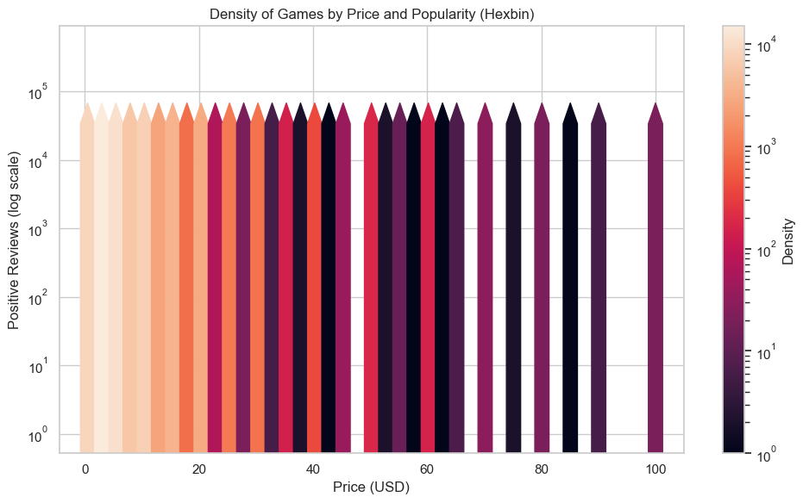

Conclusion:
The density plot shows that most games are concentrated in lower price ranges with relatively low to moderate popularity. Highly popular games are fewer and spread across different price levels, indicating that success is not limited to a specific price range.

Analysis 31: Which are the top 10 most popular games based on positive reviews?
Code
# Get top 10 games
top_games = df.sort_values(by='positive', ascending=False).head(10)

plt.figure(figsize=(10,6))

# Draw lines
plt.hlines(
y=top_games['name'],
xmin=0,
xmax=top_games['positive']
)

# Draw dots
plt.plot(
top_games['positive'],
top_games['name'],
"o"b
)

plt.title("Top 10 Games by Positive Reviews (Lollipop Chart)")
plt.xlabel("Number of Positive Reviews")
plt.ylabel("Game Name")

plt.tight_layout()
plt.show()
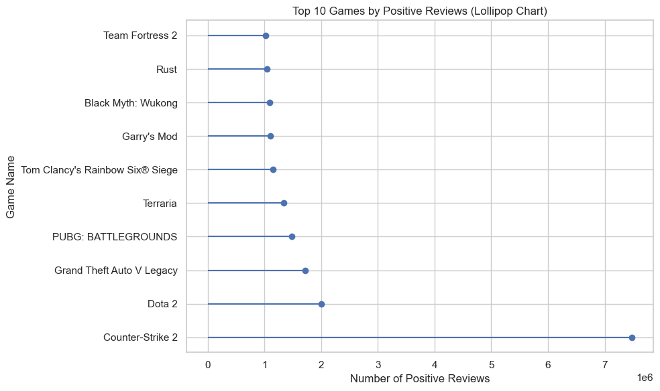
Conclusion:
A small number of games dominate in terms of positive reviews, with a significant gap between the top titles and others. This highlights the competitive nature of the platform where only a few games achieve extreme popularity.

Analysis 32: How does average popularity vary across top genres? (Radial View)
Code
import numpy as np

# Explode genres
genre_exploded = df.explode('genres')

# Get top 6 genres
top_genres = genre_exploded['genres'].value_counts().head(6).index

# Compute average popularity
genre_avg = genre_exploded[
genre_exploded['genres'].isin(top_genres)
].groupby('genres')['positive'].mean()

# Normalize (log scale to avoid distortion)
genre_avg = np.log1p(genre_avg)

# Prepare angles
labels = genre_avg.index
values = genre_avg.values

angles = np.linspace(0, 2*np.pi, len(labels), endpoint=False)
values = np.append(values, values[0])
angles = np.append(angles, angles[0])

plt.figure(figsize=(8,8))
ax = plt.subplot(111, polar=True)

ax.plot(angles, values)
ax.fill(angles, values, alpha=0.3)

ax.set_xticks(angles[:-1])
ax.set_xticklabels(labels)

plt.title("Average Popularity Across Top Genres (Radial Plot)")

plt.tight_layout()
plt.show()
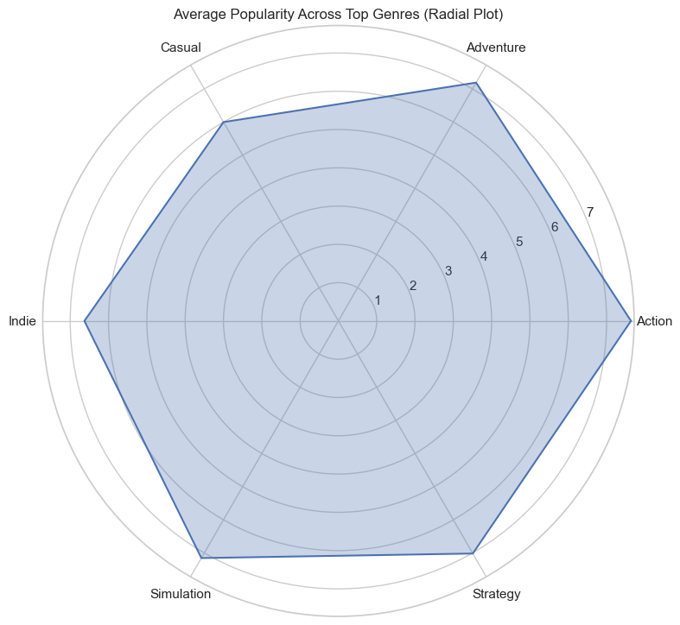
Conclusion:
The radial plot shows variation in average popularity across genres, with some genres clearly outperforming others. This indicates that player engagement is not evenly distributed and depends strongly on genre preferences.

Analysis 33: Can games be grouped into distinct clusters based on popularity and engagement?
Code
import pandas as pd
import matplotlib.pyplot as plt
import seaborn as sns
import numpy as np
from sklearn.cluster import KMeans

# Select required columns
cluster_df = df[['positive', 'average_playtime_forever', 'price']].copy()

# Clean data
cluster_df = cluster_df[
(cluster_df['positive'] > 0) &
(cluster_df['average_playtime_forever'] > 0)
].dropna()

# Log transform (important for skew)
cluster_df['log_positive'] = np.log1p(cluster_df['positive'])
cluster_df['log_playtime'] = np.log1p(cluster_df['average_playtime_forever'])

# Features for clustering
cluster_df['log_ccu'] = np.log1p(df.loc[cluster_df.index, 'peak_ccu'])

X = cluster_df[['log_positive', 'log_playtime', 'log_ccu']]
# Apply KMeans
kmeans = KMeans(n_clusters=3, random_state=42, n_init=10)
cluster_df['cluster'] = kmeans.fit_predict(X)

# Safe sampling (FIXED)
sample_data = cluster_df.sample(min(10000, len(cluster_df)), random_state=42)

# Plot
plt.figure(figsize=(10,6))

sns.scatterplot(
data=sample_data,
x='log_positive',
y='log_playtime',
hue='cluster',
palette='Set1'
)

plt.title("Game Clusters Based on Popularity and Playtime")
plt.xlabel("Log Positive Reviews")
plt.ylabel("Log Playtime")

plt.tight_layout()
plt.show()
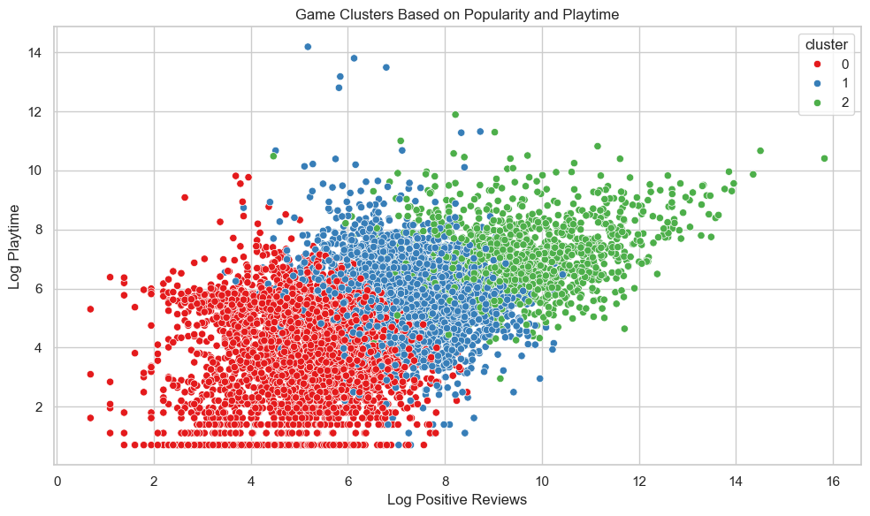
Conclusion:
The clustering reveals three distinct engagement segments, but with noticeable overlap, indicating that game success is not driven by a single factor. High-performing games tend to combine strong player activity and sustained engagement rather than excelling in just one metric.

Analysis 34: How do different clusters compare across multiple game metrics?
Code
from pandas.plotting import parallel_coordinates

# Create mean dataframe (with correct columns)
mean_df = cluster_df.groupby('cluster')[[
'log_positive',
'log_playtime',
'log_ccu'
]].mean().reset_index()

# Normalize
for col in ['log_positive', 'log_playtime', 'log_ccu']:
mean_df[col] = (mean_df[col] - mean_df[col].min()) / (mean_df[col].max() - mean_df[col].min())

plt.figure(figsize=(8,5))

parallel_coordinates(
mean_df,
'cluster',
linewidth=3
)

plt.title("Cluster Comparison Across Game Metrics (Clean View)")

plt.tight_layout()
plt.show()
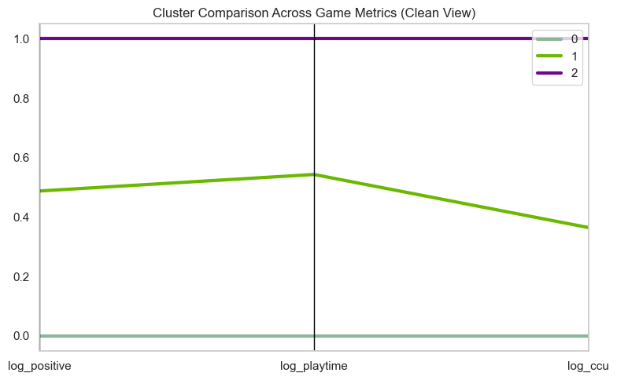
Conclusion:
The visualization highlights a clear hierarchy among clusters. One cluster consistently dominates across all engagement metrics, while another remains uniformly low, indicating that successful games tend to perform well across multiple dimensions rather than excelling in just one.

Analysis 35: How does popularity distribution vary across different price segments?
Code
import numpy as np

# Create price categories (if not already created)
df['price_category'] = pd.cut(
df['price'],
bins=[0, 5, 15, 30, 60, 200],
labels=['Very Low', 'Low', 'Medium', 'High', 'Very High']
)

# Prepare data
violin_df = df[df['positive'] > 0].copy()
violin_df['log_positive'] = np.log1p(violin_df['positive'])

# Plot
plt.figure(figsize=(10,6))

sns.violinplot(
data=violin_df,
x='price_category',
y='log_positive'
)

plt.title("Popularity Distribution Across Price Segments")
plt.xlabel("Price Category")
plt.ylabel("Log Positive Reviews")

plt.tight_layout()
plt.show()
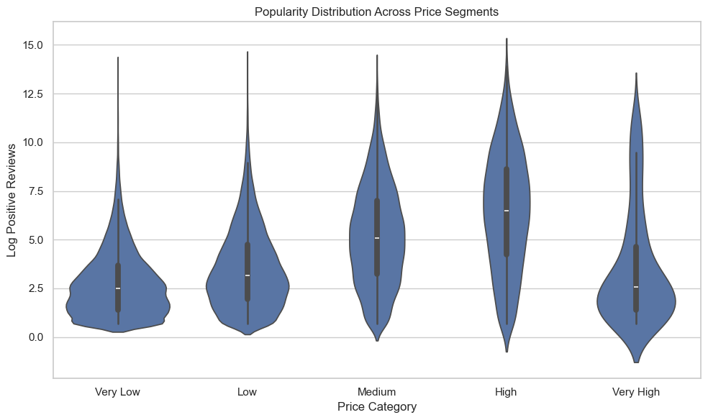
Conclusion:
The distribution of popularity varies significantly across price segments. Lower-priced games show a wider spread with both low and extremely high performers, while higher-priced games tend to have more consistent but less extreme popularity.

Analysis 36: How do price, popularity, and player activity interact?
Code
import numpy as np

# Prepare data
bubble_df = df[
(df['positive'] > 0) &
(df['peak_ccu'] > 0) &
(df['price'] > 0)
].copy()

# Reduce skew
bubble_df = bubble_df[
(bubble_df['positive'] < 500000) &
(bubble_df['peak_ccu'] < 500000)
]

# Log transform
bubble_df['log_positive'] = np.log1p(bubble_df['positive'])
bubble_df['log_ccu'] = np.log1p(bubble_df['peak_ccu'])

# Sample for performance
bubble_df = bubble_df.sample(min(5000, len(bubble_df)), random_state=42)

plt.figure(figsize=(10,6))

plt.scatter(
bubble_df['price'],
bubble_df['log_positive'],
s=bubble_df['log_ccu'] * 5, # bubble size
alpha=0.4
)

plt.title("Price vs Popularity with Player Activity (Bubble Chart)")
plt.xlabel("Price (USD)")
plt.ylabel("Log Positive Reviews")

plt.tight_layout()
plt.show()
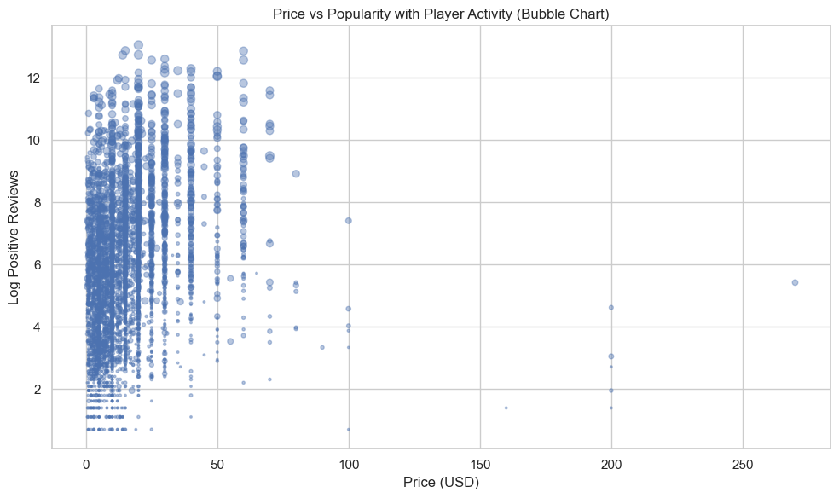
Conclusion:
The bubble chart shows that highly active games with large player bases are mostly concentrated in lower to mid-price ranges. High-priced games rarely achieve both high popularity and high concurrent player activity.

Analysis 37: Which game genres frequently appear together?
Code
import numpy as np
from itertools import combinations

# Ensure genres are lists
genre_df = df[df['genres'].notna()].copy()

# Get top genres (limit for clarity)
top_genres = genre_df.explode('genres')['genres'].value_counts().head(10).index

# Create co-occurrence matrix
matrix = pd.DataFrame(0, index=top_genres, columns=top_genres)

for genres in genre_df['genres']:
if isinstance(genres, list):
filtered = [g for g in genres if g in top_genres]
for g1, g2 in combinations(filtered, 2):
matrix.loc[g1, g2] += 1
matrix.loc[g2, g1] += 1

# Plot heatmap
plt.figure(figsize=(8,6))

sns.heatmap(
matrix,
annot=True,
fmt='d',
cmap='YlOrRd'
)

plt.title("Genre Co-occurrence Heatmap")

plt.tight_layout()
plt.show()
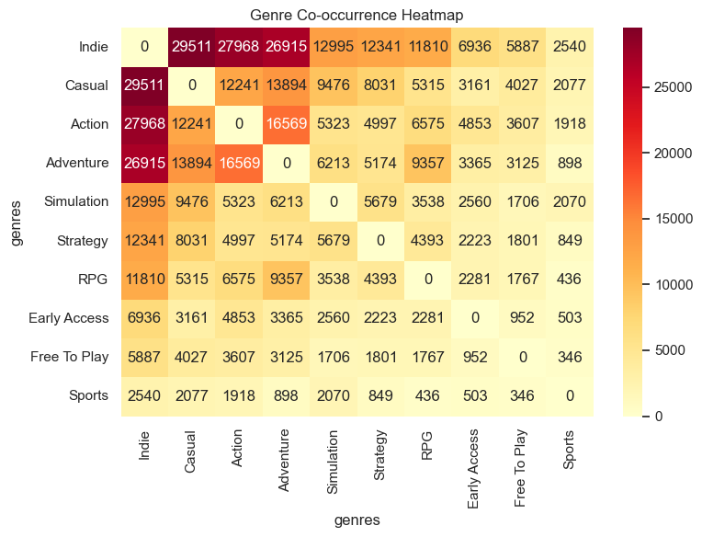
Conclusion:
The heatmap reveals strong co-occurrence patterns between specific genres, highlighting common combinations such as action-adventure or RPG-strategy. These patterns reflect consistent design trends and player preferences.

Analysis 38: What is the distribution of games across different genres?
Code
import matplotlib.pyplot as plt
from collections import Counter

# Flatten genres
all_genres = []
for genres in df['genres']:
if isinstance(genres, list):
all_genres.extend(genres)

# Count top 10 genres
genre_counts = Counter(all_genres)
top_genres = dict(genre_counts.most_common(10))

# Prepare data
labels = list(top_genres.keys())
sizes = list(top_genres.values())

plt.figure(figsize=(10,6))

plt.pie(
sizes,
labels=labels,
autopct='%1.1f%%',
startangle=140
)

plt.title("Top Genre Distribution (Proportion View)")

plt.tight_layout()
plt.show()
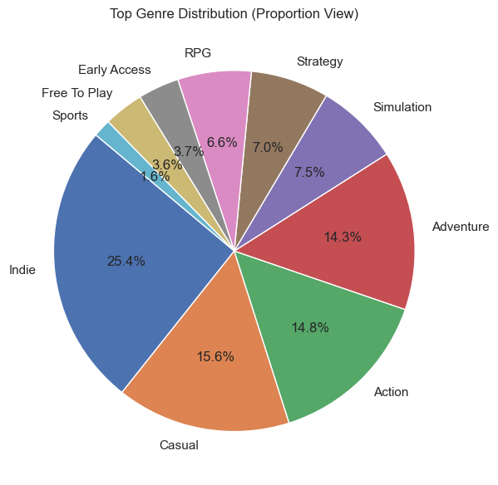
Conclusion:
The distribution of genres is highly uneven, with a few genres dominating the platform. This indicates that game development is concentrated around popular genres with proven demand.

Analysis 39: How have top game genres evolved over time?
Code
# Explode genres
genre_year_df = df.explode('genres')

# Get top 5 genres (to avoid clutter)
top_genres = genre_year_df['genres'].value_counts().head(5).index

# Filter only those
genre_year_df = genre_year_df[genre_year_df['genres'].isin(top_genres)]

# Count per year per genre
trend_df = genre_year_df.groupby(['year', 'genres']).size().unstack().fillna(0)

# Plot
plt.figure(figsize=(10,6))

plt.stackplot(
trend_df.index,
trend_df.T,
labels=trend_df.columns
)

plt.title("Evolution of Top Genres Over Time")
plt.xlabel("Year")
plt.ylabel("Number of Games")

plt.legend(loc='upper left')

plt.tight_layout()
plt.show()
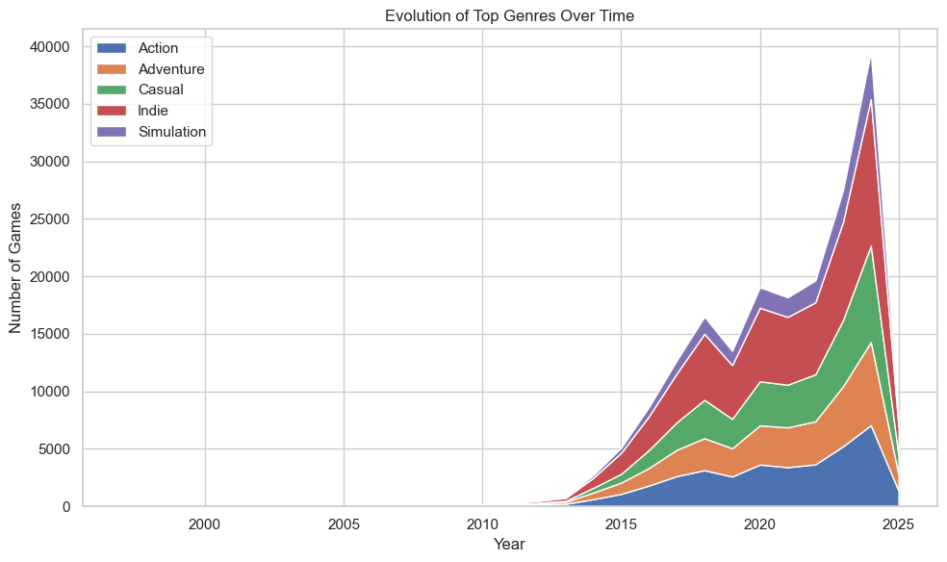
Conclusion:
The stacked area chart shows that certain genres have consistently dominated over time, while others have experienced growth or decline. This reflects evolving player preferences and changing development trends on the platform.

Analysis 40: What are the key relationships between major game metrics?
Code
import numpy as np

# Select important numerical features
corr_df = df[[
'price',
'positive',
'negative',
'average_playtime_forever',
'peak_ccu',
'pct_pos_total'
]].copy()

# Clean
corr_df = corr_df.dropna()

# Log transform skewed columns
corr_df['positive'] = np.log1p(corr_df['positive'])
corr_df['negative'] = np.log1p(corr_df['negative'])
corr_df['peak_ccu'] = np.log1p(corr_df['peak_ccu'])
corr_df['average_playtime_forever'] = np.log1p(corr_df['average_playtime_forever'])

# Correlation matrix
corr = corr_df.corr()

plt.figure(figsize=(8,6))

sns.heatmap(
corr,
annot=True,
cmap='coolwarm',
fmt=".2f"
)

plt.title("Correlation Between Game Metrics")

plt.tight_layout()
plt.show()
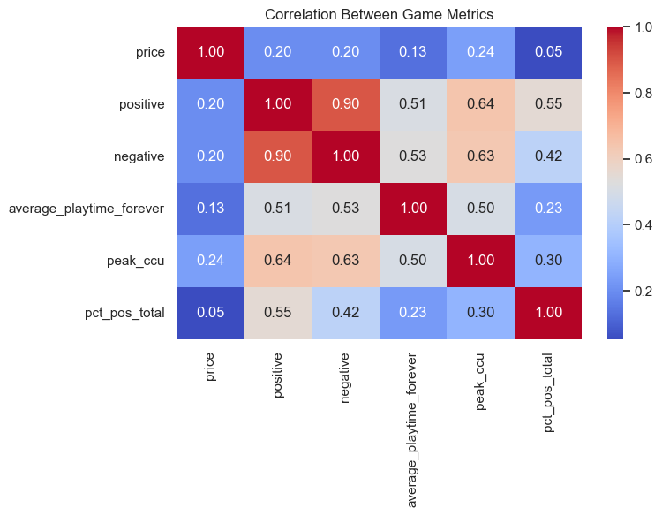
Conclusion:
The correlation analysis highlights strong relationships between player engagement metrics such as positive reviews, concurrent users, and playtime. In contrast, price shows weak correlation with success, indicating that game popularity is driven more by user experience and engagement rather than pricing strategy.

5. Results and Insights
This chapter presents the key results and insights derived from the data analysis performed on the Steam Games Dataset (2025). The analysis involved multiple visualizations and statistical observations to understand patterns related to pricing, genres, user engagement, and game performance.
The objective of this chapter is to summarize the findings obtained from the visualizations and highlight important trends identified during the analysis.

5.1 Key Patterns and Trends Identified

The analysis of the Steam Games Dataset (2025) revealed several significant patterns and trends across different variables such as pricing, genres, release trends, user engagement, and reviews. These patterns provide valuable insights into the behavior of the gaming market and player preferences.

1. Pricing Trends
One of the most prominent patterns observed in the dataset is related to game pricing:
• A large proportion of games are either free-to-play or priced at a lower range
• High-priced games are comparatively fewer in number
• Free games tend to attract a larger number of users and higher engagement
• Affordable pricing plays a crucial role in increasing accessibility and popularity
This indicates that the gaming industry is increasingly adopting pricing strategies that favor wider audience reach.

2. Genre Popularity Trends
Genre-based analysis highlights clear trends in player preferences:
• Action and Indie genres dominate the platform in terms of number of games
• Multiplayer and Adventure genres show strong engagement levels
• Certain niche genres have smaller but highly dedicated audiences
• Genre diversity indicates the availability of a wide range of gaming experiences
These observations suggest that genre selection is a key factor influencing game success.

3. Release Trends Over Time
Time-based analysis of game releases revealed the following:
• The number of games released has increased significantly over the years
• Recent years show rapid growth in game production
• The industry is becoming more competitive due to the increasing number of releases
This trend reflects the expansion and continuous evolution of the gaming industry.

4. User Engagement Patterns
User engagement metrics such as playtime and concurrent users show important trends:
• Games with higher playtime tend to retain users for longer durations
• Peak concurrent users indicate the popularity of games during specific periods
• Highly engaging games are often associated with popular genres
This demonstrates that engagement is a strong indicator of a game's success.

5. Review and Rating Trends
User reviews play a significant role in determining game performance:
• Games with higher positive review percentages tend to be more successful
• Negative reviews can reduce user interest and engagement
• User feedback directly impacts the reputation and popularity of a game
This highlights the importance of maintaining quality and user satisfaction.

6. Relationship Between Key Variables
The analysis also revealed relationships between different variables:
• Price and Engagement – Lower-priced or free games generally have higher engagement
• Reviews and Popularity – Positive reviews correlate with higher popularity
• Genre and Playtime – Certain genres lead to longer gameplay duration
Understanding these relationships helps in identifying factors that contribute to game success.

7. Overall Market Trends
From the overall analysis, the following broader trends were identified:
• Growth of the free-to-play gaming model
• Increasing competition in the gaming market
• Strong influence of user reviews and ratings
• Rising importance of engagement metrics
These trends provide a comprehensive understanding of how the gaming ecosystem operates on the Steam platform.

5.2 Insights Derived from the Data Analysis
The data analysis of the Steam Games Dataset (2025) provided several meaningful insights into the gaming industry, user behavior, and the factors that contribute to the success of games. These insights were derived from various visualizations and relationships identified during the analysis.
• One of the most important insights is that pricing plays a significant role in attracting users. Free-to-play and low-cost games tend to have a larger user base and higher engagement compared to expensive games. This suggests that affordability increases accessibility and encourages more players to try games
• However, price alone does not determine success. Many low-priced or free games outperform high-priced games in terms of engagement and popularity. This indicates that factors such as gameplay quality, user experience, and content value are more important than price
• Genre selection has a strong impact on game performance. Popular genres such as Action and Indie consistently show higher numbers of games and greater user engagement. This suggests that developers often focus on these genres due to their demand in the market
• User engagement metrics such as playtime and peak concurrent users provide valuable insights into player behavior. Games with higher playtime indicate better user retention, while high concurrent user counts reflect popularity at a given time
• User reviews are a critical factor in determining the success of a game. Games with a higher percentage of positive reviews tend to attract more players and maintain long-term engagement. Positive feedback builds trust among users and increases the likelihood of new players trying the game
• Negative reviews can significantly impact a game's reputation and reduce its popularity. This highlights the importance of maintaining quality and addressing user concerns
• The steady increase in game releases over time indicates rapid growth in the gaming industry. However, it also reflects increased competition among developers, making it more challenging for individual games to stand out
• The relationship between different variables, such as price, reviews, and engagement, shows that game success depends on a combination of factors rather than a single attribute
• Data analysis plays an important role in decision-making. Developers and publishers can use insights from data to improve pricing strategies, choose appropriate genres, and enhance user experience
• Overall, the analysis demonstrates that understanding user behavior and market trends is essential for success in the gaming industry
6. Conclusion

6.1 Conclusion
This project focused on the analysis of the Steam Games Dataset (2025) using data visualization techniques in Python. The dataset included a large number of records containing detailed information about game pricing, genres, release trends, user reviews, and engagement metrics.
Through systematic data preprocessing and analysis, the raw dataset was transformed into a structured and meaningful format. Various visualization techniques were applied to explore patterns, relationships, and trends within the data.
The analysis led to several important conclusions:
• A large proportion of games on Steam are free-to-play or priced at a lower range, indicating the growing popularity of affordable gaming models
• Game success is influenced more by user experience, quality, and engagement rather than just price
• Popular genres such as Action and Indie dominate the platform and attract a significant number of players
• User engagement metrics such as playtime and concurrent users provide a clear indication of game popularity
• Positive user reviews play a crucial role in determining the success and reputation of a game
• The number of game releases has increased over the years, showing rapid growth and increasing competition in the gaming industry
Overall, the project successfully demonstrated how data visualization techniques can be used to analyze large datasets and extract meaningful insights. The use of Python libraries such as Pandas and Matplotlib helped in simplifying complex data into understandable visual representations.

6.2 Future Scope
Although the project achieved its objectives, there are several opportunities for further improvement and expansion:
• Integration of real-time data using APIs to perform up-to-date analysis
• Application of machine learning algorithms to predict game success, user engagement, or review ratings
• Performing sentiment analysis on user reviews to understand player opinions in depth
• Development of an interactive dashboard using tools like Power BI or Tableau for better visualization
• Inclusion of additional features such as player demographics, achievements, and game updates
• Comparative analysis with other gaming platforms to gain broader insights
• Implementation of recommendation systems to suggest games based on user preferences
These enhancements can make the project more advanced and useful for real-world applications.

6.3 Final Remarks
The Steam Games Data Visualization project highlights the importance of data analysis in understanding industry trends and user behavior. It demonstrates how structured analysis and visualization can convert raw data into valuable insights.
This project not only strengthens technical skills in Python and data visualization but also provides a deeper understanding of the gaming ecosystem. It serves as a strong foundation for further exploration in the fields of data science, analytics, and business intelligence.

7. References

7.1 Online Resources
• Kaggle – Steam Games Dataset (2025)
• Official documentation of Python libraries
• Online tutorials for data analysis and visualization

7.2 Websites
• https://www.kaggle.com

7.3 Books and Study Material
• Data Analytics and Visualization study materials
• Academic notes and lecture materials

7.4 Tools and Technologies
• Python Programming Language
• Pandas Library / NumPy Library / Matplotlib Library
• Jupyter Notebook / VS Code
• Microsoft Excel
• Microsoft Word

7.5 Acknowledgment
• Guidance from faculty members
• Support from institution
• Online learning platforms and resources

