Binary tree depth question output==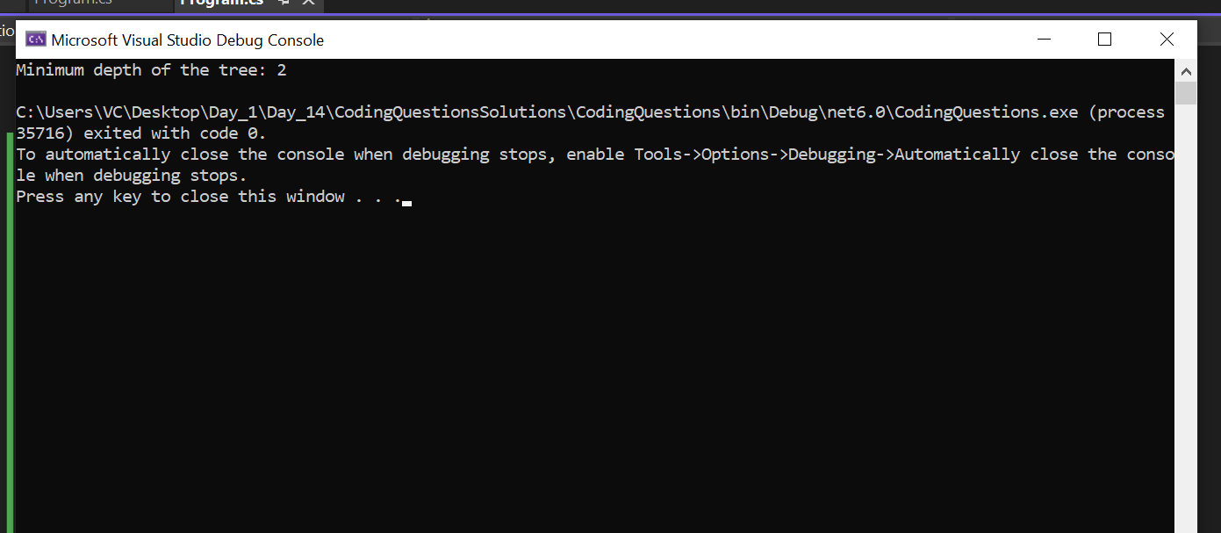

Linked list questions output==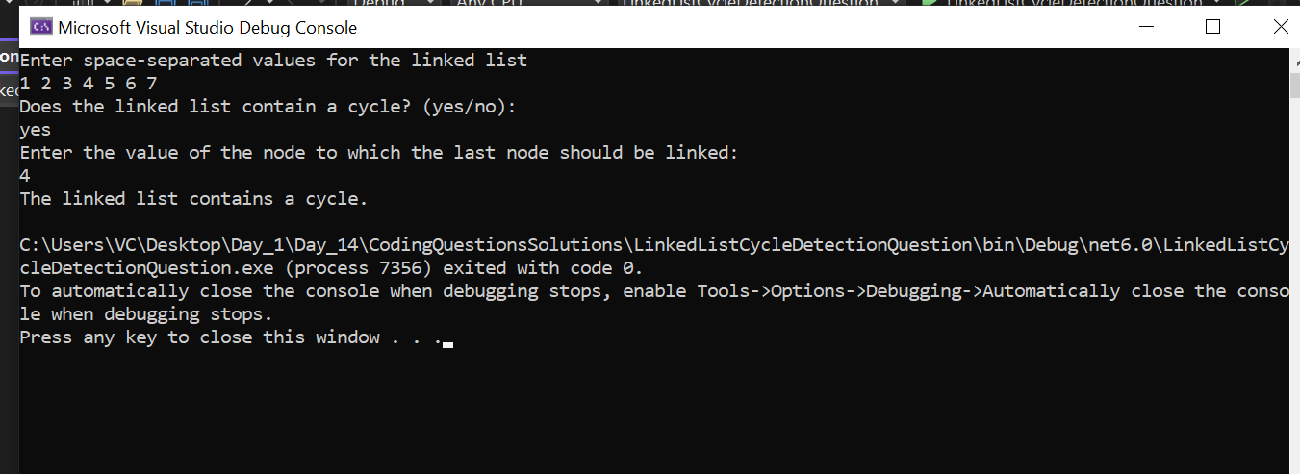

Excel sheet question output==

