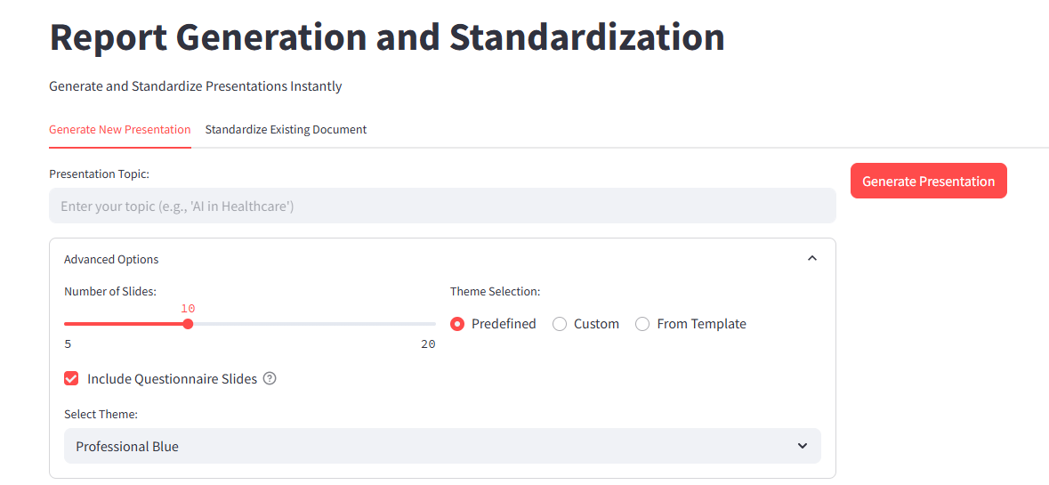

1. As soon as you click on this link: [Streamlit Application,](https://huggingface.co/spaces/SVNIT25/PPTX_generativeai) it will take you to this page.
2. This Page contains 2 tabs, Generate New Presentation & Standardize Existing Document.
3. In the 1st tab, you can create a new presentation by just entering your Topic Name.
4. You can also select Advanced Options to modify your PPT
5. In Advanced Option, you can modify the Number of slides you want (5-20)
6. Other than that, there is an option to select a Theme for your Presentation.
7. It comes with 3 different options

* Predefined- It has 4 predefined styles to choose from

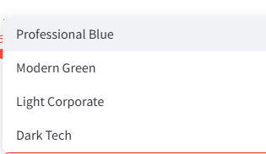

* Custom Theme- This gives you the flexibility to choose different colors for your PPT

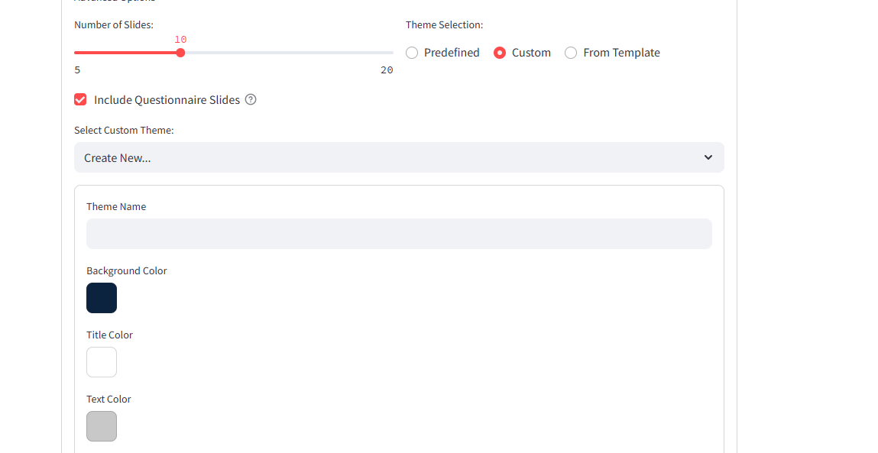

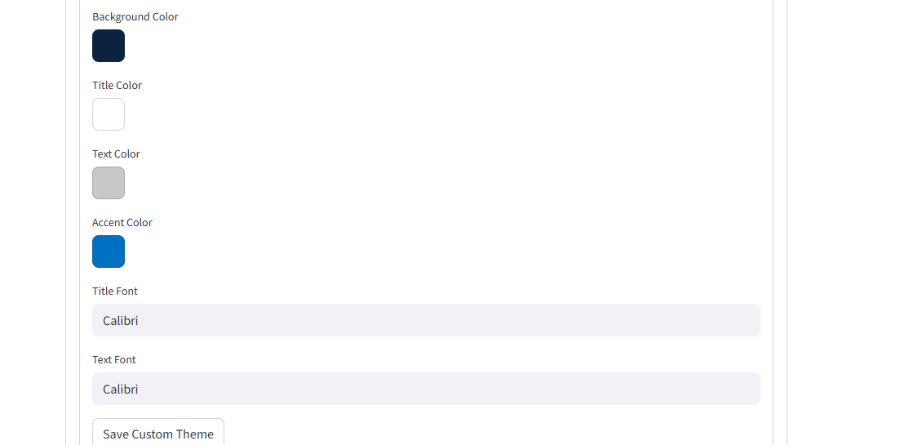

* Example Theme: You can upload a theme you have in your device, to apply it to your new presentation.

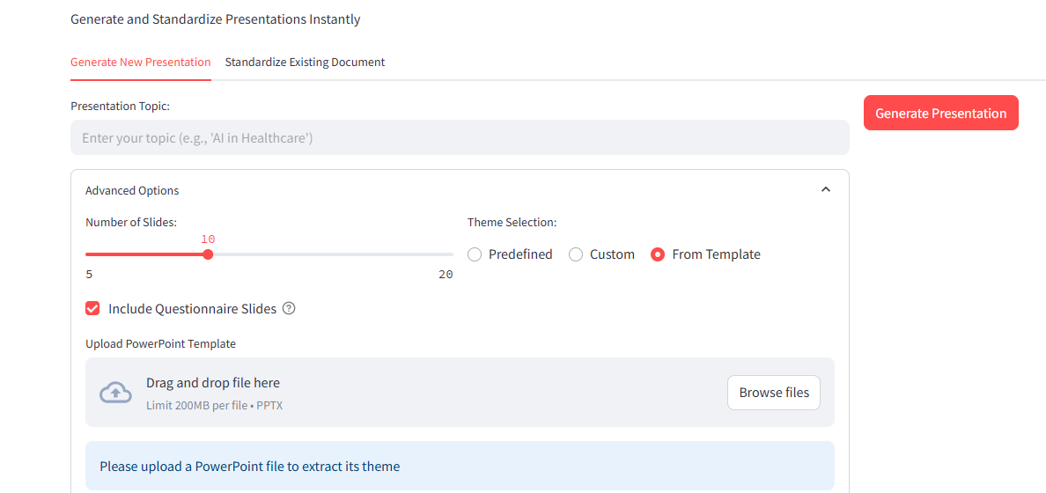

1. After selecting the appropriate theme, you simply click the Generate Presentation button.
2. And your Presentation will be generated in a few seconds.
3. You will get 3 export options:

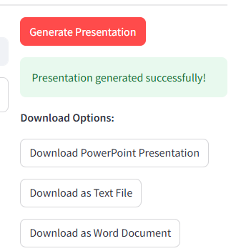

1. For the next Tab, which is Standardize existing documents:

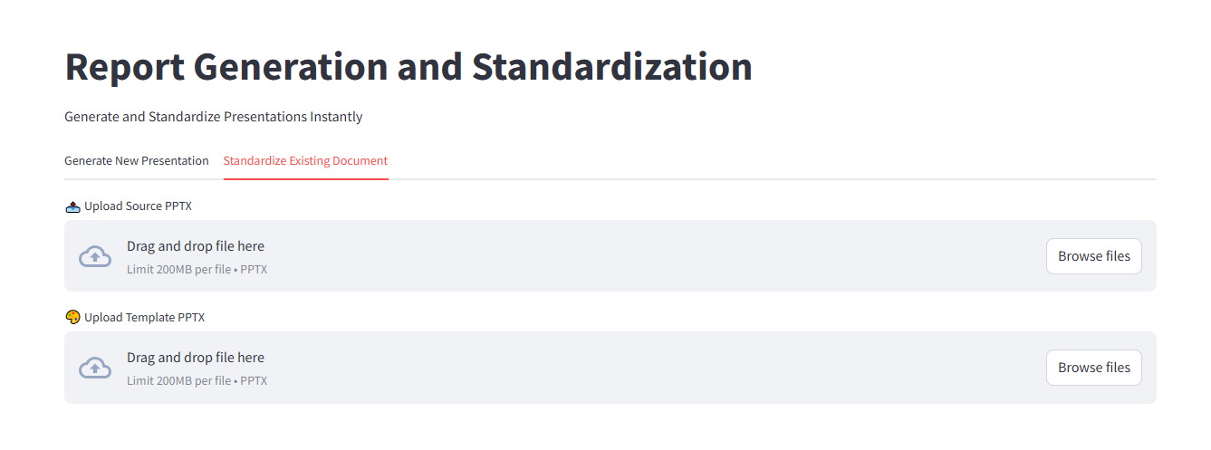

1. You must upload 2 documents here:

* Your source PPT, which needs to be standardized
* The template file, which needs to be applied to the source file

1. After uploading both the documents, just click on the Standardize button, and in a few seconds, your Standardized ppt will be available for download.

