1. Connect to the Excel workbook "Sample-Superstore.xlsx", and the Excel spreadsheet "Orders”. Create a viz which shows a staked bar chart with region shown as stacks, Sales in columns and category in rows (the Sum of the Sales Volume as the bars, and the Region Name being the Color)

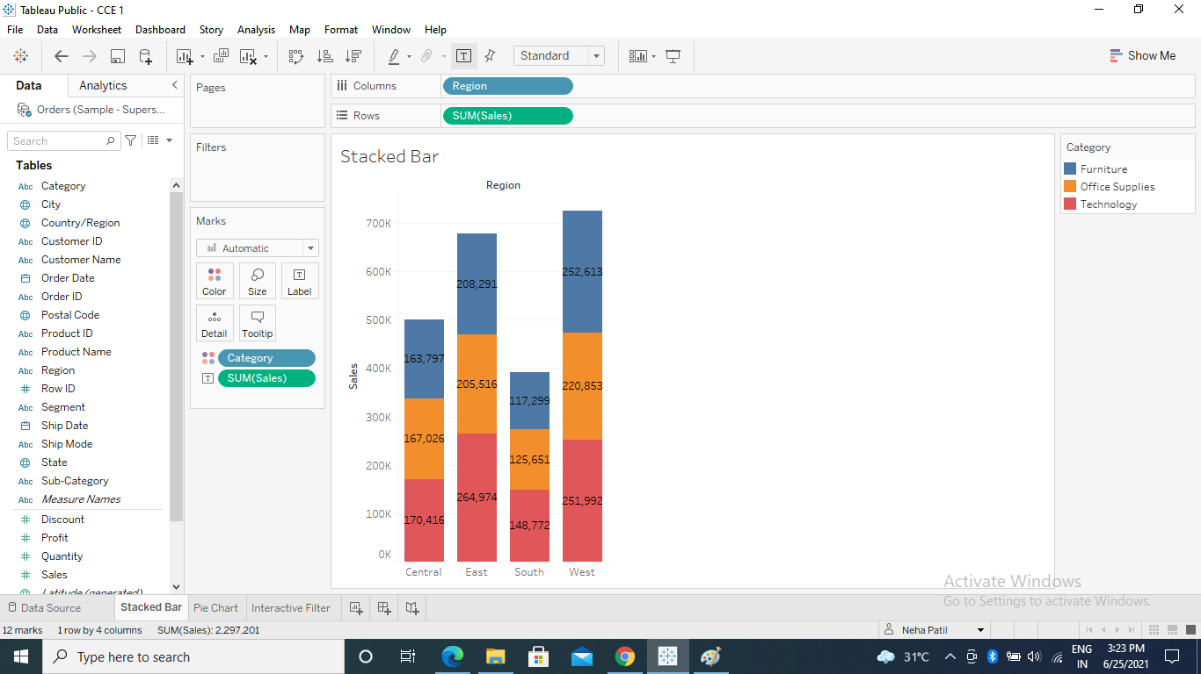

1. Create a pie chart showing region wise sum of sales. Show sales in percentages. Use tool tip to display the sales and region

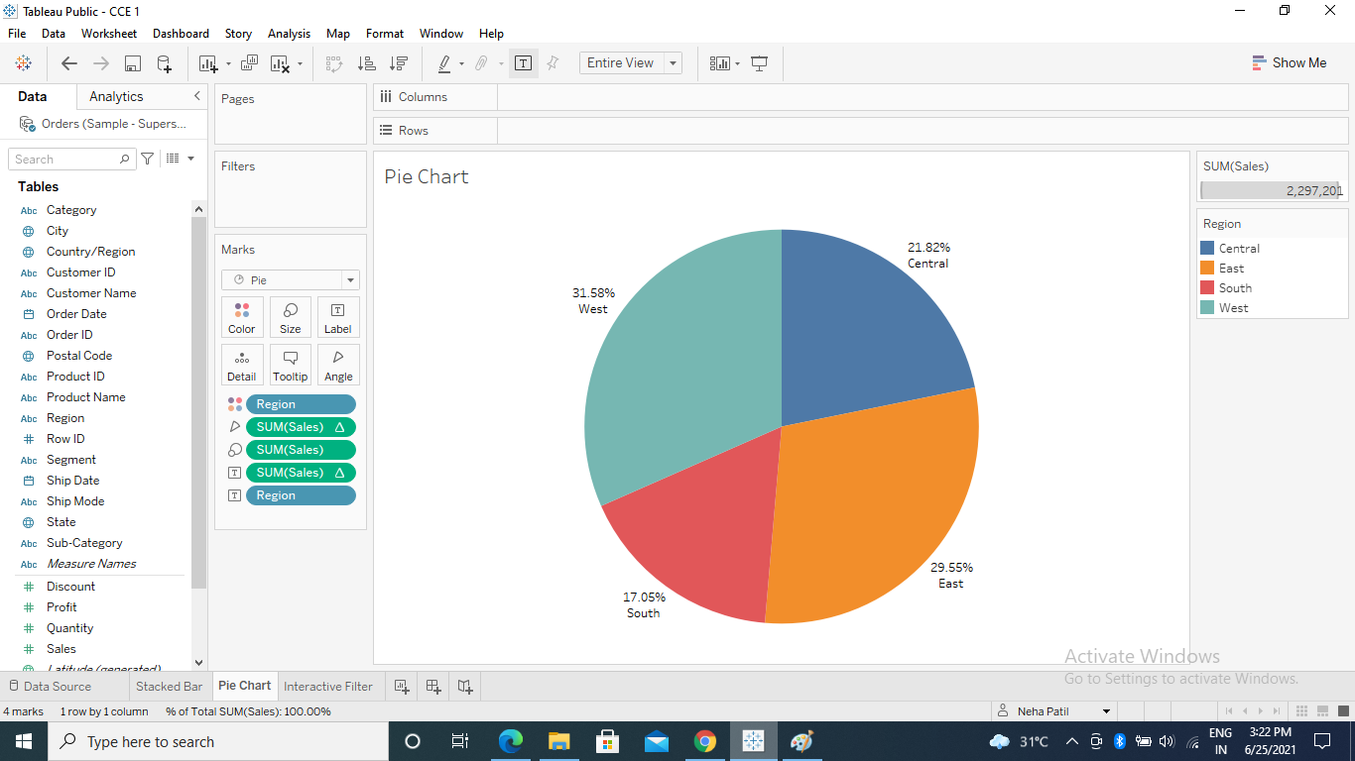

1. Create a visualization using sum of profits Vs subcategory. Apply interactive filter (use subcategory in filters) and show only selected subcategory.

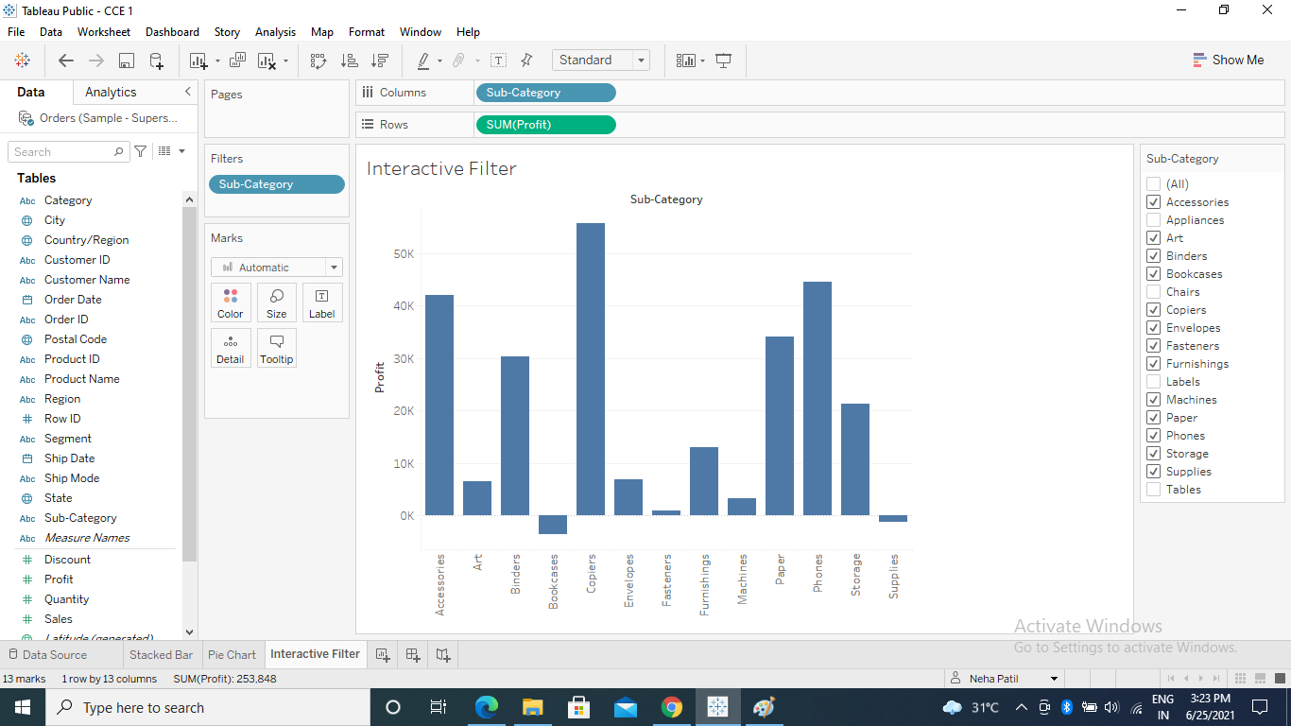

4.Create a bar in bar chart for sales and profit where profit and sales are shown in different

bars with different colors (one inside the other)

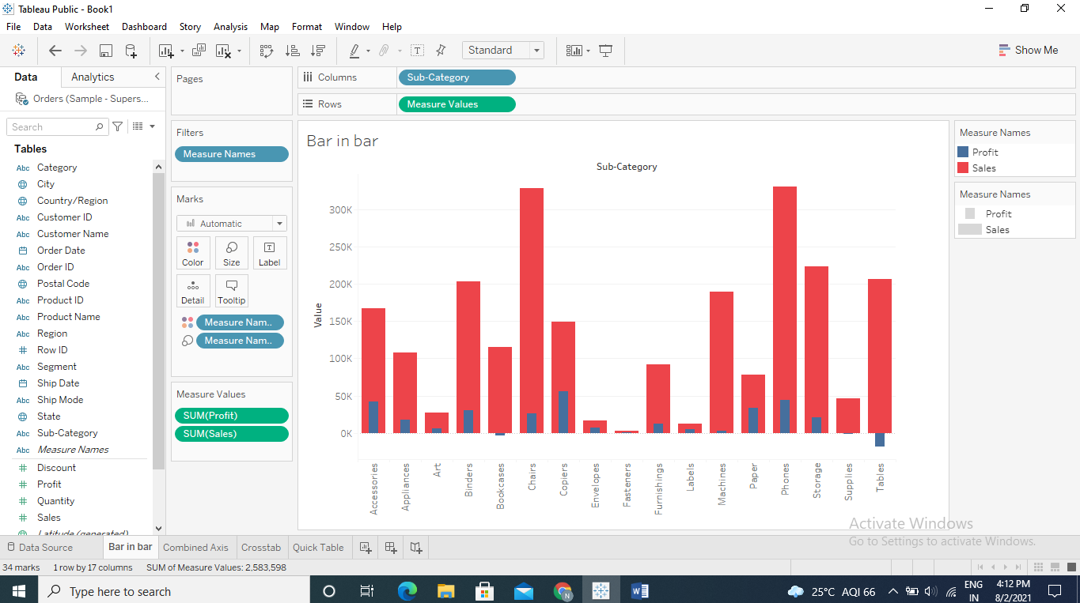

5. Create a combined axis chart where sales and profit are shown o different axis in the same

chart. Synchronize the axis.

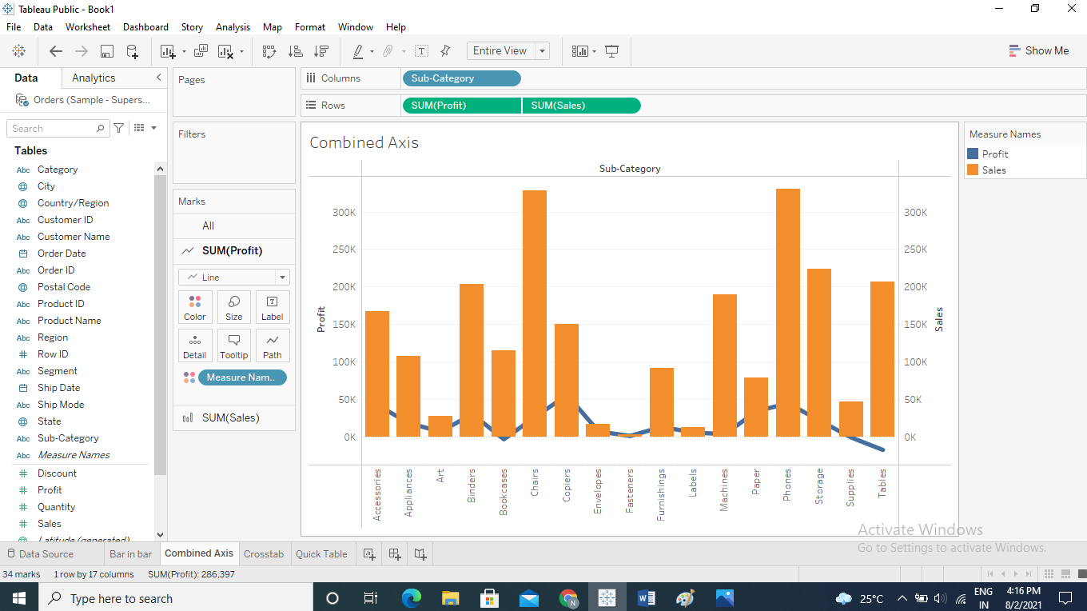

6. Create a crosstab using region, category, and subcategory with sales data. Show row and

column wise grand total. Also show subtotal.

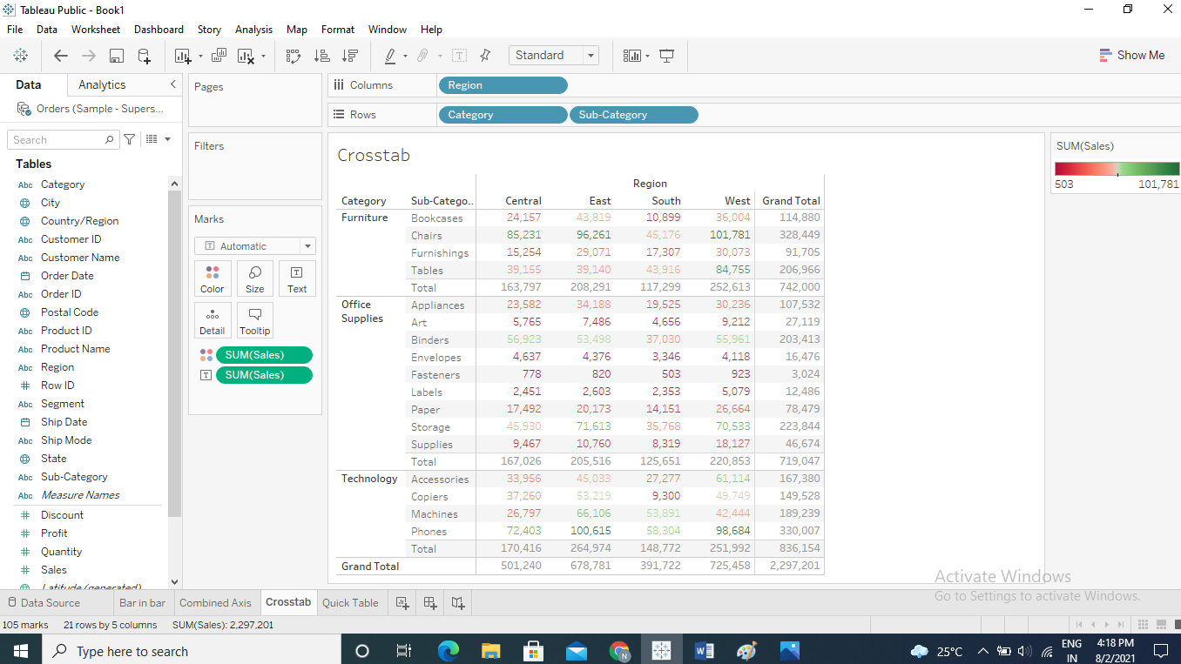

7. Use quick Table calculation for any data of your choice.

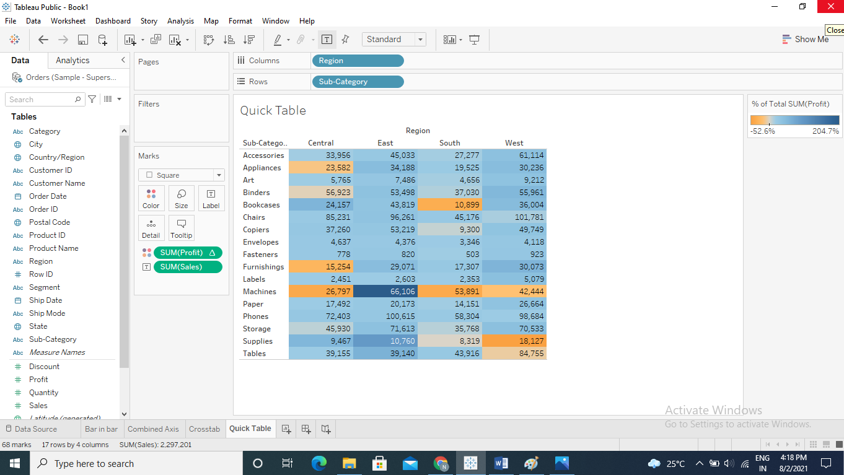

1. Open Tableau, and connect to the Excel workbook “SourceDataf.xlsx”, and the Excel

              Spreadsheet ”CDs”.

1. Create a viz which shows a bar chart for size per “File Extension”. (There are 3 File

              Extensions show biggest file size for each of these file extensions.)

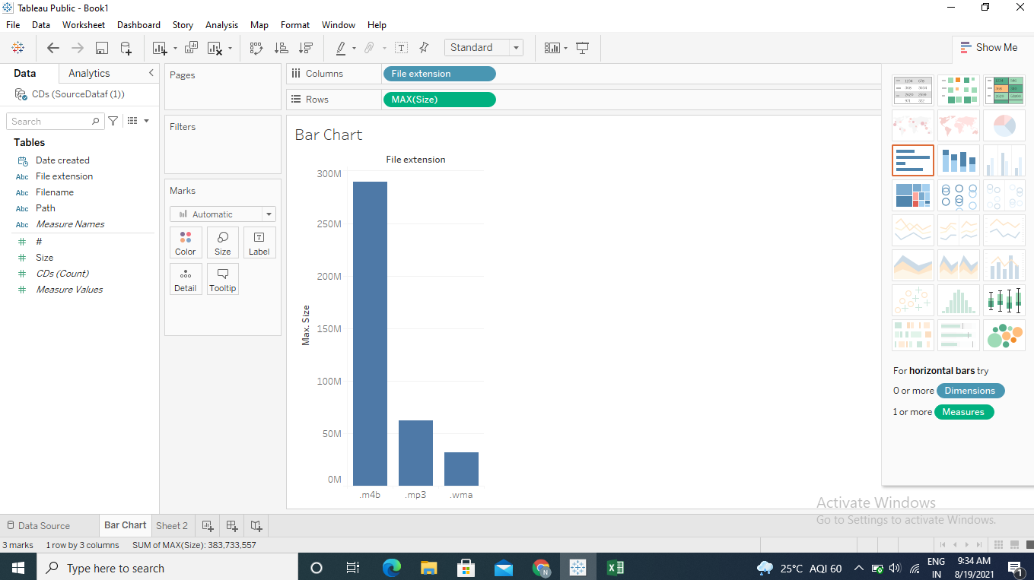

1. Connect to the HPIRegions spreadsheet in the SourceDataf workbook.
2. Create a viz (stacked bar chart) showing the Date going along the bottom (convert it continuous data and show day of date) , the Sum of the SalesVolume as the bars, and the RegionName being the color.
3. Highlight the West Midlands Region. Highlight the West Midlands Region.

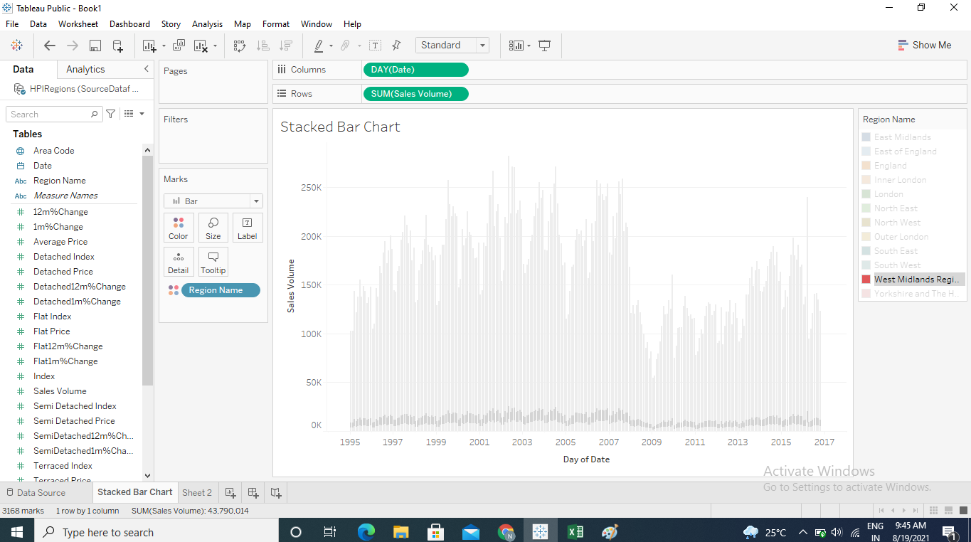

1. Connect to the HPIRegions spreadsheet in the SourceDataf workbook.
2. Create a viz (bar chart) which shows the Year (Date) (going across) by SUM (Sales Volume)

    (going up). Drag & Region Name to the Color mark. Rename this as “Viz 1”.

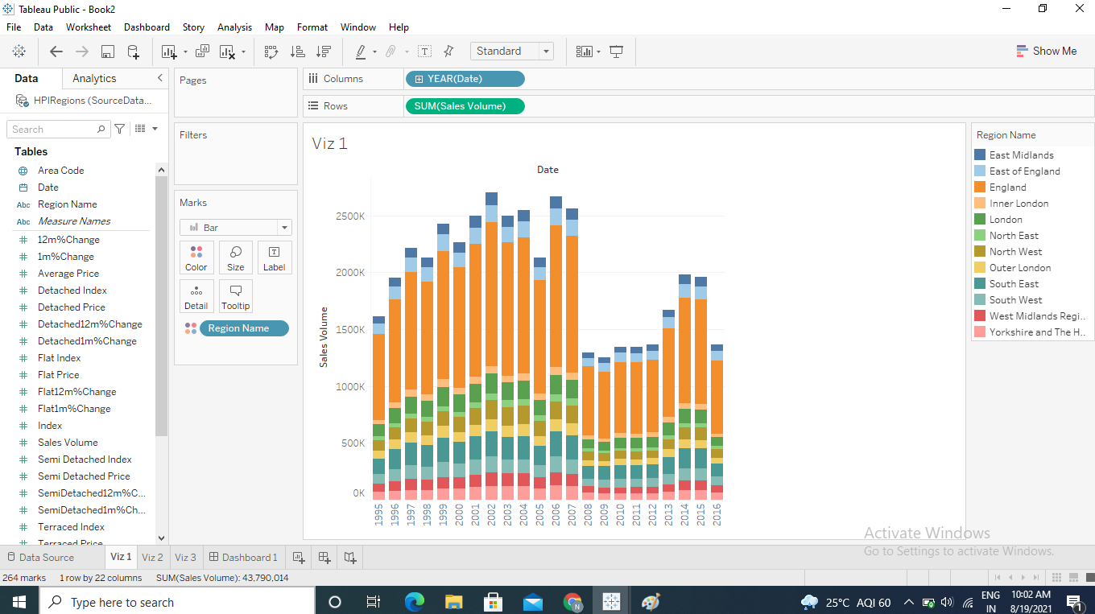

1. Create a second viz which has: Region Name on the Rows, and Sum (Sales Volume) in the

Text marks. Rename this as Viz 2.

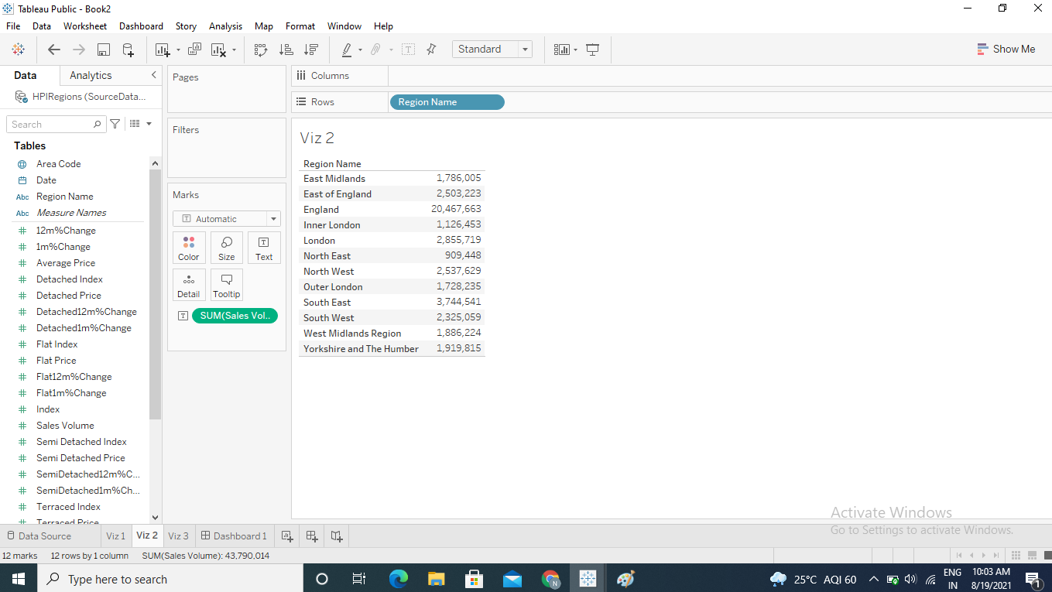

1. Create a dashboard which has:

“Viz 2” in the top-left hand corner.

 “Viz 3” in the top-right hand corner.

 “Viz 1” in the bottom half.

Before you do it, have a think about what the best order is to add the Vizzes into the

dashboard.

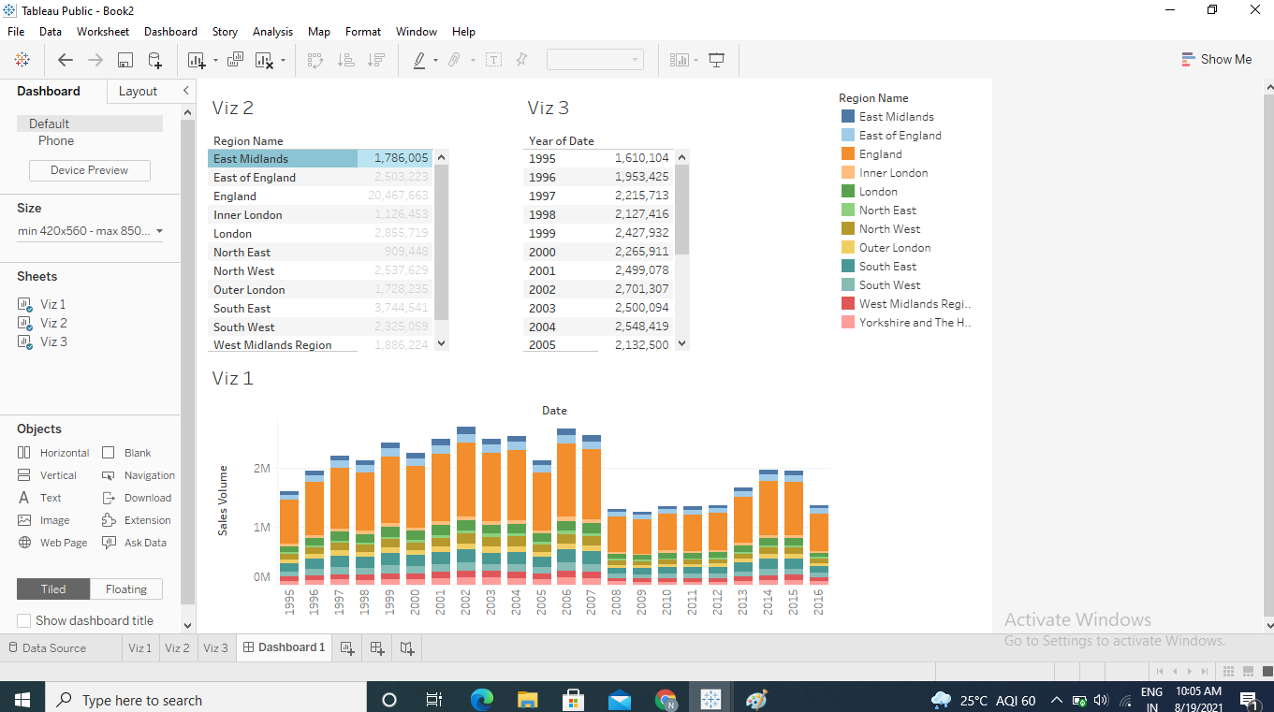

1. Click on the Use as Filter on Viz 2 and click on East “Midlands” in Viz 2. See what happens.

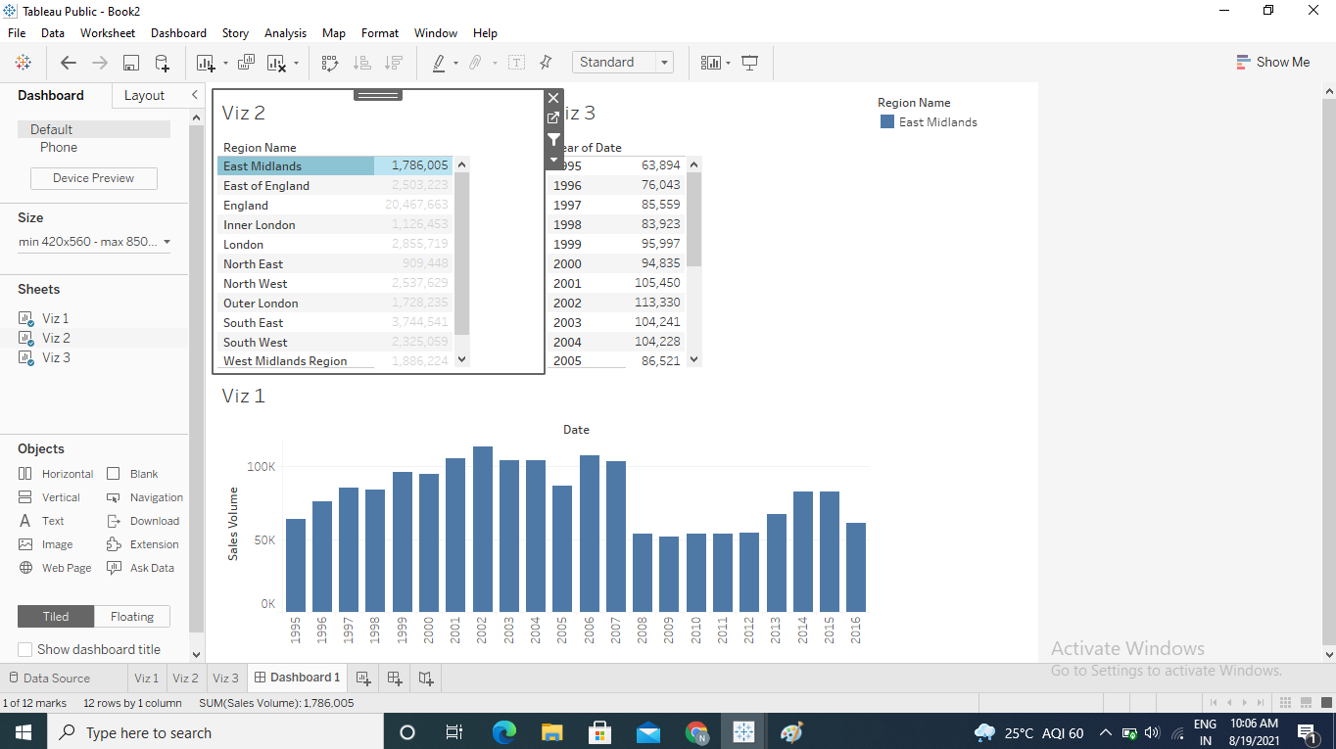

1. Create a story for the above visualizations.

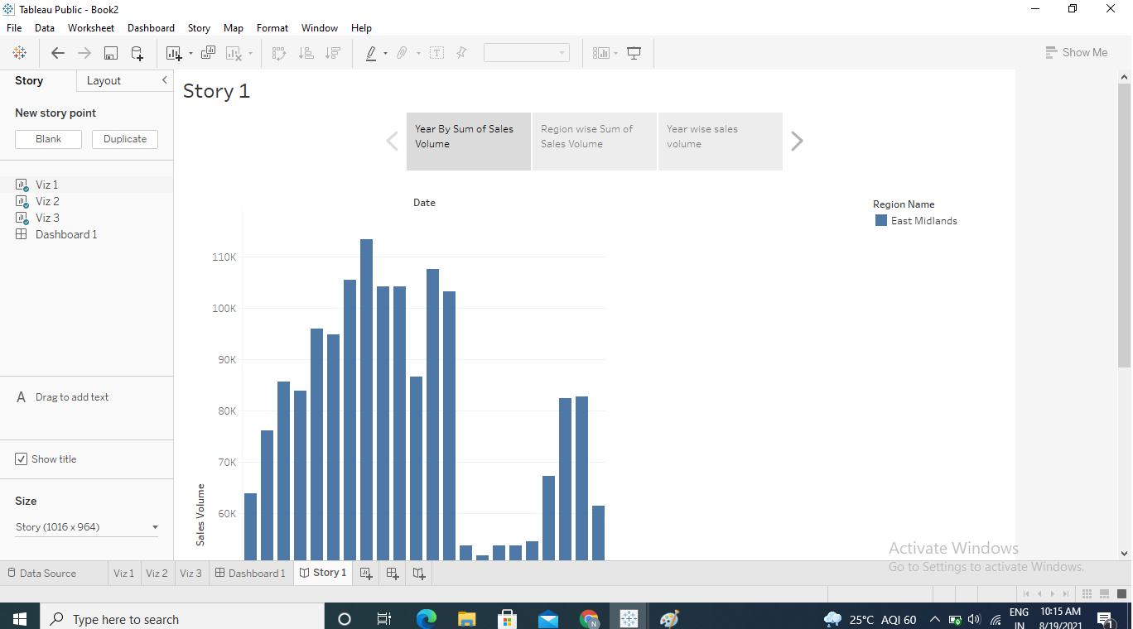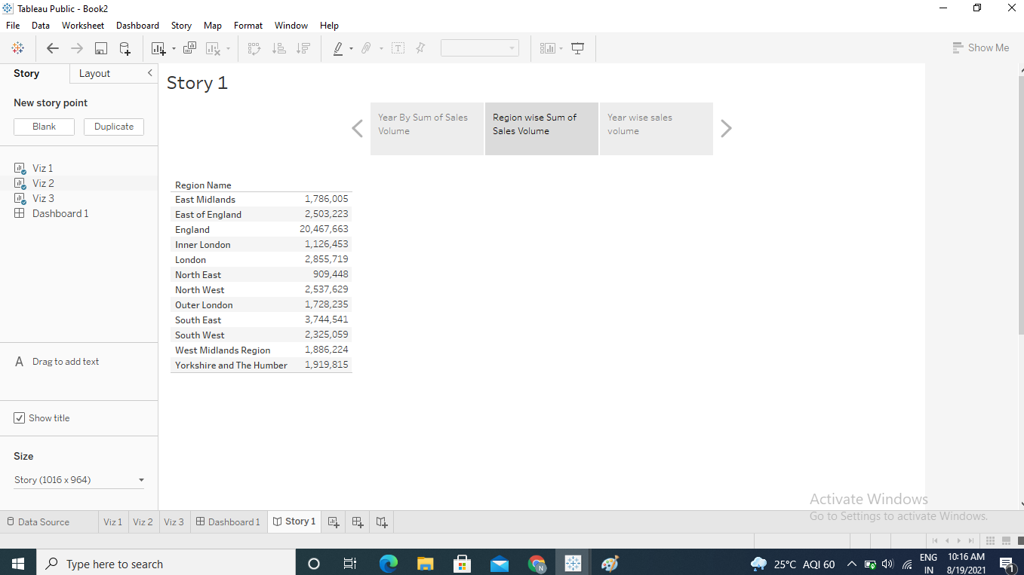

1. Connect to the HPIRegions spreadsheet in the SourceDataf workbook.
2. Create a bar chart, with RegionName and Year (Date) in the Columns shelf and AVG (Average Price) in the Rows shelf.

