Data Analytics with R

Session 1: Assignment 2

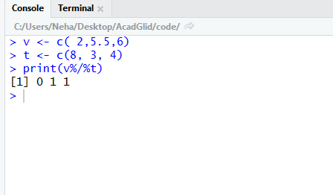

1. library(readxl)

Fi<- list.files(pattern ='*.xlsx' )

DF <- lapply(Fi,read_excel)

1. library(read.csv)

Da <- list.files(pattern ='*.csv')

DF <- lapply(Da, read_csv)