**Movie Analysis**

Created By: Nehareeka Rayat

Framework Used

Angular version: ^6.0

NPM version: 6.1.0

Node version: 8.11.3

**Functionalities**

Pagination: Displays only 10 rows per page and provides navigation to next page, previous page, last and first page. Current page is highlighted.

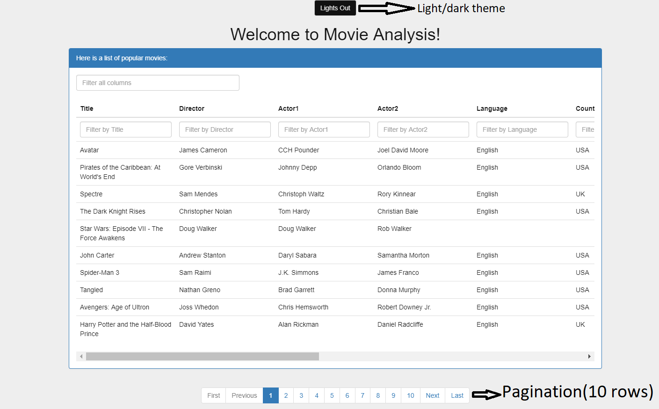

Light/Dark theme: default theme is Light. Click on the button on top tp switch between themes.

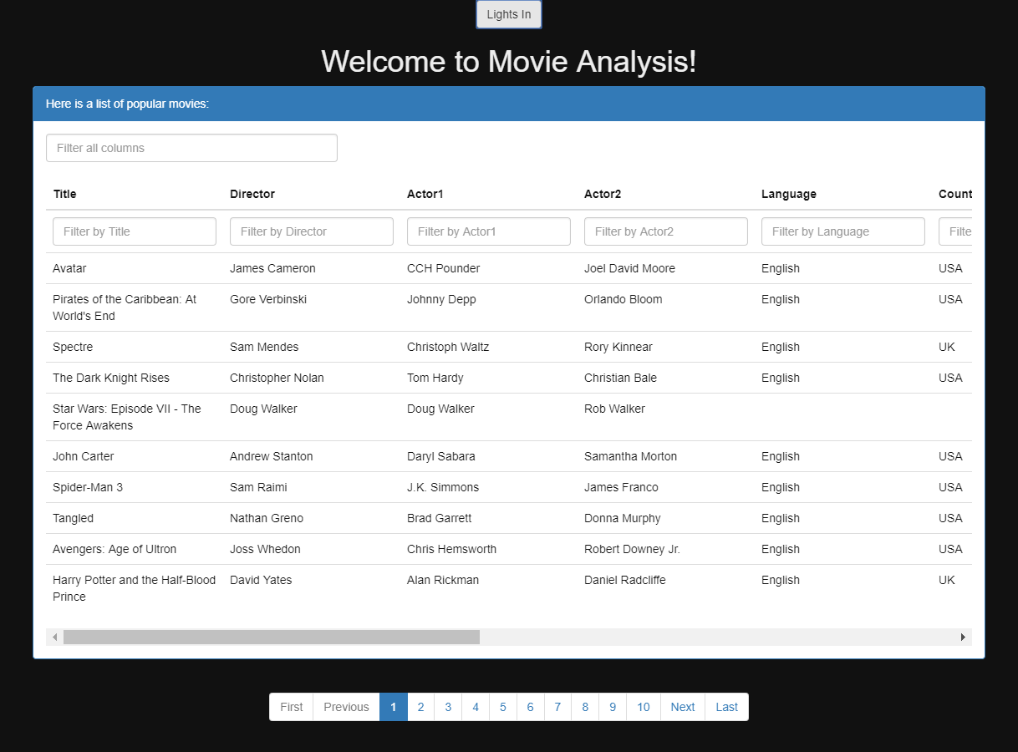

**Sort by columns:**

Sort functionality is available for all columns except the last Imdb link column. ^ arrow indicates ascending sort and down arrow sorts in descending sort. If there is no arrow, the table will go back to initial display of records as retrieved from server.

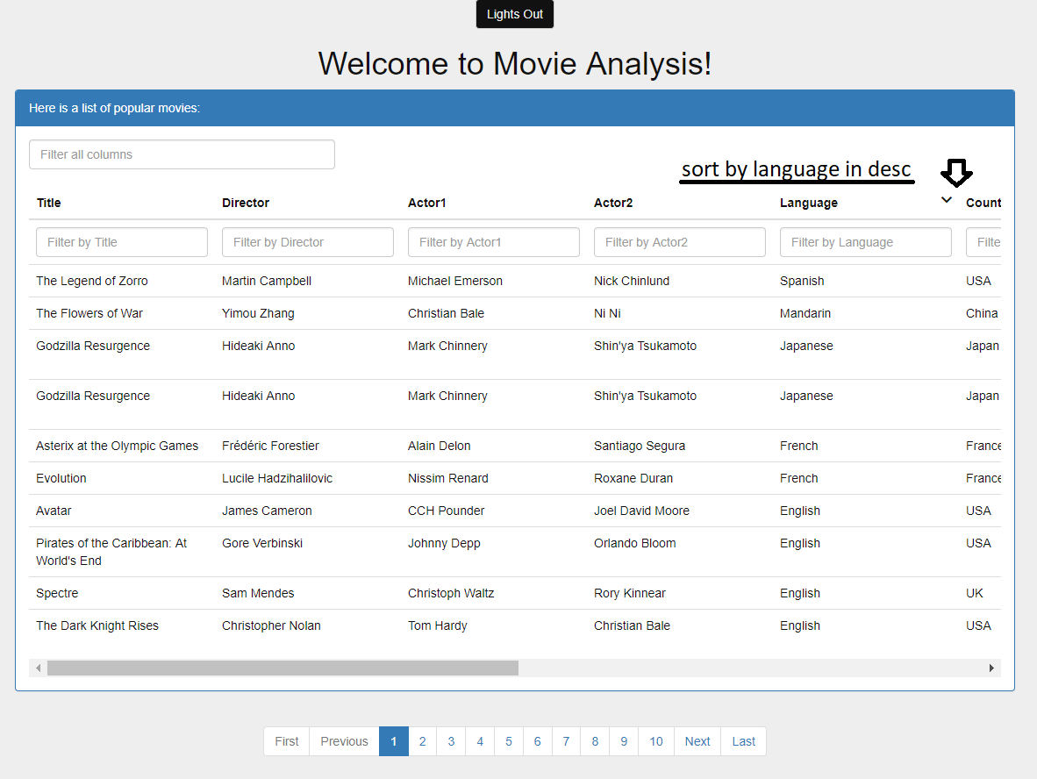

**Filter:**

Filtering is available for the entire table and also per column, except Imdb link column.

* All columns: Example, filter by “John”, all records with column value having substring “john” is listed.

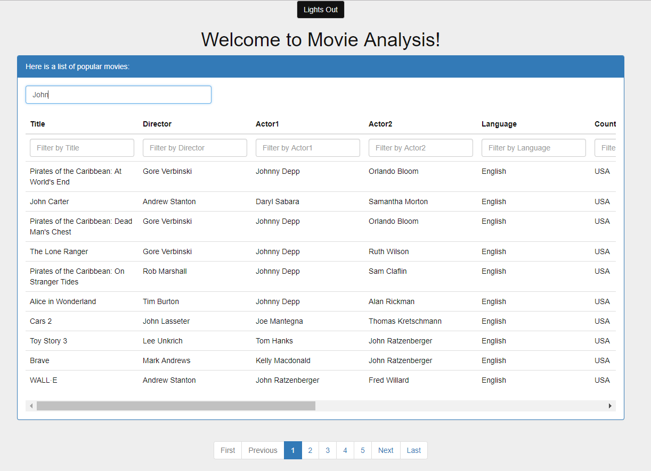

* Each column: Filter is available for each column and several columns can be filtered together

Example, Filter using all ‘UK’ ‘Drama’ movies in year ‘2014’, sorted in ascending order of ‘Budget’.

