**Movie Analysis**

Created By: Nehareeka Rayat

Framework Used

Angular version: ^6.0

NPM version: 6.1.0

Node version: 8.11.3

Front End: Angular, bootstrap, html, css

Back end: Asp.Net Core with Entity Framework

DataBase: MySQL

**Setup:**

Unzip the file and open in any editor.

Build the C# solution

For db setup, run below commands:

* dotnet ef database update
* dotnet ef migrations add InititalDb
* dotnet ef database update

Run npm install on the project root folder to install all required packages.

Run ng build to build the angular app.

Start ng build:watch

Start the C# application

**Functionalities**

Pagination: Displays only 10 rows per page and provides navigation to next page, previous page, last and first page. Current page is highlighted.

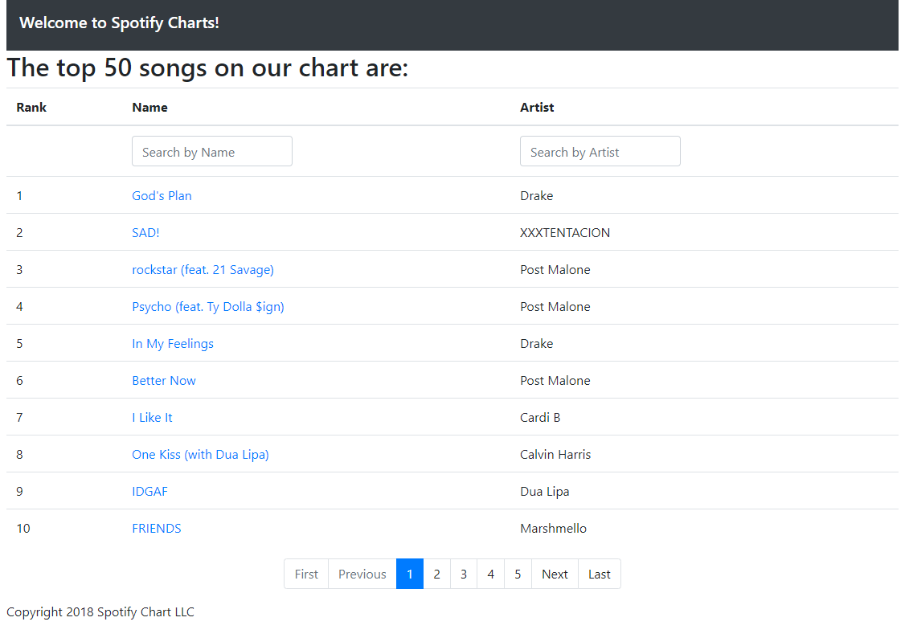

**Sort by columns:**

Sort functionality is available for all columns.

^ arrow indicates ascending sort and down arrow sorts in descending sort. This applies to only the top 50 songs in the database by rank.

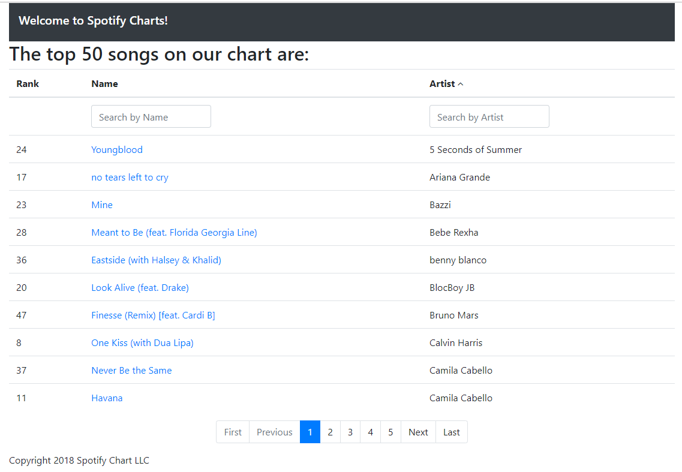

To get back to the original top 50 songs, click on Rank column and the data will be sorted by rank.

**Filter:**

Filter is available for each column and several columns can be filtered together. This is applied to all Songs in the database.

Example, Filter using all ‘artists’ whose name has “sh” with songs having string “al”

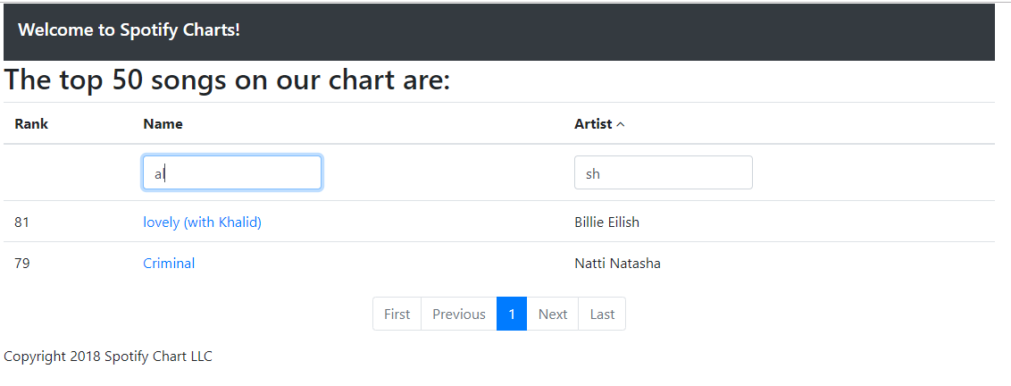

**Song Details**

Every song name is a hyperlink, clicking on which displays the details of the song as stored in the database. You can go back to the list by clicking on the back button.

