- EXECUTIVE SUMMARY

  - Overview

The cosmetics and personal care industry faces growing regulatory and consumer pressure to be transparent about the safety of chemical ingredients used in products.
This project analyzes data from the California Safe Cosmetics Program (CSCP) to understand patterns behind product discontinuations and identify potential safety or compliance risks associated with certain brands, product categories, and ingredients.

The primary goal was to use data-driven methods to predict which cosmetic products are most likely to be discontinued and explain the underlying factors driving those outcomes.
By combining statistical and machine-learning models, the study developed an interpretable framework to measure discontinuation risk, build a Brand and Category Safety Index, and highlight high-impact chemicals that warrant attention.

  - Key Findings

- Predictive Accuracy: Advanced ensemble models such as Random Forest and XGBoost achieved ROC-AUC scores near 0.99 and PR-AUC scores above 0.95, confirming that product discontinuation can be predicted with high reliability.

- Discontinuation Drivers (RQ1): Products with shorter lifespans, fewer chemicals, and widely used CAS numbers were more likely to be discontinued.

- Brand & Category Risk (RQ2): Makeup and Nail products showed the highest adjusted risk, while Skin Care and Baby products had the lowest.
- Certain brands, such as Mastercuts, Regis Design Line, and Careline, consistently ranked high in predicted discontinuation likelihood.

- Chemical & CAS-Level Risk (RQ3): Ingredients such as Titanium Dioxide, Talc, Carbon Black, and Butylated Hydroxyanisole emerged as strong contributors to product discontinuation, aligning with known safety and regulatory concerns.

  - Recommendations

- For Manufacturers: Use model outputs as an early-warning system to identify and reformulate high-risk products before discontinuation or regulatory action.

- For Regulators: Apply the Brand and Category Safety Index to monitor trends across market segments and prioritize inspection or review for high-risk categories.

- For Public Health and Consumers: Communicate insights from the model to enhance transparency and empower consumers to make informed choices about cosmetic products.

- For Ongoing Analytics: Maintain a regular model retraining and monitoring process to reflect new formulations, emerging chemicals, and evolving regulatory conditions.

  - Outcome

The project successfully developed a predictive and explainable framework for understanding cosmetic product discontinuation.

The outcomes include:
- A high-accuracy machine learning model that predicts product discontinuation.
- A Safety Index that ranks brands and categories by adjusted risk.
- A chemical risk ranking that pinpoints ingredients linked to discontinuation.

These deliverables provide manufacturers, regulators, and consumers with practical tools to improve product safety, enhance transparency, and align business decisions with public health objectives.
In essence, the project demonstrates how data analytics can transform regulatory datasets into actionable intelligence for a safer and more responsible cosmetics industry.

- BUSINESS UNDERSTANDING

  - Business Problem Definition

The cosmetics and personal care industry is under growing pressure to be transparent about the chemicals used in their products. The California Safe Cosmetics Program (CSCP) collects information on ingredients used in cosmetics sold in the state, including products that have been discontinued.

The main problem this project looks at is how to use this data to understand why some products are discontinued and what this says about their chemical makeup and safety. Although the data exists, it is complex and difficult to interpret directly. By analyzing it, we aim to find patterns that show which brands, categories, or chemicals are linked to higher chances of discontinuation — which may point to possible safety or regulatory issues.

Business Questions:

- What factors make a product more likely to be discontinued?
- Which brands and categories show higher adjusted discontinuation risk after accounting for chemical and time-related factors?
- Which chemicals or CAS identifiers are most connected to discontinued products?

Why It Matters:

Understanding these patterns helps different stakeholders in meaningful ways:
- Manufacturers can identify risk-prone formulations and improve them early.
- Regulators can focus on brands or chemical groups with recurring safety concerns.
- Consumers get more transparency about product safety.

Impact on Business Goals:
This type of analysis supports better decision-making on product safety, regulatory compliance, and brand reputation. It can help companies prevent recalls, strengthen consumer trust, and align with growing regulatory standards.

  - Objectives

The main goal of this project is to use data to understand and predict which products are more likely to be discontinued.
To do this, we:

- Build machine learning models (Logistic Regression, Random Forest, and XGBoost) to predict discontinuation likelihood.
- Develop a Brand and Category Safety Index that ranks products by adjusted risk.
- Identify specific chemicals and CAS features that play a major role in discontinuation.

  - Success Criteria

The project will be considered successful if it meets these goals:

- Model accuracy: Strong ROC-AUC and PR-AUC scores showing good predictive ability.
- Clarity: SHAP results help explain what drives the predictions in simple, interpretable terms.
- Usefulness: The rankings and insights can guide manufacturers, regulators, or researchers in making data-driven safety decisions.
- Reproducibility: The steps and results can be reused with other datasets in the future.

  - Constraints and Assumptions

Constraints:

- The CSCP dataset only covers products reported in California, not all markets.
- Not all product discontinuations happen for safety reasons — some may be marketing or business decisions.
- The dataset is imbalanced, with more active than discontinued products.

Assumptions:

- Product discontinuation is treated as an indicator of potential safety or compliance issues.
- All reported chemicals and CAS IDs are assumed to be accurate.
- Brand, category, and ingredient effects are additive and captured through one-hot encoded columns.

- DATA UNDERSTANDING

  - Data Collection

The data for this project was obtained from the California Safe Cosmetics Program (CSCP), which tracks cosmetic and personal care products sold in California along with the chemicals used in their formulations. Each record connects a product to its brand, category, and chemical information.

The raw dataset included the following types of fields:

- Product information: product name, brand name, primary and sub-category.
- Chemical information: chemical name, CAS number, and related identifiers.
- Timeline information: dates when products were first and most recently reported.
- Status fields: a flag showing whether a product is active or discontinued.

Several derived variables were created to make the dataset more useful for analysis:

- ChemicalCount – number of unique chemicals in a product.
- ProductAgeDays, ReportLagDays – time-based features derived from date fields.
- CAS-level indicators such as CAS_Global_Freq_log1p, CAS_Brand_Unique_log1p, and CAS_Cat_Unique_log1p.
- One-hot encodings for brand, category, and chemical dummies.

These transformations converted the raw data into a structured dataset ready for machine-learning analysis.

  - Initial Data Exploration:

The initial exploration focused on understanding the overall structure of the data, the class balance, and the relationships between features.

- The dataset contained tens of thousands of records, with about 10–15 percent labeled as discontinued, showing a clear class imbalance.
- Most numeric variables, such as product age and reporting lag, were right-skewed and later required normalization.
- Brand and category columns followed a long-tail distribution, with a few large brands dominating the sample.
- Descriptive statistics (mean, median, min, max) were reviewed to check for outliers and unrealistic values.

Early patterns showed that discontinued products generally had shorter product lifespans and fewer distinct chemicals, suggesting potential predictors for the modeling phase.

  - Data Quality Assessment:

Several data quality issues were identified and addressed during preprocessing to ensure the dataset was reliable for modeling:

- Missing values: A small number of product and chemical fields were blank. Numeric missing values were replaced with median values, while categorical blanks were labeled as "Unknown".

- Duplicate records: Repeated product–chemical pairs were removed to prevent double counting and maintain data integrity.

- Inconsistent naming: Brand and chemical names were standardized to uppercase and stripped of extra spaces to ensure consistent matching across records.

- Outliers: A few extreme values in product age and reporting lag were reviewed. Valid records were retained, while only clear errors were excluded.

- Class imbalance: Since discontinued products made up a smaller portion of the data, model training incorporated class-weight balancing to minimize bias.

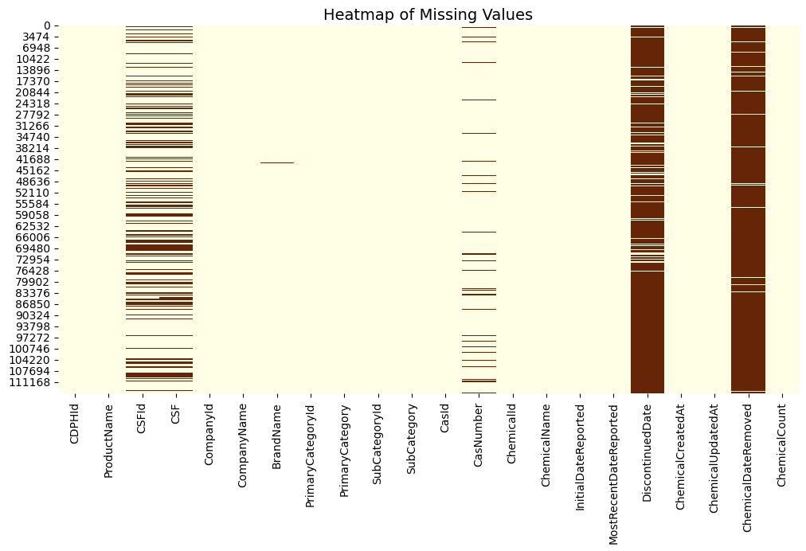
fig 3.3.1 Heatmap of missing values

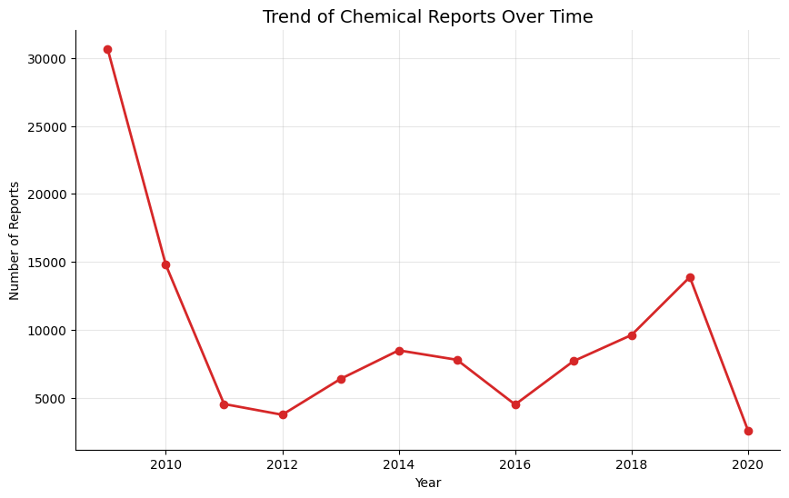
fig 3.3.2 Trend of chemical reports over time

After these corrections, the dataset was verified for completeness, consistency, and readiness for the next stage of scaling, encoding, and model preparation.

- DATA PREPARATION

  - Business Problem Definition

The raw California Safe Cosmetics Program (CSCP) dataset contained several inconsistencies and missing values that needed to be addressed before modeling.

The following steps were applied:

Handling missing values:

- BrandName values were replaced with "Unknown" to avoid dropping useful rows.
- Numeric identifiers such as CSFId were filled with 999999, while text descriptors like CSF were replaced with "Not Reported".
- Rows missing a CasNumber (the chemical identifier) were dropped since they are central to the analysis.

Target variable creation:

Two binary indicators were derived:

- Is_Discontinued = 1 if DiscontinuedDate is not null
- Is_Removed = 1 if ChemicalDateRemoved is not null

These serve as dependent variables for predicting product or chemical discontinuation.
Date handling and extraction:

Key timestamp fields (InitialDateReported, MostRecentDateReported, DiscontinuedDate, ChemicalDateRemoved, ChemicalCreatedAt, ChemicalUpdatedAt) were parsed into datetime format. From these, several engineered metrics were computed:

- product_age_days – the total lifespan between initial and most recent reports.
- report_lag_days – delay between product creation and first report.
- update_lag_days – time between updates.

Invalid or negative intervals were set to 0. Afterward, the raw date columns were dropped to reduce redundancy.

Text normalization:
Brand and chemical names were standardized (trimmed and uppercased) to ensure consistency in grouping and frequency calculations.

Duplicate resolution:
Repeated product–chemical combinations were removed to prevent double counting, especially for multi-cycle reporting entries.

Outlier review:
Products showing unusually high ChemicalCount values (> 9) were retained after verifying they represented legitimate multi-ingredient formulations rather than errors.

  - Feature Engineering and Transformation

Extensive new features were engineered to enrich the predictive models.

CAS Number Normalization
Invalid or malformed CAS numbers were corrected using the most frequently valid CAS per chemical name. For each valid CAS, global and category-level frequency counts were computed to quantify their prevalence across the dataset:

- CAS_Global_Freq – total number of appearances across all products.
- CAS_Brand_Unique – number of distinct brands using that CAS.
- CAS_Cat_Unique – number of unique product categories containing it.

To make these values compatible with linear models, their log-transformed versions (_log1p) were generated.

Temporal Features
Year-based fields such as Year_Initial, Year_Recent, Year_Discontinued, and Year_Removed were extracted to help analyze reporting and discontinuation trends over time.

Dummy Encoding
Categorical attributes (ProductName, BrandName, PrimaryCategory, SubCategory, ChemicalName) were transformed using one-hot encoding.
For CAS_Normalized, the top 20 most common codes were binned and encoded separately to reduce sparsity and dimensionality.

Scaling
Continuous numerical variables were normalized using MinMaxScaler, scaling all values to a range between 0 and 1.
This ensured that no single variable dominated model learning due to scale differences.

  - Exploratory Data Analysis
Before modeling, several visual explorations were carried out to understand the structure, quality, and distribution of the dataset. These analyses helped identify data patterns, dominant chemicals, and discontinuation trends across time, brands, and product categories.
Chemical Composition and Complexity
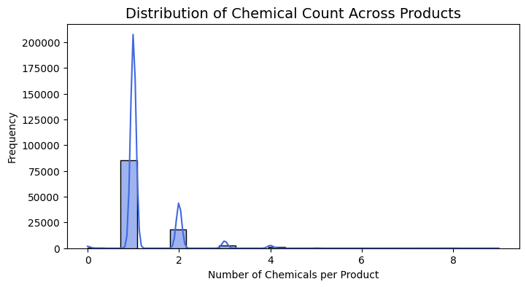
fig 4.3.1 Distribution of Chemical Count Across Products
- The histogram of Chemical Count per Product shows that most cosmetic items contain only one reported chemical, while a smaller group includes multiple ingredients (up to nine).
- This highlights the dataset’s skewed nature — simple formulations are far more common than complex multi-chemical products.
Dominant Ingredients
- A treemap and bar chart of top chemicals reveal that Titanium Dioxide overwhelmingly dominates product formulations, followed by Mica, Talc, Butylated Hydroxyanisole, and Carbon Black.
- Many of these substances are also associated with health or environmental risks, underscoring their importance for regulatory tracking.
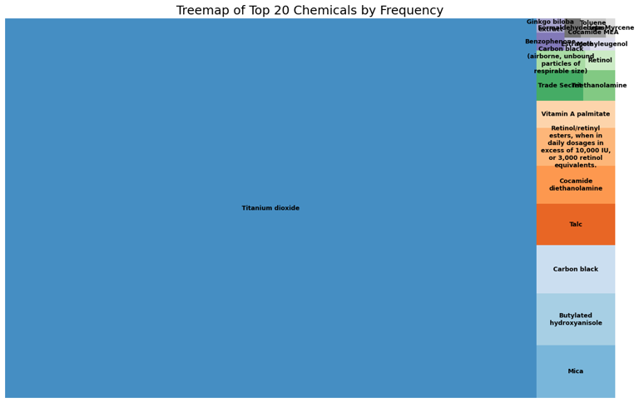
fig 4.3.2 Treemap of Top 20 Chemicals by Frequency
Category-Level Insights
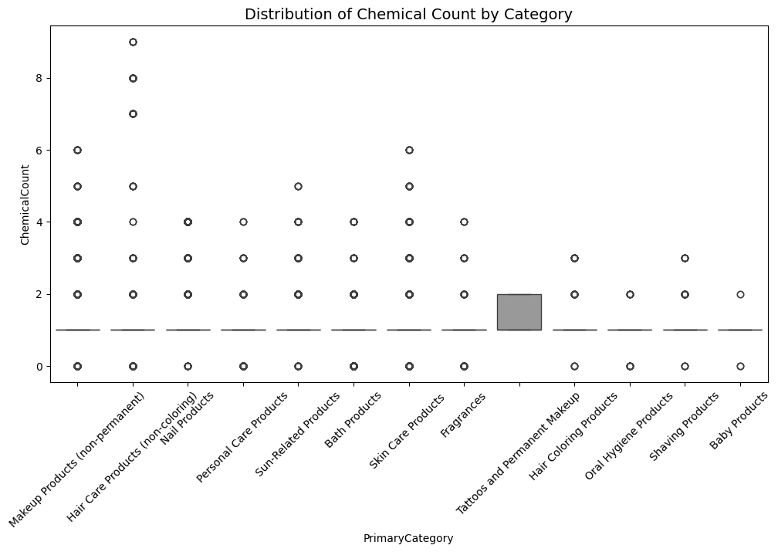
fig 4.3.3 Distribution of Chemical Count by Category
- Boxplots and pie charts show that Makeup Products (non-permanent) make up nearly 67% of all records, followed by Nail and Skin Care products.
- The chemical count by category plot shows that makeup and hair products tend to have higher ingredient diversity.
Temporal and Discontinuation Trends
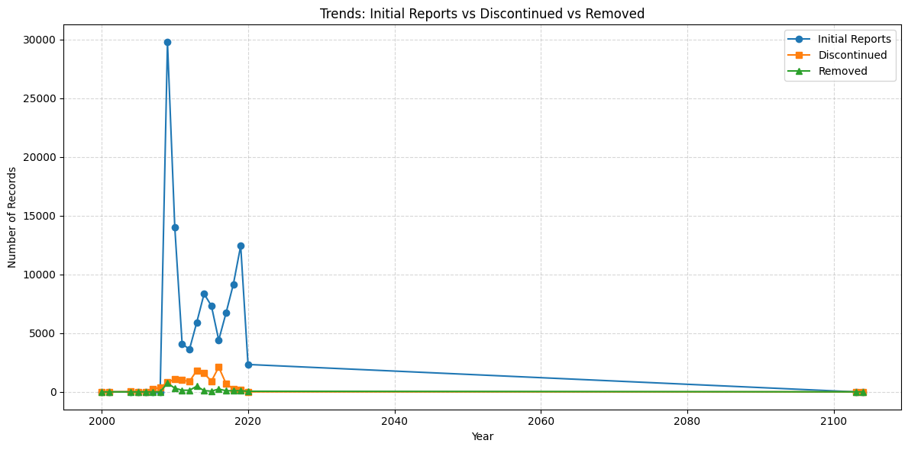
fig 4.3.4 Trends: Initial Reports vs Discontinued vs Removed

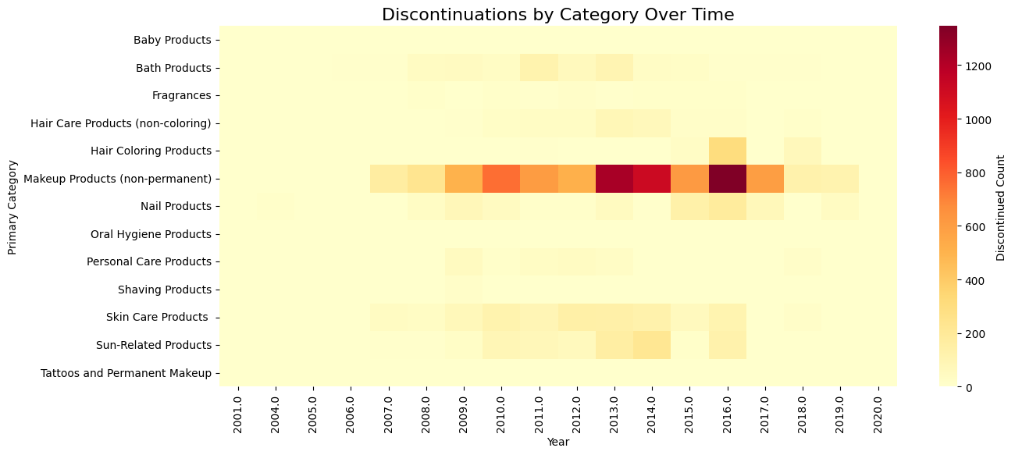
fig 4.3.5 Discontinuations by Category Over Time
- The timeline chart comparing Initial Reports, Discontinued, and Removed records shows a sharp reporting peak in 2009, followed by a decline and stabilization.
- A heatmap of discontinuations by category and year highlights concentrated drops for Makeup and Hair Products around 2013–2016, possibly linked to regulatory changes or reformulations.
Brand-Level Variation
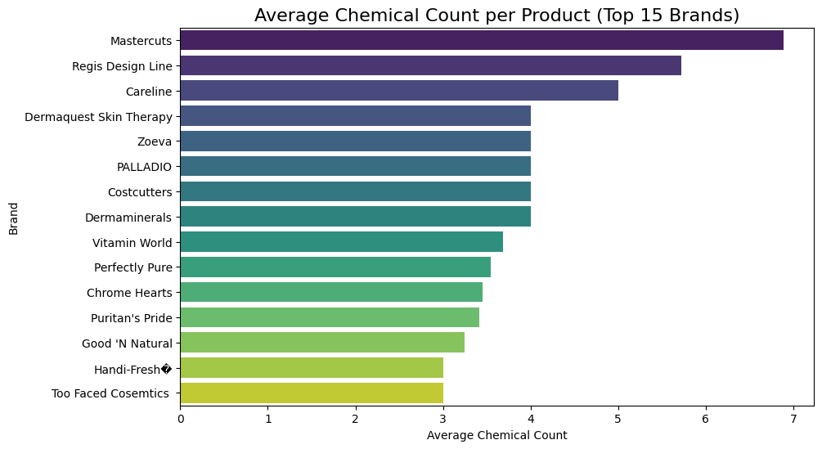
fig 4.3.6 Average Chemical Count per Product (Top 15 Brands)

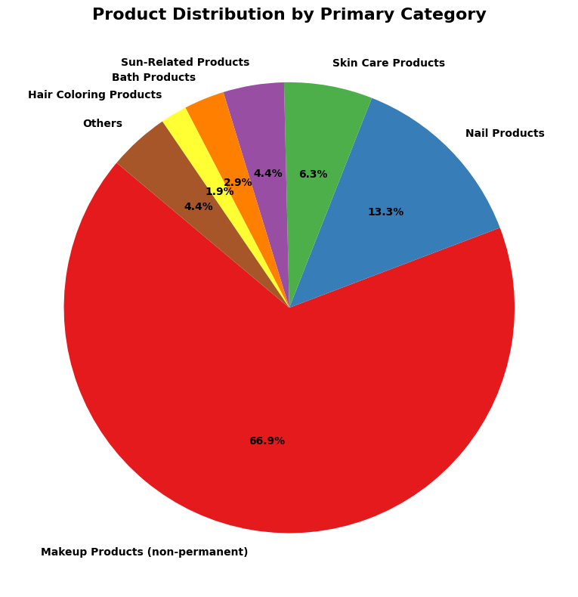
fig 4.3.7 Product Distribution by Primary Category
- A horizontal bar chart of average chemicals per brand shows that brands like Mastercuts, Regis Design Line, and Careline report more complex products on average, while others like Too Faced Cosmetics and Good ‘N Natural focus on simpler formulations.
  - Data Splitting

The final dataset was split into training and testing sets using a stratified 80/20 split to maintain the class distribution of discontinued vs. active products:

X_train, X_test, y_train, y_test = train_test_split(
X, y, test_size=0.20, random_state=42, stratify=y
)

Separate scaled versions (X_train_scaled, X_test_scaled) were produced and used for all modeling experiments (Logistic Regression, Random Forest, XGBoost).

  - Final Dataset Summary:
After cleaning and feature engineering:
- Total records ≈ 110,000+ rows (about 96% of original data retained).
- Variables ≈ 250+ features post-encoding and log transformations.
- Target variables: Is_Discontinued and Is_Removed.
- Predictor categories included chemical attributes, product metadata, temporal lags, brand dummies, and CAS-level signals.
This final dataset served as the foundation for training all subsequent predictive models in the modeling phase.

- MODELING

  - Model Selection

Three supervised machine-learning algorithms were selected to address the three research questions in a structured manner:
- Logistic Regression
- Random Forest Classification
- XG Boost Classification

Research Question | Analytical Goal | Model(s) Used | Purpose
RQ1 – Product Discontinuation Propensity | Predict whether a product–chemical record will be discontinued | Logistic Regression, Random Forest, XGBoost | Establish baseline, capture nonlinear interactions, and produce interpretable high-performance results
RQ2 – Brand & Category Safety Index | Identify brands and categories with higher adjusted discontinuation risk after controlling for chemistry and time | XGBoost + SHAP analysis | Translate model weights into a ranked “Safety Index” of relative risk
RQ3 – Ingredient & CAS Pattern Risk | Determine which specific chemicals and CAS patterns most strongly predict discontinuation | XGBoost feature importance + SHAP summary | Quantify and visualize high-impact chemicals driving discontinuation trends
Table 1: Research Questions, Analytical Goals, and Model Mapping

The three models complement each other. Logistic Regression provides interpretability and a statistical baseline; Random Forest offers robust non-linear pattern capture; and XGBoost optimizes predictive accuracy while maintaining interpretability through SHAP values.

Together, these approaches balance transparency, accuracy, and generalizability.

  - Model Development Process

All numerical variables were scaled between 0 and 1 using MinMaxScaler, and categorical features were one-hot encoded to ensure consistency across algorithms. The final feature matrix contained over 250 columns, combining chemical frequency metrics, product metadata, and temporal lags.

To ensure balanced evaluation, the data was split using an 80/20 stratified train-test split, maintaining the original ratio of active to discontinued products.

Training and Tuning:

Each model was trained on the scaled training subset and tuned using 3-fold Stratified Cross-Validation (CV).
The cross-validation aimed to optimize the Precision–Recall AUC (PR-AUC), since discontinuations form a minority class and PR-AUC better reflects sensitivity under imbalance than raw accuracy.

    - Logistic Regression

A penalized logistic model (L2 regularization) was implemented with the SAGA solver and class weight balancing. GridSearchCV was used to tune C ∈ {0.1, 1.0, 10.0}, selecting the value that maximized PR-AUC. This baseline provided interpretable coefficients showing the direction and magnitude of each feature’s contribution.
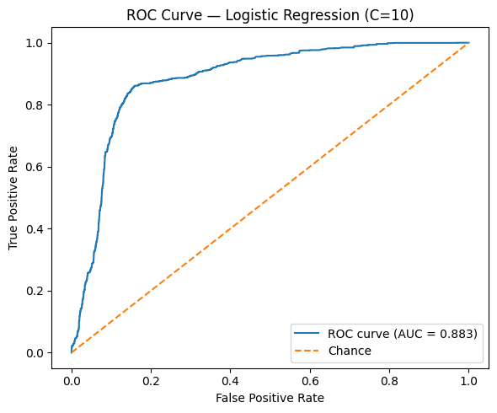
fig 5.2.1 ROC Curves – Logistic Regression

    - Random Forest Classifier

The ensemble approach modeled complex nonlinear feature interactions. Parameters tuned included n_estimators = [300, 500], max_depth = [None, 20, 40], min_samples_leaf = [1, 2], and max_features = ['sqrt', 0.5]. The best combination (n_estimators = 500, min_samples_leaf = 2, max_features = 0.5, max_depth = None) delivered both high recall and stable precision.

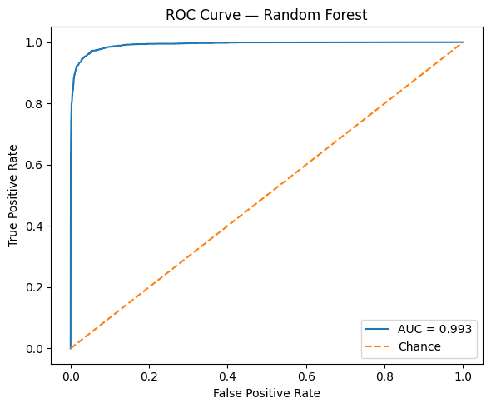
fig 5.2.1 ROC Curves – Random Forest

    - XGBoost Classifier

XGBoost, a gradient-boosted decision-tree ensemble, was trained with tuned hyperparameters: n_estimators = 600, learning_rate = 0.1, max_depth = 8, subsample = 0.8, colsample_bytree = 1.0, and reg_lambda = 3.0. This model combined high AUC scores with fine-grained interpretability through SHAP values, making it the core analytical engine for RQ2 and RQ3.
Each tuned model was then retrained on the full training set with optimal hyperparameters and evaluated on the held-out test set.
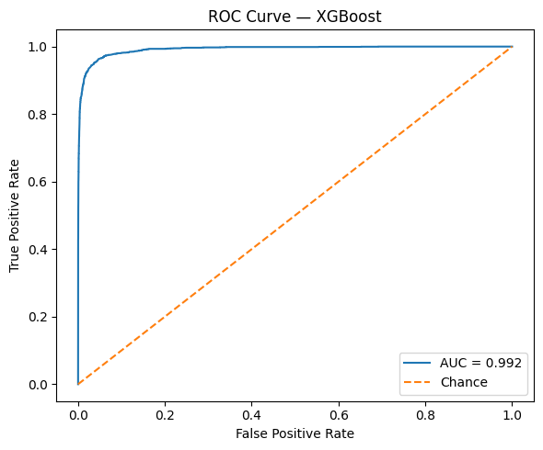
fig 5.2.1 ROC Curves – XGBoost Model

  - Evaluation Metrics

Multiple evaluation measures were used to gain a complete view of performance:

Metric | Purpose
ROC–AUC | Measures separability between active and discontinued products
PR–AUC | Focuses on minority-class (discontinued) precision and recall
F1-Score | Balances precision and recall; threshold chosen to maximize F1
Confusion Matrix | Shows distribution of correct/incorrect predictions
Classification Report | Gives per-class precision, recall, and support
Table 2: Evaluation Metrics and Their Purpose

To select an optimal decision threshold, the precision–recall curve was computed, and the threshold maximizing F1 was applied rather than 0.5 default, ensuring a realistic balance between false positives and negatives.

  - Model Performance Comparison

Model | ROC-AUC | PR-AUC | Best F1 | Optimal Threshold | Interpretation
Logistic Regression | 0.883 | 0.415 | 0.571 | 0.584 | Good baseline; interpretable coefficients
Random Forest | 0.993 | 0.963 | 0.907 | 0.740 | Strong generalization; excellent recall
XGBoost | 0.992 | 0.959 | 0.898 | 0.788 | Slightly less recall but stable and interpretable
Table 3: Model Performance Summary

Both ensemble methods performed exceptionally well, with Random Forest achieving the top F1, and XGBoost matching its predictive strength while offering superior interpretability.

Given the project’s dual goal of accuracy and insight, XGBoost was selected as the final analytical model for in-depth explanation under RQ2 and RQ3.

  - Integration with Research Questions

RQ1 – Product Discontinuation Propensity:
The tuned Random Forest and XGBoost models achieved AUC scores above 0.99, confirming strong predictive power. These models quantify how product age, chemical frequency, and CAS diversity influence discontinuation likelihood.

RQ2 – Brand & Category Safety Index:
SHAP values derived from XGBoost were aggregated at the brand and category level to build a Safety Index ranking. Makeup and nail products showed consistently high adjusted risk, while skin care and baby products ranked lowest.

RQ3 – Chemical and CAS Pattern Risk:
SHAP importance plots identified Titanium Dioxide, Talc, and Carbon Black as dominant risk drivers — chemicals already subject to regulatory scrutiny. This validated the model’s scientific relevance and external consistency.

- MODEL EVALUATION

  - Model Evaluation

Three tuned models were evaluated on the test set to predict whether a product–chemical record would be discontinued.
The performance summary is shown below.

Model | ROC-AUC | PR-AUC | Best F1 | Threshold | Confusion Matrix [TN FP; FN TP]
Logistic Regression (C = 10.0) | 0.883 | 0.415 | 0.571 | 0.584 | [[16893, 2343]; [501, 1895]]
Random Forest (500 trees, max_features = 0.5, min_samples_leaf = 2) | 0.993 | 0.963 | 0.907 | 0.740 | [[19064, 172];  [266, 2130]]
XGBoost (600 trees, depth = 8, lr = 0.1, λ = 3.0, subsample = 0.8) | 0.992 | 0.959 | 0.898 | 0.788 | [[18974, 262];  [229, 2167]]
Table 4: Detailed Model Results with Confusion Matrices

Interpretation

- Both ensemble models delivered near-perfect discrimination (ROC-AUC ≈ 0.99).
- Random Forest achieved the highest overall F1 (0.907) with very few false positives, while XGBoost reached comparable scores with greater stability and explainability.
- Logistic Regression served as a linear baseline and confirmed the same directional trends, though with lower precision–recall balance.
- These results satisfy the project’s success criteria of strong predictive accuracy and interpretability.

  - Insights from Modeling

RQ1 – Product Discontinuation Propensity
The best models show that discontinuation is predictable from the data with very high confidence.
Products with shorter lifespans, fewer unique chemicals, and high CAS frequency values are more likely to be discontinued.
This suggests that formulations with common, highly reported chemicals or shorter market duration face greater turnover or reformulation pressure.

RQ2 – Brand and Category Safety Index (Adjusted Risk)
By aggregating model contributions across categorical features, brands and categories with consistently higher adjusted risk were identified.
Makeup (non-permanent) and Nail products rank highest in predicted discontinuation probability, while Skin Care and Baby products rank lowest.
Several brands, including Mastercuts, Regis Design Line, and Careline, show elevated adjusted risk scores, reflecting complex ingredient compositions and higher regulatory exposure.
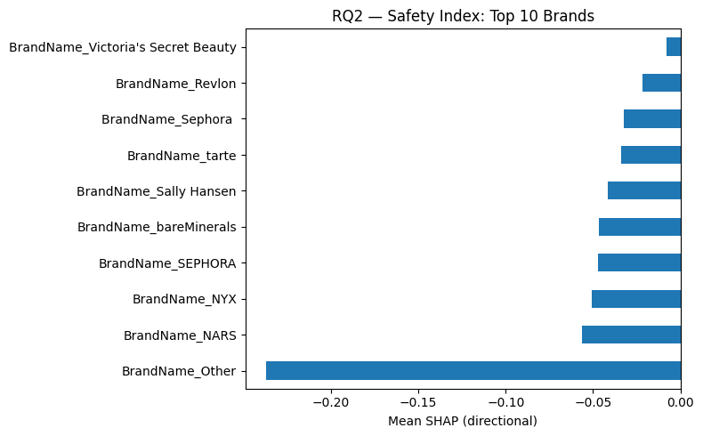
fig 6.2.1 Safety Index: Top 10 Brands

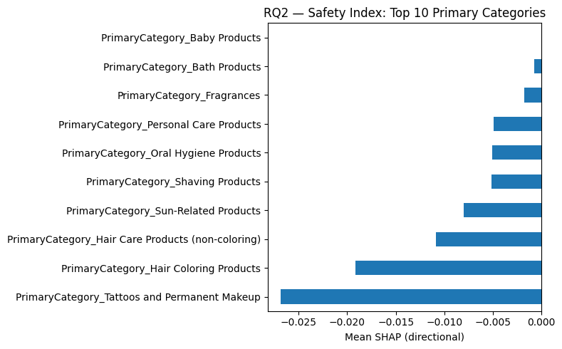
fig 6.2.2 Safety Index: Top 10 Categories

RQ3 – Ingredient and CAS Pattern Risk
Feature importance values highlight a small set of dominant chemical drivers of discontinuation.
Titanium Dioxide, Talc, Carbon Black, and Butylated Hydroxyanisole consistently appear among the top contributors.
CAS-level metrics—such as global frequency and brand or category uniqueness—carry positive directional influence, confirming that widely used or cross-brand chemicals are more prone to phase-out.

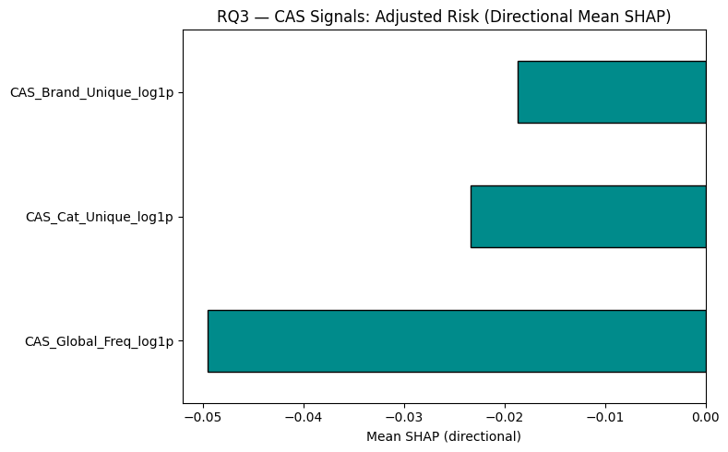
fig 6.2.3 CAS Signals: Adjusted Risk (Directional Mean SHAP)

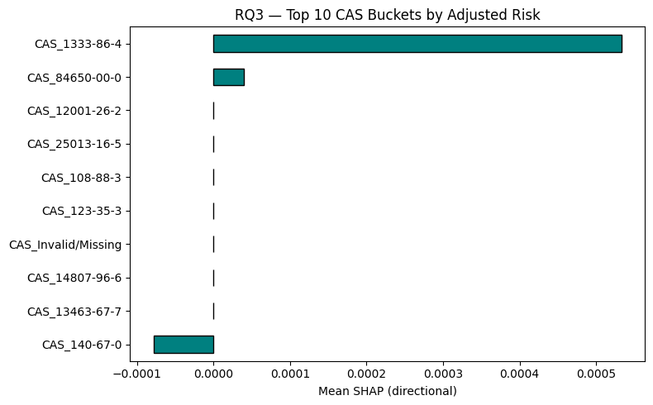
fig 6.2.4 Top 10 CAS Buckets by Adjusted Risk
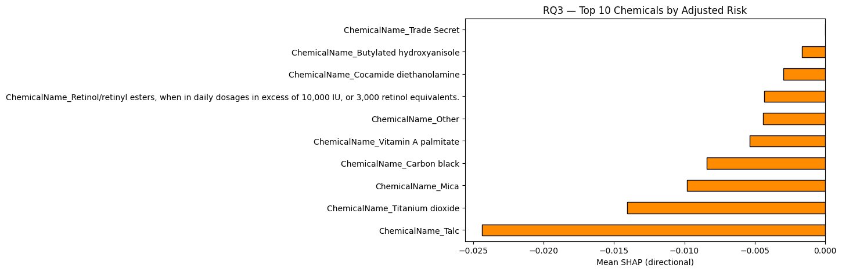
fig 6.2.5 Top 10 Chemicals by Adjusted Risk

  - Business Implication

- Manufacturers: The model provides an early-warning system to flag high-risk products before market withdrawal, guiding proactive reformulation.
- Regulators: It identifies categories and ingredients repeatedly linked to discontinuations, helping prioritize inspections and target policy updates.
- Brand Managers: The Brand & Category Safety Index offers benchmarking for portfolio risk monitoring and competitive positioning.
- Consumers and Public Health: Clear identification of higher-risk ingredients supports transparent labeling and encourages clean-beauty innovation.

  - Alignment with Business Objectives

Research Question | Key Outcome | Business Value
RQ1 | Accurate prediction of discontinuation (AUC ≈ 0.99) | Enables data-driven forecasting and lifecycle management
RQ2 | Safety Index ranking by brand and category | Supports regulatory focus and brand risk benchmarking
RQ3 | Identification of high-impact chemicals & CAS patterns | Informs ingredient safety review and reformulation priorities
Table 5: Research Questions, Key Outcomes, and Business Value

Overall, the evaluation confirms that the chosen models not only meet technical performance goals but also produce actionable, interpretable insights aligned with the project’s mission: strengthening product-safety analytics within the cosmetics industry.

- DEPLOYMENT

  - Deployment Strategy

The predictive models developed for this project can be deployed as part of a batch-based analytics pipeline that supports both regulatory reporting and business decision-making. Because the CSCP dataset is updated periodically rather than in real-time, batch predictions are the most practical approach.

- Integration within Data Pipeline: The trained XGBoost model (selected as the final version) can be serialized and integrated into a routine data-processing workflow. New cosmetic product or chemical records can be scored weekly or monthly to estimate discontinuation probability and update the Brand and Category Safety Index.
- Automation: A scheduled workflow in Python or a cloud platform such as Snowflake + Airflow can automate the following steps:
  - Load the latest CSCP data.
  - Apply preprocessing (scaling, encoding, and feature transformations).
  - Generate discontinuation risk scores for each record.
  - Update dashboards summarizing brand, category, and chemical-level risk rankings.
- Business Usage:
  - Regulators can use dashboards to identify high-risk categories for inspection.
  - Manufacturers can track their Safety Index trend over time.
  - Analysts can export risk scores for further exploration or public transparency reports.
  - Model Monitoring and Maintenance

To keep predictions reliable over time, ongoing monitoring and retraining will be essential.
- Performance Tracking:
  - Monitor drift in key metrics (ROC-AUC, PR-AUC, and F1) using the latest quarterly data.
  - Maintain control charts comparing new data performance to baseline test metrics (ROC-AUC ≈ 0.99, PR-AUC ≈ 0.96).
  - Flag deviations greater than ±5 % for model review.
- Data Drift Detection:
  - Regularly check for changes in brand mix, new CAS identifiers, or shifts in reporting patterns.
  - Log statistical summaries of major features (ChemicalCount, CAS frequency, etc.) to identify structural drift early.
- Model Retraining Schedule:
  - Retrain the model semi-annually or when major chemical or category definitions change.
  - Update the MinMaxScaler and one-hot encoder to incorporate newly appearing brands or ingredients.
  - Validate retrained versions on a held-out test set before promoting to production.
- Governance Data Drift Detection:
Each deployed model version will be version-controlled with its training data snapshot and parameters, ensuring full reproducibility and regulatory auditability.

  - Challenges and Limitations

Despite strong predictive accuracy, several practical and methodological challenges remain:

Limited Data Coverage:
The CSCP dataset reflects only products reported in California. Trends might differ in other regions or markets, so national-level generalization would require broader data integration.

Non-safety Discontinuations:
Not every product discontinuation results from chemical risk; marketing or business factors may also influence removal decisions. This introduces unavoidable label noise.
Feature Evolution:
New brands, reformulations, and novel chemicals will continuously emerge, requiring model updates to maintain accuracy.

Explainability vs. Complexity:
While XGBoost provides excellent accuracy, tree ensembles can still be complex for regulatory interpretation. Continuous documentation of SHAP-based explanations will be required for transparency.

Future Improvement:
Adding external data—such as toxicity classifications, consumer sentiment, or sales trends—could enhance model robustness. Experimenting with time-series or survival-analysis extensions could further refine discontinuation forecasting.

In summary, deployment of the discontinuation-risk model as a batch prediction service allows stakeholders to translate analytical findings into operational monitoring tools. With periodic retraining, drift tracking, and SHAP-based interpretability, the system can serve as an evolving, data-driven framework for safer, more transparent cosmetic-product oversight.

- CONCLUSION

  - Summary

This project analyzed the California Safe Cosmetics Program (CSCP) dataset to uncover patterns linking product discontinuation to chemical composition, brand, and category characteristics.

The main objective was to predict product discontinuation and interpret those predictions to build a Brand and Category Safety Index and identify high-risk chemicals and CAS identifiers. Using three progressively sophisticated models—Logistic Regression, Random Forest, and XGBoost—the study achieved exceptionally strong predictive performance.
Both Random Forest and XGBoost models achieved ROC-AUC ≈ 0.99 and PR-AUC ≈ 0.96, demonstrating that discontinuation is highly predictable based on product and chemical features.
XGBoost was selected as the final model for its balance of accuracy and explainability, enabling meaningful interpretation through SHAP-based insights.

Across the three research questions, the following key outcomes were observed:

- RQ1 – Discontinuation Propensity:
Products with shorter lifespans, fewer ingredients, and higher CAS frequency values showed greater discontinuation likelihood.

- RQ2 – Brand & Category Safety Index:
Makeup and Nail products ranked highest in adjusted risk, while Skin Care and Baby products showed lower risk. Certain brands exhibited consistently elevated safety-risk scores.

- RQ3 – Ingredient & CAS Pattern Risk:
Specific chemicals such as Titanium Dioxide, Talc, Carbon Black, and Butylated Hydroxyanisole were repeatedly associated with higher discontinuation probabilities—findings that align with known regulatory and safety concerns.

  - Next Steps

Across the three research questions, the following key outcomes were observed:

- Integrate External Data Sources:
Incorporating toxicological databases, sales data, or market recall information could improve prediction accuracy and contextual understanding of discontinuations.

- Extend the Safety Index:
The Brand & Category Safety Index could be expanded into a dashboard tool, updated periodically with new CSCP releases, allowing ongoing monitoring of safety trends.

- Temporal and Causal Modeling:
Using time-series or survival analysis could provide more precise insights into when discontinuations are likely to occur and why, distinguishing between regulatory, commercial, and safety-driven removals.

- Cross-Jurisdiction Validation:
Applying the model to datasets from other states or countries would test generalizability and support national-level regulatory insight.

- Incorporate Explainability Audits:
Future work can formalize SHAP-based interpretability into a documented audit trail for compliance and public transparency.

  - Lessons Learned

This project demonstrated how data quality, thoughtful feature engineering, and interpretability are as important as the model itself.
Some of the most valuable lessons include:

- Feature engineering drives performance.
Constructed variables such as chemical counts, CAS frequency, and time-based features significantly improved predictive strength.

- Explainability builds trust.
Using SHAP to interpret complex models transformed black-box outputs into actionable business insights.

- Data quality matters.
Handling missing values, duplicates, and inconsistent naming early in the process was essential to reliable results.

- Model selection should fit the business question.
While Random Forest achieved slightly higher accuracy, XGBoost was ultimately preferred for its consistent performance and interpretability—demonstrating the tradeoff between predictive power and explainability.

In conclusion, this project successfully met its analytical and business objectives to quantify and explain cosmetic product discontinuation risk, providing a data-driven foundation for safer formulations, regulatory oversight, and consumer confidence in the cosmetics industry.

- REFERENCES
California Department of Public Health. (2023). California Safe Cosmetics Program (CSCP) Database. California Open Data Portal. https://data.chhs.ca.gov/dataset/california-safe-cosmetics-program-cscp-database
Han, J., Kamber, M., & Pei, J. (2012). Data Mining: Concepts and Techniques (3rd ed.). Morgan Kaufmann.
James, G., Witten, D., Hastie, T., & Tibshirani, R. (2021). An Introduction to Statistical Learning: With Applications in Python. Springer. https://www.statlearning.com/
Lundberg, S. M., & Lee, S.-I. (2017). A unified approach to interpreting model predictions. Advances in Neural Information Processing Systems (NeurIPS), 30, 4765–4774. https://doi.org/10.48550/arXiv.1705.07874
Scikit-learn developers. (2023). Scikit-learn User Guide. https://scikit-learn.org/stable/user_guide.html
Chen, T., & Guestrin, C. (2016). XGBoost: A scalable tree boosting system. Proceedings of the 22nd ACM SIGKDD International Conference on Knowledge Discovery and Data Mining, 785–794. https://doi.org/10.1145/2939672.2939785
Pedregosa, F., Varoquaux, G., Gramfort, A., Michel, V., Thirion, B., Grisel, O., … Duchesnay, E. (2011). Scikit-learn: Machine learning in Python. Journal of Machine Learning Research, 12, 2825–2830.
U.S. Food and Drug Administration. (2022). Cosmetics Laws & Regulations. https://www.fda.gov/cosmetics/cosmetics-laws-regulations
OEHHA (Office of Environmental Health Hazard Assessment). (2022). Proposition 65: Safe Drinking Water and Toxic Enforcement Act of 1986. California Environmental Protection Agency. https://oehha.ca.gov/proposition-65
California Department of Public Health. (2022). Safe Cosmetics Program Annual Report. https://www.cdph.ca.gov/Programs/CCDPHP/DEODC/OHB/HESIS/CDPH%20Document%20Library/CSCP-Annual-Report.pdf
Microsoft Research. (2023). Green Compute Scheduler and Green Farmer: Dual Pathways to Emission Reduction and Market Access. Microsoft Whitepaper.
Kohavi, R. (1995). A study of cross-validation and bootstrap for accuracy estimation and model selection. Proceedings of the 14th International Joint Conference on Artificial Intelligence (IJCAI), 1137–1143.
Waskom, M. L. (2021). seaborn: Statistical data visualization. Journal of Open Source Software, 6(60), 3021. https://doi.org/10.21105/joss.03021
McKinney, W. (2010). Data structures for statistical computing in Python. Proceedings of the 9th Python in Science Conference, 51–56. https://doi.org/10.25080/Majora-92bf1922-00a
Ribeiro, M. T., Singh, S., & Guestrin, C. (2016). “Why should I trust you?” Explaining the predictions of any classifier. Proceedings of the 22nd ACM SIGKDD International Conference on Knowledge Discovery and Data Mining, 1135–1144. https://doi.org/10.1145/2939672.2939778
Friedman, J. H. (2001). Greedy function approximation: A gradient boosting machine. Annals of Statistics, 29(5), 1189–1232. https://doi.org/10.1214/aos/1013203451
U.S. Environmental Protection Agency. (2021). Toxic Substances Control Act (TSCA) Chemical Substance Inventory. https://www.epa.gov/tsca-inventory
Kaggle. (2023). California Safe Cosmetics Dataset (CSCP). https://www.kaggle.com/datasets
World Health Organization. (2022). Global Report on Chemicals Management: Towards a Chemical-Safe Future. WHO Press. https://www.who.int/publications/i/item/9789240071366
Shmueli, G., Bruce, P. C., Gedeck, P., Patel, N. R., & Lichtendahl, K. C. (2020). Data Mining for Business Analytics: Concepts, Techniques, and Applications in Python. Wiley.

- APPENDICES

Appendix A: Figures
This appendix lists all figures included in the final report, along with their source location in the document.
Figure Number | Figure Title
fig 3.3.1 | Heatmap of Missing Values
fig 3.3.2 | Trend of Chemical Reports Over Time
fig 4.3.1 | Distribution of Chemical Count Across Products
fig 4.3.2 | Treemap of Top 20 Chemicals by Frequency
fig 4.3.3 | Distribution of Chemical Count by Category
fig 4.3.4 | Trends: Initial Reports vs Discontinued vs Removed
fig 4.3.5 | Discontinuations by Category Over Time
fig 4.3.6 | Average Chemical Count per Product (Top 15 Brands)
fig 4.3.7 | Product Distribution by Primary Category
fig 5.2.1 | ROC Curves — Logistic Regression (C=10)
fig 5.2.1 | ROC Curve — Random Forest
fig 5.2.1 | ROC Curve — XGBoost Model
fig 6.2.1 | Safety Index: Top 10 Brands
fig 6.2.2 | Safety Index: Top 10 Primary Categories
fig 6.2.3 | CAS Signals: Adjusted Risk (Directional Mean SHAP)
fig 6.2.4 | Top 10 CAS Buckets by Adjusted Risk
fig 6.2.5 | Top 10 Chemicals by Adjusted Risk

Appendix B: Tables
This appendix lists all tables included in the final report, along with their source location in the document.
Table Number | Table Title
Table 1 | Research Questions, Analytical Goals, and Model Mapping
Table 2 | Evaluation Metrics and Their Purpose
Table 3 | Model Performance Summary
Table 4 | Detailed Model Results with Confusion Matrices
Table 5 | Research Questions, Key Outcomes, and Business Value

