Executive Sales Performance Dashboard using Python, MySQL & Power BI

End-to-End Data Analytics Portfolio Project

Prepared by:

Neha Arun Sadar

Tools:

Python | MySQL | Power BI | Pandas | NumPy

GitHub:

https://github.com/Nehas9975/Executive_Sales_Performance_Dashboard

1. Introduction
This portfolio project demonstrates the complete data analytics workflow from data cleaning and SQL analysis to interactive dashboard development.
The Executive Sales Performance Dashboard is an end-to-end Data Analytics project developed using Python, MySQL, and Power BI. The objective of this project is to analyze retail sales data from the Superstore dataset and generate meaningful business insights. The project demonstrates the complete analytics workflow, including data cleaning, SQL-based analysis, and dashboard visualization.
Python was used to clean and preprocess the dataset, MySQL was used to validate and analyze business data using SQL queries, and Power BI was used to build an interactive dashboard that presents key performance indicators (KPIs) and business trends.
2. Problem Statement
Retail businesses generate large volumes of sales data every day. Analyzing this data manually is time-consuming and often leads to inefficient decision-making. Businesses require an efficient solution that can clean data, perform business analysis, and visualize important metrics.
This project addresses these challenges by using Python for data preprocessing, MySQL for SQL-based business analysis, and Power BI for interactive dashboard visualization.
3. Objectives
- Clean and preprocess the Superstore Sales dataset using Python.
- Validate and analyze sales data using MySQL.
- Create an interactive dashboard using Power BI.
- Analyze sales across categories, regions, states, cities, and products.
- Generate meaningful business insights.
- Support data-driven business decision-making.
4. Dataset Description
The Superstore Sales dataset contains retail sales transaction records. It includes information about customer orders, product categories, sales, order dates, shipping details, and geographical locations.
The dataset was cleaned using Python, validated through SQL queries in MySQL, and visualized using Power BI.

Figure 4.1: Dataset Shape

Dataset Information
- Dataset Name: Superstore Sales Dataset
- Total Records: 9,800
- Total Columns: 22
- Total Orders: 4922
- Total Customers: 793
- File Format: CSV
- Data Source: Kaggle – Superstore Sales Dataset
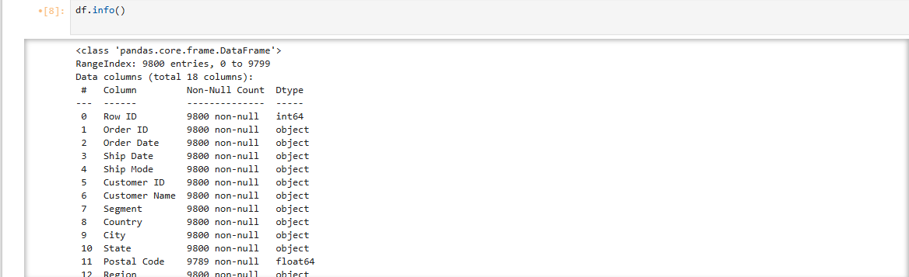

Figure 4.2 Dataset Information

Columns Used
- Order ID
- Order Date
- Ship Date
- Customer ID
- Customer Name
- Category
- Product Name
- Sales
- Region
- State
- City
- Year
- Month
- Quarter
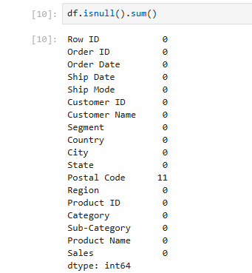
Figure 4.3 Missing Value Analysis

5. Tools & Technologies
Tool | Purpose
Python | Data Cleaning & Preprocessing
Pandas | Data Manipulation
NumPy | Numerical Computations
Matplotlib | Data Visualization
Seaborn | Advanced Statistical Data Visualization
MySQL | SQL Analysis & Data Validation
Jupyter Notebook | Python Development
Power BI Desktop | Dashboard Development
CSV | Dataset Storage

Python was used to clean and preprocess the dataset. Pandas and NumPy were used for data manipulation, while Matplotlib was used for exploratory visualization. The cleaned dataset was then imported into MySQL for SQL analysis and validation. Finally, Power BI was used to create an interactive Executive Sales Dashboard.

6. Project Workflow
Raw Dataset (og_superstore.csv)

Python Data Cleaning (Jupyter Notebook)

Clean Dataset (clean_superstore.csv)

MySQL Analysis (sales_analysis.sql)

Power BI Dashboard (Executive_Sales_Dashboard.pbix)

Business Insights & Executive Report

Figure 6.1:End-to-End Data Analytics Workflow

7. Dashboard

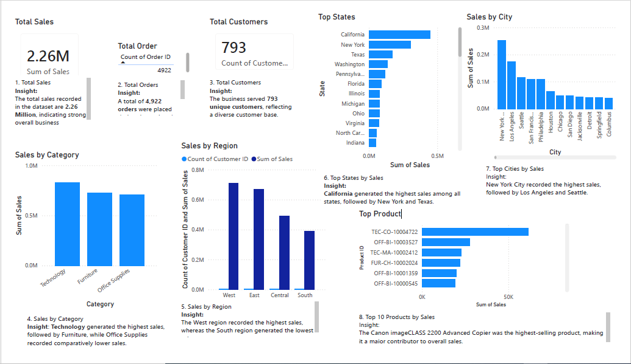
Figure 7.1: Executive Sales Performance Dashboard

The dashboard presents the overall sales performance using KPIs and visualizations.
It includes:
- Total Sales Total Orders
- Total Customers
- Sales by Category
- Sales by Region
- Top 10 States
- Top 10 Cities
- Top 10 Products
The dashboard enables users to identify high-performing products, regions, and customer trends.

8. SQL Analysis
Business analysis was performed using SQL queries in MySQL.
The following analyses were completed:
- Total Records :-
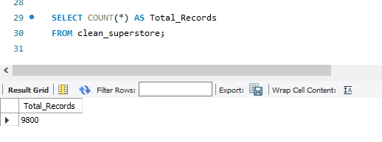
Figure 8.1 Total Records
- Total Sales :-
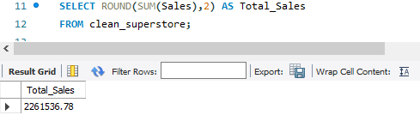
Figure 8.2 Total Sales
- Total Customers:-
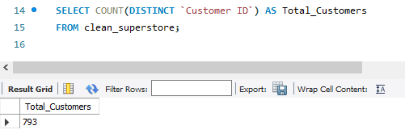
Figure 8.3 Total Customers

- Sales by Category:-
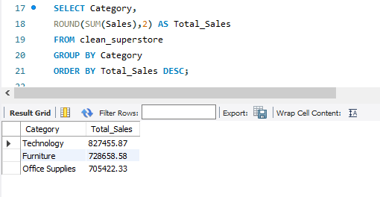

Figure 8.4 Sales by Category

- Sales by Region:-
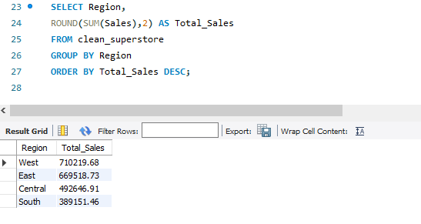
Figure 8.5 Sales by Region

9. Key Insights

9.1 Total Sales
The total sales recorded are 2.26 Million, indicating strong business performance.

9.2 Total Orders
The company processed 4,922 orders during the analysis period.

9.3 Total Customers
The dataset contains 793 unique customers.

9.4 Sales by Category
Technology generated the highest sales, followed by Furniture and Office Supplies.

9.5 Sales by Region
The West region generated the highest revenue, while the South region recorded the lowest sales.

9.6 Top States
California generated the highest sales, followed by New York and Texas.

9.7 Top Cities
New York City achieved the highest sales among all cities.

9.8 Top Products
Canon imageCLASS 2200 Advanced Copier generated the highest sales.

10. Business Recommendations
- Increase investment in Technology products.
- Improve marketing efforts in the South region.
- Maintain inventory for top-selling products.
- Monitor monthly sales trends.
- Use dashboard insights for strategic decision-making.

11. Conclusion
This project successfully demonstrates an end-to-end data analytics workflow using Python, MySQL, and Power BI.
Python was used for data cleaning and preprocessing, MySQL for business analysis and validation, and Power BI for interactive visualization. The dashboard provides valuable insights into sales performance across different business dimensions and supports data-driven decision-making.

12. Project Highlights
- End-to-End Data Analytics Workflow
- Python Data Cleaning & Preprocessing
- SQL Business Analysis using MySQL
- Interactive Dashboard using Power BI
- GitHub Portfolio Documentation

13. Future Scope
- Profit Analysis Dashboard
- Discount Analysis
- Customer Segmentation
- Sales Forecasting using Machine Learning
- Real-time Database Integration
- Interactive Drill-through Reports
- Mobile-friendly Dashboard

14. References
- Kaggle – Superstore Sales Dataset
- Microsoft Power BI Documentation
- Pandas Documentation
- NumPy Documentation
- MySQL Documentation
- Matplotlib Documentation

15. Key Skills Demonstrated
- Python Programming
- SQL
- MySQL
- Data Cleaning & Preprocessing
- Exploratory Data Analysis (EDA)
- Data Visualization
- Dashboard Development
- Power BI
- Business Intelligence
- Business Reporting

