Customer Shopping Behaviour Analysis
Project: Capstone 1 – PRDA-05
Tools Used: Microsoft Excel, SQL and Power BI

Project Overview
The objective of this project is to analyse customer shopping behaviour using transaction data collected from shopping malls in Istanbul.
The analysis focuses on understanding customer preferences based on gender, age group, product category and payment method. The goal is to identify important shopping trends and provide business recommendations to improve sales and customer satisfaction.
Project Objectives
- Analyse shopping distribution according to gender.
- Understand shopping patterns across different age groups.
- Identify which gender and age group generate the highest revenue.
- Analyse product category preferences.
- Understand customer payment method preferences.
- Identify relationships between payment methods and customer demographics.
- Create visualisations and derive meaningful business insights.

Tools and Technologies
- Microsoft Excel: Data cleaning, sorting, filtering and PivotTable analysis.
- SQL: Data querying and analysis.
- Power BI: Creating charts, dashboards and visualising business insights.

Data Analysis and Key Findings
1 Shopping Distribution by Gender
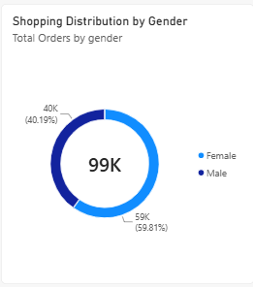

The analysis compares the number of shopping transactions made by male and female customers. It helps identify which gender participates more actively in shopping and understand customer purchasing patterns based on gender.

2 Shopping Distribution by Age Group
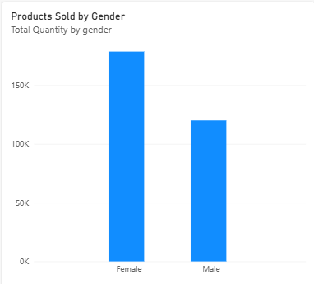
Customers are divided into different age groups to analyse their shopping behaviour and compare shopping activity across age categories. This analysis helps identify which age group makes the highest number of shopping transactions.

3 Revenue by Gender and Age Group
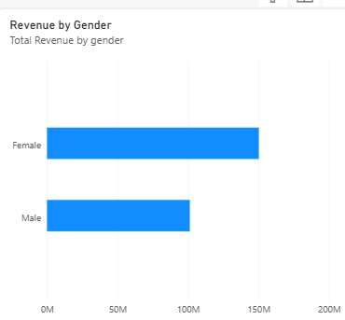
Revenue is calculated by multiplying Quantity by Price. This analysis compares the revenue generated by male and female customers and by different age groups. It helps identify which gender and age group contribute the highest revenue to the business.

4 Purchase Category by Gender

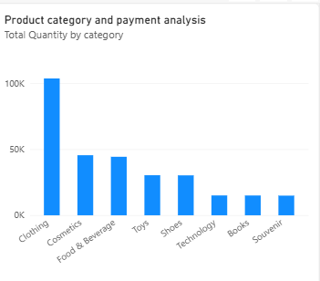
The analysis compares customer purchases across different product categories based on gender. It helps identify the most popular product categories and understand the purchasing preferences of male and female customers.
Key Findings:
- Clothing generates the highest revenue, followed by Shoes and Technology.
- Female customers contribute more revenue than male customers across all product categories.
- Sports and Home & Living generate comparatively lower revenue.
Conclusion:
The analysis shows that Clothing, Shoes, and Technology are the major revenue-generating categories. The business can focus on these categories to improve sales and plan targeted marketing campaigns.

5 Shopping Distribution by Age

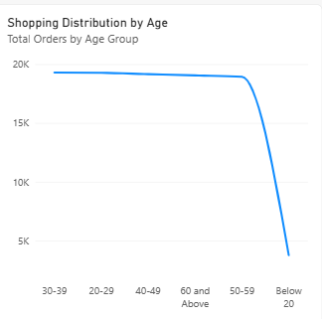
The analysis compares shopping transactions across different age groups to understand customer purchasing behaviour. It helps identify which age groups are more active in shopping and which customer segments contribute most to overall shopping activity.
Key Findings:
- The 36–45 age group shows the highest shopping activity.
- Other age groups also contribute to overall shopping transactions.
- Understanding age-wise shopping patterns helps businesses identify their target customer segments.
Conclusion:
The business can use age-group analysis to create targeted marketing campaigns, offer suitable promotions, and improve customer engagement.

6 Products Sold by Age Group

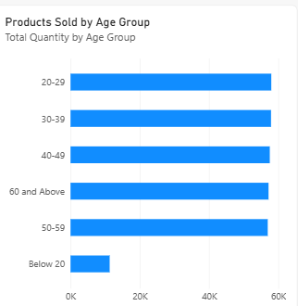
The analysis compares the number of products sold across different age groups and product categories. It helps identify which age groups purchase more products and understand customer preferences across different categories.
Key Findings:
- The 36–45 age group purchases the highest number of products across most categories.
- Customers aged 18–25 and 26–35 also show strong purchasing activity, especially in Clothing, Shoes, and Technology.
- Customers aged 56 and above show comparatively lower product purchase volumes.
Conclusion:
The business can focus on the 36–45 age group through targeted promotions and personalised offers. It can also attract younger customers with special offers on popular product categories such as Clothing, Shoes, and Technology.

7. Revenue Generated by Age Group

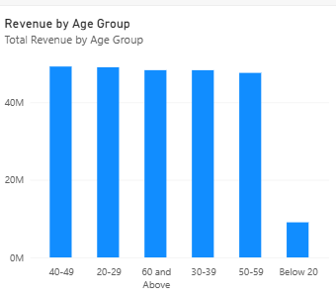
The analysis compares the total revenue generated by different age groups. It helps identify which customer age group contributes the highest revenue to the business and understand the spending patterns of different customer segments.
Key Findings:
- The 36–45 age group generates the highest revenue.
- Other age groups also contribute to the total business revenue.
- Comparing revenue across age groups helps identify the most valuable customer segments.
Conclusion:
The business can focus on the 36–45 age group through targeted marketing campaigns, loyalty programmes, and personalised offers to increase customer engagement and revenue.

8. Purchase Category Distribution by Gender
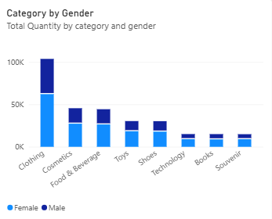
The analysis compares the number of purchases made by male and female customers across different product categories. It helps understand the shopping preferences of each gender and identify which product categories are more popular among male and female customers.
Key Findings:
- Clothing is one of the most popular product categories among both male and female customers.
- Female customers show higher purchasing activity across several product categories.
- Shoes and Technology are also popular categories among customers.
Conclusion:
The business can use these insights to plan gender-based marketing campaigns, provide relevant product recommendations, and improve sales across different product categories.

9. Payment Method by Gender
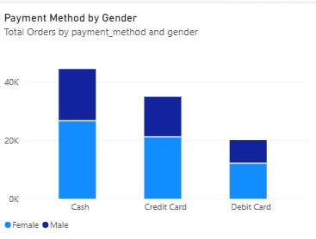
The analysis compares the payment methods used by male and female customers. It helps understand customer payment preferences and identify whether payment choices differ based on gender.
Key Findings:
- Cash is one of the commonly used payment methods among customers.
- Both male and female customers use different payment methods, including Cash, Credit Card, and Debit Card.
- Comparing payment methods by gender helps businesses understand customer payment preferences.
Conclusion:
The business should continue offering multiple payment options, including cash, credit cards, and debit cards, to provide convenience and improve the customer shopping experience.

Business Insights
- Female customers contribute a higher share of total revenue in this dataset.
- The 36–45 age group is the highest revenue-generating age segment.
- Clothing is the leading product category by revenue.
- Cash is the most frequently used payment method.
- Customer purchasing patterns vary across age groups and product categories.
Business Recommendations
- Targeted Marketing: Create marketing campaigns for customer segments that contribute the highest revenue.
- Inventory Planning: Maintain sufficient stock of high-performing product categories such as clothing.
- Payment Options: Continue supporting popular payment methods while providing alternative digital payment options.
- Customer Engagement: Introduce offers and loyalty programmes to encourage repeat purchases.
- Sales Monitoring: Use Power BI dashboards to monitor sales, revenue and customer trends regularly.
- Mall Performance: Compare shopping mall performance and plan location-specific promotional activities.

Conclusion
This project helped identify customer shopping patterns based on gender, age group, product category and payment method.
The analysis provides useful insights into customer preferences and revenue contribution. Businesses can use these findings to improve marketing strategies, inventory planning and customer engagement.
By using Excel, SQL and Power BI, the project demonstrates how data analysis can support better business decisions.

