1. create new SSIS package for convert string columns in lower to Upper and Upper to lower.  
     
   Please refer attached sheet(Ship Mode, Customer Name, Segment)

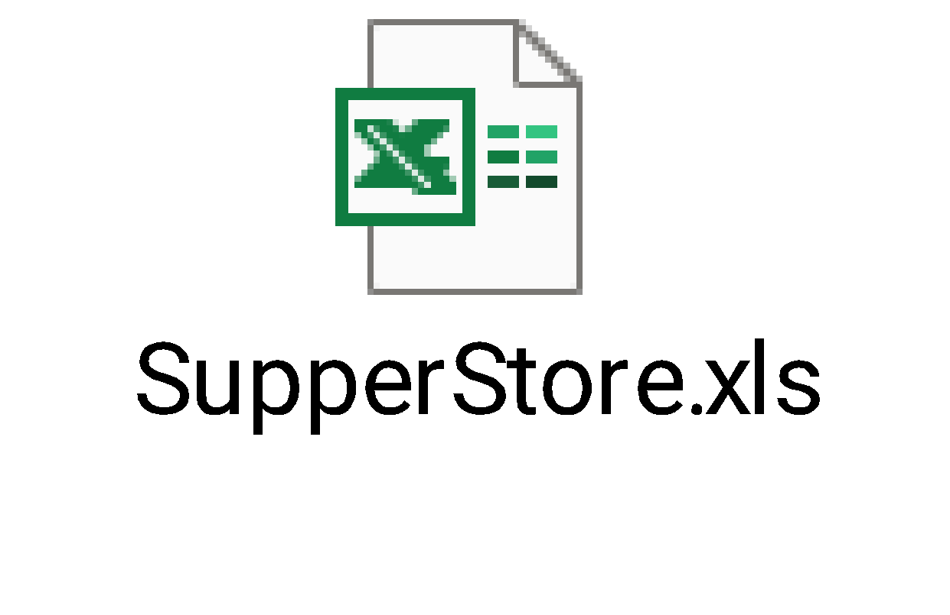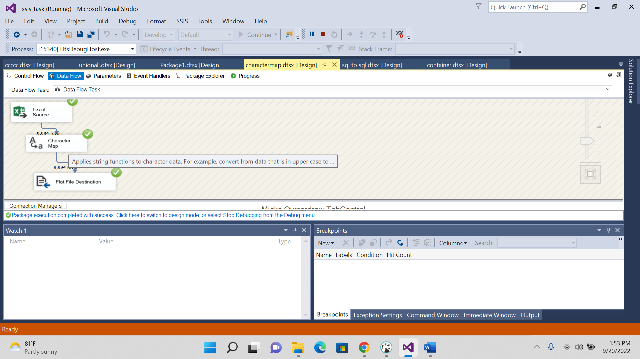

Output:

2.

**CREATE** **TABLE** [NA_STORE_DESTINATION] (

[Row ID] **float**,

[Order ID] **varchar**(255),

[Order Date] **datetime**,

[Ship Date] **datetime**,

[Ship Mode] **varchar**(255),

[Customer ID] **varchar**(255),

[Customer Name] **varchar**(255),

[Segment] **varchar**(255),

[Country] **varchar**(255),

[City] **varchar**(255),

[State] **varchar**(255),

[Postal Code] **float**,

[Region] **varchar**(255),

[Product ID] **varchar**(255),

[Category] **varchar**(255),

[Sub-Category] **varchar**(255),

[Product Name] **varchar**(255),

[Sales] **float**,

[Quantity] **float**,

[Discount] **float**,

[Profit] **float**,

[CM_Ship Mode] **nvarchar**(255),

[CM_Customer Name] **nvarchar**(255),

[CM_Segment] **nvarchar**(255)

);

**select** * **from** NA_STORE_DESTINATION

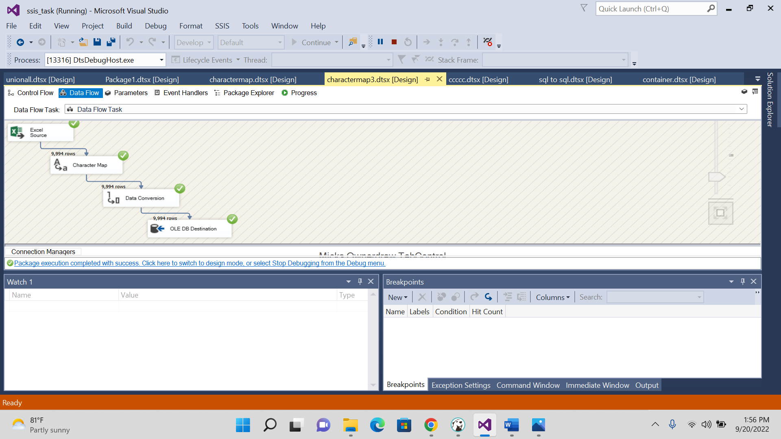

Output:

