1.Create Lookup Transformation----Redirect row to no match output:  
  
Source---Flat file----Destination---SQL Table.

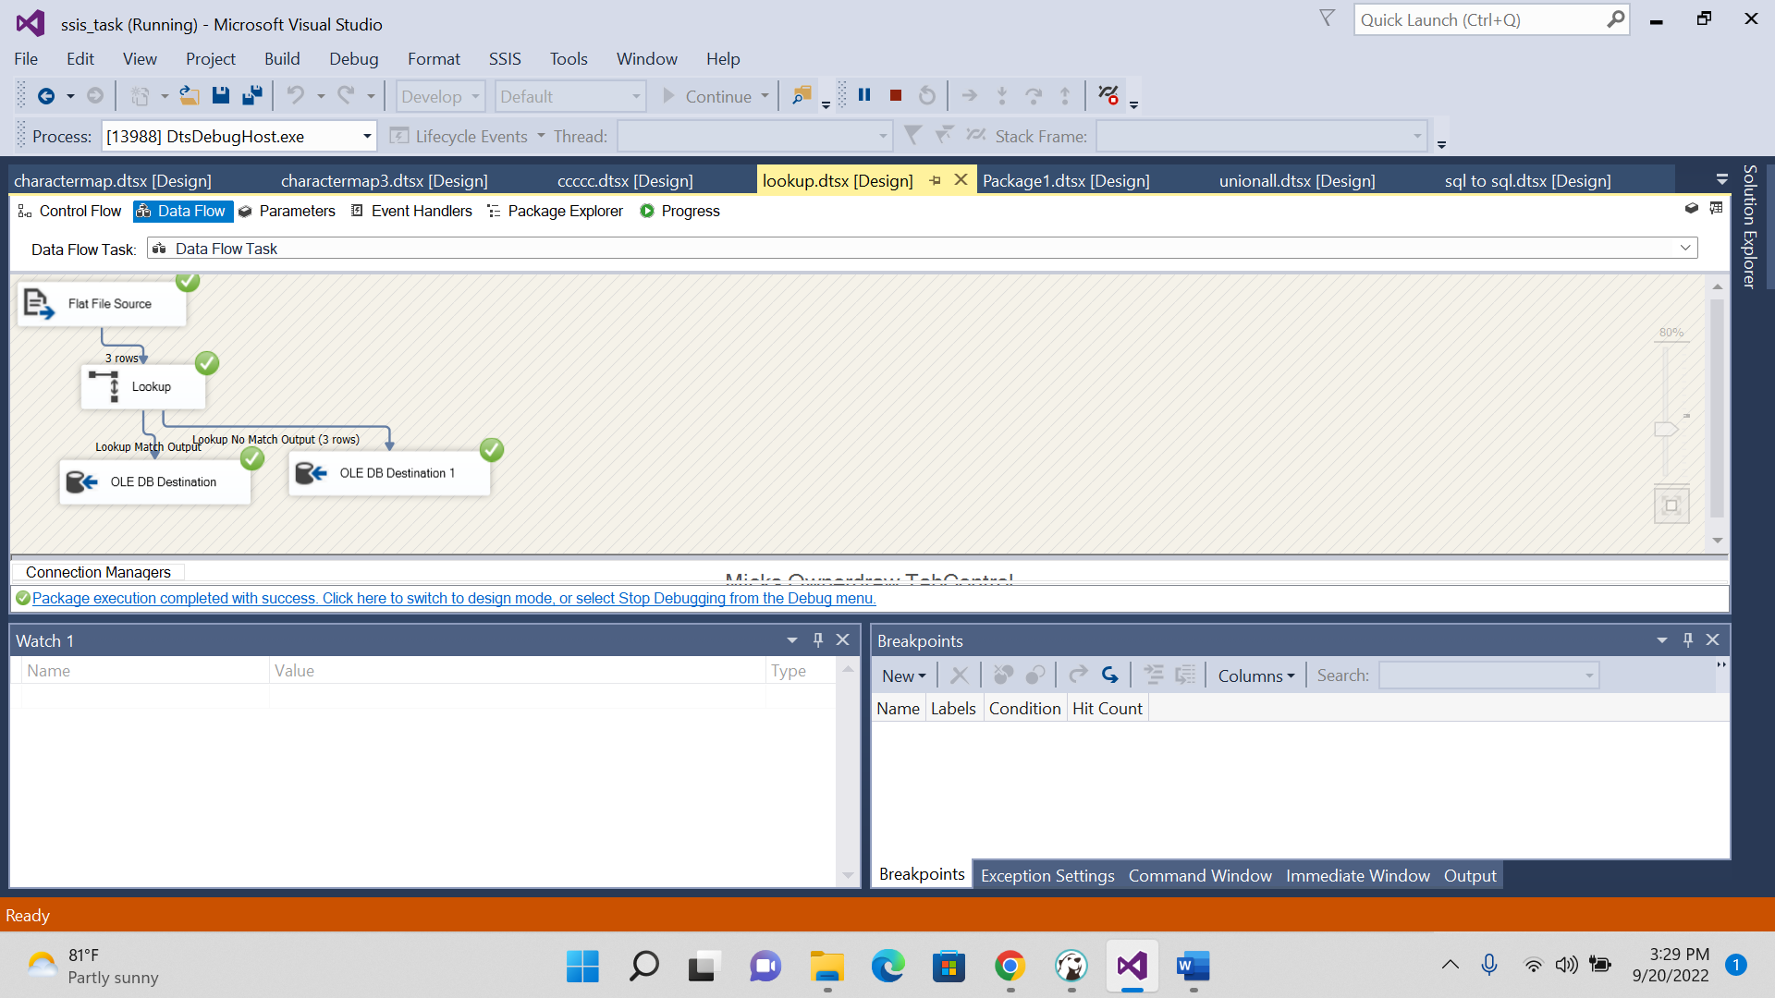

**create** **table** NA_STUDENT_NEW21(

s_name **varchar**(50),

s_id **int**,

s_age **int**,

s_mobile **varchar**(50)

);

**select** * **from** NA_STUDENT_NEW21

