**Module (Bootstrap Basic & Advanced) – 6**

• What are the advantages of Bootstrap?

Responsive design: Bootstrap is designed to be responsive, meaning that it will automatically adjust its layout to fit any screen size.

Pre-built components: Bootstrap includes pre-built components, such as buttons, forms, and navigation bars.

Customization:  This can be done by changing the colors, fonts, and other aspects of the framework.

Documentation and support: Bootstrap has excellent documentation and support. This makes it easy for developers to learn how to use the framework .

Community: Bootstrap has a large and active community of developers. This can be a valuable resource for developers who need help or advice.

• What is a Bootstrap Container, and how does it work?

A Bootstrap container is a responsive layout element that is used to contain the content within it.

There are two types of Bootstrap containers:

.container class provides a responsive fixed-width container. This means that the container will automatically adjust its width to fit within the viewport of the device it is being viewed on.

.container-fluid class provides a full-width container, spanning the entire width of the viewport

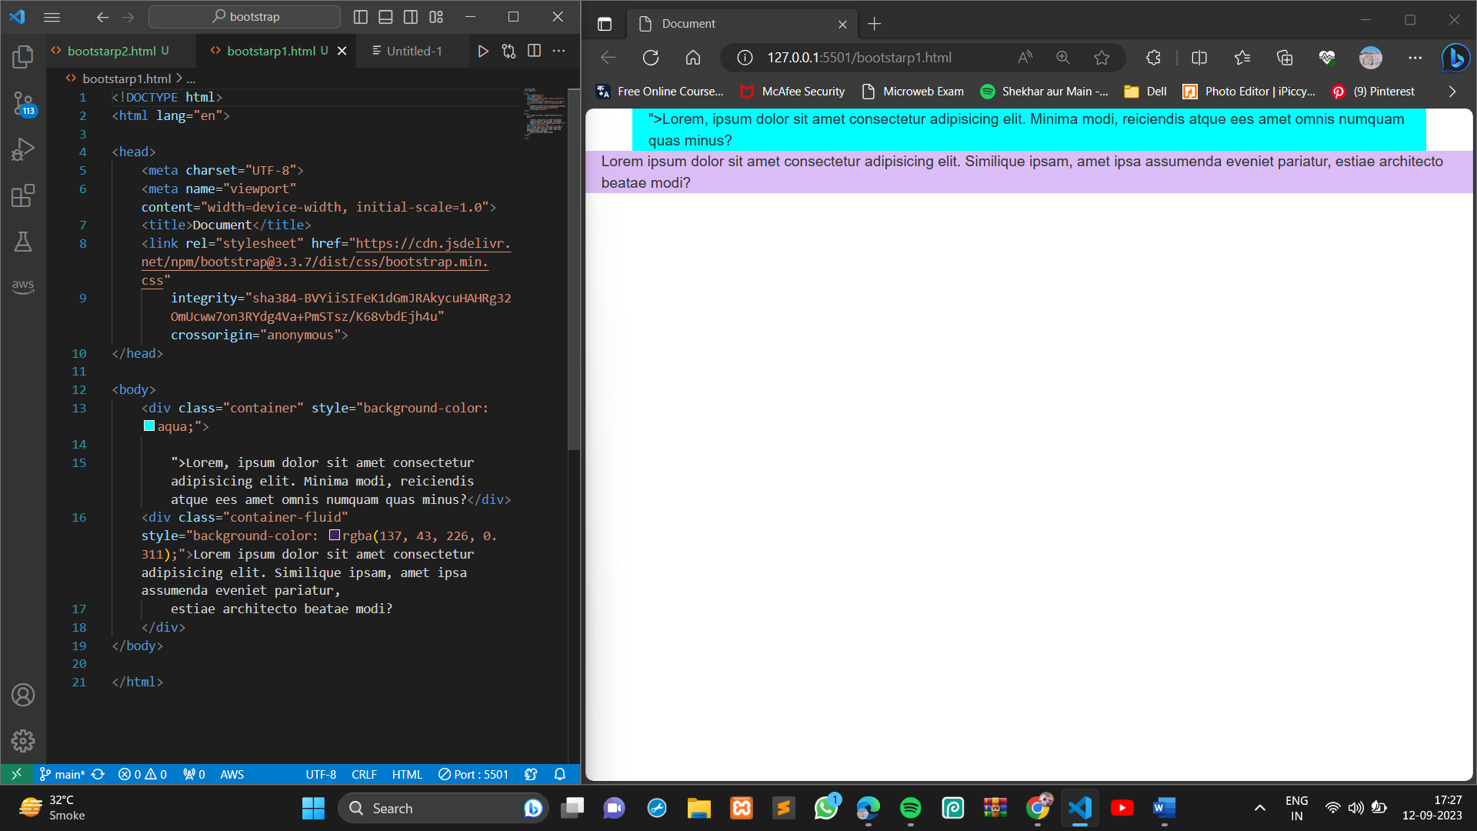

• What are the default Bootstrap text settings?

The default Bootstrap text settings are as follows:

* Font-size: 16px
* Line-height: 1.5
* Font-family: "Helvetica Neue", Helvetica, Arial, sans-serif
* Font-weight: normal
* Color: black

In addition to these default settings, there are a number of Bootstrap utility classes that can be used to style text in different ways.

• What do you know about the Bootstrap Grid System?

The Bootstrap grid system used to create responsive and consistent layouts. It is based on flexbox, which is a modern CSS layout system that is designed to be responsive.

The Bootstrap grid system divides the page into a series of columns, and each column can be assigned a width.

The Bootstrap grid system is based on flexbox.

The Bootstrap grid system is fully responsive.

The Bootstrap grid system is very flexible.

The columns can then be arranged in rows to create different layouts.

The Bootstrap grid system is made up of the following components:

* Containers: Containers are used to wrap the content that you want to place in the grid.
* Rows: Rows are used to arrange the columns in the grid.
* Columns: Columns are used to define the width of the content.
* Grid gutters: Grid gutters are the spaces between the columns. They help to create a more visually appealing layout.

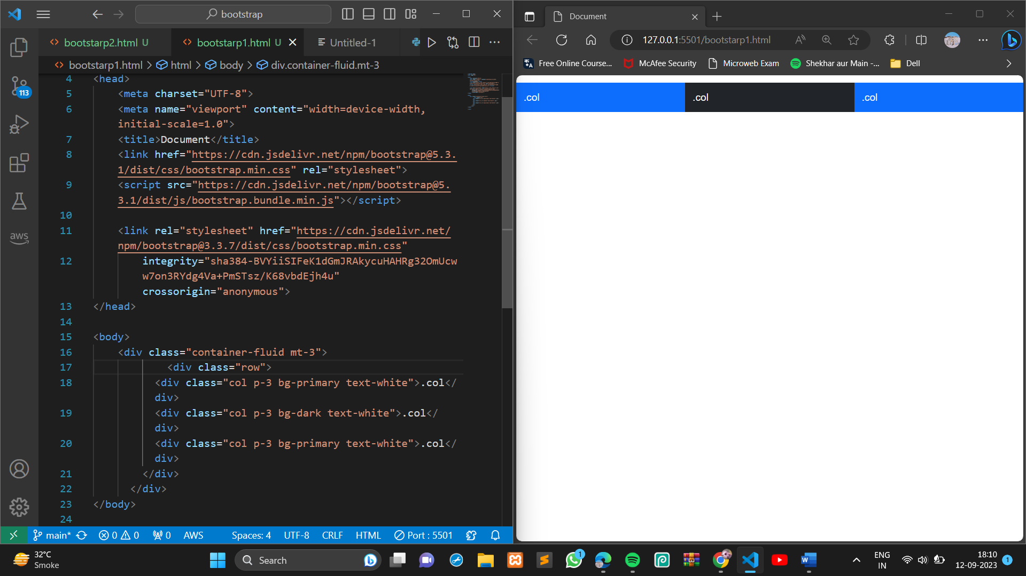

The Bootstrap grid system has six default breakpoints,The breakpoints are as follows:

* Extra small (xs): Phones
* Small (sm): Tablets
* Medium (md): Desktops
* Large (lg): Laptops
* Extra large (xl): Desktops and large
* Extra extra large (xxl): Large displays

• What is the difference between Bootstrap 4 and Bootstrap 5

|  |  |  |  |  |  |  |
| --- | --- | --- | --- | --- | --- | --- |
| Feature | Bootstrap 4 | Bootstrap 5 |  |  |  |  |
| Support for older browsers | Supports Internet Explorer 10 and 11 | Does not support Internet Explorer 10 and 11 |  |  |  |  |
| Grid system | Based on flexbox, has five default breakpoints | Based on flexbox, has six default breakpoints |  |  |  |  |
| Components | Includes a number of components, such as cards, forms, and tables | Includes a number of new components, such as accordion, carousel, and offcanvas |  |  |  |  |
| Theming system | Uses Sass variables to customize the look and feel | Uses Sass variables and a new theming system to customize the look and feel |  |  |  |  |
| Accessibility | Has some accessibility features | Has improved accessibility features |  |  |  |  |

• What is a Button Group, and what is the class for a basic Button Group?

A button group is a Bootstrap component that allows you to group a series of buttons together. This can be useful for creating a toolbar or for grouping related actions.

The class for a basic button group is .btn-group.

This class will automatically apply some basic styling to the buttons, such as rounding the corners and adding a small margin between the buttons.

This will create a button group with two buttons, one with the primary color and one with the secondary color.

You can also use the .btn-group class to create a vertical button group. To do this, add the .btn-group-vertical class to the <div> element.

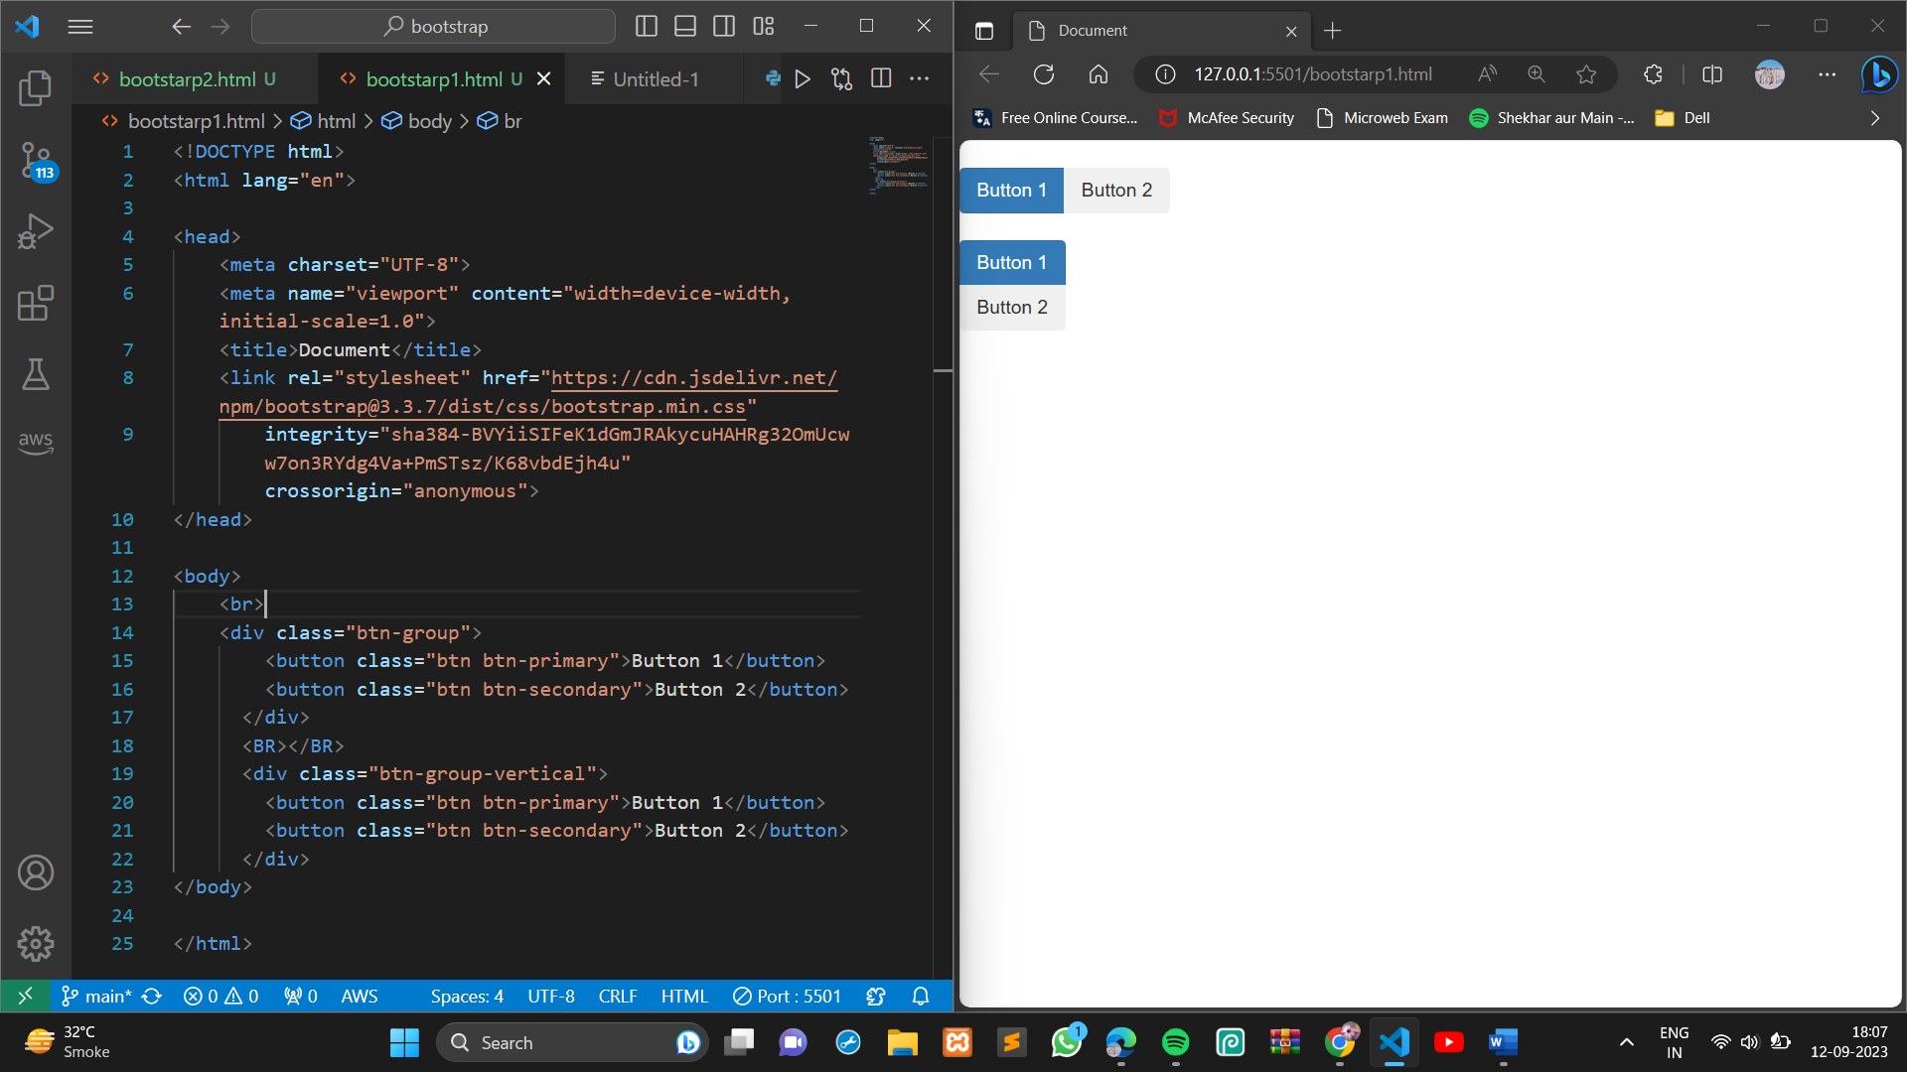

• How can you use Bootstrap to make thumbnails?

.img-thumbnail class to create a thumbnail image. This class is a shorthand for the .thumbnail class, and it is more commonly used.

The .rounded class will add a rounded border to the image.

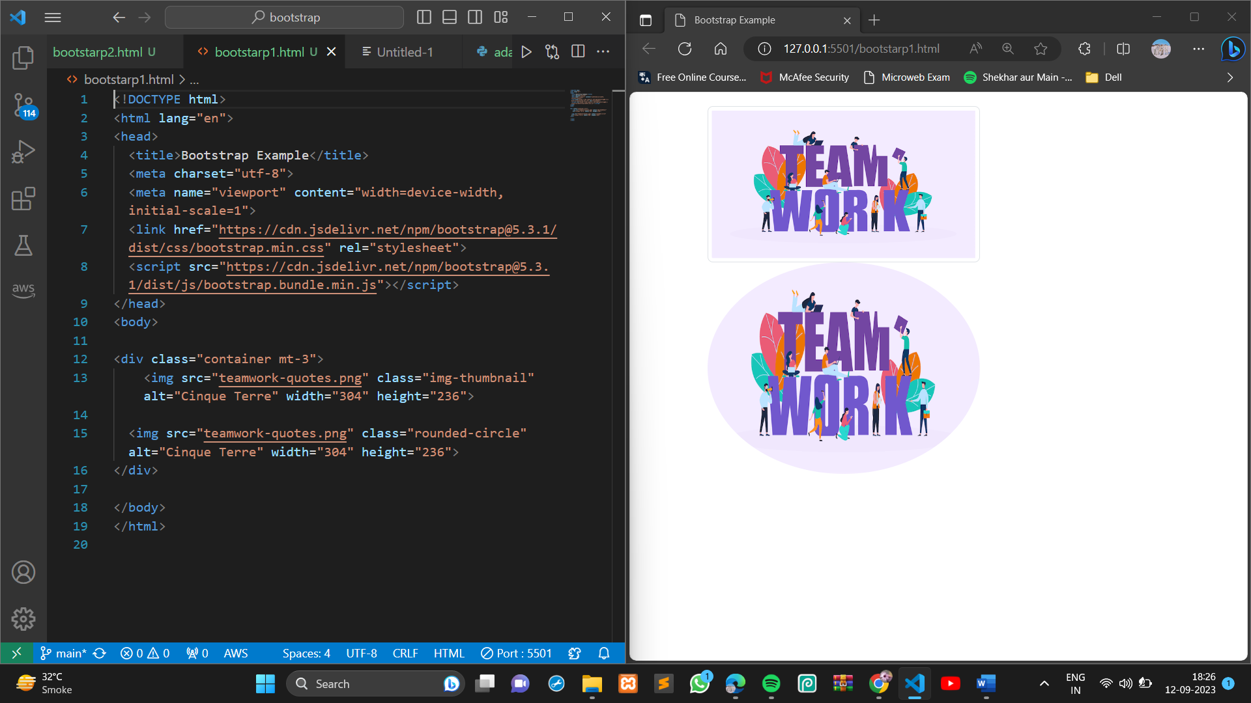

• In Bootstrap 4, what is flexbox?

Flexbox is a CSS layout method that is used to arrange items in rows or columns. It is a more flexible and efficient way to layout content than traditional CSS methods, such as floats and positioning.

Bootstrap 4 uses flexbox to power its grid system and other layout features. This makes it easier to create responsive and dynamic layouts that work well on all devices.

• How can one create an alert in Bootstrap?

To create an alert in Bootstrap, you can use the .alert class. This class will automatically apply some basic styling to the alert, such as a border, a background color, and a padding.

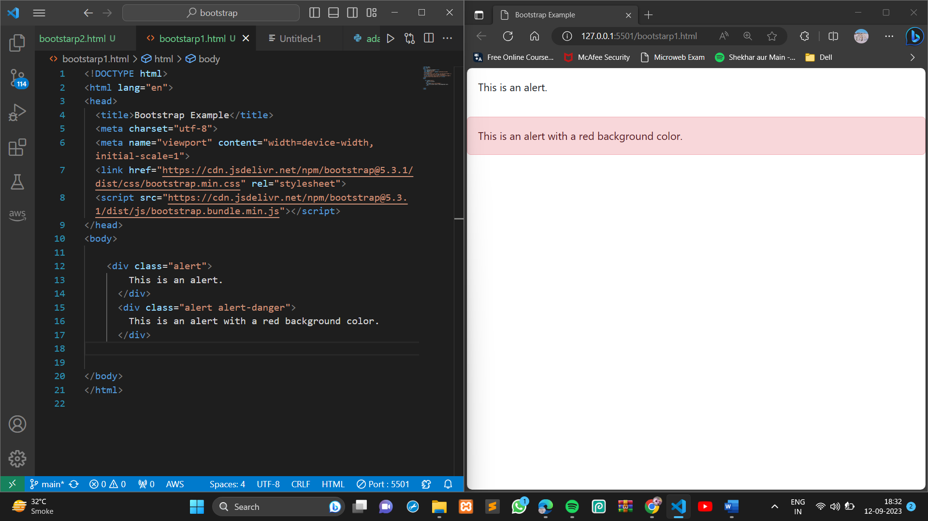

• What is a bootstrap card and how would you create one?

A **card** is a flexible and extensible content container. It includes options for headers and footers, a wide variety of content, contextual background colors, and powerful display options.

