ASSIGNMENT-HTML

1.Are the HTML tags and elements the same thing?

=>Tags are used to mark up the start of an HTML element and they are usually enclosed in angle brackets. An example of a tag is: <h1>.

Most tags must be opened <h1> and closed </h1> to function.

Example:-

<a href=”https//google.com”> Google </a>

In the above <a> and </a> is HTML tag.

An HTML element is everything from the start tag to the end tag:

<tagname>Content goes here...</tagname>

Example:-

Example:-

<a href=”https//google.com”> Google </a>

Above all the content between <a> and </a> is called the element

2.What are tags and attributes in HTML?

=> Tags are used to mark up the start of an HTML element and they are usually enclosed in angle brackets. An example of a tag is: <h1>.

Most tags must be opened <h1> and closed </h1> to function.

Example:-

<a href=”https//google.com”> Google </a>

In the above <a> and </a> is HTML tag.

HTML attributes are provided tag additional information

Example:-

<a href=”https//google.com”> Google </a>

In the above <a> is a tag that has href attribute this provides a link to the anchor tag

3.What are void elements in HTML?

* Void elements are tag that doesn’t have a closing tag and that tag does not have any contain inside them.

Example of such elements are <br>, <hr>, <img>, <input>, <link>, <base>, <meta>, <param>, <area>, <embed>, <col>, <track>, <source> etc.

Example:-

<html>

<body>

<h2 style=”color:green;”> Hello </h2>

<p>Good Moring…<br>Neha</P>

</body>

</html>

Output:-

Hello

Good Moring…

Neha

4.What are HTML Entities?

=> HTML character entities are used as a replacement for reserved characters in HTML. You can also replace characters that are not present on your keyboard with entities.

Example:-

<html>

<body>

<h1>HTML Entity Example</h1>

<h2>The less-than sign: &lt;</h2>

</body>

</html>

Output:-

# HTML Entity Example

## The less-than sign: <

5.What are the different types of lists in HTML?

Unordered HTML List

An unordered list starts with the <ul> tag. Each list item starts with the <li> tag.The list of items will be marked with bullets.

Ordered HTML List

An ordered list starts with the <ol> tag. Each list item starts with the <li> tag.

The list items will be marked with numbers by default:

HTML Description Lists.

A description list is a list of terms, with a description of each term.

The <dl> tag defines the description list, the <dt> tag defines the term , and the <dd> tag describes

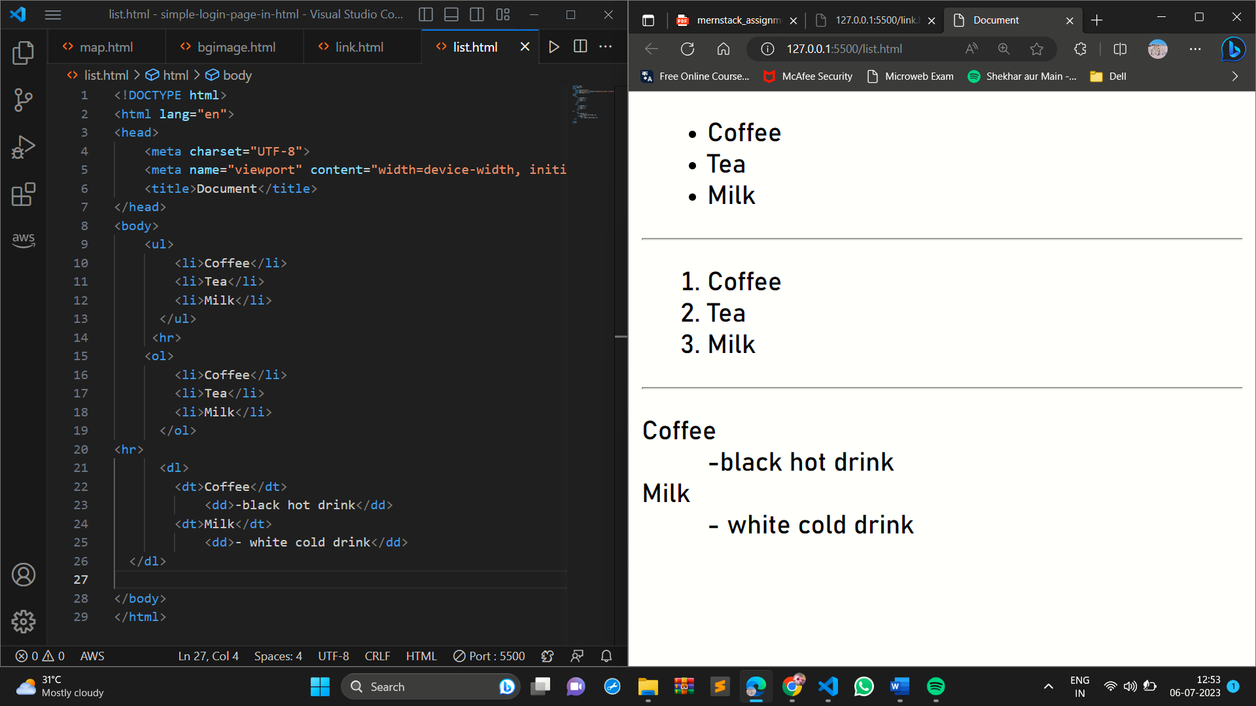

6.What is the ‘class’ attribute in HTML?

=>

The class attribute specifies one or more class names for an element.

The class attribute is mostly used to point to a class in a style sheet.

In the below code picture <div> tag has class attributes, in code has two div and both have different class

The first div has the main name class and the second have the sun class

In style class define the “ . “ symbol to give class style

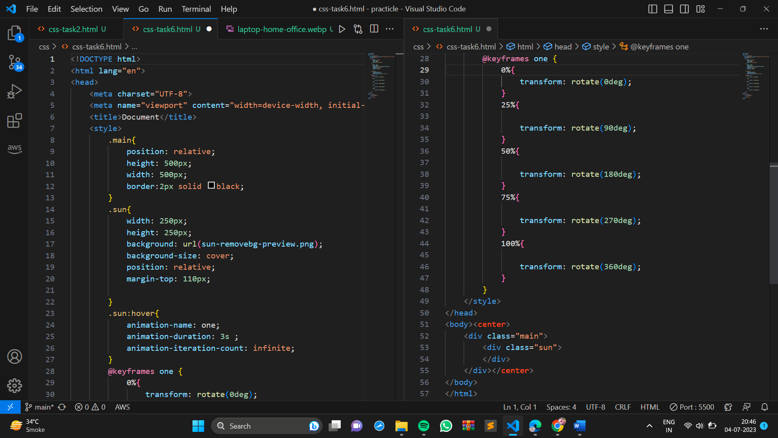

7.What is the difference between the ‘id’ attribute and the ‘class’ attribute of HTML elements?

=>

|  |  |
| --- | --- |
| Id | Class |
| the ID name starts with the "#" symbol followed by a unique name assigned to it. | "class" assigned to an element has its name starting with "." followed by the class name. |
| ID is unique on a page and can only apply to at most one element | The class can be applied to multiple elements so it could be multiple times on a single page. |

8.What are the various formatting tags in HTML?

HTML contains several elements for defining text with a special meaning.

Formatting elements were designed to display special types of text:

<b> - Bold text

<strong> - Important text

<i> - Italic text

<em> - Emphasized text

<mark> - Marked text

<small> - Smaller text

<del> - Deleted text

<ins> - Inserted text

<sub> - Subscript text

<sup> - Superscript text

9.How is Cell Padding different from Cell Spacing?

Cell Padding: it is a table formatting tag that is used to increase inside cell space.

Cell Spacing: it is a table formatting tag that is used to increase outer cell space.

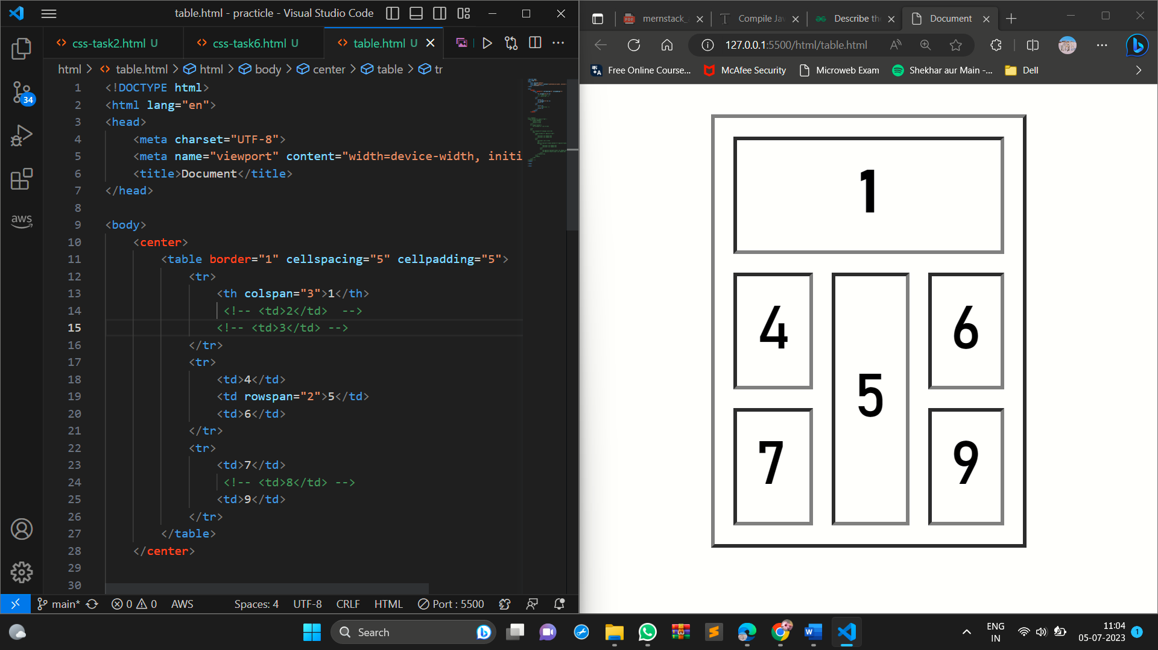

11.What is the difference between a block-level element and an inline element?

Block-level Element:- this type element occupied 100% width ex- <p>,<div>

Inline-level Element:- this type of element is occupied according to their content width. Ex- <span>

Example:-

DOCTYPE html>

<html>

<body>

<p>This is an inline span <span>Hello World</span> element inside a paragraph.</p>

<p>The SPAN element is an inline element.</p>

</body>

</html>

Output:-

This is an inline span Hello World element inside a paragraph.

The SPAN element is an inline element.

12.How to create a Hyperlink in HTML?

=><!DOCTYPE html>

<html>

<body>

<a href=”https//google.com”> Google </a>

</body>

</html>

Output:-

Google

13.What is the use of an iframe tag?

An HTML iframe is used to display a web page within a web page.

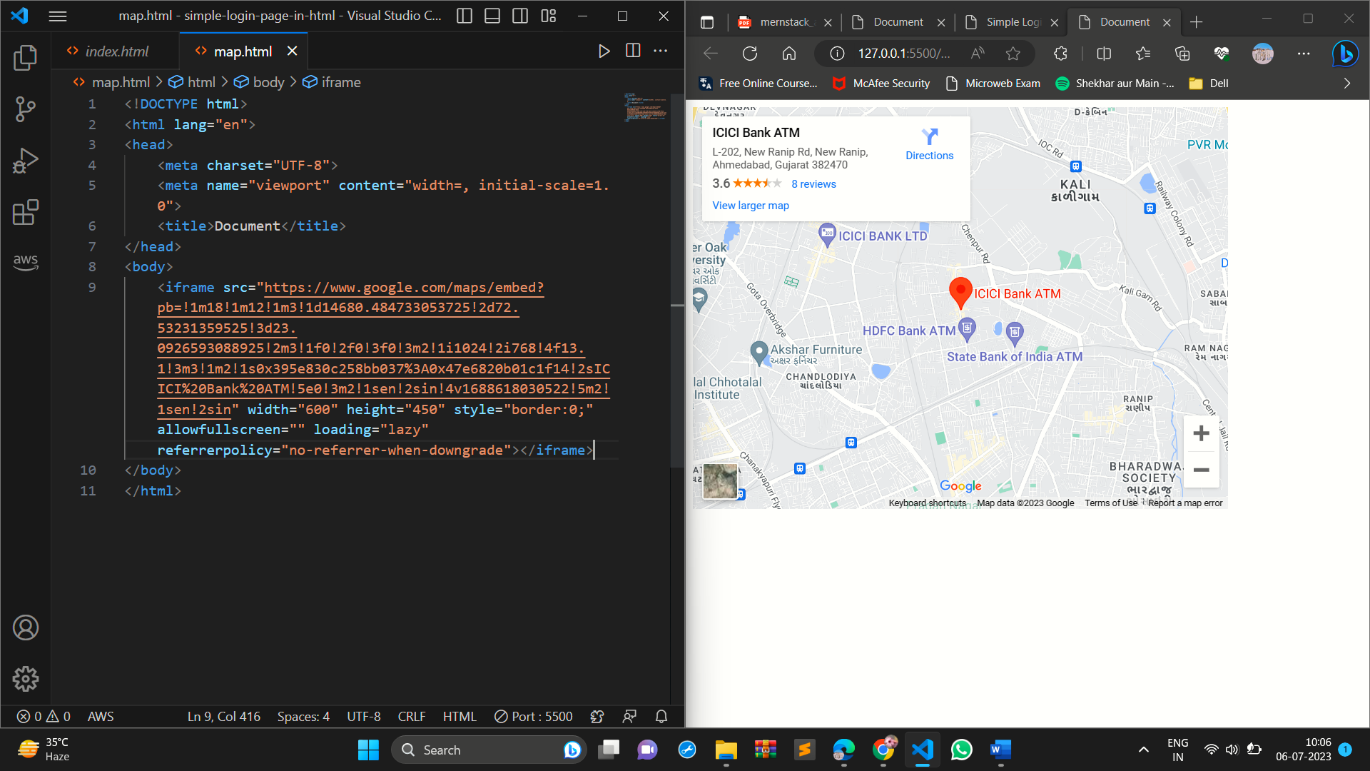

14.What is the use of a span tag? Explain with example.

The <span> tag is an inline container used to mark up a part of a text, or a part of a document.

The <span> tag is easily styled by CSS or manipulated with JavaScript using the class or id attribute.

Example:-

DOCTYPE html>

<html>

<body>

<p>This is an inline span <span style=”color:red;”>Hello World</span> element inside a paragraph.</p>

<p>The SPAN element is an inline element.</p>

</body>

</html>

Output:-

This is an inline span Hello World element inside a paragraph.

The SPAN element is an inline element.

15.How to insert a picture into a background image of a web page?

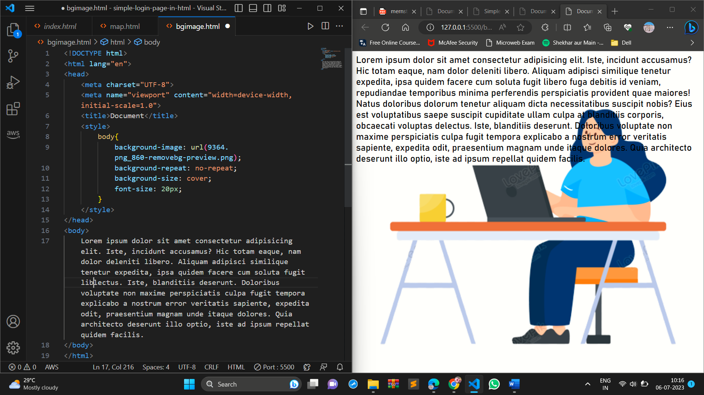

16.How are active links different from normal links?

=>An HTML link is displayed in a different color depending on whether it has been visited, is unvisited, or is active.

An unvisited link is underlined and blue ,A visited link is underlined and purple ,An active link is underlined and red

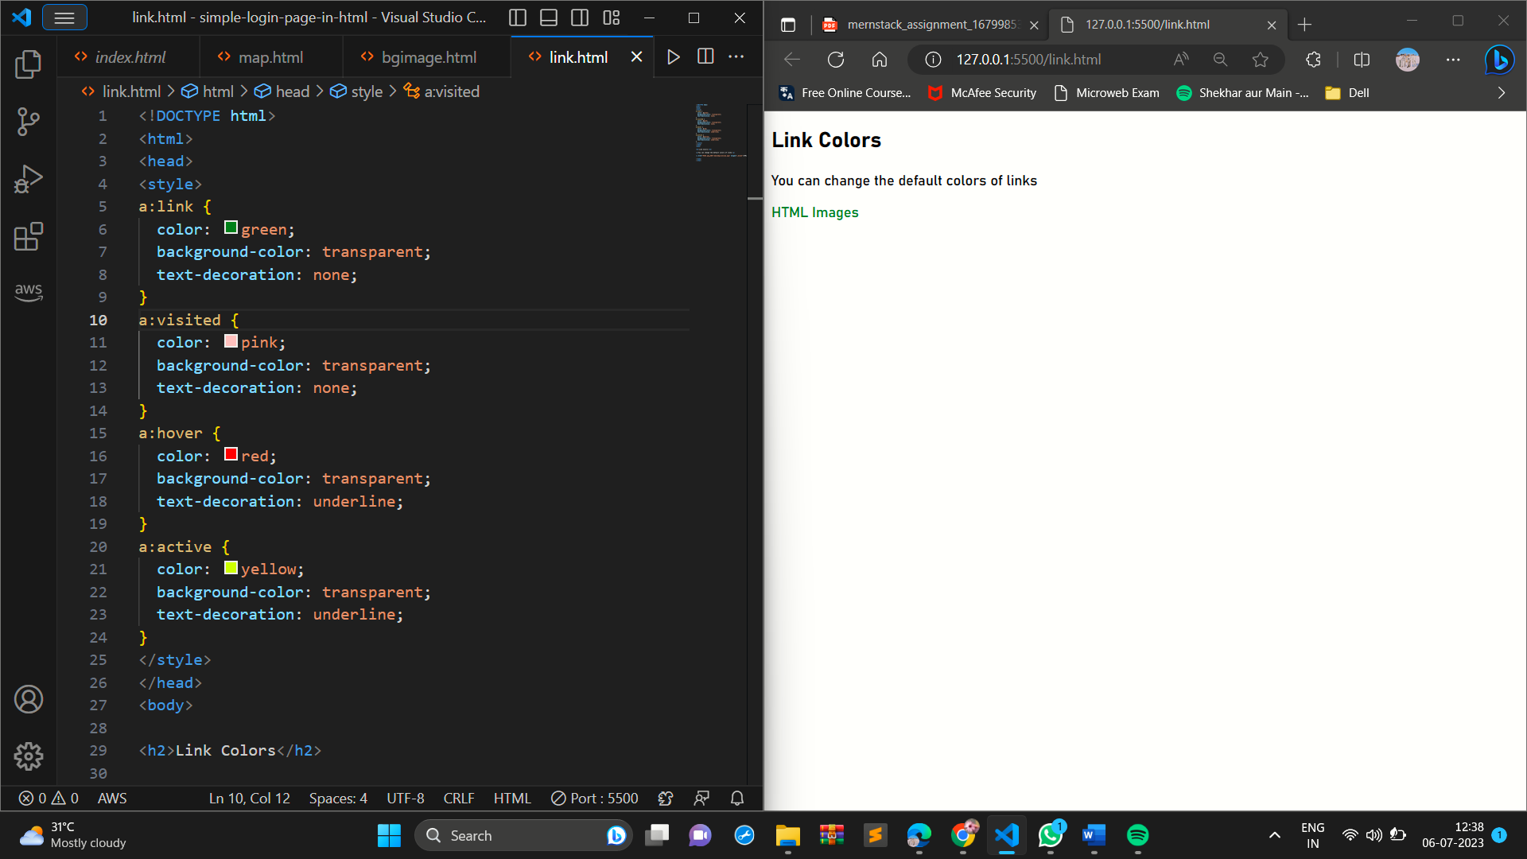

17.What are the different tags to separate sections of text?

=><br> tag: This tag is used to break the current line of text and start a new line. It does not create any space between the lines, so if you want to add some space, you can use CSS to do so.

<p> tag: This tag is used to define a paragraph of text. It creates a new paragraph and adds some space before and after the paragraph.

<blockquote> tag: This tag is used to define a large quoted section of text. It creates a new block of text that is indented and has a different font style.

In addition to these three tags, there are also other tags that can be used to separate sections of text, such as the <hr> tag, which creates a horizontal rule, and the <div> tag, which can be used to define a generic section of text.

18.What is SVG?

SVG stands for Scalable Vector Graphics.

SVG defines vector-based graphics in XML format.

<html>  
<body>  
  
<h1>My first SVG</h1>  
  
<svg width="100" height="100">  
  <circle cx="50" cy="50" r="40" stroke="green" stroke-width="4" fill="yellow" />  
</svg>  
  
</body>  
</html>

My first SVG

19.What is difference between HTML a.nd XHTML?

=>HTML and XHTML are both markup languages used to create web pages. However, there are some key differences between the two languages.

HTML is a subset of XML, while XHTML is a strict subset of XML. This means that XHTML documents must follow all of the rules of XML, while HTML documents can be more forgiving.

XHTML tags must be in lowercase, while HTML tags can be in either upper or lowercase. This is because XHTML is an XML language, and XML is case-sensitive.

XHTML documents must have a Document Type Declaration (DTD), while HTML documents do not. The DTD is a file that defines the structure of an XHTML document.

In general, XHTML is considered to be a more robust and standards-compliant language than HTML. HTML is still widely used

20.What are logical and physical tags in HTML?

Logical tags are used to convey the meaning of the text enclosed in the tags. For example, the <strong> tag is a logical tag that indicates that the text enclosed in the tags is important. The <em> tag is another logical tag that indicates that the text enclosed in the tags is emphasized.

Physical tags are used to control the physical appearance of the text enclosed in the tags. For example, the <b> tag is a physical tag that bolds the text enclosed in the tags. The <i> tag is another physical tag that makes the text enclosed in the tags italic.

this means that logical tags convey the meaning of the text, while physical tags control the appearance of the text.

Logical tags <strong> <em> <cite> <dfn><abbr>

Physical tags <b> <i> <u> <big> <small>