**Module (JQuery Basic, Effects & Advanced) – 5**

• What is jQuery?

jQuery is a JavaScript library that makes it easier to write JavaScript code for web pages.

It is easy to learn and use, it easier to do things like select elements from the DOM, add event handlers, and create animations.

jQuery is a lightweight, "write less, do more", JavaScript library.

The jQuery library contains the following features:

* HTML/DOM manipulation
* CSS manipulation
* HTML event methods
* Effects and animations
* AJAX
* Utilities

• How to Apply CSS Using JQuery, How to Add Class and Remove Class in Jquery , JQuery Animation?

apply CSS using jQuery, you can use the .css() method.

Example

$('div').css('background-color', 'red');

The .css() method takes two arguments: the first argument is the CSS property name, and the second argument is the value of the CSS property.

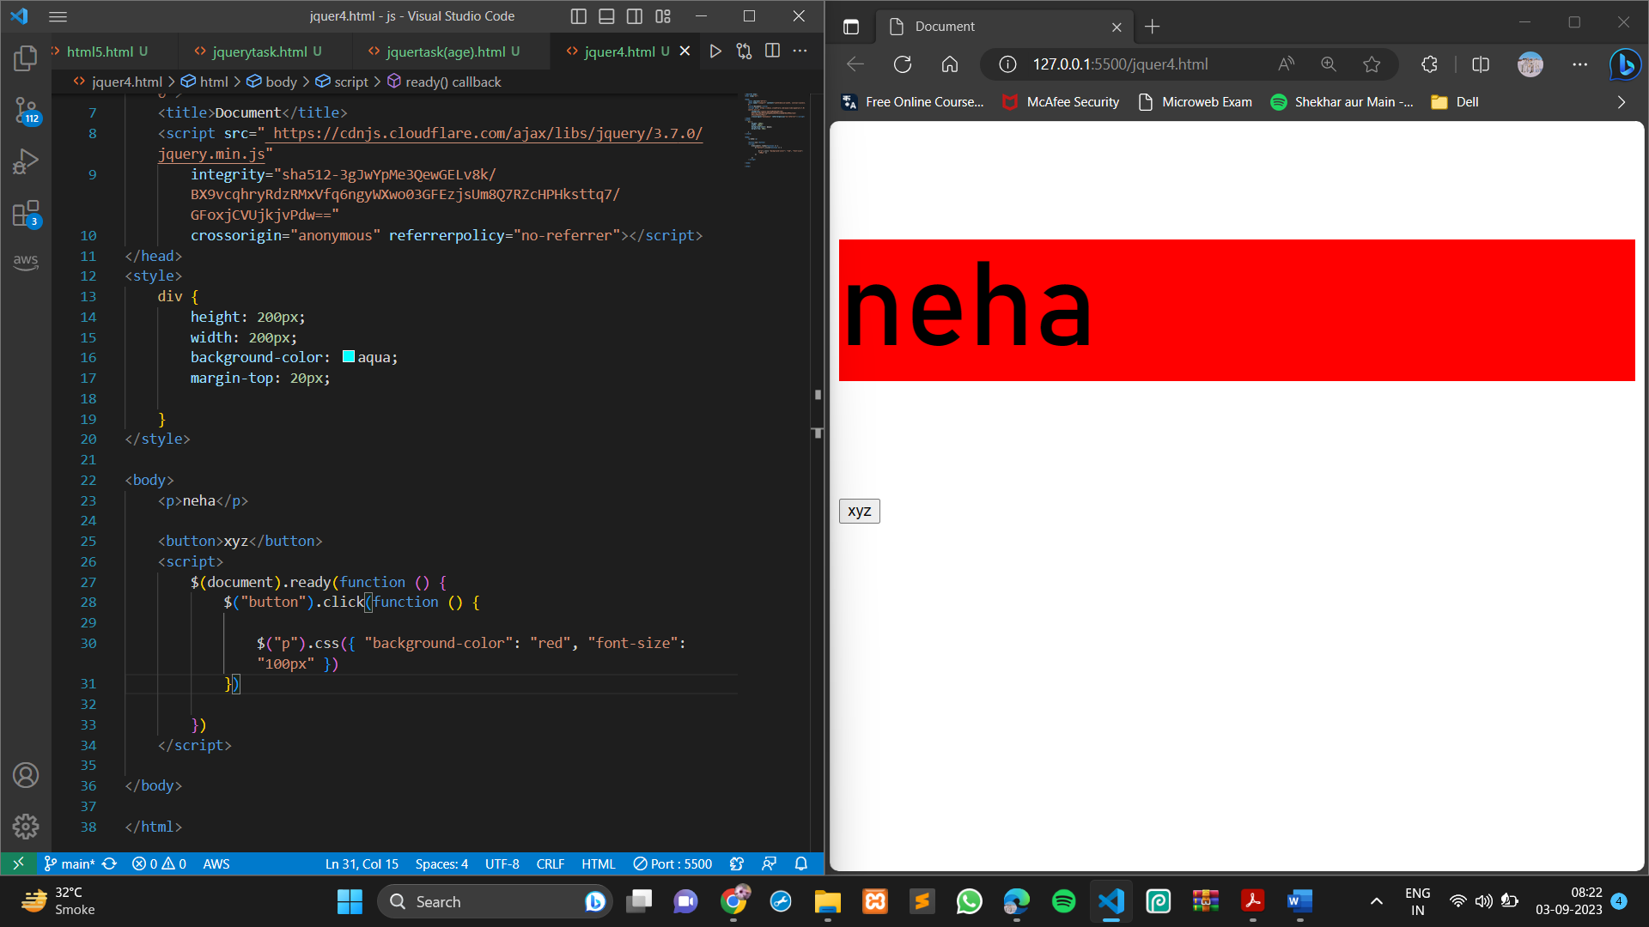

The addClass() method adds one or more class names to the selected elements.

Syntax

$(*selector*).addClass(*classname*,function(*index,currentclass*))

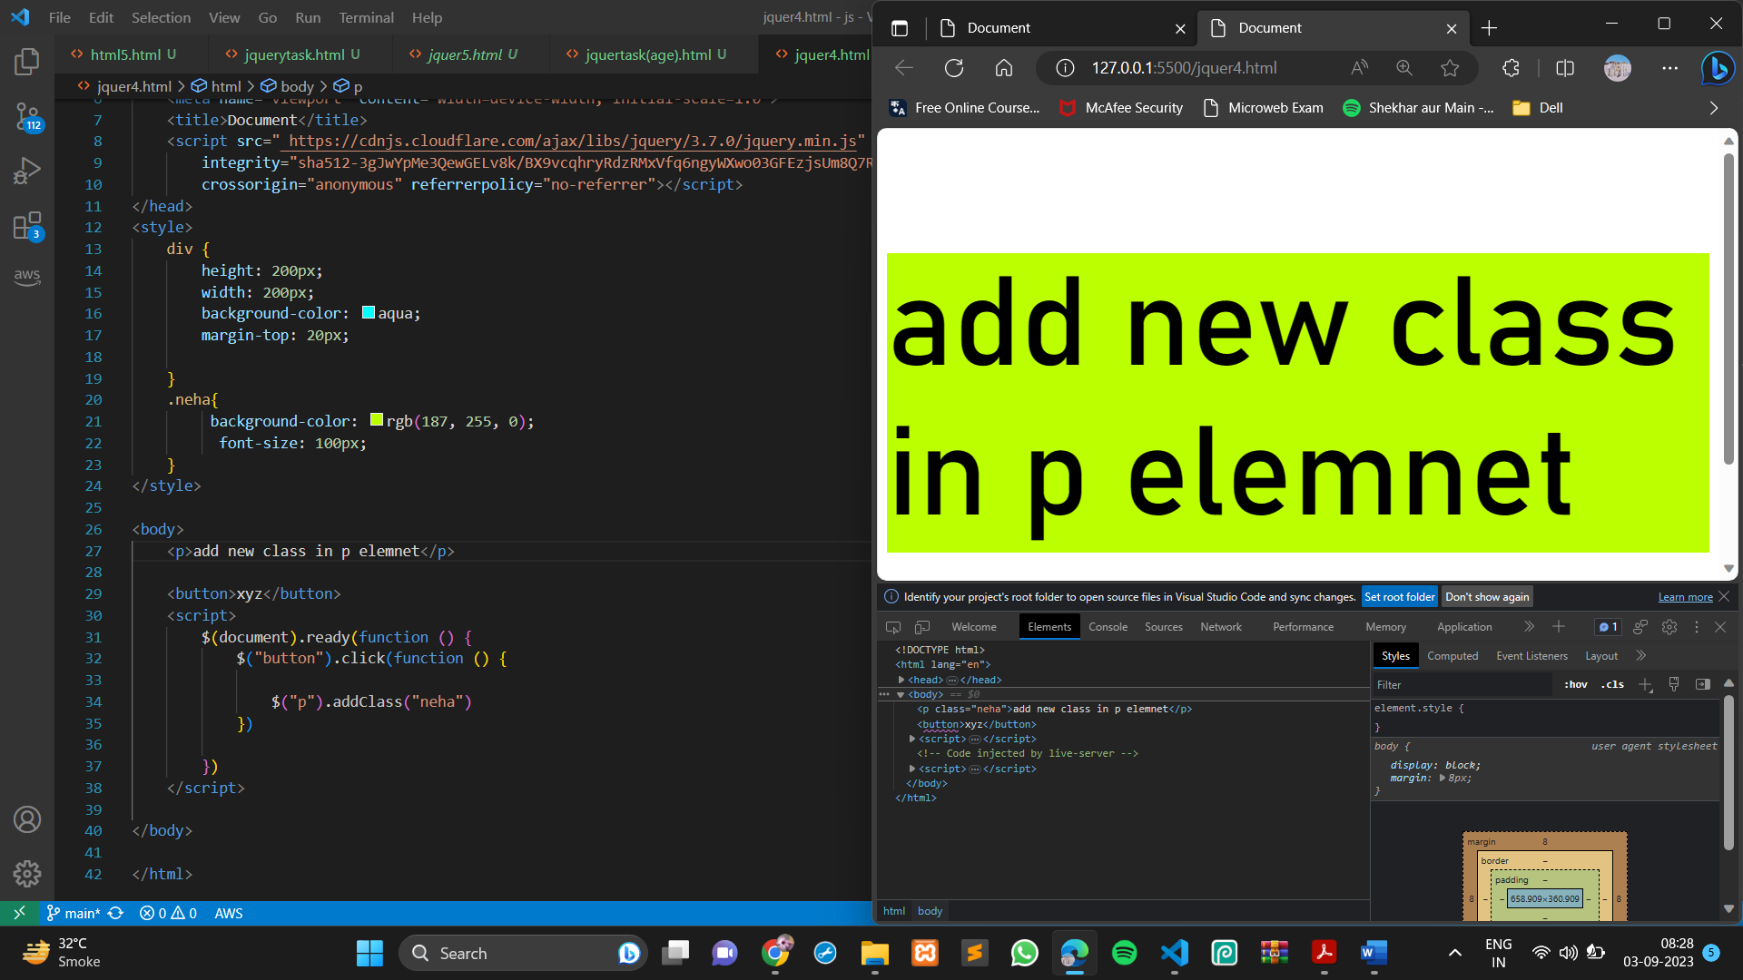

The jQuery animate() method is used to create custom animations.

**Syntax:**

$(*selector*).animate({*params*}*,speed,callback*);

The required params parameter defines the CSS properties.

The optional speed parameter specifies the duration of the effect like following values: "slow", "fast", or milliseconds.

The optional callback parameter is a function to be executed after the animation completes.

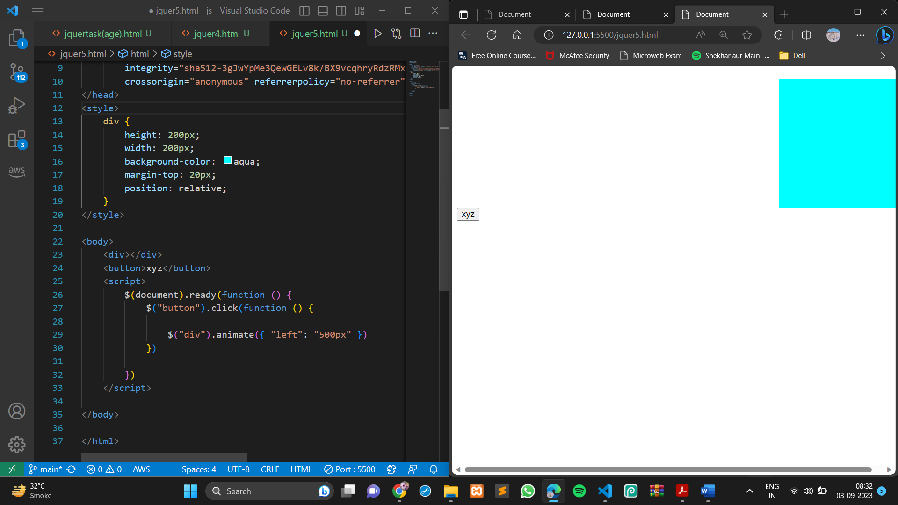

• How to create slider with animation?

With jQuery you can create a sliding effect on elements.

* slideDown() :- The jQuery slideDown() is used to slide down an element
* slideUp():-The jQuery slideUp() is used to slide up an element.
* slideToggle():-The jQuery slideToggle() combination of both slideDown() and slideUp() methods.

