1. What are the new tags added in HTML5?

<article> tag: Defines an independent or self-contained content of a webpage.

<aside> tag: Defines content that is only slightly related to the rest of the page.

<audio> tag: Defines an audio file.

<canvas> tag: This is used for rendering dynamic bitmap graphics on the fly, such as graphs or games.

<command> tag: Represents a command the user can invoke.

<details> tag: Defines additional details that the user can view or hide.

<dialog> tag: Defines a dialog box or window.

<footer> tag: Represents the footer section of the webpage.

<header> tag: Defines the introductory or navigational content of the webpage.

<mark> tag: Defines the marked text

<nav> tag: Used for declaring the navigational section in HTML documents.

<progress> tag: Defines a progress bar.

<section> tag: Defines a section of a document.

<time> tag: Defines a time.

<video> tag: Defines a video file.

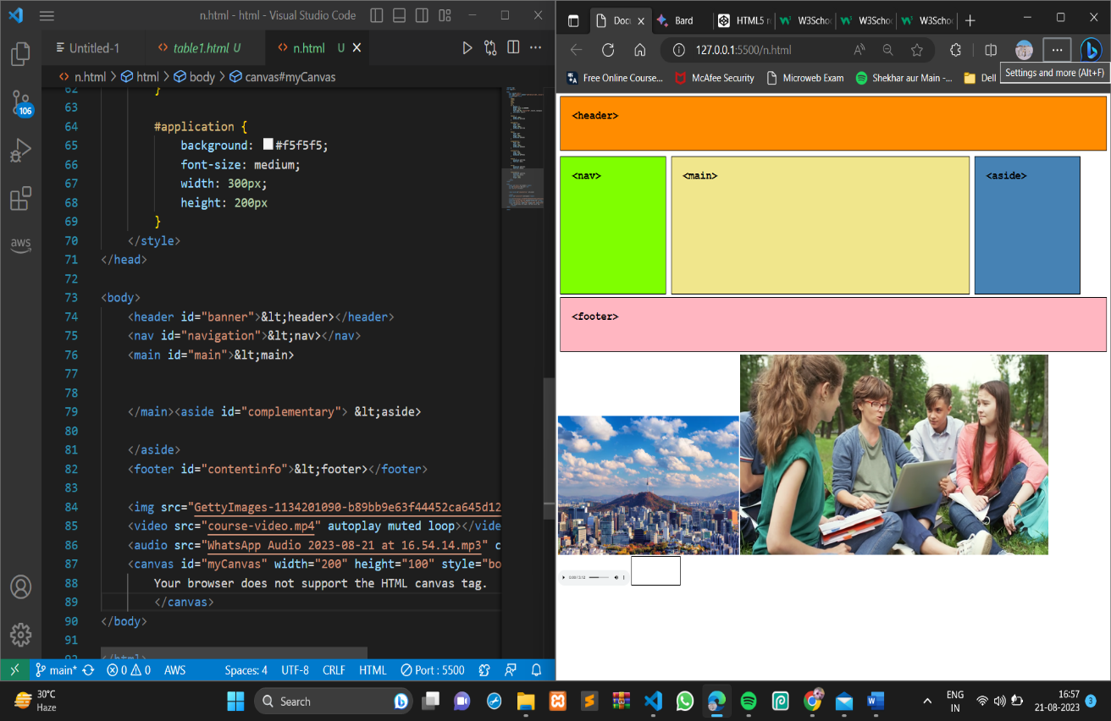

1. How to embed audio and video in a webpage?

<audio src="audio_file.mp3" controls></audio>

The src attribute specifies the URL of the audio file. The controls attribute tells the browser to display the default playback controls for the audio file.

<video src="video_file.mp4" controls></video>

The src attribute specifies the URL of the video file. The controls attribute tells the browser to display the default playback controls for the video file.

Example:-

<video src="course-video.mp4" autoplay muted loop></video>

<audio src="WhatsApp Audio 2023-08-21 at 16.54.14.mp3" controls></audio>

1. Semantic element in HTML5?

Semantic elements in HTML5 are elements that have a meaning or purpose beyond simply formatting text. They are designed to help web browsers and search engines understand the structure of a web page, which can make it easier for users to find and understand the content.

<article>: Defines an independent or self-contained content of a webpage.

<aside>: Defines content that is only slightly related to the rest of the page.

<header>: Defines the introductory or navigational content of the webpage.

<footer>: Represents the footer section of the webpage.

<nav>: Used for declaring the navigational section in HTML documents.

<section>: Defines a section of a document.

1. Canvas and SVG tags.

Canvas

The HTML Canvas element provides HTML a bitmapped surface to work with. It is used to draw graphics on the web page. The html 5 <canvas> tag is used to draw graphics using scripting language like JS. The HTML <canvas> element is only a container for graphics, you must need a scripting language to the graphics draw.

The Canvas allows for dynamic and Scriptable of 2D Shapes.

example

<canvas id="myCanvas1" width="300" height="100" style="border:2px solid;"> </canvas>

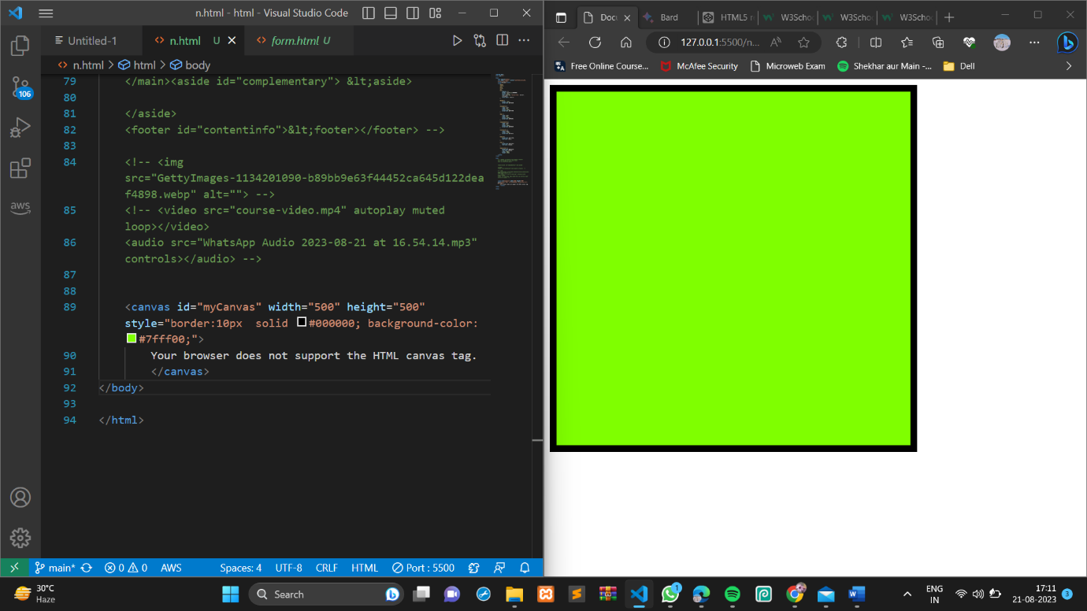

SVG

The html SVG is an acronym which stands for Scalable Vector Graphics.

SVG is a language that is used to describe graphics.

Svg is use two create 2d grapichs

SVG is mostly used for vector type diagrams like pie charts, 2- Dimensional graphs in an x, y coordinate system etc.

