Basics of Nmap

I learnt the bascis of Network Scanning, TCP Flags and 3-way Handshaking concepts.Did a demonstration of the the process of the TCP 3-way Handshake and analysed using wireshark.

Nmap scanme.nmap.org - Default scanner used to scan the 1000 ports and it doesn’t involve Imcp echo packets.So by using this commands got a summary which is show below

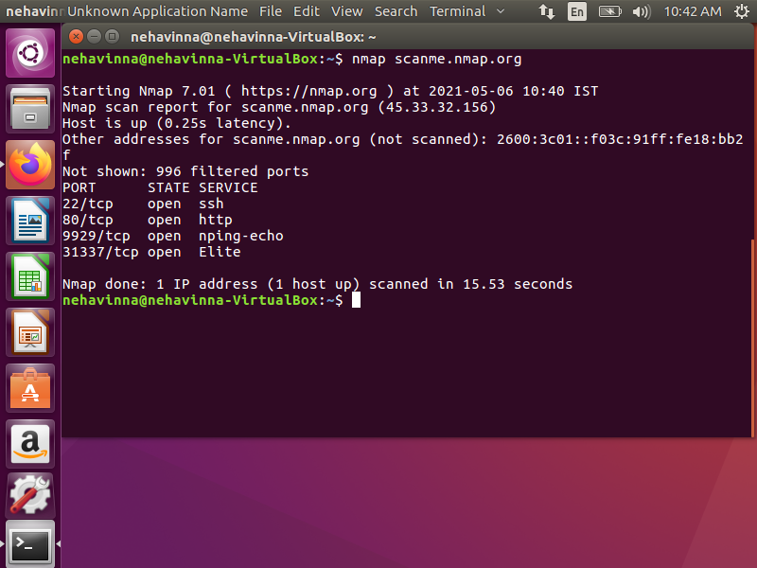

Nmap –sn 192.168.1.1 – ping sweep – I uesd to find what device is currently on my network

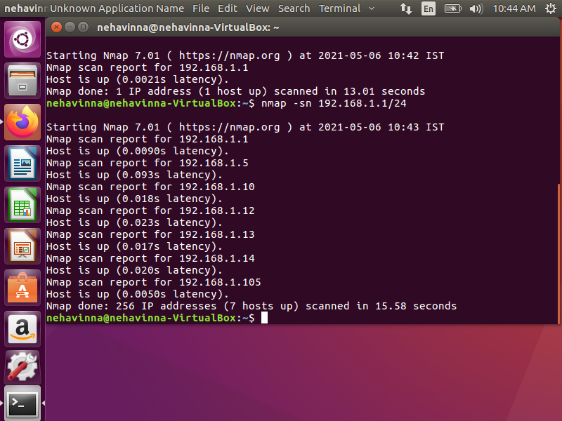

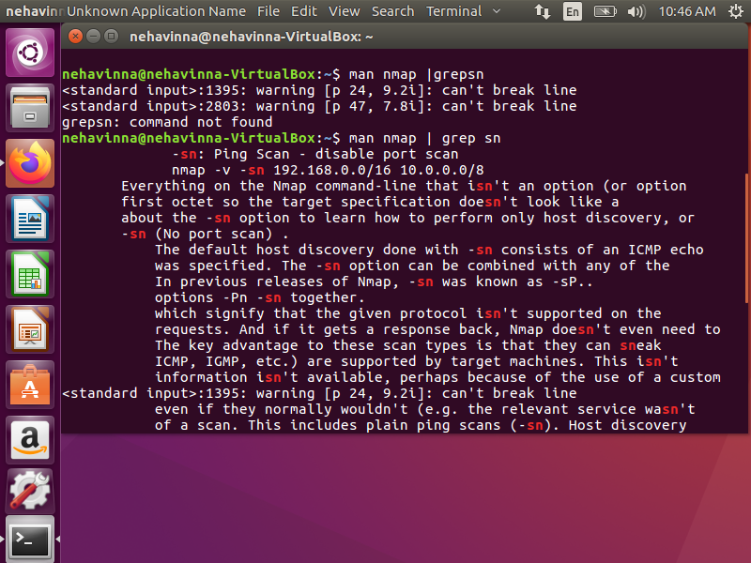

I used this command for host discovery using IMCP echo packects I send request check whether the host is up or not

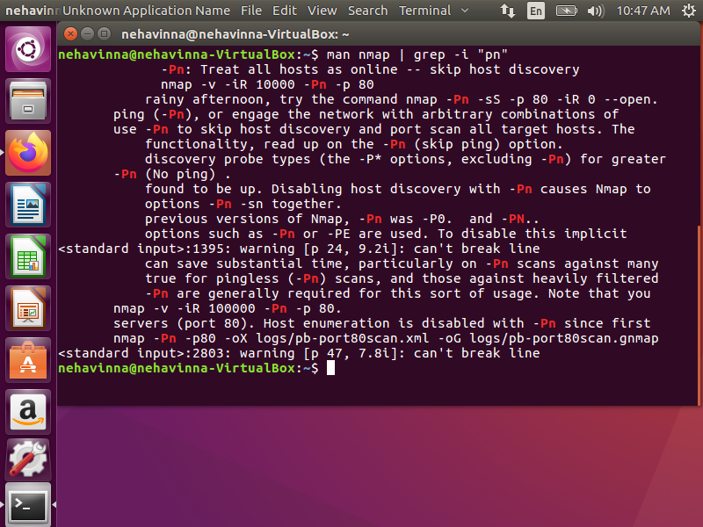

I used this command to find which ip is blocked from scanning

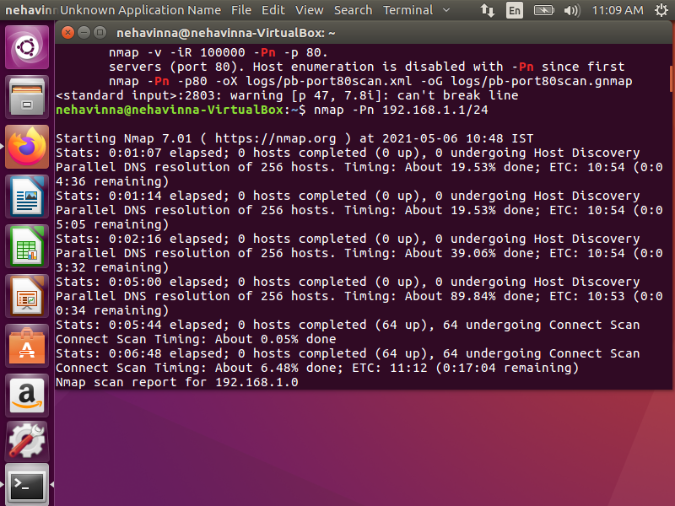

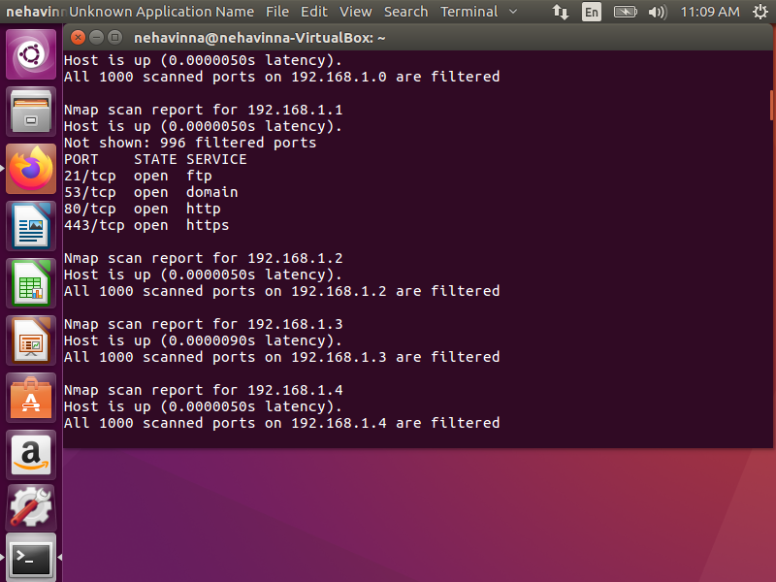

I used this to scan my network .