Host discovery ,port scanning and os & Service Version scanning

Nmap –Pn host

I used this command for host discovery using IMCP echo packects I send request check whether the host is up or not.

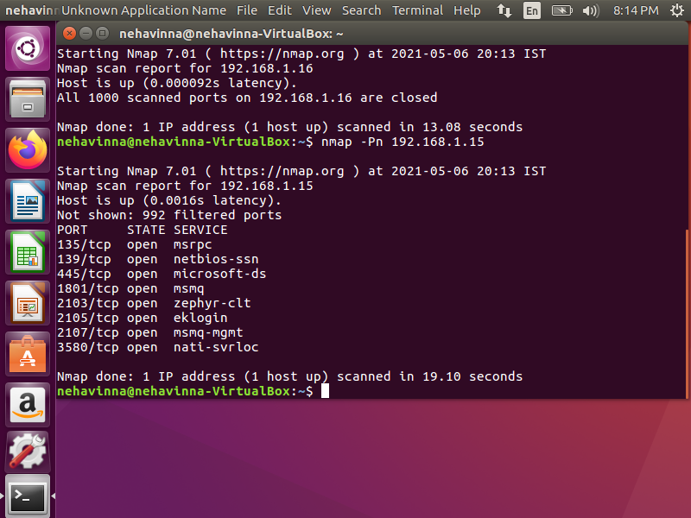

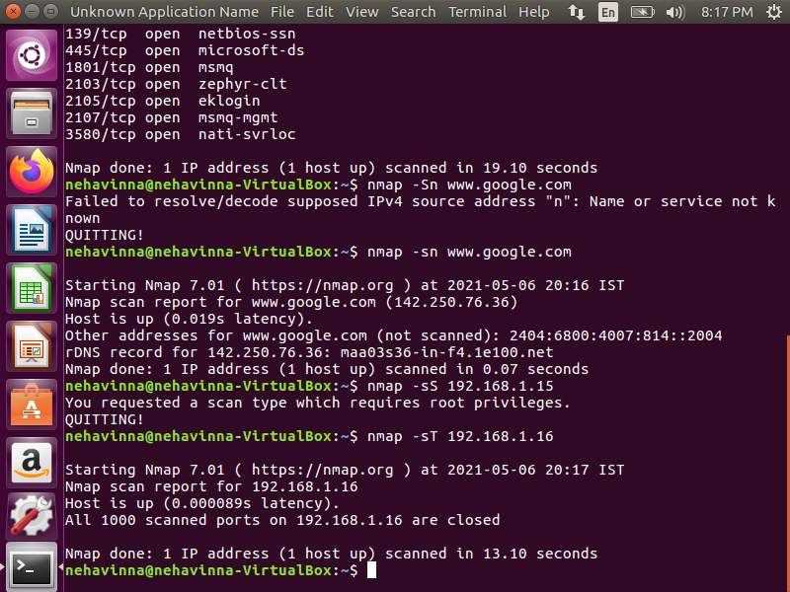

Nmap –sT host- It is used to find the tcp connects. By using wireshark we can find a detail explination of 3-way handshaking

Nmap –p 443 host- I used this command to find wether 443 port is open or not in my entire subnet

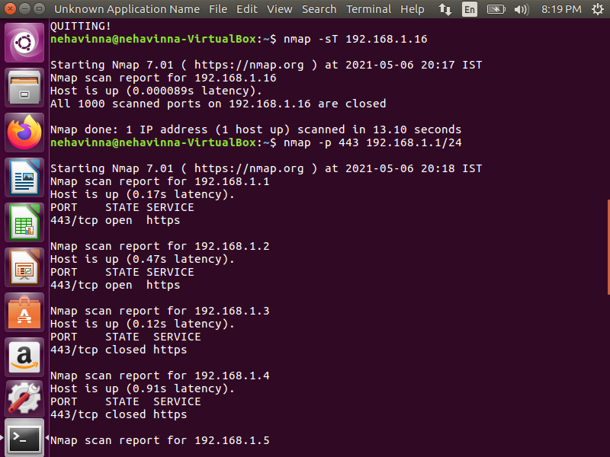sudo Nmap –O host – I used this command to find the operating system of the host

Sudo Nmap –O –sV host- I used –sV command to find what all service version is in the host

Sudo nmap –A host – I used this command to do aggresssive scanning. In this scanning we can find os,service version and nmap scripting

