Inverse TCP scanning and Firewall detection

Sudo nmap –sX host

Sudo nmap –sF host

Sudo nmap –sN host

These command are used to find open ports

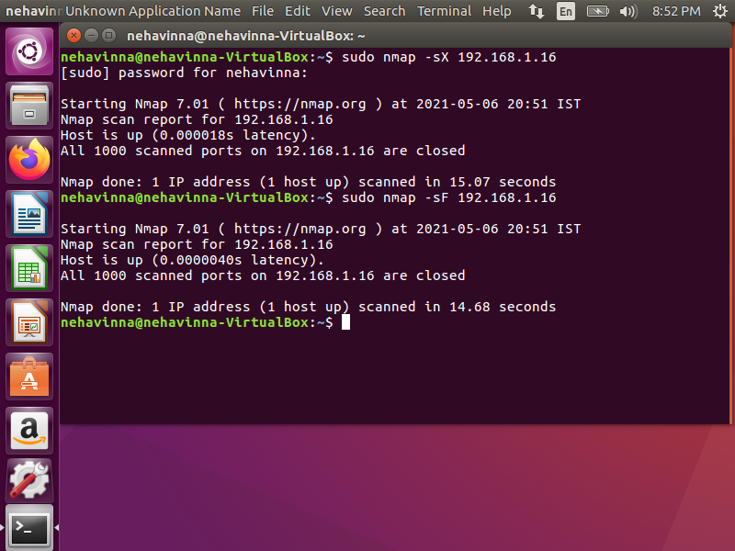



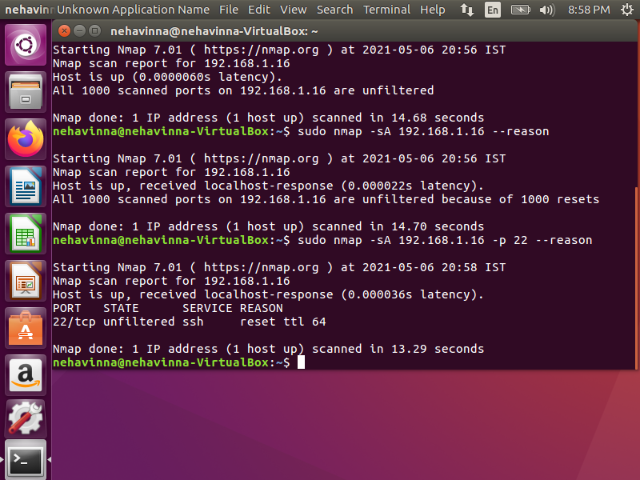

Nmap –sA host- using ack probing we can fine whether firewall is there are not.

Ack=1 firewall present

Ack=0 firewall absent