Planning New Urban Hubs in Western Democratic Republic of the Congo through Conditional Location Optimization and an Assessment Framework for Functional Autonomy
PAMBOLO MAYAMBO Néhémie
Department of Mathematics, Statistics and Computer Science, University of Kinshasa, Kinshasa, Democratic Republic of the Congo
Corresponding author: nehemiemayambo@gmail.com
ORCID: https://orcid.org/0009-0001-5168-273X
Abstract—This study investigates where additional urban hubs could improve territorial integration across Greater Bandundu, Greater Équateur, Kinshasa and Kongo Central. A directed October 2026 OpenStreetMap road graph and complete WorldPop and GHS-POP population grids support conditional location allocation. Twenty-six existing hubs remain fixed; three, five or ten new service centres are selected to maximize additional modelled population within 100 km. Candidate grids of 10 and 25 km use a documented protected-area mask and point-sampled land-cover exclusions. Twenty-four new optimizations compare population products, road-class sets, candidate grids and an optional 15-km water-proximity constraint. All terminate with zero optimality gap. With WorldPop and main roads, five new centres increase five-kilometre-demand coverage from 59.08% to 64.68% on the 25-km candidate grid and to 65.57% on the 10-km grid. At ten new centres on the coarse grid, coverage reaches 69.17%. These conditional gains complement earlier network and population sensitivity experiments. Functional autonomy is operationalized as an assessment framework separating measured accessibility proxies from unmeasured productive, energy, service and trade functions. Water proximity is tested as a resource-access condition, not evidence of reliable supply. Selected centres identify sectors for further investigation, not cleared construction parcels or proven sovereign cities. Historical inheritance remains contextual; no colonial causal effect is estimated. Household-access validation, operational transport verification, land rights, investment costs and functional-autonomy observations remain required before implementation.
Keywords—new urban hubs; conditional location allocation; functional autonomy; territorial integration; population coverage; Democratic Republic of the Congo.

I. INTRODUCTION
Accessibility analysis connects the spatial distribution of inhabitants with the opportunities they can reach. A transport system can contain many mapped features while providing uneven access to services, and geographical proximity alone does not demonstrate functional connectivity. Transport geography and accessibility research distinguish infrastructure, network impedance, land use, and individual constraints [1], [2]. Global mapping of urban–rural catchments further shows why demand outside large cities must be retained when describing access [3]. These distinctions are particularly relevant to large territories where digital infrastructure inventories are more available than observations of journeys.
The study examines Greater Bandundu, Greater Équateur, Kinshasa, and Kongo Central as one interconnected territorial system. Its ten provinces span the Atlantic interface, the metropolitan concentration around Kinshasa, and substantial interior and northern settlement areas. The planning objective is to locate additional urban hubs that could extend interior service coverage and provide a basis for investigating relative functional autonomy. Accessibility gains are measured conditionally; economic independence, employment and viable urban construction are not inferred from them. Existing-hub analysis supplies the baseline, and new candidate-centre optimization is introduced in Sections II.L–M and III.L–M.
The initial version used a connected synthetic graph and population around 26 named nodes to explore p-median scenarios. Median models provide a clear distance-minimization benchmark [4], [5], but forcing connectivity can conceal precisely the disconnections a regional study should describe. A coverage formulation [6] offers an alternative when demand cells can remain without a route to selected facilities: unreachable demand is retained in the denominator rather than assigned an arbitrary finite journey. Shortest-path calculations [7] must then be performed on a graph whose edge semantics are explicit.
The revised contribution combines an audited baseline with a new-centre location experiment. It compares two population products and road assumptions, then selects screened candidate centres in addition to all 26 existing hubs. The central question is where additional hubs can maximize modelled service coverage, how grid and resource-access assumptions change those solutions, and which further evidence would be necessary to assess functional autonomy. Exact optimization, input checks and an explicit autonomy framework are kept distinct from empirical outcome validation.
Three testable propositions organize the analysis. First, a centrality ranking derived from the synthetic graph should not be treated as stable if changing its topology changes key node ranks substantially. Second, expanding the selected hub set can increase coverage, but the percentage reached may depend materially on the population product and graph assumptions. Third, the earlier proposition of an elbow around ten p-median facilities is assessed using an explicit rule, rather than visual inspection. These are model comparisons, not tests of a colonial cause or of reduced economic dependence on Kinshasa.
Historical transport development motivates the integration question, but no colonial-era network is digitized or compared with current data here. A causal colonial claim is therefore omitted from the title and findings. The ambition of new urban hubs and relative functional autonomy is retained through conditional location optimization and a specified evidence framework; realized sovereignty is not asserted. This distinction permits territorial planning questions without treating a desired future as an observed result.

II. MATERIALS AND METHOD

A. Study Area, Sources, and Evidence Status
The administrative units are Kinshasa, Kongo Central, Kwango, Kwilu, Maï-Ndombe, Équateur, Mongala, Nord-Ubangi, Sud-Ubangi, and Tshuapa. They are analysed jointly. The common comparison mask uses geoBoundaries COD ADM1, boundary identifier COD-ADM1-28894549, with the producer metadata and geometry retained [8]. A separate boundary sensitivity check uses COD-AB ADM1 v01, valid on 11 September 2019. Boundaries are operational masks, not a resolution of legal or customary territorial claims. Road features are selected using the corresponding ten province codes in the HOT export; small differences between feature attribution and the raster mask are therefore possible.
TABLE I
SOURCES AND ANALYTICAL ROLES
Source / edition | Role | Evidence status
WorldPop 2025 R2025A v1 [9] | Population counts, ~100 m | Constrained alpha model
GHS-POP 2025 R2023A [13] | Alternative population, 1 km | Modelled 2025 epoch
GHS-SMOD 2025 R2023A V2.0 [14] | Settlement classes, 1 km | Standard model classification
geoBoundaries COD ADM1 [8] | Common raster mask | Represented boundaries
HOT/OSM, 5 Oct. 2026 [19] | Directed road geometry | Mapped; operation unverified
Released v1.0.0 inputs | 26 hub coordinates; audits | Legacy candidate set

WorldPop and GHS-POP provide estimated population distributions, not regional census observations. Research on household-based estimation and spatial disaggregation shows the methodological diversity of these products [10], [12]. Cell-level accuracy findings from an unconstrained WorldPop simulation in Namibia [11] are not transferred as numerical error bounds to the constrained DRC product. Comparing two products measures disagreement; shared inputs and modelling assumptions prevent interpreting agreement as independent validation. All source epochs, download URLs, checksums, and generated file counts are recorded in the accompanying replication package.
The baseline existing-hub set contains 26 named GeoNames nodes retained from the original analysis. Masina and Bolenge are excluded as separate facilities to avoid the earlier duplication of Kinshasa and Mbandaka. The name “Bandundu Province” in the source identifier refers to the point used for Bandundu; its label is shortened to Bandundu in the manuscript without moving the coordinate. The nodes are candidate service locations, not a complete regional urban census. These 26 hubs remain fixed in the additional-centre experiment; new screened sites form a separate decision set in Section II.L.
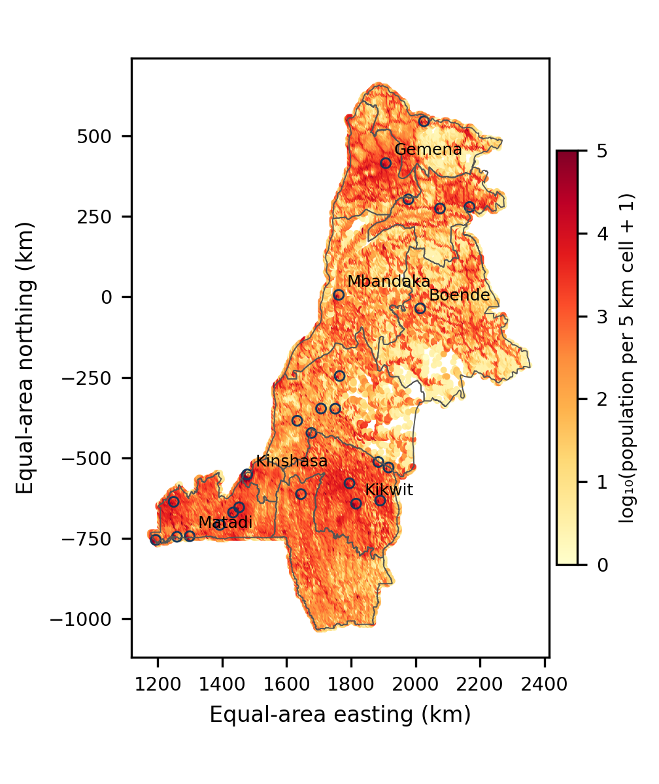
Fig. 1. Common regional mask, WorldPop demand aggregated to 5 km cells, and the 26 existing candidate hubs (open circles). Projection: EPSG:6933. Boundary source: geoBoundaries; population: WorldPop. Colours show modelled counts, not observed density.

B. Mass-Conserving Demand and Settlement Classification
For WorldPop, positive finite pixel counts are retained when their pixel centres fall inside the union of the ten provinces. Coordinates are transformed from WGS84 to the equal-area CRS EPSG:6933. A source count is assigned to the one-kilometre bin defined by floor(x/1000), floor(y/1000); five-kilometre cells are nested groups of these bins. Counts are summed, never averaged as if they were densities. No positive population is removed because a cell is rural or disconnected from roads. Each populated grid-cell centre becomes a demand point with its aggregated count as weight.
GHS-POP is processed analogously from the native one-kilometre Mollweide raster [13]. Selected native pixel centres are transformed and assigned to the same equal-area grid. This method conserves the selected count but does not reconstruct subpixel settlement locations. Transforming pixel centres between grids also creates alignment effects. One- and five-kilometre grids are compared to assess aggregation sensitivity; no conclusion of parcel-scale accuracy follows from choosing the finer grid. Zero-count and nodata locations are distinguished during raster processing.
Settlement classes are sampled from GHS-SMOD at hub coordinates and at WorldPop demand-cell centres [14], using the GHSL documentation and the Degree of Urbanisation approach [15]–[18]. The classification replaces the earlier interpretation of five-kilometre buffers as urban agglomerations. It is not used to discard rural demand. A sampled urban-centre code indicates the raster class at a point, not the city’s full footprint, official administrative population, or economic function. Section II.I extends point sampling with explicit classified-cell component footprints and population sums.

C. Directed Graph from Mapped Road Geometry
The new graph uses the HOT/OSM road extract dated 5 October 2026 [19]. Main road classes include trunk, primary, secondary, tertiary, their links, unclassified, residential, service, living street, and road. A separate scenario also includes tracks. Paths, footways, construction features, points, and polygons are not added as roads. The main model is a road model; rail, river, and air layers from the original inventory are contextual data and are not silently connected into an operational multimodal graph.
Every retained line is decomposed into consecutive geometry vertices, with WGS84 geodesic lengths as arc weights. Exact shared coordinates establish junctions. Interior vertices retain the layer attribute; endpoints use a common transition level. Existing one-way attributes are respected, including reverse direction where encoded. Missing one-way attributes are treated as bidirectional, and duplicate parallel arcs retain the shortest length. These rules preserve mapped disconnection instead of adding a minimum spanning tree. They do not guarantee a routable inventory: missing access restrictions, bridge or layer tags, inaccurate intersections, and absent original OSM node identifiers can create false joins or missing links.
Road-network modelling is sensitive to representation [22]. Humanitarian mapping evolves over time [20], and documented inequalities in OSM building completeness [21] cannot be treated as numerical estimates of road completeness. The study therefore uses explicit perturbations rather than claiming a known completeness percentage. Mapped roadless areas and environmental interpretation also depend on data and scale [23]. Routes leaving the ten-province extraction are not evaluated; a missing within-region path is not proof that no journey is possible through neighbouring areas or another transport mode.
Demand and hubs are attached to their nearest retained graph vertex using a spherical nearest-neighbour search and geodesic offsets. Attachment is accepted only when the offset is at most 1, 2.5, or 5 km, depending on the scenario. The offset is included in distance at both ends. These are assumed straight connectors; neither terrain nor water crossings are checked. Nearest-vertex attachment differs from snapping to the closest point along a segment. Paths are computed on the reversed directed graph to recover demand-to-hub distances. Unattached or unreachable cells remain in the total population denominator.
dᵢⱼ = aᵢ + shortest_path(vᵢ → vⱼ) + aⱼ. (1)
Here a denotes connector length and v the attached vertex. If either endpoint fails the connector threshold or no directed path exists, d is infinite. A 100-km threshold is an explicit planning-distance assumption, not a travel-time budget, service standard, or empirically calibrated catchment. The model estimates neither effective speeds nor seasonal travel times. The earlier distance-to-time conversions are withdrawn because no representative speed or transfer dataset was available.

D. Population Coverage Optimization
The maximal covering model selects exactly p facilities among the 26 existing candidates, with p equal to 5, 10, or 15 [6]. Let Pᵢ be grid-cell population, yⱼ indicate a selected hub, and Cᵢ contain candidates reachable from cell i within 100 km under the attachment rule. The objective and constraints are:
maximize Σᵢ Pᵢ zᵢ; Σⱼ yⱼ = p. (2)
0 ≤ zᵢ ≤ 1; zᵢ ≤ Σⱼ∈Cᵢ yⱼ; yⱼ ∈ {0,1}. (3)
Cells with identical candidate-coverage sets are grouped into binary coverage patterns and their populations summed. This is an exact compression of the objective, not spatial subsampling. Although z is continuous, an optimum with binary y covers all eligible patterns with z = 1 because population weights are positive. SciPy mixed-integer programming uses HiGHS; the selected-set objective is independently recomputed from coverage patterns [29], [30]. Reported solver optimality concerns the specified finite problem, not the correctness of road geometry or the suitability of facility locations.
Coverage is 100 times covered population divided by all selected regional population. All 26 hubs are also evaluated as a ceiling for this candidate set and threshold. Selected identities are one optimizer output; equally optimal sets can exist. If coverage saturates, additional mandated facility slots may add no population. The model does not include installation budgets, capacities, service quality, provincial quotas, functional economic complementarity, or household ability to use a route. It therefore cannot identify a financially optimal number of urban investments.

E. Joint Scenario Stress Test
The study evaluates the complete factorial combination in Table II: two population products, two demand resolutions, two road-class definitions, three connector limits, two feature-removal conditions, and two hub-coordinate conditions. The design has 96 configurations for each p and 288 optimization runs. A fixed random sample removes 1% of selected road features in the perturbed condition. A separate fixed perturbation moves each hub 250 m along a random azimuth. Both use seed 20261006 and are held constant across population products and demand resolutions for comparability.
TABLE II
FACTORS IN THE JOINT SCENARIO DESIGN
Factor | Levels
Population | WorldPop; GHS-POP
Demand cell | 1 km; 5 km
Road classes | Main; main plus tracks
Connector limit | 1; 2.5; 5 km
Feature removal | 0%; fixed 1% random sample
Hub displacement | 0; fixed 250 m random direction

Removal and displacement magnitudes are deliberately labelled stress assumptions. Their probabilities are not calibrated to OSM omission rates or geolocation errors. The design combines input and structural choices simultaneously, but does not estimate the full uncertainty distribution. Minimum–maximum coverage envelopes are not confidence intervals or forecasts. A single deletion and displacement realization per condition cannot characterize stochastic tail behaviour; the supplementary five-realization experiment provides an additional check but still cannot estimate tails. Road additions, speed uncertainty, and operational multimodal links are not included in the 288-run design. Candidate-grid and ecological-screening sensitivity are evaluated separately in Section II.H.
Sensitivity literature distinguishes scenario exploration from variance-based attribution [25]–[28]. The factorial stresses introduce population, aggregation, geometry, and topology choices. Their coverage envelopes are scenario ranges. Section II.I adds exact finite-design variance attribution with an explicit independent uniform measure on categorical levels; no empirically calibrated error probabilities are implied.

F. Audit of the Earlier Topology, Median, and Candidate Scores
The earlier 26-node graph is re-created using a minimum spanning tree supplemented by k nearest neighbours, with k = 1, 2, 3, 4, 5, and 8. Undirected radius graphs use 15, 25, 40, 50, and 100 km without forced connectivity. Edges are weighted by Haversine distance. Normalized weighted betweenness, component counts, isolates, and closeness with the reachable-fraction correction are exported for all nodes. Average ranks are used for ties. For disconnected graphs, reachability accompanies centrality rather than comparing raw closeness without its support.
The released p-median distances and buffer-based population weights are also retained solely for an audit. Exact mixed-integer programs are solved for p = 2 through 20 [4], [5]. These distances use the rounded edge lengths in the released graph. The revised elbow rule selects the first p for which each of the next three proportional improvements is below 5%. It is specified before interpreting the expanded curve; eligible values are p = 2 through 17. A proposed elbow around p = 8–12 is not accepted unless the rule is met. Because the data were already explored in the first version, this is a transparent audit rule, not a prospectively registered confirmatory hypothesis.
The initial greenfield-site workflow is moved out of the main location recommendation. Its cached environmental sample of 75 compatible points is audited under the seven-variable reference vector (0.24, 0.20, 0.16, 0.08, 0.04, 0.08, 0.20) and a uniform vector. The six preliminary weights had been (0.30, 0.25, 0.20, 0.10, 0.05, 0.10); slope introduced the seventh variable. These weights were assumptions, not expert elicitation or an AHP pairwise-consistency calculation. For each centre, 5,000 Dirichlet weight vectors with concentration 60 and seed 20260902 select one winner per province. The Monte Carlo calculation does not enforce the separate 100-km intersite spacing condition.
For clarity, the cached hydrological proxy is explicitly defined. Exposure is high when mapped-water distance is at most 5 km and exploratory slope is at most 2%; otherwise it is moderate when distance is at most 15 km and slope at most 5%; otherwise it is low. A missing input must be reported as unclassified. Slope is 100 times the larger north–south or east–west elevation difference divided by 2,000 m, using five SRTM90 sample queries around the site. It is a kilometre-scale gradient, not surveyed parcel slope. This rule is a proximity–terrain flag; it uses no river discharge, water level, return period, or inundation depth.
The WorldCover tree-cover class was excluded conservatively in the legacy screen [24], but does not distinguish primary forest from degraded secondary cover or agroforestry. The 10-versus-25-km candidate-grid comparison, extreme tree-exclusion sensitivity, and a current protected-area mask are added in Section II.H. Forest integrity, tenure, and cadastral constraints remain unvalidated. Consequently, the legacy candidate scores cannot support a new-town recommendation. The audit illustrates preference sensitivity only and is separated from the gridded existing-hub coverage model.

G. Verification and External Validation Boundary
Computational verification includes population-sum conservation, checksums, compressed-file integrity, graph counts, solver status, and objective recomputation. Cross-product agreement, recovery of known place names, and stability under assumptions are treated as diagnostics, not empirical validation. No observed regional origin–destination matrix, matched road-flow dataset, or field survey is used to validate the coverage values.
A secondary source was nevertheless examined: the JICA Kinshasa transport master-plan report published in April 2019 [32]. It describes 2017 travel-speed surveys on 13 urban routes and count surveys. The route inventory and report pages are retained in the supplement. Those urban route observations do not provide a compatible regional OD matrix or a validation target for the ten-province 100-km hub-coverage objective. Their existence is documented without computing a misleading regional MAE, RMSE, or predictive R². A future urban submodel could be tested against digitized route observations, but that test has not been performed here.
An external input check compares the October 2026 OSM extract with Slagter et al.’s satellite-detected 2019–2025 forest-road development [33], [34]. The reference is clipped to the ten-province union. Lines are projected to a local azimuthal equidistant CRS (19°E, 1°S), divided into subsegments no longer than 25 m, and sampled at subsegment midpoints. Each sample receives its subsegment length as weight. Agreement at tolerance t is the length-weighted fraction whose nearest mapped-road line lies within t. Tolerances are 25, 50, 100, and 250 m; OSM road sets are the main classes, main classes plus tracks, and all mapped line classes. Repeating the calculation at 50 m checks numerical sampling sensitivity. Road geometry agreement does not test graph junctions, traversability, travel time, or coverage. The satellite product represents newly detected forest roads rather than the entire public road network, has its own detection errors, and is not treated as field ground truth. Possible subsequent OSM reuse of satellite mapping cannot be ruled out.
The World Bank AICD inventory and documentation are also downloaded [35]. Positive traffic records are distinguished from the −99 missing sentinel and zero-ID placeholders. Repeated identical traffic values on subdivided segments are not treated as independent observations. The same spatial agreement procedure is applied as a historical corridor benchmark; shared map provenance and the age of the counts limit independence and relevance.

H. Repeated Stresses and Environmental Grid Comparison
An additional experiment holds the main road classes, five-kilometre demand grid, and five-kilometre connectors constant while testing 50-, 100-, and 150-km coverage thresholds. Five independent realizations jointly remove 1% of road features and move hub coordinates 250 m in random directions; seeds are 20261007–20261011, with coordinate azimuth seeds offset by 100000. A separate unperturbed baseline is retained. Both population products and p = 5, 10, and 15 are evaluated, giving 108 additional exact optimizations. These repeated stresses assess realization dependence; five draws do not estimate tails, a calibrated probability distribution, or separate variance contributions of deletion and displacement.
Candidate screening is recomputed at 10 and 25 km on one regional mask, with an EPSG:6933 origin at zero. Centres inside the mask must be at least 40 km from existing hubs and at most 25 km from a mapped road or 15 km from a mapped waterway. Road input is held constant between grids; river, rail, and aerodrome geometry comes from the original retained multimodal inventory. Demographic potential is recomputed from the complete five-kilometre WorldPop grid as Σᵢ Pᵢ/[1+(dᵢⱼ/100)²], using projected distances in kilometres. Normalization bounds are shared across both grids. The six reference preference weights and uniform weights are compared; neither is claimed to be elicited. No new slope, tenure, infrastructure-capacity, or constructability assessment is supplied.
Native WorldCover 2021 v200 pixels are sampled at candidate centres [24]. Strict screening admits classes 20, 30, 40, and 60. An extreme sensitivity condition also admits tree-cover class 10 to measure dependence on the hard exclusion; it does not classify forest degradation or endorse forest conversion. Results refer to centre classifications, not the complete land-cover composition of a 10- or 25-km square. A finer forest-integrity layer is still needed to distinguish primary from degraded secondary cover.
The official UNEP-WCMC protected-area view of WDPCA, October 2026, is queried for COD [36]. It returns 59 polygon records and one point record. Designated, Inscribed, and Established statuses are admitted to the exclusion mask; Proposed records are not treated as established protections. Overlapping records are unioned. Two rules are compared: centre intersection with protected polygons, and any intersection of the full square grid cell with polygons or a point-only reported-area buffer. The latter buffer has radius √(reported area/π) in the equal-area CRS and is a screening assumption, not a legal boundary. Protected-area raw geometries and attributes are not redistributed; users must obtain them from the producer under its terms.
A further source check transcribes the two observed screen-line counts in JICA Table 2.3.18 (printed p. 2-94): SL A, 311,333 PCU/day; SL B, 335,747 PCU/day [32]. The table also reports JICA’s calibrated traffic-model estimates, 287,878 and 316,870. These are genuine secondary traffic observations and another model’s outputs. The present maximal-covering model does not predict PCU/day. Consequently, no predictive error against these counts is assigned to the present model and JICA’s calibration is not presented as its validation.

I. Variance Attribution and Settlement Footprints
An exact functional ANOVA decomposes coverage variance on the complete 96-configuration factorial table separately for p = 5, 10, and 15. The six categorical factors are population product, demand-grid resolution, road-class set, connector distance, deletion level, and coordinate-displacement level. Each enumerated level is assigned equal independent probability for this calculation only. For each factor subset, its variance component equals the variance of its conditional cell means minus the components of all proper nonempty subsets. Dividing by total variance gives a first-order share for each singleton; summing all components containing that factor gives its total-effect share. All 63 nonempty components are included and their sum is checked against total variance. This is finite-design attribution under a declared scenario measure, not a calibrated error distribution or a continuous-parameter Monte Carlo Sobol estimate [27], [28].
Morphological settlement footprints are extracted from the native 2025 GHS-SMOD R2023A V2.0 one-kilometre Mollweide raster [14]–[18]. Published codes 30 (urban centre), 23 (dense urban cluster), and 22 (semi-dense urban cluster) are labelled separately using four-connected cells. The complete COD administrative union is applied by cell-centre inclusion before labelling; study-region selection follows labelling, avoiding artificial splits at provincial boundaries. Producer classification and smoothing are retained. Native, aligned GHS-POP cells are summed over each component. These derived classified-cell polygons are not official UCDB identifiers, functional urban areas, or administrative city populations. Hub membership requires its point to lie in a component; unmatched points are retained. Rural demand is not discarded.

J. Published Route Benchmark and Spatial Road Variation
A Logistics Cluster distance catalogue dated 6 September 2018 provides road distances for Kinshasa, Matadi and Bandundu [37]. The GeoNames hub coordinates are attached to the same directed main-road graph and track-inclusive alternative used in the covering experiment. Both directions of each pair are computed, including endpoint offsets. The comparison is an external route benchmark: catalogue terminals, prescribed itineraries, seasonal accessibility and measurement methods are unspecified, and the reference predates the OSM snapshot by eight years. The catalogue is therefore not treated as observed GPS trajectories or a calibrated error sample. The Matadi–Bandundu entry is checked for consistency with the two other entries before any interpretation.
The satellite-road comparison is extended by province and detection period, retaining the same 25-m midpoint sampling and 100-m tolerance. Within each road set, subsegment weights are aggregated in fixed 25- and 50-km projected blocks. For each block size, 1,000 draws resample the nonempty blocks with replacement using seed 20261008; agreement is recomputed as total matched length divided by total reference length. The 2.5th and 97.5th percentiles describe conditional spatial resampling variation. They are not confidence bounds for total road completeness, routing error or hub coverage: reference detection error, private access, temporal mismatch and unsampled roads remain unmodelled. No coverage optimization is added by these 4,000 resampling draws.
The supplementary preference-weight screen remains an audit rather than the basis of new-centre selection. A consultation protocol and blank forms are available for a future preference study, but no expert response is claimed. The new-centre model instead maximizes additional population coverage and uses explicit alternative constraints. It does not depend on the old assumed weights, the CRITIC vector, or an unavailable expert panel. Avoiding preference aggregation does not validate the inputs, establish construction feasibility or remove the requirement for external access observations.

K. Conditional Ferry Connectivity and Data-Derived Weights
The Logistics Cluster access report of 18 April 2024 identifies Bandundu access via Mongata with a bac and reports 405 km [38]. It also describes difficult road conditions and another ferry-dependent itinerary. Route numbers differ between its table and mapped RN17 annotations; this inconsistency is retained. Three OSM ways forming Bac Bandundu (49809124, 980566897, 980566898) are retrieved on 8 October 2026 [39]. Their geometry is added to each main/track road graph, using exact shared coordinates only. No artificial gap link is created. Bidirectional usability is assumed for a conditional diagnostic; waiting, fares, capacity limits, security and seasonality are omitted. This scenario tests an identifiable structural omission, without certifying current operation or replacing the road-only baseline.
Twelve new maximal-covering optimizations use this conditional ferry graph: two road-class sets, two population products, and p = 5, 10 and 15. Demand remains the complete one-kilometre grid, connectors remain at most 5 km, and the covering threshold remains 100 km, with no deletion or coordinate displacement. Baselines are matched to the corresponding existing runs. Paths beyond 100 km need not be evaluated for this objective. Each selected-set objective is independently recomputed. These targeted mode-availability tests are distinct from the 288-run factorial and are not fitted failure probabilities.
A CRITIC-style diagnostic derives weights from the six existing candidate-score columns [40]. Scores retain their common 0–1 transformations rather than being rescaled separately to each grid’s observed extrema. For each strict full-cell environmental screen, sigma_j is score standard deviation across retained centres (ddof = 0), r_jk is Pearson correlation, C_j = sigma_j Σ_k(1 − r_jk), and w_j = C_j / Σ_l C_l. Each retained centre has equal sampling weight. Separate 10- and 25-km computations are compared with the assumed and uniform vectors on exactly the same candidate sets. Tied provincial maxima are retained. Contrast/correlation weights describe the chosen evaluation matrix; they do not estimate expert preferences, validate the six transformations, or justify the original 30/25/20/10/5/10 allocation retrospectively.

L. Conditional Allocation of Additional Urban Hubs
All 26 existing hubs are retained as a fixed service baseline. This assumes comparable service availability and no capacity limits; actual service inventories are unavailable. Let b_i be one if demand cell i lies within 100 km of at least one fixed hub in the specified graph. New candidate set J comprises screened 10- or 25-km grid centres from Section II.H: at least 40 km from the retained hubs, permitted WorldCover point classes 20, 30, 40 or 60, and no full-cell intersection with the protected-area polygons or the reported-area point buffer. This retains 1,583 and 241 centres, respectively. Proximity to the 26 hubs does not establish distance from every town or village. A candidate can represent expansion of an existing rural settlement; neither vacant land nor a legally new city is established.
Candidate centres attach to the nearest retained road vertex with a geodesic connector at most 5 km; connectors are assumed, not newly designed roads. Demand is the full 5-km grid from each population product, with the same attachment rule. Unattached and unreachable cells remain in the denominator. The candidate set after attachment has 1,291/1,358 centres on the 10-km grid and 201/208 on the 25-km grid for main roads/roads plus tracks. The directed geometry graph and distance threshold are unchanged. Ferries are not added in this experiment, to retain a matched road-only baseline; Section III.K is a separate conditional mode test.
For a_ij = 1 when cell i can reach new candidate j within 100 km including connectors, maximize Σ_i P_i(1−b_i)y_i subject to y_i ≤ Σ_j a_ij x_j, Σ_j x_j = q, and binary x_j. Covered-demand variables y_i lie in [0,1]; positive weights and binary site choices yield exact covered masses. No preference weights or economic-autonomy score enter this objective. The baseline union is counted once and removed from marginal demand. Demand with identical full candidate-incidence vectors is aggregated by population sum using packed bits; no 26-site encoding limit applies. The reported selected sets are one optimum, with possible ties. Chosen q values are scenarios, not an estimated optimum number of cities; no budget or site-capacity model is available.
On the 25-km candidate grid, q = 3, 5 and 10 are crossed with two road sets and two population products, giving 12 runs. An additional q = 5 screen requires distance to mapped water at most 15 km, giving four runs. The 10-km grid repeats q = 5 with and without this water constraint across both road sets and products, giving eight runs. The total is 24 new optimizations, distinct from the 408 existing-hub and audit runs. Every objective is recomputed from the original demand weights and selected-site union. This experiment varies candidate grids but holds demand resolution at 5 km; earlier 1/5-km existing-hub sensitivities do not establish fine-grid stability of the new-site solutions. The water threshold is an explicit scenario choice, not an elicited or calibrated standard.

M. Functional Autonomy as an Assessment Framework
Relative functional autonomy denotes the capacity of a hub and its hinterland to satisfy essential functions while exchanging with other territories. It does not imply isolation or national political sovereignty. Urban–rural linkage frameworks examine flows of people, products, services and information [41]; polycentricity has scale-dependent functional meanings and cannot be inferred solely from several selected points [42]. This study treats autonomy as a planning hypothesis requiring separately documented functions, not as an existing composite score.
The operational evidence framework specifies productive capacity as the share of hinterland output processed locally; energy as hours of dependable service and the capacity to sustain critical uses; services as the proportion of identified health, education and administrative needs met locally; employment as local jobs and work-related travel; exchanges as observed origin–destination links; and dependence as the share of essential supply or services requiring Kinshasa. Their denominators, territories, dates and service categories must be defined before collection. None of these outcomes is estimated from population, illumination or proximity alone. Available population potential, land-cover class and mapped road/water/rail/air distances are reported as contextual proxies only. Missing energy, employment, production and trade observations remain missing; no zero, imputed achievement or sovereignty threshold is substituted.
The optional water constraint connects one resource-access consideration to the location model without an arbitrary weighted index. Distance to a waterway cannot establish potable water, dry-season yield, flood safety or navigability. Evaluating a new-city scenario would require engineering and financial designs for production, utilities, services and connections, followed by feasibility and rights assessments. Realized autonomy would require subsequent observations; any simulation of future autonomy must remain conditional on separately specified investment assumptions.

III. RESULTS AND DISCUSSION

A. Population Coverage of the Study Mask
TABLE III
MODELLED POPULATION AND DEMAND GRIDS
Measure | WorldPop | GHS-POP
Regional total | 43,302,132 | 34,033,890
Positive 1-km cells | 219,279 | 147,956
Positive 5-km cells | 24,553 | 21,120
Difference from WorldPop | Reference | −21.40%

The common geoBoundaries mask yields 43.30 million inhabitants in WorldPop and 34.03 million in GHS-POP (Table III). Aggregation conserves each selected raster total to numerical precision. The common five-kilometre count comparison has Pearson correlation 0.8714 and Spearman correlation 0.9305, while the sum of absolute cell-count differences is 23.90 million. High spatial association therefore coexists with substantial disagreement in total and local magnitude; neither product is established as ground truth by these statistics.
Using COD-AB with the same WorldPop raster and pixel-centre rule gives 43,227,817.80, reproducing the approximately 43.23 million total in the original manuscript. The geoBoundaries total is 74,313.94 higher, or 0.17% relative to COD-AB. This boundary comparison is an additional count audit, not a second execution of every road optimization. It separates a modest mask effect on the regional total from the much larger population-product difference. Boundary changes can still have locally important effects that the aggregate percentage conceals.
At the retained hub coordinates, GHS-SMOD identifies 21 urban-centre cells, four dense-urban-cluster cells (Inongo, Nioki, Mushie, and Kutu), and one very-low-density rural cell (Mangai). The last result can reflect point position and classification resolution; it is not a claim that Mangai lacks urban functions. WorldPop demand assigned by cell-centre sampling to the GHS-SMOD urban-centre class totals 15.31 million. This cross-product overlay is descriptive and does not measure an official metropolitan population. Small assignments to the water class also reveal alignment or model inconsistencies and should not be interpreted as confirmed residence on open water.

B. Mapped Road Reachability
The main road graph contains 106,892 features, 1,734,033 vertices, 3,594,763 directed arcs, and 1,273 weak components. Including tracks produces 147,365 features, 2,518,218 vertices, 5,187,173 arcs, and 2,779 weak components. The larger component count partly reflects additional disconnected track features; it does not imply that adding tracks reduces connectivity. Geometry vertices are computational routing nodes, not inhabited localities or intersections verified in the field.
TABLE IV
WORLDPOP ACCESS TO ALL 26 EXISTING HUBS
Road set | Connector km | Reachable % | ≤100 km %
Main | 1 | 78.49 | 55.59
Main | 2.5 | 82.03 | 58.11
Main | 5 | 84.95 | 59.37
+ tracks | 1 | 81.44 | 57.59
+ tracks | 2.5 | 84.16 | 59.07
+ tracks | 5 | 86.16 | 59.90

Under the main-road, five-kilometre connector condition, 84.95% of WorldPop population can reach some candidate hub through the graph. Another 11.18% attaches to a vertex but lacks a directed path to an eligible hub; 3.86% fails attachment. Population within 100 km of any of the 26 candidates is 59.37%. The mean distance of reachable demand is 79.82 km, but this conditional mean excludes unreachable demand and must not be reported as the mean journey of all regional inhabitants.
The one-kilometre connector condition excludes Mangai as an eligible main-road hub because its nearest retained vertex is approximately 1.85 km away. Increasing the attachment threshold therefore changes both demand eligibility and facility eligibility. The pattern illustrates why an off-network rule is part of the model, not a harmless preprocessing option. Roads omitted from mapping, functional river connections, routes through neighbouring provinces, and seasonal operability could all alter these reachability results. “Unreachable in this graph” is the appropriate interpretation, rather than “physically isolated.”

C. Existing-Hub Coverage and Joint Sensitivity
TABLE V
BASELINE OPTIMIZED COVERAGE WITHIN 100 KM
p | WorldPop % | GHS-POP %
5 | 40.00 | 54.95
10 | 50.97 | 62.70
15 | 56.38 | 66.19

The baseline uses one-kilometre cells, main roads, five-kilometre connectors, and no deliberate removal or displacement. Ten selected hubs cover 50.97% of WorldPop population but 62.70% of GHS-POP population (Table V; Fig. 2). The 11.73 percentage-point difference remains after holding these model choices constant. Coverage with all 26 hubs is 59.37% for WorldPop and 68.15% for GHS-POP. These ceilings concern the fixed candidate set, distance threshold, and road graph, not a national maximum achievable through infrastructure investment.
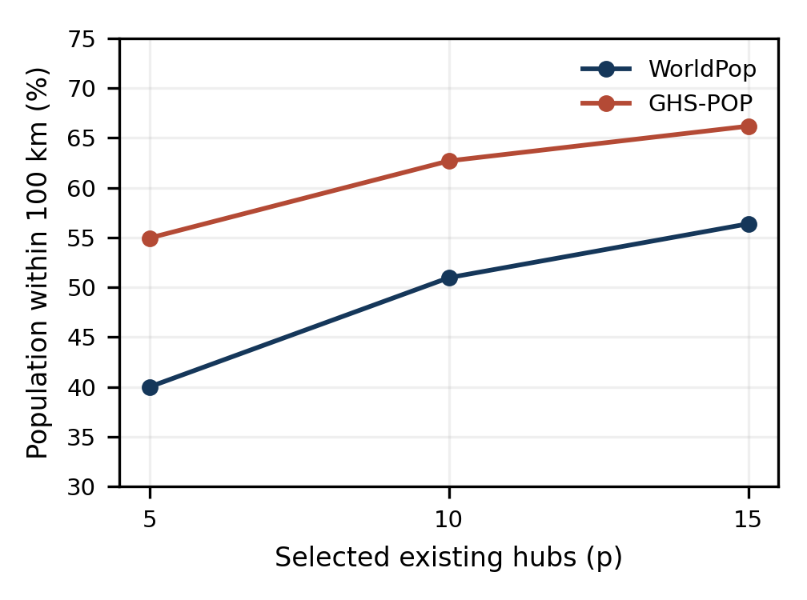
Fig. 2. Baseline maximal coverage for two population products. Main roads, 1-km demand cells, connectors ≤5 km, and no deliberate perturbation. Percentages use each product’s own regional total.
One WorldPop optimum for p = 5 selects Kinshasa, Mbanza-Ngungu, Tshela, Kikwit, and Gemena. For p = 10, one optimum selects Kinshasa, Matadi, Boma, Mbanza-Ngungu, Tshela, Kenge, Idiofa, Bulungu, Bumba, and Gemena. The selected identities are examples of optimal solutions to a coverage problem; they are not a priority list for public construction. Multiple solutions may attain the same objective, and the fixed candidate set does not contain every locality or potential service location. An optimality gap of zero cannot resolve these planning limitations.
TABLE VI
JOINT SCENARIO ENVELOPES: 96 CONFIGURATIONS PER P
p | Minimum % | Maximum % | Median %
5 | 33.51 | 55.17 | 44.91
10 | 40.40 | 63.35 | 53.46
15 | 44.10 | 67.16 | 57.31

All 288 optimizations terminate with solver status zero and reported MIP gap zero; recomputed coverage agrees with the solved objective. Joint scenario ranges are wide (Table VI). The median is merely the median of the equally enumerated configurations; it is not the expected real-world outcome. Treating every configuration equally in this descriptive summary does not supply a probabilistic prior for product correctness or network incompleteness. The complete run table preserves factor levels and denominators so individual assumptions can be inspected.
Increasing p from five to ten raises baseline WorldPop coverage by 10.97 percentage points, and increasing it from ten to fifteen adds 5.41 points. GHS-POP gains are 7.75 and 3.49 points. These diminishing increments support a discussion of saturation for the chosen service-distance model. They do not establish p = 10 as the best investment count, because no budget, facility capacity, or benefit valuation enters the objective. Unlike the legacy median problem, this model also retains demand that no eligible facility can cover.

D. Synthetic-Graph Centrality and Median Audit
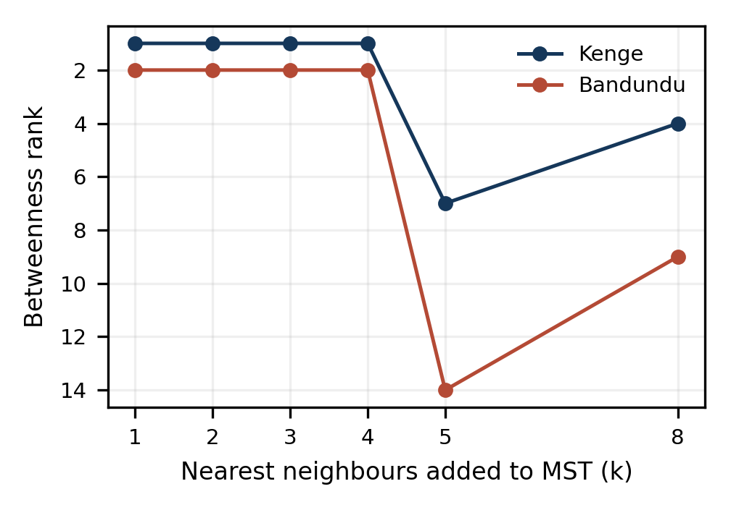
Fig. 3. Betweenness ranks of Kenge and Bandundu change when the synthetic graph is rebuilt. Lower rank numbers indicate higher betweenness. These are graph-model rankings, not measured corridor functions.
TABLE VII
SELECTED TOPOLOGY DIAGNOSTICS
Topology | Edges | Comps. | Isolates
MST + 1 neighbour | 25 | 1 | 0
MST + 3 neighbours | 49 | 1 | 0
MST + 5 neighbours | 74 | 1 | 0
Radius 40 km | 2 | 24 | 22
Radius 50 km | 3 | 23 | 20
Radius 100 km | 16 | 12 | 8

Kenge moves from betweenness rank 1 in MST + 3 to rank 7 in MST + 5; Bandundu moves from rank 2 to rank 14. The whole-node rank correlation between those two configurations is only 0.4275. Radius graphs at 15 and 25 km have no edges; at 100 km there are 12 components and eight isolated nodes, including Kenge and Bandundu. This change falsifies the interpretation of the baseline centrality leaders as topology-independent territorial hinges. The main results therefore do not rely on synthetic-graph centrality to rank regional investments.
Exact optimization confirms the earlier median objective at p = 5, 10, and 15 on its own released inputs: mean distances are 80.44, 28.36, and 12.58 km. However, the buffer weights sum to 7.37 million, only 17.05% of the COD-AB regional total arithmetically; that ratio is not a unique population coverage estimate because buffers can overlap. The earlier distances therefore describe a selected-node demand model, not complete regional accessibility. The expanded p = 2–20 curve meets no eligible elbow under the three-successive-gains-below-5% rule; neither 2% nor 10% alternatives identify one. The claim of an established ten-hub elbow is withdrawn.
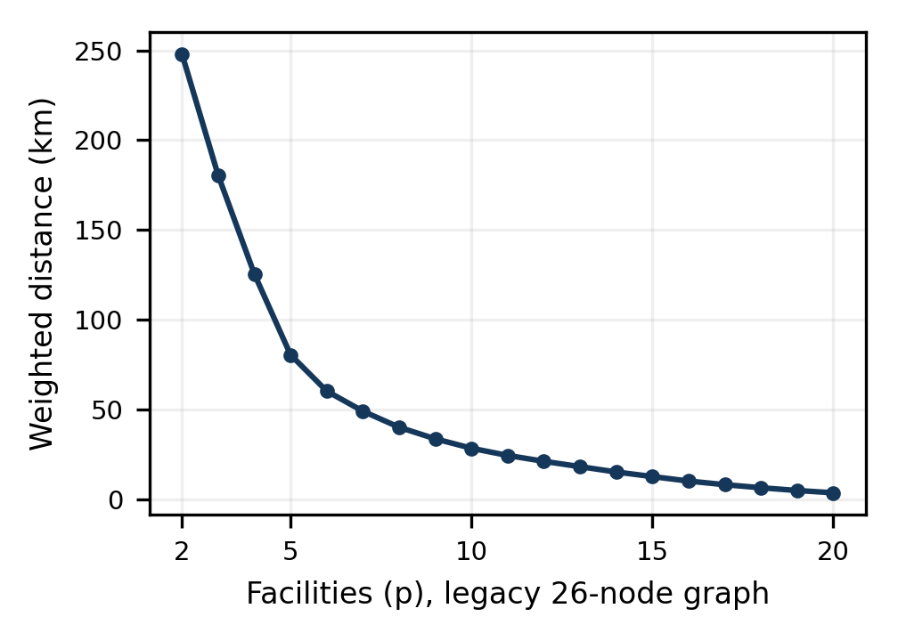
Fig. 4. Exact legacy p-median curve for p = 2–20. Population weights are the original node buffers, not the regional demand grid. No eligible p meets the stated three-successive-gains-below-5% elbow rule.

E. Candidate Weight Audit and Environmental Interpretation
TABLE VIII
DOMINANT CANDIDATE UNDER ALTERNATIVE WEIGHT CENTRES
Province | Reference winner (%) | Uniform winner (%)
Équateur | Buanza (49.40) | Inganda (82.76)
Kinshasa | Komo (72.14) | Komo (85.90)
Kongo Central | Kimpika (59.98) | Vemadja (48.74)
Kwango | Fumu-Mashi (95.46) | Fumu-Mashi (70.60)
Kwilu | Pana (74.10) | Kiboba (92.00)
Maï-Ndombe | Ebale (98.18) | Ebale (75.10)
Mongala | Amamba (86.90) | Amamba (95.38)
Nord-Ubangi | Bale Deuxième (81.68) | Bale Deuxième (54.66)
Sud-Ubangi | Bwamandema (94.08) | Bwamandema (99.94)
Tshuapa | Yanganga (100) | Yanganga (100)

Uniform rather than reference weight centres change the dominant winner in three provinces: Équateur, Kongo Central, and Kwilu (Table VIII). Frequencies are conditional on the same cached 75-point environmental sample and within-province competition, not on all feasible regional land. The sample contains only three candidates in Équateur, two in Mongala, and one in Tshuapa. Yanganga’s 100% frequency is therefore mechanically guaranteed by the absence of a competitor; it does not demonstrate exceptional site robustness. This distinction corrects an important overinterpretation of the earlier Monte Carlo result.
Neither Yanganga nor Ebale can be described as a validated sovereign hub from these scores. Functional independence would require evidence of productive activity, local processing, employment, energy reliability, service capacity, trade patterns, and institutional arrangements. A proximity score supplies none of these directly. The broader urban planning literature stresses substantive urban functions and governance [31]. The audit is retained to demonstrate how preference choices and candidate availability affect a score, without endorsing those legacy identities. The new conditional allocation in Section III.L uses a different objective and a complete screened candidate grid.
The hydrological flag is now reproducible, but scientific transparency does not make it a flood-risk model. A nearby river can support transport or increase inundation exposure; the sign of its effect depends on terrain, stage, protection, and settlement use. Likewise, the strict tree-cover exclusion can be precautionary without being ecologically precise. A current protected-area mask and an extreme tree-exclusion sensitivity test are now supplied; parcel tenure and forest integrity remain unverified. These omissions materially prevent endorsing greenfield urban construction.

F. External Validity, Planning Meaning, and Remaining Requirements
The revised model quantifies a relationship between estimated population, mapped roads, candidate facilities, and a distance threshold. It does not measure actual journeys, induced development, or a shift of trade away from Kinshasa. Polycentricity requires complementary functions and interactions, not merely selecting several points. A coverage objective can favour dense, well-mapped areas even when a planner prioritizes provincial equity. Conversely, demanding one hub per province can reduce distance-based efficiency. These are explicit policy choices that should be compared using observed costs and service objectives rather than hidden inside a claim of sovereignty.
The direct road graph is a methodological improvement over forced MST connectivity, but remains a provisional representation. A 1% deletion stress tests fragility without estimating omitted roads; adding tracks broadens mapped access without certifying their passability. No speed model is calibrated. Population products disagree considerably, and a 2025 modelled epoch does not synchronize perfectly with a 2026 road snapshot. Alternative 50- and 150-km thresholds are now tested, but no service-specific empirical threshold is calibrated. None of these qualifications can be replaced by calling an internal consistency check validation.
The secondary JICA report confirms that observed urban mobility evidence exists locally [32]. Its units, spatial scope and period differ from the regional covering target. The external road and route checks in Sections III.I–J expose mismatches, including a Bandundu discrepancy partly explained by the omitted ferry in Section III.K, rather than establish population-access accuracy. A defensible outcome validation would pair geocoded service-access or journey observations with the same endpoints, modes and dates, first resolve major routing anomalies, and then evaluate errors on withheld observations. Until that test is executed, this article remains an exploratory geospatial sensitivity study.
A causal historical study is a separate requirement. It would digitize colonial-era routes, document post-independence construction and maintenance, harmonize historical settlement demand, and compare spatial configurations under explicit counterfactuals. Current centrality or coverage alone cannot apportion fragmentation between inherited infrastructure and later investment failures. Historical explanation is therefore excluded from the quantitative conclusions. The results can motivate that subsequent research without establishing its answer.
For implementation, an agency should first agree on a service definition, candidate universe, and admissible routes. Population totals should be reconciled with nationally accepted sources; graph junctions and access restrictions should be inspected; hydrographic navigation and rail operations require their own inventories. Equity, capacities, finance, climate risk, customary tenure, and conservation exclusions must be added before evaluating new locations. The present computations provide a transparent baseline for those choices rather than a substitute for them.

G. Additional Scenario and Conservation Results
All 108 additional covering optimizations report zero solver status and zero MIP gap. Table IX gives the five-realization ranges for p = 10; it holds grid resolution and road classes constant. Differences across coverage thresholds express a policy-distance assumption, while variation within a product and threshold reflects the combined deletion–coordinate stress. These ranges remain descriptors of the chosen stresses, not confidence bounds on actual service coverage.
TABLE IX
TEN-HUB COVERAGE IN FIVE REPEATED JOINT STRESSES
Product | Limit km | Range % | Mean %
WorldPop | 50 | 35.27–36.38 | 35.99
WorldPop | 100 | 48.51–49.92 | 49.54
WorldPop | 150 | 60.70–61.52 | 61.19
GHSPOP | 50 | 51.31–52.38 | 51.95
GHSPOP | 100 | 60.85–62.21 | 61.74
GHSPOP | 150 | 69.18–70.10 | 69.70

The common regional mask contains 7,677 ten-kilometre centres and 1,239 twenty-five-kilometre centres. Remoteness and mapped-access rules retain 6,519 and 1,047, respectively. Protected polygons contain 1,044 and 167 of those centres. Testing the whole square footprint instead excludes 1,298 and 268 cells, before land-cover screening (Table X). The point-only reported-area buffer intersects no eligible cell in this region. Polygon overlap is dissolved, so cells are counted once. A difference between centre and footprint screening is not a discrepancy in the source; it follows from the explicitly different spatial tests.
TABLE X
CANDIDATE GRID AND PROTECTED POLYGON INTERSECTIONS
Grid km | Eligible | Centre mask | Cell mask
10 | 6519 | 1044 | 1298
25 | 1047 | 167 | 268

TABLE XI
LAND-COVER AND FULL-CELL PROTECTED-AREA SCREENING
Grid km | Tree rule | Land-cover pass | After PA mask
10 | Strict tree exclusion | 1728 | 1583
10 | Tree admitted test | 6401 | 5156
25 | Strict tree exclusion | 273 | 241
25 | Tree admitted test | 1033 | 772

Table XI evaluates the land-cover and protected-area rules jointly. Admitting mapped tree cover is deliberately an extreme diagnostic. It measures the influence of the exclusion without identifying which forest could lawfully or ecologically be converted. The detailed output preserves reference and uniform-weight winners at each resolution and mask rule. Changed candidate centres and conditional ranks must not be interpreted as parcel relocation recommendations. Unlike the existing-hub coverage model, this supplementary screen includes preference weights and still requires consultation, slope and flood analysis, and a land-rights assessment.
The strict full-cell screen retains candidates in all ten provinces at 10 km but in only nine at 25 km; Équateur has none at the coarser resolution. Among the nine common provinces, the geodesic shift between the top-scored 10- and 25-km centres has a median of 212.22 km (maximum 313.70 km) under reference weights and 52.02 km (maximum 264.13 km) under uniform weights. Thus, province-specific winners are not stable under this change of sampling grid. The comparison concerns conditional point-centre sampling and ranking, not evidence that urban sites should be moved by those distances.
The JICA screen-line observations are now included as an external evidence inventory. Their units, domain, and model target prevent a valid direct comparison to a percentage of regional population within a distance threshold. JICA’s estimated counts differ from its observations by −7.53% and −5.62%, calculated from its published numbers; these percentages belong to JICA’s own calibration. They are not errors of the model developed here. The principal empirical-validation objection therefore remains unresolved, despite the successful acquisition of actual secondary traffic observations.

H. Finite Design Attribution and Morphological Footprints
For ten hubs, the population product accounts for 86.07% of variance as a first-order effect and 86.42% as a total effect (Table XII). Interactions collectively account for 2.81%; the total variance is 45.73 squared percentage points. First-order shares sum to 97.19%. Total effects overlap through interactions and must not be summed. The dominant population-product effect applies to this specific equal-weight scenario design, not to all plausible uncertainties. Uncertain speeds do not enter the revised distance objective. Road additions, calibrated omission rates, continuous error distributions, environmental criteria, and service-specific thresholds are outside this decomposition; they cannot be assigned zero influence on this basis.
TABLE XII
VARIANCE ATTRIBUTION FOR TEN HUBS
Factor | First order % | Total effect %
Population product | 86.07 | 86.42
Demand grid | 2.29 | 4.43
Road classes | 2.11 | 2.60
Connectors | 5.16 | 7.48
Road deletion | 1.55 | 1.93
Hub displacement | 0.00 | 0.01

The native classification yields 47 urban-centre components, 182 dense urban-cluster components, and 139 semi-dense urban-cluster components intersecting study-region cell centres. Under eight-connectivity the counts are 47, 182, and 132, respectively; the difference is confined to the semi-dense class. Twenty-five of 26 hub points fall within a classified component. Mangai remains unmatched and is not snapped to a neighbouring urban component. Table XIII gives examples of footprint-based population estimates. These are modelled GHS-POP estimates over morphological raster footprints, not observed census counts or empirical validation. The main covering demand remains the complete regional population grid, avoiding double-counting hub populations.
TABLE XIII
EXAMPLES OF CLASSIFIED SETTLEMENT FOOTPRINTS
Hub | Area km² | GHS POP 2025
Kinshasa | 501 | 12,960,942
Matadi | 43 | 415,704
Mbandaka | 41 | 464,868
Kikwit | 72 | 488,734
Kenge | 20 | 108,940
Inongo | 12 | 48,529

I. External Road Input Check
The clipped satellite reference contains 12,798 line fragments totalling 2,062.53 km (Table XIV). At a 100-m tolerance, length-weighted agreement is 4.91% for the main-road set, 20.93% with tracks, and 20.96% for all mapped classes. At 250 m, these shares are 5.58%, 24.43%, and 24.52%. Across both reference inventories and all road-set/tolerance combinations, changing midpoint sampling from 25 to 50 m changes agreement by at most 0.113 percentage points. Low agreement provides an external warning about representation of recently developed forest roads; it cannot be interpreted as a national OSM completeness estimate. Tracks dominate the additional matches. Detected logging roads may be private, seasonal, abandoned, or unsuitable for public access, so unmatched lines are not inserted into the operational graph automatically. Their unmatched fraction is not substituted for the model’s assumed 1% random-deletion rate.
TABLE XIV
SATELLITE FOREST ROAD LENGTH AGREEMENT PERCENT
OSM set | 25 m | 50 m | 100 m | 250 m
Main classes | 4.19 | 4.63 | 4.91 | 5.58
Including tracks | 16.41 | 18.68 | 20.93 | 24.43
All mapped classes | 16.42 | 18.70 | 20.96 | 24.52

The World Bank AICD road file supplies 859 records [35]. After removing two zero-ID dummy records and excluding the −99 missing sentinel, only five segments have positive AADT values: one value of 510 and four repeated values of 966. Documentation dates traffic to 2004, describes units as passenger-vehicle units, and warns that only one road has traffic information. These are not five independent count stations. The five segments total 323.36 km of projected reference geometry; main-road spatial agreement is 84.30% at 100 m and 92.55% at 250 m. Because this historical catalogue may share source cartography with OSM, this is a corridor-consistency benchmark, not an independent predictive test. The study does not predict AADT, so neither traffic value is used to calculate model error or validate population coverage.
This external evidence partly addresses input validity, but does not fulfil validation of the 100-km population-coverage target. Neither satellite road detections nor historical traffic counts reveal which households use the selected hubs. That target still requires geographically matched journey/access observations or a defensible secondary accessibility benchmark. The satellite result also shows why uniform deletion alone cannot be interpreted as a calibrated network-error distribution.

J. Route Discrepancies and Conditional Spatial Variation
Table XV reports forward road paths; reverse paths differ by less than 0.08 km for these pairs. Endpoint offsets are below 0.014 km and cannot explain the discrepancies. Kinshasa–Matadi is 336.03 km in the main graph, 5.34% below the published 355 km. Kinshasa–Bandundu is 922.62 km, 88.29% above 490 km; inclusion of tracks reduces it to 879.89 km but leaves a 79.57% difference. Section III.K tests the omitted Bandundu ferry as a structural explanation; route definitions and epoch differences remain additional limitations. No connector is inserted merely to force agreement. The Bandundu result prevents a general claim that the graph produces externally validated road distances.
TABLE XV
PUBLISHED AND MODELLED FORWARD ROAD DISTANCES
Route from Kinshasa | Published km | Main km | With tracks km
Matadi | 355 | 336.03 | 334.92
Bandundu | 490 | 922.62 | 879.89

The catalogue also gives Matadi–Bandundu as 1,051 km, exceeding 355 + 490 km by 206 km. A symmetric shortest-path distance matrix cannot satisfy these three values simultaneously. The entry is retained in the audit but excluded as a calibration target; other catalogue values may represent prescribed routes rather than common shortest paths. With only two coherent pair benchmarks and unspecified itineraries, no regional accuracy statistic or fitted error distribution is justified. Neither pair validates the proportion of households within 100 km of a hub.
Reference-road agreement is spatially uneven. With tracks at 100 m, Tshuapa has 47.14% agreement across 454.17 km of reference roads, whereas Mongala has 10.03% across 505.05 km. Small samples in Kwango and Nord-Ubangi cannot support general provincial omission estimates; Kinshasa has no reference sample. For detection periods 2019–2022 and 2023–2025, track-inclusive agreement is 31.22% and 10.19%, respectively. These differences may reflect mapping lag, location and road types as well as detection behaviour. They are not identified causal effects of road age.
TABLE XVI
CONDITIONAL SPATIAL RESAMPLING AT 100 M TOLERANCE
Road set | Block km | Agreement % | 2.5–97.5 percentiles %
Main | 25 | 4.91 | 3.07–7.50
Main | 50 | 4.91 | 3.00–8.37
Main + tracks | 25 | 20.93 | 12.81–30.95
Main + tracks | 50 | 20.93 | 12.06–32.26

The 25-km partition has 131 nonempty blocks and the 50-km partition 76; each is resampled 1,000 times. Wider ranges at 50 km reinforce the need to respect spatial dependence. This strengthens the uncertainty characterization of the external input check without calibrating the covering model. Road operability, household access, reference error and seasonal variation still require matched evidence. Uniform 1% deletion remains a stress assumption rather than an estimated error rate.

K. Ferry Omission and Criterion-Weight Diagnostics
The original Kinshasa–Bandundu path detours toward Kikwit (Fig. 5). Adding the three mapped ferry ways changes the main-road path from 922.62 to 398.99 km and the track-inclusive path from 879.89 to 384.04 km. The main-road conditional route is 1.48% shorter than the report’s 405-km Mongata itinerary; the track alternative is 5.17% shorter. This explains an important part of the graph discrepancy through a documented omitted mode, conditional on availability. The comparison is a geographically plausible published-route benchmark, not GPS accuracy validation or proof of safe current operation. The 2018 distance of 490 km remains a different, unspecified-itinerary benchmark.
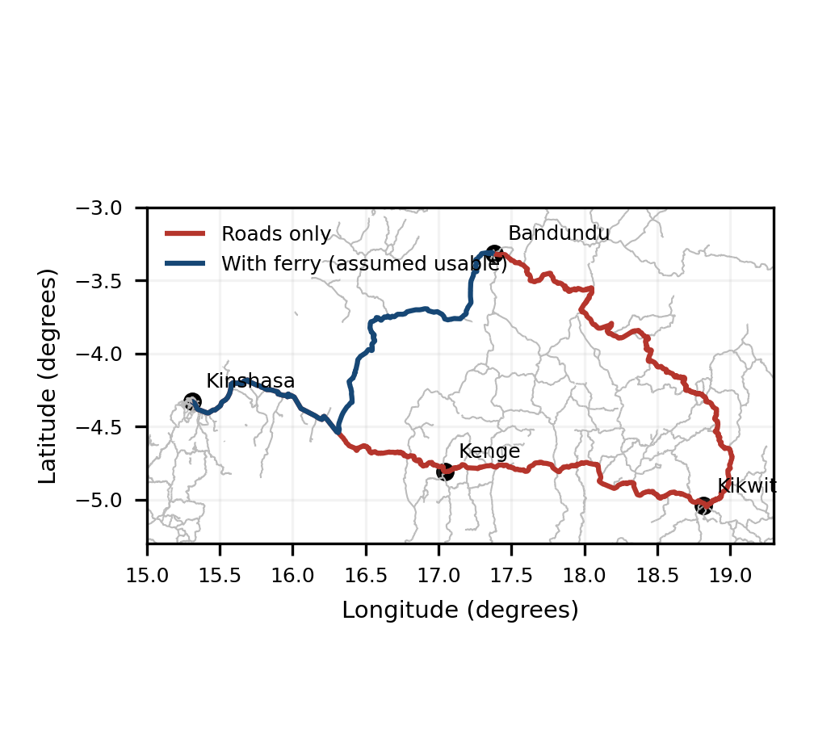
Fig. 5. Calculated Kinshasa–Bandundu paths in the road-only graph and after adding mapped Bandundu ferry geometry. Ferry use is assumed, not observed. OSM-derived geometry [19], [39]; plotted in longitude/latitude for diagnosis.
All twelve optimizations return solver status zero and zero gap. Coverage for p = 5 and 10 is unchanged within numerical precision; this does not imply identical optimizer-selected sets. For p = 15, the gains are 0.079 and 0.078 percentage points for WorldPop without and with tracks, and 0.050 and 0.049 for GHS-POP (Table XVII). A severe long-distance route discrepancy can therefore coexist with a small change in this specific 100-km covering objective. That result does not establish that omitted ferries elsewhere are unimportant or that population access is validated.
TABLE XVII
CONDITIONAL FERRY COVERAGE WITH FIFTEEN HUBS
Product | Road set | Before % | Ferry % | Gain pp
GHS-POP | Main | 66.19 | 66.24 | 0.050
WorldPop | Main | 56.38 | 56.46 | 0.079
GHS-POP | Tracks | 66.59 | 66.64 | 0.049
WorldPop | Tracks | 57.02 | 57.10 | 0.078

TABLE XVIII
CRITIC-STYLE WEIGHTS ON RETAINED CANDIDATE SCORES
Criterion | 10 km weight % | 25 km weight %
Population | 14.78 | 14.35
Road | 10.48 | 10.87
Water | 17.69 | 18.33
Rail | 10.58 | 11.08
Air | 11.36 | 11.27
Territorial gap | 35.12 | 34.09

CRITIC assigns the largest weight to the territorial-gap score: 35.12% at 10 km and 34.09% at 25 km, compared with the assumed 10%. This reflects its dispersion and intercriteria contrast, not measured societal importance. At 10 km, CRITIC changes seven of ten provincial top-centre identities relative to both assumed and uniform weights. At 25 km it changes four of nine relative to assumed weights and three relative to uniform weights. The original allocation is thus not endorsed by this data-derived comparator. Criterion directions, decay scales, candidate sampling and masks remain analyst choices requiring substantive justification. Actual expert responses remain absent, and the main covering objective uses none of these weights.

L. New Urban Hub Location Results
All 24 new-centre optimizations terminate with solver status zero and optimality gap zero; recomputed unions match the objective. Their baseline differs from the earlier ten-selected-hub result: here all 26 existing hubs are fixed, and demand resolution is 5 km. Thus WorldPop main-road baseline coverage is 59.08%, not 50.97%; the corresponding GHS-POP value is 68.04%. These are assumed service-distance coverages, not observations of functioning services.
TABLE XIX
ADDITIONAL CENTRES ON THE 25 KM CANDIDATE GRID
Road set | Product | q | Coverage % | Gain pp
Main | GHS | 3 | 70.81 | 2.76
Main | GHS | 5 | 72.50 | 4.46
Main | GHS | 10 | 75.96 | 7.91
Main | WP | 3 | 62.59 | 3.52
Main | WP | 5 | 64.68 | 5.61
Main | WP | 10 | 69.17 | 10.09
Tracks | GHS | 3 | 71.29 | 3.06
Tracks | GHS | 5 | 73.02 | 4.79
Tracks | GHS | 10 | 76.67 | 8.44
Tracks | WP | 3 | 63.91 | 4.59
Tracks | WP | 5 | 66.09 | 6.77
Tracks | WP | 10 | 70.55 | 11.23

With WorldPop and main roads, three, five and ten additional centres increase coverage to 62.59%, 64.68% and 69.17%, equivalent to marginal gains of 3.52, 5.61 and 10.09 percentage points. Five centres add 2.43 million modelled inhabitants to coverage; they do not create that population or predict migration. Including tracks raises the five-centre marginal gain to 6.77 points. Population-product and graph changes affect the attainable benefit, so one solution cannot be presented as a unique territorial optimum.
TABLE XX
FIVE NEW CENTRES ACROSS CANDIDATE GRIDS
Road set | Product | 25 km % | 10 km %
Main | WP | 64.68 | 65.57
Main | GHS | 72.50 | 73.38
Tracks | WP | 66.09 | 66.63
Tracks | GHS | 73.02 | 73.90

On the 10-km candidate grid, five centres reach 65.57% WorldPop main-road coverage, a gain of 6.49 points or 2.81 million modelled inhabitants beyond the fixed baseline. Its gain is 0.88 point above the coarse-grid gain. The corresponding GHS-POP gain rises from 4.46 to 5.34 points. With tracks, finer-grid gains are 7.32 points for WorldPop and 5.67 for GHS-POP. These grids are not nested candidate subsets, so monotonicity is not guaranteed generally; the observed improvement is specific to these runs. The 25-km strict screen omits Équateur, and point-level land cover does not establish the suitability of an entire grid cell.
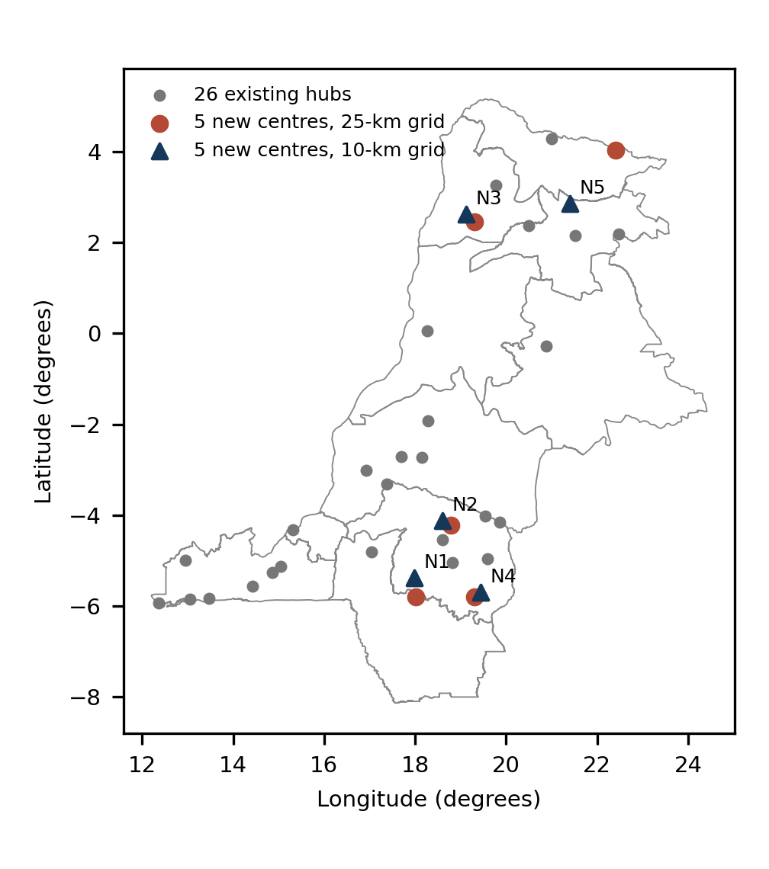
Fig. 6. One optimal five-new-centre set for WorldPop and main roads on each candidate grid, with all 26 existing hubs fixed. N1–N5 refer to Table XXI. Coordinates locate sampled sectors, not construction parcels. Boundary: geoBoundaries; optimization inputs: OSM, WorldPop, WorldCover and protected-area screening.
TABLE XXI
ONE OPTIMAL FIVE CENTRE SET ON THE 10 KM GRID
Site | Province | Lon ° | Lat ° | Water km
N1 | Kwilu | 17.982 | -5.377 | 23.87
N2 | Kwilu | 18.604 | -4.119 | 24.49
N3 | Sud-Ubangi | 19.122 | 2.627 | 9.19
N4 | Kwilu | 19.433 | -5.692 | 5.81
N5 | Mongala | 21.402 | 2.862 | 12.38

The identifiers in the supplementary table retain exact input coordinates and grid indices. Changing grids changes selected sectors: the five-centre WorldPop main-road set spans Kwilu, Sud-Ubangi and Mongala on the 10-km grid, compared with Kwango, Kwilu, Sud-Ubangi and Nord-Ubangi on the 25-km grid. No province quota is imposed. This concentration reflects the marginal coverage objective and screened opportunities; it does not justify excluding other provinces from investment. Optimality is conditional on the candidate set and encoded distances, not on urban viability, public costs or provincial equity.

M. Resource Conditions and Functional Autonomy Interpretation
The optional mapped-water constraint reduces WorldPop five-centre coverage from 64.68% to 64.58% on the coarse main-road grid, and from 65.57% to 65.43% on the fine grid. The respective losses are 0.11 and 0.14 point, with different selected identities possible. For GHS-POP and main roads, the coarse loss is 0.03 point and the fine-grid optimal objective is unchanged. Across all matched road/product/grid comparisons the largest loss is 0.26 point. This quantifies an explicit coverage–resource-proximity trade-off; it neither proves water sufficiency nor ranks normative priorities.
N1 and N2 in the fine-grid unconstrained WorldPop example lie approximately 23.87 and 24.49 km from mapped water. Their access advantage therefore cannot be interpreted as water autonomy; an implementation dossier would need a source and supply design. N3–N5 are within 15 km, but still lack measured water quality, reliable energy, production, jobs and service capacity. None is labelled a proven sovereign city. Their role is to identify sectors where a new hub or settlement upgrade could serve otherwise uncovered modelled demand, and where functional investments could be investigated.
The new-centre module restores the planning question without reviving the old arbitrary preference ranking. Historical network orientation remains relevant context, while a causal colonial attribution is outside the executed design. Likewise, a coverage gain is not evidence that trade dependence on Kinshasa decreases. Productive and service functions, interprovincial exchanges and governance must be specified and observed before that conclusion. The principal validation gap remains household/service-access observations compatible with the same modes, dates and locations; exact solver gaps do not close it.

IV. CONCLUSION
Conditional new-centre allocation extends the original territorial ambition beyond selecting existing hubs. Keeping all 26 existing hubs fixed, five additional centres on the coarse grid increase WorldPop main-road five-kilometre-demand coverage from 59.08% to 64.68%; the finer candidate grid reaches 65.57%. Ten coarse-grid centres reach 69.17%. These are exact optima for the encoded candidate sets and assumed 100-km access threshold, not established construction plans. Product, road and candidate-grid choices materially affect the solutions.
New urban hubs remain the planning objective, and relative functional autonomy is retained as a specified assessment framework. The model locates sectors with conditional marginal service benefits and evaluates one explicit water-proximity constraint. It does not establish reliable utilities, local transformation, employment, observed trade independence or parcel feasibility. Historical causation is not estimated. The previous input and sensitivity audits remain necessary: mapped connectivity, population modelling and assumed connectors constrain interpretation. Twenty-four new-centre runs complement 408 previous optimizations. Neither the optimum count of cities nor their realized sovereignty is demonstrated. Matched access observations, operational verification, rights and cost studies, and functional data are required before implementation; the main new-centre objective does not depend on an unavailable expert panel.

DATA AND AUTHOR STATEMENTS
The replication package provides scripts, derived results, parameters, source metadata, checksums, and reproduction instructions. The original v1.0.0 archive (https://doi.org/10.5281/zenodo.22287394) predates these revisions. The repository is https://github.com/Nehemy29/rdc-hubs-urbains-optimisation-spatiale. Revised files accompany resubmission and require a new public release with its own archive citation. Large raw third-party datasets are reacquired from their producers under documented terms. The small OSM ferry extract and OSM-derived diagnostic paths are supplied with ODbL attribution; protected-area and satellite reference geometries are not redistributed.
The sole author is responsible for the study, interpretation, and manuscript. As declared in the submitted version, the research received no external funding and the author reports no conflict of interest. Only public aggregate geospatial data are used; no individual mobility record or new human-participant survey is analysed. Computational verification and literature checks are distinguished from empirical field validation throughout.

REFERENCES
[1] J.-P. Rodrigue, The Geography of Transport Systems, 5th ed. Routledge, 2020.
[2] K. T. Geurs and B. van Wee, “Accessibility evaluation of land-use and transport strategies: Review and research directions,” Journal of Transport Geography, vol. 12, no. 2, pp. 127–140, 2004.
[3] A. Cattaneo, A. Nelson, T. McMenomy, “Global mapping of urban–rural catchment areas reveals unequal access to services,” Proceedings of the National Academy of Sciences, vol. 118, Art. no. e2011990118, 2021, doi: 10.1073/pnas.2011990118.
[4] S. L. Hakimi, “Optimum distribution of switching centers and the absolute centers and medians of a graph,” Operations Research, vol. 12, no. 3, pp. 450–459, 1964.
[5] C. S. ReVelle and R. W. Swain, “Central facilities location,” Geographical Analysis, vol. 2, no. 1, pp. 30–42, 1970.
[6] R. Church and C. ReVelle, “The maximal covering location problem,” Papers of the Regional Science Association, vol. 32, pp. 101–118, 1974.
[7] E. W. Dijkstra, “A note on two problems in connexion with graphs,” Numerische Mathematik, vol. 1, pp. 269–271, 1959.
[8] D. Runfola et al., “geoBoundaries: A global database of political administrative boundaries,” PLOS ONE, vol. 15, no. 4, Art. no. e0231866, 2020, doi: 10.1371/journal.pone.0231866.
[9] WorldPop, “Global population estimates 2015–2030, R2025A, version 1: COD 2025 constrained 100 m (alpha),” University of Southampton, 2025, doi: 10.5258/SOTON/WP00839. [Online]. Available: https://hub.worldpop.org/geodata/summary?id=73055.
[10] G. Boo, E. Darin, D. R. Leasure et al., “High-resolution population estimation using household survey data and building footprints,” Nature Communications, vol. 13, Art. no. 1330, 2022, doi: 10.1038/s41467-022-29094-x.
[11] D. R. Thomson, D. R. Leasure, T. Bird et al., “How accurate are WorldPop-Global-Unconstrained gridded population data at the cell-level?: A simulation analysis in urban Namibia,” PLOS ONE, vol. 17, Art. no. e0271504, 2022, doi: 10.1371/journal.pone.0271504.
[12] N. Metzger, J. E. Vargas-Muñoz, R. C. Daudt et al., “Fine-grained population mapping from coarse census counts and open geodata,” Scientific Reports, vol. 12, Art. no. 20085, 2022, doi: 10.1038/s41598-022-24495-w.
[13] M. Schiavina, S. Freire, A. Carioli, and K. MacManus, “GHS-POP R2023A—GHS population grid multitemporal (1975–2030),” European Commission, Joint Research Centre, dataset, 2023, doi: 10.2905/2FF68A52-5B5B-4A22-8F40-C41DA8332CFE.
[14] M. Schiavina, M. Melchiorri, and M. Pesaresi, “GHS-SMOD R2023A—GHS settlement layers, application of the Degree of Urbanisation methodology,” European Commission, Joint Research Centre, dataset, 2023, doi: 10.2905/A0DF7A6F-49DE-46EA-9BDE-563437A6E2BA.
[15] European Commission, Joint Research Centre, GHSL Data Package 2023, Public Release GHS P2023, updated edition. Publications Office of the European Union, 2024, doi: 10.2760/098587.
[16] European Commission et al., Applying the Degree of Urbanisation—A Methodological Manual to Define Cities, Towns and Rural Areas for International Comparisons. Publications Office of the European Union, 2021, doi: 10.2785/706535.
[17] L. Dijkstra, A. J. Florczyk, S. Freire et al., “Applying the Degree of Urbanisation to the globe: A new harmonised definition reveals a different picture of global urbanisation,” Journal of Urban Economics, vol. 125, Art. no. 103312, 2021, doi: 10.1016/j.jue.2020.103312.
[18] European Commission, Joint Research Centre, Applying the Degree of Urbanisation Method to National Population and Housing Census with GHSL Tools, JRC124765, 2021, doi: 10.2760/939289.
[19] OpenStreetMap contributors and Humanitarian OpenStreetMap Team, “Democratic Republic of the Congo roads export,” snapshot 5 Oct. 2026, ODbL 1.0. [Online]. Available: https://production-raw-data-api.s3.amazonaws.com/ISO3/COD/roads/hotosm_cod_roads_osm_gpkg.zip
[20] B. Herfort, S. Lautenbach, J. Porto de Albuquerque et al., “The evolution of humanitarian mapping within the OpenStreetMap community,” Scientific Reports, vol. 11, Art. no. 3037, 2021, doi: 10.1038/s41598-021-82404-z.
[21] B. Herfort, S. Lautenbach, J. Porto de Albuquerque et al., “A spatio-temporal analysis investigating completeness and inequalities of global urban building data in OpenStreetMap,” Nature Communications, vol. 14, Art. no. 3985, 2023, doi: 10.1038/s41467-023-39698-6.
[22] G. Boeing, “Street Network Models and Indicators for Every Urban Area in the World,” Geographical Analysis, vol. 54, pp. 519-535, 2022, doi: 10.1111/gean.12281.
[23] M. T. Hoffmann, K. Ostapowicz, K. Bartoń et al., “Mapping roadless areas in regions with contrasting human footprint,” Scientific Reports, vol. 14, Art. no. 4722, 2024, doi: 10.1038/s41598-024-55283-3.
[24] D. Zanaga et al., “ESA WorldCover 10 m 2021 v200,” dataset, 2022, doi: 10.5281/zenodo.7254221.
[25] S. Razavi et al., “The future of sensitivity analysis: An essential discipline for systems modeling and policy support,” Environmental Modelling & Software, vol. 137, Art. no. 104954, 2021, doi: 10.1016/j.envsoft.2020.104954.
[26] A. Saltelli et al., “Five ways to ensure that models serve society: A manifesto,” Nature, vol. 582, pp. 482–484, 2020, doi: 10.1038/d41586-020-01812-9.
[27] A. Puy, S. Lo Piano, A. Saltelli, and S. A. Levin, “sensobol: An R package to compute variance-based sensitivity indices,” Journal of Statistical Software, vol. 102, no. 5, pp. 1–37, 2022, doi: 10.18637/jss.v102.i05.
[28] I. M. Sobol’, “Global sensitivity indices for nonlinear mathematical models and their Monte Carlo estimates,” Mathematics and Computers in Simulation, vol. 55, nos. 1–3, pp. 271–280, 2001.
[29] C. R. Harris et al., “Array programming with NumPy,” Nature, vol. 585, pp. 357–362, 2020, doi: 10.1038/s41586-020-2649-2.
[30] P. Virtanen et al., “SciPy 1.0: Fundamental algorithms for scientific computing in Python,” Nature Methods, vol. 17, pp. 261–272, 2020, doi: 10.1038/s41592-019-0686-2.
[31] UN-Habitat, World Cities Report 2022: Envisaging the Future of Cities. Nairobi, Kenya, 2022.
[32] Japan International Cooperation Agency, The Project for Urban Transport Master Plan in Kinshasa City (PDTK), Final Report, vol. 1, part 1, Apr. 2019. [Online]. Available: https://openjicareport.jica.go.jp/pdf/12340295_01.pdf.
[33] B. Slagter et al., “Forest roads (Congo Basin),” ver. 1.04, Zenodo, doi: 10.5281/zenodo.20201702. Dataset file: forestroads_afr_2019-01_2025-12.zip. Accessed: 7 Oct. 2026.
[34] B. Slagter et al., “Monitoring road development in Congo Basin forests with multi-sensor satellite imagery and deep learning,” Remote Sensing of Environment, vol. 315, art. 114380, 2024, doi: 10.1016/j.rse.2024.114380.
[35] World Bank, “Congo, Dem. Rep. Roads,” AICD/Tecsult road inventory and documentation. [Online]. Available: https://datacatalog.worldbank.org/search/dataset/0040251/congo-dem-rep-roads. Accessed: 7 Oct. 2026.
[36] UNEP-WCMC and IUCN, “Protected Planet: World Database on Protected and Conserved Areas (WDPCA), protected-area view,” Oct. 2026. [Online]. Available: https://www.protectedplanet.net/. Accessed: 7 Oct. 2026.
[37] Logistics Cluster, “Democratic Republic of Congo: Distances—Roads & Waterways,” 6 Sep. 2018, map/table CODDISTCAPITTOMAJORTOWN4L. [Online]. Available: https://logcluster.org/sites/default/files/public/maps/coddistcapittomajortown4l_20180906.pdf. Accessed: 8 Oct. 2026.
[38] Logistics Cluster, “RDC—Territoires de Kwamouth, Bagata, Kenge et Bandundu: contraintes d’accès physiques et logistiques,” 18 Apr. 2024. Available: https://logcluster.org/sites/default/files/public/2024-04/codaccessconstraintcrisekwamouthmaindombea3l_20240418.pdf. Accessed: 8 Oct. 2026.
[39] OpenStreetMap contributors, “Bac Bandundu ferry geometry,” ways 49809124, 980566897 and 980566898, retrieved via Overpass on 8 Oct. 2026, ODbL 1.0. Available: https://www.openstreetmap.org/way/49809124.
[40] D. Diakoulaki, G. Mavrotas, and L. Papayannakis, “Determining objective weights in multiple criteria problems: The CRITIC method,” Computers & Operations Research, vol. 22, no. 7, pp. 763–770, 1995, doi: 10.1016/0305-0548(94)00059-H.

[41] UN-Habitat, Urban-Rural Linkages: Guiding Principles and Framework for Action to Advance Integrated Territorial Development. Nairobi, 2019. Available: https://unhabitat.org/urban-rural-linkages-guiding-principles.
[42] M. Brezzi and P. Veneri, “Assessing Polycentric Urban Systems in the OECD: Country, Regional and Metropolitan Perspectives,” OECD Regional Development Working Papers, No. 2014/01, 2014, doi: 10.1787/5jz5mpdkmvnr-en.

