Urban Hub Coverage and Road Accessibility in Western Democratic Republic of the Congo: A Geospatial Analysis of Data and Model Sensitivity
PAMBOLO MAYAMBO Néhémie
Department of Mathematics, Statistics and Computer Science, University of Kinshasa, Kinshasa, Democratic Republic of the Congo
Corresponding author: nehemiemayambo@gmail.com
ORCID: https://orcid.org/0009-0001-5168-273X
Abstract—Regional accessibility estimates can be strongly influenced by population models and assumed network connectivity. This study examines these effects across ten interconnected provinces in western and north-western Democratic Republic of the Congo. It combines WorldPop 2025, GHS-POP 2025, GHS-SMOD settlement classifications, administrative boundaries, and an OpenStreetMap road extract dated 5 October 2026. Population counts are aggregated to mass-conserving one- and five-kilometre equal-area grids. A directed graph preserves mapped road geometry and disconnection, while a maximal covering model selects among 26 existing hubs. The analysis also includes 288 factorial optimizations and 108 repeated-stress and threshold runs, together with a 10/25-kilometre candidate-grid comparison using current protected-area masks. Under the common regional mask, WorldPop estimates 43.30 million inhabitants and GHS-POP 34.03 million, a difference of 21.40%. With one-kilometre demand cells, the baseline road classes, and assumed connectors of at most five kilometres, ten selected hubs cover 50.97% of WorldPop population within a 100-kilometre distance threshold, compared with 62.70% using GHS-POP. Across the joint scenarios, ten-hub coverage ranges from 40.40% to 63.35%; this envelope is not a confidence interval. The synthetic-graph audit reveals centrality rank changes and does not support a predefined p-median elbow criterion. These results demonstrate sensitivity of modelled coverage, rather than observed travel behaviour, historical causality, or the feasibility of new towns. No compatible regional flow or field dataset was available for empirical validation; operational multimodal and planning recommendations therefore remain conditional.
Keywords—road accessibility; maximal covering location; gridded population; network topology; sensitivity analysis; Democratic Republic of the Congo.

I. INTRODUCTION
Accessibility analysis connects the spatial distribution of inhabitants with the opportunities they can reach. A transport system can contain many mapped features while providing uneven access to services, and geographical proximity alone does not demonstrate functional connectivity. Transport geography and accessibility research distinguish infrastructure, network impedance, land use, and individual constraints [1], [2]. Global mapping of urban–rural catchments further shows why demand outside large cities must be retained when describing access [3]. These distinctions are particularly relevant to large territories where digital infrastructure inventories are more available than observations of journeys.
The study examines Greater Bandundu, Greater Équateur, Kinshasa, and Kongo Central as one interconnected territorial system. Its ten provinces span the Atlantic interface, the metropolitan concentration around Kinshasa, and substantial interior and northern settlement areas. The objective is to measure how population representation and mapped road connectivity alter the coverage attainable by a limited set of existing hubs. The analysis does not assume that every mapped road is usable or that every waterway is navigable. It also does not infer that improving a mathematical coverage objective creates employment, economic autonomy, or an equitable allocation of public investment.
The initial version used a connected synthetic graph and population around 26 named nodes to explore p-median scenarios. Median models provide a clear distance-minimization benchmark [4], [5], but forcing connectivity can conceal precisely the disconnections a regional study should describe. A coverage formulation [6] offers an alternative when demand cells can remain without a route to selected facilities: unreachable demand is retained in the denominator rather than assigned an arbitrary finite journey. Shortest-path calculations [7] must then be performed on a graph whose edge semantics are explicit.
The revised contribution is a reproducible comparison of two gridded population products, two demand resolutions, and several road and attachment assumptions, together with an audit of the earlier model. Regional masks, graph construction rules, and computational optimality are distinguished from external validity. The main research question is: how sensitive is the modelled population coverage of existing hubs to population inputs, spatial aggregation, mapped roads, off-network attachment, and controlled perturbations?
Three testable propositions organize the analysis. First, a centrality ranking derived from the synthetic graph should not be treated as stable if changing its topology changes key node ranks substantially. Second, expanding the selected hub set can increase coverage, but the percentage reached may depend materially on the population product and graph assumptions. Third, the earlier proposition of an elbow around ten p-median facilities is assessed using an explicit rule, rather than visual inspection. These are model comparisons, not tests of a colonial cause or of reduced economic dependence on Kinshasa.
Historical transport development remains a motivation for asking regional questions, but no colonial-era network is digitized or compared with the current data here. The revised title therefore omits historical causal and sovereignty claims. Planning interpretation is restricted to identifying assumptions and areas requiring investigation. This narrower framing also allows the principal analytical findings to be evaluated independently of a political description of the desired territorial future.

II. MATERIALS AND METHOD

A. Study Area, Sources, and Evidence Status
The administrative units are Kinshasa, Kongo Central, Kwango, Kwilu, Maï-Ndombe, Équateur, Mongala, Nord-Ubangi, Sud-Ubangi, and Tshuapa. They are analysed jointly. The common comparison mask uses geoBoundaries COD ADM1, boundary identifier COD-ADM1-28894549, with the producer metadata and geometry retained [8]. A separate boundary sensitivity check uses COD-AB ADM1 v01, valid on 11 September 2019. Boundaries are operational masks, not a resolution of legal or customary territorial claims. Road features are selected using the corresponding ten province codes in the HOT export; small differences between feature attribution and the raster mask are therefore possible.
TABLE I
SOURCES AND ANALYTICAL ROLES
Source / edition | Role | Evidence status
WorldPop 2025 R2025A v1 [9] | Population counts, ~100 m | Constrained alpha model
GHS-POP 2025 R2023A [13] | Alternative population, 1 km | Modelled 2025 epoch
GHS-SMOD 2025 R2023A V2.0 [14] | Settlement classes, 1 km | Standard model classification
geoBoundaries COD ADM1 [8] | Common raster mask | Represented boundaries
HOT/OSM, 5 Oct. 2026 [19] | Directed road geometry | Mapped; operation unverified
Released v1.0.0 inputs | 26 hub coordinates; audits | Legacy candidate set

WorldPop and GHS-POP provide estimated population distributions, not regional census observations. Research on household-based estimation and spatial disaggregation shows the methodological diversity of these products [10], [12]. Cell-level accuracy findings from an unconstrained WorldPop simulation in Namibia [11] are not transferred as numerical error bounds to the constrained DRC product. Comparing two products measures disagreement; shared inputs and modelling assumptions prevent interpreting agreement as independent validation. All source epochs, download URLs, checksums, and generated file counts are recorded in the accompanying replication package.
The existing candidate set contains 26 named GeoNames nodes retained from the original analysis. Masina and Bolenge are excluded as separate facilities to avoid the earlier duplication of Kinshasa and Mbandaka. The name “Bandundu Province” in the source identifier refers to the point used for Bandundu; its label is shortened to Bandundu in the manuscript without moving the coordinate. The nodes are candidate service locations, not a complete regional urban census. No new-city location is optimized in the main revised model.
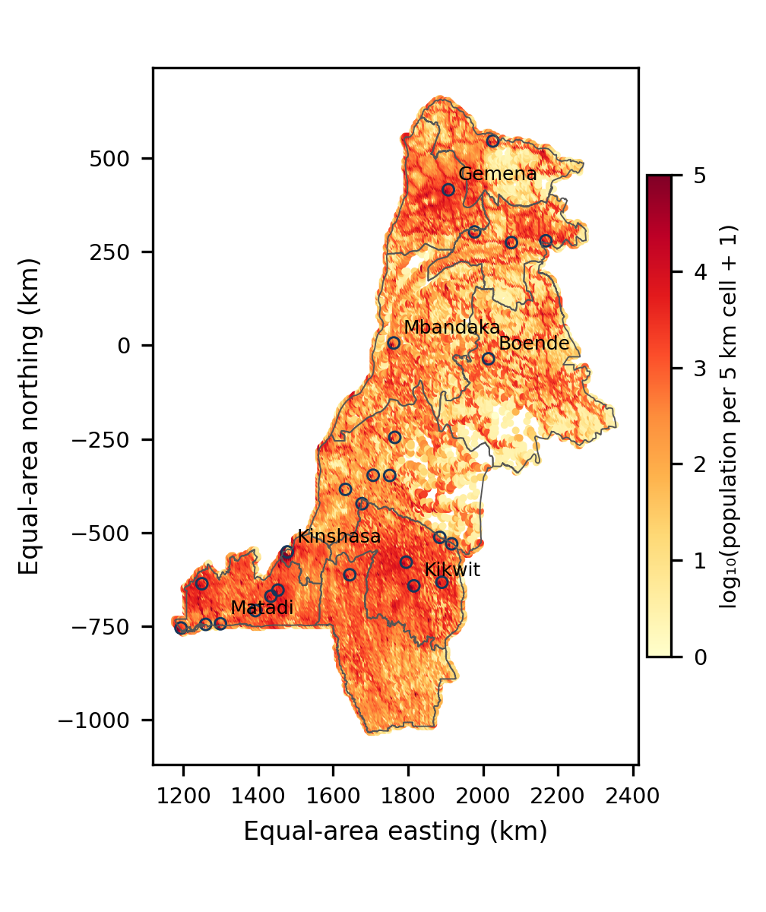
Fig. 1. Common regional mask, WorldPop demand aggregated to 5 km cells, and the 26 existing candidate hubs (open circles). Projection: EPSG:6933. Boundary source: geoBoundaries; population: WorldPop. Colours show modelled counts, not observed density.

B. Mass-Conserving Demand and Settlement Classification
For WorldPop, positive finite pixel counts are retained when their pixel centres fall inside the union of the ten provinces. Coordinates are transformed from WGS84 to the equal-area CRS EPSG:6933. A source count is assigned to the one-kilometre bin defined by floor(x/1000), floor(y/1000); five-kilometre cells are nested groups of these bins. Counts are summed, never averaged as if they were densities. No positive population is removed because a cell is rural or disconnected from roads. Each populated grid-cell centre becomes a demand point with its aggregated count as weight.
GHS-POP is processed analogously from the native one-kilometre Mollweide raster [13]. Selected native pixel centres are transformed and assigned to the same equal-area grid. This method conserves the selected count but does not reconstruct subpixel settlement locations. Transforming pixel centres between grids also creates alignment effects. One- and five-kilometre grids are compared to assess aggregation sensitivity; no conclusion of parcel-scale accuracy follows from choosing the finer grid. Zero-count and nodata locations are distinguished during raster processing.
Settlement classes are sampled from GHS-SMOD at hub coordinates and at WorldPop demand-cell centres [14], using the GHSL documentation and the Degree of Urbanisation approach [15]–[18]. The classification replaces the earlier interpretation of five-kilometre buffers as urban agglomerations. It is not used to discard rural demand. A sampled urban-centre code indicates the raster class at a point, not the city’s full footprint, official administrative population, or economic function. Full connected-component agglomeration areas are not estimated in this study.

C. Directed Graph from Mapped Road Geometry
The new graph uses the HOT/OSM road extract dated 5 October 2026 [19]. Main road classes include trunk, primary, secondary, tertiary, their links, unclassified, residential, service, living street, and road. A separate scenario also includes tracks. Paths, footways, construction features, points, and polygons are not added as roads. The main model is a road model; rail, river, and air layers from the original inventory are contextual data and are not silently connected into an operational multimodal graph.
Every retained line is decomposed into consecutive geometry vertices, with WGS84 geodesic lengths as arc weights. Exact shared coordinates establish junctions. Interior vertices retain the layer attribute; endpoints use a common transition level. Existing one-way attributes are respected, including reverse direction where encoded. Missing one-way attributes are treated as bidirectional, and duplicate parallel arcs retain the shortest length. These rules preserve mapped disconnection instead of adding a minimum spanning tree. They do not guarantee a routable inventory: missing access restrictions, bridge or layer tags, inaccurate intersections, and absent original OSM node identifiers can create false joins or missing links.
Road-network modelling is sensitive to representation [22]. Humanitarian mapping evolves over time [20], and documented inequalities in OSM building completeness [21] cannot be treated as numerical estimates of road completeness. The study therefore uses explicit perturbations rather than claiming a known completeness percentage. Mapped roadless areas and environmental interpretation also depend on data and scale [23]. Routes leaving the ten-province extraction are not evaluated; a missing within-region path is not proof that no journey is possible through neighbouring areas or another transport mode.
Demand and hubs are attached to their nearest retained graph vertex using a spherical nearest-neighbour search and geodesic offsets. Attachment is accepted only when the offset is at most 1, 2.5, or 5 km, depending on the scenario. The offset is included in distance at both ends. These are assumed straight connectors; neither terrain nor water crossings are checked. Nearest-vertex attachment differs from snapping to the closest point along a segment. Paths are computed on the reversed directed graph to recover demand-to-hub distances. Unattached or unreachable cells remain in the total population denominator.
dᵢⱼ = aᵢ + shortest_path(vᵢ → vⱼ) + aⱼ. (1)
Here a denotes connector length and v the attached vertex. If either endpoint fails the connector threshold or no directed path exists, d is infinite. A 100-km threshold is an explicit planning-distance assumption, not a travel-time budget, service standard, or empirically calibrated catchment. The model estimates neither effective speeds nor seasonal travel times. The earlier distance-to-time conversions are withdrawn because no representative speed or transfer dataset was available.

D. Population Coverage Optimization
The maximal covering model selects exactly p facilities among the 26 existing candidates, with p equal to 5, 10, or 15 [6]. Let Pᵢ be grid-cell population, yⱼ indicate a selected hub, and Cᵢ contain candidates reachable from cell i within 100 km under the attachment rule. The objective and constraints are:
maximize Σᵢ Pᵢ zᵢ; Σⱼ yⱼ = p. (2)
0 ≤ zᵢ ≤ 1; zᵢ ≤ Σⱼ∈Cᵢ yⱼ; yⱼ ∈ {0,1}. (3)
Cells with identical candidate-coverage sets are grouped into binary coverage patterns and their populations summed. This is an exact compression of the objective, not spatial subsampling. Although z is continuous, an optimum with binary y covers all eligible patterns with z = 1 because population weights are positive. SciPy mixed-integer programming uses HiGHS; the selected-set objective is independently recomputed from coverage patterns [29], [30]. Reported solver optimality concerns the specified finite problem, not the correctness of road geometry or the suitability of facility locations.
Coverage is 100 times covered population divided by all selected regional population. All 26 hubs are also evaluated as a ceiling for this candidate set and threshold. Selected identities are one optimizer output; equally optimal sets can exist. If coverage saturates, additional mandated facility slots may add no population. The model does not include installation budgets, capacities, service quality, provincial quotas, functional economic complementarity, or household ability to use a route. It therefore cannot identify a financially optimal number of urban investments.

E. Joint Scenario Stress Test
The study evaluates the complete factorial combination in Table II: two population products, two demand resolutions, two road-class definitions, three connector limits, two feature-removal conditions, and two hub-coordinate conditions. The design has 96 configurations for each p and 288 optimization runs. A fixed random sample removes 1% of selected road features in the perturbed condition. A separate fixed perturbation moves each hub 250 m along a random azimuth. Both use seed 20261006 and are held constant across population products and demand resolutions for comparability.
TABLE II
FACTORS IN THE JOINT SCENARIO DESIGN
Factor | Levels
Population | WorldPop; GHS-POP
Demand cell | 1 km; 5 km
Road classes | Main; main plus tracks
Connector limit | 1; 2.5; 5 km
Feature removal | 0%; fixed 1% random sample
Hub displacement | 0; fixed 250 m random direction

Removal and displacement magnitudes are deliberately labelled stress assumptions. Their probabilities are not calibrated to OSM omission rates or geolocation errors. The design combines input and structural choices simultaneously, but does not estimate the full uncertainty distribution. Minimum–maximum coverage envelopes are not confidence intervals or forecasts. A single deletion and displacement realization per condition cannot characterize stochastic tail behaviour; the supplementary five-realization experiment provides an additional check but still cannot estimate tails. Road additions, speed uncertainty, and operational multimodal links are not included in the 288-run design. Candidate-grid and ecological-screening sensitivity are evaluated separately in Section II.H.
Sensitivity literature distinguishes transparent scenario exploration from global variance-based attribution [25]–[28]. This factorial design is not a Sobol decomposition and no Sobol indices are reported. It addresses the earlier weight-only experiment by introducing population, aggregation, geometry, and topology stresses. It cannot establish that all relevant uncertainty sources have been exhausted. Baseline comparisons hold road classes, grid resolution, connectors, and perturbations constant while changing the population product.

F. Audit of the Earlier Topology, Median, and Candidate Scores
The earlier 26-node graph is re-created using a minimum spanning tree supplemented by k nearest neighbours, with k = 1, 2, 3, 4, 5, and 8. Undirected radius graphs use 15, 25, 40, 50, and 100 km without forced connectivity. Edges are weighted by Haversine distance. Normalized weighted betweenness, component counts, isolates, and closeness with the reachable-fraction correction are exported for all nodes. Average ranks are used for ties. For disconnected graphs, reachability accompanies centrality rather than comparing raw closeness without its support.
The released p-median distances and buffer-based population weights are also retained solely for an audit. Exact mixed-integer programs are solved for p = 2 through 20 [4], [5]. These distances use the rounded edge lengths in the released graph. The revised elbow rule selects the first p for which each of the next three proportional improvements is below 5%. It is specified before interpreting the expanded curve; eligible values are p = 2 through 17. A proposed elbow around p = 8–12 is not accepted unless the rule is met. Because the data were already explored in the first version, this is a transparent audit rule, not a prospectively registered confirmatory hypothesis.
The initial greenfield-site workflow is moved out of the main location recommendation. Its cached environmental sample of 75 compatible points is audited under the seven-variable reference vector (0.24, 0.20, 0.16, 0.08, 0.04, 0.08, 0.20) and a uniform vector. The six preliminary weights had been (0.30, 0.25, 0.20, 0.10, 0.05, 0.10); slope introduced the seventh variable. These weights were assumptions, not expert elicitation or an AHP pairwise-consistency calculation. For each centre, 5,000 Dirichlet weight vectors with concentration 60 and seed 20260902 select one winner per province. The Monte Carlo calculation does not enforce the separate 100-km intersite spacing condition.
For clarity, the cached hydrological proxy is explicitly defined. Exposure is high when mapped-water distance is at most 5 km and exploratory slope is at most 2%; otherwise it is moderate when distance is at most 15 km and slope at most 5%; otherwise it is low. A missing input must be reported as unclassified. Slope is 100 times the larger north–south or east–west elevation difference divided by 2,000 m, using five SRTM90 sample queries around the site. It is a kilometre-scale gradient, not surveyed parcel slope. This rule is a proximity–terrain flag; it uses no river discharge, water level, return period, or inundation depth.
The WorldCover tree-cover class was excluded conservatively in the legacy screen [24], but does not distinguish primary forest from degraded secondary cover or agroforestry. The 10-versus-25-km candidate-grid comparison, extreme tree-exclusion sensitivity, and a current protected-area mask are added in Section II.H. Forest integrity, tenure, and cadastral constraints remain unvalidated. Consequently, the legacy candidate scores cannot support a new-town recommendation. The audit illustrates preference sensitivity only and is separated from the gridded existing-hub coverage model.

G. Verification and External Validation Boundary
Computational verification includes population-sum conservation, checksums, compressed-file integrity, graph counts, solver status, and objective recomputation. Cross-product agreement, recovery of known place names, and stability under assumptions are treated as diagnostics, not empirical validation. No observed regional origin–destination matrix, matched road-flow dataset, or field survey is used to validate the coverage values.
A secondary source was nevertheless examined: the JICA Kinshasa transport master-plan report published in April 2019 [32]. It describes 2017 travel-speed surveys on 13 urban routes and count surveys. The route inventory and report pages are retained in the supplement. Those urban route observations do not provide a compatible regional OD matrix or a validation target for the ten-province 100-km hub-coverage objective. Their existence is documented without computing a misleading regional MAE, RMSE, or predictive R². A future urban submodel could be tested against digitized route observations, but that test has not been performed here.

H. Repeated Stresses and Environmental Grid Comparison
An additional experiment holds the main road classes, five-kilometre demand grid, and five-kilometre connectors constant while testing 50-, 100-, and 150-km coverage thresholds. Five independent realizations jointly remove 1% of road features and move hub coordinates 250 m in random directions; seeds are 20261007–20261011, with coordinate azimuth seeds offset by 100000. A separate unperturbed baseline is retained. Both population products and p = 5, 10, and 15 are evaluated, giving 108 additional exact optimizations. These repeated stresses assess realization dependence; five draws do not estimate tails, a calibrated probability distribution, or separate variance contributions of deletion and displacement.
Candidate screening is recomputed at 10 and 25 km on one regional mask, with an EPSG:6933 origin at zero. Centres inside the mask must be at least 40 km from existing hubs and at most 25 km from a mapped road or 15 km from a mapped waterway. Road input is held constant between grids; river, rail, and aerodrome geometry comes from the original retained multimodal inventory. Demographic potential is recomputed from the complete five-kilometre WorldPop grid as Σᵢ Pᵢ/[1+(dᵢⱼ/100)²], using projected distances in kilometres. Normalization bounds are shared across both grids. The six reference preference weights and uniform weights are compared; neither is claimed to be elicited. No new slope, tenure, infrastructure-capacity, or constructability assessment is supplied.
Native WorldCover 2021 v200 pixels are sampled at candidate centres [24]. Strict screening admits classes 20, 30, 40, and 60. An extreme sensitivity condition also admits tree-cover class 10 to measure dependence on the hard exclusion; it does not classify forest degradation or endorse forest conversion. Results refer to centre classifications, not the complete land-cover composition of a 10- or 25-km square. A finer forest-integrity layer is still needed to distinguish primary from degraded secondary cover.
The official UNEP-WCMC protected-area view of WDPCA, October 2026, is queried for COD [33]. It returns 59 polygon records and one point record. Designated, Inscribed, and Established statuses are admitted to the exclusion mask; Proposed records are not treated as established protections. Overlapping records are unioned. Two rules are compared: centre intersection with protected polygons, and any intersection of the full square grid cell with polygons or a point-only reported-area buffer. The latter buffer has radius √(reported area/π) in the equal-area CRS and is a screening assumption, not a legal boundary. Protected-area raw geometries and attributes are not redistributed; users must obtain them from the producer under its terms.
A further source check transcribes the two observed screen-line counts in JICA Table 2.3.18 (printed p. 2-94): SL A, 311,333 PCU/day; SL B, 335,747 PCU/day [32]. The table also reports JICA’s calibrated traffic-model estimates, 287,878 and 316,870. These are genuine secondary traffic observations and another model’s outputs. The present maximal-covering model does not predict PCU/day. Consequently, no predictive error against these counts is assigned to the present model and JICA’s calibration is not presented as its validation.

III. RESULTS AND DISCUSSION

A. Population Coverage of the Study Mask
TABLE III
MODELLED POPULATION AND DEMAND GRIDS
Measure | WorldPop | GHS-POP
Regional total | 43,302,132 | 34,033,890
Positive 1-km cells | 219,279 | 147,956
Positive 5-km cells | 24,553 | 21,120
Difference from WorldPop | Reference | −21.40%

The common geoBoundaries mask yields 43.30 million inhabitants in WorldPop and 34.03 million in GHS-POP (Table III). Aggregation conserves each selected raster total to numerical precision. The common five-kilometre count comparison has Pearson correlation 0.8714 and Spearman correlation 0.9305, while the sum of absolute cell-count differences is 23.90 million. High spatial association therefore coexists with substantial disagreement in total and local magnitude; neither product is established as ground truth by these statistics.
Using COD-AB with the same WorldPop raster and pixel-centre rule gives 43,227,817.80, reproducing the approximately 43.23 million total in the original manuscript. The geoBoundaries total is 74,313.94 higher, or 0.17% relative to COD-AB. This boundary comparison is an additional count audit, not a second execution of every road optimization. It separates a modest mask effect on the regional total from the much larger population-product difference. Boundary changes can still have locally important effects that the aggregate percentage conceals.
At the retained hub coordinates, GHS-SMOD identifies 21 urban-centre cells, four dense-urban-cluster cells (Inongo, Nioki, Mushie, and Kutu), and one very-low-density rural cell (Mangai). The last result can reflect point position and classification resolution; it is not a claim that Mangai lacks urban functions. WorldPop demand assigned by cell-centre sampling to the GHS-SMOD urban-centre class totals 15.31 million. This cross-product overlay is descriptive and does not measure an official metropolitan population. Small assignments to the water class also reveal alignment or model inconsistencies and should not be interpreted as confirmed residence on open water.

B. Mapped Road Reachability
The main road graph contains 106,892 features, 1,734,033 vertices, 3,594,763 directed arcs, and 1,273 weak components. Including tracks produces 147,365 features, 2,518,218 vertices, 5,187,173 arcs, and 2,779 weak components. The larger component count partly reflects additional disconnected track features; it does not imply that adding tracks reduces connectivity. Geometry vertices are computational routing nodes, not inhabited localities or intersections verified in the field.
TABLE IV
WORLDPOP ACCESS TO ALL 26 EXISTING HUBS
Road set | Connector km | Reachable % | ≤100 km %
Main | 1 | 78.49 | 55.59
Main | 2.5 | 82.03 | 58.11
Main | 5 | 84.95 | 59.37
+ tracks | 1 | 81.44 | 57.59
+ tracks | 2.5 | 84.16 | 59.07
+ tracks | 5 | 86.16 | 59.90

Under the main-road, five-kilometre connector condition, 84.95% of WorldPop population can reach some candidate hub through the graph. Another 11.18% attaches to a vertex but lacks a directed path to an eligible hub; 3.86% fails attachment. Population within 100 km of any of the 26 candidates is 59.37%. The mean distance of reachable demand is 79.82 km, but this conditional mean excludes unreachable demand and must not be reported as the mean journey of all regional inhabitants.
The one-kilometre connector condition excludes Mangai as an eligible main-road hub because its nearest retained vertex is approximately 1.85 km away. Increasing the attachment threshold therefore changes both demand eligibility and facility eligibility. The pattern illustrates why an off-network rule is part of the model, not a harmless preprocessing option. Roads omitted from mapping, functional river connections, routes through neighbouring provinces, and seasonal operability could all alter these reachability results. “Unreachable in this graph” is the appropriate interpretation, rather than “physically isolated.”

C. Existing-Hub Coverage and Joint Sensitivity
TABLE V
BASELINE OPTIMIZED COVERAGE WITHIN 100 KM
p | WorldPop % | GHS-POP %
5 | 40.00 | 54.95
10 | 50.97 | 62.70
15 | 56.38 | 66.19

The baseline uses one-kilometre cells, main roads, five-kilometre connectors, and no deliberate removal or displacement. Ten selected hubs cover 50.97% of WorldPop population but 62.70% of GHS-POP population (Table V; Fig. 2). The 11.73 percentage-point difference remains after holding these model choices constant. Coverage with all 26 hubs is 59.37% for WorldPop and 68.15% for GHS-POP. These ceilings concern the fixed candidate set, distance threshold, and road graph, not a national maximum achievable through infrastructure investment.
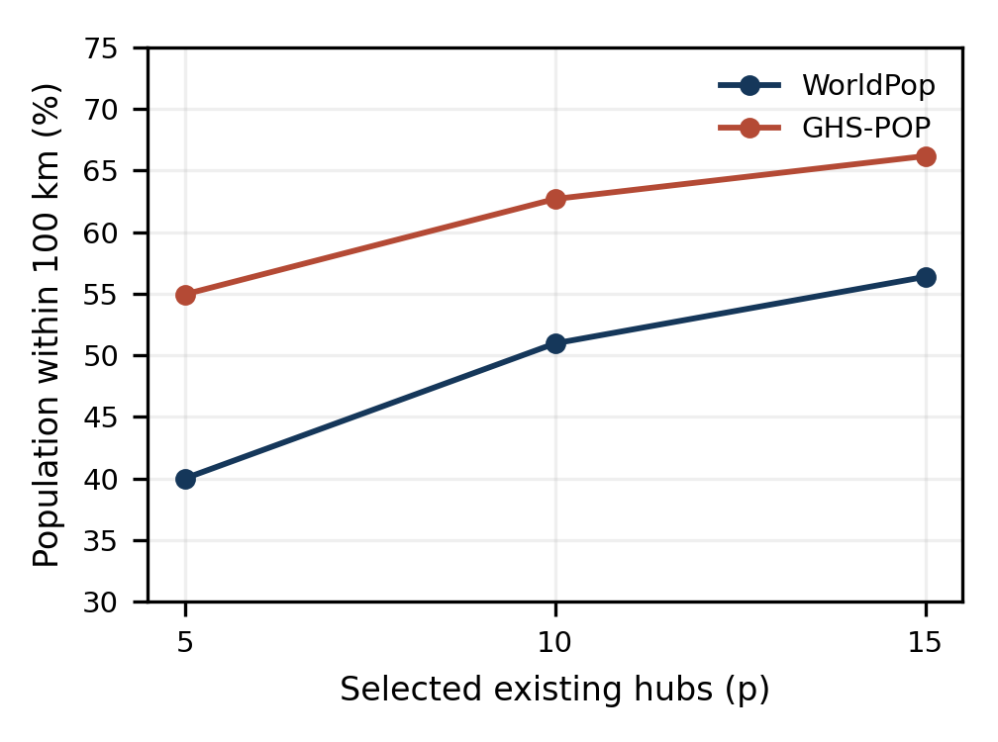
Fig. 2. Baseline maximal coverage for two population products. Main roads, 1-km demand cells, connectors ≤5 km, and no deliberate perturbation. Percentages use each product’s own regional total.
One WorldPop optimum for p = 5 selects Kinshasa, Mbanza-Ngungu, Tshela, Kikwit, and Gemena. For p = 10, one optimum selects Kinshasa, Matadi, Boma, Mbanza-Ngungu, Tshela, Kenge, Idiofa, Bulungu, Bumba, and Gemena. The selected identities are examples of optimal solutions to a coverage problem; they are not a priority list for public construction. Multiple solutions may attain the same objective, and the fixed candidate set does not contain every locality or potential service location. An optimality gap of zero cannot resolve these planning limitations.
TABLE VI
JOINT SCENARIO ENVELOPES: 96 CONFIGURATIONS PER P
p | Minimum % | Maximum % | Median %
5 | 33.51 | 55.17 | 44.91
10 | 40.40 | 63.35 | 53.46
15 | 44.10 | 67.16 | 57.31

All 288 optimizations terminate with solver status zero and reported MIP gap zero; recomputed coverage agrees with the solved objective. Joint scenario ranges are wide (Table VI). The median is merely the median of the equally enumerated configurations; it is not the expected real-world outcome. Treating every configuration equally in this descriptive summary does not supply a probabilistic prior for product correctness or network incompleteness. The complete run table preserves factor levels and denominators so individual assumptions can be inspected.
Increasing p from five to ten raises baseline WorldPop coverage by 10.97 percentage points, and increasing it from ten to fifteen adds 5.41 points. GHS-POP gains are 7.75 and 3.49 points. These diminishing increments support a discussion of saturation for the chosen service-distance model. They do not establish p = 10 as the best investment count, because no budget, facility capacity, or benefit valuation enters the objective. Unlike the legacy median problem, this model also retains demand that no eligible facility can cover.

D. Synthetic-Graph Centrality and Median Audit
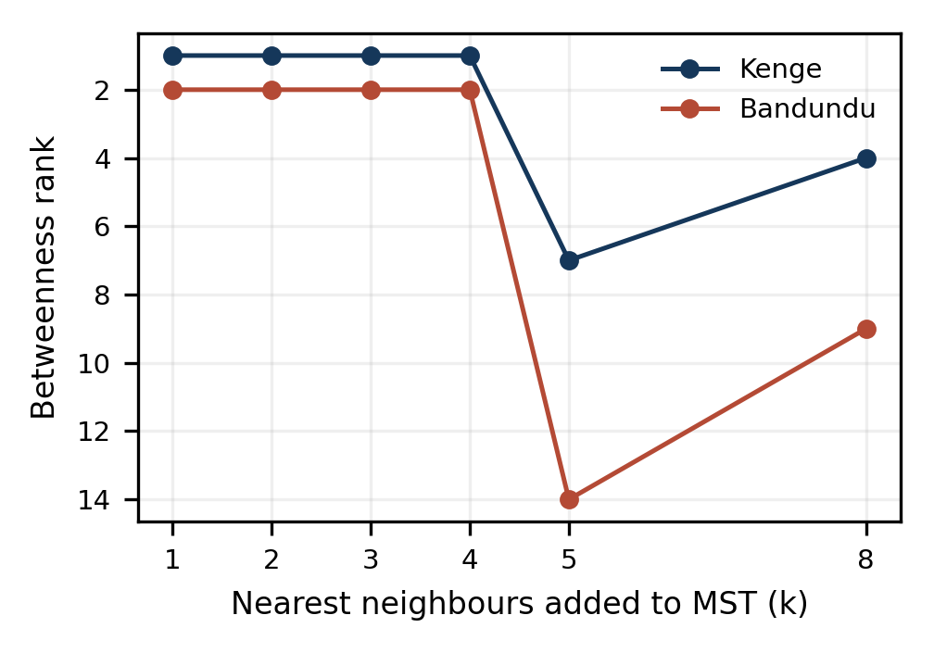
Fig. 3. Betweenness ranks of Kenge and Bandundu change when the synthetic graph is rebuilt. Lower rank numbers indicate higher betweenness. These are graph-model rankings, not measured corridor functions.
TABLE VII
SELECTED TOPOLOGY DIAGNOSTICS
Topology | Edges | Comps. | Isolates
MST + 1 neighbour | 25 | 1 | 0
MST + 3 neighbours | 49 | 1 | 0
MST + 5 neighbours | 74 | 1 | 0
Radius 40 km | 2 | 24 | 22
Radius 50 km | 3 | 23 | 20
Radius 100 km | 16 | 12 | 8

Kenge moves from betweenness rank 1 in MST + 3 to rank 7 in MST + 5; Bandundu moves from rank 2 to rank 14. The whole-node rank correlation between those two configurations is only 0.4275. Radius graphs at 15 and 25 km have no edges; at 100 km there are 12 components and eight isolated nodes, including Kenge and Bandundu. This change falsifies the interpretation of the baseline centrality leaders as topology-independent territorial hinges. The main results therefore do not rely on synthetic-graph centrality to rank regional investments.
Exact optimization confirms the earlier median objective at p = 5, 10, and 15 on its own released inputs: mean distances are 80.44, 28.36, and 12.58 km. However, the buffer weights sum to 7.37 million, only 17.05% of the COD-AB regional total arithmetically; that ratio is not a unique population coverage estimate because buffers can overlap. The earlier distances therefore describe a selected-node demand model, not complete regional accessibility. The expanded p = 2–20 curve meets no eligible elbow under the three-successive-gains-below-5% rule; neither 2% nor 10% alternatives identify one. The claim of an established ten-hub elbow is withdrawn.
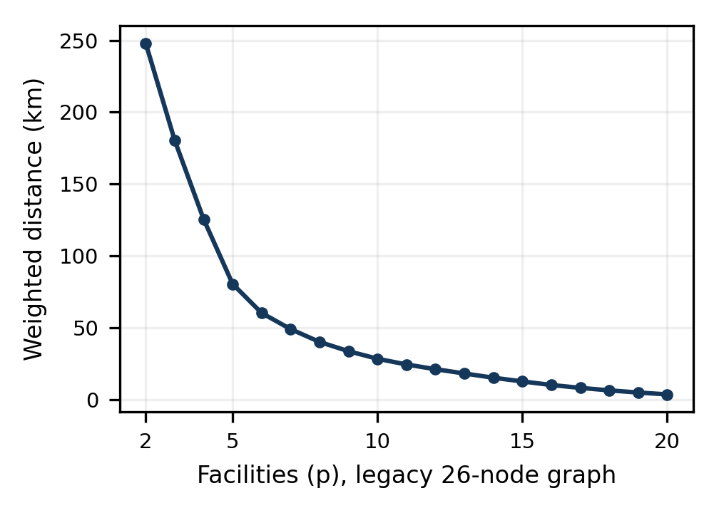
Fig. 4. Exact legacy p-median curve for p = 2–20. Population weights are the original node buffers, not the regional demand grid. No eligible p meets the stated three-successive-gains-below-5% elbow rule.

E. Candidate Weight Audit and Environmental Interpretation
TABLE VIII
DOMINANT CANDIDATE UNDER ALTERNATIVE WEIGHT CENTRES
Province | Reference winner (%) | Uniform winner (%)
Équateur | Buanza (49.40) | Inganda (82.76)
Kinshasa | Komo (72.14) | Komo (85.90)
Kongo Central | Kimpika (59.98) | Vemadja (48.74)
Kwango | Fumu-Mashi (95.46) | Fumu-Mashi (70.60)
Kwilu | Pana (74.10) | Kiboba (92.00)
Maï-Ndombe | Ebale (98.18) | Ebale (75.10)
Mongala | Amamba (86.90) | Amamba (95.38)
Nord-Ubangi | Bale Deuxième (81.68) | Bale Deuxième (54.66)
Sud-Ubangi | Bwamandema (94.08) | Bwamandema (99.94)
Tshuapa | Yanganga (100) | Yanganga (100)

Uniform rather than reference weight centres change the dominant winner in three provinces: Équateur, Kongo Central, and Kwilu (Table VIII). Frequencies are conditional on the same cached 75-point environmental sample and within-province competition, not on all feasible regional land. The sample contains only three candidates in Équateur, two in Mongala, and one in Tshuapa. Yanganga’s 100% frequency is therefore mechanically guaranteed by the absence of a competitor; it does not demonstrate exceptional site robustness. This distinction corrects an important overinterpretation of the earlier Monte Carlo result.
Neither Yanganga nor Ebale can be described as a validated sovereign hub from these scores. Functional independence would require evidence of productive activity, local processing, employment, energy reliability, service capacity, trade patterns, and institutional arrangements. A proximity score supplies none of these directly. The broader urban planning literature stresses substantive urban functions and governance [31]. The audit is retained to demonstrate how preference choices and candidate availability affect a score, while the proposed sites cease to be planning recommendations.
The hydrological flag is now reproducible, but scientific transparency does not make it a flood-risk model. A nearby river can support transport or increase inundation exposure; the sign of its effect depends on terrain, stage, protection, and settlement use. Likewise, the strict tree-cover exclusion can be precautionary without being ecologically precise. A current protected-area mask and an extreme tree-exclusion sensitivity test are now supplied; parcel tenure and forest integrity remain unverified. These omissions materially prevent endorsing greenfield urban construction.

F. External Validity, Planning Meaning, and Remaining Requirements
The revised model quantifies a relationship between estimated population, mapped roads, candidate facilities, and a distance threshold. It does not measure actual journeys, induced development, or a shift of trade away from Kinshasa. Polycentricity requires complementary functions and interactions, not merely selecting several points. A coverage objective can favour dense, well-mapped areas even when a planner prioritizes provincial equity. Conversely, demanding one hub per province can reduce distance-based efficiency. These are explicit policy choices that should be compared using observed costs and service objectives rather than hidden inside a claim of sovereignty.
The direct road graph is a methodological improvement over forced MST connectivity, but remains a provisional representation. A 1% deletion stress tests fragility without estimating omitted roads; adding tracks broadens mapped access without certifying their passability. No speed model is calibrated. Population products disagree considerably, and a 2025 modelled epoch does not synchronize perfectly with a 2026 road snapshot. Alternative 50- and 150-km thresholds are now tested, but no service-specific empirical threshold is calibrated. None of these qualifications can be replaced by calling an internal consistency check validation.
The secondary JICA report confirms that some observed mobility evidence exists locally [32]. Its spatial and temporal scope must be respected. The defensible next validation would define a measurable target, identify corresponding road geometry and survey dates, and compare modelled urban distances or travel times with digitized route observations. Regional hub coverage would require representative service access or OD evidence across the study system. Until such a matched test is executed, the present article remains an exploratory geospatial sensitivity study. The absence of that empirical test is a substantive limitation, not a minor editorial detail.
A causal historical study is a separate requirement. It would digitize colonial-era routes, document post-independence construction and maintenance, harmonize historical settlement demand, and compare spatial configurations under explicit counterfactuals. Current centrality or coverage alone cannot apportion fragmentation between inherited infrastructure and later investment failures. Historical explanation is therefore excluded from the quantitative conclusions. The results can motivate that subsequent research without establishing its answer.
For implementation, an agency should first agree on a service definition, candidate universe, and admissible routes. Population totals should be reconciled with nationally accepted sources; graph junctions and access restrictions should be inspected; hydrographic navigation and rail operations require their own inventories. Equity, capacities, finance, climate risk, customary tenure, and conservation exclusions must be added before evaluating new locations. The present computations provide a transparent baseline for those choices rather than a substitute for them.

G. Additional Scenario and Conservation Results
All 108 additional covering optimizations report zero solver status and zero MIP gap. Table IX gives the five-realization ranges for p = 10; it holds grid resolution and road classes constant. Differences across coverage thresholds express a policy-distance assumption, while variation within a product and threshold reflects the combined deletion–coordinate stress. These ranges remain descriptors of the chosen stresses, not confidence bounds on actual service coverage.
TABLE IX
TEN-HUB COVERAGE IN FIVE REPEATED JOINT STRESSES
Product | Limit km | Range % | Mean %
WorldPop | 50 | 35.27–36.38 | 35.99
WorldPop | 100 | 48.51–49.92 | 49.54
WorldPop | 150 | 60.70–61.52 | 61.19
GHSPOP | 50 | 51.31–52.38 | 51.95
GHSPOP | 100 | 60.85–62.21 | 61.74
GHSPOP | 150 | 69.18–70.10 | 69.70

The common regional mask contains 7,677 ten-kilometre centres and 1,239 twenty-five-kilometre centres. Remoteness and mapped-access rules retain 6,519 and 1,047, respectively. Protected polygons contain 1,044 and 167 of those centres. Testing the whole square footprint instead excludes 1,298 and 268 cells, before land-cover screening (Table X). The point-only reported-area buffer intersects no eligible cell in this region. Polygon overlap is dissolved, so cells are counted once. A difference between centre and footprint screening is not a discrepancy in the source; it follows from the explicitly different spatial tests.
TABLE X
CANDIDATE GRID AND PROTECTED POLYGON INTERSECTIONS
Grid km | Eligible | Centre mask | Cell mask
10 | 6519 | 1044 | 1298
25 | 1047 | 167 | 268

TABLE XI
LAND-COVER AND FULL-CELL PROTECTED-AREA SCREENING
Grid km | Tree rule | Land-cover pass | After PA mask
10 | Strict tree exclusion | 1728 | 1583
10 | Tree admitted test | 6401 | 5156
25 | Strict tree exclusion | 273 | 241
25 | Tree admitted test | 1033 | 772

Table XI evaluates the land-cover and protected-area rules jointly. Admitting mapped tree cover is deliberately an extreme diagnostic. It measures the influence of the exclusion without identifying which forest could lawfully or ecologically be converted. The detailed output preserves reference and uniform-weight winners at each resolution and mask rule. Changed candidate centres and conditional ranks must not be interpreted as parcel relocation recommendations. Unlike the existing-hub coverage model, this supplementary screen includes preference weights and still requires consultation, slope and flood analysis, and a land-rights assessment.
The strict full-cell screen retains candidates in all ten provinces at 10 km but in only nine at 25 km; Équateur has none at the coarser resolution. Among the nine common provinces, the geodesic shift between the top-scored 10- and 25-km centres has a median of 212.22 km (maximum 313.70 km) under reference weights and 52.02 km (maximum 264.13 km) under uniform weights. Thus, province-specific winners are not stable under this change of sampling grid. The comparison concerns conditional point-centre sampling and ranking, not evidence that urban sites should be moved by those distances.
The JICA screen-line observations are now included as an external evidence inventory. Their units, domain, and model target prevent a valid direct comparison to a percentage of regional population within a distance threshold. JICA’s estimated counts differ from its observations by −7.53% and −5.62%, calculated from its published numbers; these percentages belong to JICA’s own calibration. They are not errors of the model developed here. The principal empirical-validation objection therefore remains unresolved, despite the successful acquisition of actual secondary traffic observations.

IV. CONCLUSION
Replacing selected-node demand with complete gridded population and preserving mapped road disconnection materially changes the scope of the accessibility question. Across the same ten-province mask, WorldPop and GHS-POP differ by 21.40% in total population. Baseline ten-hub coverage within 100 km is 50.97% versus 62.70%; the joint scenario envelope spans 40.40–63.35%. These calculated differences show that population and network assumptions must accompany any reported hub result.
The audits also change the interpretation of the previous application: Kenge and Bandundu centrality ranks are topology-sensitive, the specified p-median elbow is not supported, and Yanganga’s perfect selection frequency follows from a single candidate in its province. Exact solver results establish optimality only within the encoded models. An additional 108 optimization runs, alternative grid screens, and an October 2026 protected-area mask strengthen sensitivity analysis. No compatible empirical regional flow or field validation has been completed, and no historical cause, sovereign economic function, or feasible new-town site is demonstrated. The contribution is therefore a reproducible analysis of model sensitivity, with operational planning claims reserved for subsequent matched validation.

DATA AND AUTHOR STATEMENTS
The revision replication package supplies scripts, derived result tables, parameter definitions, source URLs, checksums, and figure-generation instructions. The original v1.0.0 archive remains at https://doi.org/10.5281/zenodo.22287394; it does not contain the new revision analyses. The repository is https://github.com/Nehemy29/rdc-urban-hubs-spatial-optimization. Revision files are provided separately with this resubmission material and require a new public version to be archived as the revised release. Third-party raw datasets are not redistributed in the revision package; producer terms and attribution are documented.
The sole author is responsible for the study, interpretation, and manuscript. As declared in the submitted version, the research received no external funding and the author reports no conflict of interest. Only public aggregate geospatial data are used; no individual mobility record or new human-participant survey is analysed. Computational verification and literature checks are distinguished from empirical field validation throughout.

REFERENCES
[1] J.-P. Rodrigue, The Geography of Transport Systems, 5th ed. Routledge, 2020.
[2] K. T. Geurs and B. van Wee, “Accessibility evaluation of land-use and transport strategies: Review and research directions,” Journal of Transport Geography, vol. 12, no. 2, pp. 127–140, 2004.
[3] A. Cattaneo, A. Nelson, T. McMenomy, “Global mapping of urban–rural catchment areas reveals unequal access to services,” Proceedings of the National Academy of Sciences, vol. 118, Art. no. e2011990118, 2021, doi: 10.1073/pnas.2011990118.
[4] S. L. Hakimi, “Optimum distribution of switching centers and the absolute centers and medians of a graph,” Operations Research, vol. 12, no. 3, pp. 450–459, 1964.
[5] C. S. ReVelle and R. W. Swain, “Central facilities location,” Geographical Analysis, vol. 2, no. 1, pp. 30–42, 1970.
[6] R. Church and C. ReVelle, “The maximal covering location problem,” Papers of the Regional Science Association, vol. 32, pp. 101–118, 1974.
[7] E. W. Dijkstra, “A note on two problems in connexion with graphs,” Numerische Mathematik, vol. 1, pp. 269–271, 1959.
[8] D. Runfola et al., “geoBoundaries: A global database of political administrative boundaries,” PLOS ONE, vol. 15, no. 4, Art. no. e0231866, 2020, doi: 10.1371/journal.pone.0231866.
[9] WorldPop, “Global population estimates 2015–2030, R2025A, version 1: COD 2025 constrained 100 m (alpha),” University of Southampton, 2025, doi: 10.5258/SOTON/WP00839. [Online]. Available: https://hub.worldpop.org/geodata/summary?id=73055.
[10] G. Boo, E. Darin, D. R. Leasure et al., “High-resolution population estimation using household survey data and building footprints,” Nature Communications, vol. 13, Art. no. 1330, 2022, doi: 10.1038/s41467-022-29094-x.
[11] D. R. Thomson, D. R. Leasure, T. Bird et al., “How accurate are WorldPop-Global-Unconstrained gridded population data at the cell-level?: A simulation analysis in urban Namibia,” PLOS ONE, vol. 17, Art. no. e0271504, 2022, doi: 10.1371/journal.pone.0271504.
[12] N. Metzger, J. E. Vargas-Muñoz, R. C. Daudt et al., “Fine-grained population mapping from coarse census counts and open geodata,” Scientific Reports, vol. 12, Art. no. 20085, 2022, doi: 10.1038/s41598-022-24495-w.
[13] M. Schiavina, S. Freire, A. Carioli, and K. MacManus, “GHS-POP R2023A—GHS population grid multitemporal (1975–2030),” European Commission, Joint Research Centre, dataset, 2023, doi: 10.2905/2FF68A52-5B5B-4A22-8F40-C41DA8332CFE.
[14] M. Schiavina, M. Melchiorri, and M. Pesaresi, “GHS-SMOD R2023A—GHS settlement layers, application of the Degree of Urbanisation methodology,” European Commission, Joint Research Centre, dataset, 2023, doi: 10.2905/A0DF7A6F-49DE-46EA-9BDE-563437A6E2BA.
[15] European Commission, Joint Research Centre, GHSL Data Package 2023, Public Release GHS P2023, updated edition. Publications Office of the European Union, 2024, doi: 10.2760/098587.
[16] European Commission et al., Applying the Degree of Urbanisation—A Methodological Manual to Define Cities, Towns and Rural Areas for International Comparisons. Publications Office of the European Union, 2021, doi: 10.2785/706535.
[17] L. Dijkstra, A. J. Florczyk, S. Freire et al., “Applying the Degree of Urbanisation to the globe: A new harmonised definition reveals a different picture of global urbanisation,” Journal of Urban Economics, vol. 125, Art. no. 103312, 2021, doi: 10.1016/j.jue.2020.103312.
[18] European Commission, Joint Research Centre, Applying the Degree of Urbanisation Method to National Population and Housing Census with GHSL Tools, JRC124765, 2021, doi: 10.2760/939289.
[19] OpenStreetMap contributors and Humanitarian OpenStreetMap Team, “Democratic Republic of the Congo roads export,” snapshot 5 Oct. 2026, ODbL 1.0. [Online]. Available: https://production-raw-data-api.s3.amazonaws.com/ISO3/COD/roads/hotosm_cod_roads_osm_gpkg.zip
[20] B. Herfort, S. Lautenbach, J. Porto de Albuquerque et al., “The evolution of humanitarian mapping within the OpenStreetMap community,” Scientific Reports, vol. 11, Art. no. 3037, 2021, doi: 10.1038/s41598-021-82404-z.
[21] B. Herfort, S. Lautenbach, J. Porto de Albuquerque et al., “A spatio-temporal analysis investigating completeness and inequalities of global urban building data in OpenStreetMap,” Nature Communications, vol. 14, Art. no. 3985, 2023, doi: 10.1038/s41467-023-39698-6.
[22] G. Boeing, “Street Network Models and Indicators for Every Urban Area in the World,” Geographical Analysis, vol. 54, pp. 519-535, 2022, doi: 10.1111/gean.12281.
[23] M. T. Hoffmann, K. Ostapowicz, K. Bartoń et al., “Mapping roadless areas in regions with contrasting human footprint,” Scientific Reports, vol. 14, Art. no. 4722, 2024, doi: 10.1038/s41598-024-55283-3.
[24] D. Zanaga et al., “ESA WorldCover 10 m 2021 v200,” dataset, 2022, doi: 10.5281/zenodo.7254221.
[25] S. Razavi et al., “The future of sensitivity analysis: An essential discipline for systems modeling and policy support,” Environmental Modelling & Software, vol. 137, Art. no. 104954, 2021, doi: 10.1016/j.envsoft.2020.104954.
[26] A. Saltelli et al., “Five ways to ensure that models serve society: A manifesto,” Nature, vol. 582, pp. 482–484, 2020, doi: 10.1038/d41586-020-01812-9.
[27] A. Puy, S. Lo Piano, A. Saltelli, and S. A. Levin, “sensobol: An R package to compute variance-based sensitivity indices,” Journal of Statistical Software, vol. 102, no. 5, pp. 1–37, 2022, doi: 10.18637/jss.v102.i05.
[28] I. M. Sobol’, “Global sensitivity indices for nonlinear mathematical models and their Monte Carlo estimates,” Mathematics and Computers in Simulation, vol. 55, nos. 1–3, pp. 271–280, 2001.
[29] C. R. Harris et al., “Array programming with NumPy,” Nature, vol. 585, pp. 357–362, 2020, doi: 10.1038/s41586-020-2649-2.
[30] P. Virtanen et al., “SciPy 1.0: Fundamental algorithms for scientific computing in Python,” Nature Methods, vol. 17, pp. 261–272, 2020, doi: 10.1038/s41592-019-0686-2.
[31] UN-Habitat, World Cities Report 2022: Envisaging the Future of Cities. Nairobi, Kenya, 2022.
[32] Japan International Cooperation Agency, The Project for Urban Transport Master Plan in Kinshasa City (PDTK), Final Report, vol. 1, part 1, Apr. 2019. [Online]. Available: https://openjicareport.jica.go.jp/pdf/12340295_01.pdf.
[33] UNEP-WCMC and IUCN, “Protected Planet: The World Database on Protected and Conserved Areas (WDPCA), protected-area view,” Oct. 2026. [Online]. Available: https://www.protectedplanet.net/ and https://data-gis.unep-wcmc.org/server/rest/services/ProtectedSites/The_World_Database_of_Protected_Areas/FeatureServer. Accessed: 7 Oct. 2026.

