Brain Tumor MRI Classification Model
Field Guide for Clinical and Operational Use
Model: ResNet18 pretrained image classifier
Use case: MRI slice classification into glioma, meningioma, or pituitary tumor
Final Project – MPHY 6120 AI in Medicine
Nehemyah Green, Ledi Anggara, Trent Levy

Status: Supporting image review, not for standalone diagnosis
Intended use statement
This tool is designed to support image review by providing a preliminary tumor class prediction and visual explanation. It should not be used as the only basis for diagnosis, treatment planning, or patient management decisions.

1. Executive Summary
This tool is a deep learning based image classification model developed to support the review of brain tumor MRI images. The model takes one MRI brain slice as input and predicts whether the image is most consistent with glioma, meningioma, or pituitary tumor. In addition to the predicted label, the tool provides a confidence score and visual explanation outputs, including Grad-CAM, Grad-CAM++, and occlusion sensitivity maps. These outputs are included to help the clinical user understand where the model is looking, not to replace clinical interpretation.
The primary users are radiologists, radiation oncologists, and clinical AI implementation teams. In a clinical workflow, the model should be used as a second reader or triage support tool after MRI acquisition and before final clinical sign-off. It may also be helpful for education, quality review, and early research evaluation where users want to compare model attention with visible tumor features.
The internal test results show strong model performance. In the held-out test set of 909 images, the model correctly classified 902 images, corresponding to an overall accuracy of 99.2% with an approximate 95% confidence interval of 98.4% to 99.6%. The ROC-AUC was approximately 1.00 for all three classes, and average precision was approximately 0.999 to 1.000. The calibration analysis showed a low Brier score of 0.0038, suggesting strong overall probability performance, although the reliability curve still shows that some probability bins are unstable and the model can be overconfident.
Overall, this model is promising as a clinical decision support tool. However, the current evidence is based on internal retrospective image data and formal human-in-the-loop review is needed. Final clinical responsibility must remain with the qualified clinician.
Category | Result | Operational meaning
Input | Single 2D MRI brain slice | The model does not evaluate full 3D exams or clinical history.
Output | Glioma, meningioma, or pituitary tumor plus confidence score | Use as decision support only.
Internal test set | 909 images | Held-out dataset used for final evaluation.
Overall accuracy | 99.2% (902/909), 95% CI 98.4%-99.6% | Very high internal performance.
Discrimination | ROC-AUC approximately 1.00 for all classes | The model separates the three classes very well on this dataset.
Calibration | Brier loss 0.0038 | Predicted probabilities are generally strong, but some bins are unstable.

2. Clinical Context

Clinical problem
Brain tumor classification is a common and important task in neuro-oncology imaging. In routine practice, brain MRI is interpreted by radiologists who assess tumor location, enhancement pattern, edema, mass effect, relationship to surrounding structures, and other imaging features. The interpretation then contributes to clinical decisions such as referral pathway, surgical planning, biopsy planning, radiation therapy evaluation, and patient counseling. However, tumor classification can still be challenging when image quality is limited, when only a small number of slices show the lesion clearly, or when tumors have overlapping imaging appearances.
This model addresses a focused part of that larger clinical problem. It does not attempt to replace the full radiology interpretation. Instead, it provides a fast prediction for three broad tumor classes: glioma, meningioma, and pituitary tumor. The practical value is not only the predicted class, but also the ability to provide a consistent second read and a visual explanation that can be reviewed by a human user.

Current standard of care
The current standard of care is expert interpretation of MRI by trained clinicians, usually radiologists, supported by clinical history and prior imaging when available. For many patients, the final diagnosis may require pathology from biopsy or resection. Imaging classification is therefore an important clinical input, but it is not always the final diagnostic truth.
In the current workflow, the radiologist reviews the complete MRI examination, including multiple sequences and planes. A final report is generated based on imaging findings, comparison studies, and clinical context. Any AI model used in this setting must respect this workflow. It should provide additional information without hiding uncertainty or forcing the clinician to accept the model prediction.
Current workflow step | Current practice | AI-supported change
MRI acquisition | Images acquired using local scanner protocol. | No change. Image quality remains the responsibility of the imaging team.
Image review | Radiologist reviews full exam and prior imaging. | Model provides a preliminary class prediction for selected slices.
Interpretation | Clinician integrates imaging features and clinical context. | Clinician compares model prediction and heatmap with visible anatomy.
Reporting | Final report signed by clinician. | AI result may support review, but should not automatically populate final diagnosis.
Quality review | Errors reviewed if clinically detected. | Model performance can be monitored continuously with predefined thresholds.

Expected workflow impact
The most reasonable workflow role for this model is as a decision support layer. It may help prioritize cases, provide a second opinion for common tumor classes, and encourage consistent review of imaging features. For example, when the model predicts glioma with high confidence and the heatmap overlaps the suspicious lesion, the tool may increase reader confidence. When the model prediction disagrees with the radiologist impression or the heatmap focuses outside the lesion, the case should be reviewed more carefully rather than automatically accepted.
Clinical workflow principle
The model should be treated like an assistant that flags a possibility. The radiologist or responsible clinician remains the final decision maker.

3. Technical Description

Data requirements
The model was developed using MRI brain tumor images stored as 2D image files. The dataset used in this project contained 4,239 training images, 908 validation images, and 909 test images. The three target labels were glioma, meningioma, and pituitary tumor. The training split was balanced, with each class representing approximately one third of the training images. This balanced class distribution is important because it reduces the risk that the model simply learns to favor the most common class.
Dataset component | Count / description
Training images | 4,239
Validation images | 908
Test images | 909
Classes | Glioma, meningioma, pituitary tumor
Estimated unique numeric IDs | 2,004
Input format used for modeling | Single MRI slice image, resized and normalized for ResNet18 input

Before training, the images were resized and normalized. Data augmentation was applied during training. The augmentation examples included flip, rotation, and intensity jitter. The purpose of augmentation is to reduce overfitting, teach the model to ignore small acquisition differences that are not clinically meaningful, and improve generalization compared with training longer on a small fixed dataset.
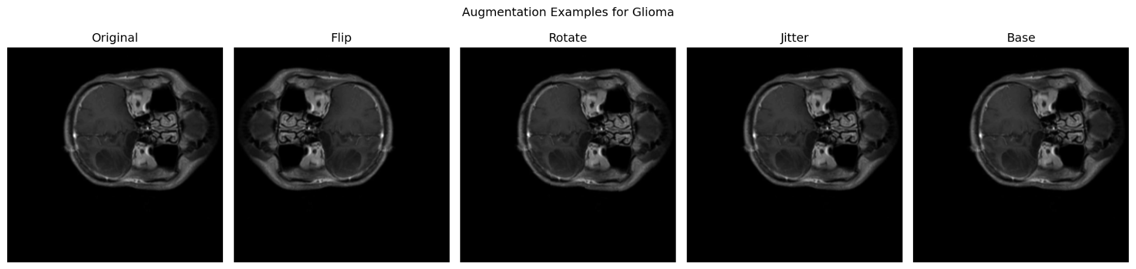
Figure 1. Example MRI augmentation used during training.

Model architecture
In this project, transfer learning was used. The model is based on a pretrained ResNet18 convolutional neural network. ResNet18 is a widely used image classification architecture that learns image features through a series of convolutional layers. This means that the model starts from weights learned from a large general image dataset, then the final classifier is adapted to the brain tumor classification task. This approach is useful when the medical dataset is smaller than the very large datasets usually needed to train deep learning models from scratch.
At a high level, the early layers detect simple features such as edges and intensity transitions, while deeper layers combine these features into more task-specific image patterns. The first convolutional layer filters show that the model learned low-level image patterns such as edges, gradients, and texture-like structures. These features are expected for an image classification model, but they do not by themselves prove that the model understands tumor biology.
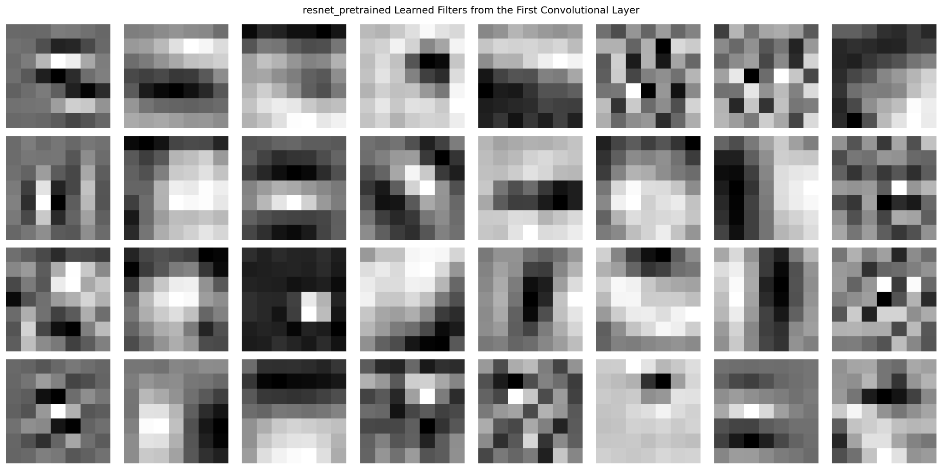
Figure 2. Learned filters from the first convolutional layer of the pretrained ResNet18 model.

Input and output specification
Item | Specification
Input image | One .jpg MRI brain slice image, preprocessed to the model input size and channel format.
Input assumptions | Image should be representative of the tumor region and similar in appearance to the training data.
Primary output | Predicted tumor class: glioma, meningioma, or pituitary tumor.
Secondary output | Confidence score for the predicted class.
Explainability outputs | Grad-CAM, Grad-CAM++, and occlusion sensitivity maps.
Unsupported inputs | Full 3D MRI exams, multi-sequence studies, DICOM metadata, non-brain images, post-operative images not represented in training, or classes outside the three target labels.

Computational requirements
Training is best performed on a GPU because model optimization requires repeated forward and backward passes through the network. Inference can usually be performed on a CPU or GPU because only one forward pass is required per image. For operational deployment, the main requirements are stable preprocessing, version-controlled model weights, input validation, logging of predictions, and a secure environment that complies with local institutional requirements.
Component | Recommended requirement
Training hardware | GPU recommended.
Inference hardware | CPU acceptable for low-volume use; GPU preferred for high-throughput workflows.
Software stack | Python, PyTorch, image preprocessing pipeline, model weight file, logging module.
Operational controls | Model versioning, data provenance, prediction logs, and periodic performance review.

4. Performance Evaluation

Evaluation dataset and endpoint
The model was evaluated on a held-out internal test set of 909 images. The endpoint was correct classification into one of three tumor classes. Because the evaluation was performed on image slices rather than full patient exams, the results should be interpreted as image-level performance. Patient-level performance may be different and should be tested separately before clinical deployment.

Primary performance metrics
Metric | Result | Comment
Overall accuracy | 99.2% (902/909), 95% CI 98.4%-99.6% | Strong internal test performance.
Glioma recall | 100.0% (301/301), 95% CI 98.7%-100.0% | No glioma cases were missed in this test set.
Meningioma recall | 98.7% (296/300), 95% CI 96.6%-99.5% | Four meningioma images were misclassified.
Pituitary tumor recall | 99.0% (305/308), 95% CI 97.2%-99.7% | Three pituitary images were misclassified.
ROC-AUC | Approximately 1.00 for all classes | Confidence intervals were not calculated for AUC in this run.
Average precision | Approximately 0.999-1.000 | Precision-recall curves show very strong separation.
Brier score | 0.0038 | Low value, but calibration bins still show instability.

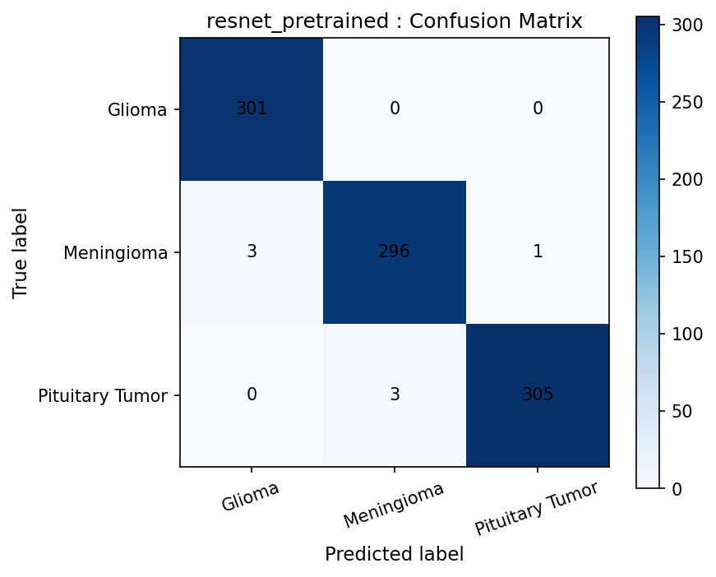
Figure 3. Confusion matrix for the ResNet18 pretrained model on the internal test set.

Class-level findings
The model performed best for glioma in this evaluation, with all glioma images correctly classified. The main remaining errors were between meningioma and glioma, and between pituitary tumor and meningioma. These errors are clinically plausible because some tumor appearances can overlap on single slices, especially when the model does not have access to full multi-sequence MRI context or clinical history.
True class | Correct | Most important observed error | Operational interpretation
Glioma | 301/301 | None observed in the test set | Strong internal performance, but should be externally validated.
Meningioma | 296/300 | Three predicted as glioma and one predicted as pituitary tumor | Review meningioma cases carefully when confidence is moderate or heatmap is off-target.
Pituitary tumor | 305/308 | Three predicted as meningioma | Pituitary region anatomy and limited field of view may affect interpretation.

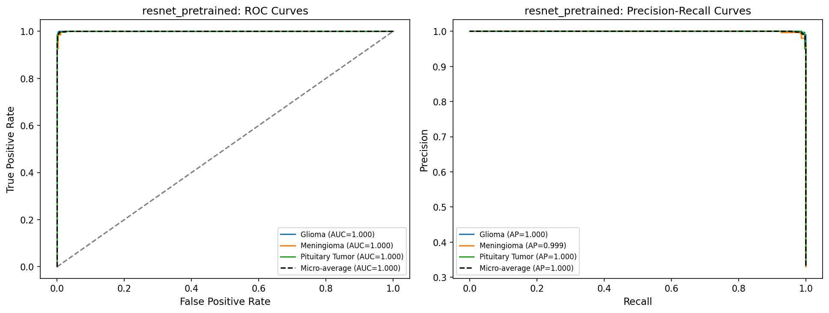
Figure 4. ROC and precision-recall curves for the ResNet18 pretrained model.

Calibration and confidence behavior
The model confidence is high for many examples. The Brier score is low, which suggests good overall probability performance. However, the calibration curve should be interpreted carefully. Some mid-range probability bins show noisy behavior because relatively few examples fall in those bins. This means the model may still appear overconfident or underconfident in specific confidence ranges. In a clinical implementation, confidence should therefore be used as a support signal, not as a direct measure of diagnostic certainty.
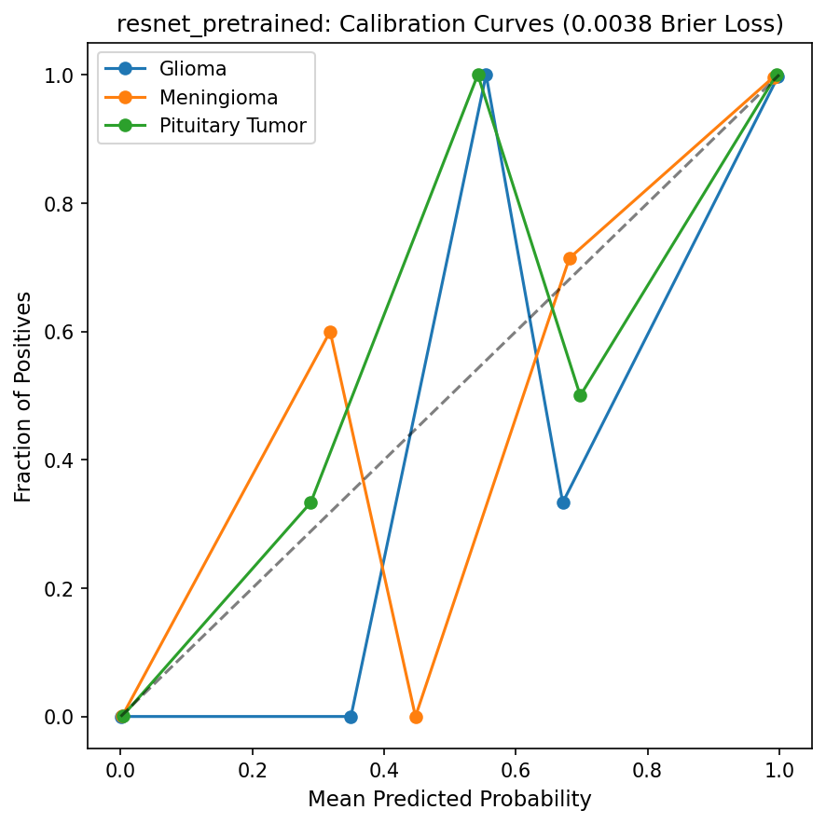
Figure 5. Calibration curve and Brier score for the ResNet18 pretrained model.

Explainability review
The explainability review used Grad-CAM, Grad-CAM++, and occlusion sensitivity. These methods provide different views of model attention. Grad-CAM highlights areas associated with the predicted class based on internal feature maps. Occlusion sensitivity tests how much the prediction changes when different regions of the image are covered. In the reviewed examples, the occlusion maps often highlighted focal image regions that appear clinically relevant. However, some maps also showed attention outside the tumor area or across broad background regions.
This is important because a correct prediction does not automatically mean the model used the correct image features. For clinical review, a prediction should be considered more trustworthy when the confidence is reasonable and the heatmap overlaps the lesion or clinically meaningful anatomy. If the heatmap is mostly outside the lesion, the result should be treated with caution even if the predicted label is correct.
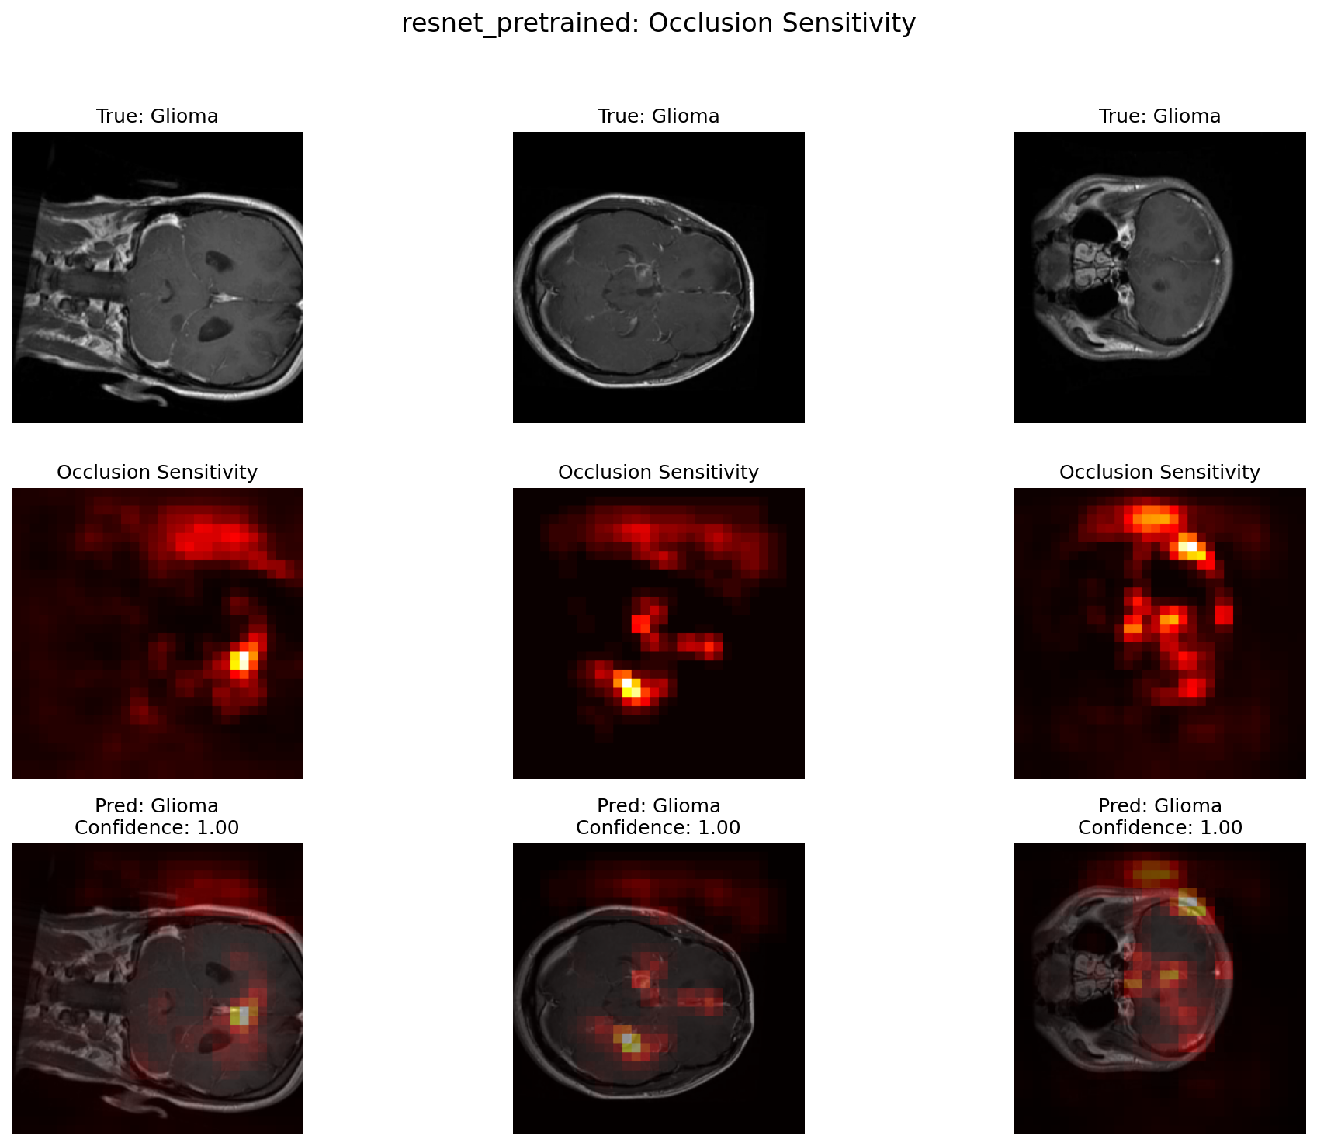
Figure 6. Occlusion sensitivity examples showing regions that influence the model prediction.
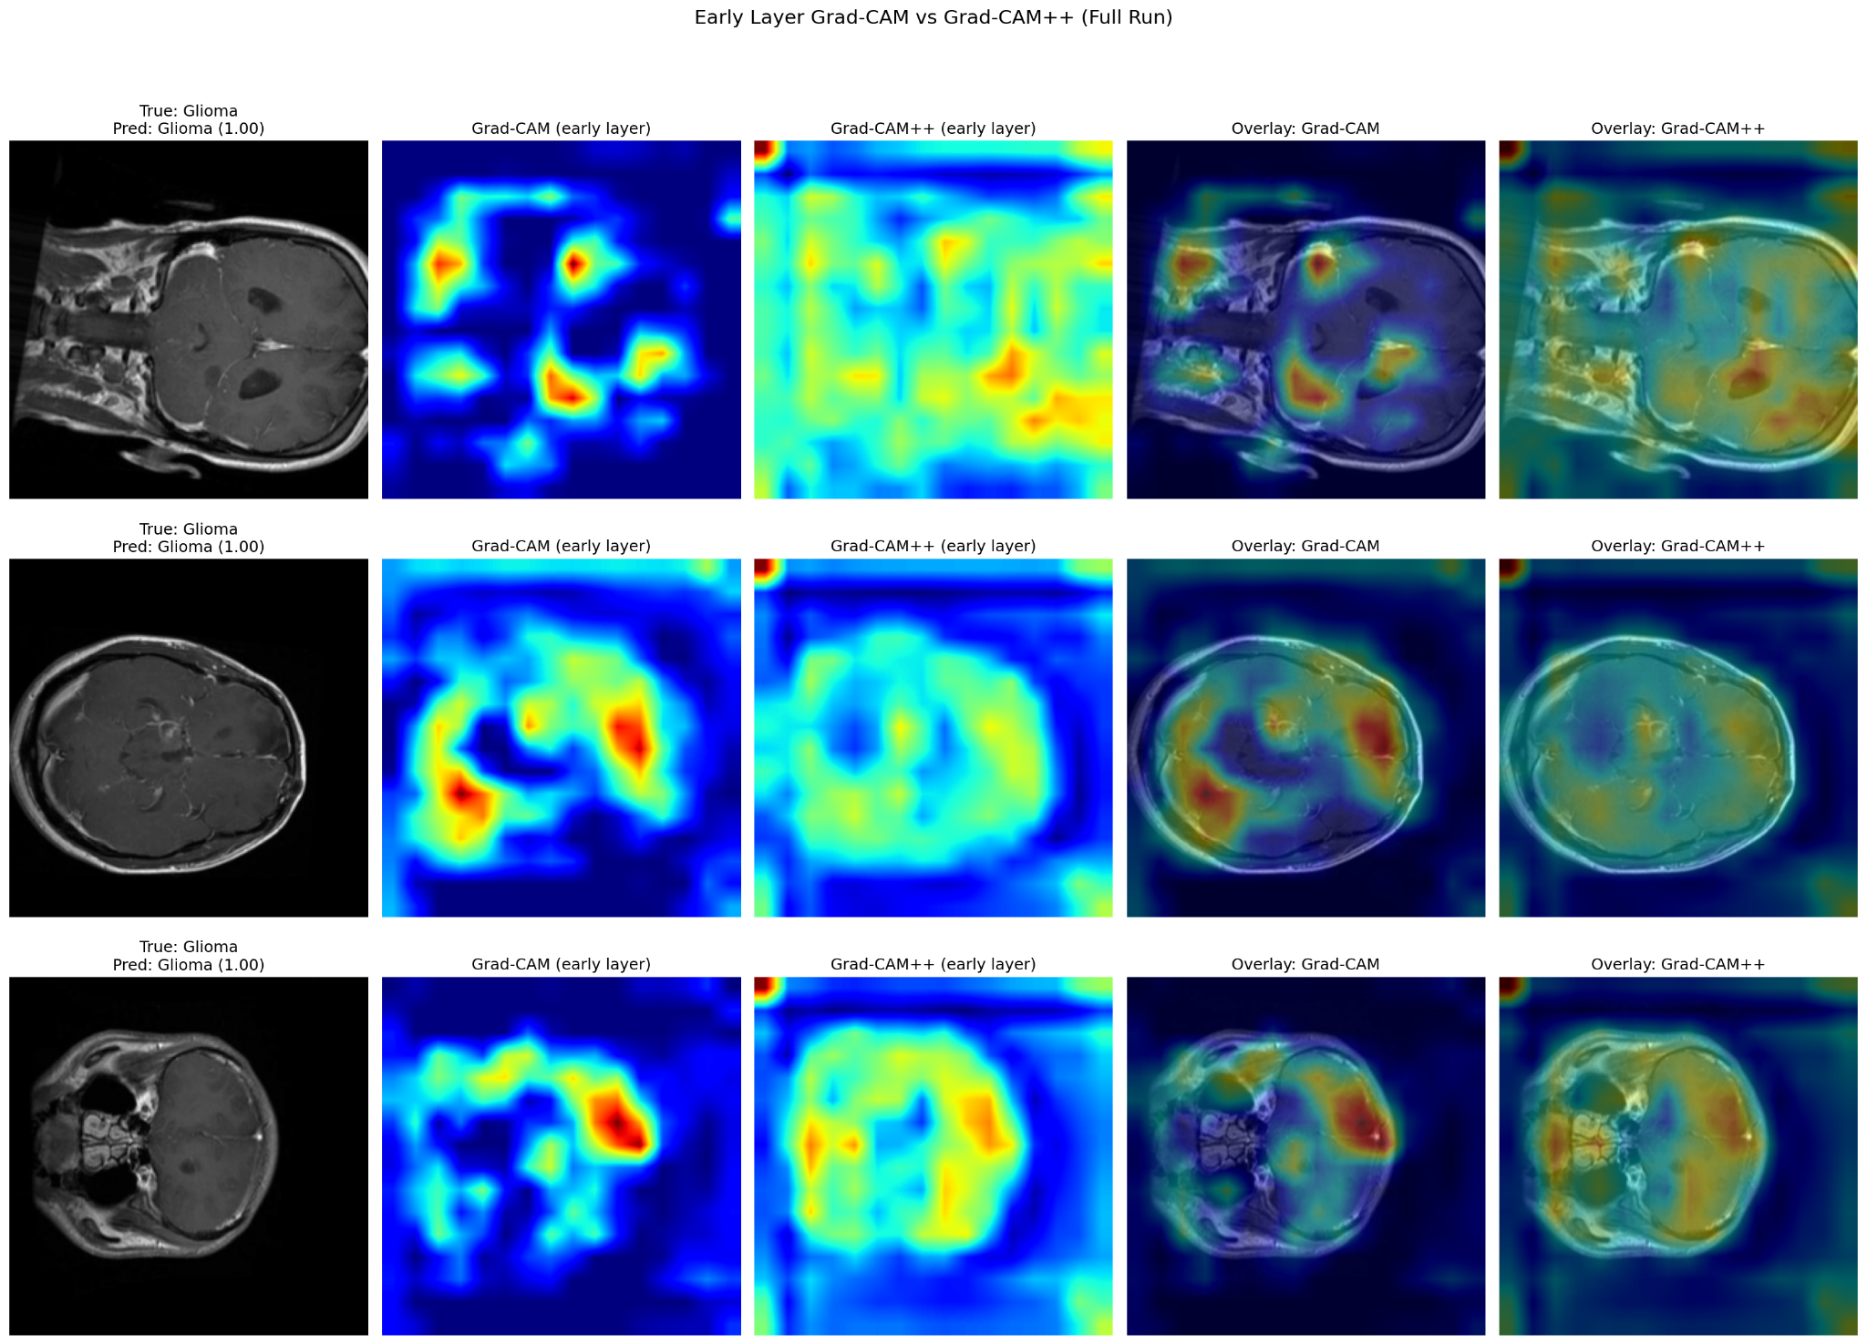
Figure 7. Early-layer Grad-CAM and Grad-CAM++ comparison examples.

Known failure modes
Failure mode | Observed evidence | Mitigation
Meningioma classified as glioma | Three meningioma images were predicted as glioma. | Flag moderate-confidence cases for additional human review.
Pituitary tumor classified as meningioma | Three pituitary images were predicted as meningioma. | Review sellar and parasellar anatomy carefully.
Overconfidence | Many correct and incorrect examples have high confidence; calibration curve has unstable bins. | Use confidence thresholds and escalation rules.
Heatmap outside lesion | Grad-CAM and occlusion maps may highlight broad or non-tumor regions. | Require human review of explanation maps before clinical trust.
No segmentation mask validation | No matched masks were available, so IoU and Dice were not calculated. | Collect lesion masks for future explanation validation.

5. Governance Framework

Acceptance testing protocol for new sites
Before this tool is used at any new site, the site should complete a formal acceptance test using local MRI images. The purpose is to confirm that the model behaves safely with the local scanner protocols, image preprocessing pathway, and patient population. The acceptance test should be completed before the model is connected to routine clinical workflow.
- Define the intended use at the site, including who can view the model output and where it appears in the workflow.
- Create a locked test dataset from local MRI images with confirmed labels. The test dataset should include all three classes and should not be used for model training.
- Verify preprocessing, including image orientation, resizing, channel conversion, intensity normalization, and file handling.
- Run the locked model version on the local test dataset without changing model weights.
- Compare model predictions against local reference labels and calculate accuracy, recall, precision, and confusion matrix.
- Review a representative sample of explanation maps with clinical users.
- Document pass or fail status, risks, required mitigations, and approval signatures before go-live.
Acceptance item | Suggested minimum criterion | Action if not met
Overall accuracy | At least 90% on local acceptance dataset | Investigate data mismatch and pause go-live.
Per-class recall | No class below 85% without documented clinical justification | Increase test set size, inspect errors, and consider retraining or restricting use.
Image preprocessing | 100% successful preprocessing with no orientation or scaling defects | Fix pipeline before further testing.
Explanation review | Most reviewed heatmaps should overlap lesion or clinically relevant anatomy | Restrict use and collect more validation data.
User training | All users trained on intended use and limitations | Do not release into clinical workflow.

Monitoring plan
After deployment, monitoring should focus on model performance, data quality, confidence behavior, and workflow impact. Monitoring is needed because clinical imaging data can drift over time. Drift may occur because of scanner upgrades, protocol changes, new patient populations, changes in image export settings, or changes in tumor case mix.

Signal to monitor | Threshold / trigger | Frequency | Owner
Prediction volume by class | Unexpected class shift greater than 20% from baseline | Monthly | AI operations lead
Low-confidence rate | Increase greater than 5 percentage points from baseline | Monthly | Clinical AI lead
Disagreement with final clinical label | Any cluster of repeated disagreement or monthly accuracy below accepted threshold | Monthly or quarterly | Radiology lead
Preprocessing failures | Any repeated failure or orientation defect | Continuous logging | Engineering support
Heatmap quality | Repeated off-target heatmaps in reviewed sample | Quarterly | Clinical reviewer and physicist
Model version and data logs | Any unapproved model or pipeline change | Continuous | Governance owner

Escalation protocol
The model should have predefined escalation rules. This is important because users should not have to decide from scratch whether a performance issue is serious enough to pause use. If the model behaves unexpectedly, the safest approach is to restrict use while the issue is investigated.
Event | Severity | Immediate action | Escalation contact
Prediction appears inconsistent with obvious image finding | Moderate | Clinician overrides model and logs case for review. | Clinical AI lead
Heatmap repeatedly focuses outside brain or outside lesion | Moderate | Continue only with caution and review additional cases. | Medical physicist / AI reviewer
Sudden performance drop or repeated class-specific errors | High | Pause routine use until root cause analysis is completed. | Radiology lead and AI operations lead
Preprocessing defect affecting image orientation or scaling | High | Pause model output immediately. | Engineering support and governance owner
Unapproved model version used clinically | High | Remove model from workflow and perform audit. | Governance owner

Human-in-the-loop requirements
Human review is required for all clinical use. The model output should be visible to trained users only, and the interface should clearly label the output as AI decision support. The user must be able to override the model without additional burden. The final report or clinical decision should not be generated automatically from the model prediction.
- A qualified clinician must confirm or reject the model prediction.
- The confidence score should be reviewed together with the image and heatmap, not in isolation.
- Discordant cases should be documented and used for periodic quality review.
- The model should not be used when the input image is outside the approved scope.
- Users should receive training on limitations, failure modes, and escalation procedures before access is granted.

6. Limitations and Risks

Known limitations
The most important limitation is that this model evaluates single 2D MRI slices rather than the full 3D MRI examination. In clinical practice, tumor classification usually depends on multiple sequences, multiple planes, prior imaging, patient history, and sometimes pathology. A single slice cannot capture the full disease context. Therefore, the model should not be interpreted as a complete diagnostic system.
- The model was evaluated on internal retrospective data only.
- External validation on new institutions, scanners, protocols, and patient populations has not yet been completed.
- The tool only predicts three classes and does not identify other brain lesions or tumor subtypes.
- The explanation maps were not quantitatively validated against segmentation masks because no matched masks were available.
- Confidence scores may appear very high even when the model is wrong or when the heatmap is not clinically convincing.

Populations and situations where performance may degrade
Performance may degrade when the input data does not look like the training data. This includes different scanner vendors, different pulse sequences, major differences in image contrast, artifacts, post-operative changes, hemorrhage, motion, pediatric cases if not represented in training, rare tumor presentations, and lesions outside the three trained categories. Local validation is especially important before using the model on a new population.

Potential for misuse
The main misuse risk is over-reliance on the model because the performance metrics appear very high. High internal accuracy does not guarantee safe performance in a new clinical setting. Another risk is treating the confidence score as diagnostic certainty. The confidence score only reflects the model output for the given image and pipeline. It does not account for clinical history, pathology, image acquisition limitations, or disease categories outside the training labels.

What this tool should not be used for
Do not use this model for these purposes
This tool should not be used as the sole basis for diagnosis, pathology replacement, treatment planning, target delineation, dose prescription, surgical decision making, or automatic report generation. It should also not be used on unsupported tumor types or low-quality images without human review.

7. Appendix

Appendix A. Detailed results table
Class | Recall | Precision | F1 score | Error summary
Glioma | 100.0% | 99.0% | 99.5% | No false negatives; three non-glioma images predicted as glioma.
Meningioma | 98.7% | 99.0% | 98.8% | Three false negatives to glioma and one to pituitary tumor; three pituitary images predicted as meningioma.
Pituitary tumor | 99.0% | 99.7% | 99.3% | Three false negatives to meningioma; one meningioma image predicted as pituitary tumor.

Appendix B. Error examples
The error analysis shows examples of correct classifications and misclassifications. The misclassified examples are useful for understanding where the model should be reviewed more carefully. Several misclassified cases still had moderate to high confidence, which supports the need for human review and monitoring rather than automated use.
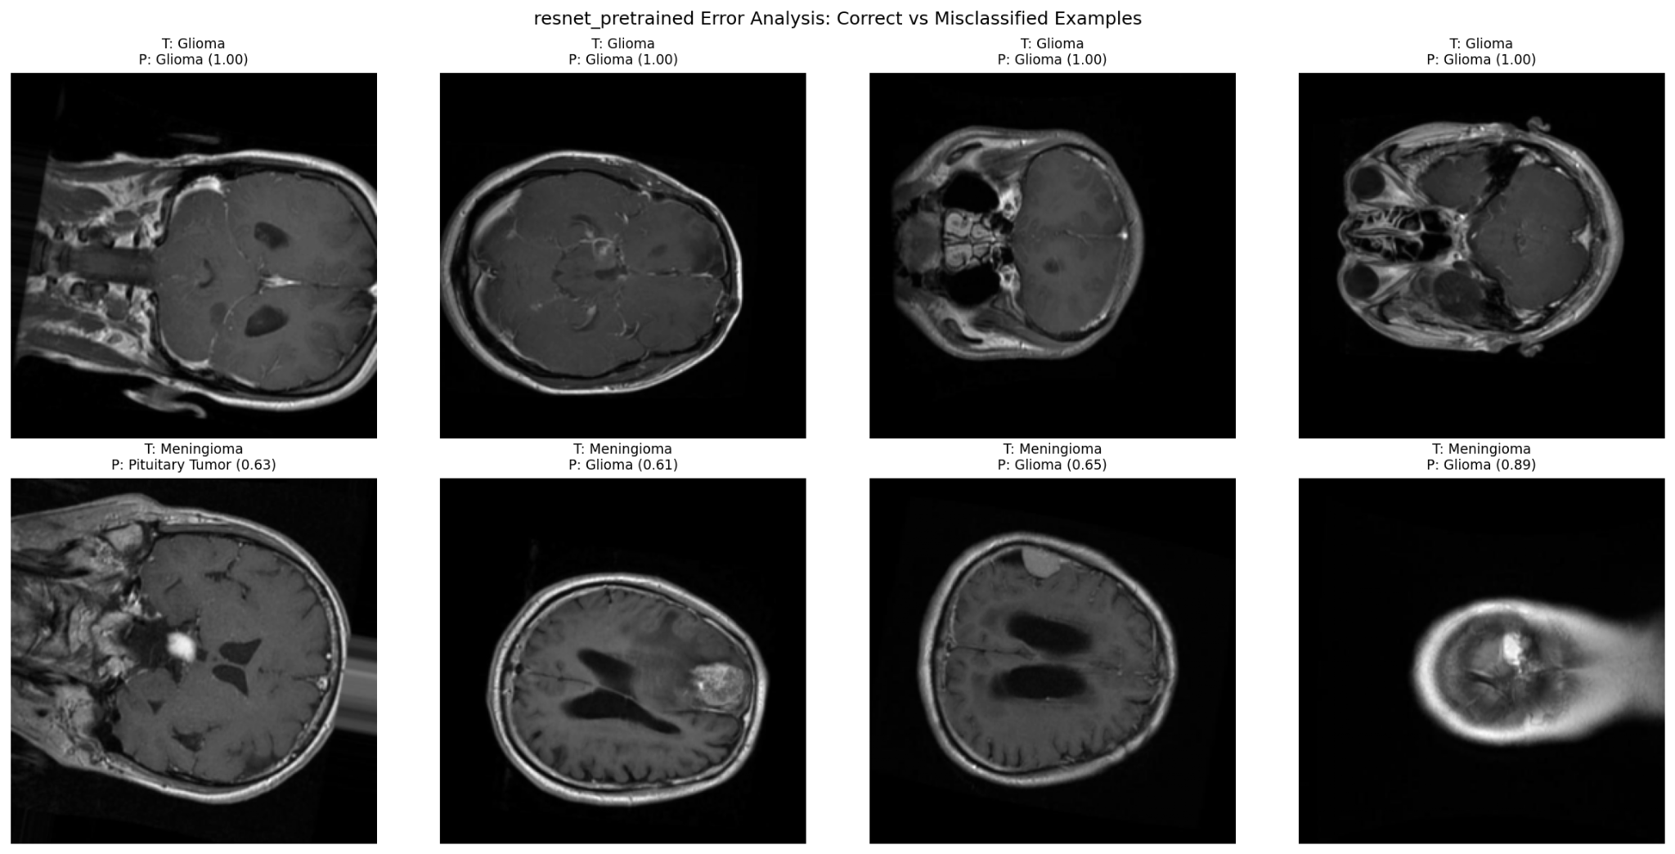
Figure 8. Correct and misclassified examples from the internal test evaluation.

Appendix C. Data review examples
The sample image grid and class distribution were used as part of the data review process. The class distribution shows a balanced training dataset. The image grid also demonstrates that images vary in orientation, tumor size, tumor appearance, and field of view. This variation is useful for model learning, but it also means that consistent preprocessing and careful validation are needed.
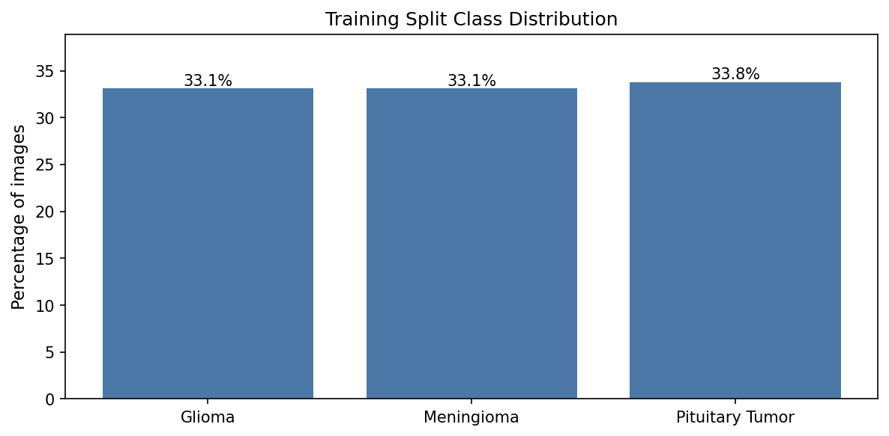
Figure 9. Training split class distribution.
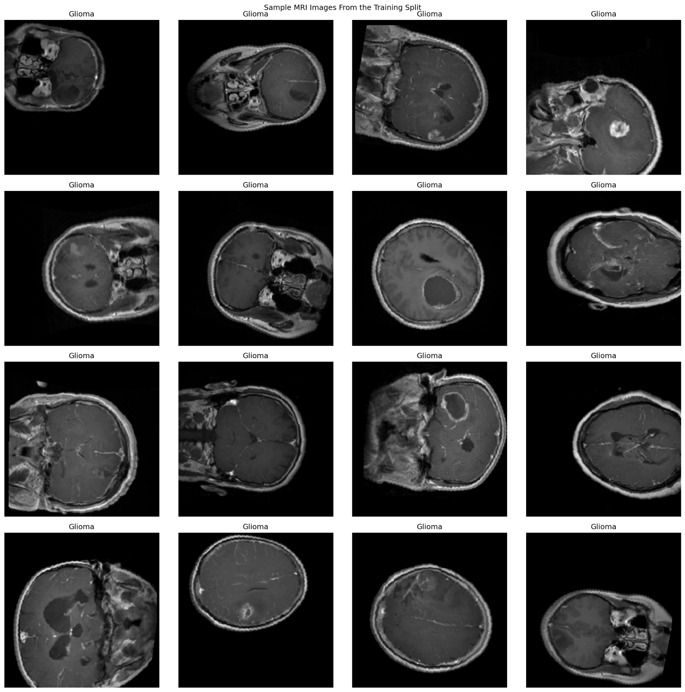
Figure 10. Sample MRI images from the training split.

Appendix D. Technical implementation notes
Area | Implementation note
Model version control | Store model weights, code commit, preprocessing settings, and class mapping together.
Class mapping | Lock the mapping between numeric output and class name to prevent reporting errors.
Preprocessing | Preprocessing must be identical between training, validation, test, and deployment.
Logging | Log image ID, model version, prediction, confidence, preprocessing status, and reviewer feedback.
Security | Use institution-approved storage and access control for patient images and prediction logs.
Future improvement | Add external validation, patient-level evaluation, 3D or multi-sequence input, and lesion mask comparison for heatmaps.

Appendix E. Source artifacts used for this guide
- Data audit report: train, validation, test counts and class names.
- Training split class distribution and sample image grid.
- Augmentation example and augmentation note.
- ResNet18 pretrained training curves.
- Confusion matrix, ROC/PR curves, calibration curve, and error analysis.
- First-layer learned filters, Grad-CAM comparison, occlusion sensitivity, and mask overlap report.

