SECOND TERM EXAMINATION
Primary
Objectives (Answer ALL Questions)
- What does computer code refer to in computer programming? (a) A secret message (b) A set of instructions (c) A computer game (d) A drawing on the screen
- What do coders do as part of their daily activities? (a) Play games (b) Write, review, and maintain codes (c) Watch movies (d) Exercise
- Why are codes important in computer programming? (a) They help with drawing pictures (b) They make the computer understand instructions (c) They create music (d) They control the weather
- How can Scratch computer codes be classified into groups? (a) By color (b) By size (c) By programming language (d) By taste
- What is an example of a text-based code in Python? (a) print("Hello, world!") (b) drawSquare() (c) playMusic() (d) moveCharacter()
- What does the code "print("Hello, world!")" tell the computer to do? (a) Play a game (b) Display the phrase "Hello, world!" on the screen (c) Turn off (d) Change the background color
- What is the term for codes that are written with numbers, alphabets, or a combination of both?
(a) Color codes (b) Sound codes (c) Text-based codes (d) Block-based codes
- How are block or visual-based codes represented? (a) As a series of numbers (b) In the form of blocks that are dragged together (c) Using only letters (d) As a secret code
- What do coders write, review, and maintain as part of their daily activities? (a) Recipes (b)Computer codes (c) Storybooks (d) Music notes
- What is the purpose of codes? (a) To confuse the computer (b) To create secret messages (c) To give the computer instructions (d) To make the screen colorful
- What is Scratch? (a) A cooking recipe (b) A visual-based programming language (c) A type of game (d) A musical instrument
- Where can you see the result of what you do in Scratch? (a) Sprites (b) Code Menu (c) Stage (d) Scripts Area
- What are characters in Scratch that we give instructions to and can animate? (a) Stage (b) Code Menu (c) Sprites (d) My Blocks
- Where is the Code Menu or Blocks Palette located in Scratch? (a) On the right side of the screen (b) In the middle of the screen (c) On the left side of the screen (d) Below the screen
- What is the entire window containing the stage, code menu, and script area commonly referred to as? (a) Scratchpad (b) Scratch interface (c) Code window (d) Scripting zone
- Which code category in Scratch is used for movement and is dark blue? (a) Looks (b) Motion (c) Sound (d) Events
- What do Looks blocks in Scratch help with? (a) Movement (b) Appearance (c) Audio (d) Decision-making
- Which code category is yellow and acts as triggers for programs in Scratch? (a) Sound (b) Events (c) Sensing (d) Control
- What color are Control blocks in Scratch, and what are they used for? (a) Dark orange, handling data (b) Yellow, triggers for programs (c) Light orange, decision-making and repetition (d) Sky blue, interacting with surroundings
- In Scratch, which category of blocks is used for mathematical operations and is green in color? (a) Operator (b) Variable (c) My Blocks (d) Events
Theory (ANSWER QUESTION 1 AND ANY 3 QUESTIONS)
- Label the various blocks based on the category they belong to
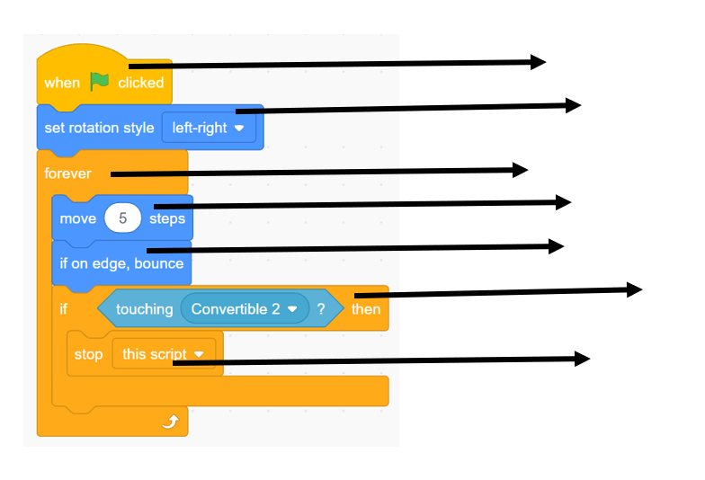
- What do Event blocks in Scratch act as?
- Which category of blocks helps us add audio to our programs in Scratch?
- Define Imagination?
- List the nine (9) code categories.
- Define the term code.

