Certainly! Here's a more detailed content for the first two slides:

**Slide 1: Introduction**

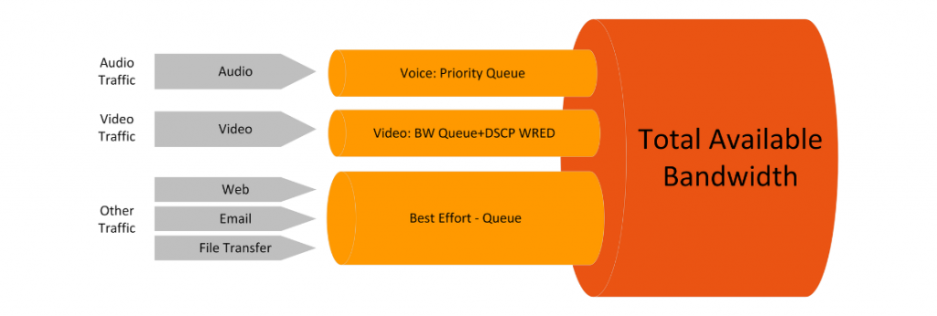

* Definition of Quality of Service (QoS)

Quality of Service (QoS) is a set of technologies and mechanisms within networking that prioritize and manage network resources to ensure the reliable and predictable delivery of services. In essence, QoS aims to guarantee a certain level of performance, such as bandwidth, latency, and packet loss, to meet the specific requirements of different applications and users.

* Importance of QoS in Networking

The importance of QoS in networking cannot be overstated, particularly in today's diverse and demanding digital landscape. As networks handle a variety of applications with varying needs, from real-time video conferencing to data-intensive file transfers, QoS ensures that critical applications receive the necessary resources to function optimally. This results in an enhanced user experience, improved network efficiency, and the ability to meet the quality expectations of different services.

**Slide 2: Overview of QoS Approaches**

* Differentiated Services (DiffServ)

DiffServ, short for Differentiated Services, is a scalable and flexible QoS approach. It involves classifying and marking packets at the network edge based on their priority or service level. This classification is achieved by assigning Differentiated Services Code Points (DSCP) to packets. Routers in the network then use these markings to make forwarding decisions, providing differentiated treatment to packets based on their assigned DSCP values. DiffServ is particularly effective in large-scale networks where explicit per-flow management may become impractical.

* Integrated Services (IntServ)

Integrated Services (IntServ) is another QoS approach that focuses on providing end-to-end guarantees for specific communication flows. It employs the Resource Reservation Protocol (RSVP) to establish and maintain dedicated resources along the entire path of a communication flow. IntServ offers different service models, such as Guaranteed Service and Controlled Load Service, allowing applications to request specific levels of performance. While IntServ ensures precise control over resource allocation, it can be challenging to scale in larger networks due to the need for per-flow reservations.

**Section 1: Integrated Services (IntServ)**

**Slide 3: Introduction to Integrated Services**

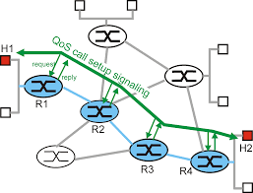

* Brief Explanation of IntServ

Integrated Services (IntServ) is a Quality of Service (QoS) approach designed to provide end-to-end guarantees for specific communication flows in a network. Unlike DiffServ, IntServ takes a per-flow approach, reserving dedicated network resources for individual communication sessions.

* Goals of IntServ

The primary goals of Integrated Services are to ensure a predictable and reliable quality of service for real-time applications. This includes minimizing delay, jitter, and packet loss, making it suitable for applications with stringent performance requirements, such as voice and video conferencing.

**Slide 4: Resource Reservation Protocol (RSVP)**

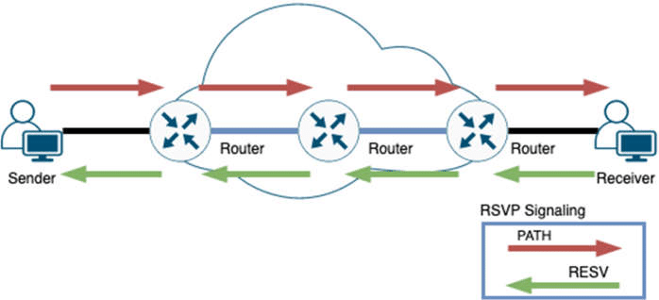

* Explanation of RSVP

The Resource Reservation Protocol (RSVP) is a signaling protocol used in IntServ to establish and maintain resource reservations across a network. RSVP allows endpoints to request specific QoS parameters for their communication sessions. It operates by sending reservation requests hop-by-hop through the network, and routers along the path allocate resources based on the received requests.

* How RSVP is Used in IntServ

RSVP is integral to the functioning of Integrated Services. When an application requires a certain level of service quality, it initiates an RSVP session setup. RSVP then signals routers along the path to reserve resources, ensuring that the requested QoS parameters, such as bandwidth and delay, are allocated for the duration of the communication session. This process enables the network to provide a guaranteed quality of service for the designated flow.

**Slide 5: IntServ Service Models**

* Guaranteed Service

Guaranteed Service is one of the IntServ service models that provides a commitment from the network to deliver a specific level of performance for a communication flow. This includes a guaranteed amount of bandwidth, low latency, and minimal packet loss. It is well-suited for applications that require a deterministic and predictable quality of service, such as real-time video or voice communication.

* Controlled Load Service

Controlled Load Service aims to emulate the performance of an unloaded network for a specific communication flow. While not guaranteeing specific performance levels like Guaranteed Service, Controlled Load Service strives to provide a consistent and controlled level of service quality, especially in scenarios where minimal delay and jitter are crucial.

* Best Effort Service

Best Effort Service is the default service model in IntServ, providing no specific guarantees for communication flows. In this model, network resources are allocated on a first-come, first-served basis. It is suitable for non-time-sensitive traffic, such as file transfers or email, where performance guarantees are not critical.

**Slide 6: IntServ Operation**

1. Steps in an IntServ Session Setup

* Admission Control: Before a communication session begins, the network performs admission control to determine whether there are sufficient resources to meet the QoS requirements of the requested service model. This step ensures that the network can fulfill the commitment made during the session setup.
* RSVP Signaling: Once admission control is successful, the initiating host sends RSVP signaling messages to routers along the path. These messages carry the QoS parameters requested for the communication session.
* Resource Reservation: Routers in the network allocate resources based on the received RSVP messages. This involves reserving bandwidth, buffer space, and other necessary resources to meet the specified QoS requirements for the communication flow.

1. Reservation Styles: Fixed Filter, Shared Explicit, Wildcard Filter

* Fixed Filter: In this reservation style, each router along the path reserves a fixed amount of resources for the communication flow. This approach is suitable for scenarios where the QoS requirements are well-known and constant.
* Shared Explicit: Resources are explicitly reserved at each router along the path, but multiple flows may share the same set of reserved resources. This style is useful for optimizing resource utilization while providing predictable performance.
* Wildcard Filter: This style allows routers to dynamically allocate resources based on the actual needs of the communication flow, adapting to changing requirements during the session. It offers flexibility in resource usage and is suitable for dynamic traffic conditions.

**Slide 6’: Packet**

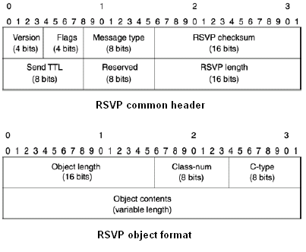

* Length (16 bits): Total length of the RSVP packet in bytes.
* RSVP Version (4 bits): Version of RSVP protocol.
* Flags (12 bits): Various flags for control information.
* Message Type (8 bits): Type of RSVP message (e.g., Path, Resv, PathErr, ResvErr).

2. IP Header (IPv4 or IPv6):

* Source and Destination IP Addresses: Identifies the source and destination of the RSVP messages.
* Protocol Field: Set to the value corresponding to RSVP (e.g., 46 for IPv6, or 17 for IPv4/UDP).

3. RSVP Common Object Header:

* Object Class: Identifies the class of RSVP object (e.g., SENDER_TSPEC, FLOWSPEC).
* C-Type: Specifies the type of information carried in the object.

4. RSVP Objects:

* Sender TSpec Object: Describes the traffic characteristics requested by the sender.
* Adspec Object: Describes the specific QoS parameters required for the flow.

**Slide 7: Advantages and Disadvantages of IntServ**

**Advantages**

1. Explicit Resource Allocation

One of the primary advantages of Integrated Services (IntServ) is its ability to provide explicit resource allocation for individual communication flows. This means that network resources are reserved and dedicated to specific flows, ensuring a consistent and predictable quality of service. Explicit resource allocation is particularly beneficial for applications with stringent performance requirements, such as real-time voice and video communication.

1. Predictable Performance

IntServ offers a high level of predictability in terms of performance. By reserving resources and guaranteeing specific quality of service parameters, such as bandwidth and delay, IntServ ensures that applications receive the required network support to meet their performance expectations. This predictability is crucial for applications that demand a deterministic and reliable network environment.

**Disadvantages**

1. Scalability Challenges

One significant drawback of IntServ is scalability challenges, especially in large and complex networks. The per-flow nature of IntServ requires the maintenance of state information at each router for every active communication session. As the number of flows increases, the scalability of IntServ becomes a concern, leading to increased signaling overhead and resource consumption.

1. Complexity in Large Networks

The implementation and management of Integrated Services introduce complexity, especially in large-scale networks. The need for routers to maintain state information for each flow and the intricacies of the Resource Reservation Protocol (RSVP) signaling contribute to the complexity. This complexity can make the network more challenging to configure, operate, and troubleshoot, particularly in extensive and dynamic environments.

**Section 2: Differentiated Services (DiffServ)**

**Slide 8: Introduction to Differentiated Services**

* *Brief Explanation of DiffServ*

Differentiated Services (DiffServ) is a Quality of Service (QoS) approach that focuses on classifying and treating network traffic based on Differentiated Services Code Points (DSCP). Unlike IntServ, which uses a per-flow model, DiffServ employs a per-hop behavior approach, making it scalable and well-suited for large networks.

* *Goals of DiffServ*

The primary goals of DiffServ are to provide scalable and flexible QoS mechanisms that can accommodate the diverse needs of applications and users within a network. DiffServ aims to simplify the implementation of QoS by classifying and marking packets at the network edge, allowing routers to make forwarding decisions based on the marked DSCP values.

**Slide 9: DiffServ Architecture**

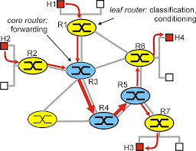

* *Differentiated Services Code Point (DSCP)*

The Differentiated Services Code Point (DSCP) is a 6-bit value in the IP header that is used to classify and mark packets based on their priority or service level. DSCP values are set at the network edge, allowing routers to differentiate between different classes of traffic. This enables routers to apply specific forwarding treatments based on the marked DSCP values.

* *Per-Hop Behavior (PHB)*

Per-Hop Behavior (PHB) defines the specific treatment that packets with a particular DSCP value receive at each hop in the network. DiffServ defines standard PHBs, such as Default Forwarding (DF), Expedited Forwarding (EF), and Assured Forwarding (AF), each with its own set of characteristics. PHBs provide a way to ensure consistent and predictable treatment of packets across the network.

**Slide 10: DiffServ Domain**

**Edge Routers and Core Routers**

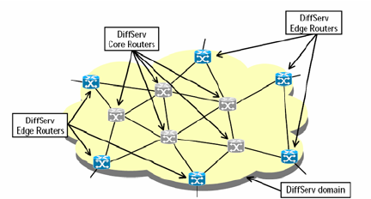

* Edge Routers

These are located at the network edge and are responsible for classifying and marking incoming packets based on their Differentiated Services Code Point (DSCP). Edge routers play a crucial role in the DiffServ architecture by determining the appropriate DSCP values for packets entering the network.

* Core Routers

Positioned within the core of the network, core routers make forwarding decisions based on the DSCP values marked by the edge routers. They do not perform additional classification but rely on the marked DSCP values to provide differentiated treatment for different classes of traffic.

* Classification and Marking at the Network Edge

At the network edge, classification and marking occur to identify and differentiate packets based on their specific service requirements. This process involves examining packet headers and assigning the appropriate DSCP values to packets. By marking packets at the network edge, DiffServ enables routers throughout the network to apply consistent treatment based on the marked DSCP values.

**Slide 11: DiffServ Per-Hop Behaviors**

* Default Forwarding (DF)

Default Forwarding is a Per-Hop Behavior (PHB) in DiffServ that applies a standard treatment to packets with the default DSCP value. Packets with the default DSCP value receive best-effort service, and their treatment is determined by the router's default forwarding behavior. This PHB is suitable for traffic that does not have specific QoS requirements.

* Expedited Forwarding (EF)

Expedited Forwarding is a PHB in DiffServ designed for low-latency and low-loss forwarding. Packets marked with the EF DSCP value are given expedited treatment, making it ideal for real-time applications such as voice and video. EF ensures minimal delay and jitter, providing a high-quality service for time-sensitive traffic.

* Assured Forwarding (AF)

Assured Forwarding is a PHB that provides different levels of priority and drop precedence for packets. AF divides traffic into classes, and each class is assigned a specific DSCP value. Within each class, packets are further categorized based on their drop precedence. AF ensures that higher-priority packets are less likely to be dropped during network congestion, offering a degree of assurance for certain service levels.

**Slide 12’: packet format**

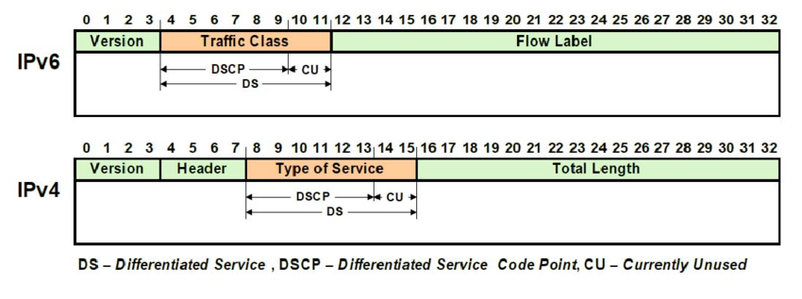

**IP Header:**

* Source and Destination IP Addresses: Identify the source and destination of the packet.
* Protocol Field: Specifies the upper-layer protocol.

**Differentiated Services Field (DS Field):**

* DSCP: Identifies the Differentiated Services Code Point, indicating the desired Per-Hop Behavior (PHB) for the packet.
* ECN: Explicit Congestion Notification flags, used for congestion control.

**Slide 13: Advantages and Disadvantages of DiffServ**

**Advantages**

* *Scalability*

One of the primary advantages of DiffServ is its scalability. DiffServ employs a simplified model where routers make forwarding decisions based on the marked Differentiated Services Code Point (DSCP) values. This approach allows DiffServ to easily scale to large and complex networks without the need for maintaining per-flow state information, making it more efficient and suitable for extensive deployments.

* *Simplified Implementation*

DiffServ offers a simpler and more straightforward implementation compared to Integrated Services (IntServ). By classifying and marking packets at the network edge and making per-hop forwarding decisions based on DSCP values, DiffServ simplifies the overall QoS architecture. This simplicity makes DiffServ easier to configure, manage, and maintain, particularly in large and dynamic network environments.

**Disadvantages**

* *Lack of Per-Flow Guarantees*

One limitation of DiffServ is the lack of per-flow guarantees. Unlike Integrated Services (IntServ), which can provide explicit resource reservations for individual communication flows, DiffServ operates on a per-hop behavior model, leading to a lack of end-to-end guarantees for specific flows. This may be a consideration for applications with strict performance requirements.

* *Limited Granularity in Service Levels*

DiffServ provides a coarse level of granularity in terms of service levels. While it offers different Per-Hop Behaviors (PHBs) for various classes of traffic, the number of available DSCP values is limited. This limitation may be a constraint for applications that require fine-grained *control* over QoS parameters, such as precise bandwidth or latency guarantees for specific flows

***Slide 14: Comparing IntServ and DiffServ***

***Scalability***

* *Integrated Services (IntServ): IntServ faces scalability challenges, especially in large networks, due to the need for maintaining state information for each communication flow. As the number of flows increases, the signaling overhead and resource consumption become significant.*
* *Differentiated Services (DiffServ): DiffServ excels in scalability, employing a simpler model where routers make forwarding decisions based on marked Differentiated Services Code Point (DSCP) values. This approach allows DiffServ to scale efficiently to large and complex networks without the burden of per-flow state maintenance.*

***Complexity***

* *Integrated Services (IntServ): IntServ introduces complexity in network management, configuration, and troubleshooting. The Resource Reservation Protocol (RSVP) signaling and the need for routers to maintain state information for each flow contribute to the overall complexity, making it challenging to deploy in large networks.*
* *Differentiated Services (DiffServ): DiffServ offers a simpler and more straightforward implementation. The classification and marking of packets at the network edge, along with per-hop forwarding decisions based on DSCP values, result in a more manageable and less complex QoS architecture.*

***Granularity of Control***

* *Integrated Services (IntServ): IntServ provides a high level of granularity in control, allowing explicit resource allocation for individual communication flows. This makes it suitable for applications that require precise performance guarantees and where per-flow QoS control is essential.*
* *Differentiated Services (DiffServ): DiffServ provides a coarser level of granularity in control compared to IntServ. While it offers different Per-Hop Behaviors (PHBs) for various classes of traffic, the number of available DSCP values is limited, which may be a consideration for applications requiring fine-grained control over QoS parameters.*

***Slide 15: Conclusion***

***Summary of Key Points***

*In summary, both Integrated Services (IntServ) and Differentiated Services (DiffServ) are QoS approaches with distinct characteristics.*

*IntServ focuses on per-flow guarantees and explicit resource reservations, making it suitable for applications with stringent performance requirements.*

*On the other hand, DiffServ excels in scalability and simplicity, providing a more manageable solution for large networks.*

***Considerations for Choosing Between IntServ and DiffServ***

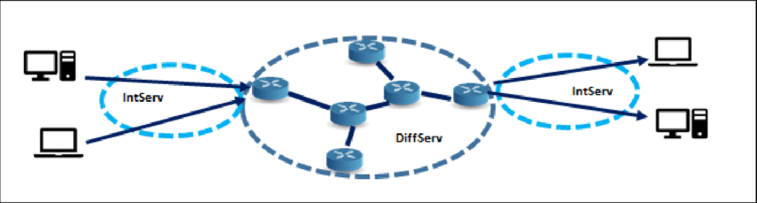

*When deciding between IntServ and DiffServ, consider the specific needs of your network and applications:*

* *Scale: For large networks with scalability requirements, DiffServ is often a preferred choice.*
* *Complexity: If simplicity and ease of implementation are critical, DiffServ may be more suitable.*
* *Granularity: If fine-grained control over individual flows is essential, IntServ may be the better option.*

*Ultimately, the choice between IntServ and DiffServ depends on the unique characteristics and demands of the network in question.*