Zoom Licensed User per Admin — How It Works

Setup (once, when an Admin is created)
- Super Admin creates a new Admin.
- System asks Zoom to create a new licensed user (uses 1 of the 250 seats) for that admin.
- Zoom returns a Zoom User ID.
- System saves that Zoom User ID on the Admin's record — permanent 1:1 link.

Every time a meeting is started
- Admin clicks "Start Meeting."
- System looks up the Zoom User ID saved for that admin.
- System asks Zoom to create a meeting hosted by that specific user.
- Admin gets a private, standalone meeting — separate from every other admin's.
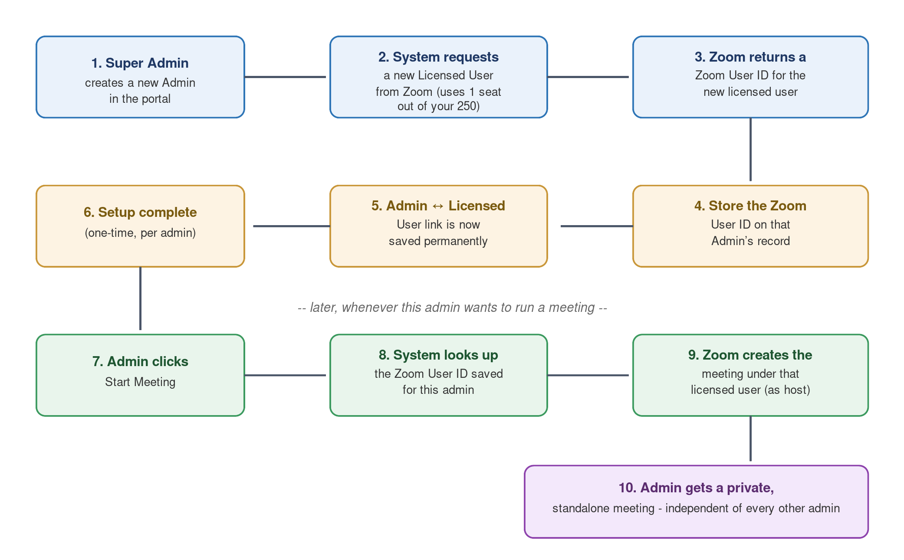

API call: create the licensed user
POST https://api.zoom.us/v2/users
Payload:
{
"action": "create",
"user_info": {
"email": "admin@company.com",
"type": 2,
"first_name": "Jane",
"last_name": "Doe"
}
}
Response (201):
{
"id": "zOu-hZs4Q9K3abEXAMPLE", // save this as zoomHostUserId
"email": "admin@company.com",
"type": 2
}
type: 2 = Licensed (consumes a seat). type: 1 = Basic (free, not usable as host).

"action" options for creating a user
action value | meaning
create | Zoom emails the user to activate + set a password. Simple, but needs manual step per admin.
autoCreate | Instant, no email. Only works if this privilege is enabled on the Zoom account (check with account owner).
custCreate | For ISV/API-partner Zoom accounts only. Not applicable to a normal Business account.
ssoCreate | Instant creation via company SSO. Only works if SSO is configured on the Zoom account.

API call: start a meeting for that user
POST https://api.zoom.us/v2/users/{zoomHostUserId}/meetings
Payload:
{
"topic": "Jane Doe Session",
"type": 1
}
Response (201):
{
"id": 87654321012, // meeting number
"password": "aB12cd",
"join_url": "https://zoom.us/j/87654321012"
}

