MOA - CDM

| **Owner** | **Task** | **Due** | **Status** |
| --- | --- | --- | --- |
| Ji Ae | Pass CITI training and send a certificate to Jihoon | 10/7 | Done |
| Ji Ae | Enroll US smart phone number for two-factor authentication and install DUO app  <https://blink.ucsd.edu/technology/security/services/two-step-login/health.html> | 10/9 | Done |
| Ji Ae | Access AWS workspace  (Kai Post, IT lead & Kevin Delaney, DBA) | 10/21 | Waiting for AWS workspace Registration Code from Jamie Poudel |
| Ji Ae | Install Jupyter Notebook | 10/21 |  |
| Ji Ae | Obtain database access  (Paresh Desai, ACTRI) | 10/21 |  |
| Ji Ae | Install R and Python packages  (with Paresh Desai Zoom) | 10/21 |  |
| Soonchul | Revise the Python code for OMOP CDM compliant UCSD-OMOP | Tue 10/18 | Done |
| Ji Ae | Deliver the UCSD results | Thursday 10/20 |  |

**Installation on the Windows Machine**

pgAdmin (<https://www.pgadmin.org/>)

Miniconda (or Anaconda) for Python 3.7 (<https://docs.conda.io/en/latest/miniconda.html>)

Type these in the conda console windows

| conda create -n moa python  conda install -c anaconda jupyter  jupyter notebook |
| --- |

> git clone<https://github.com/DigitalHealthcareLab/22MOACDM.git>

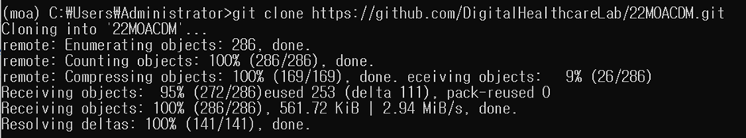

> cd 22MOACDM

> python.exe -m pip install --upgrade pip

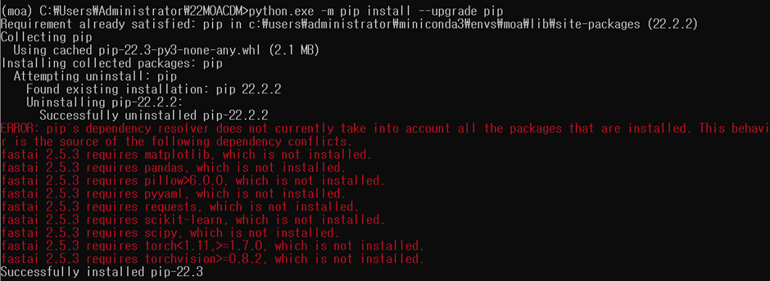

> pip install -r requirements_cpu.txt

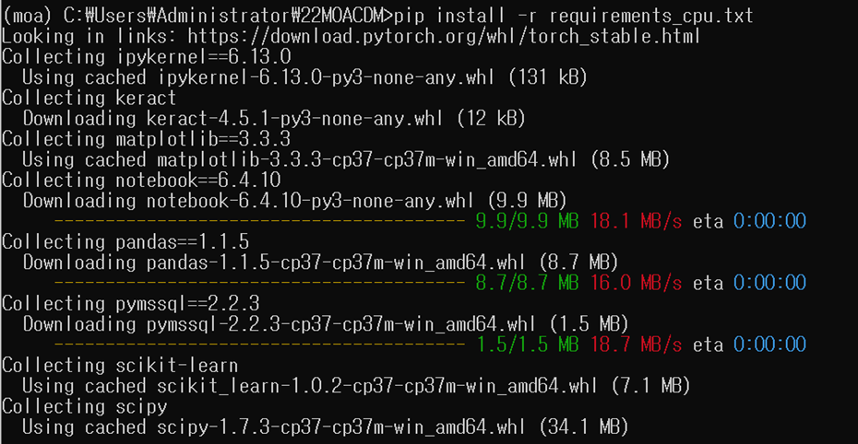

(어느정도 dependency로 에러생기더라도 실행에는 무관했음)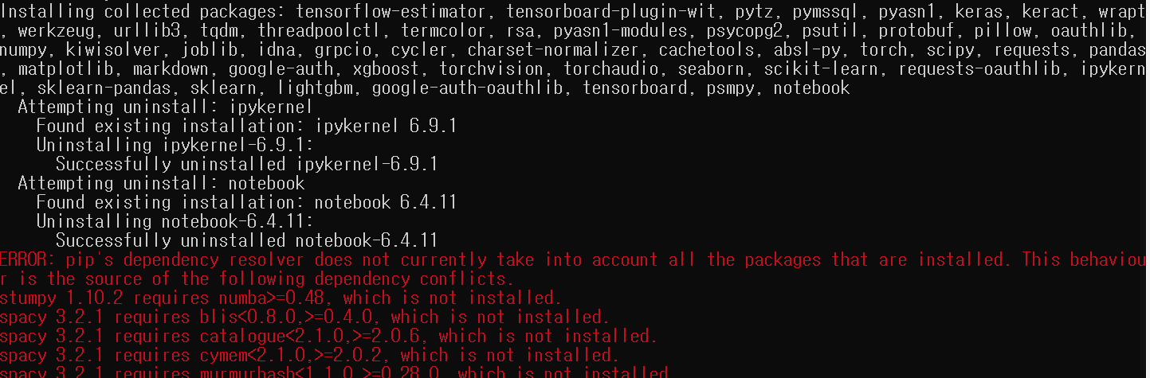

> jupyter notebook

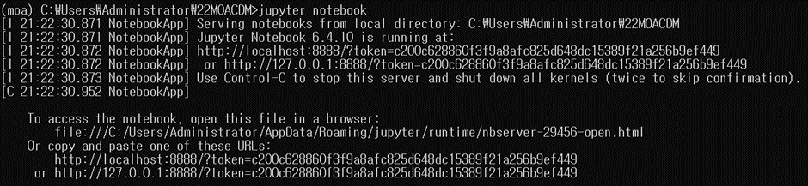

Config.json파일 클릭

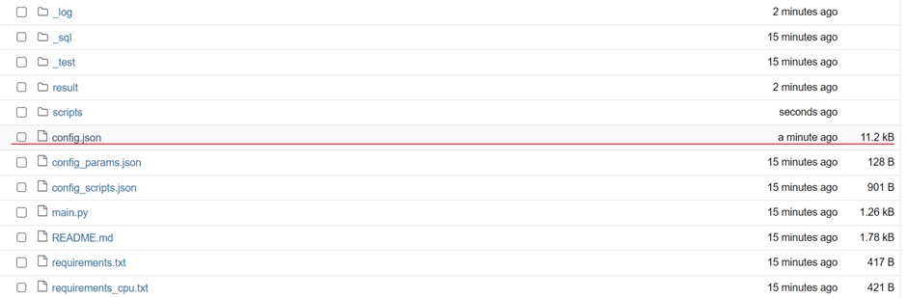

* Working date : 실행날짜
* Dbms : postgresql or mssql
* @server, user, password, port ..
* Control + Shift + F : 모두 찾기 바꾸기
  + cdm이 저장된 schema : cdm.dbo > ucsd cdm schema
  + 임시 table을 만들 schema : temp_moa.dbo > public (writable schema, public(?))

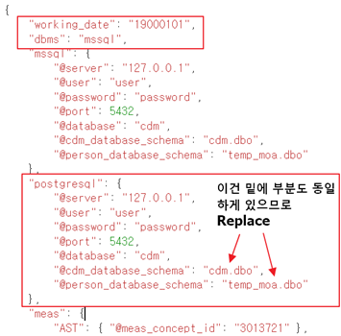

Ipynb만 쭉 실행 (1>2>3>4>7>8 순)

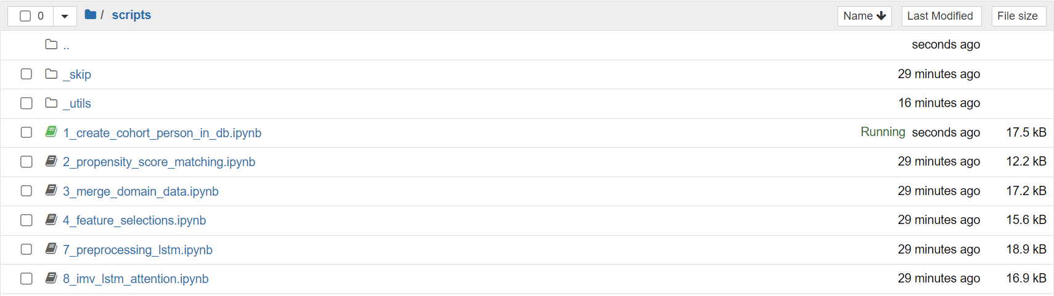

[HowToRun.pptm - Google Slides](https://docs.google.com/presentation/d/1zMGoc-7WUzhnrzYDvLSWTEfklDIii6GvcmIjUQmxLwQ/edit#slide=id.p6) (참고)

—----------------------------------------------------

R Studio, R 설치

Package 설치

install.packages(“remotes”)

remotes::install_github(“OHDSI/FeatureExtraction”)

remotes::install_github(“OHDSI/PatientLevelPrediction”)

remotes::install_github(“OHDSI/CohortGenerator”)

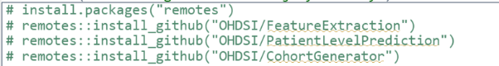

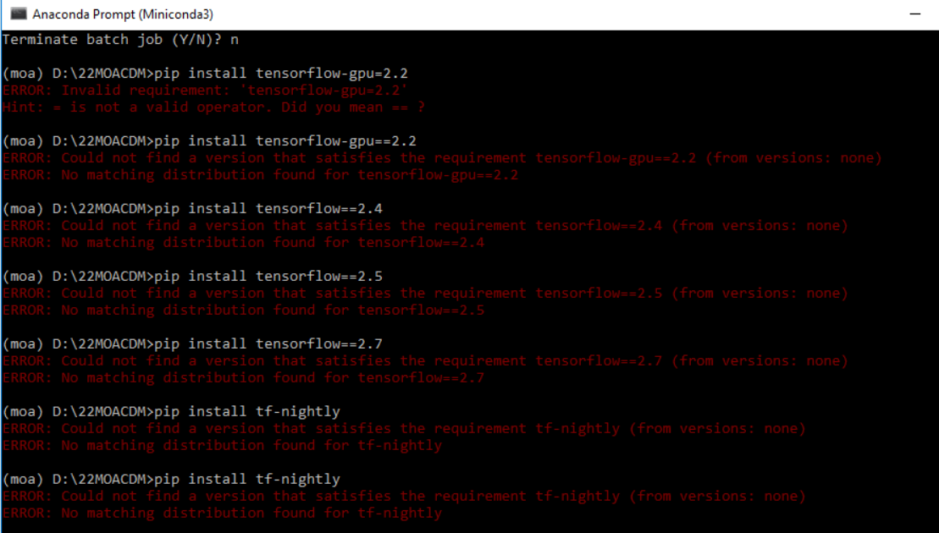

[https://github.com/NeighborHeo/MOA-CDM_AI](https://urldefense.com/v3/__https:/github.com/NeighborHeo/MOA-CDM_AI__;!!LLK065n_VXAQ!zOJMUQWIbw0G9_KTFjlHCw0oCUYJED3EQ6Afo2y34nZ8ol3U9z_HocrKh_ihlTGV$)