Introduction to Vim

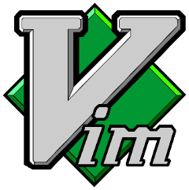

Neil Opena

February 28, 2019

**Introduction**

**What is Vim?**

Vim is a very powerful and customizable text-editor that already comes pre-installed in many of today’s computers. For many UNIX/Linux users, Vim can be accessed simply by using the terminal.

**Why should you learn Vim?**

Vim is incredibly useful especially for editing programs while using the terminal. Learning Vim can tremendously speed up your productivity when editing text files. Vim is commonly used by programmers since minute textual modifications are all that is needed for fixing programming bug. Additionally, Vim is available as a plug-in in many development environments such as NetBeans, IntelliJ and VSCode. Learning the commands will make text editing swift and ergonomic, allowing users to navigate and edit the whole document without taking their fingers off the keyboard. This user instruction is intended for students or adults that have basic knowledge of the command line / terminal.

**Installing Vim:**

* Windows users can download Vim here:
  + <https://www.vim.org/download.php>
* Linux/Unix users do not need to download Vim. It comes pre-installed in the operating system.

**Sections:**

This user instruction will guarantee readers that they will become familiar and comfortable enough to use Vim to edit any text file after completion. The following user instruction is divided into 3 sections, with each section discussing a necessary topic central to the Vim text editor.

1. Entering / Exiting Vim
2. Navigation
3. Editing

**Section 1 – Entering / Exiting Vim**

**Entering Vim**

1. Open up the Terminal (Unix/Linux) or the Command Prompt (Windows) application.
2. Type in the command prompt the following command while specifying the name of the file that you want to edit
3. Press *Enter*

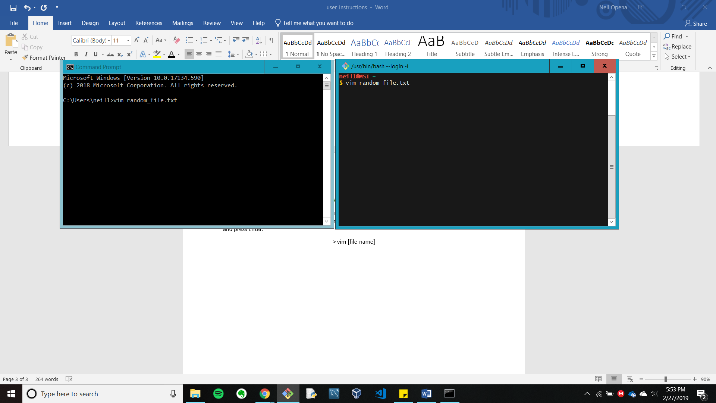 **vim [file-name]**

*Fig. 1 – Entering Vim using the Terminal (left) and Command Prompt (right)*

Before we learn the fundamental commands for navigating and editing any file, we must first learn how to exit Vim. Despite its simplicity, this step is very crucial due to Vim’s infamous method of quitting the program.

**Exiting Vim**

1. To quit without saving any changes to the file, type the following command and press *Enter*:

**:q!**

1. To quit as well as save the changes to the file, type the following command and press *Enter*:

**:wq**

**Note:** An easy way to remember the commands is by remembering them as mnemonics for quit and write-quit

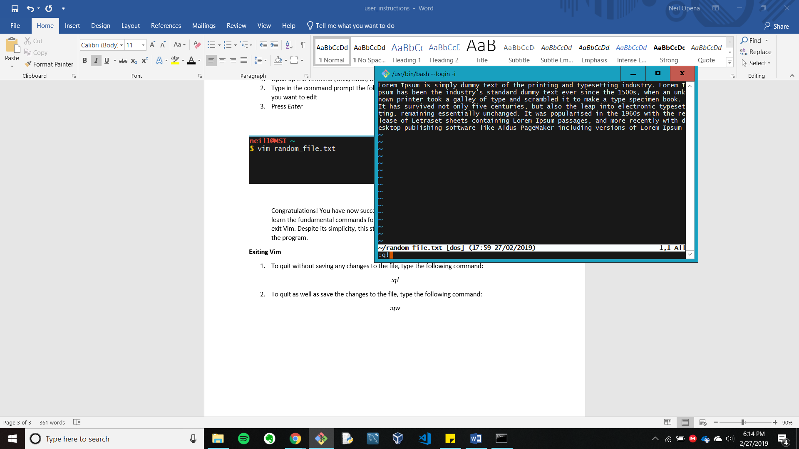.

*Fig. 2 – The quit command shown prior to its execution*

**Section 2 –Navigation**

Upon launching the Vim editor, you will be presented with a text representation of the specified file. The cursor can be located at the beginning of the file, located at the top left corner of the application. In Vim, the cursor can only be moved using the keyboard.

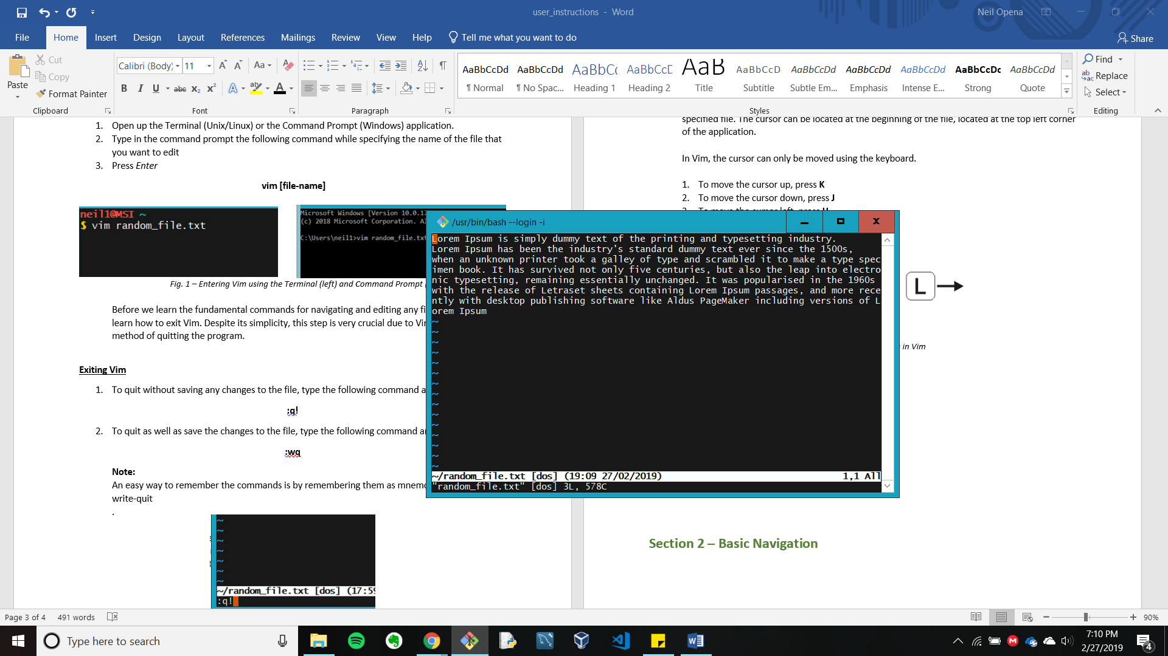

*Fig. 3 – Cursor located at the top-left corner, shown as a block*

**Basic Navigation**

1. To move the cursor up, press **k**
2. To move the cursor down, press **J**
3. To move the cursor left, press **h**
4. To move the cursor right, press **l**

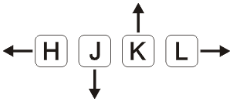

*Fig. 4 – Navigation controls diagram*

**Section 3 – Basic Editing**

Editing is very simple once you are comfortable with moving the cursor around.

**Basic Editing**

1. To insert where the cursor is located, press **i**
2. To insert at the end of the line of where the cursor is located, press **Shift-A**
3. To insert at the beginning of the line where the cursor is located, press **Shift-I**
4. To delete a character that the cursor is pointing to, press **x**

**Note:** In order to leave editing mode and to return to using the keys for navigation, press the escape button (**ESC**)

Congratulations! By now you should be comfortable with editing any file that you want with the Vim text editor. At first, it will be extremely difficult to remember the commands, but once muscle memory kicks in, it will be difficult to go back. Vim is a very rich text-editor filled with many commands. For those that want to learn more and to become more proficient with the editor, additional resources are shown below.

**Additional Resources**

1. Vim comes pre-installed with a basic tutorial to help newcomers learn the fundamentals
   1. Open up the Terminal (Unix/Linux) or the Command Prompt (Windows) application.
   2. Type in: **vimtutor**
   3. Press *Enter*
2. Learn Vim by playing a video game on your Internet Browser
   1. <https://vim-adventures.com/>