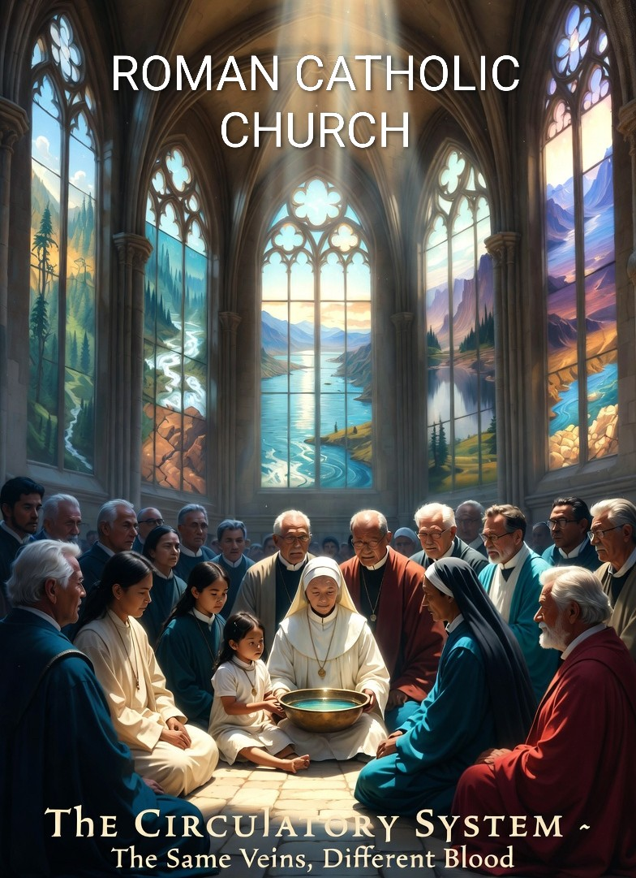
THE ROMAN CATHOLIC CHURCH

PARTNER SYNOPSIS
Global Stewardship Reconciliation Trust

THE CIRCULATORY SYSTEM · THE ATONEMENT ARCHITECTURE

The Church’s role in one sentence:
Provide infrastructure in servant posture. First Nations lead. Government buys outcomes.
The Church serves — with its schools, its hospitals, its 2,000 years of continuity,
and its commitment to structural atonement that is living, not symbolic.
The same veins. Different blood.

THE INVITATION
This is not a proposal. It is a remembering.

A note on lineage:

Frederick Joseph Hodge — the Framework Architect’s grandfather — was a Catholic educator whose work helped preserve Ontario’s separate school system. He travelled to the Vatican on behalf of that mission. This framework is an attempt to honour that legacy: the same principle of institutional partnership through integrity, not transaction, carried forward one generation.

The Catholic Church has been the circulatory system of the world’s most complex communities for two thousand years. Schools. Hospitals. Mission networks. Parishes embedded in communities that no government program can reach and no corporation would enter. The infrastructure already exists. The arteries are already there.

For a period of that history, those arteries carried poison. Residential schools. Forced assimilation. The systematic severing of Indigenous children from land, language, and lineage. The Church has acknowledged this. Pope Francis laid the foundation — writing Laudato Si’ in 2015 and delivering the formal apology for residential schools in 2022. Pope Leo, the current Holy Father, now carries that reconciliation pledge forward. This framework is addressed to him directly, and to the institution he leads. The question that remains is not whether to atone — it is how.

The most powerful act of institutional atonement
is not symbolic. It is structural.

The same veins that once carried poison,
rebuilt to carry healing to the same communities.
That is not rehabilitation. That is resurrection.

The Global Stewardship Reconciliation Trust offers the Catholic Church the structural opportunity to make TRC Calls to Action 48 and 49 real — not as a statement, not as a donation, but as an ongoing, living, operational commitment that serves communities for generations.

THE THEOLOGICAL FOUNDATION
Laudato Si’
Laudato Si’ called for integral ecology. This is it, operationalized. Paid, dignified environmental stewardship delivered through and for the communities most harmed by ecological degradation. Not a statement. A structure.

TRC Calls to Action 48 and 49
CALL TO ACTION | GSRT STRUCTURAL RESPONSE
Call 48: Acknowledge the role of church policies in contributing to the destruction of Indigenous spiritual practices. | The GSRT formalizes the Church’s servant posture with First Nations as design authority. Indigenous sovereignty over all land protocols is absolute and structurally embedded, not symbolic.
Call 49: Repudiate the Doctrine of Discovery and any concepts used to justify European sovereignty over Indigenous lands and peoples. | The framework places First Nations in the position of sovereign authority over the land they steward. The Church provides infrastructure in a servant posture. The hierarchy is explicit and permanent.

The Saint Christopher Handshake
Saint Christopher — patron of travelers, protector of the vulnerable in transit — is the framework’s spiritual protection protocol. The Quantum Data Sovereignty architecture is named the Saint Christopher Handshake: the moment participant data is entrusted to the system, it passes under the same protection the saint provides to those crossing dangerous waters.

This is not decoration. It is the framework’s acknowledgment that data sovereignty — the protection of vulnerable people’s information from extractive interests — is a sacred responsibility, not a technical one.

THE CHURCH’S ROLE
Infrastructure in Servant Posture
The Church does not lead this system. The Church serves it. This distinction is not semantics — it is the structural expression of atonement. The First Nations hold design authority, veto power, and sovereign leadership of all land-based programming. The Church brings what it has in abundance: reach, facilities, and institutional continuity.

WHAT THE CHURCH BRINGS | HOW IT SERVES THE MISSION
1,200+ schools in Kenya alone | Immediate deployment sites for CEP school integration and restoration economy education. The curriculum infrastructure already exists.
200,000+ institutions globally | Unmatched distribution network for the 12-month Steward Resilience Program and HALO deployment.
Parish networks in remote communities | Reach into communities that no government program can access. The Church is already there. The relationship already exists.
2,000 years of institutional memory | The longest-running organizational continuity on Earth. The GSRT requires multi-generational commitment. The Church is the only institution structurally capable of it.
The Hodge Legacy Connection | Frederick Joseph Hodge — the Framework Architect’s grandfather — travelled to the Vatican and secured the institutional grace that preserved Ontario’s separate Catholic school system. The same principle of institutional partnership through integrity, not transaction, underlies this proposal.

WHAT THE CHURCH RECEIVES
GIFT | DESCRIPTION
Structural Atonement | Not symbolic. Not financial. The operational embodiment of reconciliation — the Church’s infrastructure actively rebuilding what its policies once destroyed, in the same communities, with the same families.
Renewed Moral Authority | At a moment of institutional trust crisis, the Church demonstrates — visibly, measurably, over time — that its values and its actions are aligned. This cannot be purchased. It can only be earned.
Laudato Si’ Made Real | The Church’s environmental theology becomes operational, not rhetorical. Parishes, schools, and communities become active nodes in a global restoration economy.
TRC Compliance | Calls to Action 48 and 49 are fulfilled structurally, not performatively. The Church can report not what it has said, but what it has built.
A Role Worth Holding | The circulatory system is not a lesser role than the muscle. Without flow, muscle dies. The Church’s contribution is biologically essential — and the framework says so explicitly, permanently, and publicly.

THE ATONEMENT ARCHITECTURE
The Marie Hodge Intercept — Mercy

Named for the principle of protective care, the Marie Hodge Intercept monitors the system for patterns that could cause harm to the communities the Church is committed to serving. For the Church, this is Institutional Mercy — not compliance. Not liability management. Mercy.

The same spirit that moved the Prodigal Son’s father to run toward his returning child before the apology was finished. The intercept catches institutional harm before it lands. It does not wait for a complaint. It does not require a victim. It monitors for the pattern and stops it automatically. It is the Church’s promise, built into the architecture, that the arteries that once carried poison will never carry it again.

This is not the Church being watched. This is the Church choosing to be protected by something wiser than any individual within it.

The Prodigal Son Protocol

The framework’s re-entry protocol is named for the parable because the parable is the framework. Nobody is written off. Nobody is lost. The door is always open. The same warmth on return as on the first day.

This applies to participants. It also applies to institutions. The Church’s history with Indigenous communities is not disqualifying. It is the very reason the Church’s servant posture in this system carries such weight. The same institution. The same reach. The intention transformed.

The wound becomes the medicine.

Why All Three Are Essential
Remove any one cog and the system still has parts — but it stops generating value. The power is in the turning together.

FIRST NATIONS  The Muscle  Land knowledge. Sovereignty. TEK. The physical restoration no machine can replicate. Without muscle, there is nothing to move. | CATHOLIC CHURCH  The Circulatory System  2,000 years of infrastructure. Schools, hospitals, communities. Moving resources to where they are needed. Without flow, muscle dies. | GOVERNMENT  The Anchor Customer  Verified outcomes purchased at scale. Clean water. Restored land. Without demand, the system has nowhere to send its output.

You cannot have a circulatory system without muscle — there is nothing to move.
You cannot have muscle without a circulatory system — it dies without flow.
Neither sustains without a customer who values the output.

The partnership is not a compromise. It is a biological necessity.

“A circulatory system that was once used to carry poison —
rebuilt to carry healing to the same communities
is one of the most powerful acts of institutional atonement conceivable.

The same veins.
Different blood.

Global Stewardship Reconciliation Trust · Framework Architect: Neil J. Schwab
neil.schwab@live.ca · +1 (905) 868-6985 · Newmarket, Ontario · Roman Catholic Church · The Circulatory System

