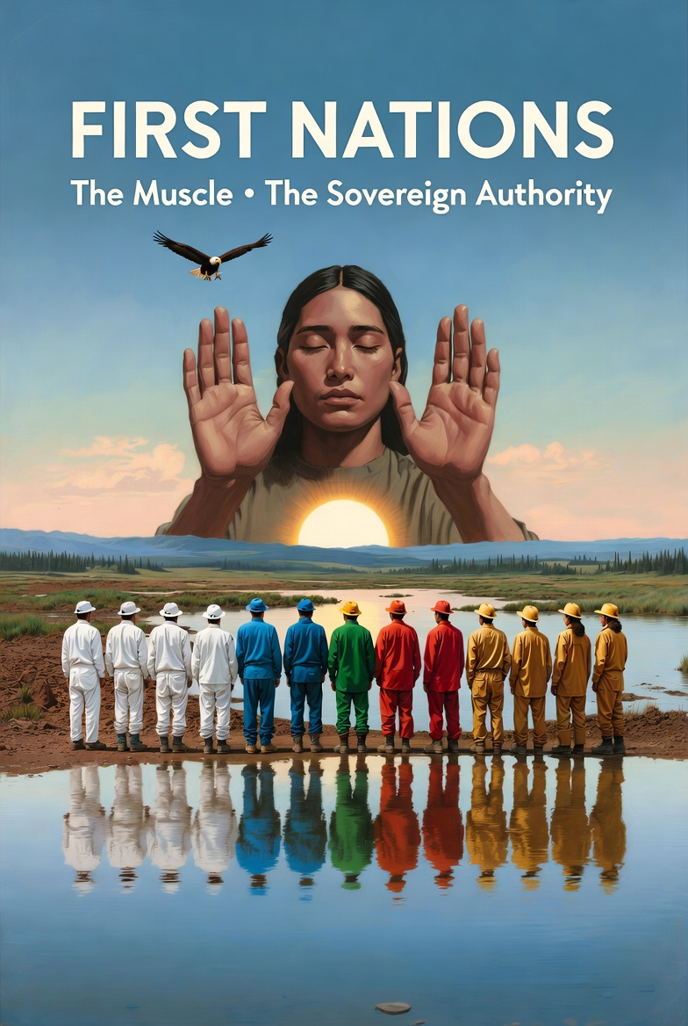
FIRST NATIONS OF CANADA

PARTNER SYNOPSIS
Global Stewardship Reconciliation Trust

THE MUSCLE · THE SOVEREIGN AUTHORITY · THE DESIGN LEAD
Nibi & Aki — Water & Land — Sovereign Restoration Economy

THE RECOGNITION
This is not an invitation to participate in someone else’s system.

This is a recognition that the system was already yours. The land knowledge, the ecological relationship, the understanding of water, soil, and living systems that took generations to accumulate — these are not inputs to a framework designed by someone else. They are the framework.

Everything built here — the colour progression, the restoration economy, the neurochemical healing arc, the waterfall architecture — is built around the principle that the people who hold the relationship with the land hold the authority over the land. Full stop.

First Nations hold the sovereign right
for stewardship of the Earth.

This is not a principle stated in the preamble.
It is the load-bearing architecture of everything that follows.

The GSRT is the economic expression of UNDRIP — the United Nations Declaration on the Rights of Indigenous Peoples — made operational through paid work, verified income, and community-controlled infrastructure.

YOUR POSITION IN THE SYSTEM
Design Authority
First Nations are the lead applicant and design authority for all GSRT programming. This means:

- Cultural protocols are set by First Nations leadership, not approved by them
- Traditional Ecological Knowledge (TEK) is integrated as primary intelligence, not supplementary input
- Veto authority over all land-use decisions is absolute and structurally embedded
- IP protection for TEK is hardcoded into the HALO data architecture — extractive interests cannot access it

The Muscle
The Muscle is not a metaphor for physical labour. It is a metaphor for biological necessity. Without muscle, the body has no capacity for action. Without First Nations leadership, this system has no legitimate relationship with the land and no capacity for real restoration.

The muscle does not serve the circulatory system. The circulatory system serves the muscle. The muscle does not answer to the anchor customer. The anchor customer buys what the muscle produces. The hierarchy is clear.

THE ECONOMIC ARCHITECTURE
The Colour Progression — Your Certification, Your Credentials
The HALO sees your Hue before you do.

The AI-HALO automatically identifies each participant’s natural gift profile — their Hue — based on skills, interests, physical capacity, and community role. A person with a Green soul for plants and living systems gets routed to terrestrial restoration. A person with a Black soul for precision and courage under pressure gets routed toward hazmat certification. Nobody is placed in the wrong water.

Your gift was always there. The system just finally has the intelligence to see it.

The colour system is built on WHMIS standards — internationally portable credentials that belong to the individual who earns them. No employer, government, or institution can revoke a certification that belongs to you.

LEVEL | WORK · INNER PARALLEL · PAY
WHITE | Materials sorting, basic stewardship. Entry point. Immediate access.  Pay: $25–50/hr
BLUE | Waterway restoration. Nibi. The act of flow — entering depth without drowning.
GREEN | Terrestrial restoration, reforestation. Aki. The act of patience — rebuilding what was degraded.
BLACK | Hazardous materials. Full WHMIS. Shadow integration. The act of courage.
GOLD | Ecosystem leadership, franchise development.  Pay: $600–1,000+/hr

The Waterfall — Your Community Keeps 80%
PILLAR | % · WHERE IT GOES
Your Income | 40% Direct to you. Always first. Non-negotiable.
Community & Elders | 20% Your community. Your Elders. Your infrastructure.
Operations | 20% System maintenance.
Innovation | 10% Your community’s future.
Reserve | 10% Emergency protection.

60% of every dollar generated flows directly to you and your community.

This is not a target. It is a mathematical constraint. The system cannot distribute itself differently and still function. Your community’s prosperity is not a goal of the architecture. It is the architecture.

THE ELDER LAYER — YOUR WISDOM IS THE FIRMWARE
This framework contains something most economic systems omit entirely: the explicit recognition that Elder knowledge is load-bearing infrastructure, not ceremonial decoration.

ELDER ROLE | HOW THE SYSTEM HONORS IT
Traditional Ecological Knowledge | TEK is protected by the HALO’s Quantum Data Sovereignty architecture. It cannot be extracted, commercialized, or accessed by parties outside your community without explicit consent.
Elder Teachers | Paid directly from the Community & Elders (20%) waterfall stream. Not as consultants. As foundational contributors whose knowledge is essential to the system’s validity.
Intergenerational Transmission | The school integration component (CEP) is built to carry Elder knowledge into classrooms at every age level — not as history, as living curriculum.
The Ancestor Layer | The framework’s firmware layer is named for the recognition that every participant arrives equipped with the wisdom of every ancestor who survived long enough to pass it forward. This is not metaphor. It is the system’s deepest design principle.

YOUR PROTECTIONS
Veto Authority
First Nations hold veto authority over all land protocol decisions. This is not subject to negotiation, government override, or Church approval. It is structural.

IP Protection via the HALO — Vacuum Sealed
Traditional Ecological Knowledge entered into the system is protected by the Saint Christopher Handshake — the Quantum Data Sovereignty protocol that vacuum-seals your Water Wisdom, land knowledge, and cultural data from extractive corporate interests. The moment an Elder’s knowledge enters the system, it passes under the same protection the saint provides to those crossing dangerous waters. It cannot be extracted, commercialized, repackaged, or accessed by any party outside your community without explicit, revocable consent.

What vacuum-sealed means in practice:

- No corporation can access TEK for product development without community consent
- No government agency can extract data for policy purposes without community approval
- No researcher can publish findings based on Elder knowledge without attribution and compensation
- The HALO logs every access attempt. Your community sees every request. You decide every answer.

The Saint Christopher Handshake does not trust external interests. It protects against them by design.

The VVV Gate
All partners, participants, and proposals must pass through the Values-Virtues-Veterans firewall before entering the deeper architecture. This gate exists to protect the integrity of First Nations-led programming from misalignment, tokenism, and exploitation.

The No Protocol
Any community, Elder, or participant can decline any work, assignment, or partnership without explanation. The No Protocol protects against overextension, misalignment, and exploitation at every level of the system.

THE UNDRIP EXPRESSION
The GSRT is UNDRIP made operational.

UNDRIP PRINCIPLE | GSRT STRUCTURAL EXPRESSION
Right to self-determination | First Nations are the design authority. All land protocols are set by First Nations leadership.
Right to maintain and strengthen distinct institutions | TEK is protected and paid for. Elder roles are structural, not symbolic.
Right to lands, territories, and resources | First Nations hold sovereign stewardship authority over all land-based programming.
Right to free, prior and informed consent | The VVV Gate and No Protocol embed consent architecture at every decision point.
Right to maintain, control, and protect cultural heritage | The Ancestor Layer and HALO data sovereignty protect cultural knowledge from extraction.

Why All Three Are Essential
Remove any one cog and the system still has parts — but it stops generating value. The power is in the turning together.

FIRST NATIONS  The Muscle  Land knowledge. Sovereignty. TEK. The physical restoration no machine can replicate. Without muscle, there is nothing to move. | CATHOLIC CHURCH  The Circulatory System  2,000 years of infrastructure. Schools, hospitals, communities. Moving resources to where they are needed. Without flow, muscle dies. | GOVERNMENT  The Anchor Customer  Verified outcomes purchased at scale. Clean water. Restored land. Without demand, the system has nowhere to send its output.

You cannot have a circulatory system without muscle — there is nothing to move.
You cannot have muscle without a circulatory system — it dies without flow.
Neither sustains without a customer who values the output.

The partnership is not a compromise. It is a biological necessity.

“First Nations hold the sovereign right
for stewardship of the Earth.

This system exists to make that sovereignty
economically real, not just legally recognized.”

Global Stewardship Reconciliation Trust · Framework Architect: Neil J. Schwab
neil.schwab@live.ca · +1 (905) 868-6985 · Newmarket, Ontario · First Nations of Canada · The Muscle · The Sovereign Authority

