Conclusion

* In conclusion, the schools that spend the most per student have the lowest percentage of overall passing score and the schools that spend the least per student have the highest percentage of overall passing score.



* The small and medium-sized schools with about 2000 students have almost the same percentage of overall passing score of 90% and the large schools with more than 2000 students have a drastic drop in the percentage of overall passing score to 58%. The conclusion is that as the school size increases, the percentage of overall passing decreases.

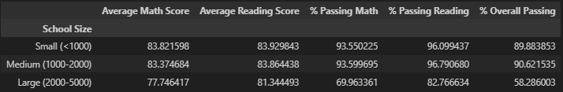

* Looking at the scores by the type of school, the Charter schools have higher scores in math, reading, and overall passing percentage compared to the District schools.

