**~DESI~**

**Scene Layouts:**

1. **Introduction**

**Voiced and text.**

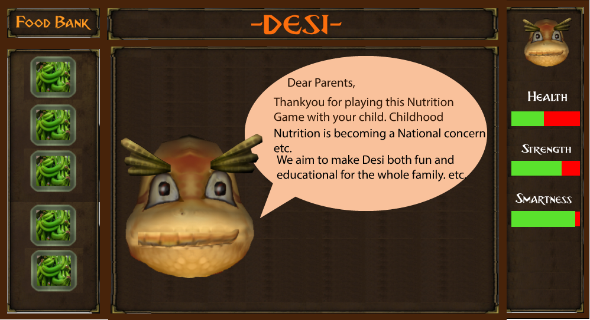

1. **Parental setup**

**Explanation**

**Please take a little time to familiarise yourself with the story by cycling through the scenes. The story is simply one of a dragon who is blown off course from the magic mountain and must make their way home. There are some simple challenges Involving food that your child must solve. Each challenge involves the major food groups and should give lessons about the USE and IMPORTANCE of PROTEINS, CARBOHYDRATES, FRUITS, VEGETABLES, FIBRE in a balanced diet.**

**On the left of the screen is a foodbank of common foods. We have taken into account ethnic origin. DRAG and drop the food item onto the blinking objects on the screen in the setup phase.**

**You also have the option to drag and drop some not so good foods such as BURGERS and SWEETS. If your child chooses these then they will be unlikely to complete the level due to undesirable consequences.**

**Your child can then play through the game. Alternatively the child can play the game on their own or with friends with randomly generated food items.**

1. **Introduction for child**

**Video Clip.**

**https://vimeo.com/265354805**

**“Hello, my name is Desi. And welcome to the MAGIC MOUNTAIN. You are about to embark on a series of extraordinary adventures and quite frankly I don’t know if you are going to make it. But what I do know is without the proper food, and what I’m talking about here is proteins, carbohydrates and vitamins (and lay off the sweets) you really haven’t got a chance of making it back to the MAGIC MOUNTAIN, you haven’t a chance. Well anyway, without further ado, let’s get ready, come on let’s go..**

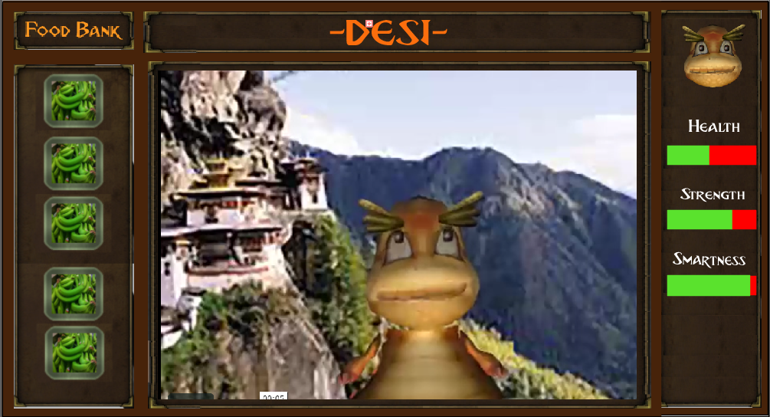

**3.MARKET**

**Voice over and Text:**

**”Time for BREAKFAST! Oh, oh here’s Bongo. He’s going to do whatever he can to try and stop DESI getting back home to the magic mountain. He’s not necessarily BAD just a little DELUDED with his life choices.”**

1. **BONGO**

**“Hey, hey what’s your name? Dethi? Radical err.. what you doing round here. Trying to get through that gate? Too rusty to open. I understand, I understand..”**

**Rabbit interrupts:”It’s your gate Bongo!”**

**Bongo:”Just ignore these trouble makers. Look, whenever I need strength I usually go for one of these cheeseburgers, shakes. Just take them, on the house.**

**Rabbit “Cheese burgers for breakfast?!”**



1. Rabbit Store.

Hover over the food item placed by parent. Rabbit explains the value of the food item.

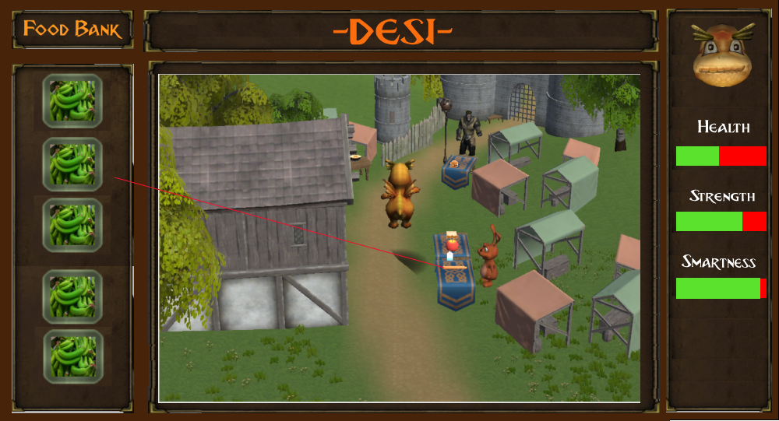

1. Scoring

Child choses items and score computed.

1. bad items cant get past scene. 2bad just gets past scene adjust health --

Else get past scene adjust health ++

6. 