Navigation

Help

Figure 1 below shows the screen you will be presented with when navigation to the web site via your internet browser by typing in the URL within its address bar.

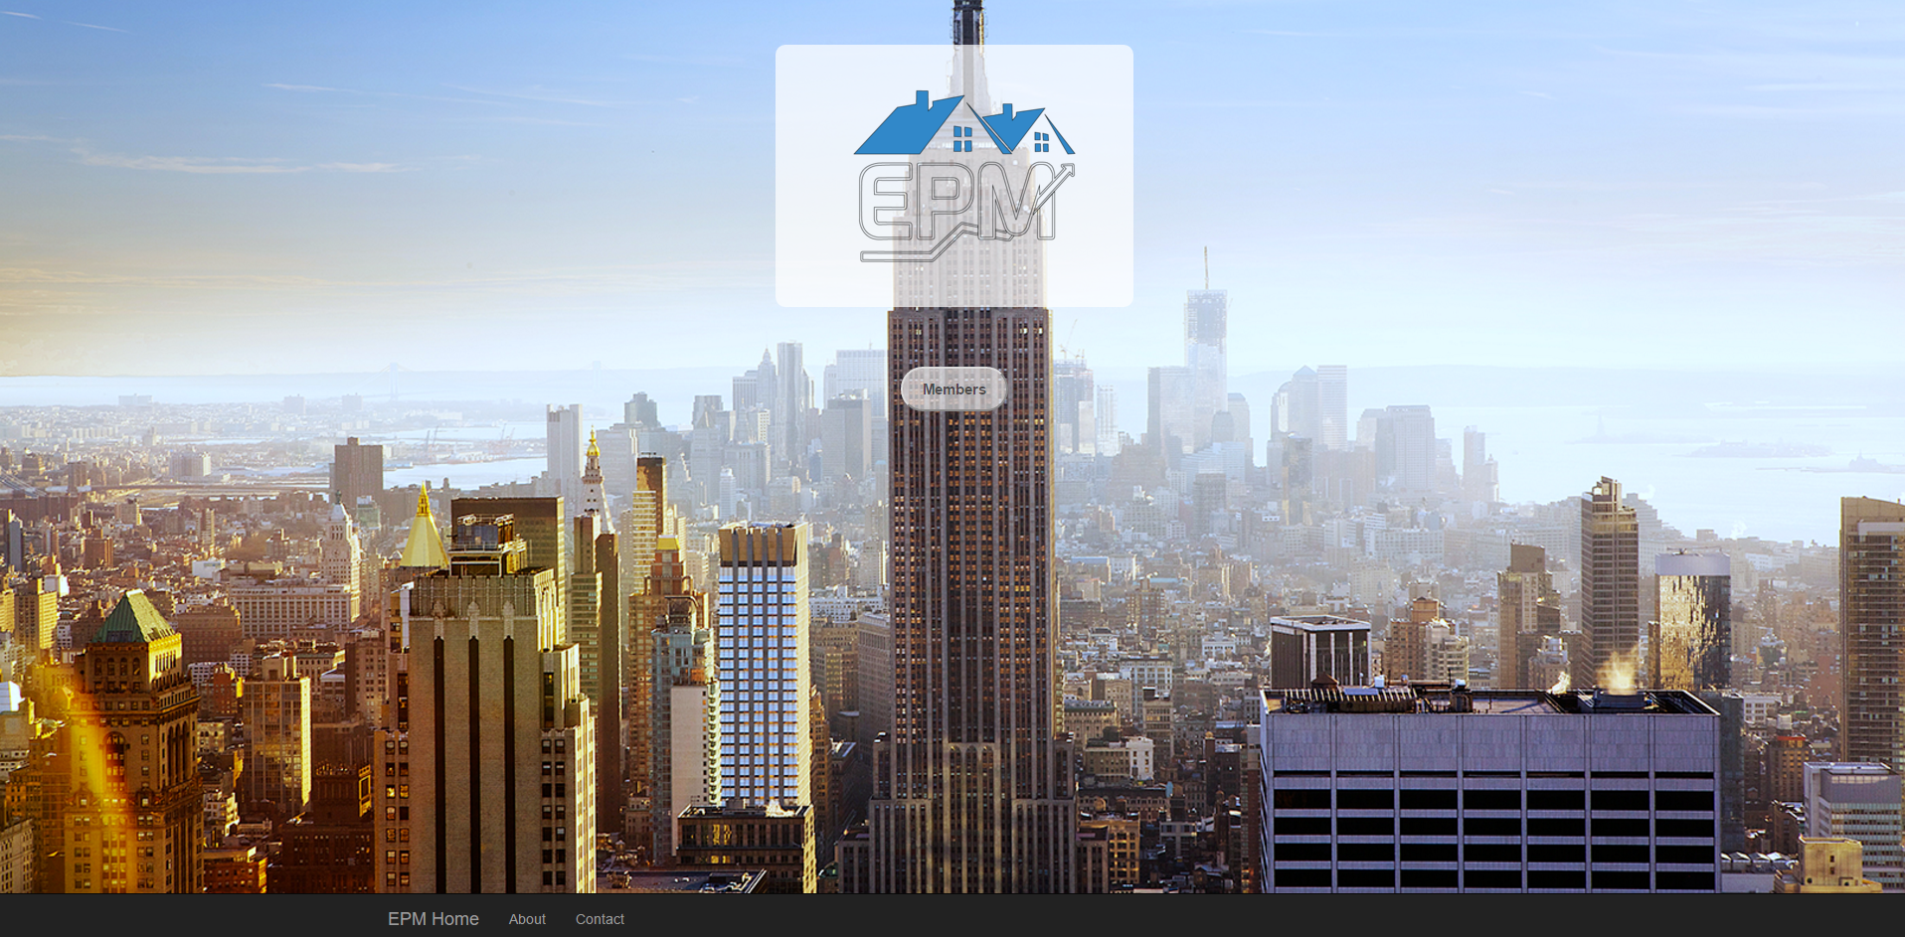

Figure - Landing page

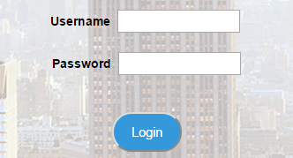From here, you can select the  button located centrally in the screen. By doing this, a login form will appear on the screen in which you must enter your username and password for your account before selecting the login button. The login form is displayed in figure 2.

Figure - Login form

Once logged in the home screen will be visible. The screen has a number of buttons that are grouped together depending on what they correspond to. What this means is the buttons that are to do with the properties within your portfolio are grouped together, the buttons that are used to manage your contractors are grouped together and the buttons used to record jobs or to-do list items are grouped together in order to make for a more easily navigated interface.