**Advanced Graphics Assignment #1**

CODEORDIE?

Austin Eathorne - 100 843 198

Neil Hansen –

**Initial Sketch**

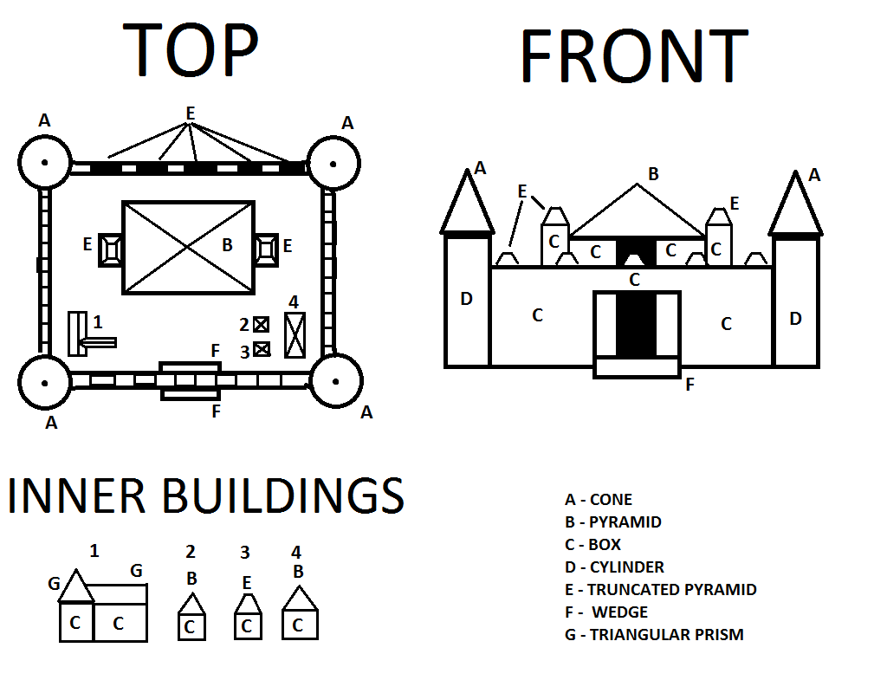

Our initial sketch shows the top and front views of our castle as well as a view of the interior buildings. Each shape is labelled with a letter, which corresponds to a shape in the legend provided. Initial sketch was made using paint.

**Object List**

All primitives excluding our grid were created using a scale of 1 in all dimensions and scaled per instance.

F = Front, B = Back, R = Right, L = Left

S = Scale, T = Translation, R = Rotation

Cone

* BR Pillar Top = S(3.0f, 2.0f, 3.0f) * T(10.5f, 7.0f, 10.5f)
* BL Pillar Top = S(3.0f, 2.0f, 3.0f) * T(-10.5f, 7.0f, 10.5f)
* FR Pillar Top = S(3.0f, 2.0f, 3.0f) * T(10.5f, 7.0f, -10.5f)
* FL Pillar Top = S(3.0f, 2.0f, 3.0f) * T(-10.5f, 7.0f, -10.5f)

Pyramid

* Castle Roof = S(10.5f, 4.0f, 10.5f) * T(0.0f, 7.0f, 2.75f)
* R Long House Top = S(2.0f, 2.0f, 5.0f) * T(7.5f, 3.0f, -6.5f)
* RB Small House = S(1.0f, 1.0f, 1.0f) * T(5.0f, 1.5f, -6.0f)

Box

* L Wall = S(1.5f, 4.0f, 18.5f) * T(-10.5f, 2.0f, 0.0f)
* R Wall = S(1.5f, 4.0f, 18.5f) * T(10.5f, 2.0f, 0.0f)
* B Wall = S(18.5f, 4.0f, 1.5f) * T(0.0f, 2.0f, 10.5f)
* FL Wall = S(7.0f, 3.0f, 1.5f) * T(-5.75f, 2.0f, -10.5f)
* FR Wall = S(7.0f, 3.0f, 1.5f) * T(5.75f, 2.0f, -10.5f)
* FL Wall = S(7.0f, 3.0f, 1.5f) * T(-5.75f, 2.0f, -10.5f)
* F Top Wall = S(18.5f, 0.5f, 1.5f) * T(0.0f, 3.75f, -10.5f)
* F Bottom Wall = S(18.5f, 0.5f, 1.5f) * T(0.0f, 0.25f, -10.5f)
* B Castle Wall = S(10.0f, 5.0f, 0.5f) * T(0.0f, 2.5f, 7.8f)
* R Castle Wall = S(0.5f, 5.0f, 10.0f) * T(5.0f, 2.5f, 3.05f)
* L Castle Wall = S(0.5f, 5.0f, 10.0f) * T(-5.0f, 2.5f, 3.05f)
* FL Castle Wall = S(4.0f, 5.0f, 0.5f) * T(-3.25f, 2.5f, -2.0f)
* FR Castle Wall = S(4.0f, 5.0f, 0.5f) * T(3.25f, 2.5f, -2.0f)
* L Castle Tower = S(3.0f, 6.0f, 4.0f) * T(-6.5f, 3.0f, 4.0f)
* R Castle Tower = S(3.0f, 6.0f, 4.0f) * T(6.5f, 3.0f, 4.0f)
* R Long House = S(2.0f, 2.0f, 5.0f) * T(7.5f, 1.0f, -6.5f)
* RB Small House = S(1.0f, 1.0f, 1.0f) * T(5.0f, 0.5f, -6.0f)
* RF Small House = S(1.0f, 1.0f, 1.0f) * T(5.0f, 0.5f, -8.0f)
* L ‘L’ House (A) = S(2.0f, 2.0f, 6.0f) * T(-7.5f, 1.0f, -5.5f)
* L ‘L’ House (B) = S(2.0f, 2.0f, 2.0f) * T(-5.5f, 1.0f, -7.5f)

Cylinder

* BR Pillar = S(1.5f, 6.0f, 1.5f) * T(10.5f, 3.0f, 10.5f)
* BL Pillar = S(1.5f, 6.0f, 1.5f) * T(-10.5f, 3.0f, 10.5f)
* FR Pillar = S(1.5f, 6.0f, 1.5f) * T(10.5f, 3.0f, -10.5f)
* FL Pillar = S(1.5f, 6.0f, 1.5f) * T(-10.5f, 3.0f, -10.5f)

Truncated Pyramid

* B Wall Tops = S(1.5f, 10.f, 1.5f) * T(8.0f - (i * spacing), 4.5f, 10.5f) [i = 0 to 4]
* F Wall Tops = S(1.5f, 10.f, 1.5f) * T(8.0f - (i * spacing), 4.5f, -10.5f) [i = 0 to 4]
* L Wall Tops = S(1.5f, 10.f, 1.5f) * T(-10.5f, 4.5f, 8.0f - (i * spacing)) [i = 0 to 4]
* R Wall Tops = S(1.5f, 10.f, 1.5f) * T(10.5f, 4.5f, 8.0f - (i * spacing)) [i = 0 to 4]
* L Castle Tower Top = S(3.0f, 3.0f, 4.0f) * T(-6.5f, 7.5f, 4.0f)
* R Castle Tower Top = S(3.0f, 3.0f, 4.0f) * T(6.5f, 7.5f, 4.0f)
* RF Small House = S(1.0f, 1.0f, 1.0f) * T(5.0f, 1.5f, -8.0f)

Wedge

* Outside Ramp = S(4.75f, 0.5f, 1.5f) * T(0.0f, 0.25f, -12.0f)
* Inside Ramp = R(180.0f * (PI / 180.0f)) * S(4.75f, 0.5f, 1.5f) * T(0.0f, 0.25f, -9.0f)

Triangular Prism

* L ‘L’ House (A) = S(2.0f, 2.0f, 6.0f) * T(-7.5f, 3.0f, -5.5f)
* L ‘L’ House (B) = R(90.0f * (PI / 180.0f)) * S(3.0f, 2.0f, 2.0f) * T(-6.0f, -3.0f, -7.5f)