Circuits and Embedded Systems

Preface:

Perhaps you’ve taken a look through some of my CET notes and are confused as to why I’m doing notes on circuits and embedded systems even though I already have notes covering computer hardware and assembly language. Well the focus of my computer hardware notes was on modern components that are common within computer hardware, and how each component works or interfaces with other components. More obvious is the focus of my assembly notes. While it was necessary to cover some low level stuff there, most of it was just repeating myself from the computer hardware notes. This document’s focus is closer to that of electrical engineering. The aim is not to go as deep as a full on electrical engineering course, but we will be covering extremely low level components, down to the molecular structure and properties of said components, as well as how to integrate them into larger circuits. Embedded systems will be less of a focus, since when we discuss embedded systems, we are usually talking about interfacing with hardware through low level code.

Introduction:

If you are new to electronics then this document is sure to be overwhelming. In all honesty, it may deal with some complex mathematics as we delve further into some of the areas that are harder to explain. I hope that you are familiar with what a circuit is at the very least. I encourage you to build some of the circuits that we’ll be covering on a bread board if you have access to the components required to do so.

Electricity:

Where better to start than the very foundations of electronics: electricity! Taking notes from the Wikipedia article on electricity (not a new concept for me to rip stuff off from there), electricity is the set of physical phenomena associated with the presence and motion of matter that has a property of electric charge. Electricity is heavily associated with magnetism. The phenomena of electricity combined with magnetism together are known as electromagnetism. Of course, electricity is more complicated than what I’ve just described, but this is a good starting spot.

Electric Current:

The word “current” can be used to describe many things: air current, water current, convection current, probability current, etc. The word means “continuously moving in a certain direction”. When we discuss electric current, we are talking about the flow of electric charge. When we say “electric charge” in the field of electronics, we are generally referring to negative charge – that is to say, an abundance of electrons. Note that electric charge *can* be positive, but we almost always mean a negative charge. In other words, electric current means the flow of electrons. Electrons flow better or worse through various materials due to molecular properties of the medium in question. Materials which inhibit the flow of electric charge are known as insulators, and materials that promote the flow of electric charge are known as conductors. The particles within a conductor which promote the flow of electric charge are called charge carriers because they literally carry the electric charge across the conductor e.g. a wire.

The measure of electric current is really the measure of how many electrons are flowing and at what rate. The Internation System of Units (SI) unit for current is called the ampere, or amp for short. The symbol for amperage is ‘A’. What may confuse some is that the symbol for current is ‘I’. The symbol for current is used in mathematical equations when we are trying to solve for missing information using algebra. This should not be confused with the measurement unit of amperes. One is a variable, the other is the measurement unit. Capiche? Good.

Voltage:

If you know anything about electronics, it’s certainly voltage. Although, do you truly know what voltage is? Likely you have some idea granted that batteries have a certain amount of voltage but then drain over time. The official definition is that voltage is the electric potential difference between two points. In a battery, for example, we have two terminals, an anode (positive charge), and a cathode (negative charge). We can measure the amount of work needed per unit of charge to move a test charge between the two terminals on the battery. The SI unit of measure for potential difference is called a volt. In terms of work per unit charge, we describe this in Joules per Coulomb. Perhaps I’ve lost you. Well maybe this will make more sense: 1 volt = 1 joule (of work) per 1 coulomb (of charge). More succinctly: V = J/C. This formula is not actually that important for our purposes, the main point to derive is that voltage really equals the potential power that we can supply to the circuit.

Resistance:

As we discussed briefly, there are conductive materials, known as conductors, but there are also inhibitors of current, known as insulents. Sometimes we wish to limit the electrical current, so we intentionally add resistance using an electrical component known as a resistor. Electrical resistance is often associated with friction, since they share similar mathematical properties. Resistance is measured in Ohms (), named after Georg Ohm.

Power:

Power is the quantification of the rate of energy transfer. Power is measured in watts (W). A watt is equal to 1 joule per second. More easily understood, however, is that the amount of watts can be descibed as W = VI where W is watts, V is voltage, and I is current. In other words, power in watts equals volts times current. We won’t measure power very frequently, but it can be useful when we only want to measure power consumption. For example, since Hydro can’t measure the exact number of volts and amps that you’ve used, they bill based on watts per minute. Power supply units for PCs and light bulbs are often rated in watts because the amount of voltage and current that they draw can fluxuate, so a more general measurement is easier for a consumer to comprehend.

Water Analogy:

The water analogy is commonly taught in schools to help students visualize the flow of current. I’ve come up with somewhat of my own water analogy. The analogy isn’t perfect, and in many ways is flawed, so keep that in mind. However, it is useful when visualizing why electric current flows the way it does.

So how exactly can we understand voltage, current, resistance and power. Well, firstly, I visualize a large dam which represents our power supply. By power supply, I’m referring to something like a battery. The voltage is the amount of water that is stored within the dam. In other words, it’s the potential difference in water (voltage in our analogy). Now then, let’s say that the dam is partially opened. The stream of water that comes out would be the current since it is no longer stagnant, but rather flowing in a particular direction (let’s pretend down a stream/river). Now let’s say that the river becomes quite narrow in certain spots. This could represent the resistance in current, since it would be forced to work its way into the bottleneck. Power is a bit harder to explain, but we can think of it lightly as the speed at which the stagnant water resting in the dam transitions to moving water down the stream.

Ohm’s Law:

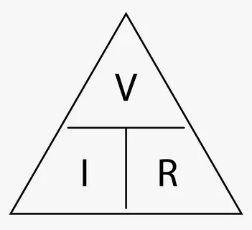 By far the most important contribution to the study of electricity is Ohm’s Law, named after Georg Ohm. The law states that the current flowing through a conductor between two points is directly proportional to the voltage across the two points. When we say directly proportional, we mean that when voltage increases, current decreases, and vice versa. This is described in the mathematical equation . I like to visualize it as a pyramid because I find that easier, as illustrated in the diagram. In order to remember the formula, I think “VIR” reading top to bottom, left to right (but maybe that isn’t helpful for you, I don’t know). Using this fundamental equation, we can solve for one unknown when two of the other variables are known. We can rearrangeintoor into. We will apply Ohms Law frequently in conjunction with other formulas as we continue through the material.

Alternating Current and Direct Current:

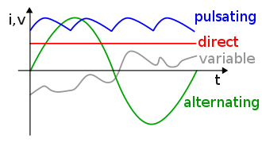 Now hopefully, you are familiar with current. As I stated in the water analogy section, the representation is not completely accurate to reality, and this happens to be one such topic where those rules don’t apply. We’ll begin with direct current, since it is the easiest to comprehend. Direct current is when electrical current flows in one direction and is therefore linear. Alternating current, however, differs in that it periodically reverses direction. The magnitude and period at which it changes can be illustrated as a sine wave, whose positive half-period corresponds with the positive direction of current, and where the negative half-period corresponds with negative direction. Other types of current include pulsating direct current, which is when current periodically changes value, but always flows in one direction (basically a hybrid of DC and AC current), as well as variable current, which is when current changes depending on external variables that control it.

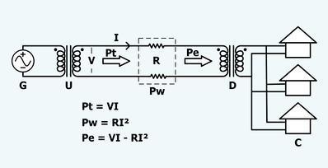 Appliances within your house run on DC. This is for a few reasons. Firstly, DC is easier to work with in complex circuitry. Second, and more importantly, is that all outlets in your house are DC outlets. Power lines actually run AC, primarily because it can be transmitted efficiently and at very high voltage, which reduces energy lost due to resistance of the wire. The way that this is achieved is with a step-up and step-down transformer. A transformer (not the autobot or decepticon kind) is a component that can increase or decrease voltage levels in an AC circuit. We will look closer at transformers and how exactly they work later on. In the schematic shown, we can see the generator (G), which then sends current to the step-up transformer (U). The voltage (V) is the start of the transmission/power line. Pt is the power entering the transmission line, I is the current in the wires, and R is the total resistance in the wires. Pw is the power lost in the lines, Pw is the power reaching the ned of the transmission line, D is the step down transformer, and finally, C are the consumer homes which recieve the AC and translate it into DC which enters the house at the breaker box and is then routed throughout the household to various outlets.

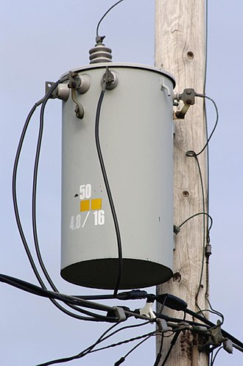Figure 1: Transformer

Circuits:

How have we not even begun to discuss circuits yet?! So much to cover in this document. A circuit is a closed loop consisting at least of a conductor, a power source, and at least one “load”. The simplest circuit consists of the anode of a battery connected to a resistor, which then feeds back into the cathode. 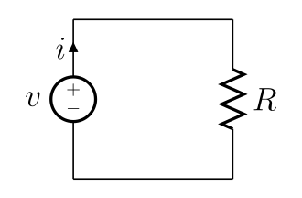In this circuit, the battery is our power source, some copper wire (pressumably) acts as the conductor through which current flows, and the resistor (R) is our “load”. A load is just any component that consumes power. If we didn’t have a load in our circuit, the current would flow extremely rapidly. If you’re familiar with the law of Conservation of Energy, you know that energy cannot be created or destroyed, only translated into different forms. In our case, electrons would cause the the molecular structure of the wire to vibrate and create heat. In other words, a circuit without a load could burn your house down if you’re not careful. When a circuit does not form a complete loop, it is called an open circuit (even though at that point it’s really not a circuit by definition). This could refer to a circuit that genuinely hasn’t been completed, or it could refer to a circuit that is entirely built, but contains switches that must be closed to complete the circuit.

Through-Hole vs. Surface Mount Circuits:

In my Computer Hardware notes, we covered PCBs, but I’ll recap once more here. A Printed Circuit Board (PCB) is a flat board upon which we can create circuits. It is typically made up of some sort of substrate such as fibreglass, as well as laminate layers made of cured resin to add thickness and stability between each layer. Thin sheets of conductive copper are sandwhiched between these layers. Small holes called vias are drilled into some of the layers to connect them together. Manufacturers can use a variety of techniques to cover the trace outline of the circuit on the copper plate and then place it in an etchant which dissolves the exposed regions of copper, leaving only the traces behind. Solder mask is then applied to the PCB prevent moisture (the green stuff). Contact points are usually left exposed.

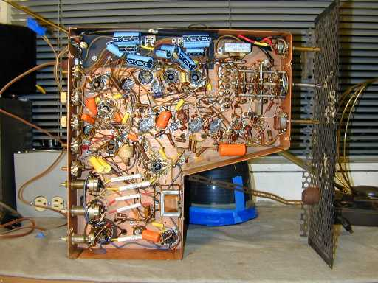

In the earlier days of electronics, when PCBs had not been invented, manufacturers used to just use solder wire together in a tangled mess. The primary purpose of the PCB is to affix electronic components to the board, which also helps with reverse engineering/readibility and cuts cost significantly since space can be optimized. The secondary pupose is to provide reliable connections. There are two methods of affixing components to a PCB: Surface mount and through-hole. Surface mount components are often smaller than through hole because they simply bond to the exposed contact points on the traces. Usually, solder paste is applied to the contact points and then the components are placed on top by some sort of machinery on an assembly line. The PCB is then sent into a sort of oven which quickly melts the solder paste and creates a bond after hardening. Through-hole is the more conventional way of putting components on boards. It is less permanent than surface mount since the connections are easily desoldered by hand. Holes are drilled through the entire PCB and are coated with a conductive material. The leads on a component can be fed through these holes and then secured in place with solder. 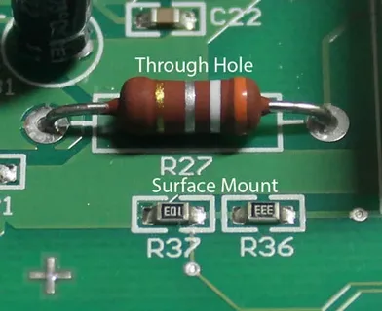Hopefully in the image above you can see the difference between the through-hole resistor and the surface mount resistor.

Resistors:

At this point you ought to understand what a resistor actually does, but there are more to resistors than meets the eye. First of all there are many types of resistor, so we will cover each of those and highlight the most important ones.  
  
- **Carbon Composition Resistor:** These resistors are the most commonly used resistor. They are low cost, and easy to make. They are made of carbon clay on the interior and are covered in a plastic casing. The leads are made of tinned copper. Carbon resistors come in a wide range of values, are low cost, and very durable.

- **Thermistor:** Thermistors are pretty ingenious inventions. Essentially, their resistance is altered based on the external temperature. Most thermistors have a negative temperature coefficient, meaning that resistance dips as temperature increases. Thermistors can be quite accurate and are probably most notably used in 3D printers to detect the heat of the hotend.

- **Wire Wound Resistor:** These resistors have a wire of manganin or constantan wound around a cylinder of insulating material. They are typically used for high power devices anywhere from 5W to 200W.

- **Metal/Carbon Film Resistor:** These resistors are made by adding a thin film of conductive material such as pure carbon or metal onto an insulating (non-conductive) core. The lead wire is welded to end caps which make contact with the conductive film. These resistors are fully non-inductive, making them suitable for high-grade applications.

- **Variable Resistor:** Variable resistors are also very neat. They function similarily to a potentiometer (which we will look at in time). The resistance is controlled by a knob, dial, or slider. This works by having a rotating shaft and a wiping contact that turns with the shaft. The wiping contact slides across an inductive material. As the wiping contact comes closer to the input terminal, the distance that the electric current has to flow across the inductive material is lessened, and and the wiping contact moves away from the input terminal, that distance increases (which increases resistance). An example of variable resistors is called a rheostat.

- **Non-Linear Resistor/Varistor:** Varistors are unique because they do not obey Ohms Law. These produce a non-linear voltage-current curve. They can be made of silicon carbide or zinc oxide.

- **Light Dependent Resistor:** Light Dependent Resistors (LDR) are photosensitive. When light is cast on an LDR, electrons are ejected from the surface, making conductivity increase (less resistant), and vice versa when light is absent.

It will be beneficial for you to learn how to read resistor color codes. Resistors will usually have colored stripes on them. The number of stripes can go from 3 to 6. Here are what each band represent depending on their number:

|  |  |  |  |  |  |  |
| --- | --- | --- | --- | --- | --- | --- |
|  | 1st Band | 2nd Band | 3rd Band | 4th Band | 5th Band | 6th Band |
| 3-Band Resistor | 1st Digit | 2nd Digit | Multiplier |  |  |  |
| 4-Band Resistor | 1st Digit | 2nd Digit | Multiplier |  |  | Tolerance |
| 5-Band Resistor | 1st Digit | 2nd Digit | 3rd Digit | Multiplier |  | Tolerance |
| 6-Band Resistor | 1st Digit | 2nd Digit | 3rd Digit | Multiplier | Tolerance | Temperature Coefficient (TCR) |

Now is this confusing? Yes. Unfortunately, I don’t make the rules. It gets worse though, because each band can be a different color, which represents a different number. The number associated with each color depends on which what band. So for example, if the first band is red, then that would mean the first digit was a 2, but if the 6th band was red, then that would mean a tolerance of 50 ppm/K... For the most part though, we don’t need to worry about the bands past the multiplier, so it’s not **that** big of a deal. Here is a chart of each color and it’s associated value:

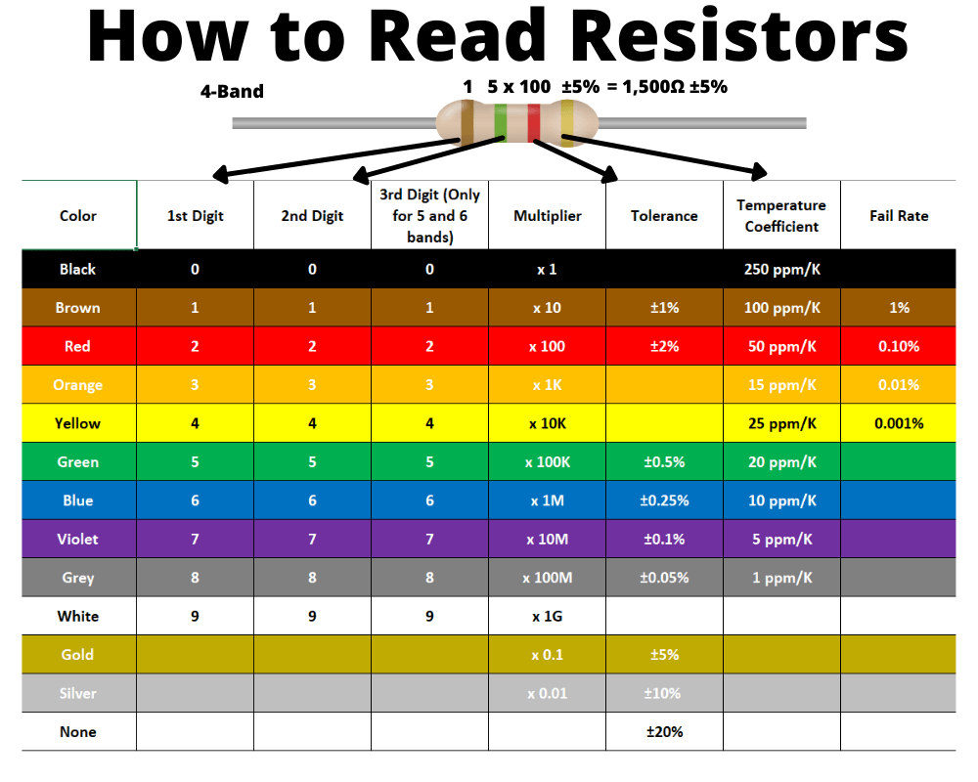

So, all you truly need to remember, is that black = 0, brown = 1, grey = 8, and white = 9. If you’re comfortable with that, and you know the colors of the rainbow, you can fill in the rest. For the multiplier column, the numbers are equal to the powers of 10. So black = 1 because 10^0 = 1.

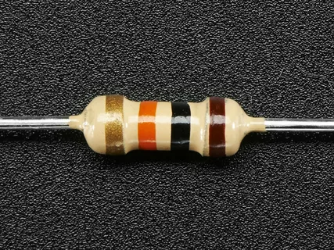 Taking a random image from the web, we can calculate it’s resistance. The first band is gold, which indicates that we’re reading it backwards, since gold has no value as the first stripe. This is a 4 band resistor, so we know that the bands will represent 1st digit, 2nd multiplier, and the tolerance. First digit is brown which = 1, then black which = 0, and then a multiplier of 3, so 10^3 = 1000Ω or 1KΩ with a tolerance of +/- 5%.

Diodes:

Semiconductors:

At this point we’ve discussed conductors, but even more integral to digital electronics are semi-conductors. A semiconductor is a material that is not conductive which is forceably altered to become semi-conductive. In digital electronics, semi-conductors are created with silicon, which comes from sand. Silicon Valley located in Northern California is named after the material since many tech startups began there after the invention of the transistor. Semiconductors were and still are an integral part of modern processor architecture.

Pulse Width Modulation:

In my notes about computer graphics, we discussed how analog video was transmitted on old-school CRT televisions. Some main take aways to research if you haven’t read those yet are AM and FM radio signals, as well as signal carriers and sub-carriers. We learned that AM stands for Amplitude Modulation (raising or lowering the peaks of a wave form but keeping the period the same). FM stands for Frequency Modulation, and is the opposite of AM. Rather than altering the amplitude of the wave, we alter the period of the wave (time required to complete a full cycle). Pulse Width Modulation is a technique which is commonly used in electronics to save on energy consumption. When working with digital electronics, we are generally dealing with square waves. By altering the duration of the digital pulses (peaks) and frequency that they are generated, we can create interesting effects. The *duty cycle* descibes the proportion of ‘on’ time to the regular interval or ‘period’ time. If you had a low duty cycle, that would mean that the digital wave remains in the ‘off’ state considerably more than the frequency of the pulses and the duration that they last for. Take the following image for example:

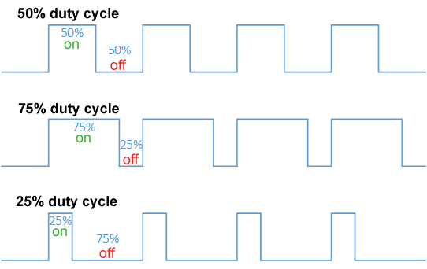 In the final wave form at the bottom, note that not only are the duration of the pulses less than the previous wave forms, but also that the frequency at which they arive is significantly less as well (more time spent in the ‘off’ state).